**Basics of Backend : Practicle for SSH**

**Name** : Bhavin Babariya

**Mentor** : Jay Motka

**Coordinator** : Kishan Das

* generate ssh key in local system

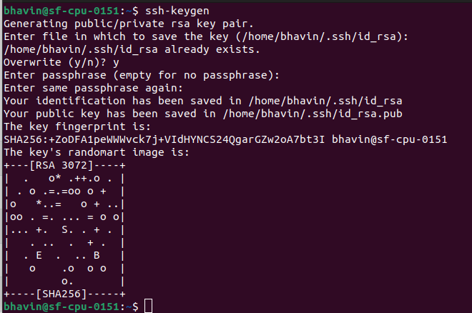

* public and private key are generated

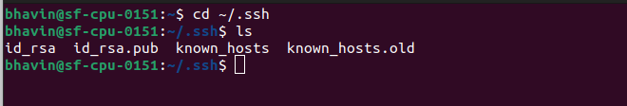

* display public key

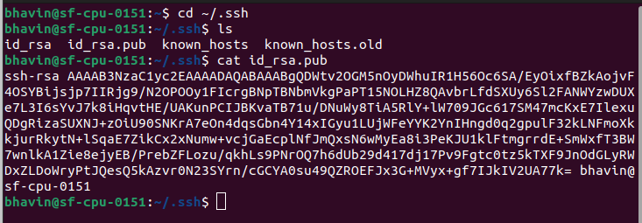

* display private key

