**Name** : Bhavin Babariya  
**Practical** : Git

**Mentor** : Jay Motka

**Coordinator** : Kishan Das

**1. Pull and Merge difference**

* Pull is combination of two commands git fetch and git merge.
* This pull request practical is performed by me and abhay together.

**Command** : git pull

We need git pull before push because remote repository is changed by other so can’t perform git push directly.

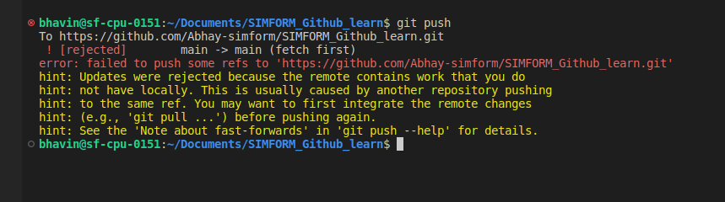

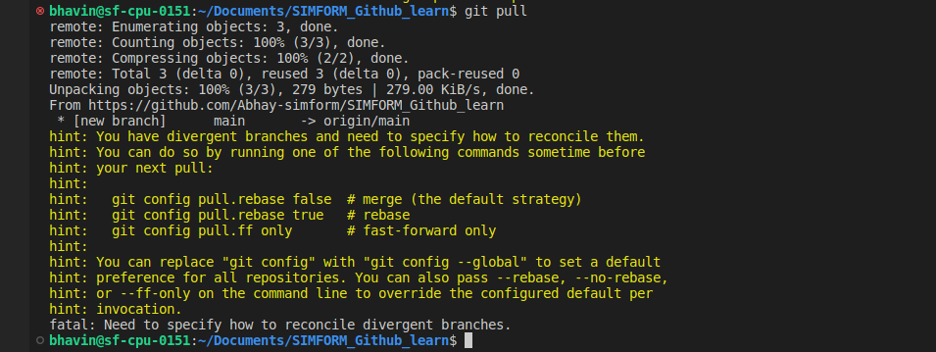

* Create branch feature1 and try to merge , merge conflict come and solve merge conflit.
* Create branch and push to remote repository

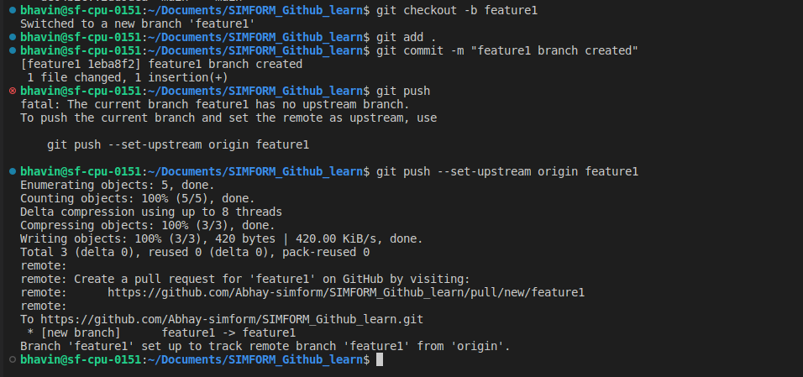

**Merge branch**

**Command :** git merge <branch-name>

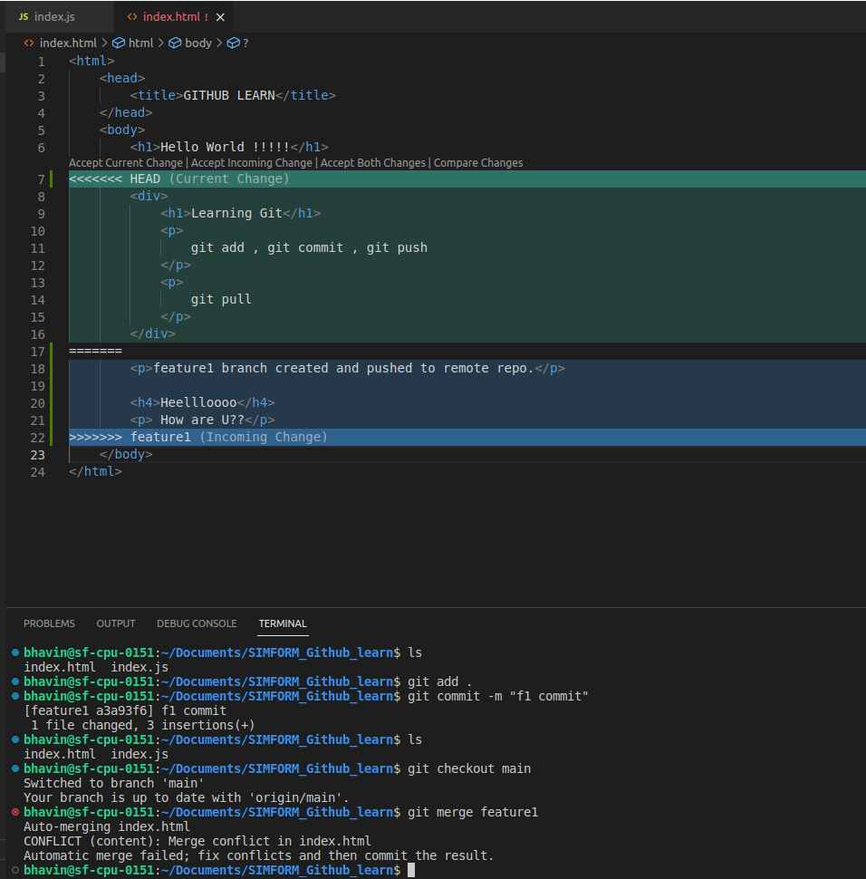

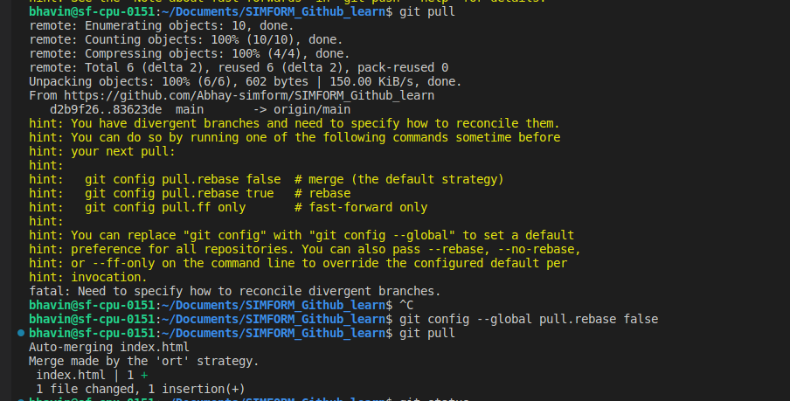

**2. Rebase**

* Create feature3 named feature branch.
* Rebase feature3 branch with main branch.

**Command :** git rebase <branch-name>

-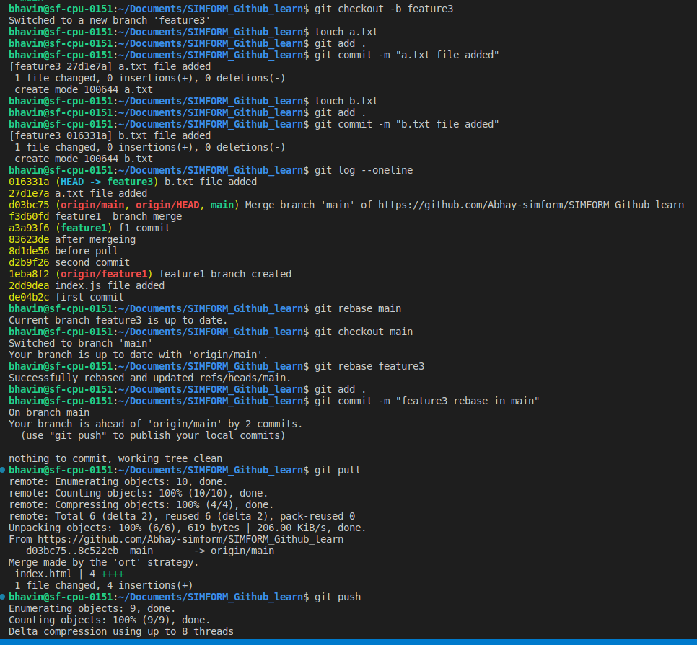

**3. Change commit message**

**Command** : git commit --amend <new-commit-message>

Output : commit message changed.

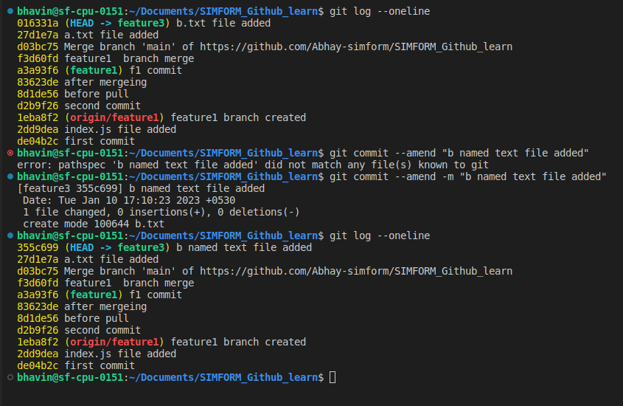

**4. cherry pick**

- Pick commit from feature branch feature3 to main branch

**Command** : git cherry-pick <commit-hash-id>

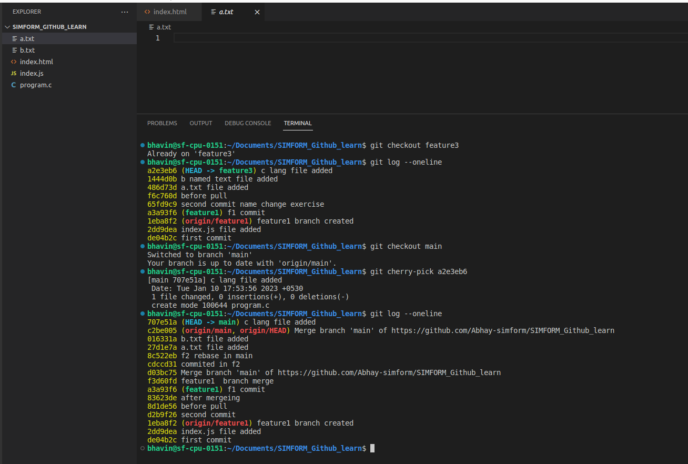

**5. Drop commit**

- Remove some commit from feature branch.

**Command** : git revert <commit-hash-id>

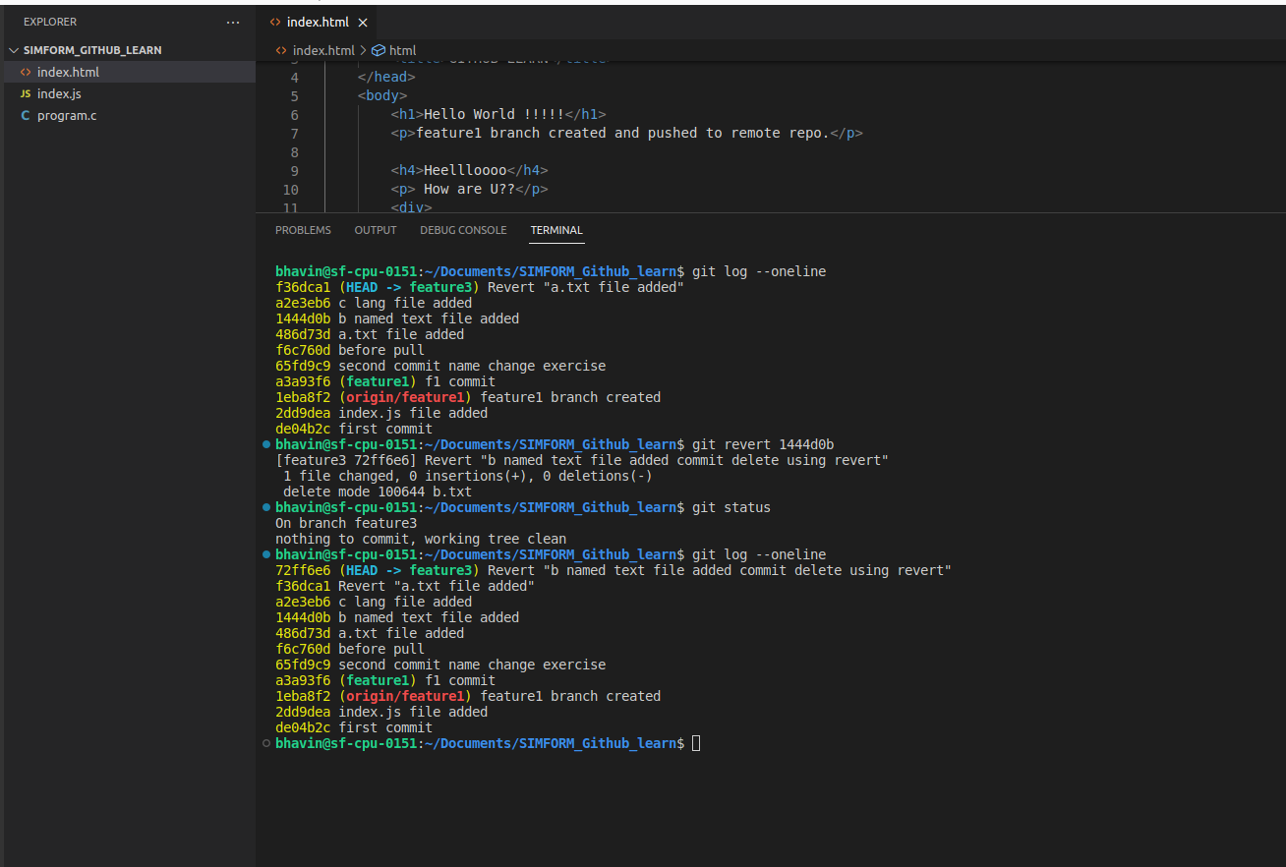

**Stash Command**

If we need to go to other branch and we don’t want to commit in current branch and dont want to lose changes then using stash command we can do this.

* store the changes

**git stash save <stash-name>**

* list stashed changes

**git stash list**

* undo stash by popping the stash

**git stash pop**

