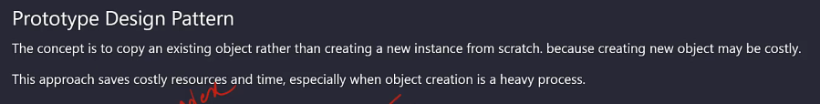

Use clone to create multiple copy of the objects

