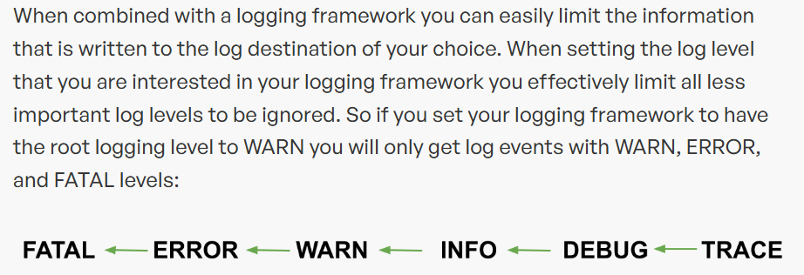

<https://edgedelta.com/company/blog/why-you-should-use-log-level>