DOCUMENTATION OF THE TASK GIVEN

Step 1
Install the required node modules
Command
npm install

Step 2
after installing the required modules , start the server
command
node index.js

Step 3
Create the required database using mongoDB , given in the end

Step 4
Open any web browser
Navigate to localhost:8000

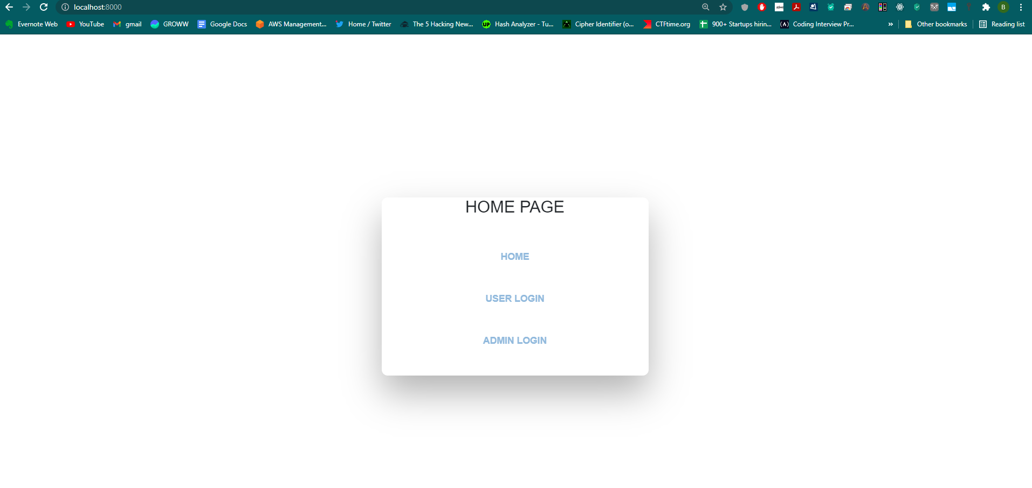

Folder structure
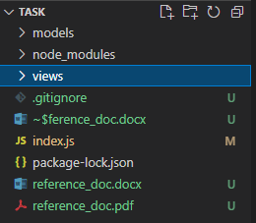

Index.js main index node js with all logic

Views has 3 pages
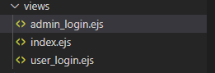

Index.ejs Home page
Admin_login.ejs login for admin page
User_login.ejs login for normal users

Models has 2 schemas
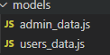

Admin_data schema for admin
Users_data schema for normal users

HOME PAGE
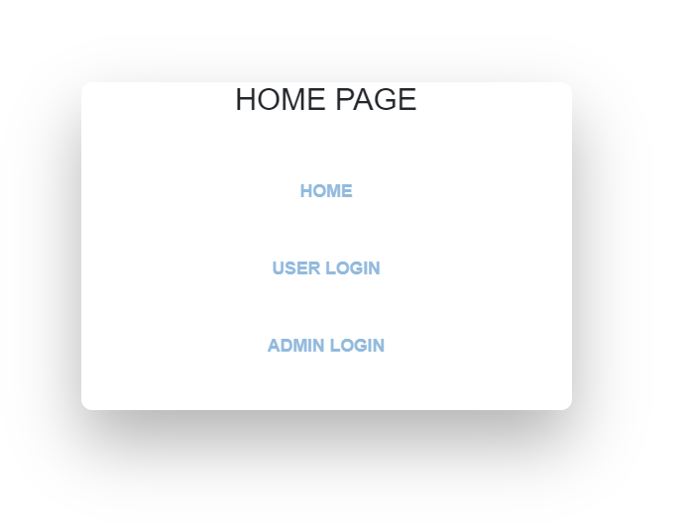

ADMIN LOGIN
http://localhost:8000/admin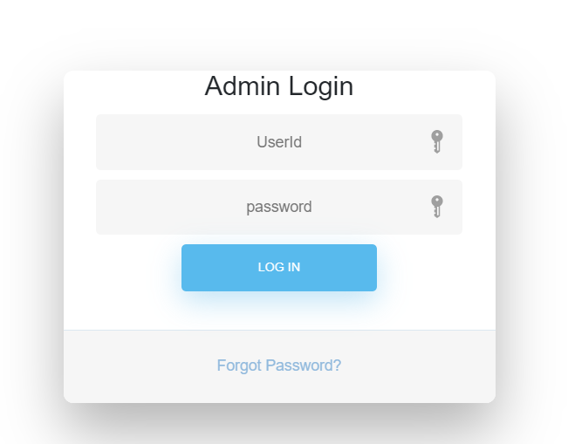

Enter the required userId and password

If such user does not exist in database
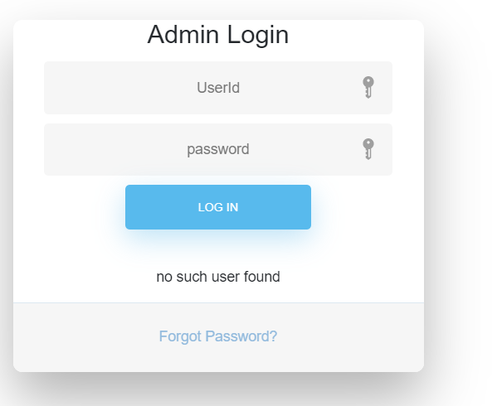

If user found
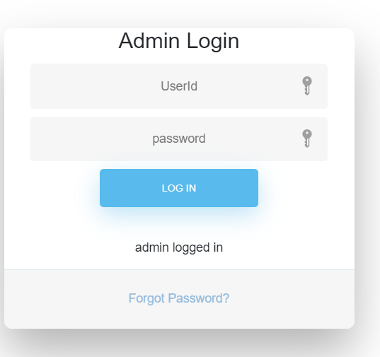
After the user has logged in we can redirect to the required page, but for now only a message is shown if the user has successfully logged in or not
Similarly done for users login
http://localhost:8000/user

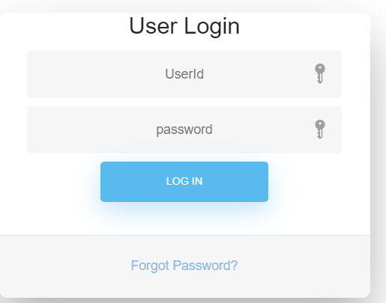

Enter username and password

If no such user found
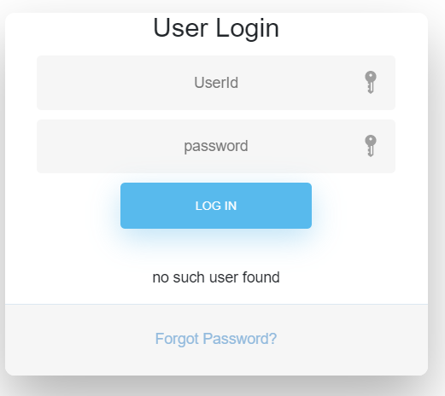

If user found
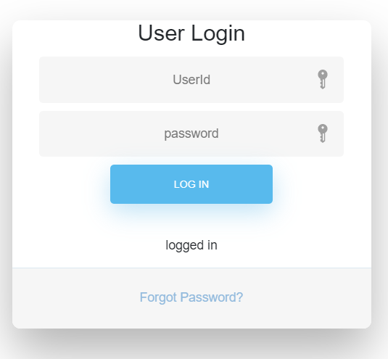

After the user has logged in we can redirect to the required page, but for now only a message is shown if the user has successfully logged in or not

DATABASE (made using mongoDB , connected locally)

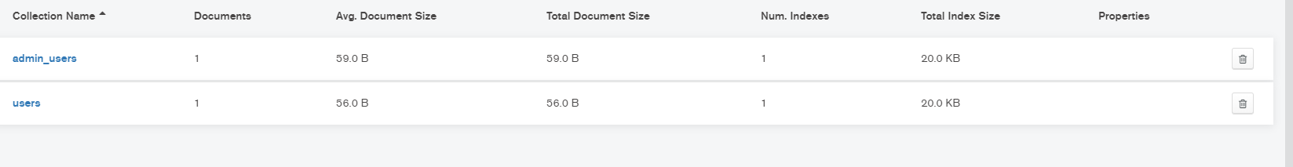
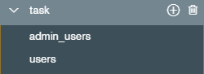

Admin_users db
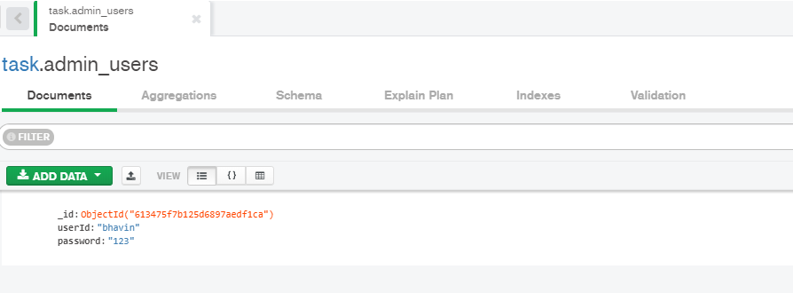

Users db
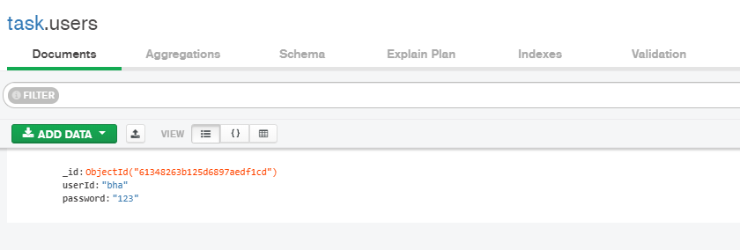Passwords can be hashed and stored in later stages of the project

