

**UNIVERSITY OF PETROLEUM & ENERGY STUDIES**

**Dehradun**

**APPLICATION CONTAINERISATION**

**Name: Bhavini Mishra**

**B. TECH CSE DevOps (2018-22)**

**Roll no.: R171218033**

**Experiment-1**

**Step-1:** Download and Install Virtual Box(5.2.44) as well as Vagrant(2.2.10)

* **Virtual box** [**https://www.virtualbox.org/wiki/Download_Old_Builds_5_2**](https://www.virtualbox.org/wiki/Download_Old_Builds_5_2)
* **Vagrant**

[**https://www.vagrantup.com/**](https://www.vagrantup.com/)

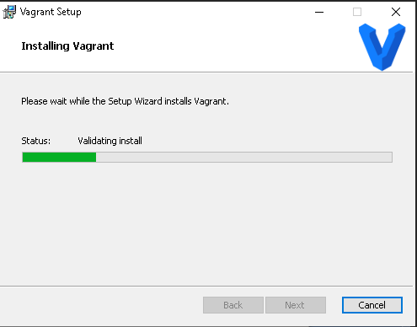

**Step-2:** After installing vagrant check the version and make a folder to initialize vagrantfile.

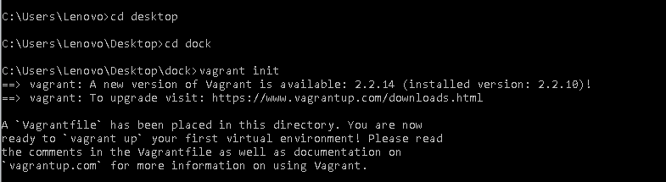

**Step-3:** Add **config.vm.box = "ubuntu/xenial64" to** vagrantfile

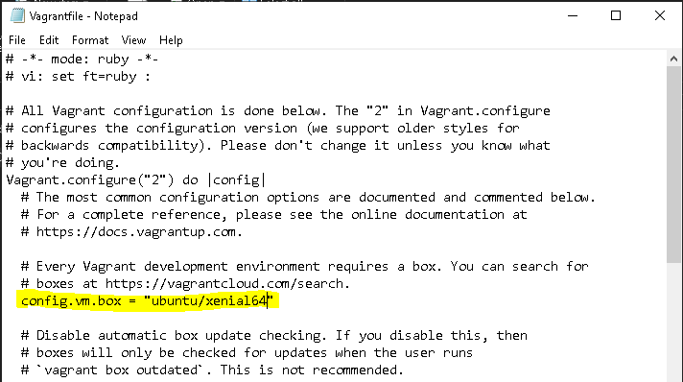

**Step-4:** Run **vagrant up** command

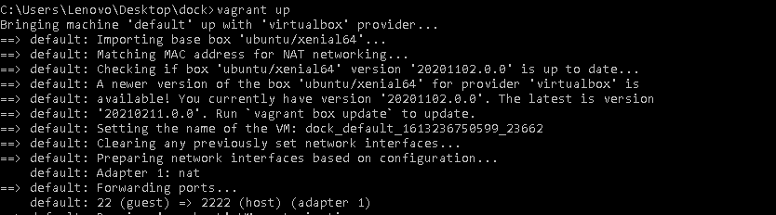

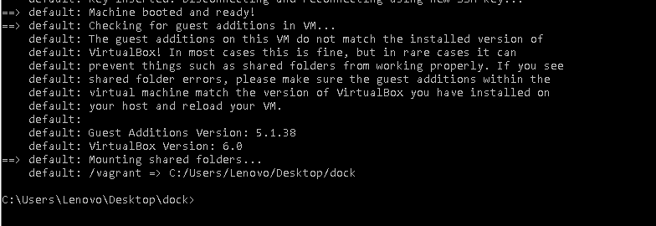

**Step-5:** Run **vagrant ssh** command to enter the virtual machine.

