

**UNIVERSITY OF PETROLEUM & ENERGY STUDIES**

**Dehradun**

**APPLICATION CONTAINERISATION**

**Name: Bhavini Mishra**

**Course: B. TECH CSE DevOps (2018-22)**

**Roll no.: R171218033**

**Experiment-3**

**Docker Network**

**Step-1:** Listing all networks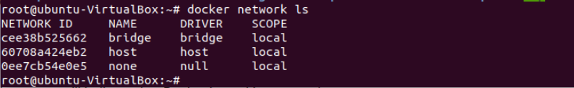

**Step-2:** Creating network net

**Step-3:** Launch container con3 of Ubuntu image in the network net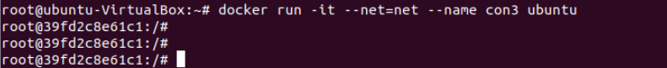

**Step-4:** Launch another container con6 of centos image in the same network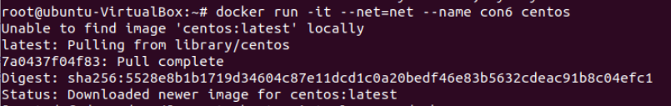

**Step-5:** Now ping con6 to con3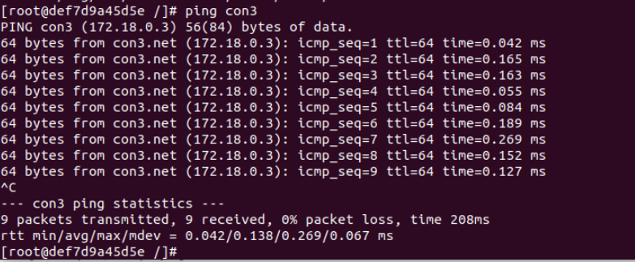

**Step-6:** Inspecting network net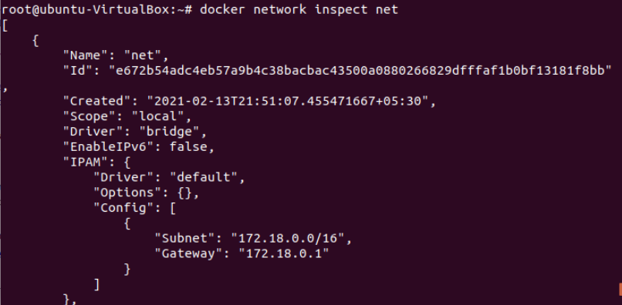

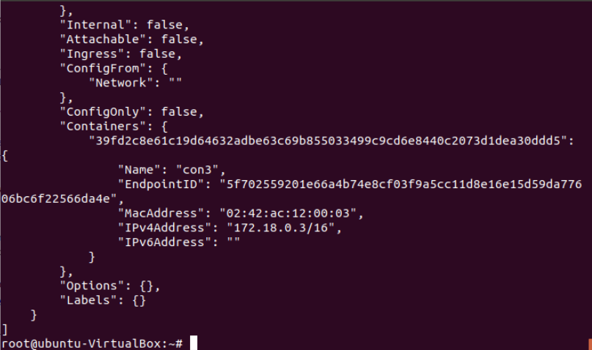

Disconnecting the container from the network

