

**UNIVERSITY OF PETROLEUM & ENERGY STUDIES**

**Dehradun**

**APPLICATION CONTAINERISATION**

**Name: Bhavini Mishra**

**B. TECH CSE DevOps (2018-22)**

**Roll no.: R171218033**

**Experiment-5**

**Docker-Compose**

**Aim- Multi-container setup using Docker Compose**

**Step 1: Install Docker-compose**

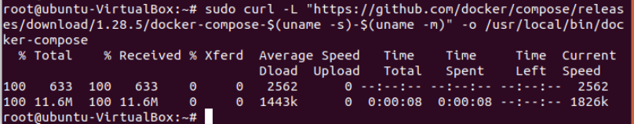

**Step 2: Apply executable permissions to the binary**

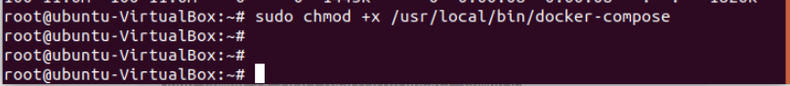

**Step 3: Check the version**

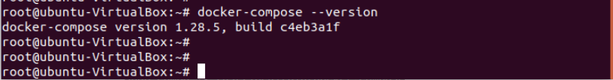

**Step 4: Create db.env file**

**Step 5: Create docker-compose.yml file and write the below code in it**

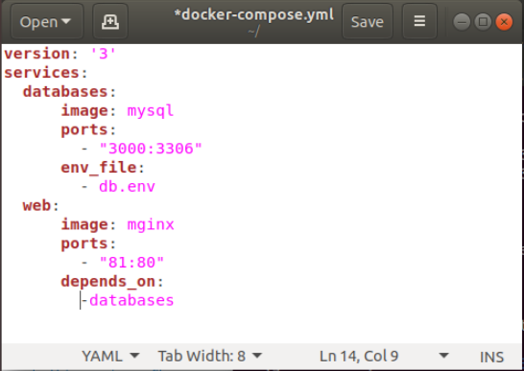

**Step 6: Run docker-compose up –d command**

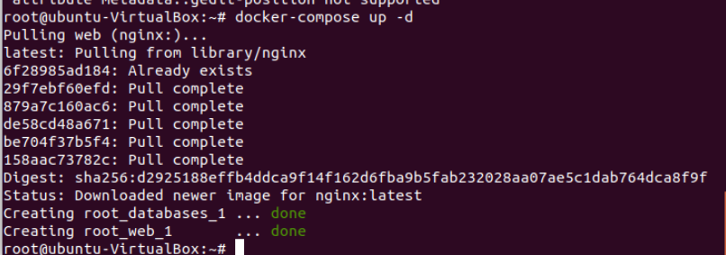

**Step 7: Containers have been launched**



**Step 8: Run the nginx server at port 81**

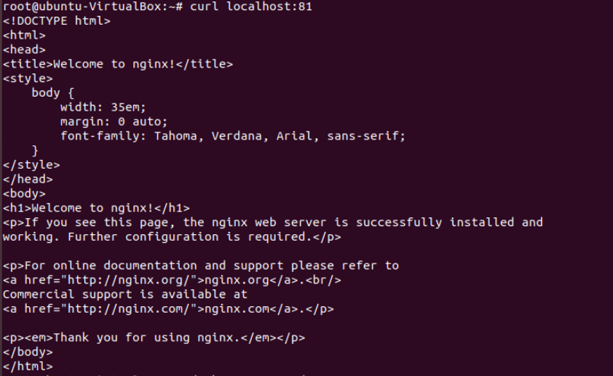

**Step 9: Run docker-compose down command to delete running containers through docker-compose.yml**

