

**UNIVERSITY OF PETROLEUM & ENERGY STUDIES**

**Dehradun**

**APPLICATION CONTAINERISATION**

**Name: Bhavini Mishra**

**B. TECH CSE DevOps (2018-22)**

**Roll no.: R171218033**

**Experiment: 6**

**Title:** Docker Linking and Swarm Docker Linking

• **Run a container in detached mode with name "sc" from image "training/postgres"**

**$ docker run -it -d --name sc training/postgres**

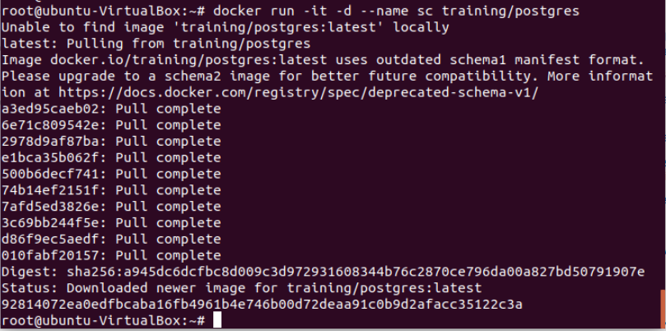

* **Run another container in detached mode with name "shi" from image "training/webapp", link container "sc" with alias "mydb" to this container and finally pass an inline command "python app.py" while running container.**

**$ docker run -it -d -–name web -–link sc:mysc training/webapp**

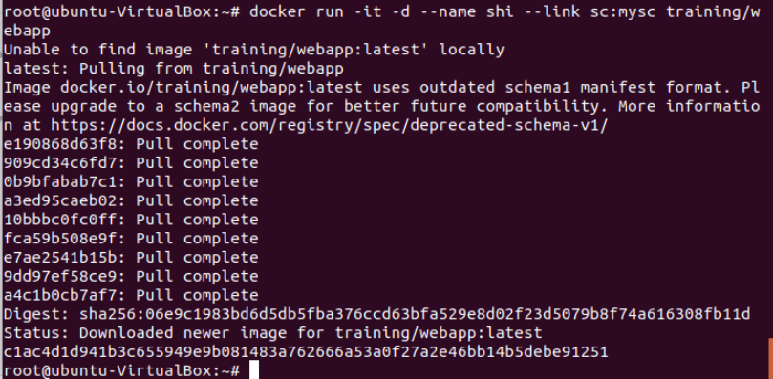

* **Take a bash terminal in "shi" container and Test container linking by doing a ping to "mysc"**

**$ docker exec -it shi bash**



* **Run ping db**

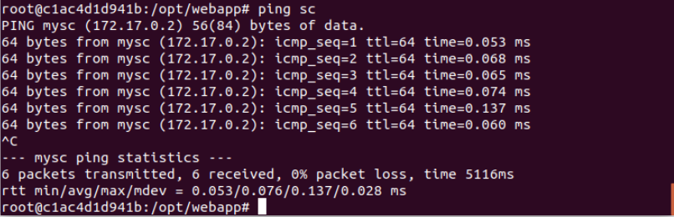

**Docker Swarm :**

**• Initialize the Swarm Cluster into one of the terminal or virtual machine by using the following command.**

**$ docker swarm init**

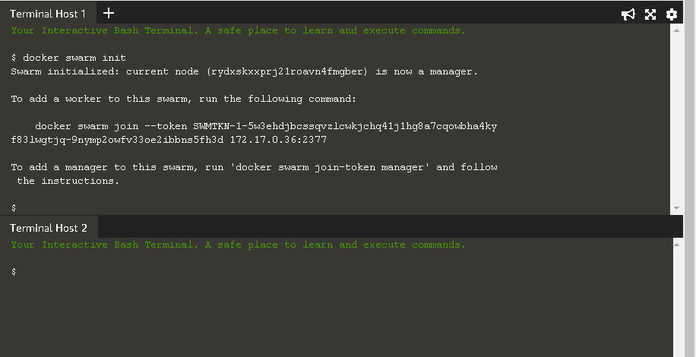

**Join the Cluster : -**

**To add a worker to this swarm, run the following command to join the node to this swarm.**

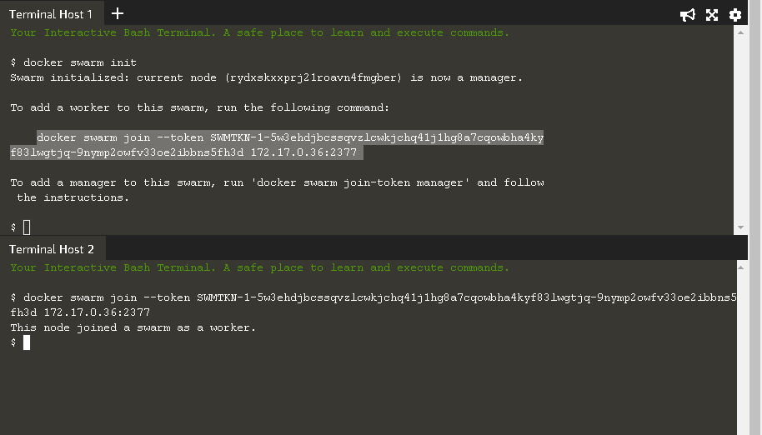

* **To see that how many nodes are joined in this Cluster by using the following command. $ docker node l**

