Topic Control in Mixed-Gender Podcast Dyads
Listening Between the Lines — Dyad-Level Bias Analysis
Does a male speaker’s new topic get taken up by the other speaker more often than a female speaker’s does? A TF-IDF lexical-overlap measure, tested with episode-aware statistics and cross-checked against a semantic similarity measure.
- Episodes: 100 mixed-gender (50 MALE→FEMALE, 50 FEMALE→MALE)
- Turn-pairs: 12,573
- Method: TF-IDF cosine similarity
Bottom line: across five independent tests and two different similarity measures, we find no robust evidence that male speakers’ topic introductions are followed up more than female speakers’ in mixed-gender dyads. The strongly “significant” naive result turns out to be a clustering artifact, not a gender effect.

1. What we measured
To assess topic control — whether a speaker’s introduction of a new subject is picked up by the other speaker — we computed TF-IDF cosine similarity between consecutive turns within each episode. A turn was classified as a topic initiation if its similarity to the immediately preceding turn fell at or below that episode’s median incoming similarity: it diverged from what was just said, rather than continuing it.
For each initiation, we located the next turn produced by the other speaker and measured the cosine similarity between the initiation and that response — the follow-up strength. A response counted as having followed up the initiation if this similarity exceeded the episode’s median outgoing similarity. Pure backchannels (yeah, right, mhm) were stripped from the turn sequence before pairing, so a filler acknowledgment could never count as either an initiation or a follow-up.
We then tested whether male initiations are followed up more than female initiations, restricted to mixed-gender host/guest dyads — MALE→FEMALE and FEMALE→MALE. Same-gender dyads (MALE→MALE, FEMALE→FEMALE) can’t supply this comparison: every initiator in those episodes is the same gender, so there’s no cross-gender contrast to draw within them.

2. Data
100 mixed-gender episodes (50 MALE→FEMALE, 50 FEMALE→MALE), drawn from a gender-balanced sample of 200 podcast episodes. All 100 had usable transcripts, yielding 12,573 initiation→response pairs — 6,444 male-initiated, 6,129 female-initiated.

3. Why the naive tests are not the test of record
Initial descriptive tests — a chi-square on the binarized follow-up outcome, a Welch’s t-test on raw similarity — suggested a large, highly significant male > female gap (chi-square p ≈ 3.5×10⁻⁸; t-test p ≈ 1.1×10⁻⁹). But these treat all 12,573 pairs as independent observations, when they’re really nested inside only 100 episodes — averaging 125.7 pairs per episode, ranging from 19 to 598. A handful of unusually talkative episodes can dominate the sample and manufacture significance that isn’t really there (pseudoreplication).
We report the naive tests only as a descriptive reference, and rely instead on:
- Mixed-effects regression (MixedLM) of outgoing similarity on initiator gender, controlling for turn length and host/guest role, with random intercepts for episode and for speaker nested in episode.
- GEE logistic regression (exchangeable correlation, clustered by episode, robust sandwich SEs) on the binarized follow-up outcome — the primary significance test for that outcome.
- A variational-Bayes mixed logistic model as a secondary cross-check — its posterior SDs ran roughly 2.4× tighter than GEE’s for the same coefficient, a known instability in that fitting method, so it isn’t treated as the test of record.
- Episode-level paired tests (paired t-test, Wilcoxon signed-rank, and a 10,000-iteration sign-flip permutation test) comparing male- vs. female-initiated follow-up within each episode directly — fully model-free, since the real sample size for this comparison is episodes, not turn-pairs.

4. Results
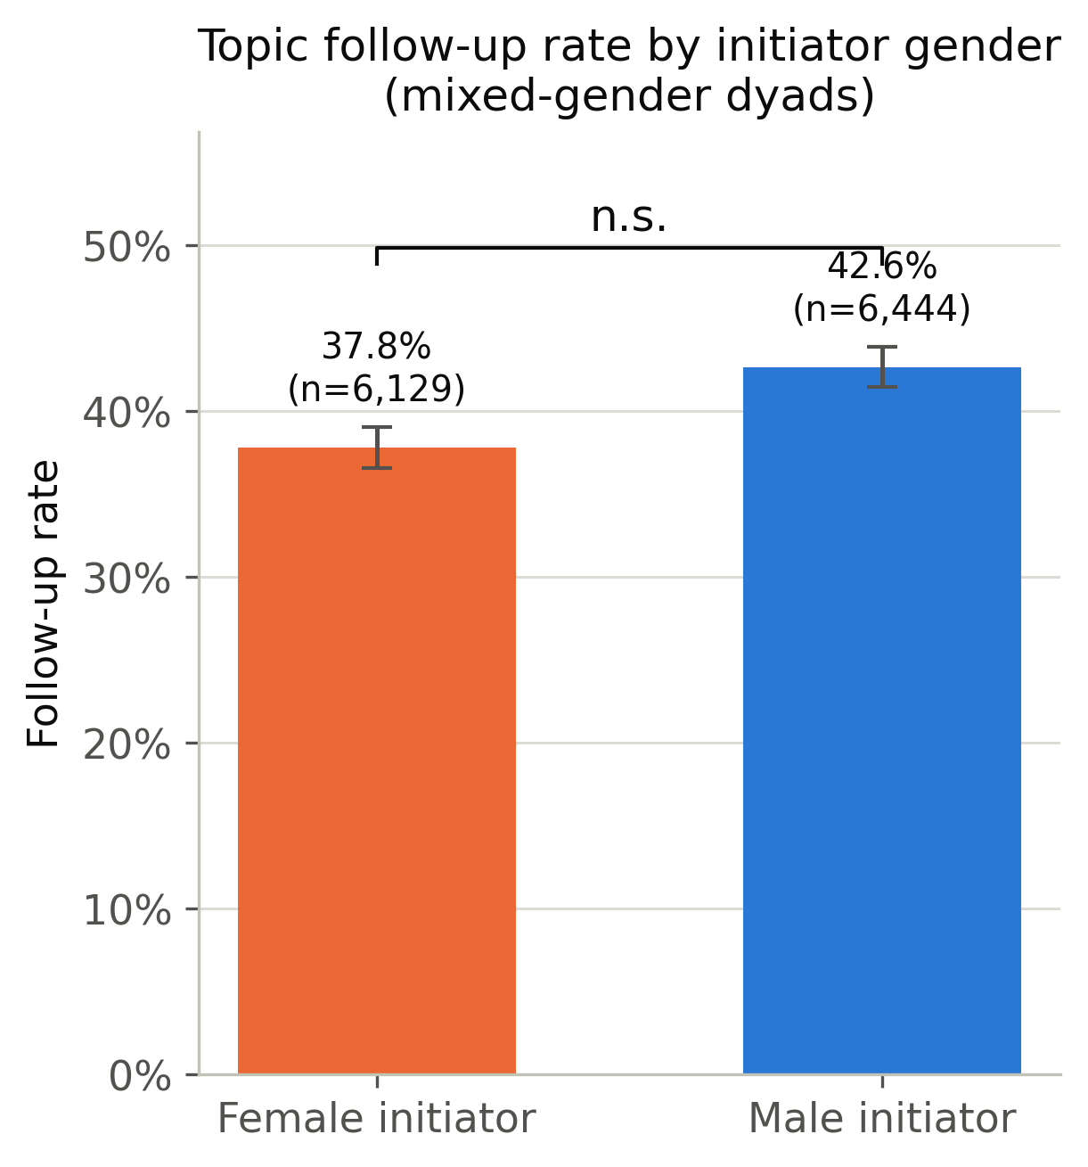
Fig. 1 — Raw follow-up rate by initiator gender (mixed-gender dyads). The naive gap shown here does not survive episode-clustered testing.
Test | Estimate | Significance
Naive chi-square (descriptive only) | male 42.6% vs. female 37.8% follow-up | p ≈ 3.5×10⁻⁸
Naive Welch’s t-test (descriptive only) | mean sim. 0.054 (male) vs. 0.042 (female) | p ≈ 1.1×10⁻⁹
Mixed-effects model (similarity) | coef = +0.003 (male) | p ≈ 0.33
GEE logistic regression (follow-up) | coef = −0.117 (log-odds) | p ≈ 0.060
Paired t-test, episode follow-up rate | male 0.417 vs. female 0.423 | p ≈ 0.75
Wilcoxon signed-rank, episode follow-up rate | — | p ≈ 0.88
Permutation test, episode follow-up rate | diff = −0.006 | p ≈ 0.74
Paired t-test, episode similarity | male 0.045 vs. female 0.044 | p ≈ 0.71
Permutation test, episode similarity | diff = +0.001 | p ≈ 0.70
Once episode clustering is properly accounted for, the apparent male > female follow-up gap is not statistically significant, and the fully model-free episode-level comparisons put the two groups at parity — within 1–2 percentage points, in either direction depending on the metric.
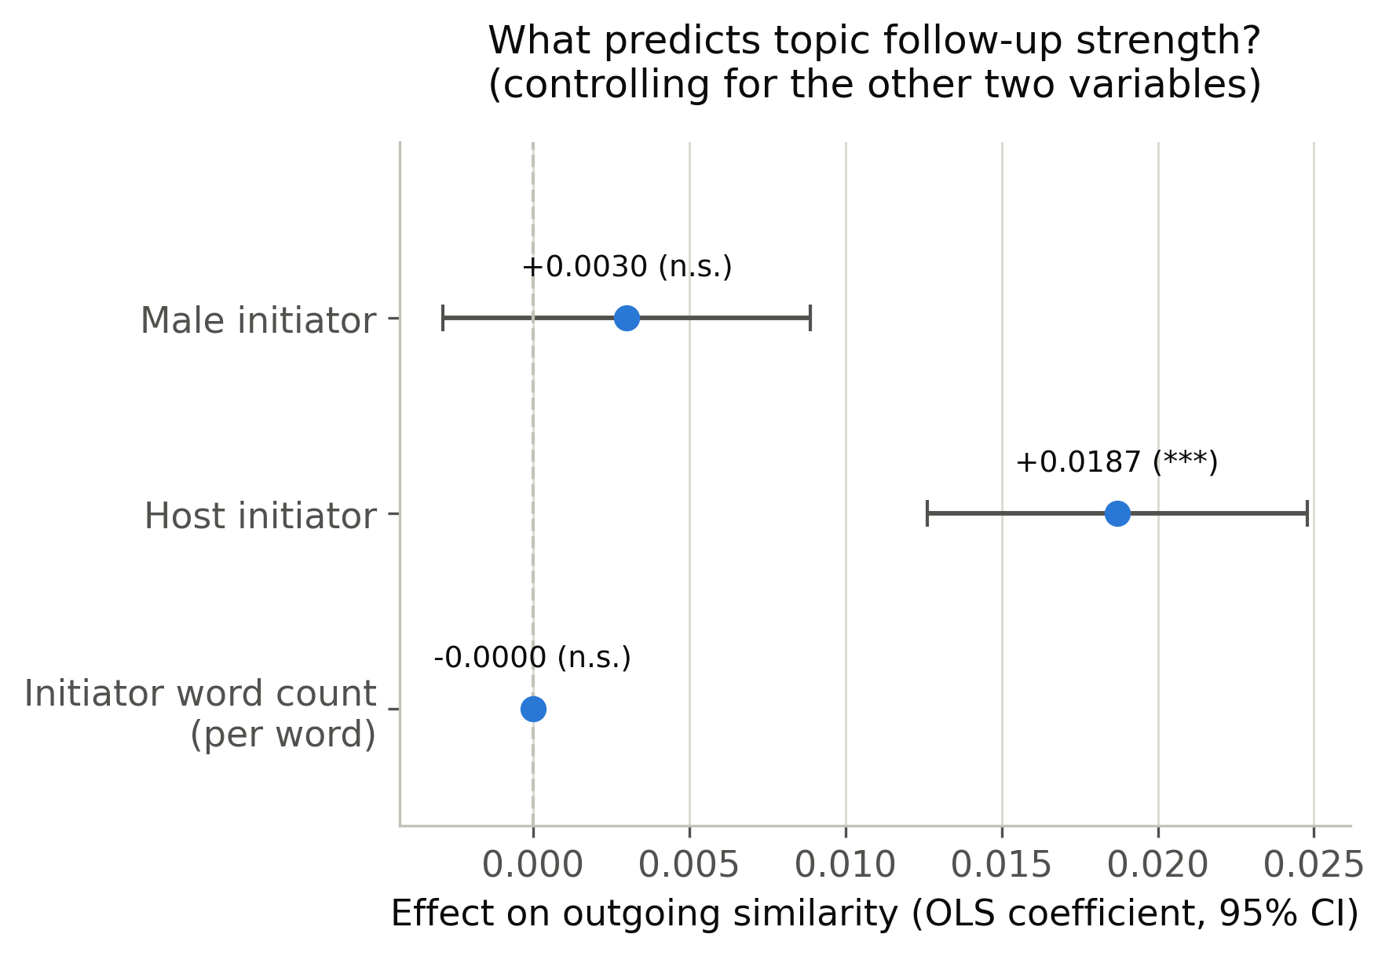
Fig. 3 — What predicts follow-up strength, controlling for the other variables. Host/guest role carries the effect; initiator gender does not.

It’s role, not gender
Both host/guest role and initiator turn length were significant predictors of follow-up strength (role: GEE coef = 0.784, p < 0.001). Because host and guest happen to skew by gender in this sample, the naive gender gap is better explained by conversational role than by speaker gender.
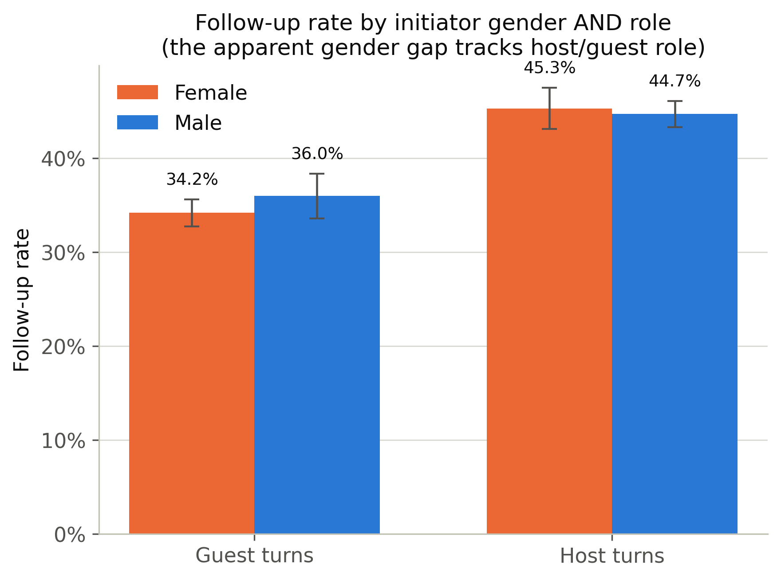
Fig. 2 — Follow-up rate by initiator gender and role. The apparent gender gap tracks host/guest role.

5. Robustness checks

Threshold sensitivity
Re-running the (naive, pooled) follow-up rate at fixed similarity thresholds of 0.05, 0.10, and 0.20 showed the same small male > female pattern in the raw counts at every threshold (e.g. at 0.10: female 12.0% vs. male 15.4%) — confirming the raw descriptive gap isn’t an artifact of the episode-median cutoff specifically, though it remains subject to the same clustering caveat as the naive tests above.
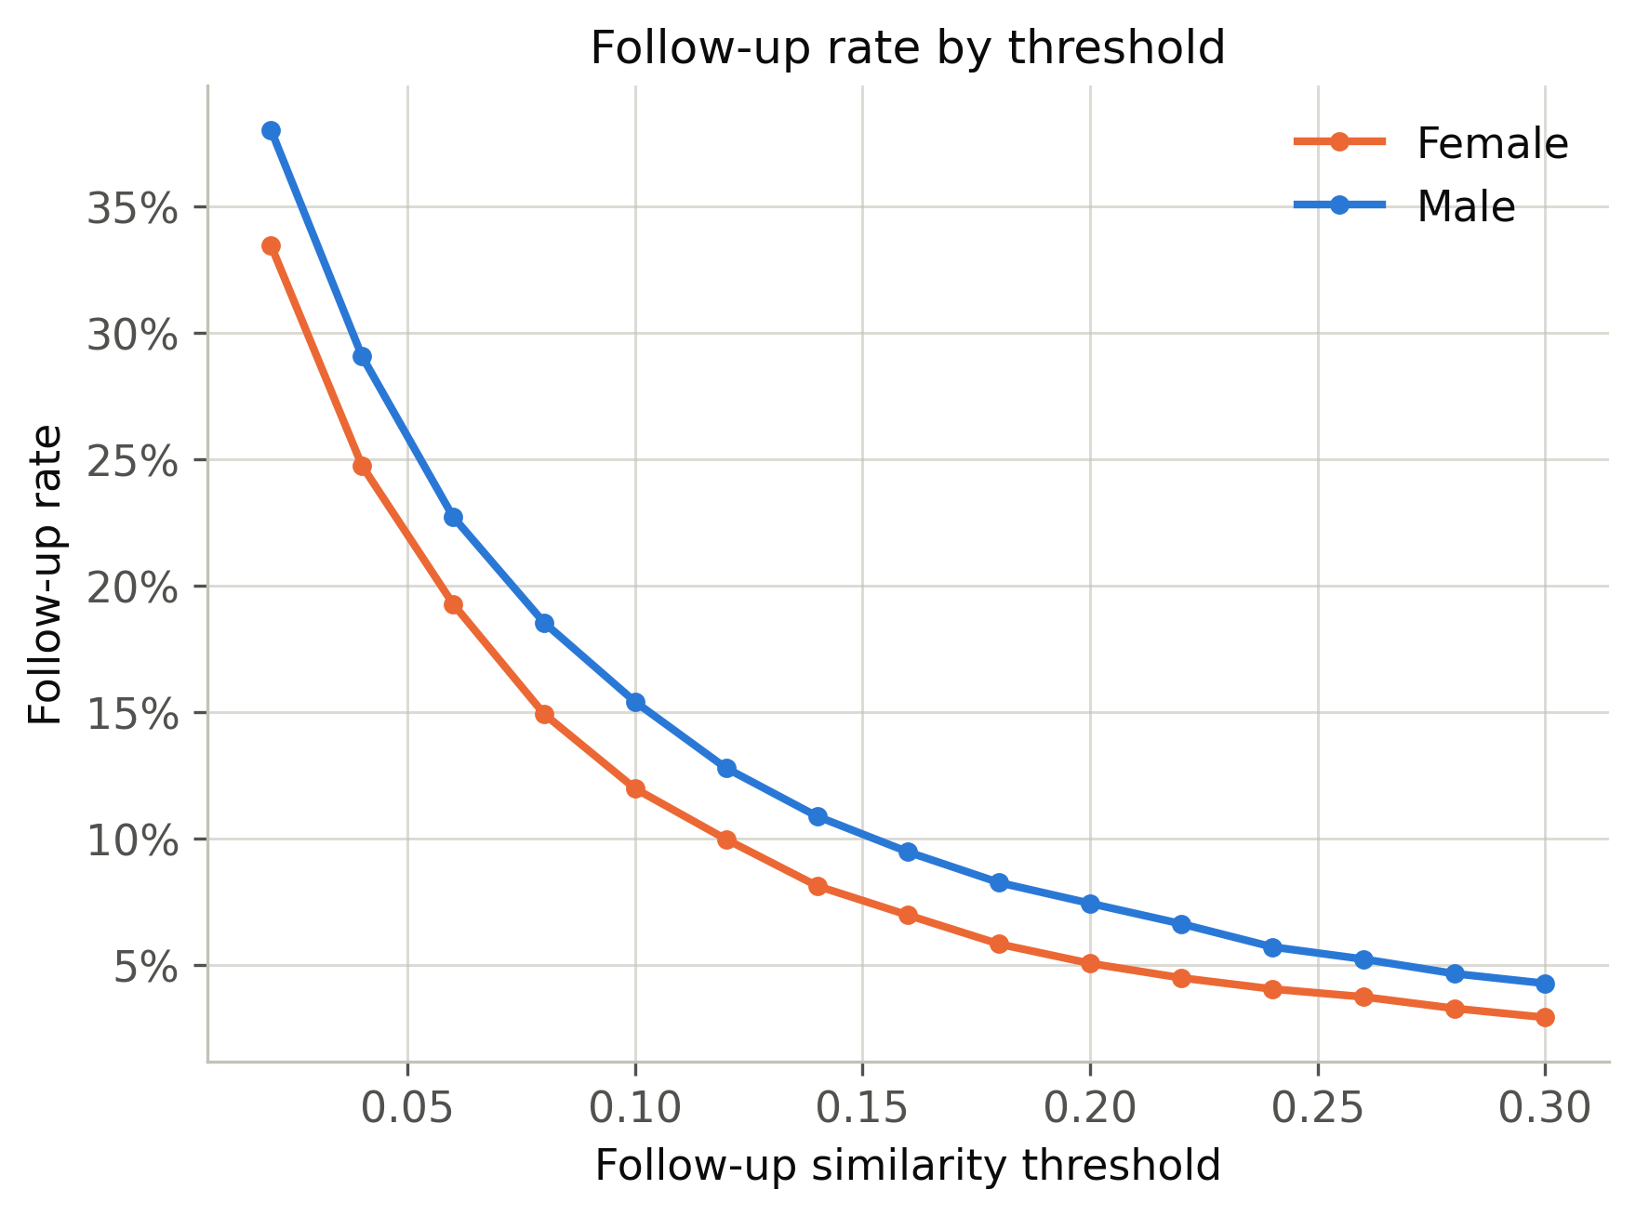
Fig. 4 — Follow-up rate by threshold. Descriptive, pooled turn-pairs — see the clustered tests above for significance.

Lexical vs. semantic similarity
To rule out TF-IDF’s lexical-overlap-only definition as the cause of the null result, we repeated the episode-level paired comparison using sentence-embedding cosine similarity (all-MiniLM-L6-v2) instead of TF-IDF. Results agreed:
- Follow-up rate: male 46.8% vs. female 48.5% (paired t-test p ≈ 0.34; permutation p ≈ 0.34)
- Mean similarity: male 0.235 vs. female 0.244 (paired t-test p ≈ 0.23; permutation p ≈ 0.23)
Again, no significant gender difference — with point estimates leaning slightly toward higher female follow-up, not lower.

6. Interpretation
Across five independent testing strategies — a mixed-effects model, clustered GEE logistic regression, a secondary GLMM, paired episode-level parametric and non-parametric tests, and a permutation test — and across two different similarity measures (lexical TF-IDF and semantic sentence embeddings), we find no robust evidence that male speakers’ topic introductions are followed up more than female speakers’ in mixed-gender dyads. The strongly significant result from naive, unclustered tests is best explained by pseudoreplication rather than a genuine gender effect; what significant structure does exist in the data is attributable to conversational role, not speaker gender.

7. Limitations
- Sample size for inference is ~100 episodes per comparison, not the ~12,500 turn-pairs; a small or moderate true effect may not be detectable at this scale.
- The balanced mixed-dyad sample (50 per dyad type) is capped by the smallest available same-gender dyad category in the underlying corpus and was not expanded further in this analysis.
- Both similarity measures are context-window-limited — comparing only the initiation to the single next opposite-speaker turn — so a topic picked up two or three turns later would not register as “followed up.”

Listening Between the Lines — src/topic_control.py, src/topic_control_embeddings_check.py, src/make_topic_control_figures.py

