import json

from flask import jsonify, request

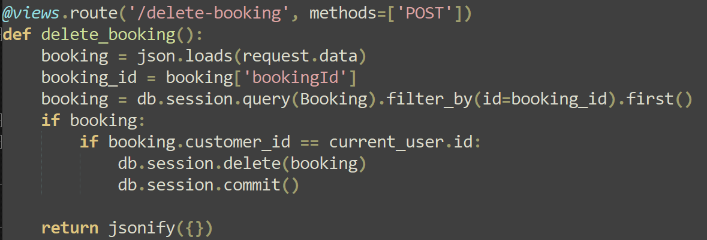

from flask import Blueprint



from sqlalchemy.orm import aliased

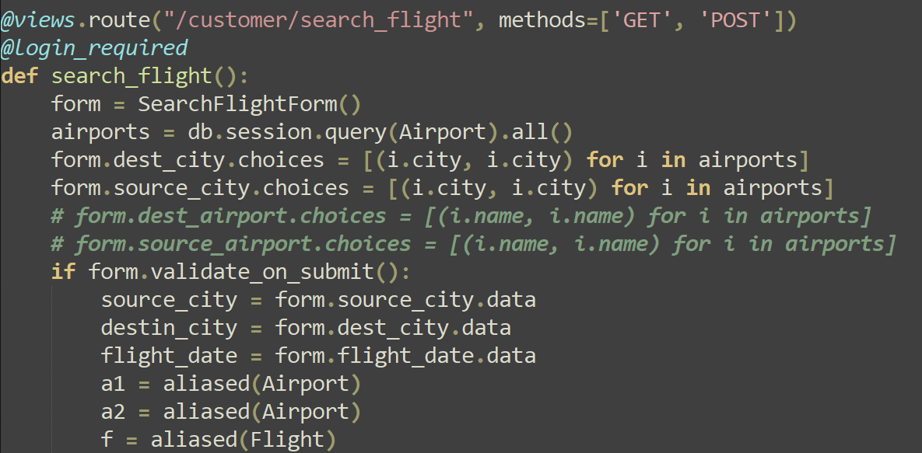

from werkzeug.utils import redirect

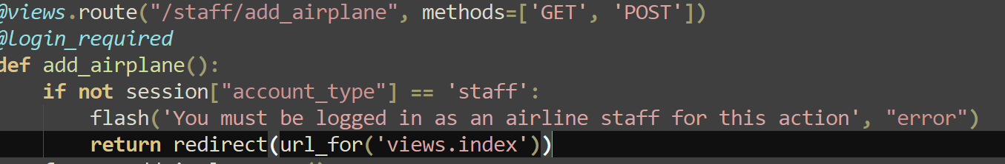

Javascript (index.js)

