# Contacts

## Language

Please use country-table.sql to update country table.

## Contact scope

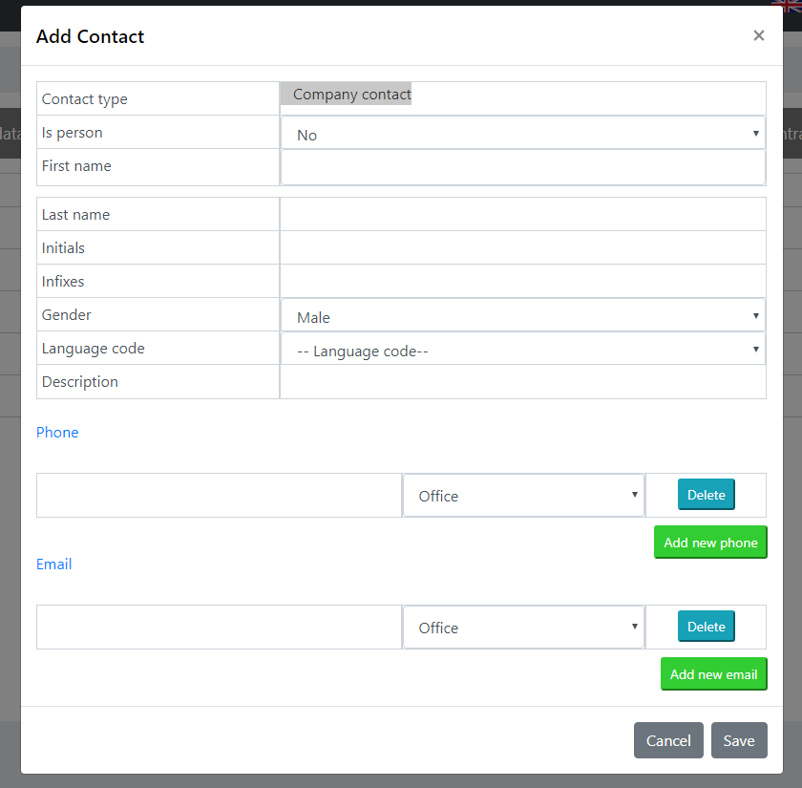

Remove contact type, remove description, is person select

Is_person default 1 in database

Language code default NL (set in ENV)

To get the language code for a contact we need to filter the country table by is_communication_language=1

## Employee scope

The following box is displayed

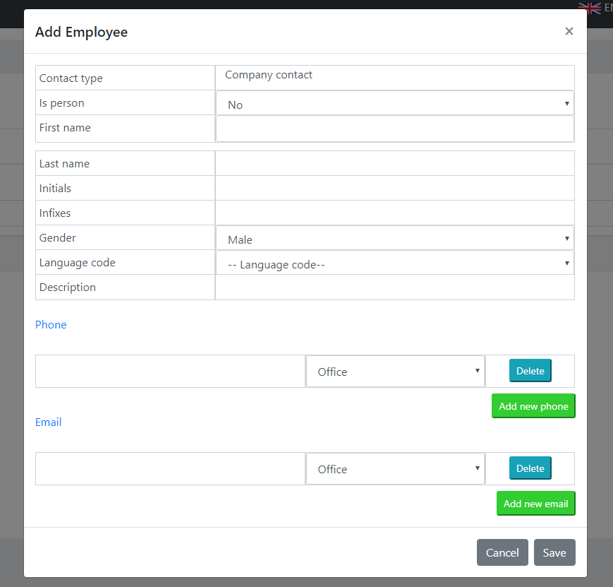

Remove: contact type (no use here), description

Default language code: NL (set in ENV)

Database: is_person always = 1

To get the language code for a contact we need to filter the country table by is_communication_language=1

## User window

A user is an employee with added data. The best way to achieve this is to first create an employee, then create a user record by selecting the employee (employee without a user id).

This is something that was not discussed before.

The form should look more like this:

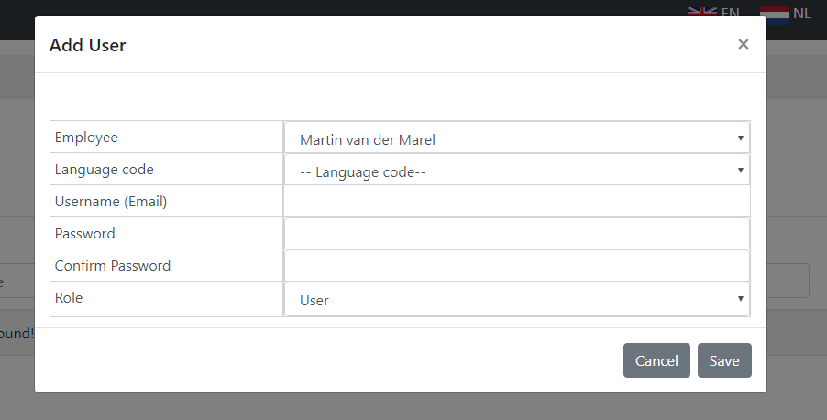

The employee box shows all employees, without a user id connected to it, for the distribution partner.

For every user, automatically an API key is generated once the user is created (not regenerated when updating the user!).

### List

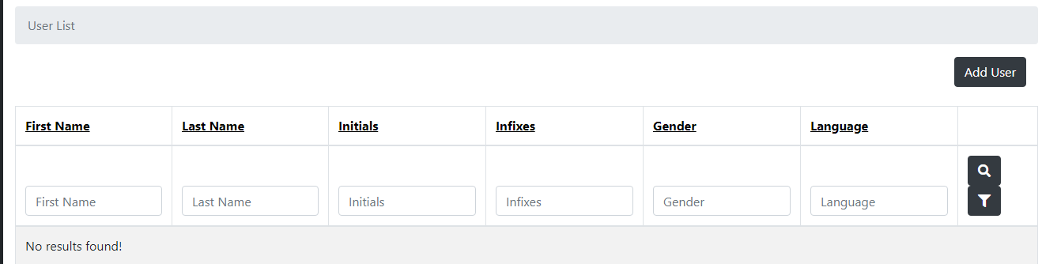

The list display should display the following columns:

* Employee (concat the firstname, infixes and lastname to get one value in the grid )
* E-mailaddress
* Role (admin, user etc)

# Distribution partner list

When a user is logged in as part of a root distribution partner, an extra menuitem will appear (“Distribution partners”). Clicking it will display a list with the distribution partners. The list does not show the root distribution partner itself (only “partner” type is displayed).

The grid contains the company.number. company. Name, distribution_partner.company_number_prefix

There is an add button, allowing to add a new distribution partner, by searching a company.

Search by company.name and/or company.number

Search result displays company.name, company.number (like the search API result for creating a new company).

Selecting a company from the result opens next window, with form to enter specifics:

* A label with the selected company name and number (from previous screen)
* The company_number_prefix
* Company number index (default 1)

Clicking save will store the distribution partner.

Edit and delete for existing is also present.