## Cleanup

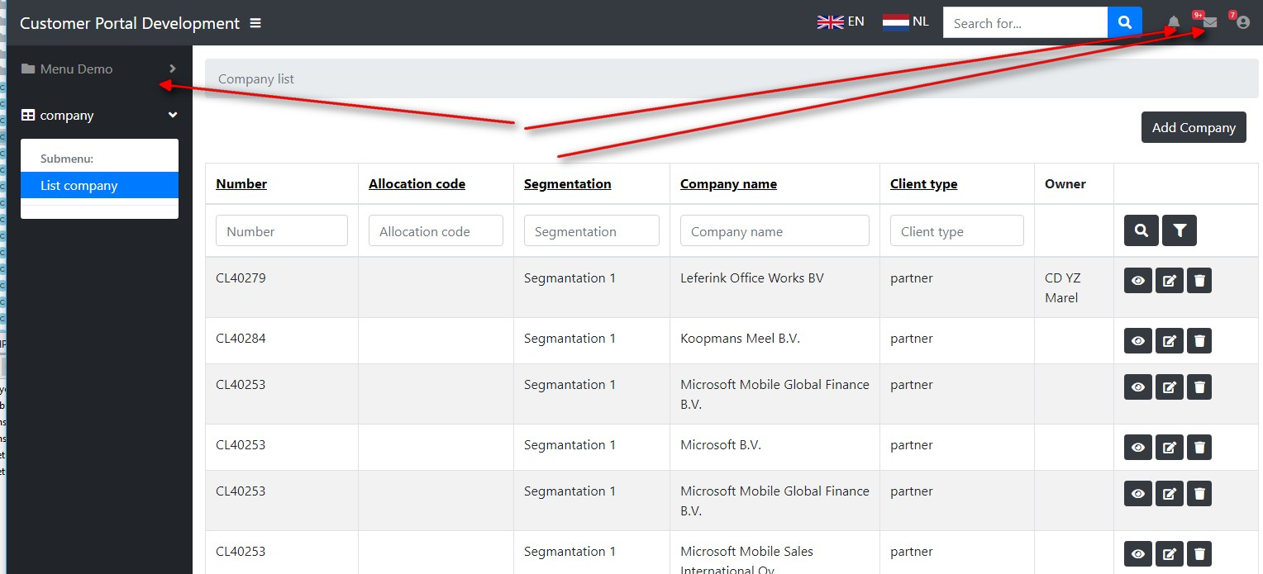

Please remove the following elements from layout. These have no function now and can be removed.

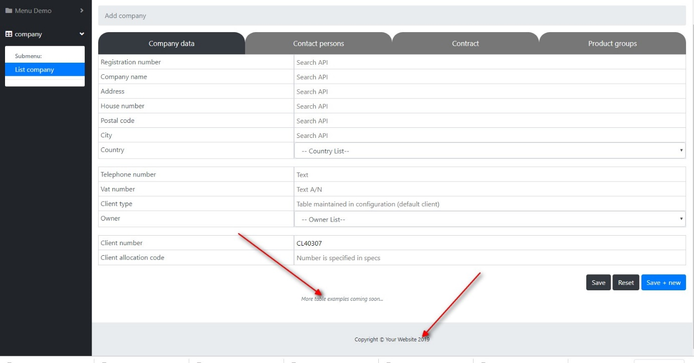

Remove these items also on every page

## Form

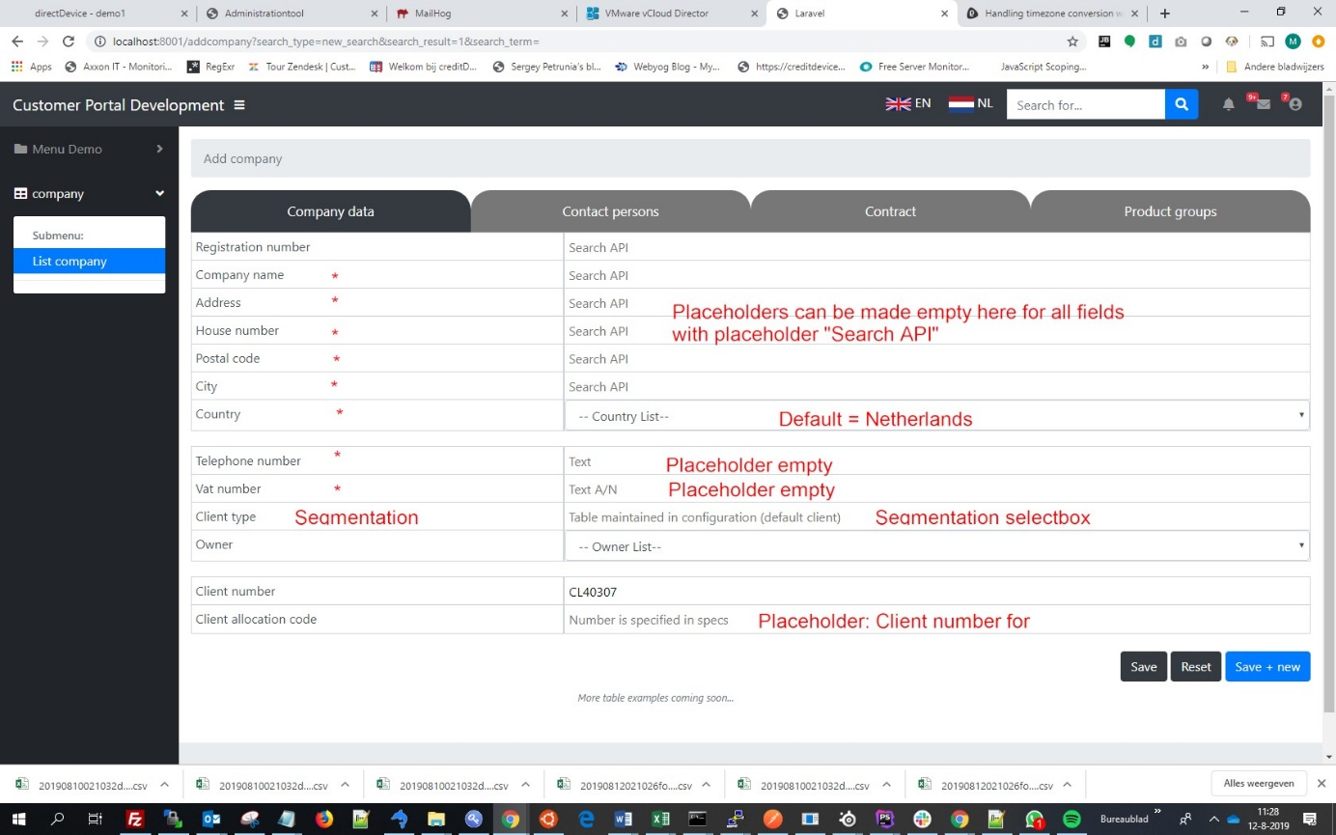

Preferences for the form:

* Remove most of the placeholder form items here
* Default country = Netherlands
* Client type = segmentation, selectbox from that table can be selected here
* Client allocation code placeholder = “Client number at client” (translatable label)
* * - fields are mandatory

## Validation

Mandatory fields are ideally validated on backend. Preferred is to have a validation class for create/update service calls, which validates input and return a validation result instance if validation fails. If no validation errors, the check can return a Boolean “true”. The validation result class is a simple class containing “messages” which can be displayed on the front-end.

I have validation-flow.txt to the zip-file so you can check how I think it may work.