Task: Week 1 — Data Cleaning & Preliminary Analysis with R
Deliverable: Technical Report & Workflow Documentation
Environment: R 4.x / Google Colab Notebook
Packages Used: palmerpenguins, tidyverse, corrplot

Data Cleaning, Preprocessing, and Exploratory Data Analysis in R

1. Dataset Overview
- Dataset Name: Palmer Archipelago Penguin Data (palmerpenguins).
- Source: Collected by Dr. Kristen Gorman and the Palmer Station, Antarctica LTER.
- Dimensions: 344 rows and 8 variables.
- Variable Description:
  - Categorical: species (Adelie, Chinstrap, Gentoo), island (Biscoe, Dream, Torgersen), sex (female, male).
  - Continuous: bill_length_mm, bill_depth_mm, flipper_length_mm, body_mass_g, and year.
- Initial Issues Identified: Multiple missing values across morphological indicators (NA count: 2 in bill/flipper measurements, 11 in sex).
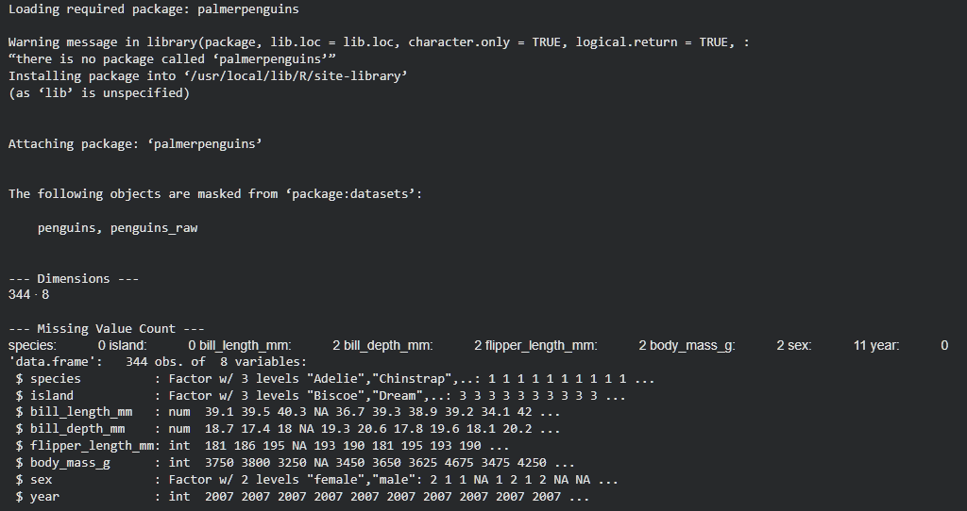

2. Data Cleaning & Preprocessing Methodology
- Missing Value Imputation:
  - Method: Median imputation for continuous variables (bill_length_mm, bill_depth_mm, flipper_length_mm, body_mass_g) to minimize distortion from skewness. Median imputation was chosen over the mean because morphological measurements (such as body mass) often exhibit skewness; the median provides a robust central tendency estimate unaffected by extreme tail values.
  - Categorical Imputation: For sex, NA values were recoded to an explicit "Unknown" category to preserve observational sample size without introducing false classifications.
- Outlier Detection and Handling:
  - Method: Interquartile Range (IQR) fence rule applied with lower bound $Q1-1.5×IQR$ and upper bound $Q3+1.5×IQR$.
  - Action: Values outside these bounds were capped to the respective threshold limits rather than removed, avoiding data loss. IQR winsorization/capping was prioritized over sample deletion to retain the complete sample size ($N=344$), ensuring downstream modeling preserves statistical power while nullifying leverage effects.
- Feature Scaling:
  - Standardized body_mass_g using Z-score scaling (scale()) to transform the variable to zero mean and unit variance. Standardizing continuous variables onto a standard normal distribution ($Mean=0,SD=1$) prevents scale-dominant bias in distance-based algorithms such as KNN, SVM, or PCA.

# 1. Inspect and impute missing numerical values using Median
data_clean <- data_raw

for (col in c("bill_length_mm", "bill_depth_mm", "flipper_length_mm", "body_mass_g")) {
med_val <- median(data_clean[[col]], na.rm = TRUE)
data_clean[[col]][is.na(data_clean[[col]])] <- med_val
}

# 2. Impute categorical missing values (Sex)
data_clean$sex <- as.character(data_clean$sex)
data_clean$sex[is.na(data_clean$sex)] <- "Unknown"
data_clean$sex <- as.factor(data_clean$sex)

# 3. Outlier Capping function (IQR Method)
cap_outliers <- function(x) {
qnt <- quantile(x, probs = c(0.25, 0.75), na.rm = TRUE)
iqr <- diff(qnt)
caps <- c(qnt[1] - 1.5 * iqr, qnt[2] + 1.5 * iqr)
x[x < caps[1]] <- caps[1]
x[x > caps[2]] <- caps[2]
return(x)
}

data_clean$body_mass_g <- cap_outliers(data_clean$body_mass_g)
data_clean$flipper_length_mm <- cap_outliers(data_clean$flipper_length_mm)

# 4. Feature Scaling (Z-score standardisation)
data_clean$body_mass_scaled <- as.numeric(scale(data_clean$body_mass_g))

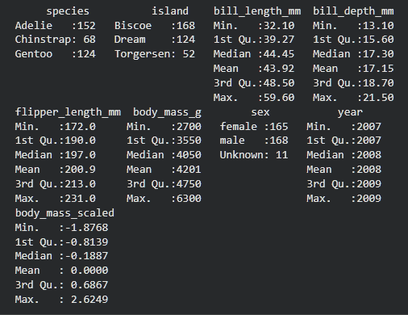

3. Exploratory Data Analysis & Visualizations
- Morphological Differences (Boxplot):

ggplot(data_clean, aes(x = species, y = body_mass_g, fill = species)) +
geom_boxplot() +
labs(title = "Body Mass Distribution across Penguin Species", x = "Species", y = "Body Mass (g)") +
theme_minimal()

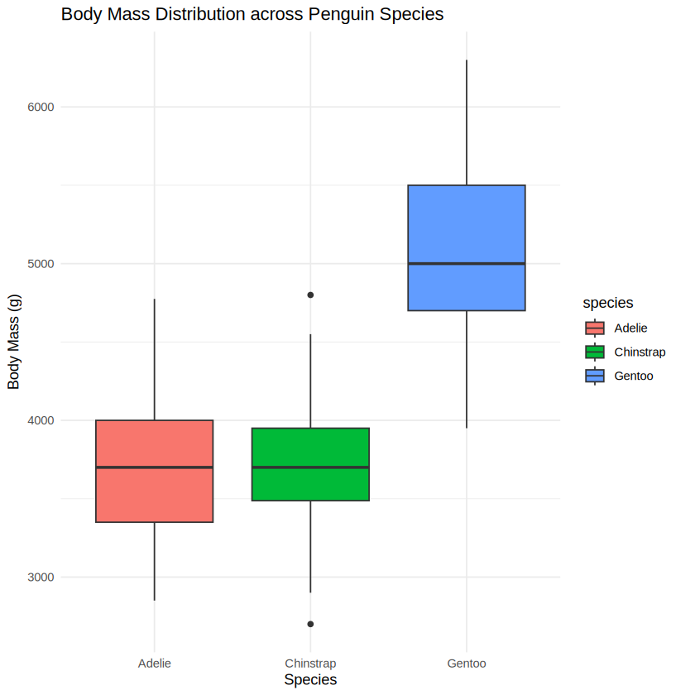
Figure 1: Body Mass Distribution
  - Insight: Gentoo penguins display a significantly higher median body mass (~5,000g) compared to Adelie and Chinstrap penguins (~3,700g).
- Correlation Matrix:

num_cols <- data_clean %>% select(where(is.numeric))
corrplot(cor(num_cols), method = "color", type = "upper", addCoef.col = "black", tl.col = "black")

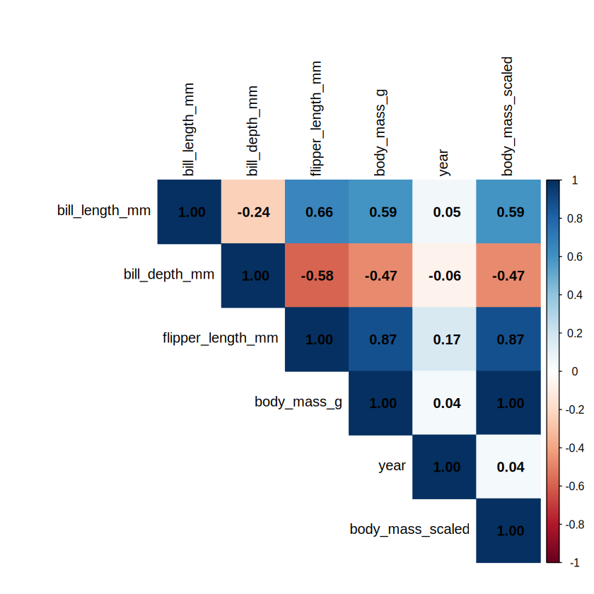
Figure 2: Feature Correlation Heatmap
  - Insight: A strong positive correlation exists between flipper_length_mm and body_mass_g ($r>0.85$), whereas bill_depth_mm shows an inverse correlation with flipper length.
- Geographical Distribution:

ggplot(data_clean, aes(x = island, fill = species)) +
geom_bar(position = "fill") +
scale_y_continuous(labels = scales::percent) +
labs(title = "Species Proportion by Island", x = "Island", y = "Percentage") +
theme_minimal()

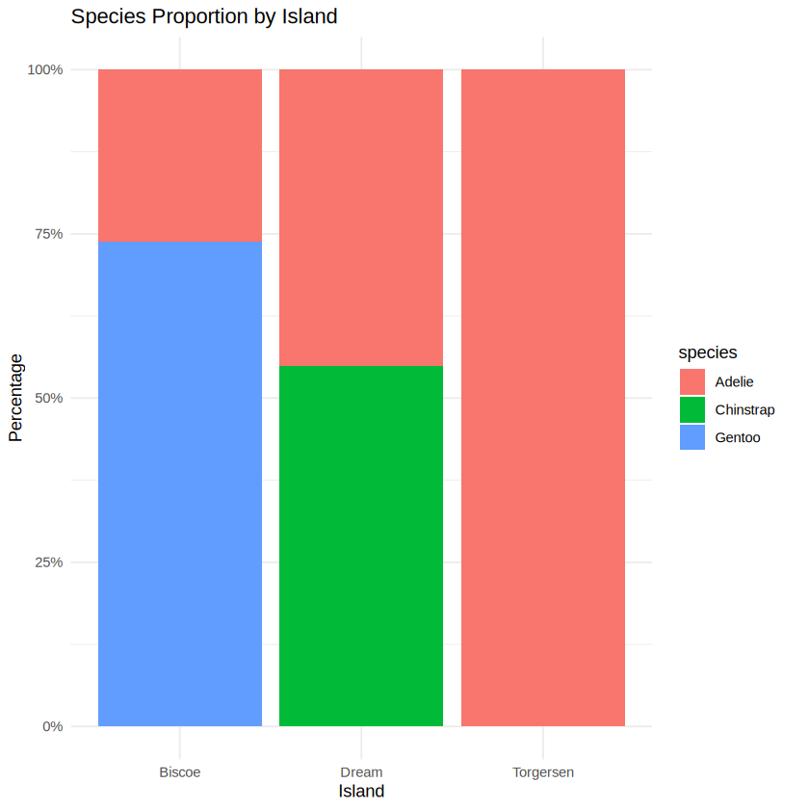
Figure 3: Species Composition by Island
  - Insight: Adelie penguins are distributed across all three islands, while Chinstrap penguins are isolated to Dream Island and Gentoo to Biscoe Island.

4. Initial Insights & Next Steps
- Strong morphological divergence indicates that bill and body mass metrics can reliably separate Gentoo from other species in predictive classification tasks.
- Island location acts as a deterministic filter for certain species, making it a critical feature for downstream modeling.

