Task: Week 2 — Data Visualization and Insight Communication using R
Deliverable: Technical Report & Workflow Documentation
Environment: R 4.x / Google Colab / ggplot2
Dataset: Palmer Archipelago Penguins (palmerpenguins)

Data Visualization and Insight Communication using R

1. Dataset Overview & Visualization Strategy
- Dataset Name: Palmer Archipelago Penguin Data (palmerpenguins).
- Source: Collected by Dr. Kristen Gorman and the Palmer Station, Antarctica LTER.
- Dimensions: 344 rows and 8 variables.
- Variable Description:
  - Categorical: species (Adelie, Chinstrap, Gentoo), island (Biscoe, Dream, Torgersen), sex (female, male).
  - Continuous: bill_length_mm, bill_depth_mm, flipper_length_mm, body_mass_g, and year.
- Communication Objective: To translate multivariate morphological and ecological data into intuitive visual narratives that highlight subpopulation variance, reveal statistical paradoxes, and communicate biological adaptations effectively.

2. Visual Analysis & Narrative Interpretations
Chart 1: Multivariable Scatter Plot with Linear Trendlines
Graph Type & Rationale: Bivariate scatter plot with species-level OLS regression lines. Ideal for identifying clustering, multivariate relationships, and subgroup slope differences.

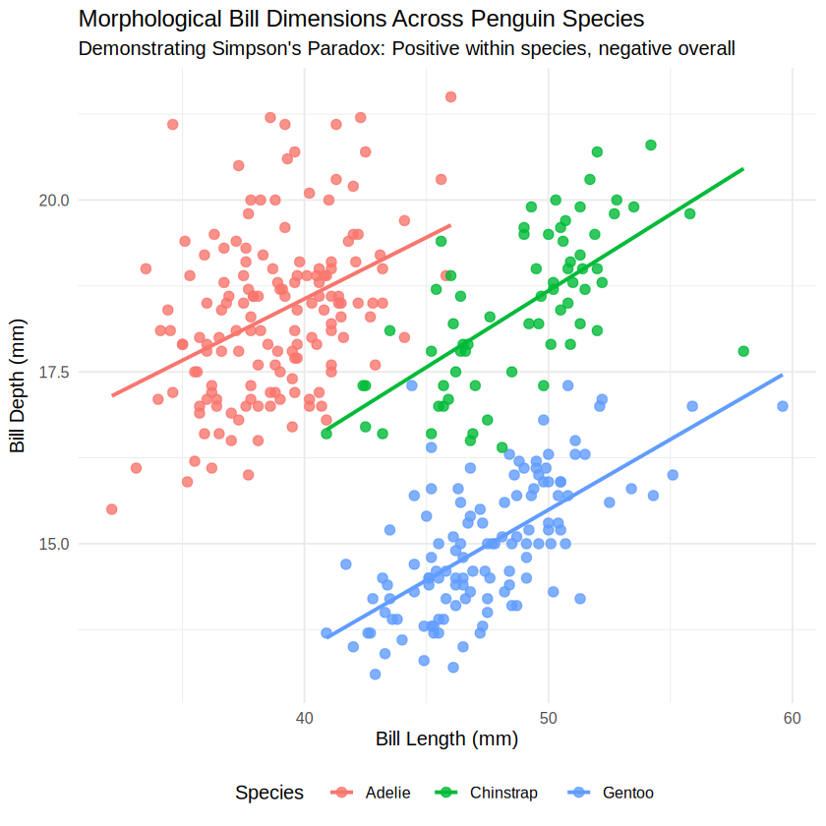
Figure 1: Morphological Bill Dimensions Across Penguin Species demonstrating Simpson's Paradox.
Code:
p1 <- ggplot(data_clean, aes(x = bill_length_mm, y = bill_depth_mm, color = species)) +
geom_point(alpha = 0.8, size = 2.5) +
geom_smooth(method = "lm", se = FALSE, linewidth = 1.1) +
labs(
title = "Morphological Bill Dimensions Across Penguin Species",
subtitle = "Demonstrating Simpson's Paradox: Positive within species, negative overall",
x = "Bill Length (mm)",
y = "Bill Depth (mm)",
color = "Species"
) +
theme_minimal(base_size = 12) +
theme(legend.position = "bottom")

print(p1)

Insight & Significance: This visualization demonstrates Simpson's Paradox. An aggregate regression line across the full dataset yields an apparent negative slope between bill length and bill depth. When stratified by species, each cluster demonstrates a consistent positive linear slope. Adelie penguins feature shorter, deeper bills, whereas Gentoo penguins exhibit longer, shallower bills.

Chart 2: Dual Histogram and Kernel Density Estimate (KDE)
Graph Type & Rationale: Overlapping density profiles combined with semi-transparent histograms. Facilitates clear identification of multi-modal distributions that aggregate summary statistics disguise.

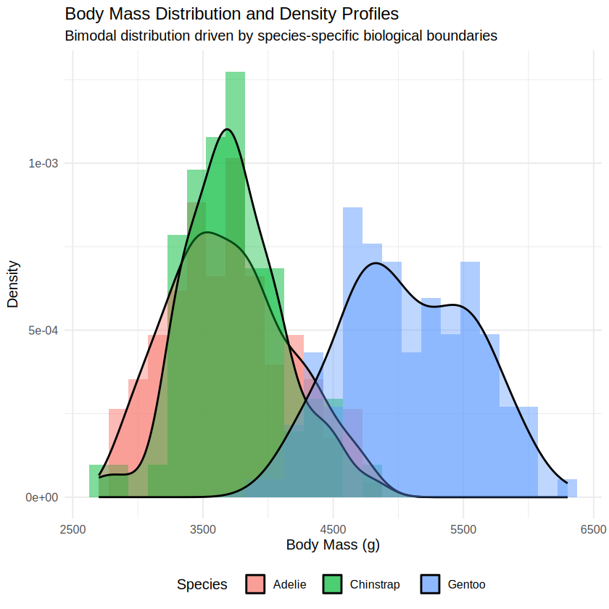
Figure 2: Body Mass Distribution and Kernel Density Profiles.
Code:
p2 <- ggplot(data_clean, aes(x = body_mass_g, fill = species)) +
geom_histogram(aes(y = after_stat(density)), bins = 25, alpha = 0.5, position = "identity") +
geom_density(alpha = 0.4, linewidth = 0.8) +
labs(
title = "Body Mass Distribution and Density Profiles",
subtitle = "Bimodal distribution driven by species-specific biological boundaries",
x = "Body Mass (g)",
y = "Density",
fill = "Species"
) +
theme_minimal(base_size = 12) +
theme(legend.position = "bottom")

print(p2)

Insight & Significance: Overall penguin mass is strongly bimodal. Adelie and Chinstrap penguins exhibit overlapping weight distributions centered near 3,700 g. Gentoo penguins occupy an isolated distribution shifted heavily to the right, centered near 5,000 g, identifying body mass as a primary morphological separator for Gentoos.

Chart 3: Faceted Categorical Bar Chart
Graph Type & Rationale: Grouped small-multiples bar chart. Splits multi-category relationships into distinct panels, preventing visual crowding across cross-tabulated demographics.

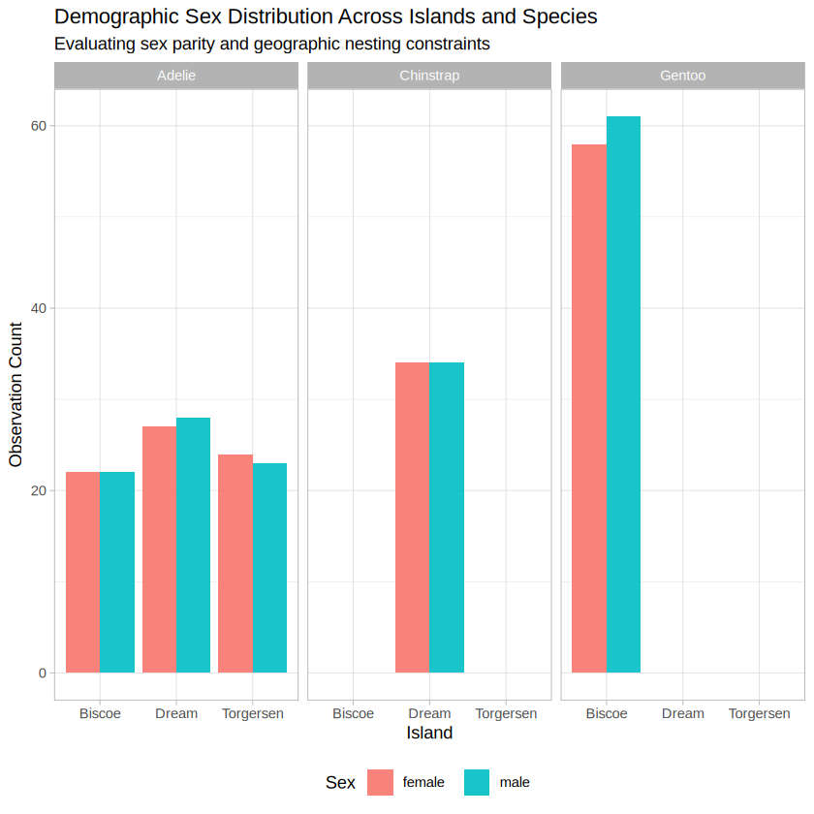
Figure 3: Demographic Sex Distribution Across Islands and Species.

Code:
p3 <- ggplot(filter(data_clean, sex != "Unknown"), aes(x = island, fill = sex)) +
geom_bar(position = "dodge", alpha = 0.9) +
facet_wrap(~ species) +
labs(
title = "Demographic Sex Distribution Across Islands and Species",
subtitle = "Evaluating sex parity and geographic nesting constraints",
x = "Island",
y = "Observation Count",
fill = "Sex"
) +
scale_fill_manual(values = c("female" = "#F8766D", "male" = "#00BFC4")) +
theme_light(base_size = 11) +
theme(legend.position = "bottom")

print(p3)

Insight & Significance: Adelie penguins inhabit all three islands, whereas Chinstraps are isolated to Dream Island and Gentoos nest exclusively on Biscoe Island. Within each colonized island, the observed sex ratio maintains near 1:1 parity, confirming an unbiased sampling regime across colonies.

Chart 4: Longitudinal Line Chart with Error Margins
Graph Type & Rationale: Time-series line chart tracking yearly morphological means with standard error bars. Assesses temporal stability and variance across observation years.

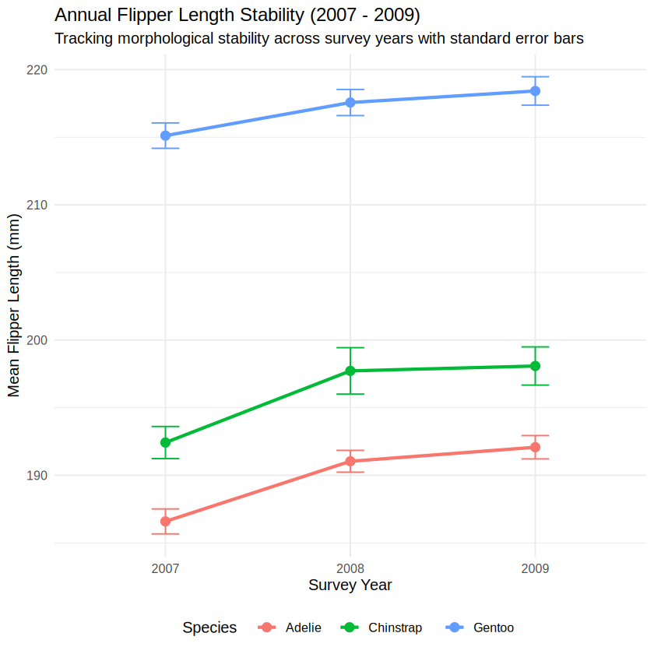
Figure 4: Annual Flipper Length Stability Across Survey Years (2007 - 2009).
Code:
yearly_trend <- data_clean %>%
group_by(year, species) %>%
summarize(
mean_flipper = mean(flipper_length_mm),
se_flipper = sd(flipper_length_mm) / sqrt(n()),
.groups = "drop"
)

p4 <- ggplot(yearly_trend, aes(x = factor(year), y = mean_flipper, group = species, color = species)) +
geom_line(linewidth = 1.2) +
geom_point(size = 3) +
geom_errorbar(aes(ymin = mean_flipper - se_flipper, ymax = mean_flipper + se_flipper), width = 0.15) +
labs(
title = "Annual Flipper Length Stability (2007 - 2009)",
subtitle = "Tracking morphological stability across survey years with standard error bars",
x = "Survey Year",
y = "Mean Flipper Length (mm)",
color = "Species"
) +
theme_minimal(base_size = 12) +
theme(legend.position = "bottom")

print(p4)

Insight & Significance: Flipper length across all species exhibited high stability from 2007 through 2009 with tight error bars. This longitudinal invariance confirms that morphological measurements reflect baseline species attributes rather than transient seasonal shifts.

3. Key Analytical Takeaways
• Morphological Discontinuity: Gentoo penguins form a distinct cluster by physical size (mass and flipper length), while Adelie and Chinstrap require bill culmen dimensions for separation.
• Simpson's Paradox: Aggregate feature correlations can contradict subgroup realities, demonstrating the critical role of subgroup visual stratification.
• Geographic Segregation: Colony habitats act as strict deterministic filters for Chinstrap and Gentoo species, serving as critical spatial features.

