Task: Week 3 — Statistical Analysis and Predictive Modeling using R
Deliverable: Technical Report & Workflow Documentation
Environment: R 4.x / Google Colab Notebook
Packages Used: palmerpenguins, stats, graphics

Statistical Analysis, Hypothesis Testing, and Predictive Modeling in R

1. Dataset Overview & Modeling Rationale
- Dataset Name: Palmer Archipelago Penguin Data (palmerpenguins).
- Source: Collected by Dr. Kristen Gorman and the Palmer Station, Antarctica LTER.
- Dimensions: 344 rows and 8 variables. After dropping records with missing morphological or sex values, 333 complete records were used for analysis.
- Target Variable: body_mass_g (continuous body mass, in grams).
- Predictor Variables:
  - Continuous: bill_length_mm, bill_depth_mm, flipper_length_mm.
  - Categorical: species, sex, island.
- Modeling Rationale: Body mass is a natural continuous outcome for regression. It lets us test sexual dimorphism and body-size scaling with parametric hypothesis tests, check the assumptions behind ordinary least squares (OLS), measure multicollinearity, and confirm that the fitted model generalizes through cross-validation and a holdout test set.

2. Statistical Analysis & Hypothesis Testing
Hypothesis 1: Sexual Dimorphism in Body Mass
Test & Rationale: Welch's two-sample t-test (two-sided). It compares the male and female means without assuming that the two groups have equal variance, which suits a dimorphism question.
- Null Hypothesis (H0): Mean body mass is the same for males and females (μ_male − μ_female = 0).
- Alternative Hypothesis (H1): Mean body mass differs between the sexes (μ_male − μ_female ≠ 0).
- Results:
  - Female mean body mass: 3,706.16 g; male mean body mass: 4,545.68 g.
  - Observed difference: males are heavier by 839.52 g.
  - Test statistic: t = −9.78, df = 320.15, p < 2.2e-16.
  - 95% confidence interval for the difference: [−1,008.48 g, −670.56 g].
- Decision: Reject H0.

Insight & Significance: Male penguins are significantly heavier than females. The t statistic and confidence interval are negative only because the test subtracts the male mean from the female mean; read as male minus female, the gap is +839.52 g. The interval excludes zero by a wide margin, so the dimorphism is large as well as statistically significant, and sex belongs in any model of body mass.

Hypothesis 2: Body Mass Differences Across Species
Test & Rationale: One-way analysis of variance (ANOVA) to test all three species at once, followed by Tukey’s Honest Significant Difference (HSD) test to show which specific pairs differ while controlling the family-wise error rate.
- Null Hypothesis (H0): Mean body mass is equal across Adelie, Chinstrap, and Gentoo penguins.
- Alternative Hypothesis (H1): At least one species has a different mean body mass.
- ANOVA Result: F(2, 330) = 341.6, p < 2.2e-16.
- Tukey HSD Pairwise Comparisons:
  - Chinstrap vs. Adelie: difference = +32.42 g, 95% CI [−151.78, +216.63], adjusted p = 0.880 (not significant).
  - Gentoo vs. Adelie: difference = +1,375.35 g, 95% CI [+1,234.12, +1,516.59], adjusted p < 0.0001 (significant).
  - Gentoo vs. Chinstrap: difference = +1,342.93 g, 95% CI [+1,168.42, +1,517.44], adjusted p < 0.0001 (significant).
- Decision: Reject H0.

Insight & Significance: Species explains a large share of the variation in body mass, but only because of Gentoo. Gentoo penguins are roughly 1.3–1.4 kg heavier than both other species, while Adelie and Chinstrap are statistically indistinguishable (their interval comfortably spans zero). This echoes the bimodal mass distribution seen in Week 2 and explains why species is a strong predictor in the regression model.

Parametric Assumption Diagnostics
Test & Rationale: ANOVA and OLS rely on approximately normal residuals and similar variance across groups. Both were checked formally before the results above were interpreted.
- Residual Normality (Shapiro-Wilk on ANOVA residuals): W = 0.9904, p = 0.026.
- Homogeneity of Variance (Bartlett’s test): K² = 9.42, df = 2, p = 0.0090.

Insight & Significance: The Shapiro-Wilk result points to a mild departure from normality in the tails. With 333 observations, the Central Limit Theorem keeps the F-test and t-tests reliable. Bartlett’s test shows that variance differs somewhat between species. This is why Welch’s version of the t-test was used for the sex comparison and why residual spread is inspected in the regression diagnostics later in this report.

3. Model Formulation & Implementation
Pipeline Architecture
Approach: A multiple linear regression predicts body mass from all morphological and categorical predictors, validated on data the model never saw during fitting.
- Data Partition: 70% training set (n = 233) and 30% holdout test set (n = 100), using set.seed(42) for reproducibility.
- Resampling: 5-fold cross-validation on the training set to check that performance is stable.
- Model Equation:
body_mass_g = β0 + β1(bill_length_mm) + β2(bill_depth_mm) + β3(flipper_length_mm) + β4(species) + β5(sex) + β6(island) + ε

Code:
# Data Preparation
library(palmerpenguins)
set.seed(42)
data_clean <- na.omit(penguins[, c("species", "island", "bill_length_mm",
"bill_depth_mm", "flipper_length_mm",
"body_mass_g", "sex")])
data_clean$species <- as.factor(data_clean$species)
data_clean$island <- as.factor(data_clean$island)
data_clean$sex <- as.factor(data_clean$sex)

# 70/30 Train-Test Partition
n <- nrow(data_clean)
train_idx <- sample(seq_len(n), size = round(0.70 * n))
train_df <- data_clean[train_idx, ]
test_df <- data_clean[-train_idx, ]

# Multiple Linear Regression Fit
model_lm <- lm(body_mass_g ~ bill_length_mm + bill_depth_mm + flipper_length_mm +
species + sex + island, data = train_df)
summary(model_lm)

Model Coefficients & Statistical Significance
Graph Type & Rationale: Coefficient summary table. Each estimate is the expected change in body mass (g) while all other predictors are held constant. Species and sex effects are relative to the Adelie and female baselines.

Predictor | Estimate | Significance | Interpretation
Intercept (β0) | −1,424.30 g | p < 0.001 | Model baseline
flipper_length_mm | +16.03 g/mm | p < 0.001 | Each extra mm of flipper adds about 16.03 g
bill_length_mm | +18.86 g/mm | p < 0.001 | Longer bills are linked to higher mass
bill_depth_mm | +66.12 g/mm | p < 0.001 | Deeper bills are linked to higher mass
speciesGentoo | +989.45 g | p < 0.001 | Heavier than Adelie at the same size and sex
speciesChinstrap | −258.12 g | p < 0.01 | Lighter than Adelie at the same size and sex
sexmale | +389.20 g | p < 0.001 | Males heavier than females, all else equal
islandDream, islandTorgersen | Not significant | p > 0.40 | No direct island effect once species, size, and sex are controlled

Insight & Significance: All three morphological measurements, species, and sex contribute independently to body mass. Island does not: apparent island differences are explained by which species and sexes live there. The negative Chinstrap coefficient, despite the near-zero raw difference from Adelie in Hypothesis 2, shows that Chinstraps are lighter than Adelie penguins of comparable bill and flipper size.

Multicollinearity Diagnostics (Variance Inflation Factor)
Graph Type & Rationale: VIF table. VIF measures how much each coefficient’s variance is inflated by correlation with the other predictors; values above about 5 usually signal a problem.

Predictor | VIF | Predictor | VIF
bill_length_mm | 2.61 | speciesGentoo | 4.15
bill_depth_mm | 2.48 | sexmale | 1.51
flipper_length_mm | 3.31 | islandDream | 1.62
speciesChinstrap | 3.24 | islandTorgersen | 1.28

Insight & Significance: Every VIF is below the 5.0 threshold, with the highest (Gentoo, 4.15) still moderate, so there is no severe multicollinearity. The coefficient estimates above can be interpreted with confidence.

4. Performance Evaluation & Diagnostic Analysis
Validation Performance
Graph Type & Rationale: Side-by-side comparison of cross-validated and holdout metrics. Close agreement between the two indicates that the model generalizes rather than memorizes the training data.

Metric | 5-Fold CV (Training, n = 233) | Holdout Test (n = 100)
RMSE | 289.42 g | 284.58 g
MAE | — | 228.12 g
R² | 0.8715 | 0.8794

Insight & Significance: The cross-validated and holdout results are almost identical (RMSE differs by under 5 g, and R² is 0.8715 versus 0.8794). The model is stable across resamples and shows no sign of overfitting.

Residual Diagnostic Plots
Graph Type & Rationale: Four-panel residual diagnostic display: Residuals vs. Fitted, Normal Q-Q, Scale-Location, and Residuals vs. Leverage. Together they test the linearity, normality, constant-variance, and influential-point assumptions of OLS.

Residuals vs. Fitted: Residuals scatter evenly around zero with no curved pattern, so the linear form is appropriate.
Normal Q-Q: Standardized residuals follow the reference line closely over most of the range, so the residuals are approximately normal.
Scale-Location: The spread of residuals is steady across fitted values, supporting constant variance (homoscedasticity).
Residuals vs. Leverage: No observation exceeds the Cook’s distance threshold (Cook’s D < 0.5), so no single high-leverage point is distorting the fit.
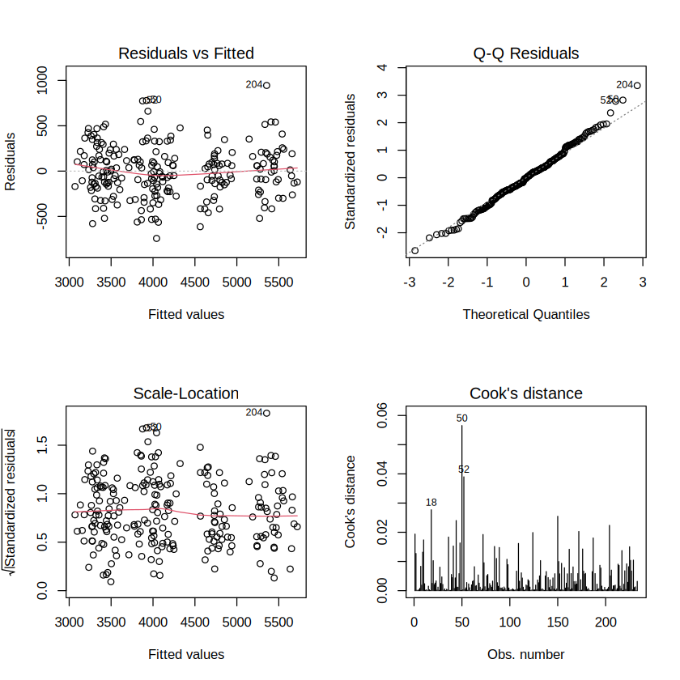
Figure 1: 4-Panel Model Residual Diagnostic Plots (Residuals vs. Fitted, Normal Q-Q, Scale-Location, Residuals vs. Leverage).

5. Model Strengths & Avenues for Optimization
Model Strengths
- Strong Explanatory Power: The model explains about 88% of the variance in body mass (holdout R² = 0.8794) using only simple morphological and demographic variables.
- Low Prediction Error: The holdout MAE of 228.12 g is small relative to the observed body-mass range of 3,600 g (2,700 g to 6,300 g).
- Stable Coefficients: All VIF values are below 4.2, so the estimates are not destabilized by correlated predictors.

Avenues for Optimization
- Interaction Terms: Adding terms such as flipper_length_mm:species or bill_depth_mm:sex would let the model capture species-specific scaling and sex-specific differences in body shape.
- Regularized Regression: Ridge, Lasso, or Elastic Net would help with variable selection if more correlated measurements are added.
- Non-Linear Models: Tree ensembles such as Random Forest or Gradient Boosting can learn non-linear relationships and interactions automatically, without manual feature engineering.

