Task: Week 4 — Comprehensive Data Analysis Reporting and Presentation
Deliverable: Final Technical Report & Presentation of Findings
Environment: R 4.x / Google Colab Notebook
Packages Used: palmerpenguins, ggplot2, dplyr, stats

Comprehensive Data Analysis Report: From Raw Data to Predictive Insight

Executive Summary
This report brings together four weeks of work on the Palmer Archipelago penguin data: cleaning, visualization, statistical testing and predictive modeling. The goal is to understand what drives penguin body mass and to build a model that can estimate it from simple field measurements.

- Data: 344 records were audited and 333 complete records were retained after removing 11 with missing values (3.2%). No duplicates and no statistical outliers were found.
- Patterns: Gentoo penguins are far heavier than Adelie and Chinstrap penguins, males are heavier than females, and flipper length is the strongest single predictor of mass (r = 0.87).
- Statistics: Males are 683 g heavier than females (Cohen’s d = 0.94). Species explains 67% of mass variance, and Adelie and Chinstrap do not differ from each other (Tukey p = 0.92).
- Model: A regression with a species-by-sex interaction predicts held-out body mass with R² = 0.87 and an average error of 285 g, about 64% lower than guessing the mean (789 g).
- Key insight: The sex gap in body mass differs by species (about 675 g in Adelie, 805 g in Gentoo and only 412 g in Chinstrap), so results should always be reported per species.

1. Introduction
1.1 Project Context and Objectives
Context: Body mass is a basic indicator of animal health and is costly and disruptive to measure in the field. If it can be estimated reliably from quick external measurements, monitoring programmes can track populations with less handling of the animals.
- Objective 1: Prepare a trustworthy dataset and document every cleaning decision.
- Objective 2: Use visualization to find patterns, paradoxes and anomalies before modeling.
- Objective 3: Test the visible patterns formally with hypothesis tests and effect sizes.
- Objective 4: Build and validate a model that predicts body mass, and say honestly how good it is.
- Objective 5: Turn the results into conclusions a non-technical audience can act on.

1.2 Dataset
- Dataset Name: Palmer Archipelago Penguin Data (palmerpenguins).
- Source: Collected by Dr. Kristen Gorman and the Palmer Station, Antarctica LTER.
- Dimensions: 344 rows and 8 variables (333 rows after cleaning).
- Target Variable: body_mass_g, the body mass of each penguin in grams.

Variable | Type | Description and role
species | Categorical | Adelie, Chinstrap or Gentoo. Predictor.
island | Categorical | Biscoe, Dream or Torgersen. Predictor.
sex | Categorical | Female or male. Predictor.
bill_length_mm | Continuous | Length of the bill in millimetres. Predictor.
bill_depth_mm | Continuous | Depth of the bill in millimetres. Predictor.
flipper_length_mm | Continuous | Length of the flipper in millimetres. Predictor.
body_mass_g | Continuous | Body mass in grams. Target.
year | Integer | Survey year (2007 to 2009). Used for the time trend only.

1.3 How the Four Weeks Fit Together
Week | Focus | Contribution to this report
1 | Data cleaning and preparation | Section 3: missing-value audit, cleaning log, outlier screen
2 | Data visualization | Section 4: six charts that reveal the main patterns
3 | Statistical analysis and modeling | Sections 5 and 6: hypothesis tests, regression, validation
4 | Reporting and presentation | Sections 7 and 8: integration, discussion, conclusions

2. Methodology
Approach: The analysis follows one pipeline in which each stage feeds the next. The charts suggest hypotheses, the tests confirm which effects are real, and the model uses those effects as predictors.
- Reproducibility: One Colab notebook runs from top to bottom with a fixed random seed (set.seed(42)) and fixed cross-validation folds, so every number in this report can be regenerated.
- Consistent presentation: A single colour palette is used for species (red, green, blue) and for sex across all charts.
- Honest validation: The data are split 70/30. Every modeling decision uses 5-fold cross-validation on the 70% training set only. The 30% holdout set is used once, at the end.
- Fair comparison: All candidate models are scored on identical folds with the same metrics (RMSE, MAE, R²) and are compared against a mean-only baseline.
- Effect sizes alongside p-values: With 333 observations almost any difference is significant, so Cohen’s d and eta-squared are reported to show how large each effect is.

Setup Code:
pkgs <- c("palmerpenguins", "ggplot2", "dplyr")
for (p in pkgs) if (!requireNamespace(p, quietly = TRUE)) install.packages(p)
invisible(lapply(pkgs, function(p) suppressPackageStartupMessages(library(p, character.only = TRUE))))

options(repr.plot.width = 8, repr.plot.height = 5.5, width = 110)
set.seed(42)

# One palette used for every chart so the story stays visually consistent
species_cols <- c(Adelie = "#F8766D", Chinstrap = "#00BA38", Gentoo = "#619CFF")
sex_cols <- c(female = "#F8766D", male = "#00BFC4")

cat("Packages loaded.\n", R.version.string, "\n")

3. Data Preparation & Cleaning
Why this matters: Every later result depends on the data being sound. The raw table was audited for missing values, duplicates and implausible values before any analysis.
3.1 Missing-Value and Duplicate Audit
Code:
missing_audit <- data.frame(
variable = names(penguins),
n_missing = sapply(penguins, function(x) sum(is.na(x))),
pct_missing = round(100 * sapply(penguins, function(x) mean(is.na(x))), 2),
row.names = NULL
)
print(missing_audit)

cat("\nRows with at least one missing value:", sum(!complete.cases(penguins)), "\n")
cat("Duplicate rows:", sum(duplicated(penguins)), "\n")

Output:
variable n_missing pct_missing
1 species 0 0.00
2 island 0 0.00
3 bill_length_mm 2 0.58
4 bill_depth_mm 2 0.58
5 flipper_length_mm 2 0.58
6 body_mass_g 2 0.58
7 sex 11 3.20
8 year 0 0.00

Rows with at least one missing value: 11

Duplicate rows: 0

Insight & Significance: Only 11 of 344 records (3.2%) are incomplete. Two penguins are missing all four measurements and nine more are missing only sex. There are no duplicate rows. Because the loss is small, deleting these records is simpler and safer than imputing values that were never observed.

3.2 Cleaning Decisions
Code:
model_vars <- c("species", "island", "bill_length_mm", "bill_depth_mm",
"flipper_length_mm", "body_mass_g", "sex", "year")

data_clean <- na.omit(penguins[, model_vars])
n_after_na <- nrow(data_clean)

data_clean <- data_clean[data_clean$sex %in% c("female", "male"), ]
data_clean$species <- droplevels(as.factor(data_clean$species))
data_clean$island <- droplevels(as.factor(data_clean$island))
data_clean$sex <- droplevels(as.factor(data_clean$sex))
data_clean <- as.data.frame(data_clean)

cleaning_log <- data.frame(
Step = c("Raw records",
"Removed: missing measurement or sex values",
"Removed: invalid sex labels",
"Final analysis records"),
Records = c(nrow(penguins),
nrow(penguins) - n_after_na,
n_after_na - nrow(data_clean),
nrow(data_clean))
)
print(cleaning_log, row.names = FALSE)

Output:
Step Records
Raw records 344
Removed: missing measurement or sex values 11
Removed: invalid sex labels 0
Final analysis records 333

Insight & Significance: The cleaning log shows exactly how 344 raw records became 333 analysis records. Factor variables were converted so that R treats species, island and sex as categories, which the regression model needs in order to build indicator variables correctly.

3.3 Outlier Screen and Descriptive Summary
Code:
num_vars <- c("bill_length_mm", "bill_depth_mm", "flipper_length_mm", "body_mass_g")

outlier_tbl <- do.call(rbind, lapply(num_vars, function(v) {
x <- data_clean[[v]]
q <- quantile(x, c(0.25, 0.75))
iqr <- diff(q)
lo <- q[1] - 1.5 * iqr
hi <- q[2] + 1.5 * iqr
data.frame(variable = v, min = min(x), max = max(x),
lower_fence = round(lo, 1), upper_fence = round(hi, 1),
n_outliers = sum(x < lo | x > hi))
}))
print(outlier_tbl, row.names = FALSE)

Output:
variable min max lower_fence upper_fence n_outliers
bill_length_mm 32.1 59.6 25.8 62.2 0
bill_depth_mm 13.1 21.5 10.9 23.3 0
flipper_length_mm 172.0 231.0 155.5 247.5 0
body_mass_g 2700.0 6300.0 1712.5 6612.5 0

Code:
desc_tbl <- data_clean %>%
group_by(species) %>%
summarise(n = n(),
mean_mass = round(mean(body_mass_g), 1),
sd_mass = round(sd(body_mass_g), 1),
mean_flipper = round(mean(flipper_length_mm), 1),
mean_bill_len = round(mean(bill_length_mm), 1),
mean_bill_depth = round(mean(bill_depth_mm), 1),
.groups = "drop")
print(as.data.frame(desc_tbl))

Output:
species n mean_mass sd_mass mean_flipper mean_bill_len mean_bill_depth
1 Adelie 146 3706.2 458.6 190.1 38.8 18.3
2 Chinstrap 68 3733.1 384.3 195.8 48.8 18.4
3 Gentoo 119 5092.4 501.5 217.2 47.6 15.0

Insight & Significance: No value falls outside the 1.5 × IQR fences, so no records needed to be removed or corrected. The species summary already shows the main story: Gentoo penguins average 5,092 g while Adelie (3,706 g) and Chinstrap (3,733 g) are almost identical.

4. Exploratory Visualization
Why this matters: Charts reveal structure that summary numbers hide. Each chart below was chosen to answer one specific question, and together they motivate the hypotheses tested in Section 5.
Chart 1: Scatter Plot with Linear Trendlines
Graph Type & Rationale: Bivariate scatter plot with a trendline per species and one pooled trendline. It shows whether a relationship holds in each subgroup and in the whole sample.
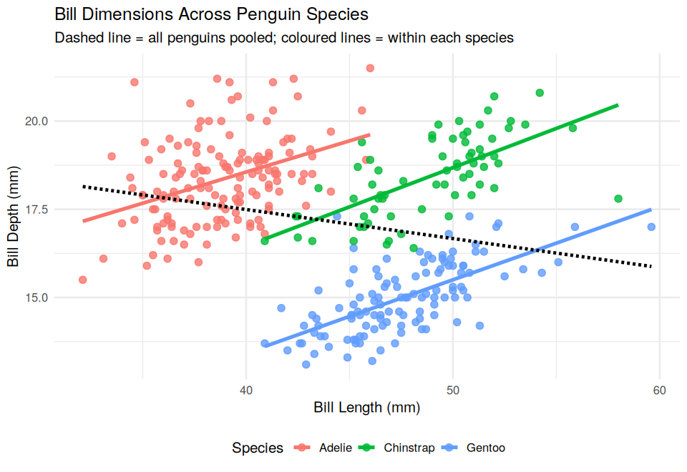
Figure 1: Bill Dimensions Across Penguin Species demonstrating Simpson’s Paradox.

Code:
overall_r <- cor(data_clean$bill_length_mm, data_clean$bill_depth_mm)

p1 <- ggplot(data_clean, aes(x = bill_length_mm, y = bill_depth_mm, color = species)) +
geom_point(alpha = 0.8, size = 2.2) +
geom_smooth(method = "lm", formula = y ~ x, se = FALSE, linewidth = 1.1) +
geom_smooth(aes(group = 1), method = "lm", formula = y ~ x, se = FALSE,
color = "black", linetype = "dashed", linewidth = 1) +
scale_color_manual(values = species_cols) +
labs(title = "Bill Dimensions Across Penguin Species",
subtitle = "Dashed line = all penguins pooled; coloured lines = within each species",
x = "Bill Length (mm)", y = "Bill Depth (mm)", color = "Species") +
theme_minimal(base_size = 12) + theme(legend.position = "bottom")
print(p1)

within_r <- sapply(split(data_clean, data_clean$species),
function(d) cor(d$bill_length_mm, d$bill_depth_mm))
cat(sprintf("Pooled correlation: r = %.3f\n", overall_r))
cat("Within-species correlations:\n"); print(round(within_r, 3))

Output:
Pooled correlation: r = -0.229

Within-species correlations:

Adelie Chinstrap Gentoo
0.386 0.654 0.654

Insight & Significance: This is Simpson’s Paradox. Across all penguins, bill length and bill depth are negatively related (the dashed line; r = −0.23). Inside each species the relationship is positive (Adelie r = 0.39, Chinstrap r = 0.65, Gentoo r = 0.65). The pooled trend is misleading because the species differ in bill shape: Adelie bills are short and deep (38.8 mm long, 18.3 mm deep), while Gentoo bills are longer and much shallower (47.6 mm long, 15.0 mm deep). Any analysis that ignored species would reach the wrong conclusion, which is why every later step includes species.

Chart 2: Histogram with Density Curves
Graph Type & Rationale: Semi-transparent histograms with overlaid density curves. They show the shape of each distribution, including groups that an overall average would hide.
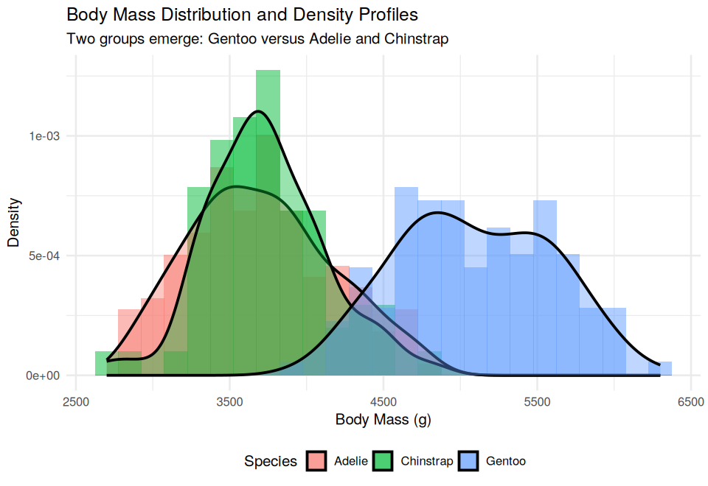
Figure 2: Body Mass Distribution and Kernel Density Profiles by Species.

Code:
p2 <- ggplot(data_clean, aes(x = body_mass_g, fill = species)) +
geom_histogram(aes(y = after_stat(density)), bins = 25, alpha = 0.5, position = "identity") +
geom_density(alpha = 0.4, linewidth = 0.8) +
scale_fill_manual(values = species_cols) +
labs(title = "Body Mass Distribution and Density Profiles",
subtitle = "Two groups emerge: Gentoo versus Adelie and Chinstrap",
x = "Body Mass (g)", y = "Density", fill = "Species") +
theme_minimal(base_size = 12) + theme(legend.position = "bottom")
print(p2)

Insight & Significance: Body mass splits into two groups. Adelie (mean 3,706 g, SD 459 g) and Chinstrap (mean 3,733 g, SD 384 g) overlap almost completely, while Gentoo (mean 5,092 g, SD 501 g) sits far to the right, with weights up to 6,300 g. Body mass therefore separates Gentoo from the other two species, but it cannot separate Adelie from Chinstrap. The two humps within the Gentoo curve hint at a male and female effect, which is tested in Section 5.

Chart 3: Faceted Bar Chart
Graph Type & Rationale: Small-multiple bar charts, one panel per species. They show geographic spread and sex balance without crowding the chart.
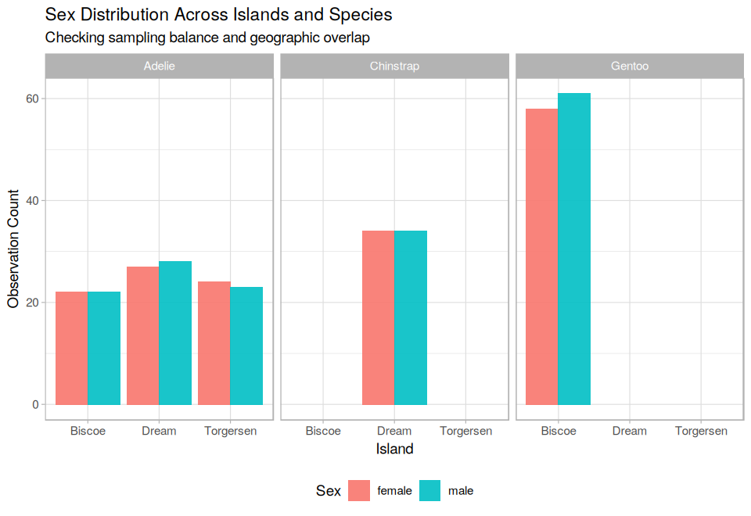
Figure 3: Sex Distribution Across Islands and Species.

Code:
p3 <- ggplot(data_clean, aes(x = island, fill = sex)) +
geom_bar(position = "dodge", alpha = 0.9) +
facet_wrap(~ species) +
scale_fill_manual(values = sex_cols) +
labs(title = "Sex Distribution Across Islands and Species",
subtitle = "Checking sampling balance and geographic overlap",
x = "Island", y = "Observation Count", fill = "Sex") +
theme_light(base_size = 11) + theme(legend.position = "bottom")
print(p3)

print(table(Species = data_clean$species, Island = data_clean$island))
print(table(Sex = data_clean$sex))

Output:
Island
Species Biscoe Dream Torgersen
Adelie 44 55 47
Chinstrap 0 68 0
Gentoo 119 0 0

Sex
female male
165 168

Insight & Significance: Chinstraps live only on Dream Island (68 birds) and Gentoos only on Biscoe Island (119 birds), while Adelie penguins are found on all three islands (44 on Biscoe, 55 on Dream and 47 on Torgersen). Within every colony the number of males and females is nearly equal, and overall there are 165 females and 168 males, so the sample is balanced by sex. Because two species each occupy one island, island and species are tangled together, which matters when interpreting the regression model later.

Chart 4: Line Chart with Error Bars
Graph Type & Rationale: Yearly means with standard error bars. They show whether measurements are stable over time and whether the survey years can be treated alike.
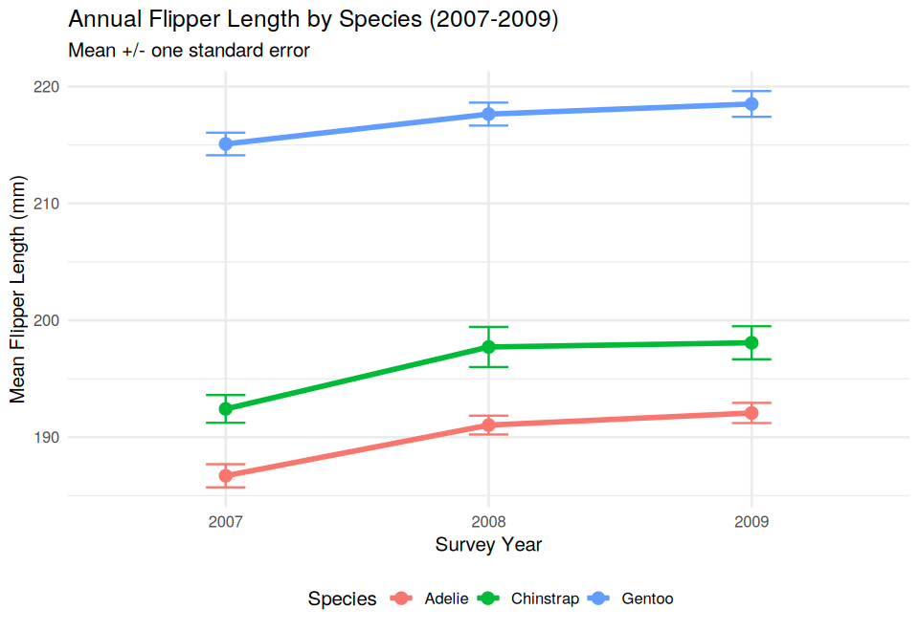
Figure 4: Annual Flipper Length by Species (2007 to 2009).

Code:
yearly_trend <- data_clean %>%
group_by(year, species) %>%
summarise(mean_flipper = mean(flipper_length_mm),
se_flipper = sd(flipper_length_mm) / sqrt(n()),
.groups = "drop")

p4 <- ggplot(yearly_trend, aes(x = factor(year), y = mean_flipper, group = species, color = species)) +
geom_line(linewidth = 1.2) +
geom_point(size = 3) +
geom_errorbar(aes(ymin = mean_flipper - se_flipper, ymax = mean_flipper + se_flipper), width = 0.15) +
scale_color_manual(values = species_cols) +
labs(title = "Annual Flipper Length by Species (2007-2009)",
subtitle = "Mean +/- one standard error",
x = "Survey Year", y = "Mean Flipper Length (mm)", color = "Species") +
theme_minimal(base_size = 12) + theme(legend.position = "bottom")
print(p4)
print(as.data.frame(yearly_trend %>% mutate(across(where(is.numeric) & !year, ~ round(.x, 2)))))

Output:
year species mean_flipper se_flipper
1 2007 Adelie 186.70 0.99
2 2007 Chinstrap 192.42 1.19
3 2007 Gentoo 215.09 0.97
4 2008 Adelie 191.04 0.81
5 2008 Chinstrap 197.72 1.72
6 2008 Gentoo 217.64 0.98
7 2009 Adelie 192.08 0.86
8 2009 Chinstrap 198.08 1.41
9 2009 Gentoo 218.51 1.10

Insight & Significance: The ranking of species is the same in every year, and standard errors are small (about 0.8 to 1.7 mm). There is, however, a modest rise between 2007 and 2008 (Adelie 186.7 mm to 191.0 mm; Chinstrap 192.4 mm to 197.7 mm), after which means level off. This is a gentle shift rather than a dramatic change, and a reminder that the three survey years are not perfectly identical. Year was therefore not used as a predictor.

Chart 5: Correlation Heatmap
Graph Type & Rationale: Colour-coded matrix of pairwise Pearson correlations. It shows at a glance which measurements move together, and which predictors overlap.
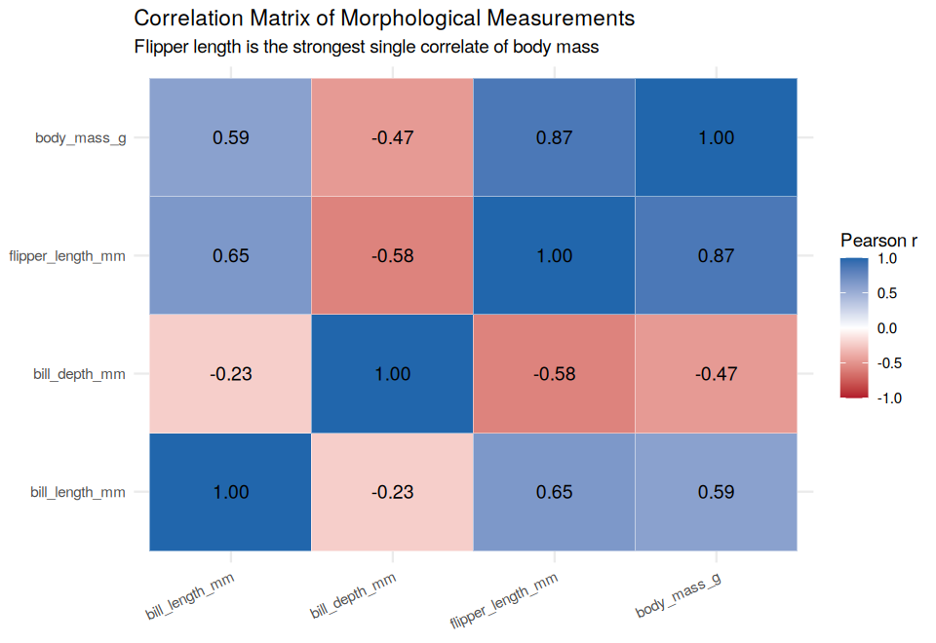
Figure 5: Correlation Matrix of Morphological Measurements.

Code:
cor_mat <- cor(data_clean[, num_vars])
cor_df <- as.data.frame(as.table(cor_mat))
names(cor_df) <- c("Var1", "Var2", "r")

p5 <- ggplot(cor_df, aes(x = Var1, y = Var2, fill = r)) +
geom_tile(color = "white") +
geom_text(aes(label = sprintf("%.2f", r)), size = 4) +
scale_fill_gradient2(low = "#B2182B", mid = "white", high = "#2166AC",
midpoint = 0, limits = c(-1, 1)) +
labs(title = "Correlation Matrix of Morphological Measurements",
subtitle = "Flipper length is the strongest single correlate of body mass",
x = NULL, y = NULL, fill = "Pearson r") +
theme_minimal(base_size = 11) +
theme(axis.text.x = element_text(angle = 25, hjust = 1))
print(p5)

Insight & Significance: Flipper length has the strongest link to body mass (r = 0.87), followed by bill length (r = 0.59). Bill depth is negatively related to mass (r = −0.47), which is another side effect of Simpson’s Paradox: Gentoo penguins are heavy but have shallow bills. The predictors also correlate with each other (flipper and bill length r = 0.65; flipper and bill depth r = −0.58), an early warning of the multicollinearity examined in Section 6.

Chart 6: Box Plot by Species and Sex
Graph Type & Rationale: Box plots show the median, spread and outliers for each group. They test whether the sex difference in body mass holds within every species.
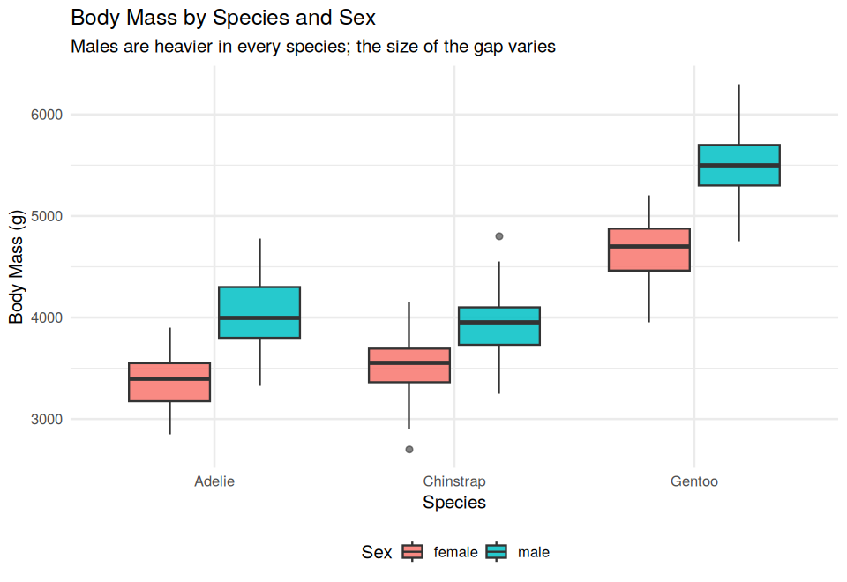
Figure 6: Body Mass by Species and Sex.

Code:
p6 <- ggplot(data_clean, aes(x = species, y = body_mass_g, fill = sex)) +
geom_boxplot(alpha = 0.85, outlier.alpha = 0.6) +
scale_fill_manual(values = sex_cols) +
labs(title = "Body Mass by Species and Sex",
subtitle = "Males are heavier in every species; the size of the gap varies",
x = "Species", y = "Body Mass (g)", fill = "Sex") +
theme_minimal(base_size = 12) + theme(legend.position = "bottom")
print(p6)

gap_m <- with(data_clean, tapply(body_mass_g, list(species, sex), mean))
sex_gap <- data.frame(species = rownames(gap_m),
female_mean = round(gap_m[, "female"], 1),
male_mean = round(gap_m[, "male"], 1),
gap_g = round(gap_m[, "male"] - gap_m[, "female"], 1),
row.names = NULL)
print(sex_gap)

Output:
species female_mean male_mean gap_g
1 Adelie 3368.8 4043.5 674.7
2 Chinstrap 3527.2 3939.0 411.8
3 Gentoo 4679.7 5484.8 805.1

Insight & Significance: Males are heavier in every species, but the size of the gap differs: about 675 g in Adelie, 805 g in Gentoo and only 412 g in Chinstrap. The Chinstrap gap is clearly smaller. This suggests that sex and species interact, a hypothesis that is tested in the model comparison in Section 6.

5. Statistical Inference
Why this matters: The charts suggest three claims: males are heavier, Gentoo is heavier than the other species, and flipper length tracks body mass. Each is tested formally here, and the assumptions behind the tests are checked.
5.1 Hypothesis 1: Body Mass by Sex (Welch’s t-test)
- Null Hypothesis (H0): Mean body mass is the same for males and females.
- Alternative Hypothesis (H1): Mean body mass differs between the sexes.
Code:
ttest_res <- t.test(body_mass_g ~ sex, data = data_clean)
cat("=== TWO-SAMPLE T-TEST: BODY MASS BY SEX ===\n")
print(ttest_res)

# Effect size: Cohen's d (how big is the difference, not just is it significant?)
g <- split(data_clean$body_mass_g, data_clean$sex)
pooled_sd <- sqrt(((length(g$female) - 1) * var(g$female) + (length(g$male) - 1) * var(g$male)) /
(length(g$female) + length(g$male) - 2))
cohens_d <- (mean(g$male) - mean(g$female)) / pooled_sd
cat(sprintf("\nMale - female difference: %.1f g | Cohen's d = %.2f\n",
mean(g$male) - mean(g$female), cohens_d))

Output:
=== TWO-SAMPLE T-TEST: BODY MASS BY SEX ===

Welch Two Sample t-test

data: body_mass_g by sex
t = -8.5545, df = 323.9, p-value = 4.794e-16
alternative hypothesis: true difference in means between group female and group male is not equal to 0
95 percent confidence interval:
-840.5783 -526.2453
sample estimates:
mean in group female mean in group male
3862.273 4545.685

Male - female difference: 683.4 g | Cohen's d = 0.94

Insight & Significance: Reject H0. Males average 4,546 g and females 3,862 g, a gap of 683 g (95% CI: 526 g to 841 g; t = −8.55, p = 4.8e-16). The negative t value only reflects the order of the groups. Cohen’s d of 0.94 is a large effect, so the difference matters in practice as well as statistically.

5.2 Hypothesis 2: Body Mass Across Species (ANOVA and Tukey HSD)
- Null Hypothesis (H0): All three species have the same mean body mass.
- Alternative Hypothesis (H1): At least one species differs.
Code:
anova_mod <- aov(body_mass_g ~ species, data = data_clean)
cat("=== ONE-WAY ANOVA: BODY MASS BY SPECIES ===\n")
print(summary(anova_mod))

ss <- summary(anova_mod)[[1]]
eta2 <- ss[["Sum Sq"]][1] / sum(ss[["Sum Sq"]])
cat(sprintf("\nEta-squared (share of mass variance explained by species): %.3f\n", eta2))

cat("\n=== TUKEY HSD POST-HOC TEST ===\n")
print(TukeyHSD(anova_mod))

Output:
=== ONE-WAY ANOVA: BODY MASS BY SPECIES ===

Df Sum Sq Mean Sq F value Pr(>F)
species 2 145190219 72595110 341.9 <2e-16 ***
Residuals 330 70069447 212332
---
Signif. codes: 0 ‘***’ 0.001 ‘**’ 0.01 ‘*’ 0.05 ‘.’ 0.1 ‘ ’ 1

Eta-squared (share of mass variance explained by species): 0.674

=== TUKEY HSD POST-HOC TEST ===

Tukey multiple comparisons of means
95% family-wise confidence level

Fit: aov(formula = body_mass_g ~ species, data = data_clean)

$species
diff lwr upr p adj
Chinstrap-Adelie 26.92385 -132.3528 186.2005 0.916431
Gentoo-Adelie 1386.27259 1252.2897 1520.2554 0.000000
Gentoo-Chinstrap 1359.34874 1194.4304 1524.2671 0.000000

Insight & Significance: Reject H0 (F(2, 330) = 341.9, p < 2e-16). Species explains 67% of the variation in body mass (eta-squared = 0.674). Tukey’s test shows that Gentoo is about 1,386 g heavier than Adelie and 1,359 g heavier than Chinstrap (both p < 0.0001), while Adelie and Chinstrap do not differ (difference 27 g, 95% CI −132 g to 186 g, p = 0.92).

5.3 Hypothesis 3: Flipper Length and Body Mass (Pearson Correlation)
- Null Hypothesis (H0): The true correlation is zero.
- Alternative Hypothesis (H1): The true correlation is not zero.
Code:
cor_res <- cor.test(data_clean$flipper_length_mm, data_clean$body_mass_g)
cat("=== PEARSON CORRELATION: FLIPPER LENGTH vs BODY MASS ===\n")
print(cor_res)

Output:
=== PEARSON CORRELATION: FLIPPER LENGTH vs BODY MASS ===

Pearson's product-moment correlation

data: data_clean$flipper_length_mm and data_clean$body_mass_g
t = 32.562, df = 331, p-value < 2.2e-16
alternative hypothesis: true correlation is not equal to 0
95 percent confidence interval:
0.8447622 0.8963550
sample estimates:
cor
0.8729789

Insight & Significance: Reject H0. The correlation is r = 0.87 (95% CI: 0.84 to 0.90; p < 2.2e-16), a strong positive relationship. This makes flipper length the most useful single measurement for estimating body mass in the model.

5.4 Assumption Checks and Robustness
Code:
cat("=== SHAPIRO-WILK NORMALITY TEST (ANOVA residuals) ===\n")
print(shapiro.test(residuals(anova_mod)))

cat("=== BARTLETT TEST FOR HOMOSCEDASTICITY ===\n")
print(bartlett.test(body_mass_g ~ species, data = data_clean))

cat("=== KRUSKAL-WALLIS ROBUSTNESS CHECK ===\n")
print(kruskal.test(body_mass_g ~ species, data = data_clean))

Output:
=== SHAPIRO-WILK NORMALITY TEST (ANOVA residuals) ===

Shapiro-Wilk normality test

data: residuals(anova_mod)
W = 0.9922, p-value = 0.07835

=== BARTLETT TEST FOR HOMOSCEDASTICITY ===

Bartlett test of homogeneity of variances

data: body_mass_g by species
Bartlett's K-squared = 5.692, df = 2, p-value = 0.05808

=== KRUSKAL-WALLIS ROBUSTNESS CHECK ===

Kruskal-Wallis rank sum test

data: body_mass_g by species
Kruskal-Wallis chi-squared = 212.09, df = 2, p-value < 2.2e-16

Insight & Significance: Both assumption tests land close to, but above, the 0.05 line: residual normality (Shapiro-Wilk p = 0.078) and equal variances (Bartlett p = 0.058). Because they are borderline, the non-parametric Kruskal-Wallis test was run as a check. It does not depend on either assumption and reaches the same conclusion (p < 2.2e-16), so the species result is robust.

5.5 Summary of Hypothesis Tests
Question | Test | Key result | Decision
Male vs. female mass | Welch’s t-test | Difference 683 g, d = 0.94, p = 4.8e-16 | Reject H0
Mass across species | ANOVA + Tukey HSD | F = 341.9, eta² = 0.674; Gentoo +1,386 g vs. Adelie | Reject H0
Adelie vs. Chinstrap | Tukey HSD | Difference 27 g, p = 0.92 | Fail to reject
Flipper vs. body mass | Pearson correlation | r = 0.87, p < 2.2e-16 | Reject H0
ANOVA robustness | Kruskal-Wallis | Chi-squared = 212.1, p < 2.2e-16 | Same conclusion

6. Predictive Modeling
Why this matters: The tests show which factors matter. The model puts them together to predict body mass for individual penguins, and validation shows how far the predictions can be trusted.
6.1 Design: Train/Test Split and Cross-Validation
- Data Partition: 70% training set (n = 233) and 30% holdout test set (n = 100).
- Resampling: 5-fold cross-validation on the training set, with the same folds used for every model.
- Baseline: A model that always predicts the mean body mass, so improvements have a reference point.
Code:
set.seed(42)
n <- nrow(data_clean)
train_idx <- sample(seq_len(n), size = round(0.70 * n))
train_df <- data_clean[train_idx, ]
test_df <- data_clean[-train_idx, ]

folds <- cut(seq_len(nrow(train_df)), breaks = 5, labels = FALSE)
folds <- sample(folds) # the same folds are reused for every candidate model

cat(sprintf("Training samples: %d (70%%) | Test samples: %d (30%%)\n", nrow(train_df), nrow(test_df)))
print(table(Fold = folds))

Output:
Training samples: 233 (70%) | Test samples: 100 (30%)

Fold
1 2 3 4 5
47 46 47 46 47

6.2 The Week 3 Model
Model Equation:
body_mass_g = β0 + β1(bill_length_mm) + β2(bill_depth_mm) + β3(flipper_length_mm) + β4(species) + β5(sex) + β6(island) + ε

Code:
rmse <- function(actual, pred) sqrt(mean((actual - pred)^2))
mae <- function(actual, pred) mean(abs(actual - pred))
r2 <- function(actual, pred) 1 - sum((actual - pred)^2) / sum((actual - mean(actual))^2)

# Native Variance Inflation Factor
calc_vif <- function(mod) {
X <- model.matrix(mod)[, -1]
vifs <- numeric(ncol(X)); names(vifs) <- colnames(X)
for (i in seq_along(vifs)) {
r2_i <- summary(lm(X[, i] ~ X[, -i]))$r.squared
vifs[i] <- 1 / (1 - r2_i)
}
vifs
}

f_full <- body_mass_g ~ bill_length_mm + bill_depth_mm + flipper_length_mm + species + sex + island
model_lm <- do.call("lm", list(formula = f_full, data = quote(train_df)))

cat("=== WEEK 3 MODEL SUMMARY (M1: full additive) ===\n")
print(summary(model_lm))
cat("=== VARIANCE INFLATION FACTORS (M1) ===\n")
print(round(calc_vif(model_lm), 2))

Output:
=== WEEK 3 MODEL SUMMARY (M1: full additive) ===

Call:
lm(formula = body_mass_g ~ bill_length_mm + bill_depth_mm + flipper_length_mm +
species + sex + island, data = train_df)

Residuals:
Min 1Q Median 3Q Max
-742.37 -169.52 -6.88 169.91 944.84

Coefficients:
Estimate Std. Error t value Pr(>|t|)
(Intercept) -1425.216 678.504 -2.101 0.036801 *
bill_length_mm 17.872 8.393 2.129 0.034320 *
bill_depth_mm 77.617 22.789 3.406 0.000782 ***
flipper_length_mm 15.106 3.410 4.429 1.48e-05 ***
speciesChinstrap -287.123 105.872 -2.712 0.007207 **
speciesGentoo 1020.081 161.943 6.299 1.57e-09 ***
sexmale 362.856 55.503 6.538 4.17e-10 ***
islandDream -35.272 69.571 -0.507 0.612654
islandTorgersen -109.755 73.263 -1.498 0.135517
---
Signif. codes: 0 ‘***’ 0.001 ‘**’ 0.01 ‘*’ 0.05 ‘.’ 0.1 ‘ ’ 1

Residual standard error: 284.6 on 224 degrees of freedom
Multiple R-squared: 0.8814, Adjusted R-squared: 0.8771
F-statistic: 208 on 8 and 224 DF, p-value: < 2.2e-16

=== VARIANCE INFLATION FACTORS (M1) ===

bill_length_mm bill_depth_mm flipper_length_mm speciesChinstrap speciesGentoo sexmale
6.25 5.73 6.82 5.11 17.48 2.21
islandDream islandTorgersen
3.24 1.83

Insight & Significance: The Week 3 model explains 88% of the variance in the training data (adjusted R² = 0.877). Flipper length (+15.1 g per mm), bill depth (+77.6 g per mm), bill length (+17.9 g per mm), species and sex are all significant, while the two island coefficients are not (p = 0.61 and 0.14). The variance inflation factors are above 5 for the bill and flipper measurements and reach 17.5 for Gentoo. This is expected, because species is closely tied to body size, and it makes individual coefficients harder to interpret. It does not damage prediction, as the validation below shows.

6.3 Model Comparison and Selection
Approach: Week 3 suggested removing predictors that add nothing and adding interaction terms. Three questions were tested: does island add anything (nested F-test), does the sex effect differ by species (nested F-test), and which model predicts best on unseen data (cross-validation).
Code:
candidates <- list(
"M0 Baseline (mean only)" = body_mass_g ~ 1,
"M1 Full additive (Wk 3)" = f_full,
"M2 Drop island" = body_mass_g ~ bill_length_mm + bill_depth_mm + flipper_length_mm + species + sex,
"M3 Drop island + species x sex" =
body_mass_g ~ bill_length_mm + bill_depth_mm + flipper_length_mm + species * sex
)

cv_scores <- function(formula) {
rm <- numeric(5); rs <- numeric(5)
for (k in 1:5) {
val <- which(folds == k)
fit <- lm(formula, data = train_df[-val, ])
pr <- predict(fit, newdata = train_df[val, ])
rm[k] <- rmse(train_df$body_mass_g[val], pr)
rs[k] <- r2(train_df$body_mass_g[val], pr)
}
c(CV_RMSE = mean(rm), CV_R2 = mean(rs))
}

fits <- lapply(candidates, function(f) do.call("lm", list(formula = f, data = quote(train_df))))

comparison <- do.call(rbind, lapply(names(candidates), function(nm) {
fit <- fits[[nm]]
cv <- cv_scores(candidates[[nm]])
pr <- predict(fit, newdata = test_df)
data.frame(Model = nm,
Adj_R2 = round(summary(fit)$adj.r.squared, 4),
AIC = round(AIC(fit), 1),
CV_RMSE = round(cv["CV_RMSE"], 2),
CV_R2 = round(cv["CV_R2"], 4),
Test_RMSE = round(rmse(test_df$body_mass_g, pr), 2),
Test_MAE = round(mae(test_df$body_mass_g, pr), 2),
Test_R2 = round(r2(test_df$body_mass_g, pr), 4),
row.names = NULL)
}))
print(comparison, row.names = FALSE)

cat("\n=== NESTED F-TEST: does island add anything? (M2 vs M1) ===\n")
print(anova(fits[["M2 Drop island"]], fits[["M1 Full additive (Wk 3)"]]))
cat("=== NESTED F-TEST: does the sex effect depend on species? (M2 vs M3) ===\n")
print(anova(fits[["M2 Drop island"]], fits[["M3 Drop island + species x sex"]]))

# Selection rule: lowest cross-validated RMSE (training data only, never the holdout)
best_name <- comparison$Model[which.min(comparison$CV_RMSE)]
final_model <- fits[[best_name]]
cat("\nSelected model (lowest CV RMSE):", best_name, "\n")

Output:
Model Adj_R2 AIC CV_RMSE CV_R2 Test_RMSE Test_MAE Test_R2
M0 Baseline (mean only) 0.0000 3786.2 809.06 -0.0180 789.17 652.51 0.0000
M1 Full additive (Wk 3) 0.8771 3305.5 287.77 0.8661 300.12 241.56 0.8554
M2 Drop island 0.8769 3304.0 287.78 0.8661 296.44 239.62 0.8589
M3 Drop island + species x sex 0.8847 3290.7 279.49 0.8725 285.04 229.75 0.8695

=== NESTED F-TEST: does island add anything? (M2 vs M1) ===

Analysis of Variance Table

Model 1: body_mass_g ~ bill_length_mm + bill_depth_mm + flipper_length_mm +
species + sex
Model 2: body_mass_g ~ bill_length_mm + bill_depth_mm + flipper_length_mm +
species + sex + island
Res.Df RSS Df Sum of Sq F Pr(>F)
1 226 18340374
2 224 18147017 2 193357 1.1934 0.3051

=== NESTED F-TEST: does the sex effect depend on species? (M2 vs M3) ===

Analysis of Variance Table

Model 1: body_mass_g ~ bill_length_mm + bill_depth_mm + flipper_length_mm +
species + sex
Model 2: body_mass_g ~ bill_length_mm + bill_depth_mm + flipper_length_mm +
species * sex
Res.Df RSS Df Sum of Sq F Pr(>F)
1 226 18340374
2 224 17031350 2 1309024 8.6083 0.0002501 ***
---
Signif. codes: 0 ‘***’ 0.001 ‘**’ 0.01 ‘*’ 0.05 ‘.’ 0.1 ‘ ’ 1

Selected model (lowest CV RMSE): M3 Drop island + species x sex

Model | Adj. R² | AIC | CV RMSE (g) | CV R² | Test RMSE (g) | Test R²
M0 Baseline (mean only) | 0.0000 | 3786.2 | 809.06 | −0.0180 | 789.17 | 0.0000
M1 Full additive (Week 3) | 0.8771 | 3305.5 | 287.77 | 0.8661 | 300.12 | 0.8554
M2 Drop island | 0.8769 | 3304.0 | 287.78 | 0.8661 | 296.44 | 0.8589
M3 Drop island + species × sex | 0.8847 | 3290.7 | 279.49 | 0.8725 | 285.04 | 0.8695

Insight & Significance: Island adds nothing (F-test p = 0.31): removing it leaves accuracy unchanged. The species × sex interaction is clearly worthwhile (F = 8.61, p = 0.0003) and lowers cross-validated error from 288 g to 279 g and AIC from 3305 to 3291. M3 was selected because it had the lowest cross-validated RMSE, a rule that uses only training data. It also performs best on the holdout, which confirms the choice rather than driving it. All three models are far better than the baseline, whose error of about 789 g is nearly three times larger.

6.4 The Selected Model
Code:
print(summary(final_model))
cat("=== VIF AFTER DROPPING ISLAND (M2, additive) ===\n")
print(round(calc_vif(fits[["M2 Drop island"]]), 2))

Output:
Call:
lm(formula = body_mass_g ~ bill_length_mm + bill_depth_mm + flipper_length_mm +
species * sex, data = train_df)

Residuals:
Min 1Q Median 3Q Max
-724.56 -148.84 -5.95 157.29 908.00

Coefficients:
Estimate Std. Error t value Pr(>|t|)
(Intercept) -1670.077 668.894 -2.497 0.013253 *
bill_length_mm 19.443 8.114 2.396 0.017388 *
bill_depth_mm 84.059 22.067 3.809 0.000180 ***
flipper_length_mm 15.077 3.294 4.577 7.83e-06 ***
speciesChinstrap -107.415 104.505 -1.028 0.305134
speciesGentoo 1061.096 149.807 7.083 1.80e-11 ***
sexmale 409.348 64.654 6.331 1.31e-09 ***
speciesChinstrap:sexmale -366.929 99.298 -3.695 0.000276 ***
speciesGentoo:sexmale 25.313 81.901 0.309 0.757556
---
Signif. codes: 0 ‘***’ 0.001 ‘**’ 0.01 ‘*’ 0.05 ‘.’ 0.1 ‘ ’ 1

Residual standard error: 275.7 on 224 degrees of freedom
Multiple R-squared: 0.8887, Adjusted R-squared: 0.8847
F-statistic: 223.5 on 8 and 224 DF, p-value: < 2.2e-16

=== VIF AFTER DROPPING ISLAND (M2, additive) ===

bill_length_mm bill_depth_mm flipper_length_mm speciesChinstrap speciesGentoo sexmale
6.21 5.69 6.65 4.37 15.31 2.20

Predictor | Estimate | p-value | Interpretation
flipper_length_mm | +15.08 g/mm | < 0.001 | Each extra mm of flipper adds about 15 g
bill_depth_mm | +84.06 g/mm | < 0.001 | Deeper bills go with heavier birds, given species
bill_length_mm | +19.44 g/mm | 0.017 | Longer bills go with heavier birds, given species
speciesGentoo | +1,061.1 g | < 0.001 | Heavier than Adelie at the same size
speciesChinstrap | −107.4 g | 0.305 | Not different from Adelie at the same size
sexmale | +409.3 g | < 0.001 | Male advantage in Adelie (baseline species)
speciesChinstrap:sexmale | −366.9 g | < 0.001 | Chinstrap males gain far less than Adelie males
speciesGentoo:sexmale | +25.3 g | 0.758 | Gentoo sex gap is similar to Adelie

Insight & Significance: The model explains 89% of the variance in the training data (adjusted R² = 0.885, residual standard error 276 g). The interaction term shows that, for penguins of the same size, the male advantage is about 409 g in Adelie and Gentoo but only about 42 g in Chinstrap (409.3 − 366.9). Chinstrap males are therefore only slightly heavier than Chinstrap females of the same size, whereas males in the other two species are about 400 g heavier.

6.5 Holdout Performance and Residual Diagnostics
Code:
test_preds <- predict(final_model, newdata = test_df)
cat(sprintf("=== HOLDOUT PERFORMANCE OF SELECTED MODEL (N = %d) ===\nRMSE: %.2f g\nMAE: %.2f g\nR2: %.4f\n",
nrow(test_df), rmse(test_df$body_mass_g, test_preds),
mae(test_df$body_mass_g, test_preds), r2(test_df$body_mass_g, test_preds)))

Output:
=== HOLDOUT PERFORMANCE OF SELECTED MODEL (N = 100) ===
RMSE: 285.04 g
MAE: 229.75 g
R2: 0.8695

Graph Type & Rationale: Four-panel residual diagnostics: Residuals vs. Fitted, Normal Q-Q, Scale-Location and Cook’s distance. They test the linearity, normality, constant-variance and influential-point assumptions of the model.
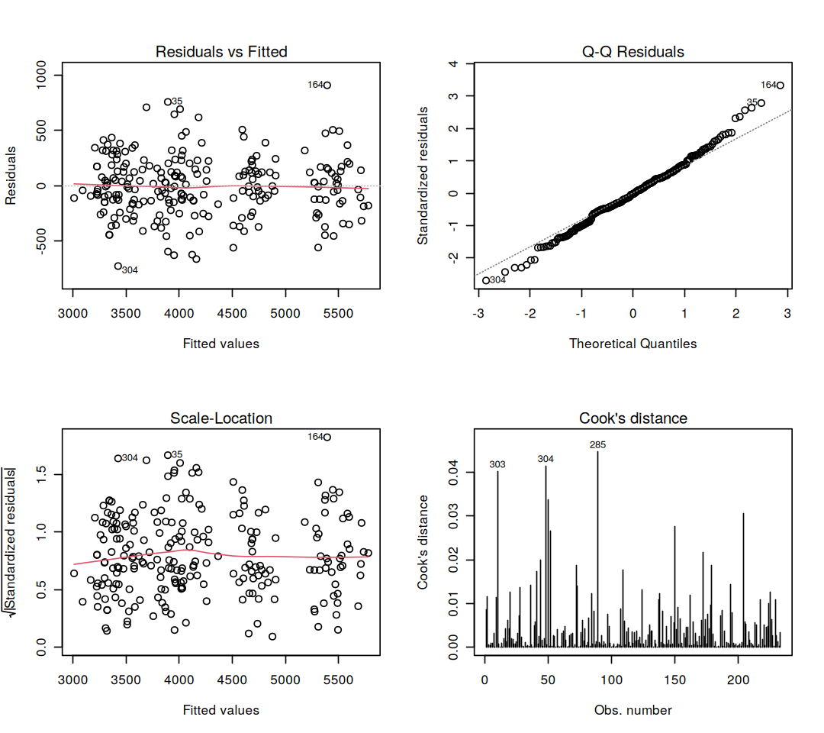
Figure 7: Four-Panel Residual Diagnostic Plots for the Selected Model.

Code:
options(repr.plot.width = 9, repr.plot.height = 8)
par(mfrow = c(2, 2))
plot(final_model, which = 1:4)
par(mfrow = c(1, 1))
options(repr.plot.width = 8, repr.plot.height = 5.5)

res_final <- residuals(final_model)
cat("=== RESIDUAL CHECKS (selected model, training data) ===\n")
print(shapiro.test(res_final))
cat(sprintf("Largest Cook's distance: %.3f (rule of thumb: investigate above 0.5)\n", max(cooks.distance(final_model))))
cat(sprintf("Observations with |standardized residual| > 3: %d\n", sum(abs(rstandard(final_model)) > 3)))

Output:
=== RESIDUAL CHECKS (selected model, training data) ===

Shapiro-Wilk normality test

data: res_final
W = 0.9931, p-value = 0.3531

Largest Cook's distance: 0.045 (rule of thumb: investigate above 0.5)

Observations with |standardized residual| > 3: 1

Residuals vs. Fitted: Residuals scatter evenly around zero with no curve, so the linear form is appropriate.
Normal Q-Q: Points follow the reference line closely, and a Shapiro-Wilk test on the residuals agrees (p = 0.353).
Scale-Location: The spread of residuals is steady across fitted values, supporting constant variance.
Cook’s Distance: The largest value is 0.045, far below the 0.5 warning level, so no single penguin distorts the model. Only one observation has a standardized residual beyond 3.

Insight & Significance: On the 100 held-out penguins the selected model reaches RMSE = 285.04 g, MAE = 229.75 g and R² = 0.8695. The cross-validated RMSE (279.49 g) and the holdout RMSE are close, which means the model generalizes and does not simply memorize the training data.

6.6 Predicted versus Actual Body Mass
Graph Type & Rationale: Scatter plot of predictions against true values on the holdout set. Points on the dashed diagonal would be perfect predictions.
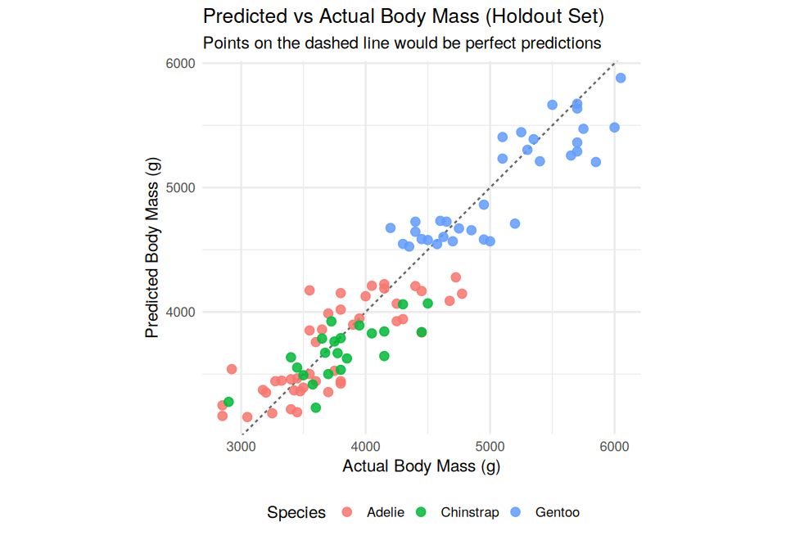
Figure 8: Predicted vs. Actual Body Mass on the Holdout Set.

Code:
pred_df <- data.frame(actual = test_df$body_mass_g, predicted = test_preds, species = test_df$species)

p7 <- ggplot(pred_df, aes(x = actual, y = predicted, color = species)) +
geom_abline(slope = 1, intercept = 0, linetype = "dashed", color = "grey40") +
geom_point(size = 2.5, alpha = 0.85) +
scale_color_manual(values = species_cols) +
labs(title = "Predicted vs Actual Body Mass (Holdout Set)",
subtitle = "Points on the dashed line would be perfect predictions",
x = "Actual Body Mass (g)", y = "Predicted Body Mass (g)", color = "Species") +
coord_equal() + theme_minimal(base_size = 12) + theme(legend.position = "bottom")
print(p7)

err_by_species <- pred_df %>% group_by(species) %>%
summarise(n = n(), RMSE = round(rmse(actual, predicted), 1), MAE = round(mae(actual, predicted), 1), .groups = "drop")
print(as.data.frame(err_by_species))

Output:
species n RMSE MAE
1 Adelie 44 297.8 241.0
2 Chinstrap 22 271.2 217.3
3 Gentoo 34 276.8 223.2

Insight & Significance: Predictions follow the diagonal for all three species, with no obvious bias for any group. Error is similar across species: RMSE is 298 g for Adelie, 271 g for Chinstrap and 277 g for Gentoo. An average error of about 285 g is roughly 7% of the typical body mass (about 4,200 g).

7. Results & Discussion
7.1 Integrated Findings
Area | Finding
Data | 333 of 344 records used after removing 11 with missing values
Data | Sex ratio is balanced: 165 females and 168 males
Visualization | Simpson’s paradox: pooled bill r = −0.23, but every species is positive (0.39 to 0.65)
Visualization | Chinstrap and Gentoo each live on a single island, so island and species overlap
Inference | Males are 683 g heavier than females (Welch p = 4.8e-16, Cohen’s d = 0.94)
Inference | Species explains 67% of body mass variance; Gentoo is 1,386 g heavier than Adelie; Chinstrap vs. Adelie p = 0.92
Inference | Flipper length and body mass correlate at r = 0.87
Modeling | Guessing the mean gives a holdout RMSE of 789 g
Modeling | Week 3 model: CV RMSE 288 g, holdout RMSE 300 g (R² = 0.855)
Modeling | Selected model (species × sex): CV RMSE 279 g, holdout RMSE 285 g (R² = 0.870)

Code:
sel <- comparison[comparison$Model == best_name, ]
m1 <- comparison[comparison$Model == "M1 Full additive (Wk 3)", ]
m0 <- comparison[comparison$Model == "M0 Baseline (mean only)", ]
tuk <- TukeyHSD(anova_mod)$species

key_findings <- data.frame(
Area = c("Data", "Data", "Visualization", "Visualization", "Inference", "Inference", "Inference",
"Modeling", "Modeling", "Modeling"),
Finding = c(
sprintf("%d of %d records used after removing %d with missing values", nrow(data_clean), nrow(penguins), nrow(penguins) - nrow(data_clean)),
sprintf("Sex ratio is balanced: %d females and %d males", sum(data_clean$sex == "female"), sum(data_clean$sex == "male")),
sprintf("Simpson's paradox: pooled bill r = %.2f, but every species is positive (%.2f to %.2f)", overall_r, min(within_r), max(within_r)),
"Chinstrap and Gentoo each live on a single island, so island and species overlap",
sprintf("Males are %.0f g heavier than females (Welch p %s, Cohen's d = %.2f)", mean(g$male) - mean(g$female),
format.pval(ttest_res$p.value, digits = 2), cohens_d),
sprintf("Species explains %.0f%% of body mass variance; Gentoo is %.0f g heavier than Adelie, Chinstrap vs Adelie p = %.2f",
100 * eta2, tuk["Gentoo-Adelie", "diff"], tuk["Chinstrap-Adelie", "p adj"]),
sprintf("Flipper length and body mass correlate at r = %.2f", cor_res$estimate),
sprintf("Guessing the mean gives a holdout RMSE of %.0f g", m0$Test_RMSE),
sprintf("Week 3 model: CV RMSE %.0f g, holdout RMSE %.0f g (R2 = %.3f)", m1$CV_RMSE, m1$Test_RMSE, m1$Test_R2),
sprintf("Selected model (%s): CV RMSE %.0f g, holdout RMSE %.0f g (R2 = %.3f)", best_name, sel$CV_RMSE, sel$Test_RMSE, sel$Test_R2)
)
)
print(key_findings, right = FALSE, row.names = FALSE)

7.2 What the Evidence Shows
- Species and sex drive body size. Gentoo penguins average about 5,092 g against roughly 3,700 g for Adelie and Chinstrap, and males are about 683 g heavier than females.
- The sex gap is not the same in every species. About 675 g in Adelie, 805 g in Gentoo and 412 g in Chinstrap. The significant species × sex interaction (p = 0.0003) is why the interaction model beat the additive one.
- Pooled data can mislead. Bill length and depth are negatively correlated overall but positively correlated inside every species, so analyses must be stratified by species.
- Flipper length is the best single measurement. It correlates with body mass at r = 0.87 and adds about 15 g per millimetre after the other predictors are held constant.
- Island adds nothing once species is known. The F-test gives p = 0.31, although island and species overlap too heavily to separate their effects in this dataset.

7.3 Statistical versus Practical Significance
Almost every test here is highly significant, so significance alone says little. The effect sizes carry the message: a 683 g sex gap and a 1,386 g Gentoo gap are large next to a typical spread of about 450 g within a group. The model’s holdout error of 285 g is about 7% of the average body mass and 64% lower than the 789 g error of simply guessing the mean. It is a useful predictor, but not a perfect one.

7.4 Implications for Practice
- Non-invasive monitoring. Field teams can estimate body mass from a flipper measurement, species and sex without weighing the bird. With an error of about ±285 g per animal, this suits tracking colony-level averages better than judging an individual bird’s condition.
- Simpler data collection. Island adds no predictive value, so it can be left out of the mass-prediction protocol. It should still be recorded for sampling design.
- Analyse by group. Because the sex gap and bill relationships differ by species, results should be reported per species and never only as a pooled average.
- Sampling design. The sex ratio is nearly even, which supports unbiased comparisons. Any future study of place effects needs Adelie, the only species seen on all three islands.

7.5 Limitations
- Observational data from one archipelago over three years. The results describe these penguins and do not show causes. Mean flipper length rose by roughly 2 to 3% from 2007 to 2008 in Adelie and Chinstrap, so conditions were not perfectly constant.
- Multicollinearity. Variance inflation factors stay above 5 for the bill and flipper measurements and reach 15 for Gentoo, because species is tied to body size. Individual coefficients are less stable to interpret, though predictions are not harmed.
- Small holdout set. With 100 test penguins the holdout RMSE is itself an uncertain estimate, which is why model choice relied on cross-validation.
- Complete-case deletion. Removing 11 records (3.2%) assumes that missingness is unrelated to body size. This is plausible but untested.
- Borderline assumptions. The Shapiro-Wilk and Bartlett tests were close to 0.05. The Kruskal-Wallis test, which does not depend on them, agreed, so the species result is robust.

8. Conclusion
8.1 Summary
Starting from 344 raw records, the pipeline cleaned the data (333 retained), visualized the main patterns, tested three hypotheses formally and built a regression model that predicts body mass with a holdout R² of 0.87 and an average error of about 285 g. Each stage informed the next: the charts motivated the hypotheses, the hypotheses chose the predictors, and the model comparison showed that the sex effect depends on species.

8.2 Lessons Learned
- Look before you model. The charts exposed Simpson’s paradox and the species-island overlap before any model was fitted, which prevented misleading conclusions.
- Report effect sizes, not only p-values. With 333 observations nearly everything is significant. Cohen’s d and eta-squared show what actually matters.
- Always compare with a baseline. The mean-only model (RMSE 789 g) gives the 285 g error its meaning.
- Protect the test set. Choosing models by cross-validation kept the holdout result honest. The close agreement between CV (279 g) and holdout (285 g) shows no overfitting.
- Check assumptions and test robustness. When two assumption tests landed near 0.05, a non-parametric test confirmed the conclusion.

8.3 Challenges Overcome
- Missing values: 11 records lacked sex or measurements. They were removed and logged in a cleaning table.
- Misleading aggregate correlations: solved by stratifying every relationship by species.
- Multicollinearity: the variance inflation factors were examined, explained by the link between species and body size, and shown not to damage predictive accuracy.
- Choosing between models fairly: all candidates used identical folds and metrics, and nested F-tests supported the decisions.
- Reproducibility: a fixed seed, fixed folds and a single top-to-bottom notebook make every number repeatable.

8.4 Future Directions
- Regularized regression (ridge, lasso, elastic net), which handles correlated predictors directly.
- Tree ensembles (random forest, gradient boosting) to capture non-linear relationships, compared with the linear model on the same folds.
- Repeated cross-validation or bootstrapping to put confidence intervals around the performance metrics.
- Prediction intervals, so field teams can see the uncertainty of each individual estimate.
- More data: additional years, colonies, and diet or climate variables, to test whether the species-specific patterns persist.
- Classification: predicting species from morphology, to complete the analytical toolkit.

8.5 The Value of a Data-Driven Approach
The most important finding is not any single number but the way the evidence built up. A pooled average would have hidden the species differences, a significance test alone would have hidden how large the effects are, and a model without a baseline or a holdout set would have hidden how good it really is. Working through cleaning, visualization, testing and validation in order replaced assumptions with evidence and produced conclusions that can be checked and repeated.

