Vision and dyslexia
By Bhavin Shah, Behavioural Optometrist (MBABO, FBCLA, MCOptom)
Seeing through the confusion
Abstract
About half of all dyslexics complain of visual symptoms such as words moving on a page. However, dyslexia is not caused by deficits in the visual system. The links between dyslexia and vision are controversial, dyslexics are more likely to have co-occurring visual deficits. This article will discuss some of the most common causes of these symptoms, how to identify those with co-occurring visual deficits, how these difficulties are assessed and some of the interventions available. It will also discuss some of the controversies about the role of vision in dyslexia and treatment options. There are several areas of visual function and processing that may contribute to symptoms, including visual tracking, convergence insufficiency, focusing dysfunction, visual stress (AKA Meares-Irlen syndrome) and visual processing (“Magnocellular” pathway). There is conflicting evidence about the proportion of dyslexics who have co-occurring visual difficulties it is certainly higher than non-dyslexics. Thankfully, there are a variety of options available to help reduce and in some cases eliminate visual symptoms. It is essential to identify those who are experiencing visual symptoms and refer them to an appropriately trained specialist, especially Behavioural Optometrists, who, unlike a high street optician, are trained with an understanding of dyslexia to assess the relevant areas of the visual system. If deficits in visual function are found, appropriate interventions such as vision therapy, reading glasses or tinted lenses can be prescribed. In cases where a deficit is found, these interventions can be highly successful in reducing visual symptoms. It must be stressed that these interventions will not treat or cure dyslexia; reducing visual symptoms can play a part in improving learning and reading outcomes.
Keywords
Vision and dyslexia, visual tracking, convergence insufficiency, visual magnocellular pathway, visual stress, Meares-Irlen Syndrome

There is significant confusion about the role that vision, and the visual system plays in dyslexia. Dyslexia is defined and accepted as a phonological deficit and not caused by deficits in the visual system. However, reading undeniably needs to use our visual system. Many dyslexics have reported visual symptoms such as intermittent blur, the apparent movement of text, seeing distortions or even “glimmering or rivers flowing” down the words. Some estimate that nearly 50% of dyslexics report visual symptoms when reading (Wilkins, 1995). These symptoms will undoubtedly interfere with the reading process. Descriptions in the popular media of the visual symptoms seen by dyslexics who are reading have only added to the misunderstanding about dyslexia and vision. As a specialist in helping those with specific learning difficulties, you will certainly have come across children who have described these visual symptoms when they read.
There are many controversies about the role of interventions targeting the visual system in helping dyslexics. Options such as coloured overlays and filters are often given out by teachers on learning that a child is dyslexic or is experiencing visual symptoms but without an understanding of the underlying visual deficits. Some therapies, such as vision therapy and tinted glasses can be expensive raising concerns about interventions that may exploit vulnerable parents desperate to find solutions for a child struggling at school; even though they may be highly effective and a worthwhile investment in many cases
So, what could be happening? What are the visual skills we need to know about? How can we understand our dyslexic children and adults? And how can we support those who need help with these difficulties?
The issue of vision and dyslexia has many areas of conflicting opinion and evidence is often as complex as the understanding, definition and diagnosis of dyslexia itself.
Reading is a complex task. Regarding the visual system, reading requires attention and fast acquisition of visuospatial, temporal, and orthographic detail. There must be rapid communication between parts of the brain that process visual, auditory and language information². Whilst this is happening, the eyes must sequentially coordinate the next step of movement, usually within about 200 milliseconds, to acquire the next chunk of information. Any disruption to this journey is likely to result in a bottleneck to the reading process. Are dyslexics more likely to have a difficulty in one or many of these steps? It’s important to remember that there are individuals who are poor readers and have difficulties with the visual process yet are not dyslexic.
Sight vs Vision
It is essential to make a distinction between the eyes/sight and the visual system. The eyes themselves are just a small part of the system. They collect light and transmit visual information to regions and pathways of the brain to process that information. The visual system encompasses the eyes, the muscle apparatus to move them to direct our gaze, processing visual information and relaying that information to various parts of the brain resulting in action including eye movements or directing the mouth to speak or body to move. There have been estimates that 80-90% of what we sense from the world comes through our visual system and over 50% of our brains are involved in visual function.
There needs to also be clarification that, in most cases, there is no underlying disease or pathology with the eyes or neuro-visual pathway; the sight (visual acuity - see below), health and integrity of the eyes and visual system are normal. Most Optometrists and Ophthalmologists are experts in diseases of the eye and much less concerned or experienced in the working of the visual pathway and its involvement in the reading process. Many dyslexics will have an eye test and be told that everything is normal when the investigation has been directed to the eyes but not the visual system. It’s like seeing your GP for dyslexia and subsequently being told that you are healthy. Most of the visual difficulties encountered by dyslexics and poor readers are functional, not physical.
Some of the most important areas of physical visual function when trying to understand vision and dyslexia are:
Visual Acuity: This is a standardised test to measure the ability of the eye to see small detail in the distance (using spectacle prescription if required). A routine sight test involves reading a letter chart with progressively smaller letters at a fixed distance (usually 6 meters in the UK). Most dyslexics can do this task with minimal effort, but this measure only gives a tiny fraction of the performance of the visual system.
Visual Tracking/Oculomotor Disorders: This pertains to the way we move our eyes to acquire sequential visual information. In the case of reading, we move our eyes from one word to the next, process the symbols of the text and then pre-plan and move our eyes to direct our visual attention to the next word or the next line in the correct order. This visual skill can include fixation, where the eyes hold the gaze at the object of interest (eg looking at a word to decode it), and saccadic movements which define the small jumping eyes movements that we make when we look from one word to the next or from the end of one line to the beginning of the next. When reading, there are a few “regressions” where the eyes move back slightly to correct an overshoot where they may have jumped too far or to go back over a word to decode it. Emerging and poor readers tend to make more eye movements and stop to take in information more frequently (increased fixations), they look at the word for longer (increased fixation duration) and they make more regressions. (Reichle et al,1998:1999)
Vergence/Binocular Vision Dysfunction: Each of our eyes align to work together and point at the same location in space, this gives us clear vision and allows us to appreciate depth. Vergence describes the ability of the eyes to work together and coordinate to give binocular vision and requires very accurate eye movement control. (Stein et al, 1998) When we are trying to direct our eyes to a point closer to us, this vergence movement is called convergence. When we move the visual axis further away, this is divergence. A common finding in people with symptomatic eyestrain and poor readers is a reduced range of convergence (Convergence Insufficiency) Figure 1 shows how the eyes have not converged sufficiently, causing a misalignment of vision which can lead to reduced vision and blur. An assessment of binocular vision can investigate stability, the range we can maintain binocular vision (fusional reserves) and the ability to resolve 3D detail (stereopsis).
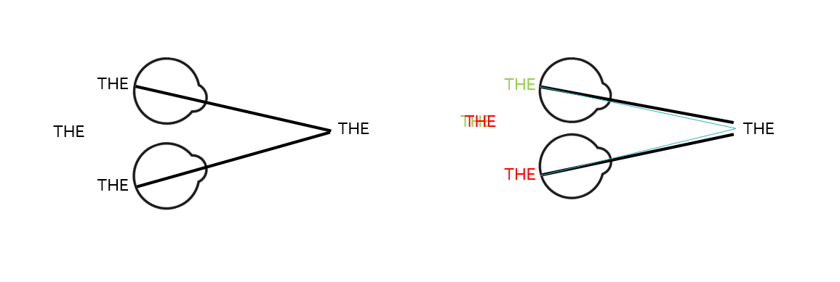
Fig 1: A misalignment of coordination between the two eyes (see right) can cause eye strain and blur
Accommodation/Focusing Dysfunction: We each have a lens inside our eyes that focuses a close object of interest on the retina to make it appear clear. Disorders of accommodation can include difficulty with the range over which we can focus (amplitude), difficulty in changing focus quickly (reduced facility) and instability of the focusing mechanism which can lead to intermittent blur. The focusing mechanism can also be prone to fatigue or low stamina. Accommodative dysfunction can be common in poor readers. An assessment will include investigation of the amplitude, facility and stability of accommodation.
Visual Stress (AKA Meares-Irlen, Scotopic Sensitivity Syndrome): This a visual/perceptual phenomenon where there is an appearance of distortion, movement, intermittent blur or other perceptual symptoms that are relieved by the use of coloured filters such as overlays or tinted lenses. The use of overlays and tints is common, however, there is significant controversy about their use and inconsistent and scant scientific evidence about the actual efficacy and the mechanism of action. One study suggested that up 95% of people who found that the use of colour improved their symptoms and ability to read have an underlying difficulty with accommodative and binocular vision skills. (Scheiman et al., 1990) Any person who is experiencing visual symptoms, especially if there is a reduction in symptoms when using a coloured filter or overlay should have their visual skills assessed. Deficits with binocular vision and accommodation will often give these symptoms and are amenable to vision therapy (see below).
Visual Magnocellular Pathway (Stein, J 2014)
The light and visual image that is seen by the eyes is sent as a signal to various part of the brain. One of the important pairs of channels is the “Magnocellular” and “Parvocellular” systems. They work in tandem to help us visually perceive and react to the world. The “Magnocellular” pathway is a very fast system that detects movement, motion and temporally sensitive changes in the environment. The “Parvocellular” is a slower-acting system that, unlike the “Magnocellular” system, allows for processing fine discrimination and detail. The “Magnocellular” system is concerned about “where” and “when” something is happening. Once a stimulus is found, the “Parvocellular” system takes over to identify the stimulus. This dual system can be highly efficient in balancing our resources in a dynamic environment. One of the functions of the “Magnocellular” system is to direct attention, control fine eye movements and detect small differences in contrast. The majority of studies have found that dyslexics are more likely to have a deficit in the “Magnocellular” pathway than non-dyslexics, along with studies showing that eye movement control and visual attention may also be impaired. There has also been some contrary evidence with some studies suggesting that this pathway is not affected in dyslexics. The opposing findings from these studies imply that we’re still learning about our understanding of the complex nature of dyslexia; there is a spectrum of neurodiversity where one individual has a “Magnocellular” deficit and another doesn’t, even though both are dyslexic.
How are the symptoms that dyslexics experience related to these visual skills? Are dyslexics more likely to have difficulties with these visual skills?
There has been a large volume of research about the influence of these visual skills on dyslexia and reading. In the same way that each dyslexic has an individual profile and there are contradictions in key indicators, there is conflicting evidence from research in this field.
A large-scale study in 2014 found only a minor increase in the incidence of abnormal visual findings in dyslexics. They suggested that 17% of dyslexic children showed some difficulty with binocular vision compared to 11% of non-dyslexics ⁶. However, this study performed only cursory investigations of the visual system and did not include reading tasks. Also, the suggestion of vision-based treatments for dyslexics was rejected even though they did not investigate if there was any improvement through these options, even for dyslexics who were exhibiting visual symptoms.
Other smaller-scale studies have investigated the visual system in more depth and have found results that show more differences in the visual system of dyslexics compared to non-dyslexics. One study found that up 64% of dyslexics showed reduced control of vergence (alignment of the two eyes at a point in space such as a book when reading) ⁴. 35% of dyslexics showed “fixational instability”, which means that their eye fixations were not stable and showed very tiny eye movements that could interfere with visual processing. These tiny movements could mean that the image appearing on the retina will be equally unstable and could give visual perceptual instability and apparent motion in text. Depending on the study you read, between 25 to 55% of dyslexics could have difficulty with focusing and accommodation ⁷.
Studies have also shown that these instabilities of binocular vision and oculomotor control are more common in dyslexics and are a correlation and a co-existing phenomenon and not a cause of dyslexia. Research and experience have also demonstrated that when dyslexics try to decode words and text, they show abnormal eye movements and binocular vision. There is an element of “searching for meaning”. Thus, it is essential to distinguish between observed difficulties of the visual system that are an effect of poor reading ability and those that contribute to the cause.
An important overarching consideration is that these visual skills are impacted by attention. As we know, there is a significant overlap between dyslexia and attention. Studies have also found a correlation between dyslexia and visual attention ⁸.
How do we identify those who need further investigation of their visual skills?
As we’ve learnt, a significant proportion of poor readers and dyslexics have visual symptoms and co-occurring difficulties with visual skills. An easy way to identify those needing further investigation is to use a questionnaire. The British Dyslexia Association has a comprehensive survey, there is a free digital version of the questionnaire at my website: https://www.centralvisionopticians.co.uk/vision-and-dyslexia-screening-tool/ which will help indicate those who need further assessment. Some of the important questions are:
- Do you have any difficulties looking at words on the page?
- Do words appear to move on the page?
- Do words ever go blurry?
- Do you ever see words appearing double?
- Do you need to use a finger to keep your position when reading?
- Do you ever skip lines or read the same line again when reading?

If any of these symptoms are present, it is important to gauge the initial onset and frequency of occurrence. Did they start recently, or many years ago? Do they happen every time they read or just once a month? Remember to be aware that some could be leading questions.
There are additional clues that you may notice. There are often excessive movements of the head when reading, children may quickly get lost on a page with lots of text, they miss (or even insert) words without realising, they may use a finger to stay on track or you may be able to observe difficulties of coordination with their eyes when they read.
Any person who finds that coloured overlays or tints improve reading speed and comfort is a candidate for needing a further assessment of their visual skills ⁵.
How can these visual skills be assessed?
If you suspect the presence of visual difficulties that could be hindering reading or progress when learning, then a referral to a specialist in vision and learning would be required. Behavioural optometrists are highly trained over several years in understanding visual skills, especially in the context of neurodevelopment and learning difficulties. They understand the impact of the visual system on the learning process and will be able to distinguish between true visual difficulties or those as a result of the underlying learning difficulty. The website of the British Behavioural Optometry Association (BABO) maintains a list of accredited members who have completed several years of training and undertake the requisite annual CPD to stay on the list: www.babo.co.uk
Other optometrists may have a special interest in vision and learning, if they are not on the BABO list, remember to check their credentials for training, experience and affiliations. Be aware that an optometrist who is not trained to assess these visual skills may find that everything is normal in the same way as asking a GP to check a dyslexic’s ability to learn.
An assessment, unlike a sight test or eye examination, consists of a comprehensive battery of validated tests to probe the limits of the visual system compared to age-matched norms, including investigations into developmental milestones, instabilities, flexibility and stamina. Hand-eye and body-eye coordination, handwriting, visual memory, visual-spatial awareness, visual processing and peripheral awareness may need to be examined because all play a part in visual function. Most findings are quantitative, but some rely on observation and qualitative assessment. Some tests are manual and others use technology such as eye tracking
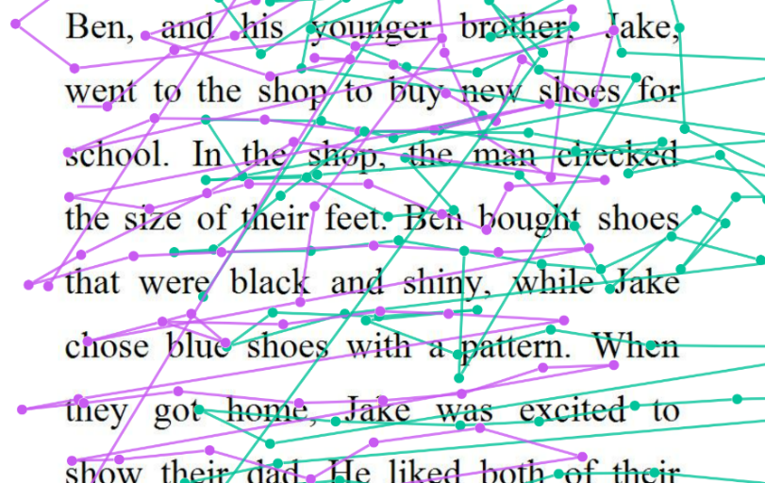
Fig 2: An assessment of eye position when reading using eye-tracking technology


Fig 3: Fusional Reserves: One of a battery of tests of Binocular Vision/Vergence

How can we help dyslexics who have co-occurring visual problems?
There are several options to help dyslexics and poor readers who have difficulties with visual skills. In many cases, a pair of reading glasses may make a huge improvement in reading speed, comfort and fluency. In my practice in 2021, I dispensed reading glasses to about half of the dyslexics I assessed. On average there was an 18% improvement in reading speed in those individuals. In some cases, the reading glasses included a prism. This is a special type of lens that has no power but can alter the visuospatial position of light entering the eye. This can make alignment and tracking easier for some people.
If certain visual skills, especially accommodation, vergence and visual tracking are below expected limits, a programme of Vision Therapy can help to resolve these. There have previously been outlandish claims that Vision Therapy can resolve almost all cases of dyslexia and improve reading skills. Vision therapy (and other methods to improve visual function) cannot treat dyslexia. However, once a deficit in visual skills has been discovered, an individualised course of exercises and therapy can improve these specific deficits, reduce symptoms and can improve success. There are several studies, in addition to a large volume of case studies, showing successes that translate to reduction, and in many cases, elimination of the visual symptoms. Disorders involving accommodation and vergence are particularly amenable to improvement through vision therapy. ^{9, 10, 11, 12}
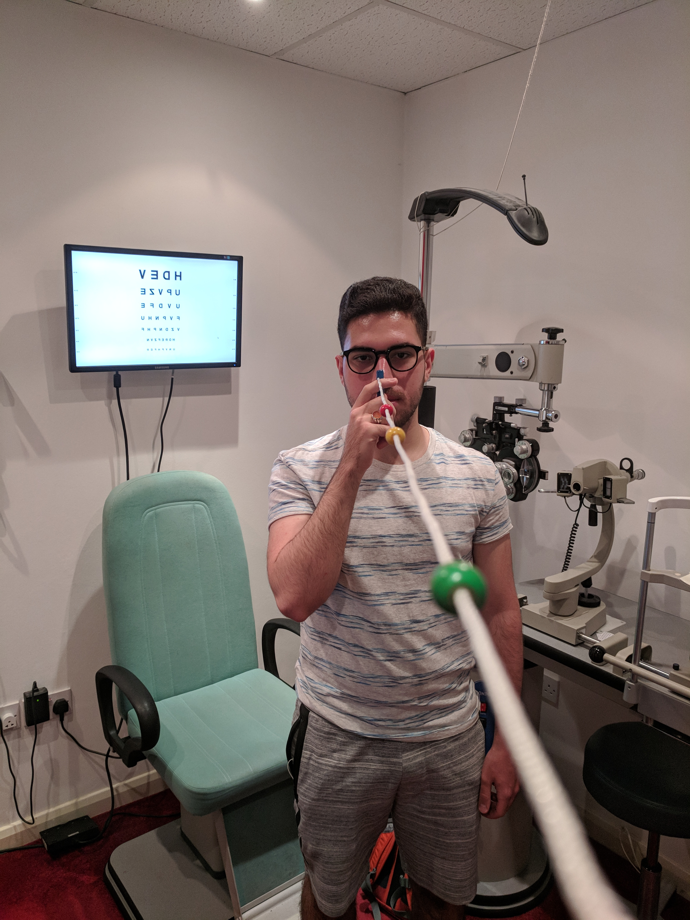
Fig 4: Vergence and Accommodative training
Computer-based games for vision therapy and training may provide a benefit to some dyslexics with visual difficulties. However, there are very few options that have been validated scientifically. Many are being used without proper research to show if results are genuine, anecdotal, accidental or just a placebo effect and translate to success in learning. Unless a child is assessed before treatment to identify the presence of difficulties with visual skills, resources and time could be better spent using alternate methods of intervention.
Tints, coloured overlays and filters: As mentioned earlier, the use of these is controversial. Whilst they can provide a substantial benefit to a small population of poor readers and dyslexics ¹³, the evidence for their use is inconclusive and their benefit is often overstated and exaggerated. In practice, in 2021, I dispensed tinted lenses to 22% of the dyslexics that I assessed and 12% of poor readers who were not dyslexic. On average there was a 19% improvement in reading speed. Research suggests the areas of concern regarding tints and colours are that there may be a placebo effect, there may be a “gender effect” to the choice of colours ¹⁴, the choice and use of tint may be inconsistent ¹⁵, there is contradictory evidence regarding claims that specific colour and depth of tint is required whilst others who claim to provide a general tint that would give a similar benefit ¹⁶.

Key points
Dyslexia is not visual in nature, but dyslexics are more likely to have a variety of co-occurring difficulties with visual function.
Watch and listen for symptoms of visual difficulties, especially intermittent blur, double vision, movement of words and text and losing position frequently. Use a suitable questionnaire for visual symptoms to identify those who require further assessment.
Build relationships with local behavioural optometrists or specialists in vision and learning.

References

Creavin, A., Lingam, R., Steer, C. & Williams, C. (2016) Ophthalmic abnormalities and reading impairment Pediatrics. 2015 Jun;135(6):1057-65.
doi: 10.1542/peds.2014-3622.
Palomo-Alvarez,C. & Puell, M.C. (2008): Accommodative function in school children with reading difficulties Graefes Archives of Clinical and Experimental Ophthalmology 2008;79:228-34
Ciuffreda KJ. (2002)The scientific basis for and efficacy of optometric vision therapy in non-strabismic accommodative and vergence disorders. Optometry 73,735-762
Elliot,D.B. & Wood, J. M. (2017) Coloured filters show gender differences and poor repeatability OPO 27
Reichle, E.D. P.Liversedge,S.P., Drieghe, D., Blythe,H.I., Joseph,S.S.L., White, S.J., & Rayner, K. (1998;1999): Using E-Z Reader to examine the concurrent development of eye-movement control and reading skill

Evans, B.J.W. & Joseph, F. (2002)The effect of coloured filters on the rate of reading in an adult student population. OPO

Fischer, B.& Hartnegg,K. (2008) Saccade control in dyslexia: development, deficits, training and transfer to reading. Optometry & Vision Development

Yeatman,J.D. (2016). What is the Role of the Visual System in Reading and Dyslexia? https://dyslexiaida.org/what-is-the-role-of-the-visual-system-in-reading-and-dyslexia/
Scheiman , M. , Blaskey, P., Ciner,E.B. , Gallaway, M. , Parisi, M., Pollack,K. and Selznick, R.(1990) : Vision characteristics of individuals identified as Irlen Filter candidates
Taran, N., Farah,R., DiFrancesco, M., Altaye, M. , Vannest, J., Holland, S., Rosch, K.., Bradley L., Schlaggar, B.L. & Horowitz-Kraus, T. (2022) The role of visual attention in dyslexia: Behavioral and neurobiological evidence

Stein, J. Dyslexia: the Role of Vision and Visual Attention. Current developmental Disorders Report 2014; 1(4): 267–280.
Raghuram, A., Gowrisankaran, S., Swanson, E., Zurakowski, D., Hunter, D. G., & Waber, D. P. (2018) Frequency of Visual Deficits in Children With Developmental Dyslexia.
Hall, R., Ray,N., Harries, P. & Stein, J. (2013) A comparison of two-coloured filter systems for treating visual reading difficulties
Stein, J.F., Riddell, P.M. & Fowler, S. (1988) Disordered vergence control in dyslexic children. Br J Ophthalmol

Sterner B., Abrahamsson, M. & Sjӧstrӧm, A. (1999) Accommodative facility training with a long-term follow-up in a sample of school-aged children showing accommodative dysfunction. Documenta Ophthalmologica Suttle CM,
Barbur, J & Conway, M.L. (2017) Coloured overlays and precision-tinted lenses: poor repeatability in a sample of adults and children diagnosed with visual stress OPO 37
Wilkins, A.J. (1995) Visual stress. Oxford: Oxford University Press
https://www.babo.co.uk accessed
https://www.centralvisionopticians.co.uk/vision-and-dyslexia-screening-tool/

