# Project – Virtual Art Gallery

## CODE –

<!DOCTYPE html>

<html>

<head>

    <title>Main Gallery</title>

</head>

<body>

    <!-- Gallery Title -->

    <h1>Virtual Art Gallery</h1>

    <p><u>Featuring 5 stunning pieces</u> from various artists and styles.</p>

    <hr>

    <!-- Artwork 1 -->

    <h2>1. Sunset Overdrive</h2>

    <img src="https://www.shutterstock.com/image-illustration/drawing-bright-sunset-sunrise-over-260nw-1048611452.jpg" alt="Sunset painting" width="300" height="200">

    <p><i>A vivid depiction of a sunset using oil paints.</i></p>

    <p><del>Originally titled 'Evening Blaze'</del></p>

    <hr>

    <!-- Artwork 2 -->

    <h2>2. Digital Dreams</h2>

    <img src="https://www.digitaldreamssystems.in/Images/About_Us1.jpeg" alt="Abstract digital art" width="300" height="200">

    <p><b>Created using Procreate and Photoshop.</b></p>

    <hr>

    <!-- Artwork 3 -->

    <h2>3. Forest Whispers</h2>

    <img src="https://www.capturelandscapes.com/wp-content/uploads/2017/07/Misty-forest-e1499694955276.jpg" alt="Photograph of a forest" width="300" height="200">

    <p>A serene photograph capturing the essence of nature.</p>

    <hr>

    <!-- Artwork 4 -->

    <h2>4. Sculpted Silence</h2>

    <img src="https://encrypted-tbn0.gstatic.com/images?q=tbn:ANd9GcQQFX9I7l4Ke0Tokd-f6EPhyAxQVQaVTlZQ3Q&s" alt="" width="300" height="200">

    <p><u>Medium:</u> Marble</p>

    <hr>

    <!-- Artwork 5 -->

    <h2>5. Urban Pulse</h2>

    <img src="https://img.freepik.com/free-vector/3d-audio-soundwave-colorful-music-pulse-oscillation-glowing-impulse-pattern_1217-3966.jpg?semt=ais_hybrid&w=740&q=80" alt="" width="300" height="200">

    <p><i>Inspired by the rhythm of city life.</i></p>

    <hr>

    <!-- Lists -->

    <h3>Gallery Rules (Ordered List)</h3>

    <ol>

        <li>Respect the artwork.</li>

        <li>No flash photography.</li>

        <li>Maintain silence.</li>

    </ol>

    <h3>Materials Used (Unordered List)</h3>

    <ul>

        <li>Oil Paint</li>

        <li>Digital Brushes</li>

        <li>Marble</li>

    </ul>

    <h3>Inspiration Sources (Nested List)</h3>

    <ul>

        <li>Nature

            <ul>

                <li>Trees</li>

                <li>Sunsets</li>

            </ul>

        </li>

        <li>Urban Life

            <ul>

                <li>Architecture</li>

                <li>Street Art</li>

            </ul>

        </li>

    </ul>

    <!-- Table -->

    <h3>Artwork Comparison</h3>

    <table border="1">

        <tr>

            <th>Artwork</th>

            <th>Medium</th>

            <th>Year</th>

        </tr>

        <tr>

            <td>Sunset Overdrive</td>

            <td>Oil Paint</td>

            <td>2022</td>

        </tr>

        <tr>

            <td>Digital Dreams</td>

            <td>Digital</td>

            <td>2023</td>

        </tr>

        <tr>

            <td>Forest Whispers</td>

            <td>Photography</td>

            <td>2021</td>

        </tr>

        <tr>

            <td>Sculpted Silence</td>

            <td>Sculpture</td>

            <td>2020</td>

        </tr>

        <tr>

            <td>Urban Pulse</td>

            <td>Acrylic</td>

            <td>2023</td>

        </tr>

    </table>

</body>

</html>

# OUTPUT—

**Welcome to the Virtual Art Gallery**

**Explore** a curated selection of *artworks* from various genres and mediums.

**Navigate to the Gallery**

Click below to enter the main gallery:

[Go to Art Gallery](http://127.0.0.1:5500/main.html)

Visit [ArtStation](https://www.artstation.com/) for more inspiration.

**Virtual Art Gallery**

Featuring 5 stunning pieces from various artists and styles.

**1. Sunset Overdrive**

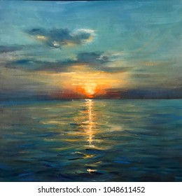

*A vivid depiction of a sunset using oil paints.*

**2. Digital Dreams**



**Created using Procreate and Photoshop.**

**3. Forest Whispers**

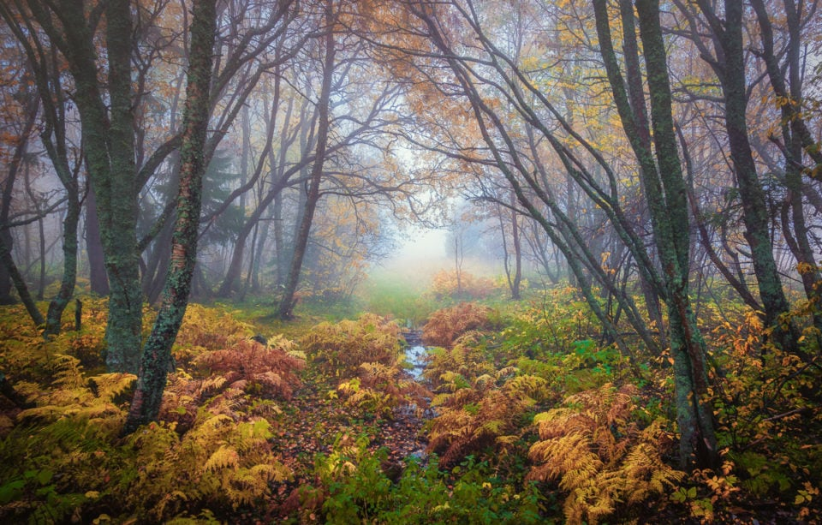

A serene photograph capturing the essence of nature.

**4. Sculpted Silence**

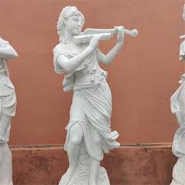

Medium: Marble

**5. Urban Pulse**

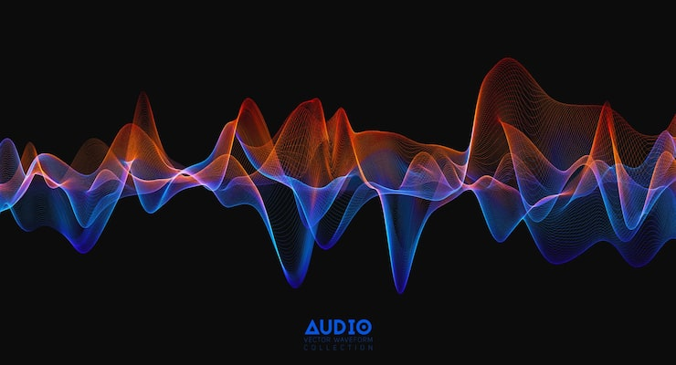

*Inspired by the rhythm of city life.*

**Gallery Rules (Ordered List)**

1. Respect the artwork.
2. No flash photography.
3. Maintain silence.

**Materials Used (Unordered List)**

* Oil Paint
* Digital Brushes
* Marble

**Inspiration Sources (Nested List)**

* Nature
  + Trees
  + Sunsets
* Urban Life
  + Architecture
  + Street Art

**Artwork Comparison**

|  |  |  |
| --- | --- | --- |
| **Artwork** | **Medium** | **Year** |
| Sunset Overdrive | Oil Paint | 2022 |
| Digital Dreams | Digital | 2023 |
| Forest Whispers | Photography | 2021 |
| Sculpted Silence | Sculpture | 2020 |
| Urban Pulse | Acrylic | 2023 |