Year: 2026-2027 Sem V-NEP
Course: ASD&D Lab
Experiment 07
Date of Performance: 22/07/2026 Date of Submission: 22/07/2026
Class:T1
Student Roll No: 2401044 StudentName:Bhavisha kewalramani

Aim: To implement monitoring using Prometheus / Grafana / Nagios.
LO mapped: LO5
LO: Implement ML lifecycle management and automated workflows using MLflow, Airflow, and monitoring tools like Prometheus/Grafana/Nagios.
Theory:
Continuous monitoring is a process to detect, report, respond all the attacks which occur in its infrastructure. Once the application is deployed into the server, the role of continuous monitoring comes in to play. The entire process is all about taking care of the company's infrastructure and respond appropriately.
Why we need Nagios Tool
Here, are the important reasons to use Nagios monitoring tool:
- Detects all types of network or server issues
- Helps you to find the root cause of the problem which allows you to get the permanent solution to the problem
- Active monitoring of your entire infrastructure and business processes
- Allows you to monitor and troubleshoot server performance issues
- Helps you to plan for infrastructure upgrades before outdated systems create failures
- You can maintain the security and availability of the service
- Automatically fix problems in a panic situation
- Nagios is the most popular, open source, powerful monitoring system for any kind of infrastructure. It enables organizations to identify and resolve IT infrastructure problems before they affect critical business processes. Nagios has the capability of monitoring applications, services and entire IT infrastructure.
- NRPE is known as Nagios Remote Plugin Executor. It is designed to execute plugins on remote systems. On Windows hosts, the equivalent remote agent is NSClient++, which listens for Nagios requests and executes local checks (disk, CPU, memory, services, etc.).
- NSClient++ runs as a Windows service on the remote host and waits for requests from the Nagios server (usually over the NRPE protocol, which NSClient++ also supports). When the Nagios server needs to check a resource on that host, it sends a command; NSClient++ executes the check locally and returns the result to Nagios.
Note on running Nagios on Windows
Nagios Core is built for Linux and does not install natively on Windows. The standard practice for a Windows machine is to run the Nagios Core server inside a Docker container (using Docker Desktop with the WSL2 backend), and to monitor Windows hosts using NSClient++, which is the Windows counterpart of NRPE. All commands below are Windows PowerShell / Command Prompt commands.

1: Pre-requisite: Install Docker Desktop
Download and install Docker Desktop for Windows and enable the WSL2 based engine. Verify the installation from PowerShell:
PS C:\Users\bhavishakd> docker --version
PS C:\Users\bhavishakd> docker version
Also make sure the WSL2 feature is enabled:
PS C:\Users\bhavishakd> wsl --install
PS C:\Users\bhavishakd> wsl --set-default-version 2

2: Pull and Run the Nagios Core Docker Image
Pull a ready-made Nagios Core image and run it as a container, mapping the web port to the host.
PS C:\Users\bhavishakd> docker pull jasonrivers/nagios:latest
PS C:\Users\bhavishakd> docker run --name nagios4 -d -p 8080:80 jasonrivers/nagios:latest
Verify the container is up and running:
PS C:\Users\bhavishakd> docker ps

3: Set the Apache/Nagios Admin Password
Set (or reset) the password for the nagiosadmin user inside the running container:
PS C:\Users\bhavishakd> docker exec -it nagios4 htpasswd -c /opt/nagios/etc/htpasswd.users nagiosadmin
Enter and confirm the password when prompted (e.g. 123456).

Access Nagios Web Interface
Access the Nagios web interface from a browser on the Windows host:
http://localhost:8080/nagios/
Prompting for Authentication Password - username: nagiosadmin
Password: 123456 (which you entered while configuration)

5: Install NSClient++ on the Windows Remote Host
On the Windows machine you want to monitor, download and silently install NSClient++ (the Windows equivalent of the NRPE agent):
PS C:\Users\bhavishakd> Invoke-WebRequest -Uri
"https://github.com/mickem/nscp/releases/latest/download/NSCP-0.5.2-x64.msi" -OutFile
"NSCP.msi"
PS C:\Users\bhavishakd> Start-Process msiexec.exe -ArgumentList '/i NSCP.msi ADDLOCAL=ALL MODULES=CheckExternalScripts,NRPEServer /qn' -Wait

6: Configure NSClient++
Edit the NSClient++ configuration file and add the Nagios server's IP address to the allowed hosts list:
PS C:\Program Files\NSClient++> notepad nsclient.ini allowed hosts=127.0.0.1,192.168.1.100
Where 192.168.1.100 is your Nagios server (Docker host) IP address.
After saving the file, restart the NSClient++ service so the change takes effect:
PS C:\Users\bhavishakd> Restart-Service nscp

7: Verify Connectivity from Nagios
From the Nagios server (inside the Docker container), run the NRPE check against the Windows remote host to confirm connectivity. Here 192.168.1.50 is the remote Windows host's IP address.
PS C:\Users\bhavishakd> docker exec -it nagios4 /opt/nagios/libexec/check_nrpe -H 192.168.1.50 NRPE v2.15

8: Add the Windows Host in Nagios
Create a configuration file for the new host inside the Nagios container. We also define a service that continuously checks whether the host is reachable (PING check).
PS C:\Users\bhavishakd> docker exec -it nagios4 sh -c "vi /opt/nagios/etc/servers/MyWindowsHost001.cfg" define host { use windows-server host_name Windows_Host_001 alias Windows Host 001 address 192.168.1.50 register 1
} define service{ host_name Windows_Host_001 service_description PING check_command check_ping!100.0,20%!500.0,60%
max_check_attempts 2 check_interval 2 retry_interval 2 check_period 24x7 check_freshness 1 contact_groups admins notification_interval 2 notification_period 24x7 notifications_enabled 1
register 1 }
Verify the configuration file for errors, then restart the Nagios container so the changes take effect:
PS C:\Users\bhavishakd> docker exec -it nagios4 /opt/nagios/bin/nagios -v /opt/nagios/etc/nagios.cfg PS C:\Users\bhavishakd> docker restart nagios4

9: Check Host in Nagios Web Interface
Open the Nagios web interface (http://localhost:8080/nagios/) and check that the new Windows host has been added and is being monitored under Current Status -> Hosts.

Output:
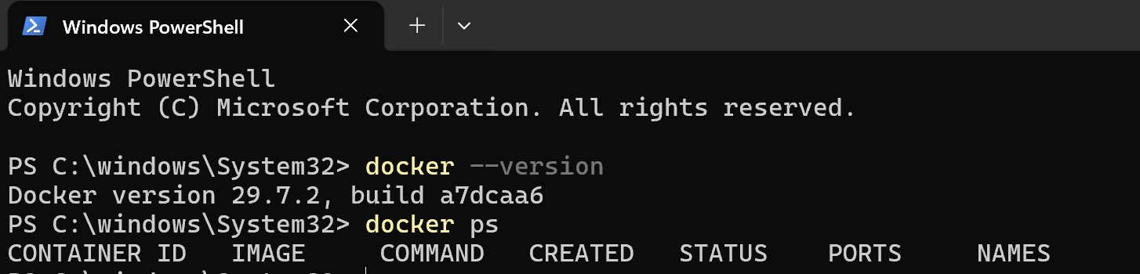
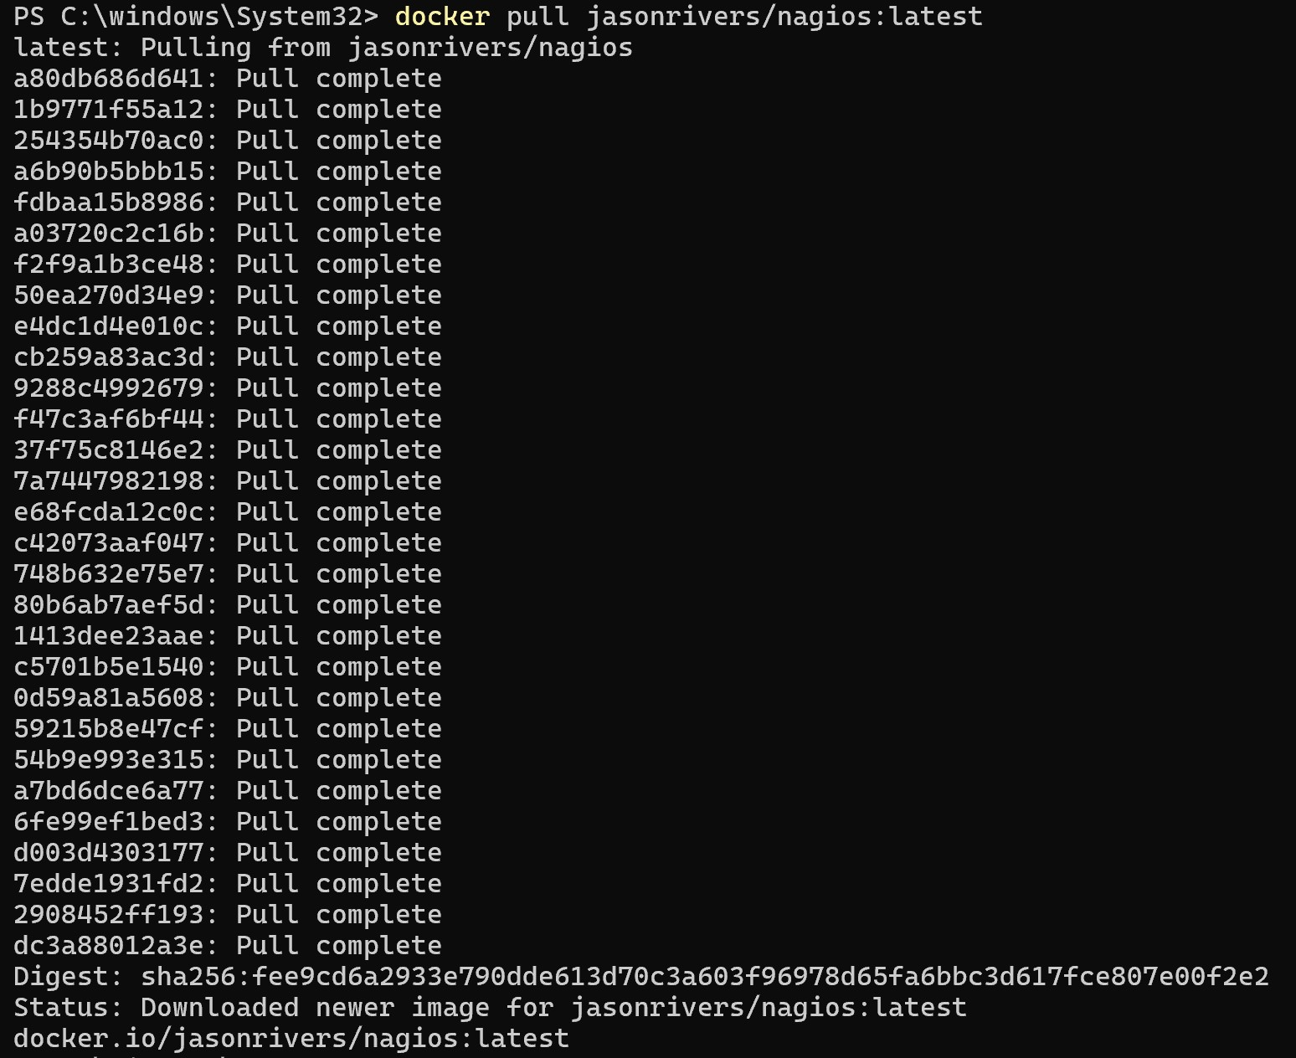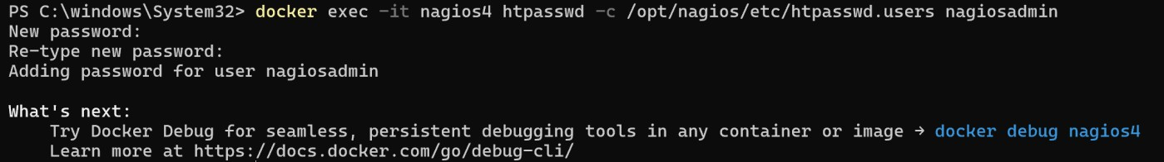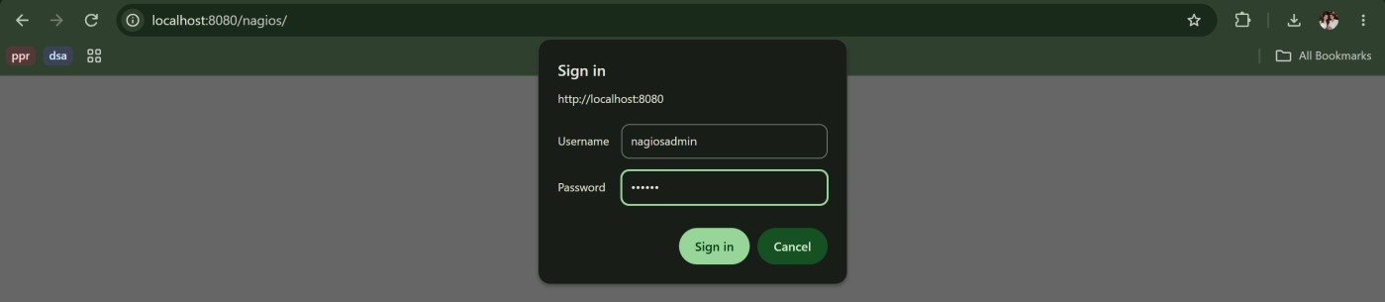
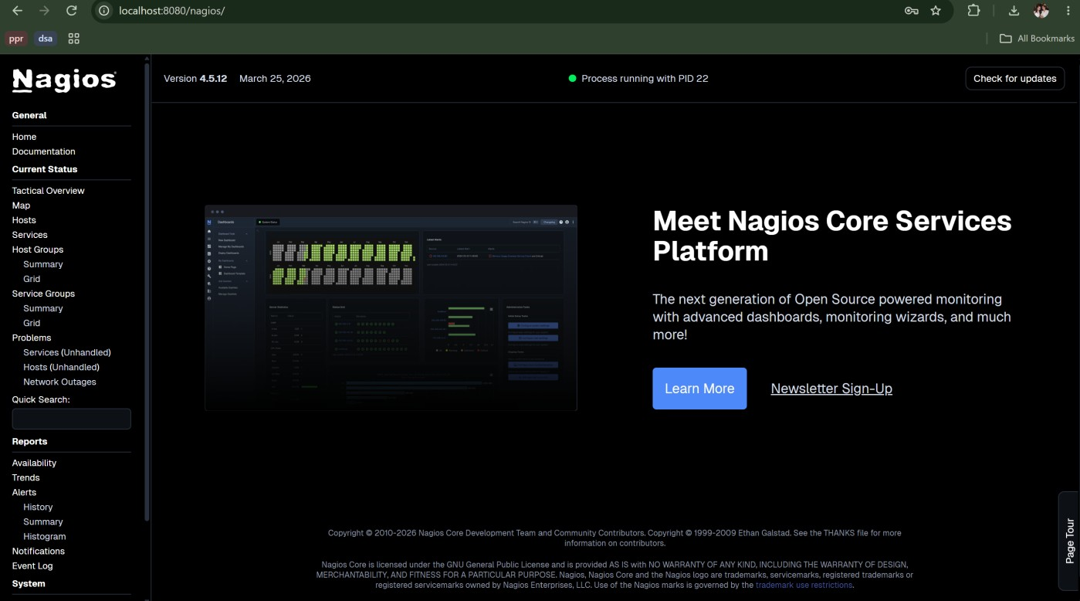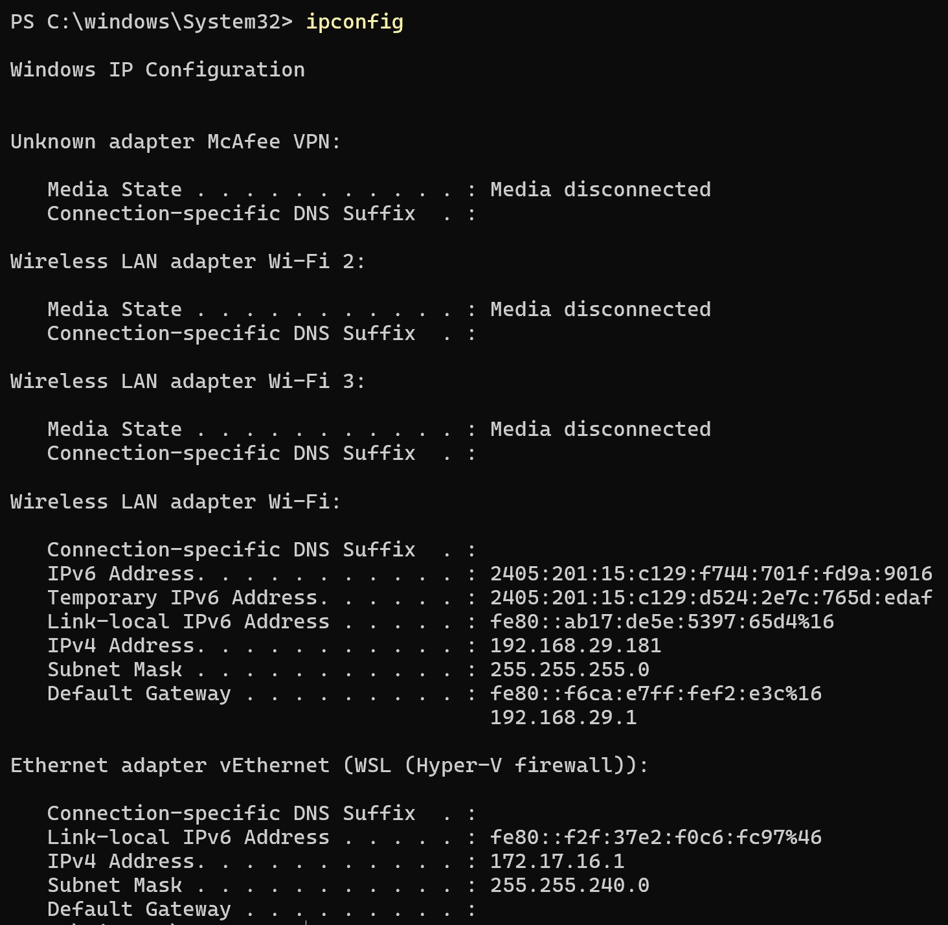

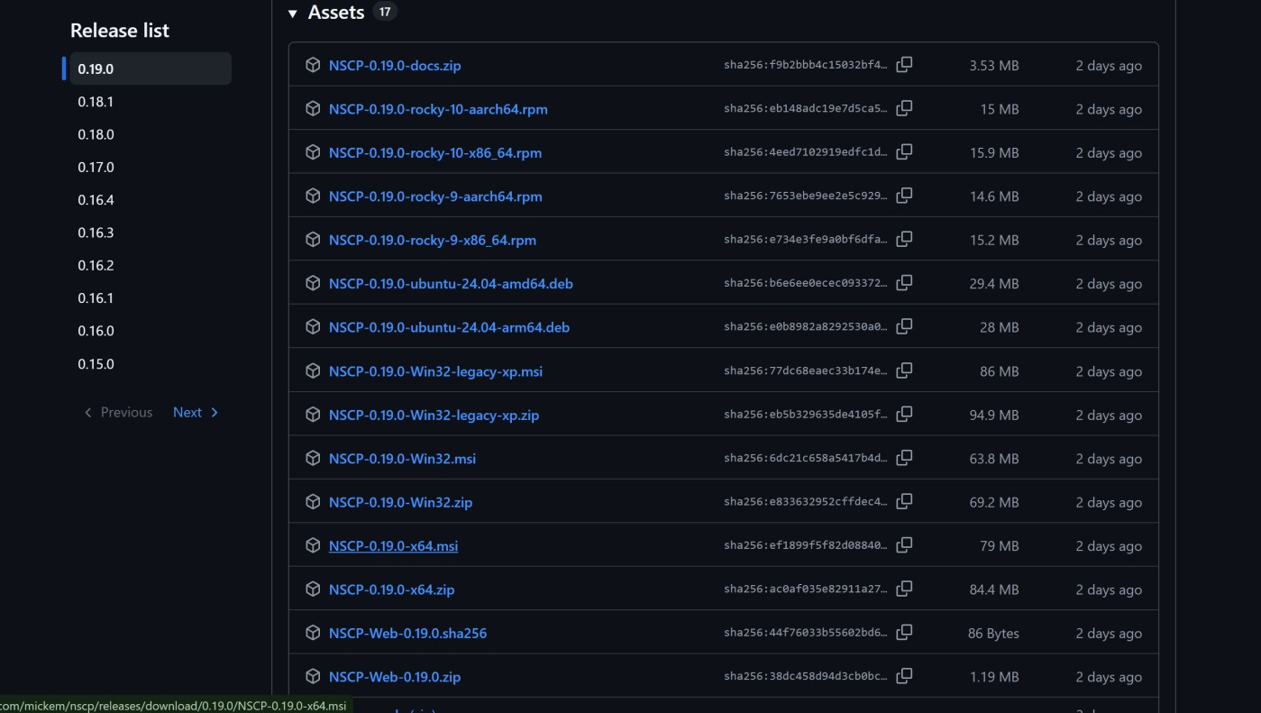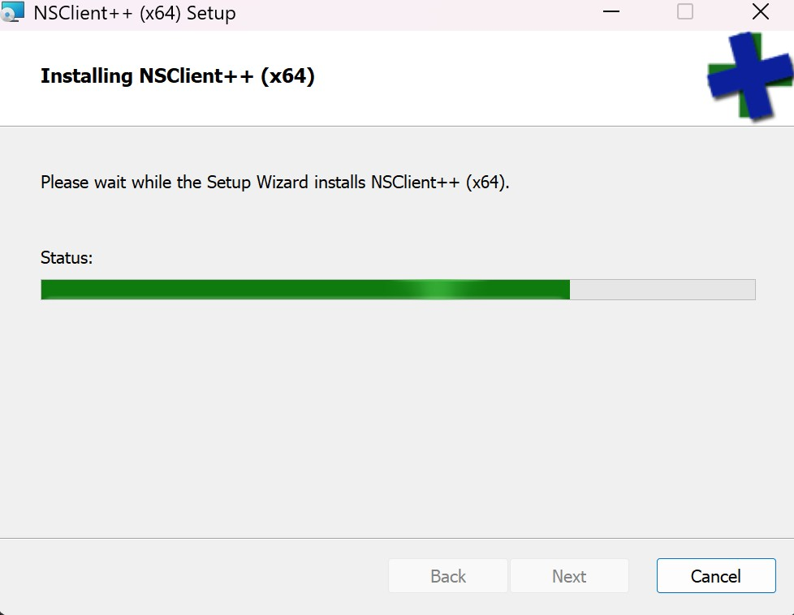

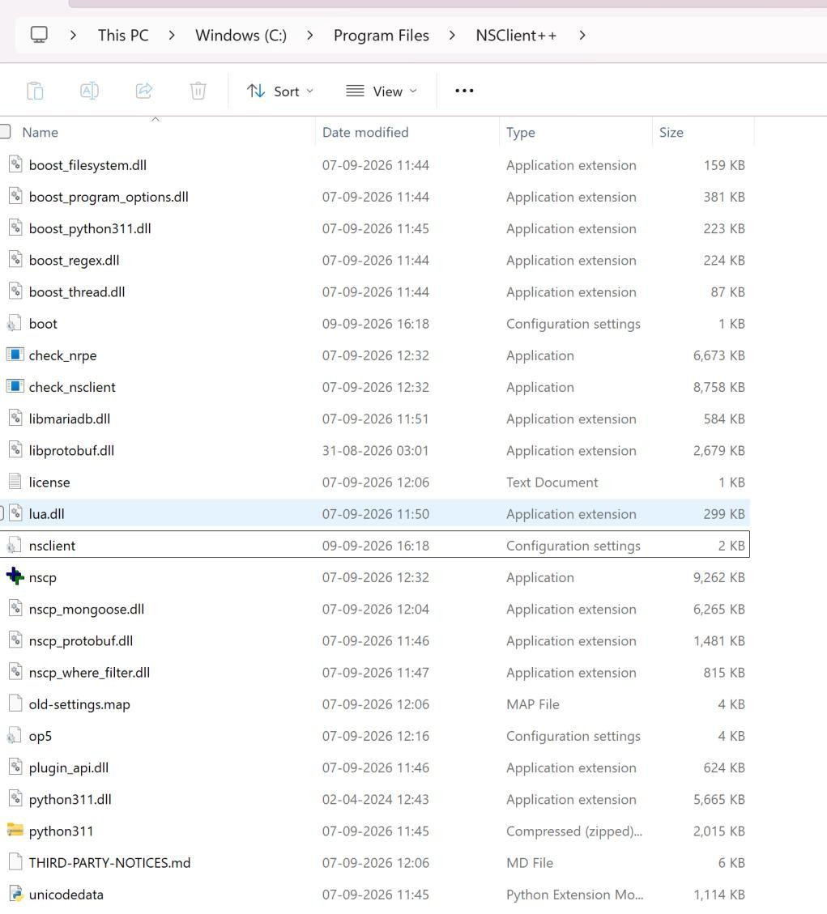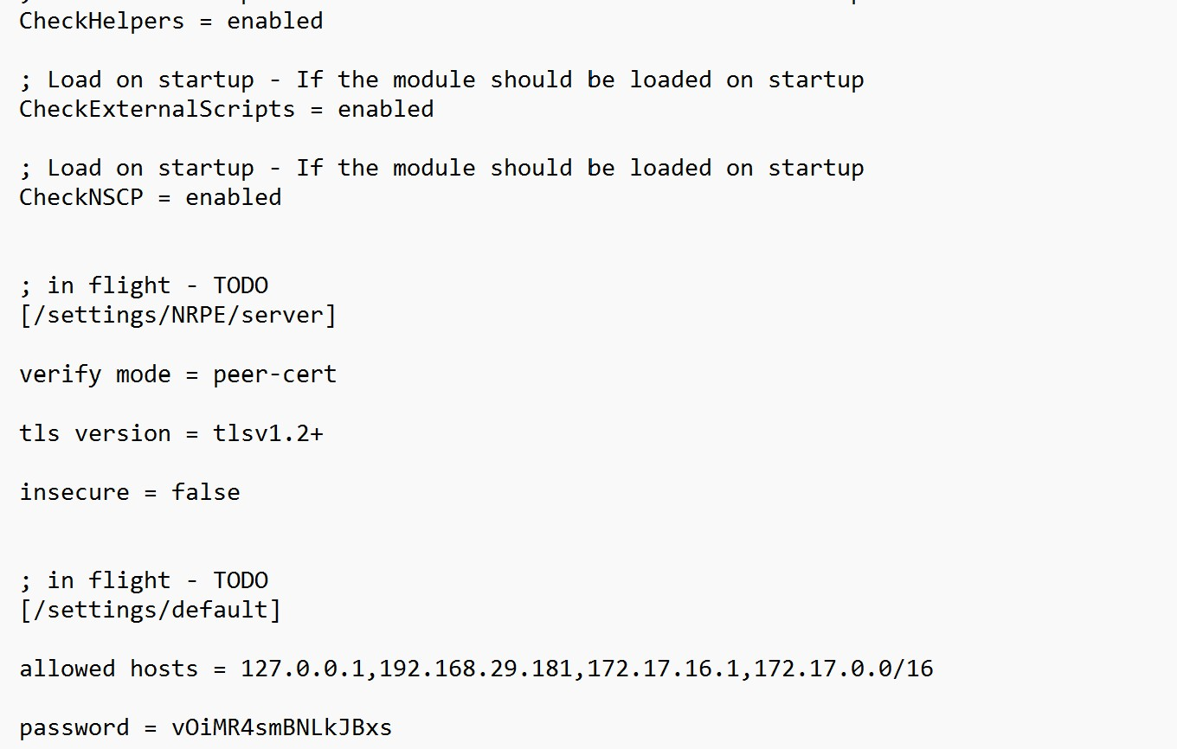

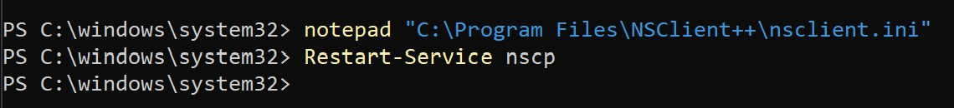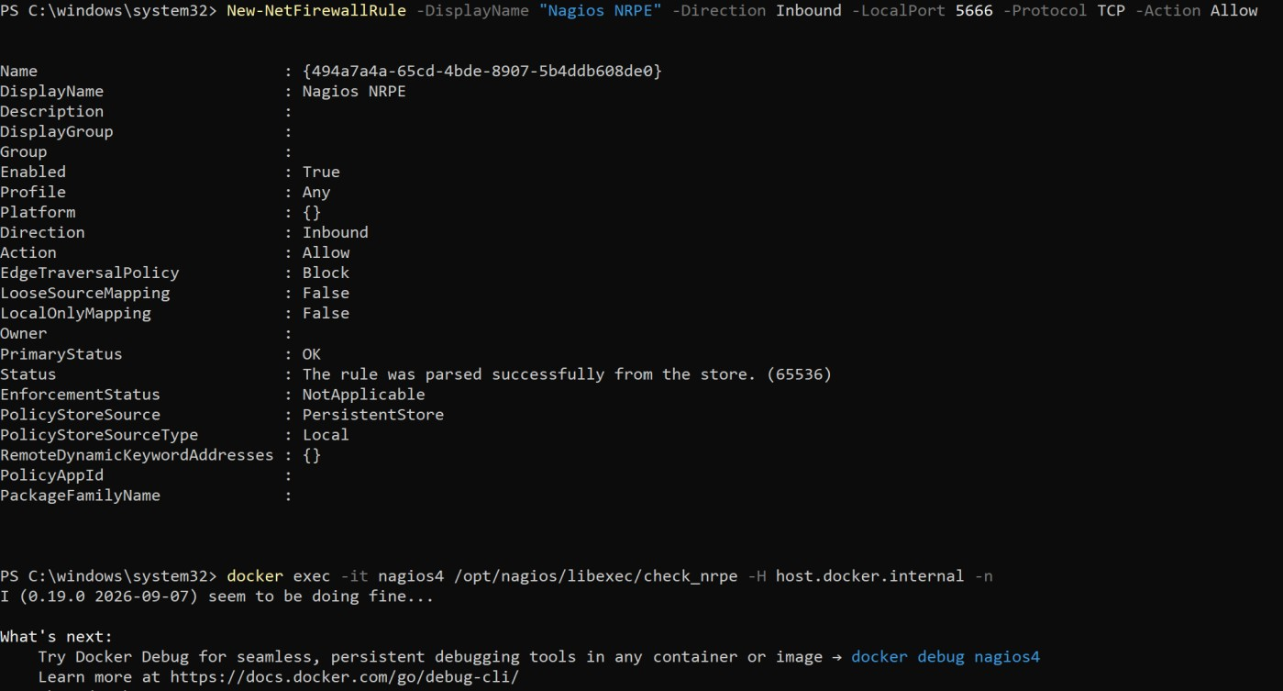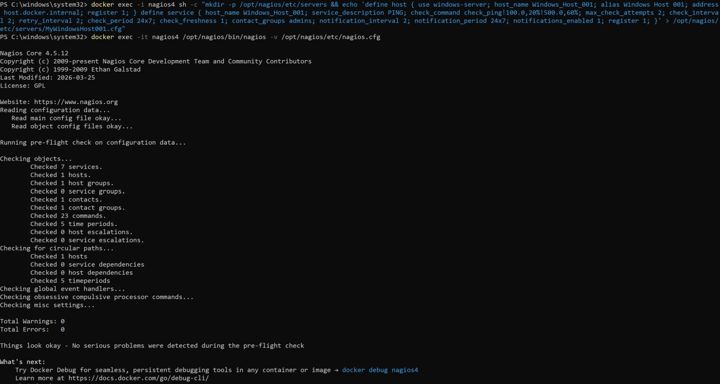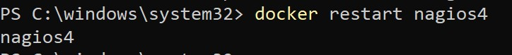

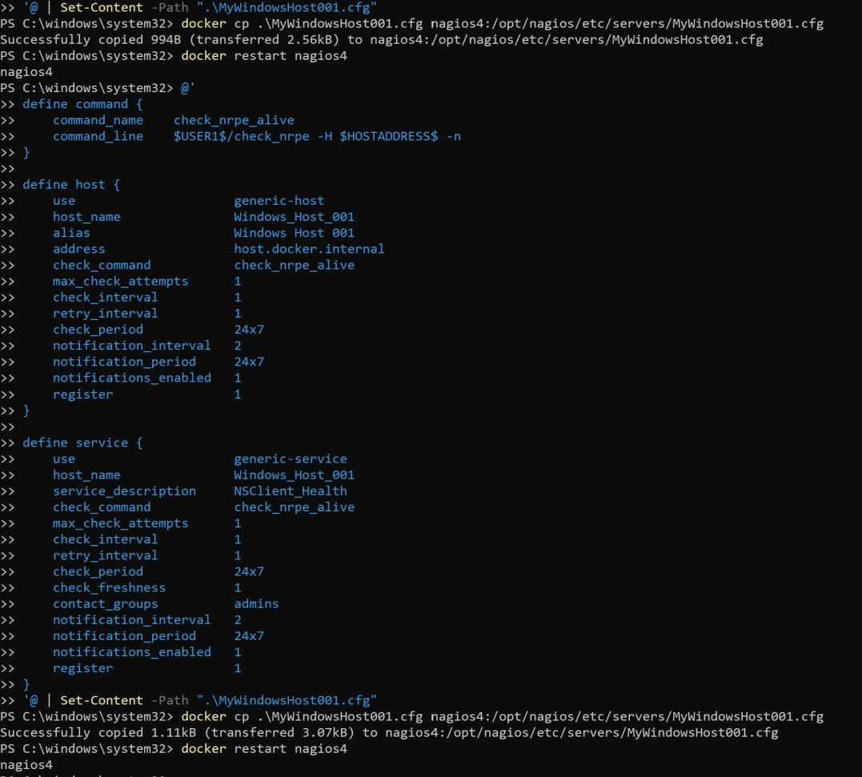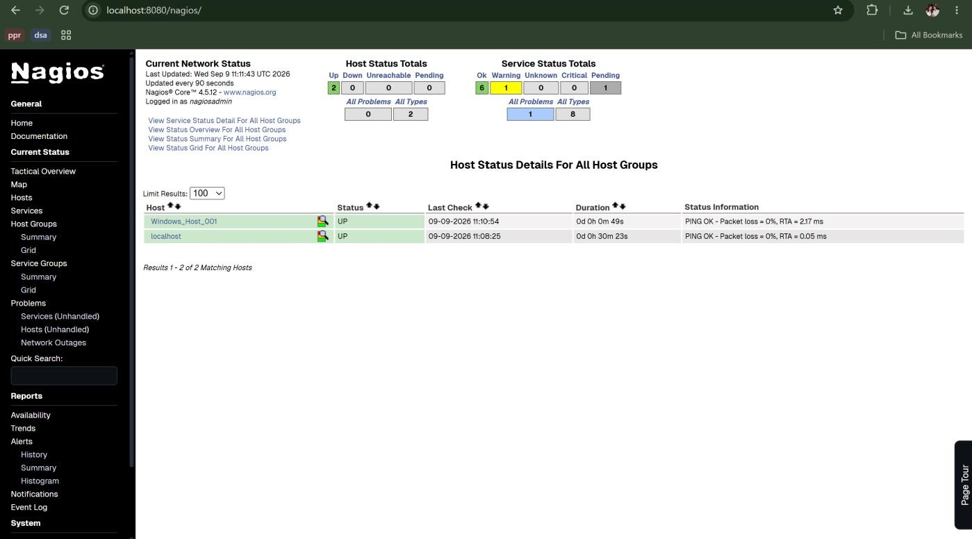

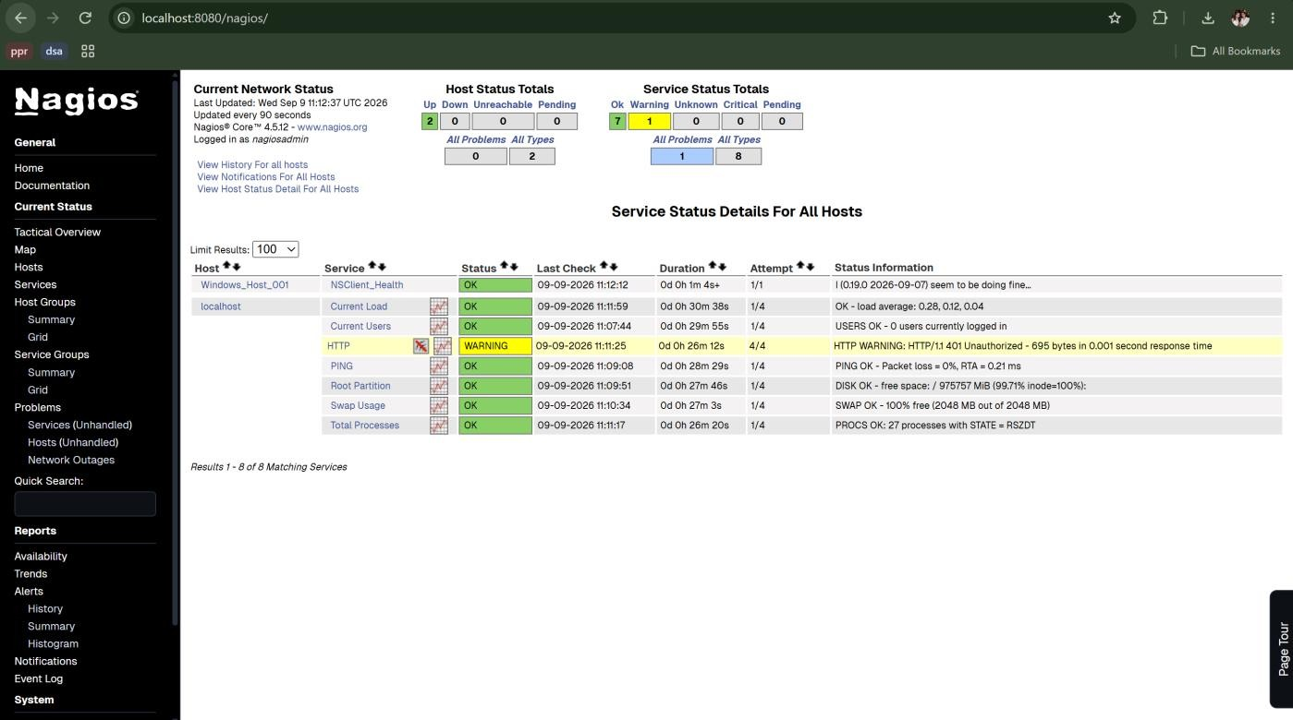
Conclusion:
In this experiment, continuous infrastructure monitoring was implemented using Nagios Core and NSClient++. Nagios Core was successfully containerized using Docker on Windows via WSL2, bypassing native operating system constraints. Communication across the container-to-host boundary was established over the NRPE protocol on port 5666. Using custom host and service definitions, remote Windows host health metrics were gathered and verified in real time on the Nagios web dashboard, demonstrating how centralized monitoring provides proactive fault detection and system visibility.
LO 5 mapped successfully.

