ClinicalView - Patient Information Portal
Prepared by: Bhavishya Venna
Assessment: Clinical Systems Analyst (R2657612), Stanford Health Care
Note: All patients, medications, allergies and documents shown in this document are made up for the demo. No real patient data was used.

Overview
ClinicalView is a web application where a user can sign in, search for a patient and view the patient’s information in one place. It was built with ASP.NET Core 8 (C#), Razor Pages, a SQLite database and Google sign-in.
Main features:
  - Sign in with Google or with a local account
  - Search patients by MRN, date of birth, first name or last name
  - View demographics, allergies, alerts and medications
  - View and download patient documents (PDF, images, Word files)
  - Print the patient summary to a PDF file
  - Works on desktop and mobile screens
  - APIs for search, demographics, allergies, alerts and medications

Sign In
The user has to sign in before seeing any patient information. There are two options: Sign in with Google, or sign in with an email and password. A demo account is shown on the page for testing.

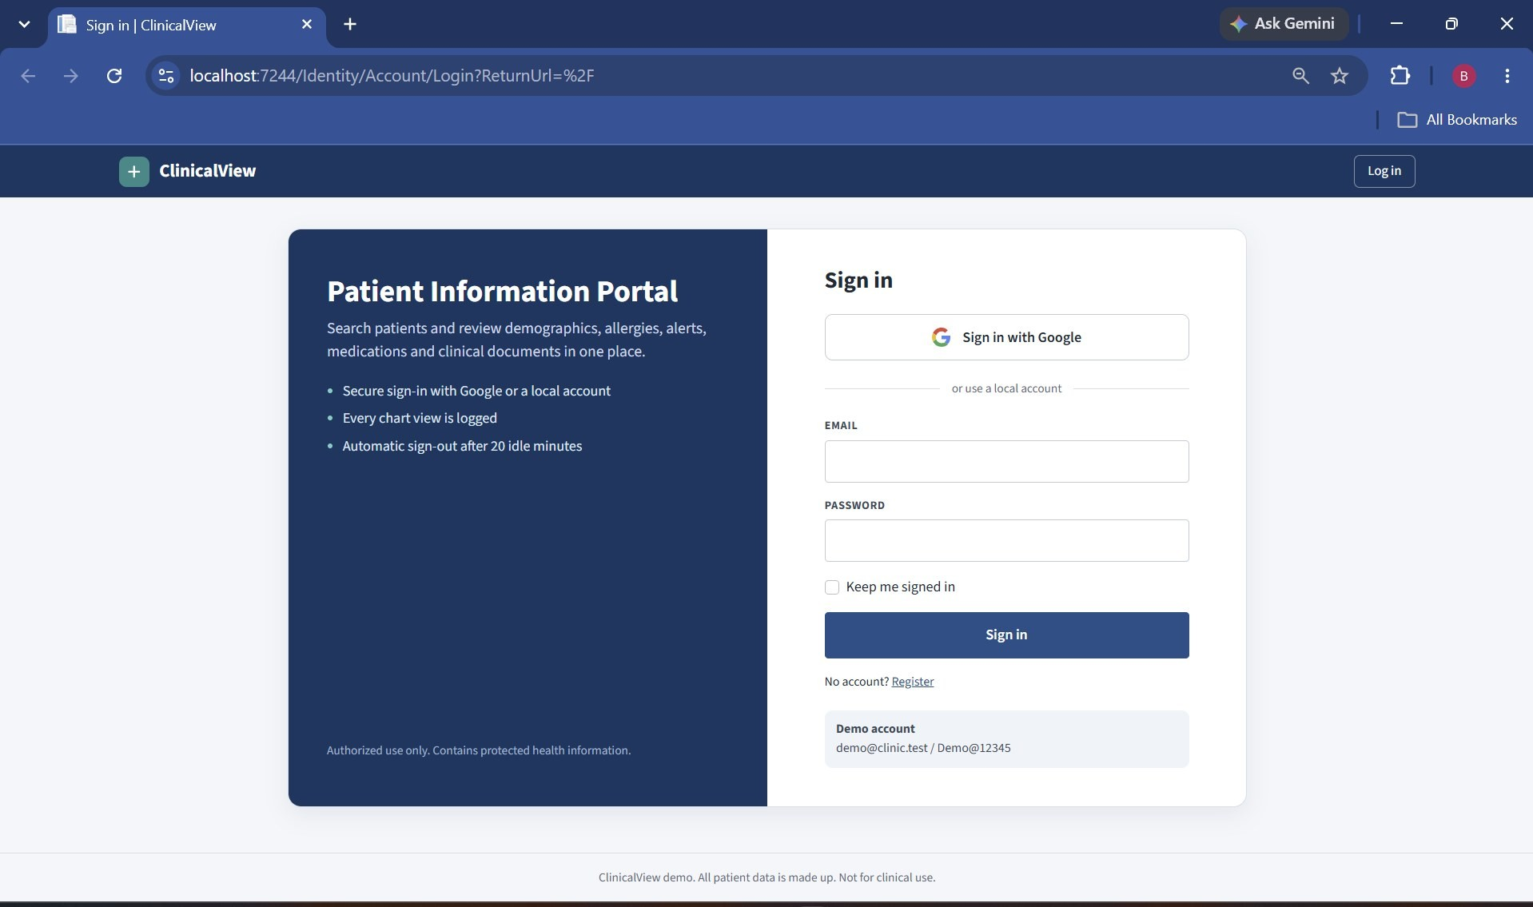
Sign in page

When the user clicks "Sign in with Google", Google asks which account to use and then asks to confirm.
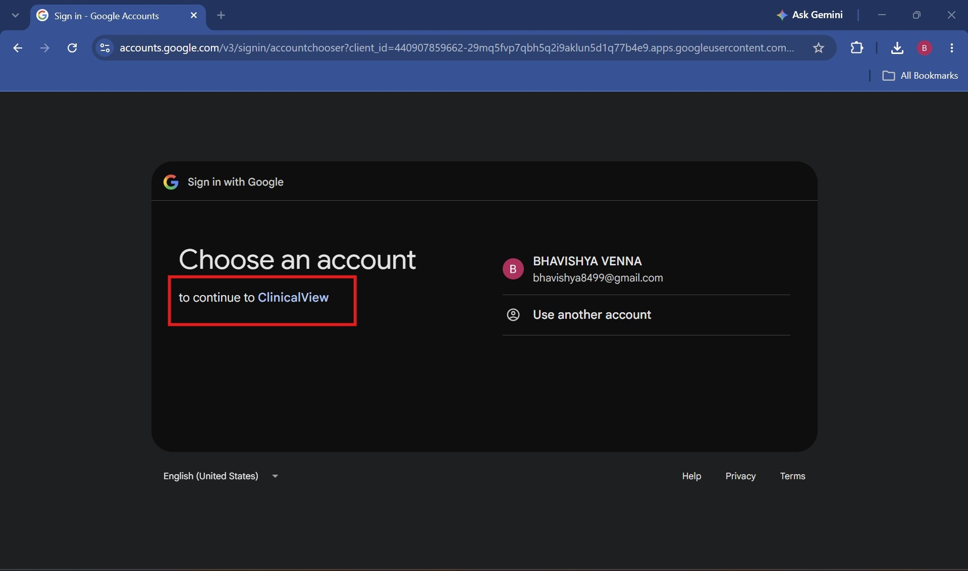
Google account selection for ClinicalView
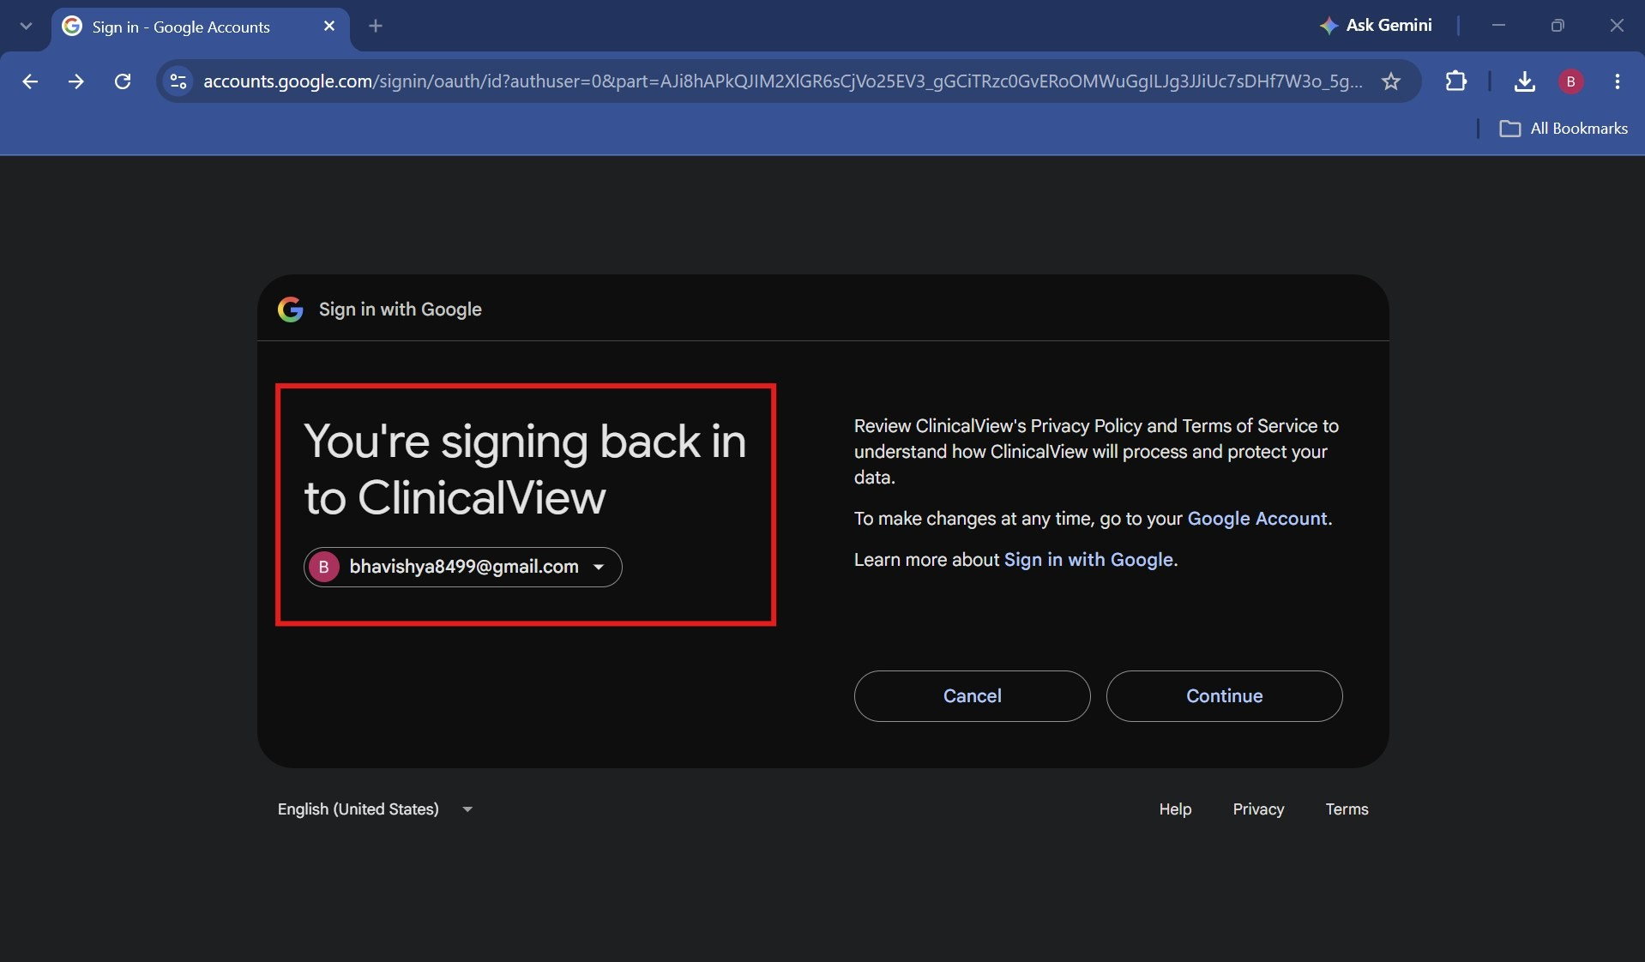
Google confirmation screen

After signing in, the user lands on the Patient Search page. The signed-in email is shown on the top right with a Log out button. The session also ends automatically after 20 minutes of no activity.
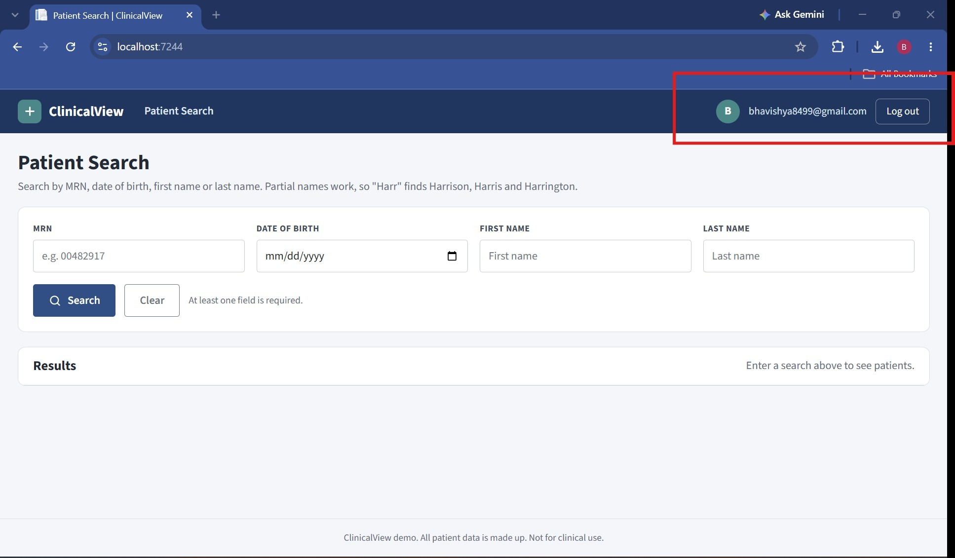
Signed in with a Google account

Patient Search
The user can search by MRN, date of birth, first name or last name. At least one field is needed. Partial names work, so typing "Harr" finds all patients whose last name starts with Harr.

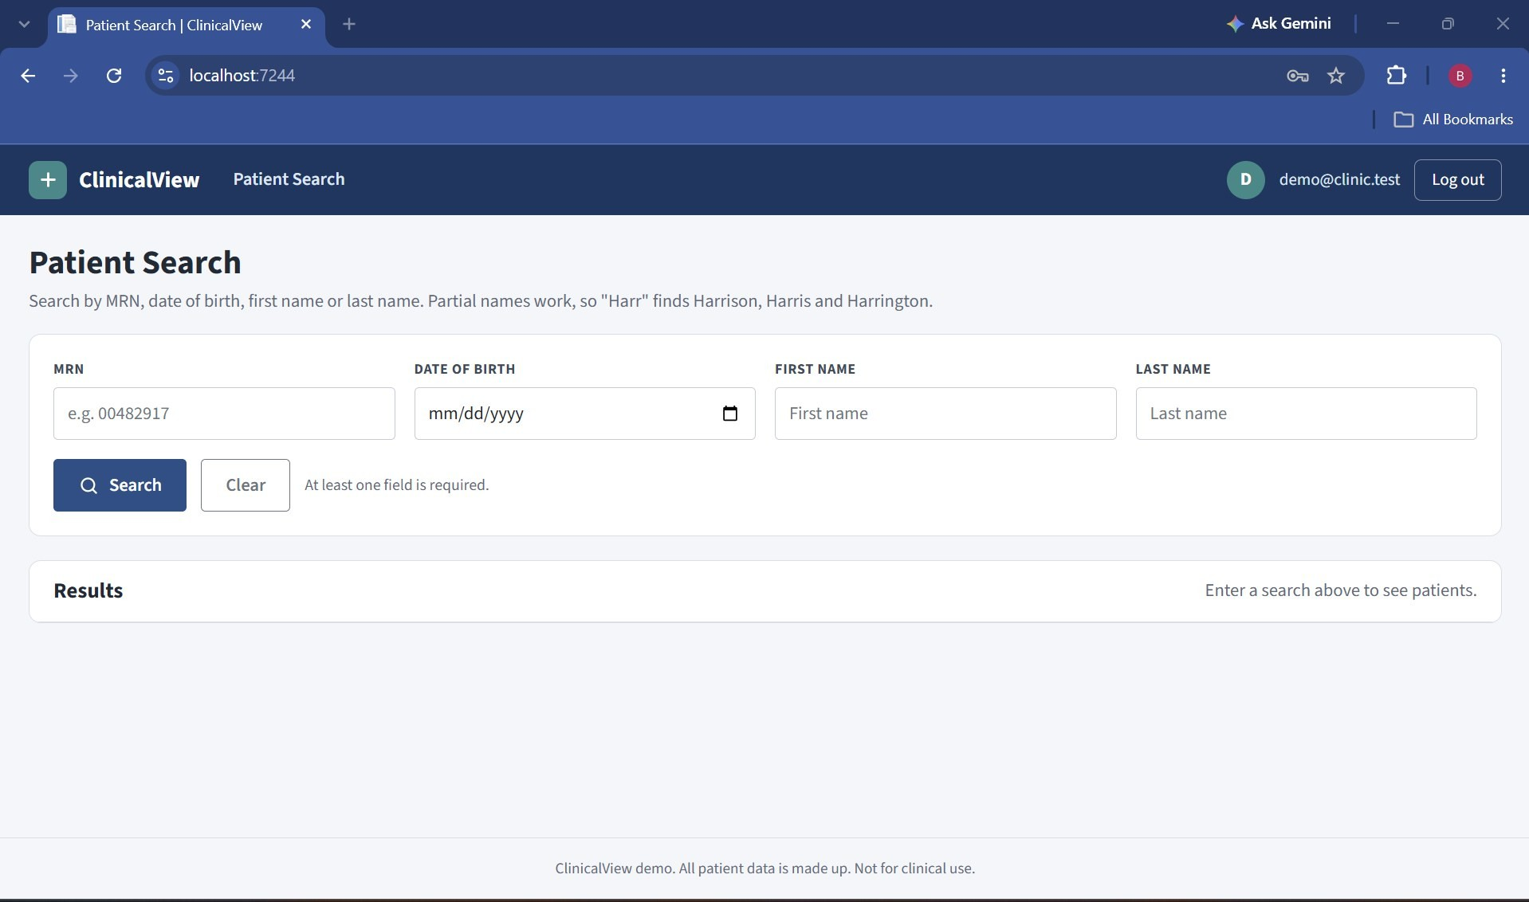
Patient Search page

If the user clicks Search without entering anything, a message is shown asking for at least one value.
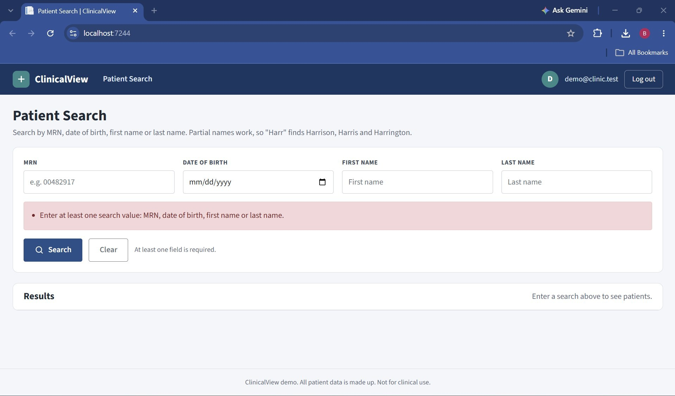
Message shown when all search fields are empty

The results show the patient name, MRN, date of birth with age, sex, phone and city. Clicking "Open chart" opens the patient’s chart.
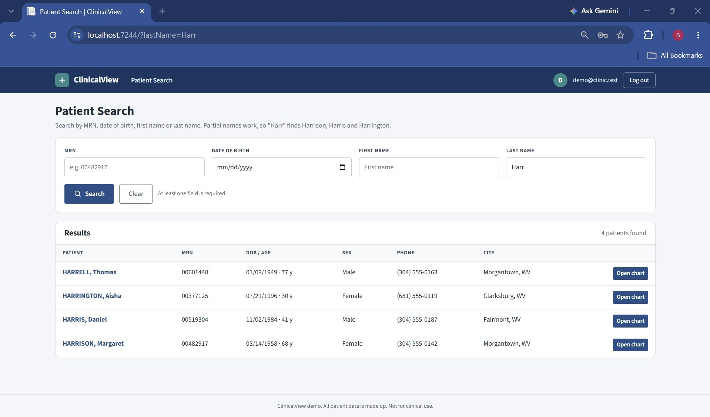
Search results for last name "Harr"

Patient Chart
The top of the chart shows the patient banner with name, age, date of birth, MRN and phone number. Active allergies are shown in red and alerts are shown next to them, so they are always visible. The menu on the left goes to each section of the chart.
The Demographics section shows the legal name, MRN, date of birth, gender, phone and address. The "Print to PDF" button downloads a PDF summary of the demographics, allergies, alerts and medications.

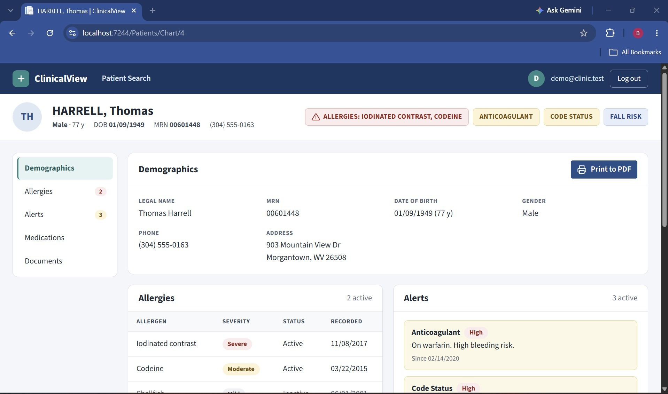
Patient banner and demographics

Allergies show the severity (Severe, Moderate, Mild) and status. Inactive allergies are shown in gray. Alerts show the type, severity, a short note and the date it was added.
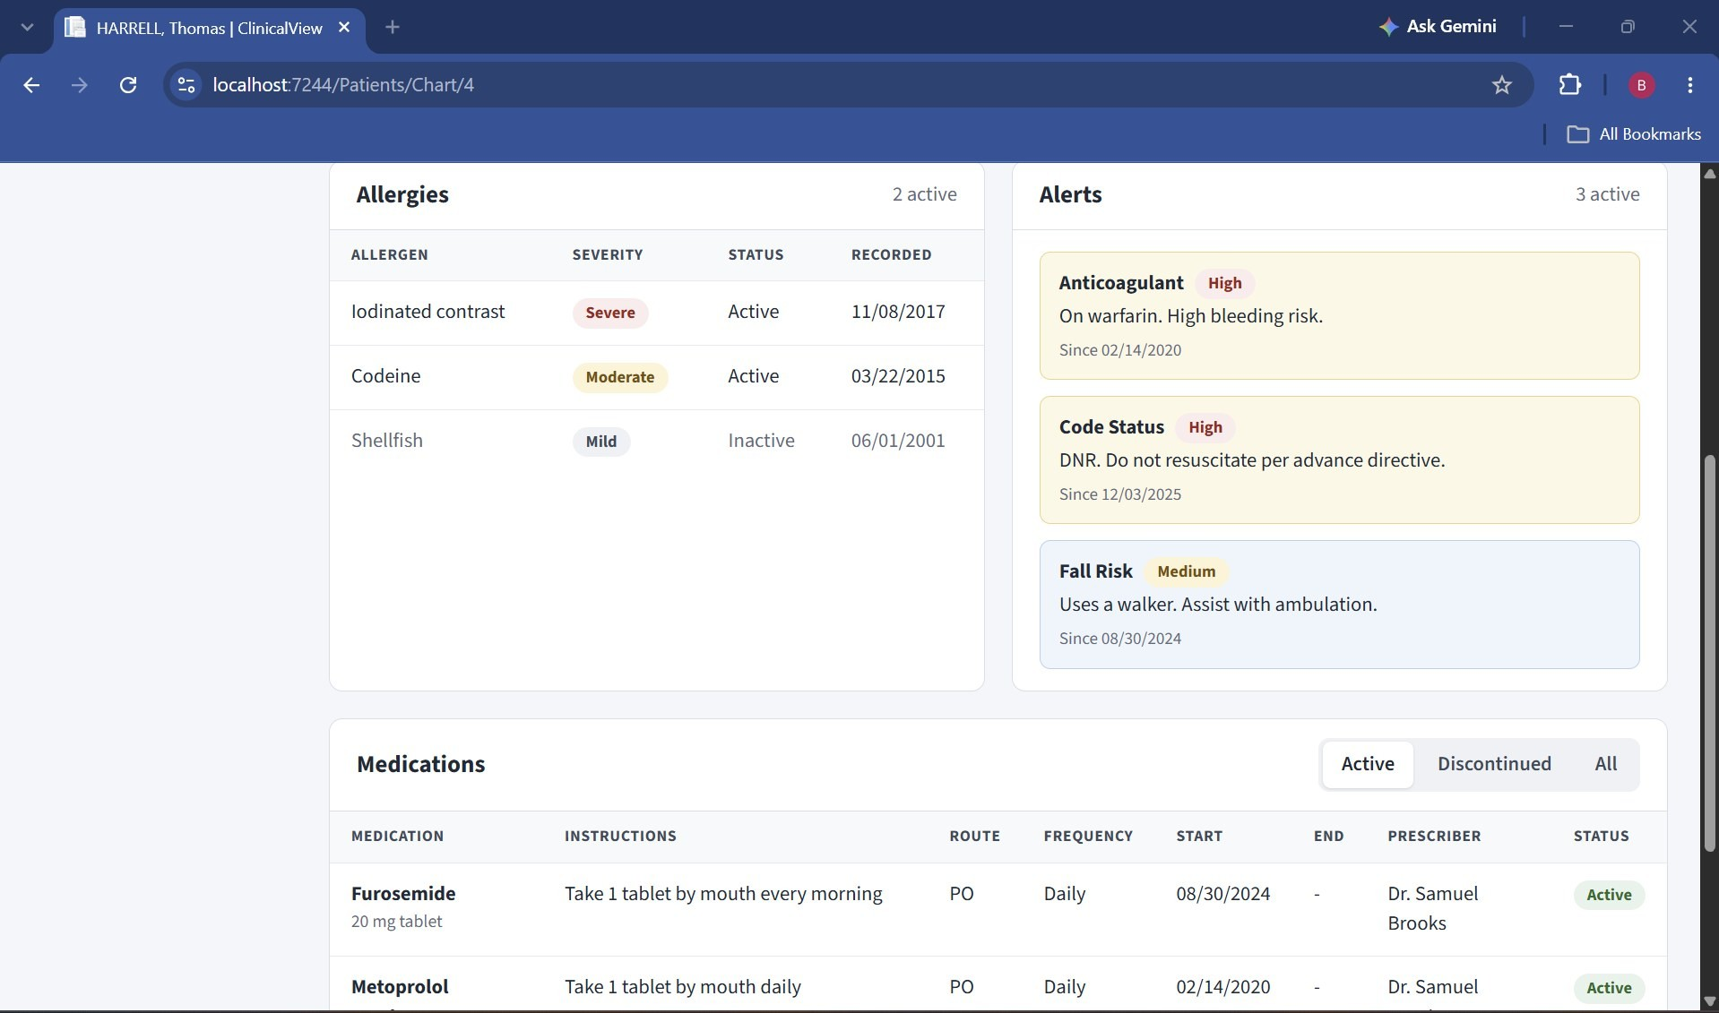
Allergies and alerts

Medications open on the Active tab. The user can switch to Discontinued or All. Each row shows the medication, strength, instructions, route, frequency, start and end date, prescriber and status.
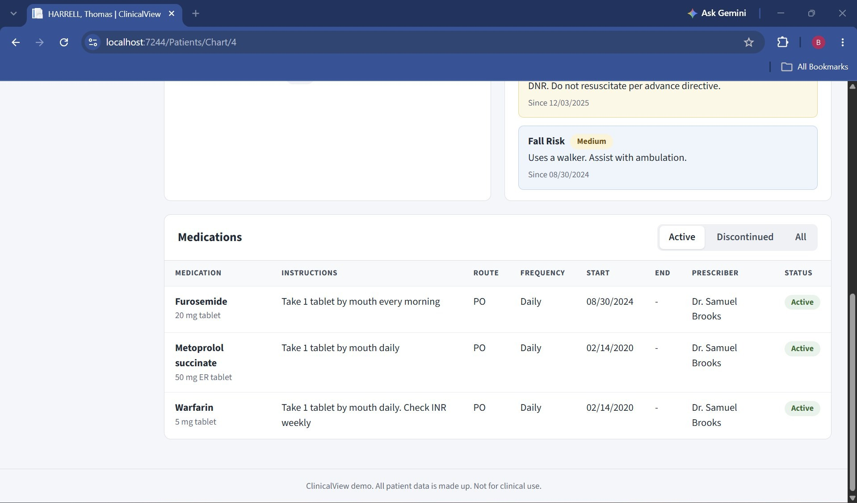
Active medications
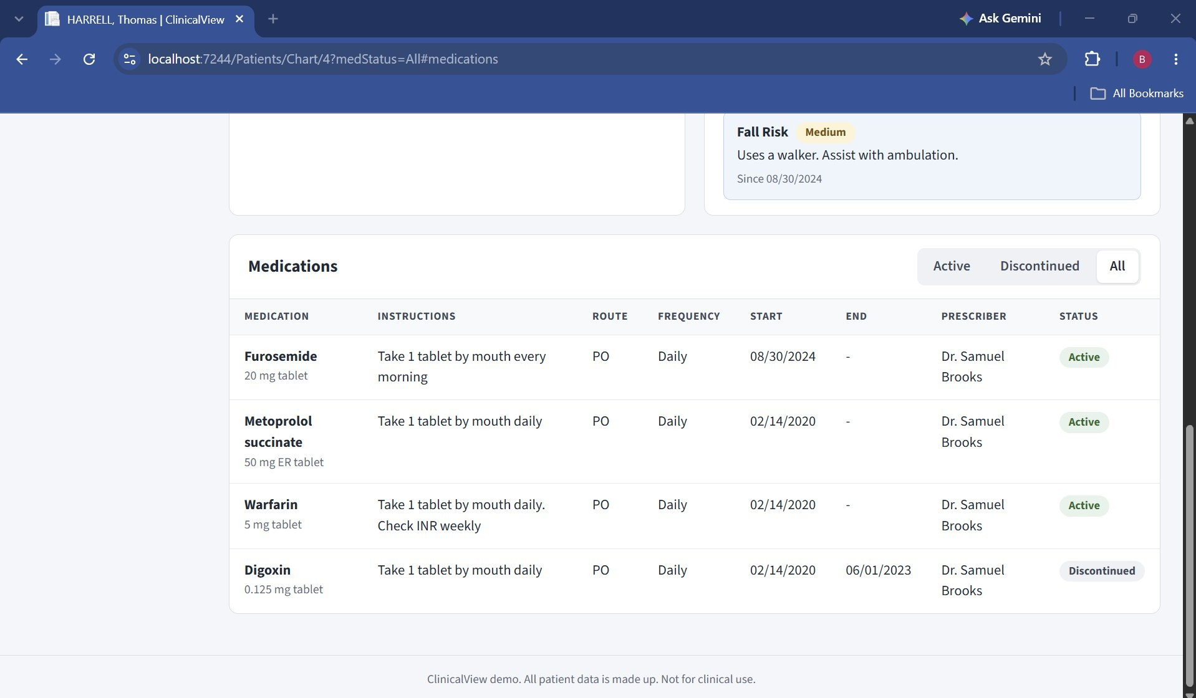
All medications, including the discontinued one (Digoxin)

Documents
The Documents page lists the patient’s files with the type, name, category, document date and upload date. PDFs and images can be opened with "View". Word files cannot be shown in the browser, so they only have a Download button.
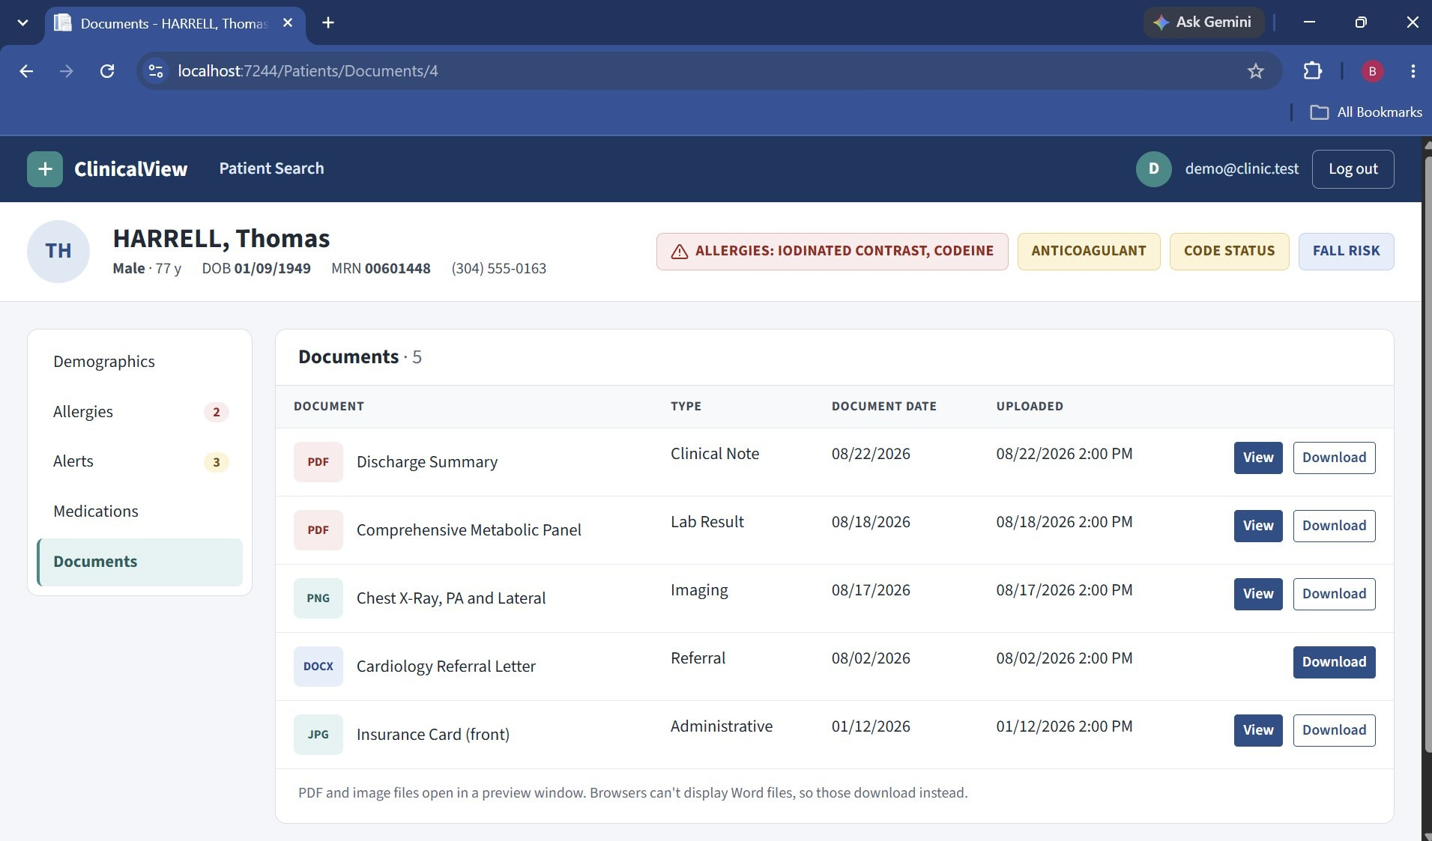
Documents list

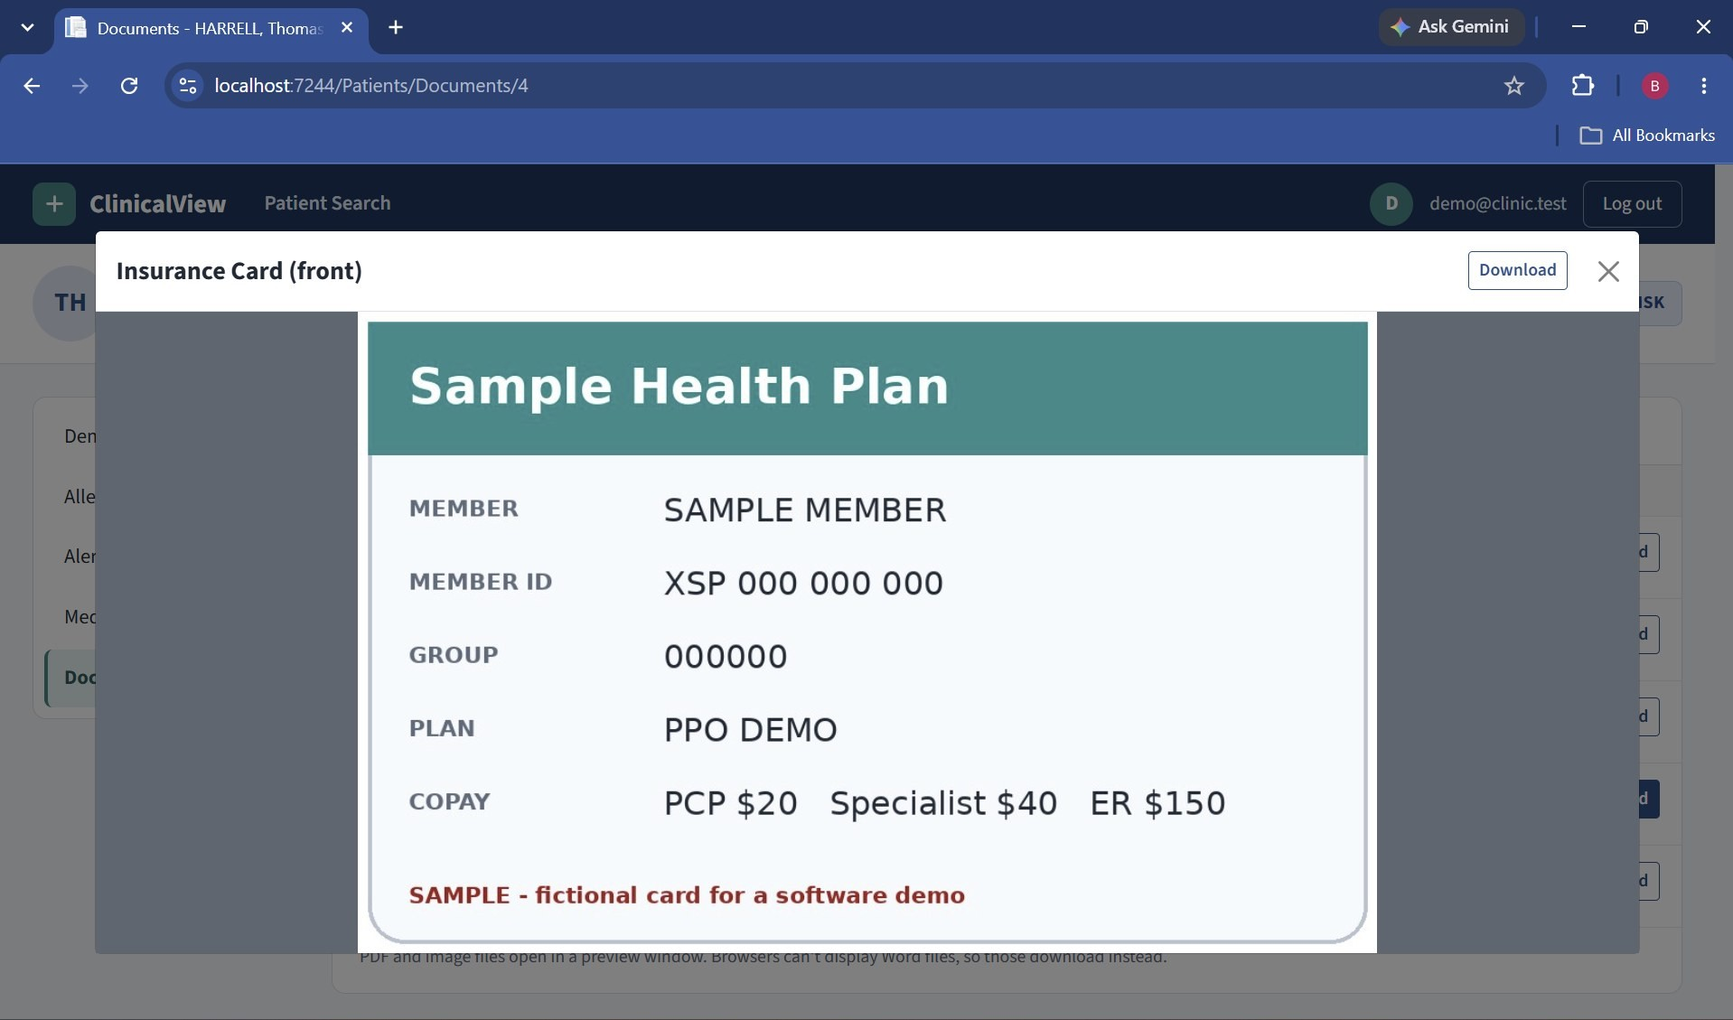
Viewing an image document (sample insurance card)

Any document can be downloaded with the Download button.
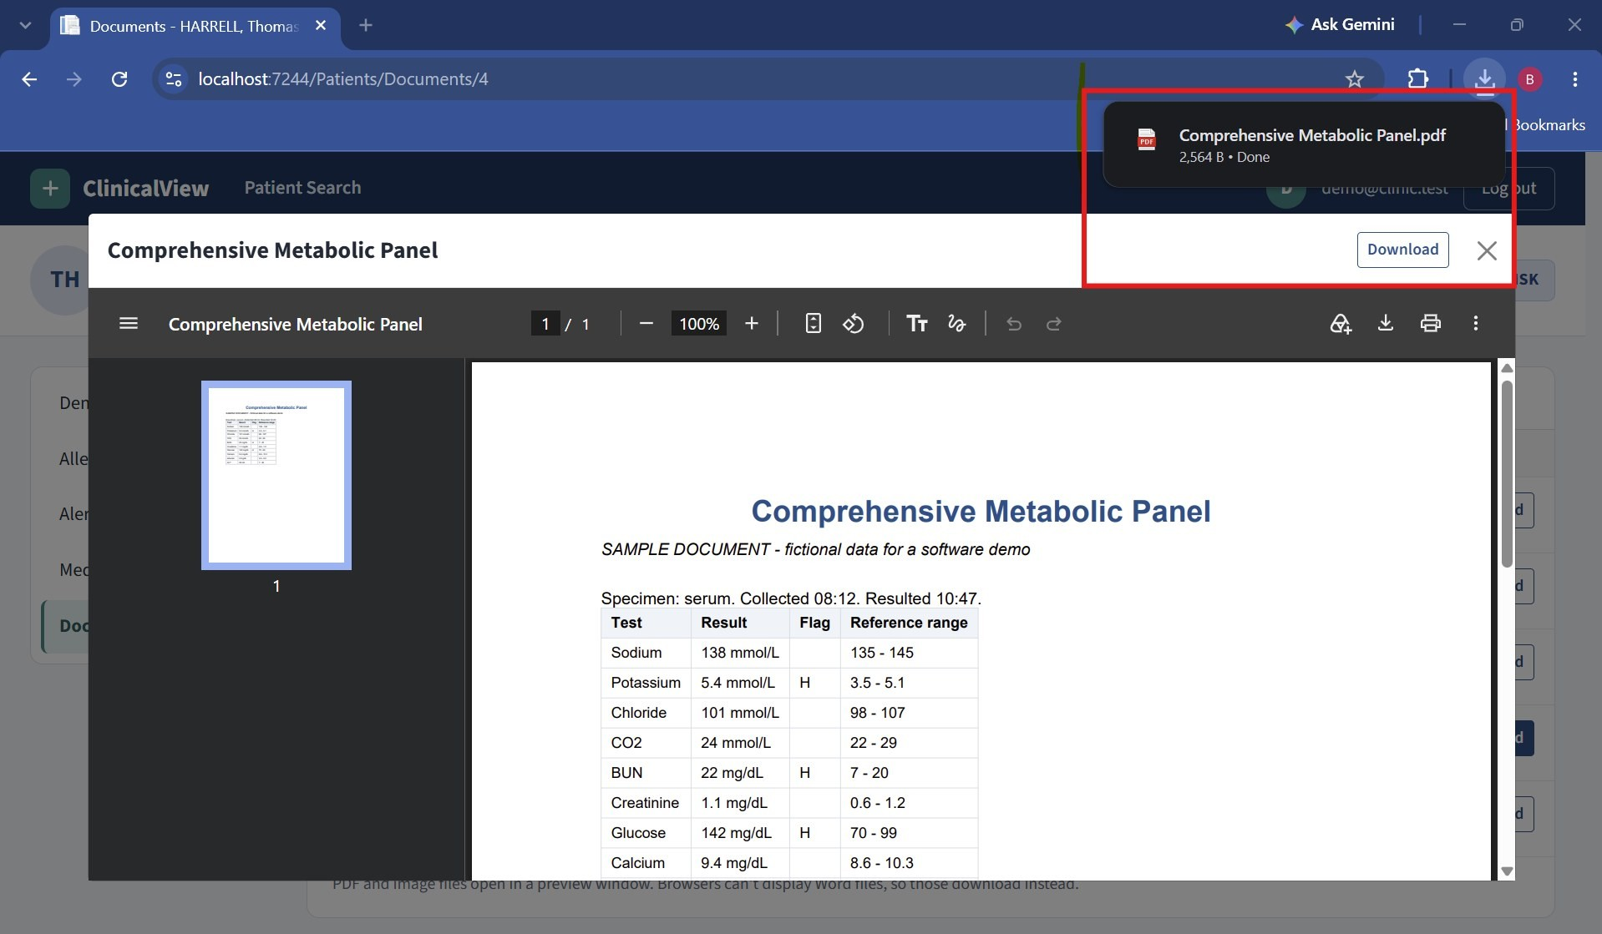
Viewing and downloading a lab result PDF

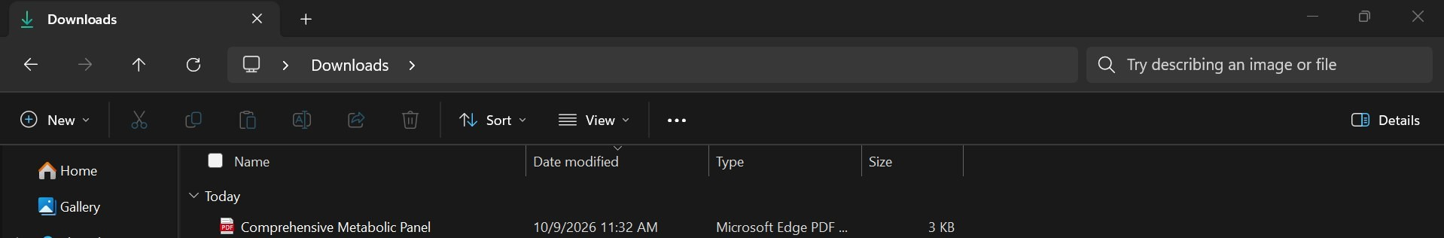
Screenshot 15: Downloaded file in the Downloads folder

Mobile View
The application adjusts to smaller screens. On a phone, the fields stack one under another and the chart menu becomes tabs at the top. This was tested using the mobile view in Chrome.
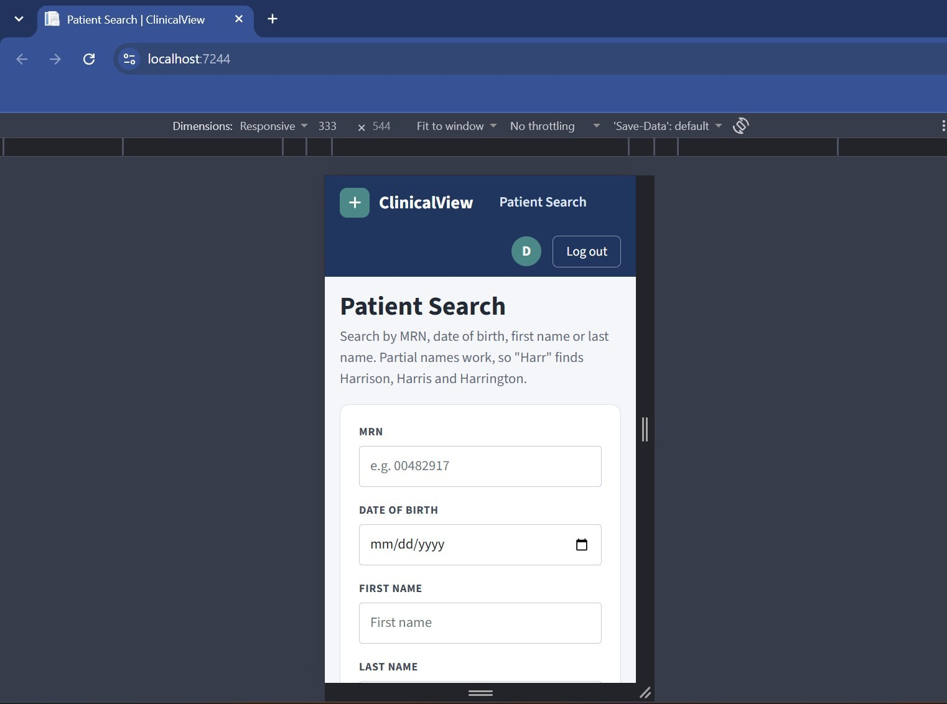
Patient Search on a mobile screen size

API Testing
The application has REST APIs that return data in JSON format. The APIs also need the user to be signed in.
  - /api/patients/search
  - /api/patients/{id}/demographics
  - /api/patients/{id}/allergies
  - /api/patients/{id}/alerts
  - /api/patients/{id}/medications
  - /api/patients/{id}/documents

Below are the results for the allergies and alerts APIs for patient 1, opened in the browser.
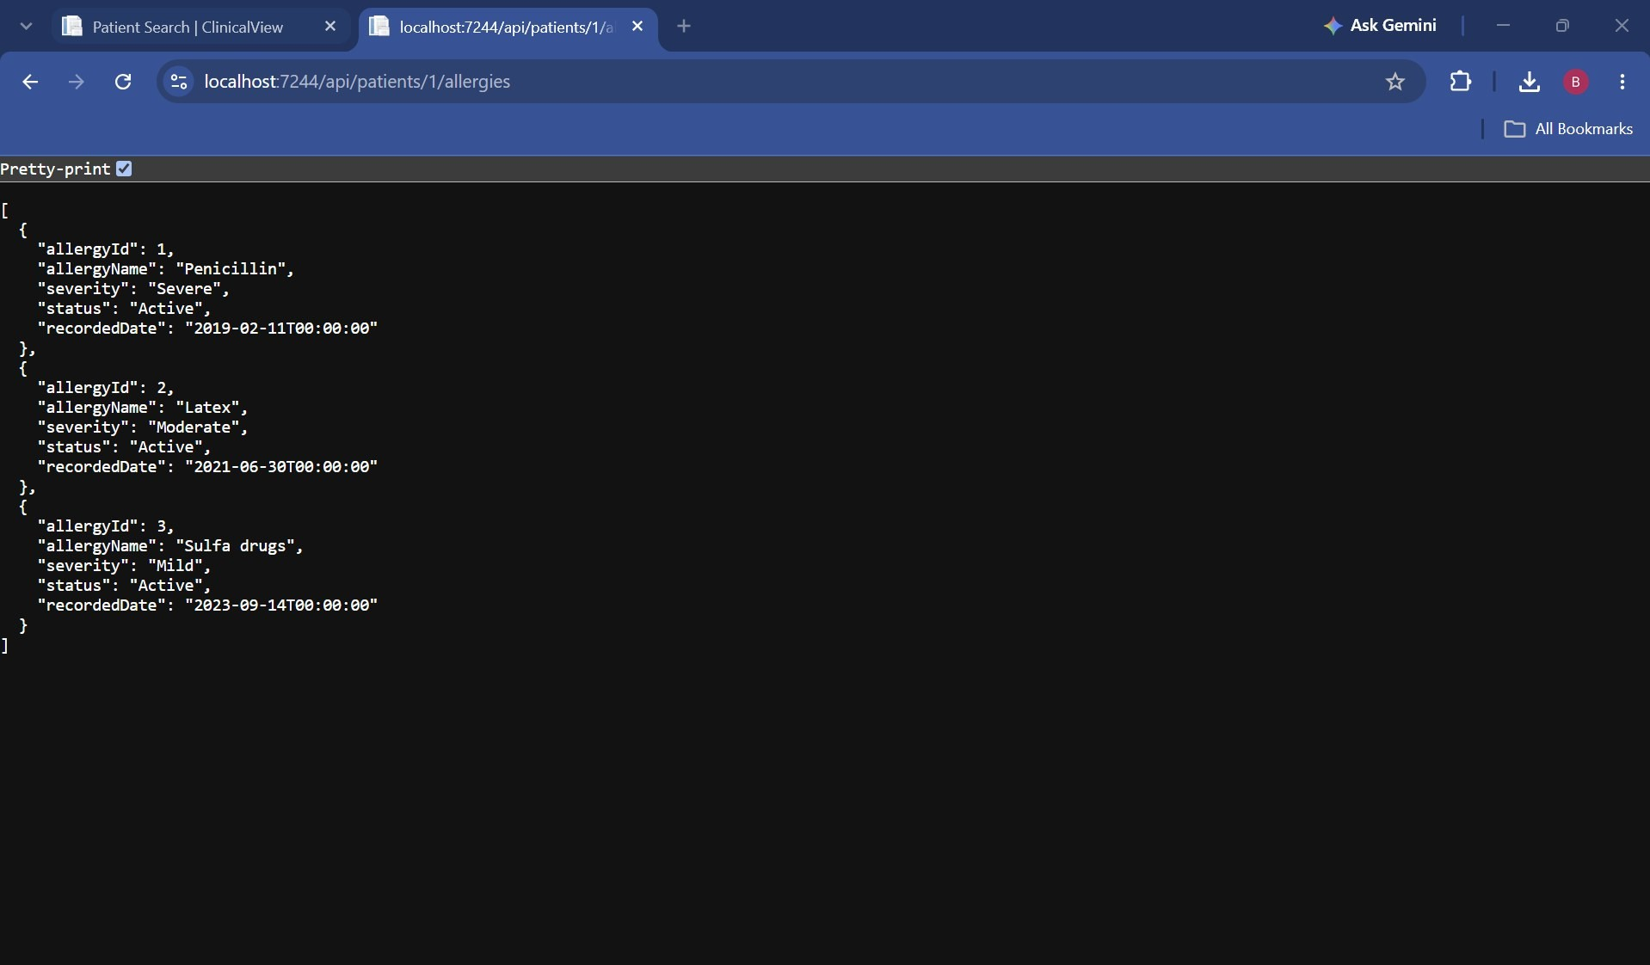
Allergies API returning JSON
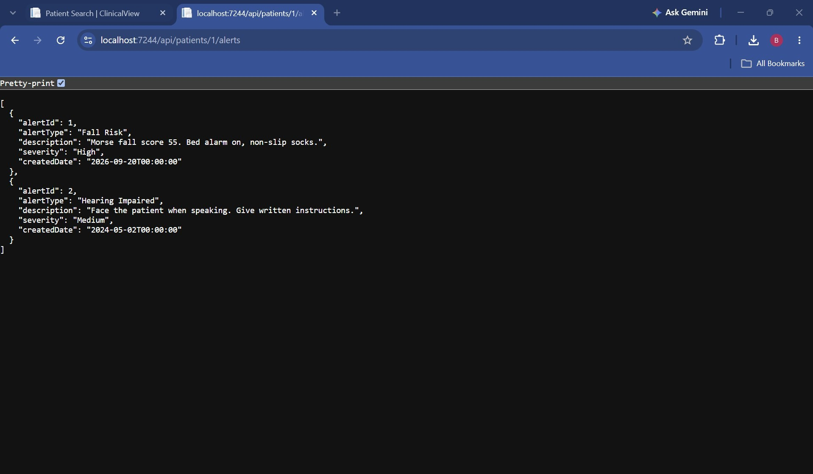
Alerts API returning JSON

Notes
  - An Alert table was added to the database, since the requirements asked for alerts but the sample database design did not include one.
  - All pages and APIs require sign-in.
  - Documents are stored outside the public web folder and can only be opened through the application after signing in.
  - Search input is validated on both the page and the server.
  - Searches, chart views, document opens and PDF prints are logged with the user’s name.
  - The Google sign-in keys are stored in User Secrets and not in the code.

