SOFTWARE ENGINEERING LAB
Paper Code: CIC-357
PRACTICAL FILE

Project Title
CREDIT CARD FRAUD DETECTION SYSTEM
Submitted By
Enrollment No.
Branch / Semester | B.Tech, Semester 5
Group Members
Submitted To
Institute

INDEX
Exp. No. | Title of Experiment | Date | Sign
1 | Problem statement for the Credit Card Fraud Detection System
2 | Requirement analysis and Software Requirement Specification (SRS)
3 | Function-oriented diagrams: Data Flow Diagram (Levels 0, 1, 2) and Structure Chart
4 | Entity Relationship (ER) diagram
5 | User's view analysis: Use Case diagram
6 | Structural view: Class diagram and Object diagram
7 | Behavioral view: State-chart diagram and Activity diagram
8 | Behavioral view: Sequence diagram and Collaboration diagram
9 (CBS 1) | Implementation view: Component diagram
10 (CBS 2) | Environmental view: Deployment diagram
11 | Testing: unit and integration testing with a testing tool (including black-box techniques)
12 | Effort estimation using Function Point (FP) analysis
13 | Time line chart: Gantt chart and PERT chart

Experiment 1: Problem Statement
Aim:- To write down the problem statement for a suggested system of relevance: the Credit Card Fraud Detection System.

Description
Credit card fraud is the unauthorised use of a payment card, or of its details, to obtain goods, services or cash. As card-not-present (online) payments, digital wallets and contactless payments have grown, fraudsters have more ways to steal card data through phishing, skimming, data breaches and account takeover, and to use it before the real cardholder notices. Banks and payment processors therefore need an automated way of deciding, within a fraction of a second, whether a card transaction is genuine or suspicious.
A Credit Card Fraud Detection System is a software platform that receives every card transaction as it happens, studies it against the cardholder's normal behaviour and known fraud patterns, and assigns it a fraud risk score. Depending on that score the transaction is approved, held for verification or declined, and suspicious cases are sent to a human fraud analyst for review. The confirmed outcomes are then fed back so that the detection model keeps learning as fraud tactics change.

Software Description
The proposed system is a web-based, service-oriented application. Its detection core is a supervised machine-learning classifier (for example Random Forest or XGBoost) trained on labelled historical transactions and combined with a configurable rule engine. It is exposed to payment gateways through a REST API and to fraud analysts and administrators through a web dashboard. A good fraud detection system should provide the following features:
- Real-time transaction scoring: every incoming transaction is scored within a few hundred milliseconds so that the payment flow is not delayed.
- Behavioural feature engineering: transaction velocity (number of transactions in the last minutes/hours), unusual amounts, new merchant or country, and distance or time between consecutive transactions.
- Hybrid detection: a machine-learning model to catch unseen patterns plus rules (for example, blocked countries or amount limits) for known fraud scenarios.
- Alert and case management: automatic alert creation, analyst assignment, review workflow and final verdict (fraud / false positive).
- Cardholder notification and step-up verification: SMS or e-mail alerts and confirmation of suspicious transactions by the cardholder.
- Continuous learning: confirmed fraud and false-positive labels are stored and used for scheduled model retraining and evaluation.
- Reports and dashboards: fraud rate, detection rate, false-positive rate, alert backlog and analyst productivity.

Problem in Existing System
- Class imbalance and hidden fraud: genuine transactions vastly outnumber fraudulent ones (in the widely used public ULB/Kaggle card dataset only 492 of 284,807 transactions, about 0.17%, are fraud). Simple approaches therefore miss most fraud or generate too many false alarms.
- Rigid rule-based checks: static rules such as fixed amount limits are easily learned and bypassed by fraudsters, and they must be updated manually every time a new pattern appears.
- False positives: legitimate purchases that are wrongly declined annoy customers and cost the bank revenue and trust.
- Delayed detection: batch or manual review often finds fraud only after the money has already moved, when it can only be recovered through chargebacks.
- Concept drift: fraud tactics change quickly, so a model that is never retrained becomes less accurate over time.
- Data privacy constraints: real card data is sensitive and regulated, which makes it difficult to share data for building and testing detection systems.

Requirements
- Security and privacy: card numbers must be tokenised or masked, all traffic encrypted, and access limited by role in line with PCI DSS guidance.
- Low latency and high throughput: scoring must complete fast enough to sit inside the payment authorisation flow and must scale during peak shopping periods.
- Accuracy: high recall (fraud caught) while keeping precision reasonable so genuine customers are not blocked; evaluated with precision, recall, F1-score and PR-AUC instead of plain accuracy.
- Integration capability: standard REST/JSON interfaces so that the system can be plugged into existing payment gateways and core banking systems.
- Explainability: each alert should show the main reasons for the high score so that analysts can take a quick and justified decision.
- Auditability: every score, decision and analyst action must be logged for audits and dispute handling.
- Easy maintenance: modular services and scripted model retraining so that rules and models can be updated without downtime.

Cost Analysis
- The proposed technology stack (Python, FastAPI, scikit-learn/XGBoost, PostgreSQL, Redis and React) is open source, so there is no licence cost for the software itself; the main costs are hosting, storage, development effort and later maintenance.
- Commercial fraud-prevention products are usually priced per transaction or by subscription, which becomes expensive at high volumes. A custom system can be cheaper in the long run and can be tuned to an organisation's own data.
- The cost has to be weighed against the loss it prevents: direct fraud losses, chargeback and investigation fees, and the customer churn caused by both fraud and wrongly declined genuine payments.
- Automation lowers the manual review effort, because analysts only see the small fraction of transactions that the model marks as risky.

Limitation
- Data dependence: model quality depends on the quantity and quality of labelled data; confirmed fraud labels arrive late (after disputes/chargebacks).
- Trade-off between false positives and missed fraud: no threshold removes both; every setting accepts some errors.
- Adversarial behaviour: fraudsters adapt, so detection needs constant monitoring and retraining.
- Explainability of complex models: ensemble and deep models are harder to explain than simple rules.
- Security concerns: the system holds sensitive financial information, so a breach would be very costly; strong security controls are mandatory.

Future Scope
- Deep-learning and graph-based models that detect fraud rings by linking shared devices, addresses and merchants.
- Unsupervised and semi-supervised anomaly detection to spot completely new fraud patterns without labels.
- Behavioural biometrics and device fingerprinting as additional risk signals.
- Explainable AI techniques (such as SHAP values) to show analysts why a transaction was flagged.
- Federated learning so that banks can improve a shared model without exchanging raw customer data.
- Extension to other payment channels such as UPI, wallets and net banking.

Implementation Note (as built in the demonstrator)
The working demonstrator implements the core of this problem statement for an Indian card portfolio: amounts are in rupees (₹) with lakh-style grouping, the synthetic customers, cities, merchants and Merchant Category Codes are Indian, and thresholds such as the high-amount limit (₹50,000) are set in INR. Names of merchants and banks are illustrative labels on invented data; no real customer data is used and no affiliation is implied.
Data and model. The public ULB/Kaggle dataset named in this experiment (284,807 transactions, 492 frauds, European cardholders, 2013, amounts in EUR) was used to train and evaluate the machine-learning component. Its features are anonymised principal components, so the model can score only transactions that carry those features; Indian demo transactions are scored by the rule engine. Both facts are stated on the application’s ML page.
Cost analysis. The demonstrator uses SQLite and runs in one process on a laptop (no PostgreSQL, Redis or containers). The stack remains open source, so the software licence cost is nil. PostgreSQL, Redis and containers stay as the proposed production design.

Experiment 2: Requirement Analysis and Software Requirement Specification (SRS)
Aim:- To do requirement analysis and develop the Software Requirement Specification sheet (SRS) for the Credit Card Fraud Detection System, following the IEEE SRS structure.

1) Introduction

1.1) Purpose
This Software Requirements Specification (SRS) gives a detailed description of the Credit Card Fraud Detection System to be developed. It states the functional and non-functional requirements, the external interfaces and the constraints of the system, and it is intended for developers, testers, project guides and the bank's fraud-operations staff. The primary purposes of the system are:
- A) Detecting fraudulent transactions: scoring every card transaction in real time and classifying it as genuine, suspicious or fraudulent.
- B) Supporting fraud operations: assisting analysts in reviewing alerts, taking decisions and blocking compromised cards quickly.
- C) Reducing losses and false alarms: protecting cardholders and the issuing bank while keeping wrongly declined genuine transactions to a minimum.

1.2) Scope
The scope of the Credit Card Fraud Detection System includes:
- A) Transaction Ingestion: receiving transaction requests from a payment gateway through a secure API and validating them.
- B) Feature Engineering: building behavioural features from the transaction and the card's recent history.
- C) Fraud Scoring: combining a machine-learning model and a rule engine to produce a fraud risk score.
- D) Decision and Alerting: approving, holding or declining a transaction and creating alerts with cardholder notifications.
- E) Case Management: letting analysts review alerts, record verdicts and block or unblock cards.
- F) Model Management: training, evaluating and deploying new model versions from confirmed labels.
- G) Admin Panel and Reports: user and role management, rule/threshold configuration and performance reports.
The system does not perform the actual payment authorisation, clearing or settlement; it only advises the authorisation flow with a risk decision.

1.3) Definitions, Acronyms, Abbreviations
Term | Meaning
Fraud | Unauthorised use of a card or card details
PAN | Primary Account Number (the card number); stored only in tokenised/masked form
ML | Machine Learning
Risk score | A value between 0 and 1 expressing the probability that a transaction is fraudulent
False positive | A genuine transaction wrongly flagged as fraud
False negative | A fraudulent transaction that is missed
Chargeback | Reversal of a transaction disputed by the cardholder
Precision / Recall | Share of flagged transactions that are truly fraud / share of all fraud that is caught
PCI DSS | Payment Card Industry Data Security Standard
API | Application Programming Interface
REST | Representational State Transfer, a web API style using HTTP and JSON
RBAC | Role-Based Access Control
GUI / DBMS / SQL | Graphical User Interface / Database Management System / Structured Query Language
OTP | One-Time Password used for step-up verification

1.4) Overview
Functional overview:
- Real-time scoring of incoming card transactions received from the payment gateway.
- Hybrid detection using an ML model and configurable rules.
- Alert generation, cardholder notification and analyst review workflow.
- Model retraining from confirmed fraud / false-positive labels.
- Admin panel for users, rules, thresholds and reports.
User experience:
- Clean analyst dashboard showing the alert queue, risk score and the top reasons for each alert.
- Secure handling of all card and customer data.
- Near real-time updates of alert status and key fraud metrics.

2) Overall Description (Product Perspective)
- Fraud prevention: catches suspicious transactions before or immediately after authorisation, reducing financial loss.
- Better customer experience: fewer wrongly declined genuine payments and faster confirmation of suspicious ones.
- Data insights: the stored scores and labels reveal fraud trends, risky merchants and peak fraud hours for future rule and model improvements.

2.1) System Interfaces
- API integration: a REST/JSON API through which the payment gateway sends transactions and receives the decision; an SMS/e-mail provider API for notifications.
- Database: a relational database (PostgreSQL) for transactions, alerts, cases, users and model metadata, and an in-memory cache (Redis) for fast access to recent card activity.

2.1.2) User Interfaces
- Analyst interface: web dashboard for alert queue, transaction details, card history and verdict submission.
- Admin interface: screens for user management, rules and thresholds, model versions and reports.

2.1.3) Hardware Interfaces
- Server hardware: application, model-inference and database servers (physical or cloud virtual machines).
- Client hardware: analysts and administrators use standard desktop/laptop web browsers.

2.1.4) Communication Interfaces
- All communication with the payment gateway, the notification provider and the dashboard uses HTTPS (TLS 1.2 or higher).
- Internal services communicate over a private network using HTTP/gRPC; database connections use SSL.

2.1.5) Memory Constraints
- Recent-activity features are cached in memory with expiry, and the model is loaded once per inference worker, to keep memory usage predictable.

2.1.6) Operation
- The scoring service runs continuously (24x7). Model training and report generation run as scheduled offline jobs so they do not affect live scoring.

2.1.7) Site Adaptation Requirements
- The dashboard should work on current versions of Google Chrome, Mozilla Firefox, Microsoft Edge and Safari, and be responsive to different screen sizes.
- Thresholds, rules and notification templates must be configurable per deployment without code changes.

2.2) Product Functions
- Receive and validate transaction requests.
- Compute features and score transactions (ML + rules).
- Approve, hold or decline transactions and raise alerts.
- Notify cardholders and collect their confirmation.
- Analyst alert review, card block/unblock and verdict recording.
- Model retraining, evaluation and deployment.
- Admin panel and reporting.

2.3) User Characteristics
- Fraud analysts: trained in fraud investigation; need clear, fast tools to judge alerts.
- Administrators: technically skilled staff who manage users, rules, thresholds and models.
- Cardholders: general public with varying technical skill; they only interact through SMS/e-mail confirmation.
- Payment gateway: an external system that interacts only through the API.

2.4) Constraints
- Performance: scoring must be fast enough for the authorisation flow, even at peak load.
- Regulatory: must follow PCI DSS guidance and applicable data-protection rules; full card numbers must not be stored in the clear.
- Data: confirmed fraud labels are few and arrive late, so the training data is highly imbalanced.
- Integration: the gateway and notification provider interfaces are controlled by third parties.

2.5) Assumptions and Dependencies
- a) A reliable network connection exists between the payment gateway and the system.
- b) Enough labelled historical data (or a public benchmark dataset) is available to train the initial model.
- c) The system depends on APIs of the payment gateway and the SMS/e-mail provider.
- d) Analysts have basic computer literacy and are trained on the alert workflow.

3) Specific Requirements

3.1) External Interfaces
- Payment Gateway API: receives a transaction request and returns the risk score and decision (APPROVE / HOLD / DECLINE).
- Notification API (SMS/e-mail): sends alerts and receives delivery status.
- Dashboard API: secured REST endpoints used by the web dashboard.

3.2) Functional Requirements
ID | Requirement | Priority
FR-1 | The system shall accept a transaction request (card token, amount, currency, merchant, time, location, channel) through a secure API and validate its format. | High
FR-2 | The system shall compute behavioural features from the transaction and the card's recent history. | High
FR-3 | The system shall produce a fraud risk score between 0 and 1 using the active ML model and rule engine. | High
FR-4 | The system shall return APPROVE, HOLD or DECLINE based on configurable score thresholds. | High
FR-5 | The system shall create a fraud alert for every HOLD or DECLINE decision. | High
FR-6 | The system shall notify the cardholder of suspicious transactions and record the reply. | Medium
FR-7 | Analysts shall be able to view, filter, assign and review alerts with the transaction and card history. | High
FR-8 | Analysts shall be able to mark an alert as confirmed fraud or false positive and block/unblock the card. | High
FR-9 | Administrators shall be able to manage users and roles. | Medium
FR-10 | Administrators shall be able to configure rules and thresholds. | Medium
FR-11 | The system shall store confirmed labels and allow administrators to retrain, evaluate and deploy a new model version. | Medium
FR-12 | The system shall generate reports on fraud rate, detection rate, false-positive rate and alert backlog. | Medium
FR-13 | The system shall log every score, decision and analyst action for audit. | High

3.3) Performance Requirements
- a) Response time: the scoring API should return a decision within about 200 ms for 95% of requests (target).
- b) Load handling: the system should handle hundreds of transactions per second and scale horizontally during peak periods.
- c) Model quality: the model should be evaluated on precision, recall, F1-score and PR-AUC on a held-out test set before deployment.

3.4) Logical Database Requirements
- a) Data model: entities Customer, Card, Merchant, Transaction, ML_Model, Fraud_Alert and Analyst with the relationships shown in the ER diagram (Experiment 4).
- b) Data integrity: primary/foreign key constraints, non-null checks on mandatory fields and unique card tokens.
- c) Retention: transaction and audit data retained for the period required by the organisation's policy.

3.5) Design Constraints
- Backend in Python (FastAPI); ML with scikit-learn / XGBoost; PostgreSQL database; Redis cache; React web dashboard.
- Services packaged as containers so that they can be deployed on any server or cloud platform.

3.6) Software System Attributes
- a) Reliability: no transaction request should be lost; if the ML service fails, the system falls back to the rule engine.
- b) Availability: the scoring service should be highly available, with health checks and redundancy.
- c) Usability: the dashboard should be simple and let analysts decide an alert in a few clicks.
- d) Maintainability and scalability: modular services, versioned models and configuration-driven rules.

3.7) Other Requirements
- Data protection: card numbers tokenised or masked; sensitive data encrypted in transit and at rest.
- Authentication and authorization: secure login, token-based sessions and role-based access, so users can only reach permitted functions.
- Auditability: tamper-evident logs of decisions and analyst actions.
- Third-party software: the system may integrate with external SMS/e-mail and identity services.

Implementation Note (as built in the demonstrator)
Status of each functional requirement in the working application (verified by automated tests, see Experiment 11):
ID | Status | How it is met in the demonstrator
FR-1 | Implemented | Token, amount, currency (INR default), merchant, country, city, channel; validated; card-number-like values rejected. Time is set by the server.
FR-2 | Implemented | 24-hour velocity, amount against the card’s average, new country, new merchant, distance and time between consecutive transactions (city level). No device or IP features.
FR-3 | Implemented (hybrid) | Rule engine always runs. The ML probability is combined (noisy-OR) when the 28 benchmark features are present; live Indian transactions are rule-scored.
FR-4 | Implemented | APPROVE / HOLD / DECLINE from configurable thresholds, validated on the server.
FR-5 | Implemented | A fraud_alerts row is created for every HOLD or DECLINE.
FR-6 | Partly | A cardholder message is queued in a simulated outbox with a one-time reply link (“Was this you?”). “Not me” blocks the card. No real SMS or e-mail provider; real e-mail is used only for the optional sign-in code.
FR-7 | Implemented | Alert queue with filters, assign to self (administrator can assign anyone), transaction and card history.
FR-8 | Implemented | Confirmed fraud (blocks the token) or false positive; one verdict per alert; manual block/unblock by administrators.
FR-9 | Implemented | Users page: create, change role, disable, reset password. Roles analyst and administrator.
FR-10 | Implemented | Thresholds, high-amount limit, blocked countries and velocity limit. Rule weights are fixed in code.
FR-11 | Partly | Confirmed labels are stored and exportable. Training and evaluation run offline (python -m ml.train); administrators deploy or retire registered models in the UI. No scheduled retraining on live labels.
FR-12 | Partly | Fraud rate, false-positive share, backlog, analyst productivity, flagged value. Detection rate is shown only for the held-out test set and the benchmark replay, because approved live transactions are never labelled.
FR-13 | Implemented | Every score, decision and action is logged; entries are hash-chained and an administrator can verify the chain (tamper-evident, not tamper-proof).

Non-functional requirements. Scoring latency (target about 200 ms for 95% of requests): measured in-process over 300 requests, median 5.8 ms, 95th percentile 7.7 ms (network and browser time excluded; not a load test). Roles are enforced by the backend on every protected route. Passwords are stored as Argon2 hashes; sign-in can require an e-mail code. Full card numbers are never accepted or stored, but TLS and PCI DSS certification are not provided; the application must be placed behind a TLS proxy before any real deployment. If the ML component is missing or fails, scoring continues with the rules (tested). Redis, PostgreSQL, containers and horizontal scaling are not implemented.

Experiment 3: Function-Oriented Diagrams: Data Flow Diagram (DFD) and Structure Chart
Aim:- To perform the function-oriented analysis of the Credit Card Fraud Detection System using Data Flow Diagrams (Level 0, Level 1, Level 2) and a Structure Chart.
Software Used:- StarUML / any UML-DFD drawing tool

Theory
Data Flow Diagrams (DFD) represent the flow of information through a system graphically instead of describing it in text. A DFD shows external entities (sources and destinations of data), processes (which transform data), data stores (where data rests) and data flows (labelled arrows). DFDs are drawn at successively deeper levels:
- Level 0 DFD (context diagram): shows the whole system as a single process together with its external entities and the data exchanged with them.
- Level 1 DFD: breaks the single process into its major sub-processes and shows the data stores they use.
- Level 2 DFD: explodes one Level 1 process into more detailed sub-processes, with inputs, processing and outputs.
A Structure Chart is the function-oriented design counterpart of a DFD: it shows the module hierarchy of the software, that is, which module calls which lower-level module.

Level 0 DFD (Context Diagram)
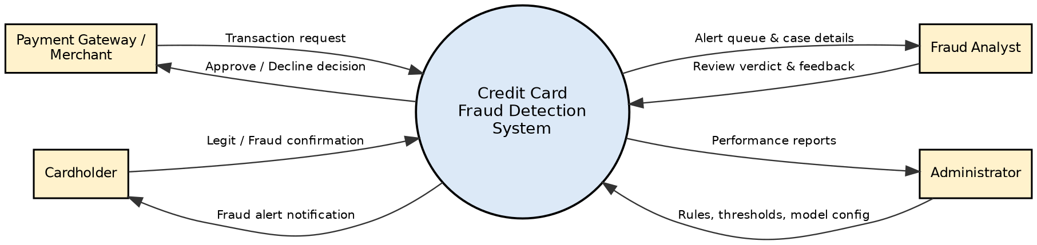
Fig. 3.1: Level 0 DFD of the Credit Card Fraud Detection System
The four external entities are the Payment Gateway/Merchant (sends transactions, receives the decision), the Cardholder (receives alerts and confirms transactions), the Fraud Analyst (reviews alerts) and the Administrator (configures rules, models and reads reports).

Level 1 DFD
The Level 1 DFD is split into two figures for readability. Figure 3.2 shows the real-time detection path (processes 1.0 to 4.0) and Figure 3.3 shows case review, model training and administration (processes 5.0 to 7.0).
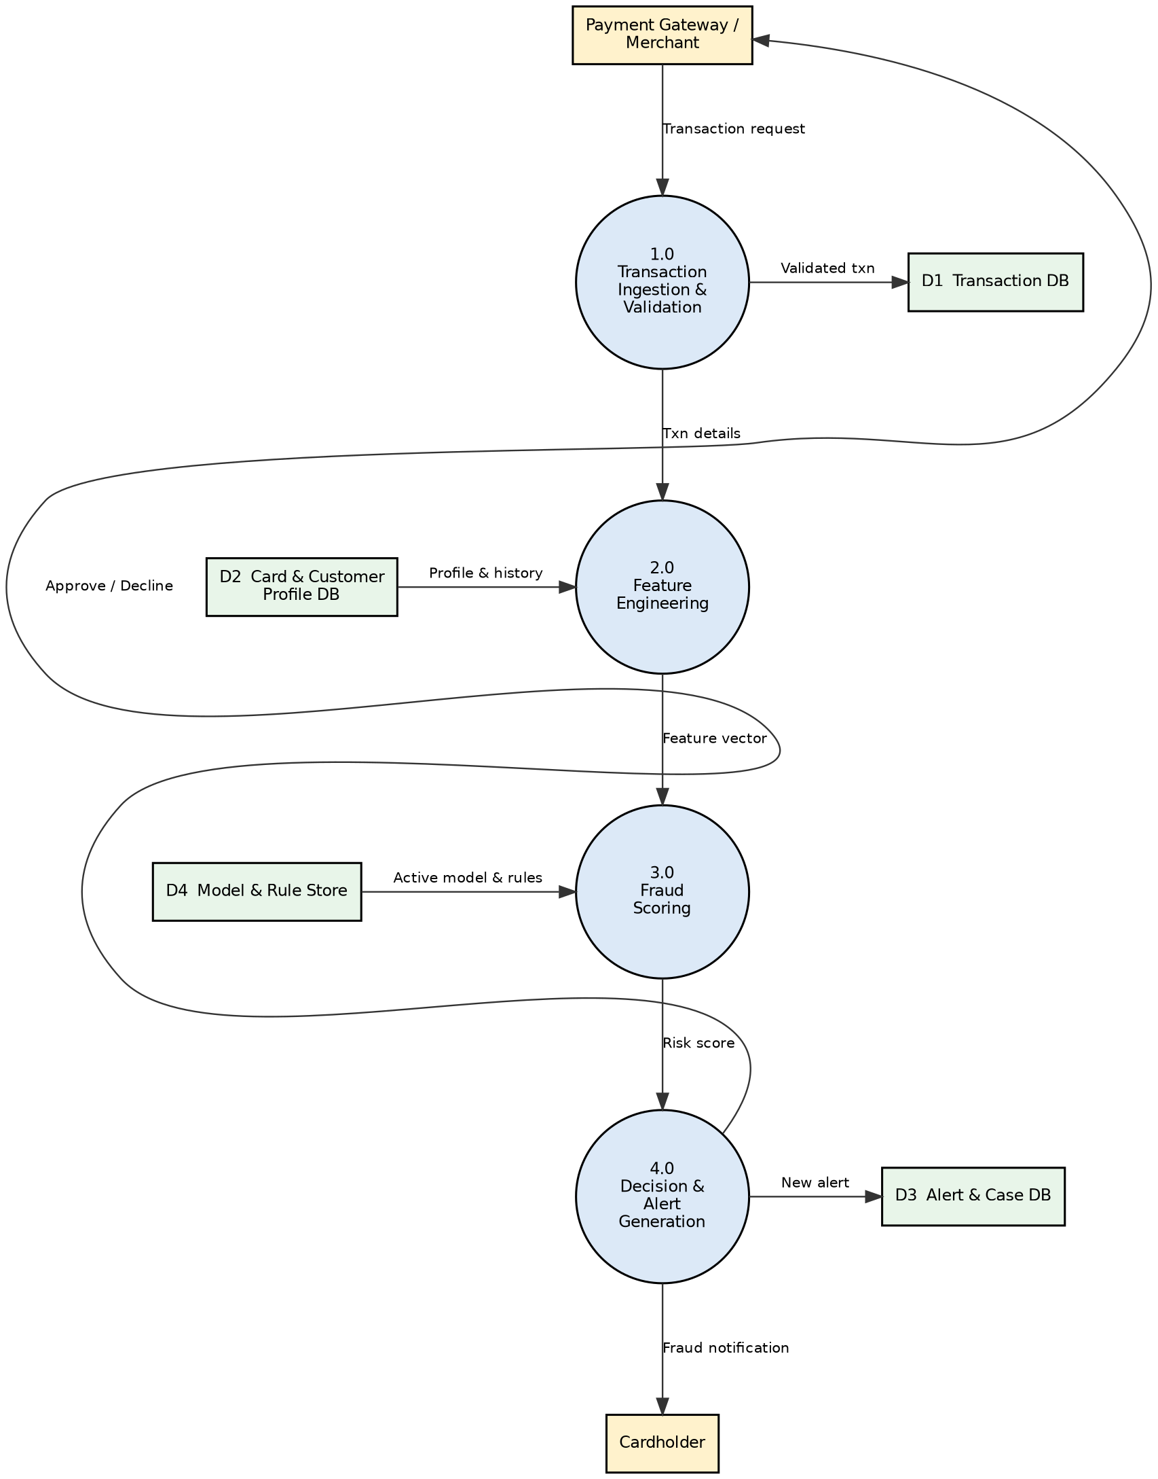
Fig. 3.2: Level 1 DFD (a): real-time detection path
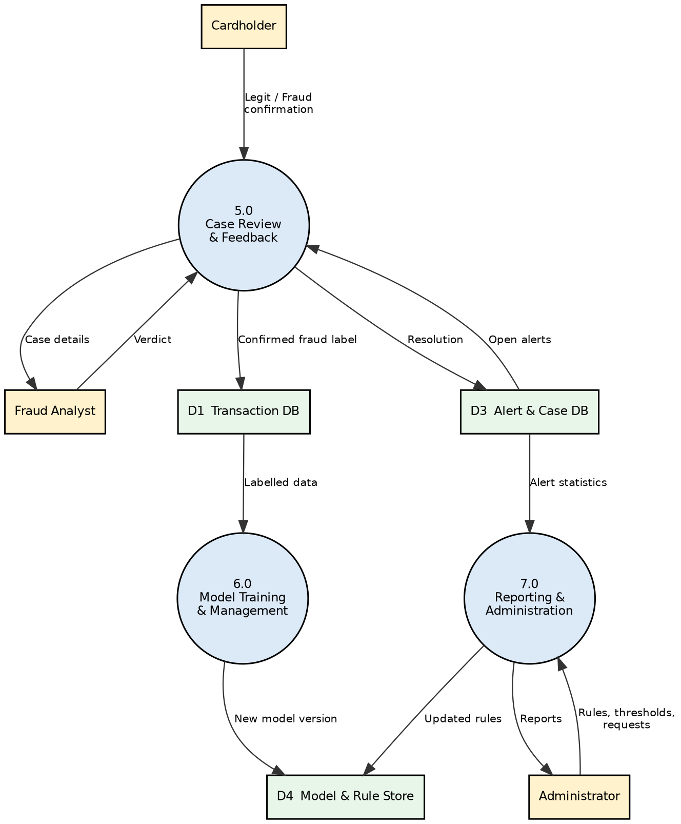
Fig. 3.3: Level 1 DFD (b): review, training and administration
Process | Description
1.0 Transaction Ingestion & Validation | Receives the request from the gateway, checks the format and card status, and stores the validated transaction in D1.
2.0 Feature Engineering | Reads the card and customer profile (D2) and recent history and builds the feature vector.
3.0 Fraud Scoring | Uses the active model and rules from D4 to compute the fraud risk score.
4.0 Decision & Alert Generation | Compares the score with thresholds, returns APPROVE / HOLD / DECLINE, creates alerts (D3) and notifies the cardholder.
5.0 Case Review & Feedback | Shows open alerts to analysts, records verdicts and cardholder confirmations and stores confirmed labels.
6.0 Model Training & Management | Retrains the model on labelled data from D1 and stores the new version in D4.
7.0 Reporting & Administration | Handles rule/threshold configuration, user requests and generates reports from stored data.

Level 2 DFD (Explosion of Process 3.0: Fraud Scoring)
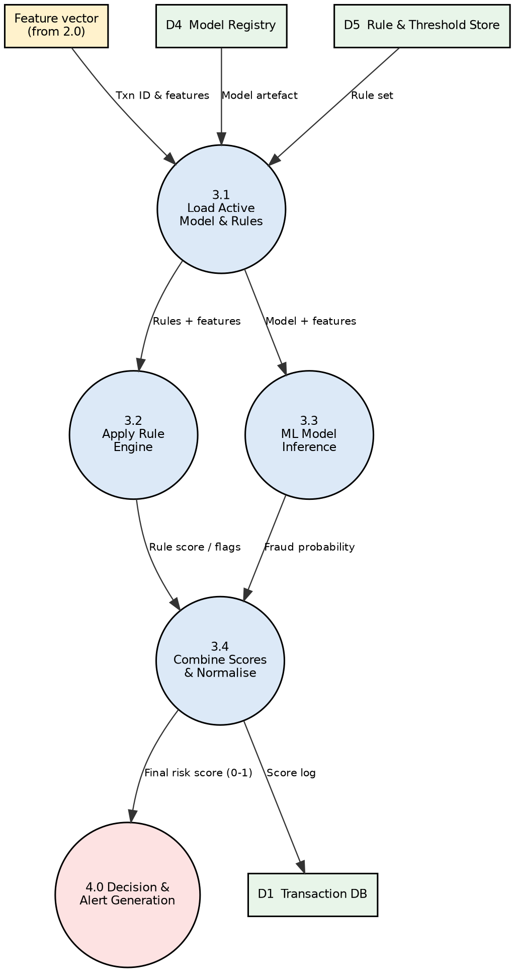
Fig. 3.4: Level 2 DFD of Process 3.0 Fraud Scoring
Process 3.0 is split into loading the active model and rule set (3.1), applying the rule engine (3.2), running the ML model inference (3.3) and combining both outputs into one normalised risk score (3.4), which is passed to Process 4.0 and logged in the transaction database.

Structure Chart
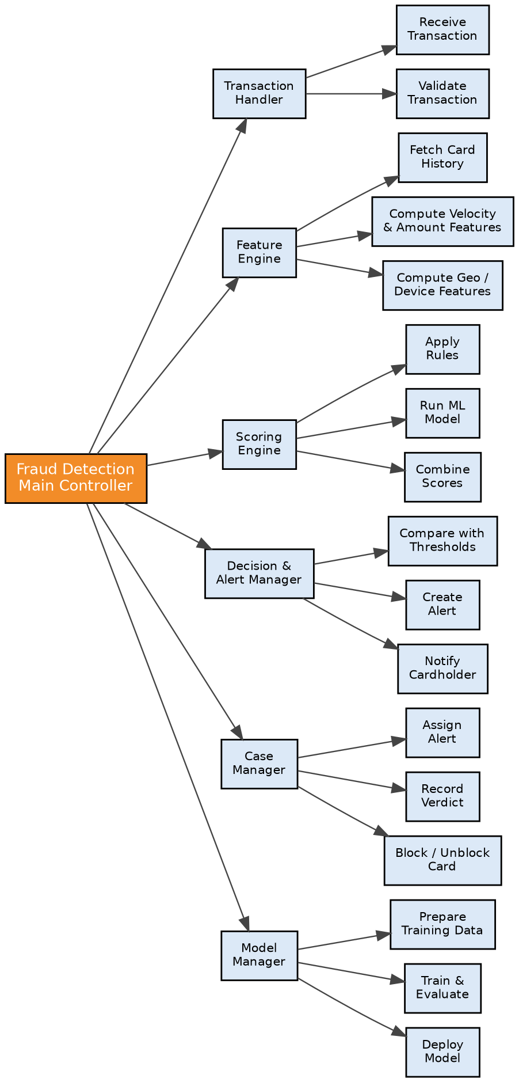
Fig. 3.5: Structure chart of the Credit Card Fraud Detection System
The Main Controller calls six first-level modules (Transaction Handler, Feature Engine, Scoring Engine, Decision & Alert Manager, Case Manager and Model Manager). Each of these calls its own lower-level modules, giving a modular, top-down design in which each module has one clear responsibility (high cohesion) and modules interact through simple data passed between them (low coupling).

Implementation Note (as built in the demonstrator)
Each DFD process and structure-chart module has a counterpart in the code. Data stores D1 to D5 are tables of one SQLite database.
Design element | Where it lives in the code
1.0 Transaction Ingestion & Validation / Transaction Handler | app/schemas/models.py (TransactionIn) and transactions_service.ingest
2.0 Feature Engineering / Feature Engine | repositories.card_history_stats and the ScoringInput built in ingest (replaces the Redis feature cache with an indexed SQL query)
3.1 Load model and rules | settings_service.load_risk_config and ml_service.ModelService (artifact hash verified before loading)
3.2 Apply rule engine | scoring.HeuristicScorer (nine rules, every point a named factor)
3.3 ML model inference | ml/wrapper.CalibratedModel through ModelService.predict
3.4 Combine scores and normalise | scoring.HybridScorer: 1 − (1 − rules)(1 − p), capped at 1
4.0 Decision & Alert Generation / Decision & Alert Manager | scoring.decide, fraud_alerts rows, notifications_service (simulated cardholder message)
5.0 Case Review & Feedback / Case Manager | transactions_service.review and assign, cards_service, notifications_service.record_reply, label export
6.0 Model Training & Management / Model Manager | ml/train.py (offline) and models_service (register, deploy, retire, replay)
7.0 Reporting & Administration | reports_service, settings_service, auth_service (users)
D1 Transaction DB / D2 Card & Customer Profile / D3 Alert & Case / D4 Model & Rule Store / D5 Rule & Threshold Store | tables transactions; customers, cards, merchants; fraud_alerts; ml_models; config
Result:- The function-oriented view of the system was analysed and the DFDs and structure chart were drawn.

Experiment 4: Entity Relationship (ER) Diagram
Aim:- To draw the ER diagram for the Credit Card Fraud Detection System.

Theory
An ER diagram is composed of entities, relationships, attributes and cardinality. Entities are the things of interest about which data is stored, relationships are the associations between entities, attributes describe the entities, and cardinality states how many instances of one entity can be related to instances of another.

ER diagram components and features
- Entities: things of interest, such as Customer, Card or Transaction.
- Relationships: connections between entities, such as a Card making Transactions.
- Attributes: descriptors of entities, such as a transaction's amount.
- Cardinality: how many entities can be related (1:1, 1:N, M:N).
- Entity categories: strong, weak and associative entities.
- Entity keys: super, candidate and primary keys (PK); a foreign key (FK) links to the primary key of another entity.
- Attribute categories: simple, composite, derived, single-valued and multi-valued attributes.

ERD for the Credit Card Fraud Detection System
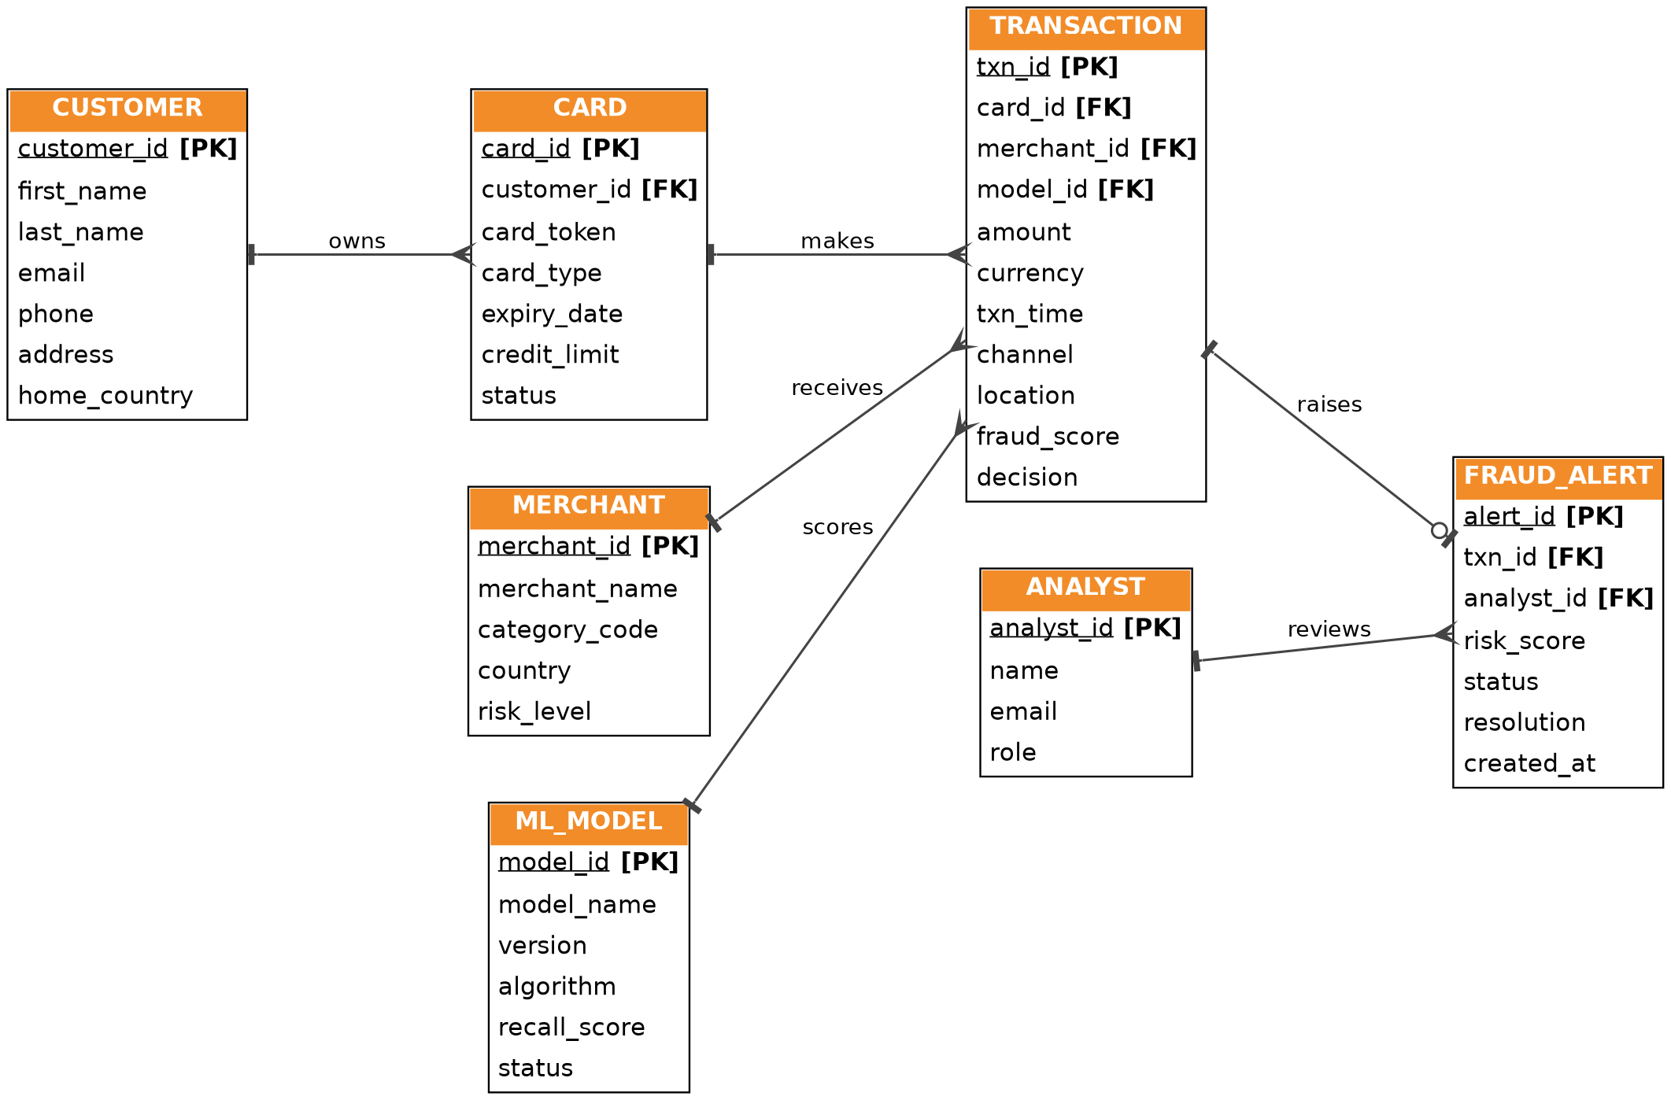
Fig. 4.1: ER diagram (crow's-foot notation)
The ER diagram shows the seven entities of the system and the relationships between them. Underlined attributes marked [PK] are primary keys and attributes marked [FK] are foreign keys.

Entities and their Attributes
- Customer: customer_id (primary key), first_name, last_name, email, phone, address, home_country. Name is a composite attribute made of first and last name.
- Card: card_id (primary key), customer_id (foreign key), card_token, card_type, expiry_date, credit_limit, status. Only a token/masked value of the card number is stored.
- Merchant: merchant_id (primary key), merchant_name, category_code, country, risk_level.
- Transaction: txn_id (primary key), card_id, merchant_id and model_id (foreign keys), amount, currency, txn_time, channel (POS/online), location, fraud_score, decision.
- ML_Model: model_id (primary key), model_name, version, algorithm, recall_score, status (active/retired).
- Fraud_Alert: alert_id (primary key), txn_id and analyst_id (foreign keys), risk_score, status, resolution (confirmed fraud / false positive), created_at.
- Analyst: analyst_id (primary key), name, email, role.

Relationships between Entities
Relationship | Entities | Cardinality | Explanation
owns | Customer - Card | 1 : N | A customer can own many cards, but each card belongs to one customer.
makes | Card - Transaction | 1 : N | A card can be used for many transactions; each transaction uses one card.
receives | Merchant - Transaction | 1 : N | A merchant receives many transactions; each transaction is made at one merchant.
scores | ML_Model - Transaction | 1 : N | One model version scores many transactions; each transaction is scored by one model version.
raises | Transaction - Fraud_Alert | 1 : 0..1 | A transaction may raise at most one alert; an alert belongs to exactly one transaction.
reviews | Analyst - Fraud_Alert | 1 : N | An analyst reviews many alerts; each alert is assigned to one analyst.

Implementation Note (as built in the demonstrator)
The working database implements the seven entities of this ER diagram. Deviations are listed below; the diagram itself is unchanged.
ER entity | Table in the demonstrator | Differences
Customer | customers | Single name field instead of first and last name; phone numbers are invented; home_country defaults to IN.
Card | cards | card_id primary key and unique card_token as designed; adds network, issuer, card_type, expiry_date, credit_limit. status is derived from a blocked flag with reason, time and actor.
Merchant | merchants | As designed (category_code, country, risk_level) plus category label and city.
Transaction | transactions (read through the view v_transactions) | Adds currency, location (city), channel, source (SEED, LIVE or BENCH), scorer version, score factors; card_id, merchant_id and model_id are foreign keys.
ML_Model | ml_models | recall_score is the recall on the held-out test set at the application’s flag threshold; also stores PR-AUC, precision, F1, artifact hash and status candidate/active/retired.
Fraud_Alert | fraud_alerts | One row per HOLD or DECLINE (unique txn_id); assigned_to, status OPEN / CONFIRMED_FRAUD / FALSE_POSITIVE, resolution note, cardholder response.
Analyst | users, exposed as the view analysts | Administrators are also rows of users; the e-mail address is the sign-in name.
(not in the ER) | config, audit, notifications, otp_challenges, meta, schema_version | Supporting tables: thresholds, hash-chained audit log, simulated outbox, one-time sign-in codes, signing secret, migration history.
Result:- The ER diagram of the Credit Card Fraud Detection System was drawn with its entities, keys and cardinalities.

Experiment 5: User's View Analysis: Use Case Diagram
Aim:- To perform the user's view analysis for the Credit Card Fraud Detection System using a use case diagram.
Software Used:- StarUML

Theory
Use case diagrams are behavioural diagrams that show the interactions between a system and its users (actors). They are used to capture the functional requirements of a system and are mainly used in the analysis and design phases. The components of a use case diagram are:
- Actor: a person, organisation or external system that interacts with the system to achieve a goal (drawn as a stick figure).
- System boundary: the rectangle that encloses the use cases of the system being modelled.
- Use case: a sequence of interactions between an actor and the system that gives the actor a useful result (drawn as an ellipse).
- Communication link / association: a line joining an actor to a use case it takes part in.
- Include: a dashed arrow labelled <<include>> from a use case to another use case whose behaviour is always used by it.
- Extend: a dashed arrow labelled <<extend>> from an optional use case to the base use case it extends under a condition.
- Generalization: a solid line with a hollow triangle showing that an actor or use case is a specialised form of another.

Use Case Diagram
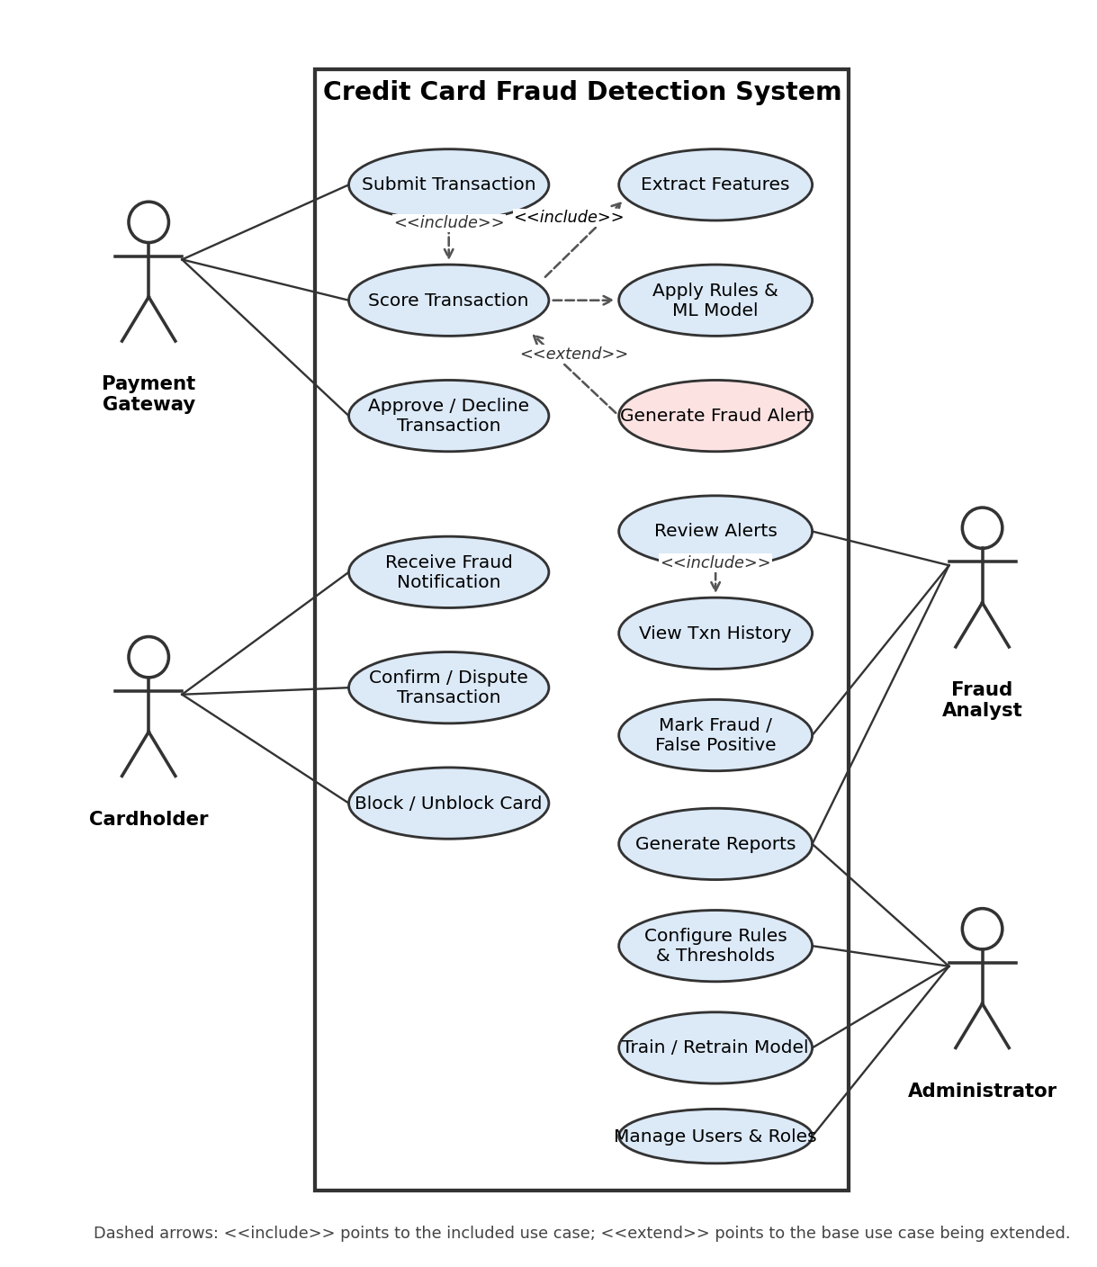
Fig. 5.1: Use case diagram of the Credit Card Fraud Detection System

Actors
Actor | Description
Payment Gateway (external system) | Sends card transactions for scoring and receives the decision.
Cardholder | Receives fraud notifications, confirms or disputes transactions and can block a card.
Fraud Analyst | Reviews alerts, studies transaction history, marks verdicts and generates reports.
Administrator | Manages users, rules, thresholds and models, and generates reports.

Use Case Descriptions

UC-01: Score Transaction
Item | Description
Primary actor | Payment Gateway
Precondition | Transaction request is received through the API and the gateway is authenticated.
Main flow | 1. System validates the request.  2. System extracts features (included use case).  3. System applies rules and the ML model (included use case).  4. System computes the risk score and returns the decision.
Extension | If the score is above the alert threshold, the use case Generate Fraud Alert is executed.
Postcondition | The transaction, score and decision are stored in the database.

UC-02: Review Alerts
Item | Description
Primary actor | Fraud Analyst
Precondition | Analyst is logged in and at least one alert is open.
Main flow | 1. Analyst opens the alert queue.  2. Analyst selects an alert and views details and card history (included use case).  3. Analyst marks the alert as confirmed fraud or false positive.  4. System saves the verdict and blocks or releases as needed.
Postcondition | Alert is closed and the label is stored for model retraining.

UC-03: Confirm / Dispute Transaction
Item | Description
Primary actor | Cardholder
Precondition | A suspicious-transaction notification was sent to the cardholder.
Main flow | 1. Cardholder receives the SMS/e-mail.  2. Cardholder replies that the transaction is genuine or not genuine.  3. System records the reply and updates the alert.
Postcondition | The alert is updated and, if not genuine, the card can be blocked.

UC-04: Train / Retrain Model
Item | Description
Primary actor | Administrator
Precondition | Administrator is logged in and new labelled data is available.
Main flow | 1. Administrator starts retraining.  2. System trains and evaluates the new model (precision, recall, F1, PR-AUC).  3. Administrator compares it with the active model and approves deployment.
Postcondition | The new model version becomes the active model in the model registry.

Implementation Note (as built in the demonstrator)
Use case | Where it is implemented
Submit Transaction, Score Transaction, Approve / Decline | POST /api/transactions and the “Submit synthetic transaction” form; response carries score, decision and factors
Generate Fraud Alert | automatic for every HOLD or DECLINE (fraud_alerts row)
Receive Fraud Notification, Confirm / Dispute Transaction, Block Card (cardholder) | Cardholder messages page (simulated outbox) and the public reply page /confirm/…; “No, this was not me” blocks the card
Review Alerts, View Txn History, Mark Fraud / False Positive | Alerts and cases page, transaction page (score factors, history, audit trail, verdict with confirmation)
Block / Unblock Card (staff) | Cards page (administrator) and automatically after a confirmed-fraud verdict
Generate Reports | Overview and Reports pages, CSV export, analyst productivity
Configure Rules & Thresholds | Fraud rules page (administrator, validated on client and server)
Train / Retrain Model | python -m ml.train offline, then Deploy or Retire on the ML model page (administrator)
Manage Users & Roles | Users page (administrator)
Result:- The use case diagram with actors, use cases and their relationships was drawn for the system.

Experiment 6: Structural View: Class Diagram and Object Diagram
Aim:- To draw the structural view diagrams (class diagram and object diagram) for the Credit Card Fraud Detection System.
Software Used:- StarUML

Theory
A class diagram is a UML structural diagram that represents the structure of a system in terms of classes and interfaces. It shows the attributes and operations of classes and the relationships between them (association, generalization, dependency, etc.). Class diagrams map directly to object-oriented languages. An object diagram is a snapshot of the system at a particular moment: it shows the instances (objects) of classes with their attribute values and the links between them. Object diagrams can be seen as instance-level class diagrams and are useful for explaining small parts of a complex system.

Class Diagram
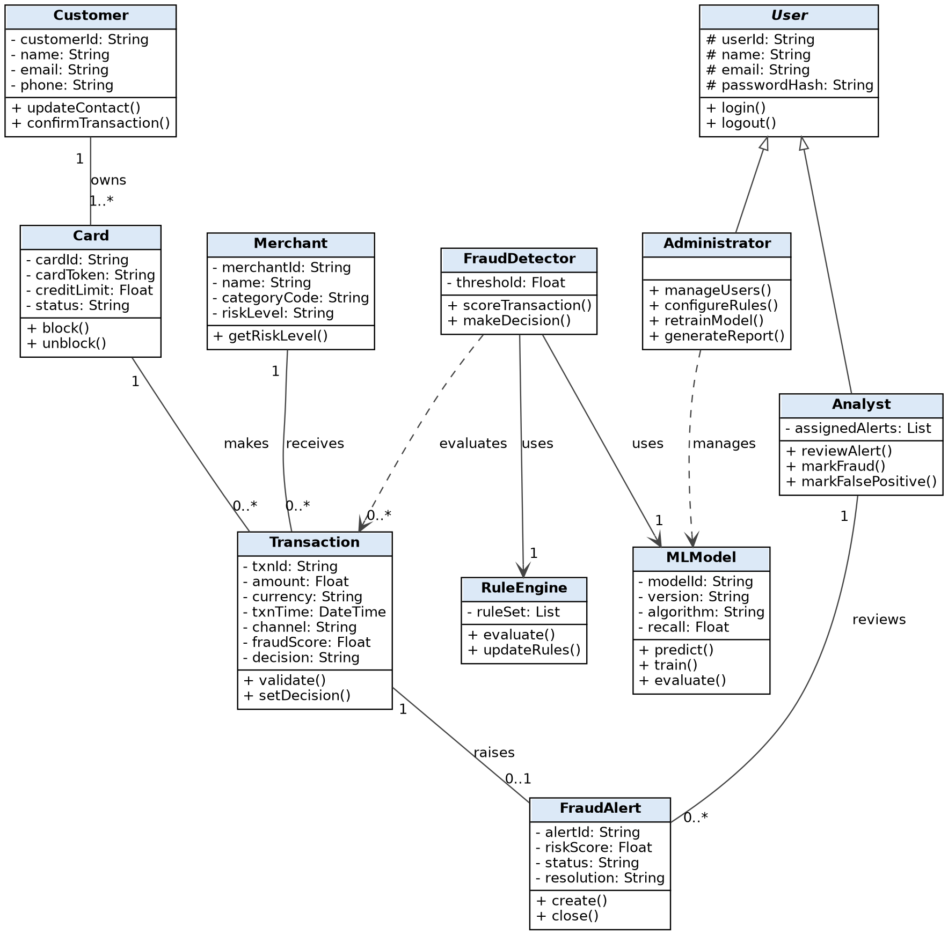
Fig. 6.1: Class diagram of the Credit Card Fraud Detection System
- Customer, Card, Merchant, Transaction: the core business classes. A customer owns 1..* cards; a card makes 0..* transactions; a merchant receives 0..* transactions.
- FraudDetector: the service class that evaluates transactions; it uses one RuleEngine and one MLModel to produce a score and decision.
- FraudAlert: raised by a transaction (0..1) and reviewed by an Analyst.
- User (abstract): parent class of Analyst and Administrator using generalization; it holds the common login data and operations. The Administrator manages the MLModel and the rules.

Object Diagram
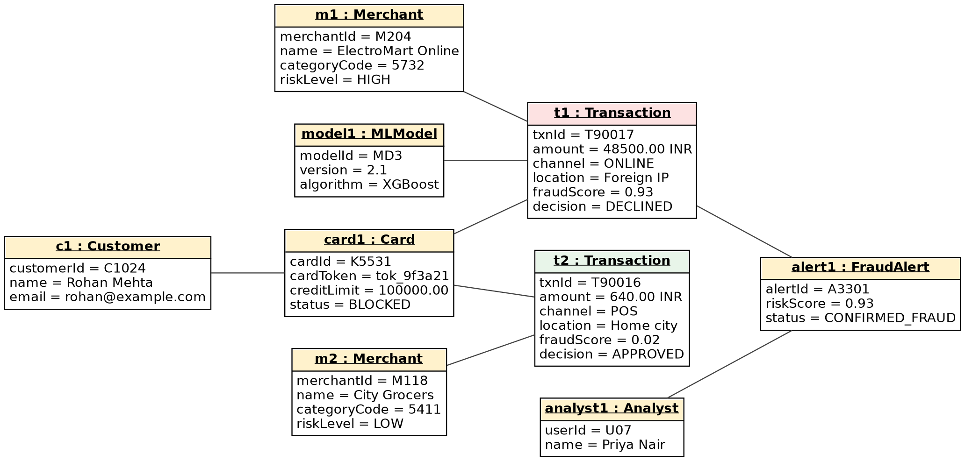
Fig. 6.2: Object diagram (snapshot of one fraud case)
The object diagram shows one snapshot: customer c1 owns card1 (now blocked), which made two transactions. Transaction t2 (a small POS purchase at a low-risk merchant) scored 0.02 and was approved. Transaction t1 (a large online purchase from a foreign location at a high-risk merchant) was scored 0.93 by model1 and declined, which raised alert1, reviewed by analyst1 and confirmed as fraud. (The names and values are sample data only.)

Implementation Note (as built in the demonstrator)
The code base is function-oriented around services and repositories rather than one Python class per entity, so the class diagram maps to modules: FraudDetector → HybridScorer and transactions_service.ingest; RuleEngine → HeuristicScorer; MLModel → CalibratedModel (ml/wrapper.py) managed by ModelService; Customer, Card, Merchant, Transaction, FraudAlert → rows of the tables listed under Experiment 4; User, Analyst, Administrator → the users table with a role checked by require_admin.
Result:- The class diagram and the object diagram of the system were drawn.

Experiment 7: Behavioral View: State-Chart Diagram and Activity Diagram
Aim:- To draw the state-chart diagram and the activity diagram for the Credit Card Fraud Detection System.
Software Used:- StarUML

Theory
A state-chart (state machine) diagram describes the different states an object goes through during its life and the events that cause it to move from one state to another. An activity diagram shows the flow of control from one activity to another; it is like a flowchart with support for decisions, parallel flows and swimlanes that show which actor or component performs each activity.

State-Chart Diagram: Life Cycle of a Transaction
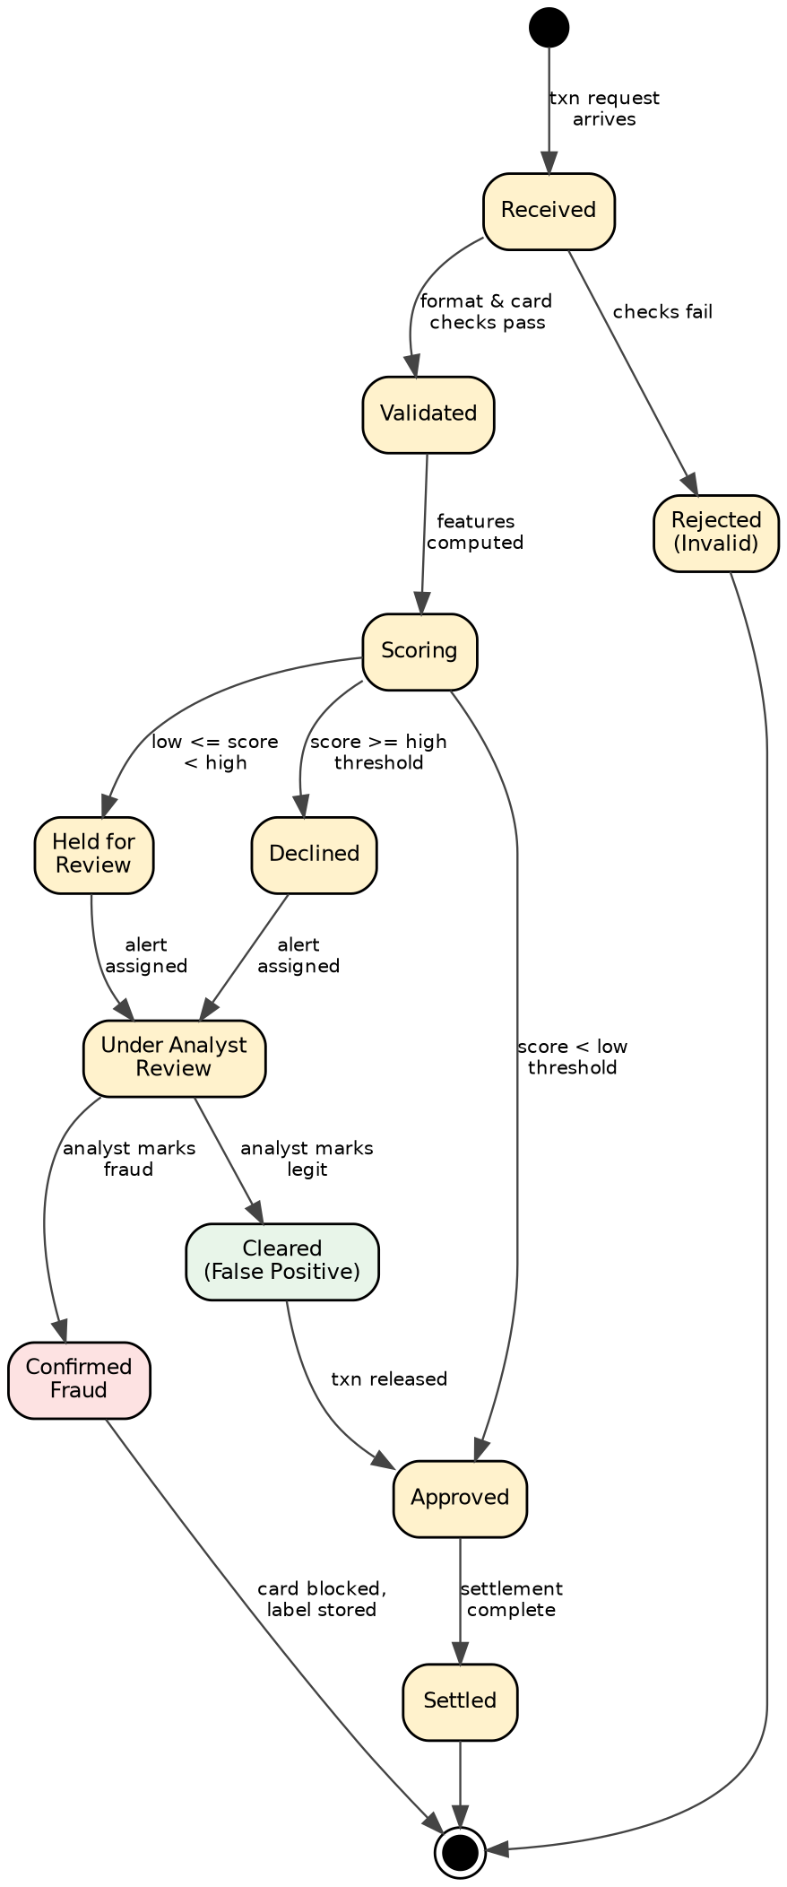
Fig. 7.1: State-chart diagram of a transaction
A transaction starts in the Received state. It is Rejected if the format or card checks fail; otherwise it is Validated and moves to Scoring once features are computed. Depending on the risk score it becomes Approved (low score), Held for Review (medium score) or Declined (high score). Held and declined transactions go to Under Analyst Review, where the analyst marks them Confirmed Fraud (card blocked, label stored) or Cleared as a false positive (transaction released and approved). Approved transactions are finally Settled.

Activity Diagram (with Swimlanes)
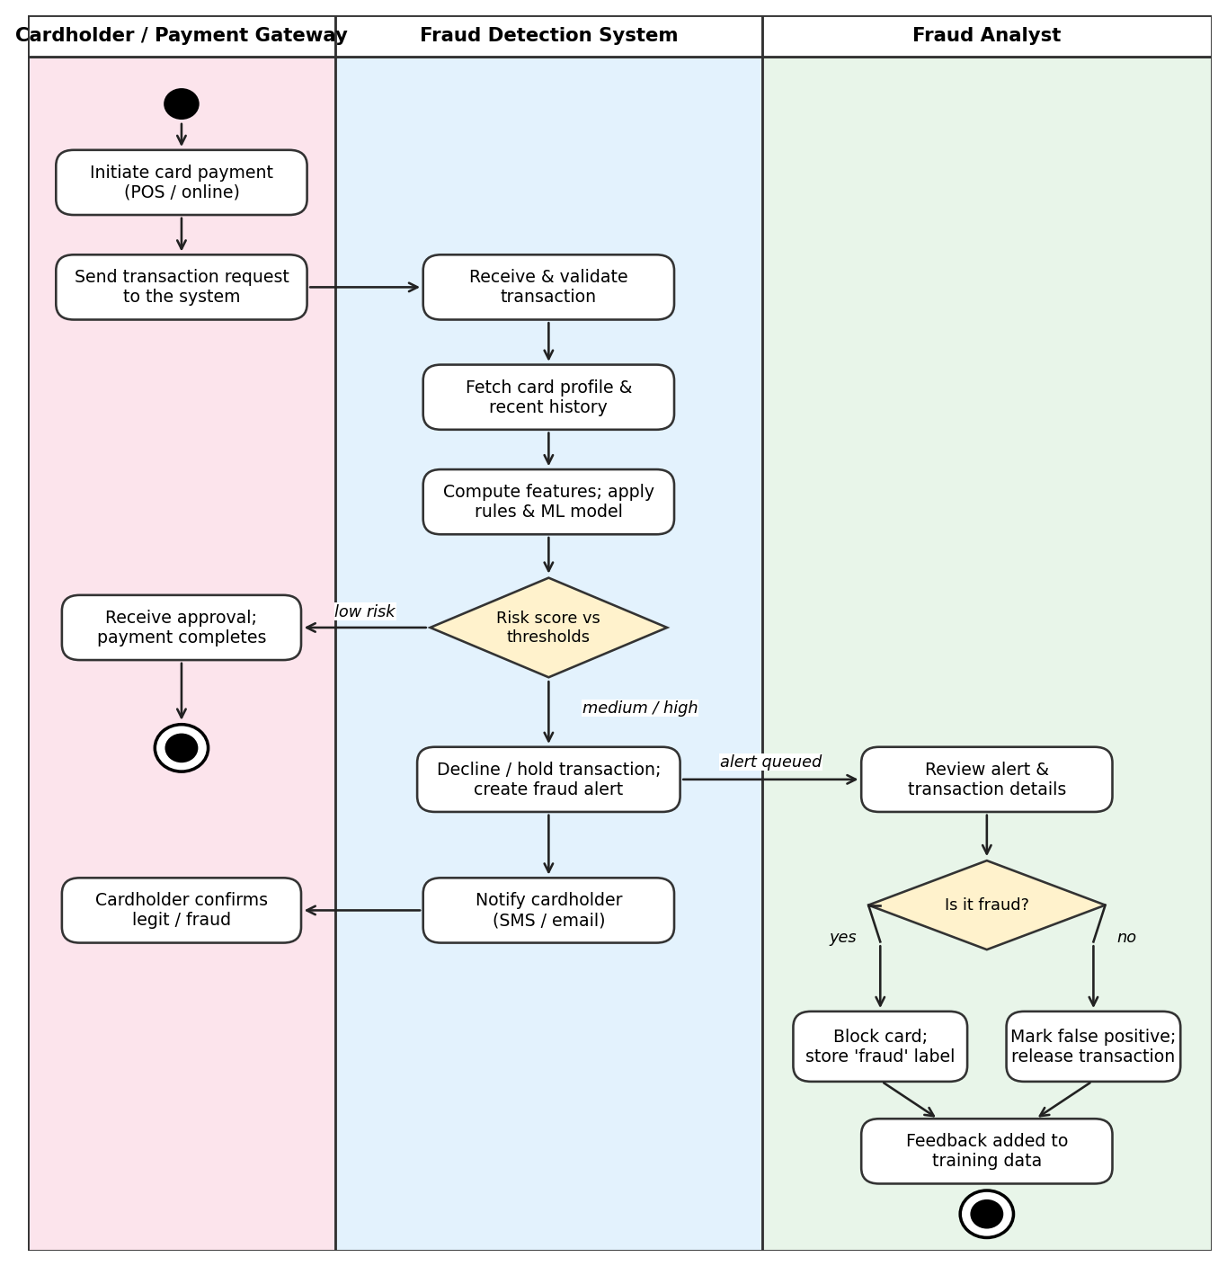
Fig. 7.2: Activity diagram of the fraud detection process
The swimlanes show the activities of the Cardholder/Payment Gateway, the Fraud Detection System and the Fraud Analyst. After a payment is initiated, the system validates it, fetches history, computes features and scores it. A low score leads to approval; a medium or high score leads to a decline/hold, an alert and a cardholder notification. The analyst reviews the alert and either blocks the card (fraud) or releases the transaction (false positive), and the outcome is added to the training data.

Implementation Note (as built in the demonstrator)
States implemented: Received → Rejected (validation error 422, or blocked card 409 with an audit entry) or Validated → Scoring → Approved, Held for Review or Declined. Held and declined transactions get an alert in state OPEN, then Confirmed Fraud (card blocked) or False Positive; a verdict is final. Not implemented: Settled, and releasing a cleared (false-positive) transaction to Approved. The demonstrator advises on risk; it does not authorise, release or settle payments.
Result:- The state-chart diagram and the activity diagram were drawn for the system.

Experiment 8: Behavioral View: Sequence Diagram and Collaboration Diagram
Aim:- To perform the behavioral view diagrams (sequence diagram and collaboration diagram) for the Credit Card Fraud Detection System.
Software Used:- StarUML

Theory
Sequence diagram: A sequence diagram is the most commonly used interaction diagram. It depicts the interaction between objects in time order, that is, the order in which messages are exchanged. It is also called an event diagram or event scenario and shows how, and in what order, the objects of a system work together.
Collaboration diagram: A collaboration (communication) diagram shows the same information as a sequence diagram but emphasises the relationships between objects instead of time. The objects are drawn as nodes, linked to each other, and the messages between them are numbered to show their order.

Sequence Diagram for the Fraud Detection System
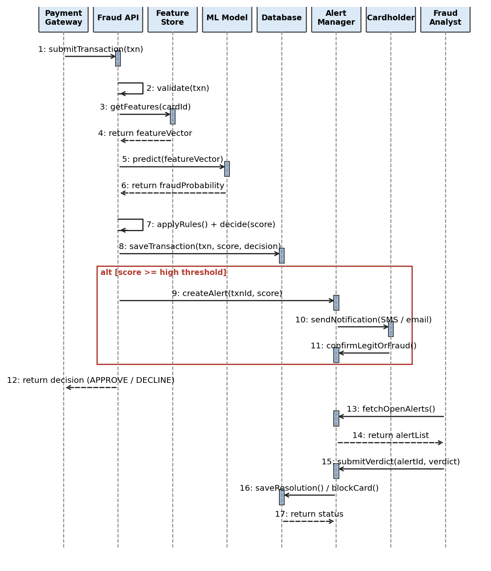
Fig. 8.1: Sequence diagram of transaction scoring and alert review
The gateway submits a transaction to the Fraud API, which validates it, obtains features from the Feature Store and the fraud probability from the ML Model, and applies the rules. The transaction and decision are saved in the database. In the alternative flow (score above the high threshold) an alert is created, the cardholder is notified and may confirm, and the DECLINE decision is returned to the gateway. Later, the analyst fetches the open alerts and submits a verdict, which the Alert Manager saves (and blocks the card if it is fraud).

Collaboration Diagram for the Fraud Detection System

Transaction scoring side
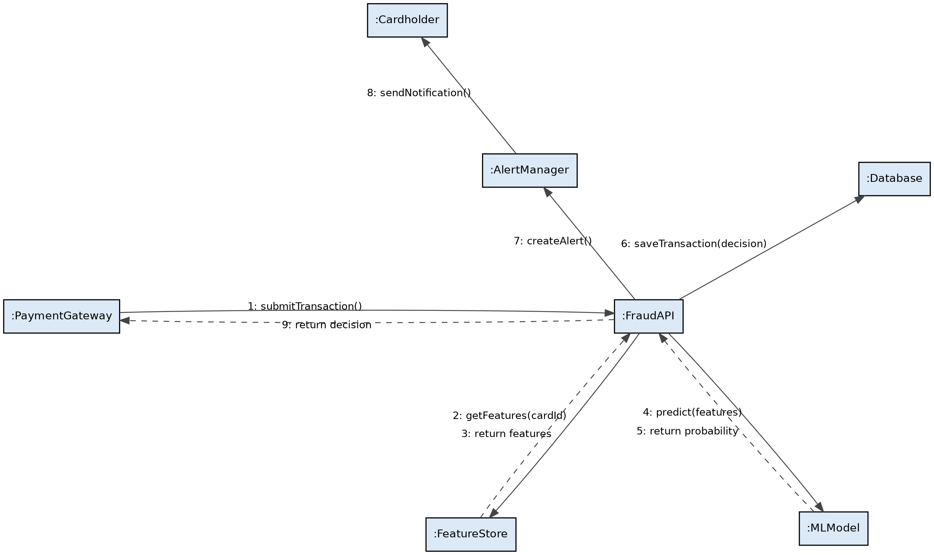
Fig. 8.2: Collaboration diagram: transaction scoring

Analyst side
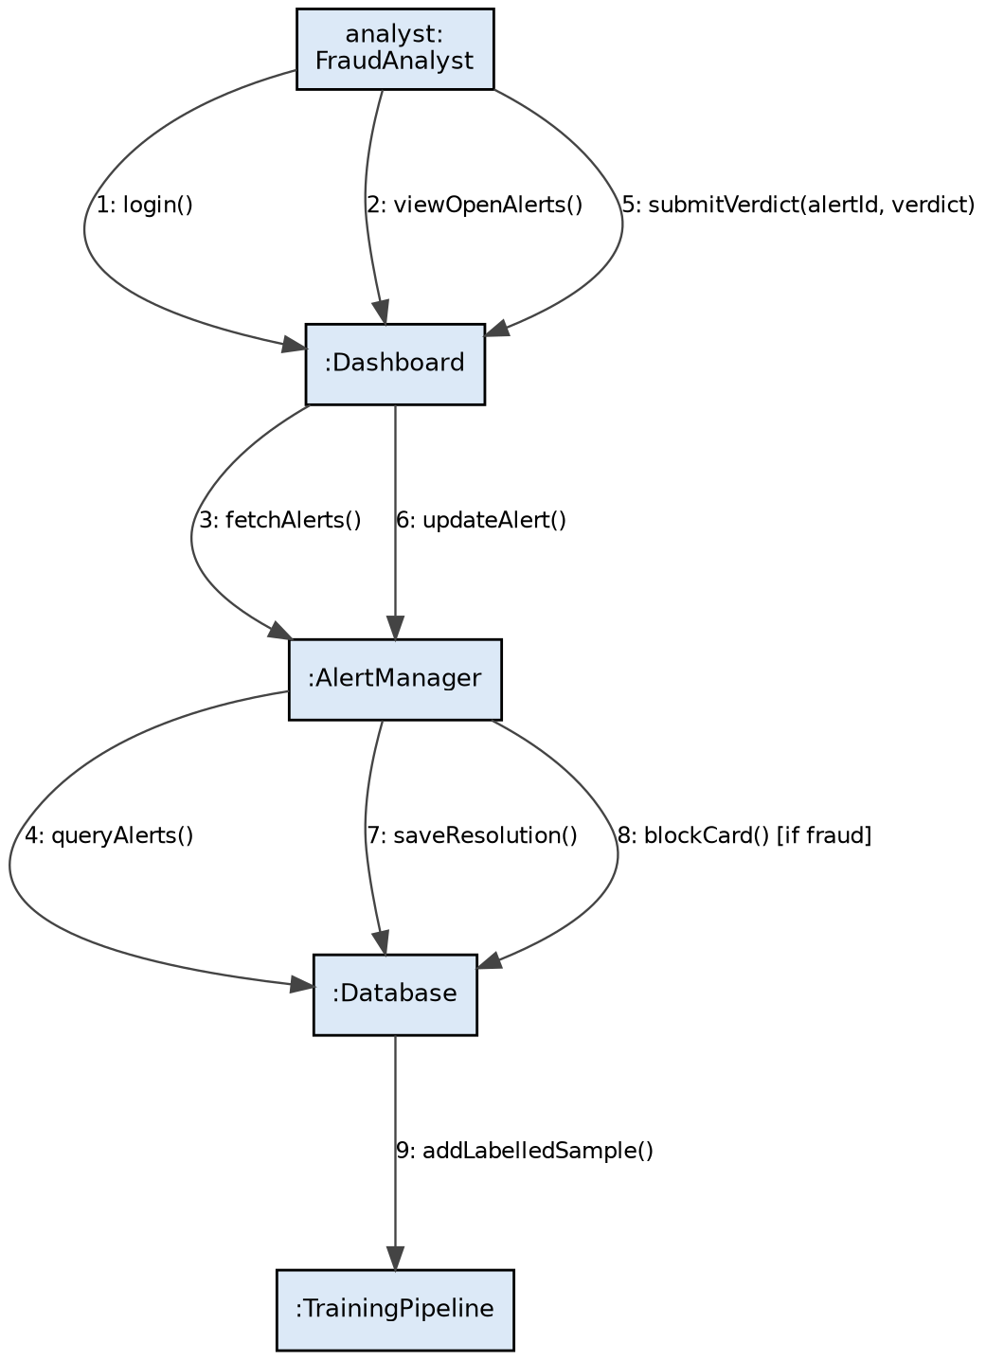
Fig. 8.3: Collaboration diagram: analyst alert review

Implementation Note (as built in the demonstrator)
The scoring sequence runs in one database transaction: validate, read the card history (the “Feature Store” is an indexed SQL query, not a separate service), score with the rules and, when features exist, the in-process ML model, save the transaction, create the alert and the simulated cardholder message, write the audit entry, return the decision. The analyst’s verdict, the card block and their audit entries are likewise committed together; a failed audit write rolls everything back (tested).
Result:- The sequence diagram and the collaboration diagrams were drawn for the system.

Experiment 9 (CBS 1): Implementation View: Component Diagram
Aim:- To perform the implementation view diagram: component diagram for the Credit Card Fraud Detection System.
Software Used:- StarUML

Theory
A component diagram is used to break down a large object-oriented system into smaller components so that it becomes easier to manage. It models the physical view of a system, such as executables, files and libraries. It visualises the relationships and organisation between the components and helps in forming an executable system. A component is a single unit of the system that is replaceable and executable. Its implementation details are hidden and it needs an interface to execute a function; it is like a black box whose behaviour is described by its provided and required interfaces.

Component Diagram
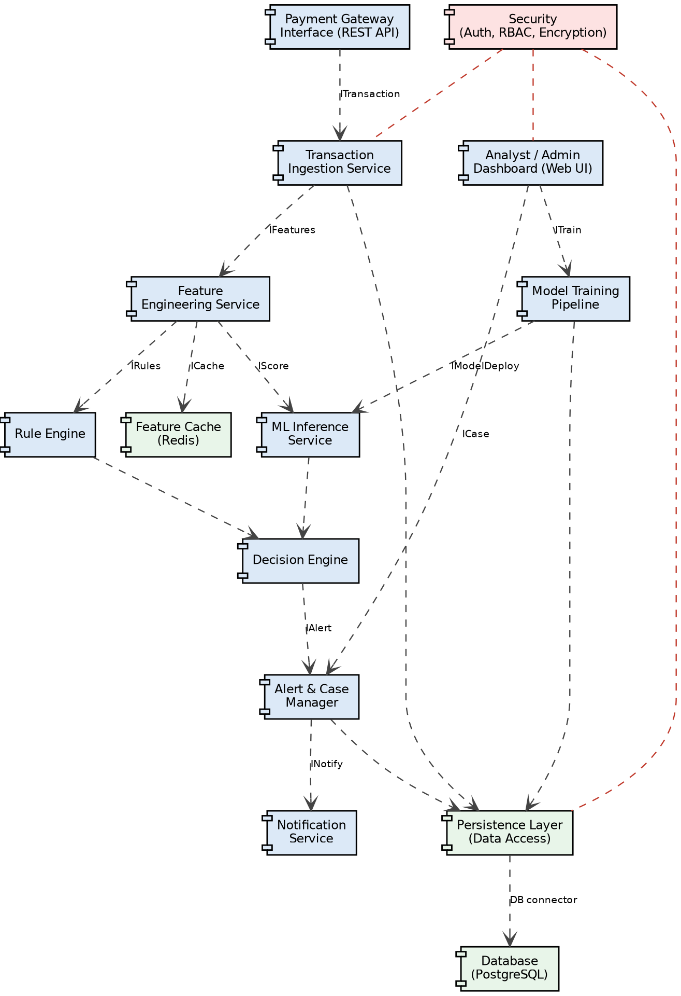
Fig. 9.1: Component diagram of the Credit Card Fraud Detection System
Component | Responsibility
Payment Gateway Interface | REST API through which the gateway submits transactions and gets decisions.
Transaction Ingestion Service | Validates and stores incoming transactions.
Feature Engineering Service | Builds behavioural features using the card history and the Redis feature cache.
Rule Engine | Applies configurable business rules and returns rule flags.
ML Inference Service | Loads the active model and returns the fraud probability.
Decision Engine | Combines rule and model outputs and applies thresholds.
Alert & Case Manager | Creates alerts, assigns cases and records analyst verdicts.
Notification Service | Sends SMS/e-mail messages to cardholders.
Analyst / Admin Dashboard | Web UI for alert review, configuration and reports.
Model Training Pipeline | Retrains and evaluates models and deploys them to the inference service.
Security | Authentication, role-based access control and encryption used by other components.
Persistence Layer, Database, Feature Cache | Data-access layer with the PostgreSQL database (connected by a database connector) and the Redis cache.

Implementation Note (as built in the demonstrator)
The demonstrator is a modular monolith. The as-built component diagram is shown below; the target design above is unchanged. Differences: no Redis feature cache (SQL query instead), PostgreSQL replaced by SQLite, ML inference runs in-process rather than as a separate service, the Notification Service is a simulated outbox (optional SMTP only for sign-in codes), and training is an offline command.
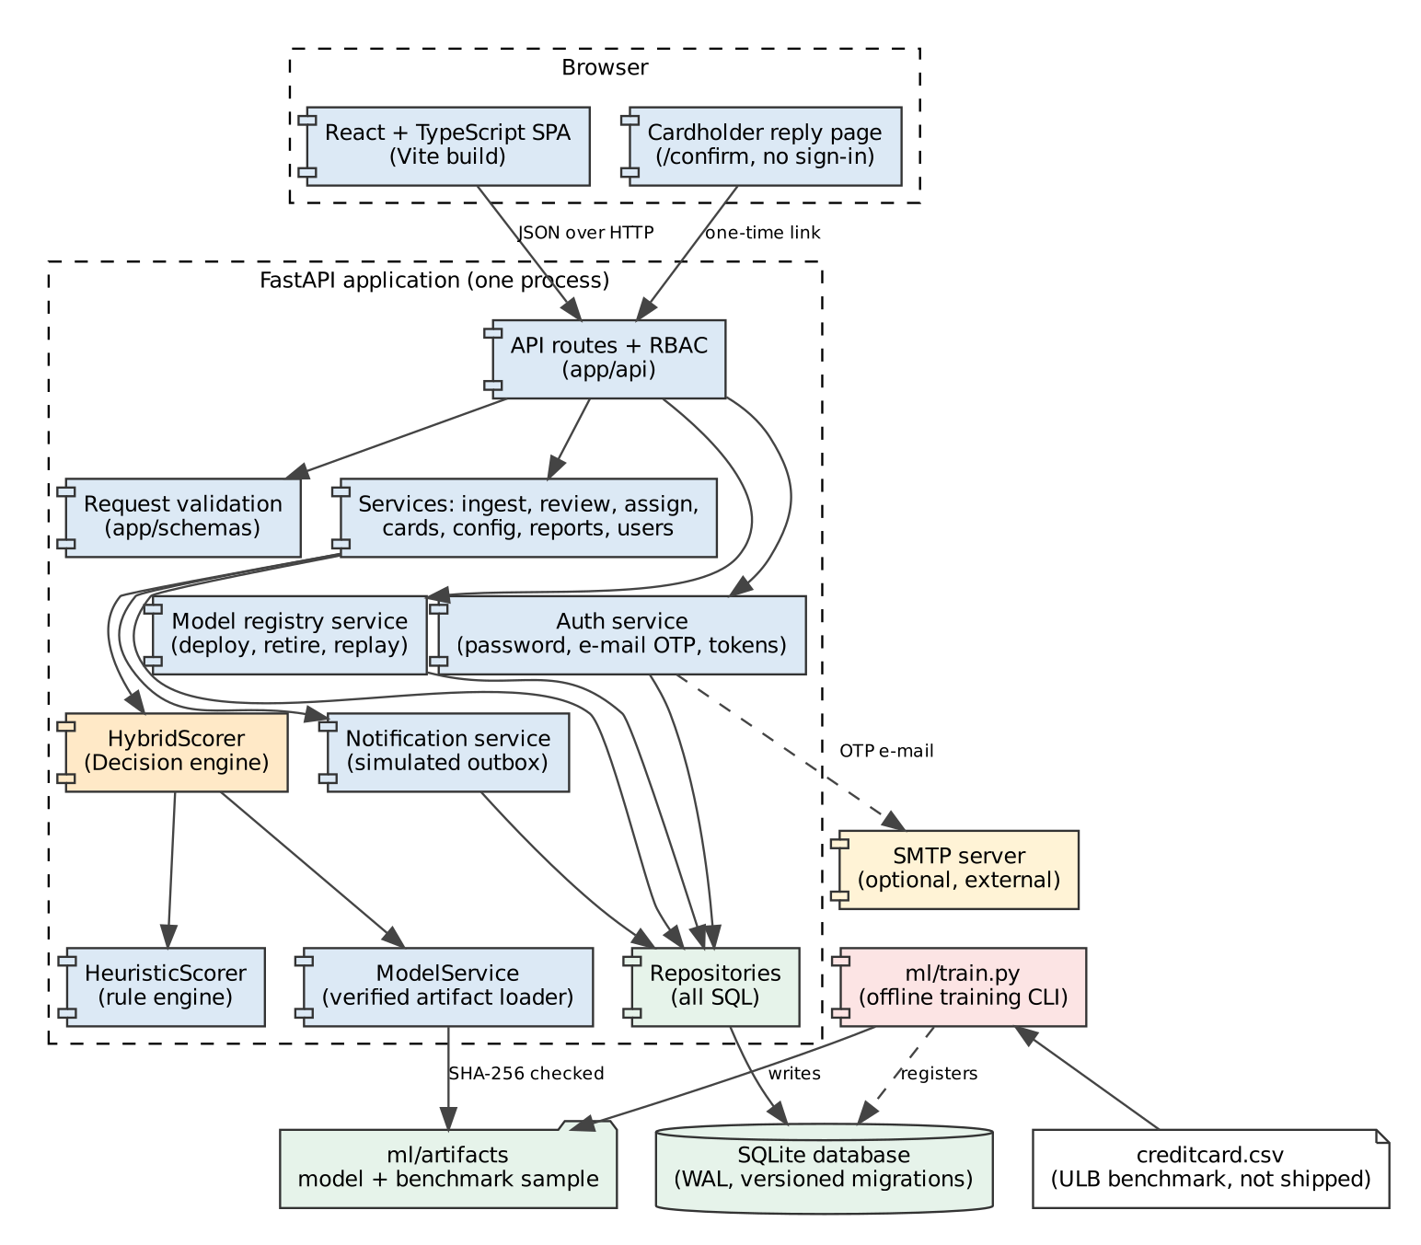
Fig. 9.2: As-built component diagram of the demonstrator
Result:- The component diagram of the system was drawn.

Experiment 10 (CBS 2): Environmental View: Deployment Diagram
Aim:- To perform the environmental view diagram: deployment diagram for the Credit Card Fraud Detection System.
Software Used:- StarUML

Theory
The deployment diagram visualises the physical hardware on which the software will be deployed. It shows the static deployment view of a system, in terms of nodes and their relationships. It maps the software architecture created in design to the physical system architecture where the software is executed as nodes. Since many nodes are involved, the relationships between them are shown by communication paths.

Deployment Diagram
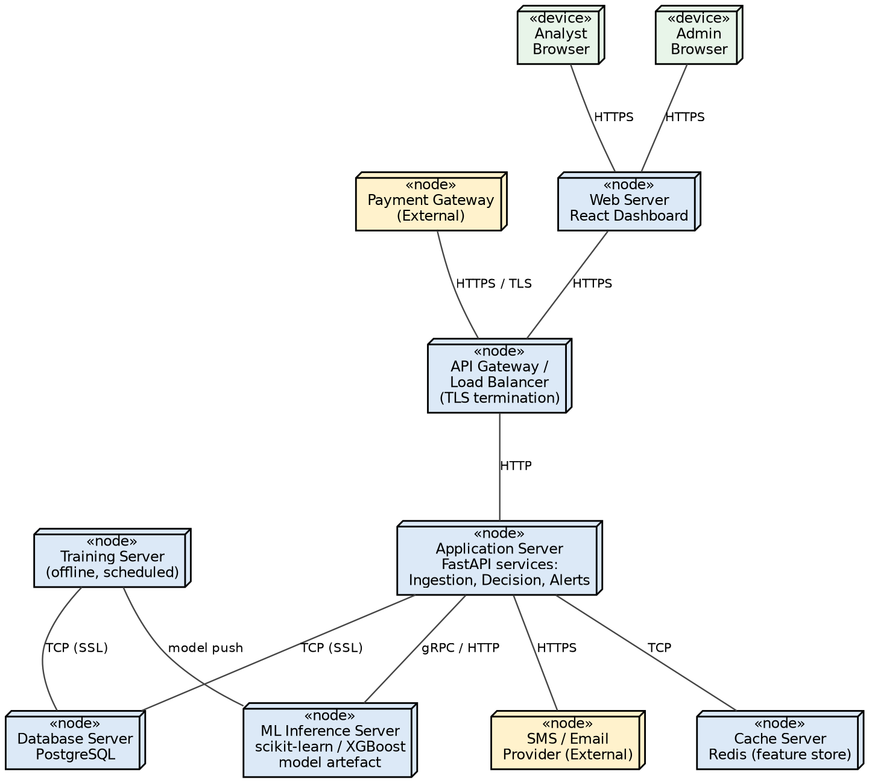
Fig. 10.1: Deployment diagram of the Credit Card Fraud Detection System
Node | Software deployed / role | Connection
Analyst / Admin Browser | Standard web browser used to access the dashboard | HTTPS to the web server
Web Server | Serves the React dashboard | HTTPS to the API gateway
Payment Gateway (external) | Sends transaction requests | HTTPS/TLS to the API gateway
API Gateway / Load Balancer | TLS termination, authentication and request routing | HTTP to the application server
Application Server | FastAPI services: ingestion, decision engine, alert and case manager | gRPC/HTTP to the ML server; TCP to cache and database; HTTPS to SMS/e-mail provider
ML Inference Server | Trained model artefact (scikit-learn / XGBoost) served for real-time predictions | Receives model updates from the training server
Cache Server | Redis store for recent card activity used in feature computation | TCP
Database Server | PostgreSQL database for transactions, alerts, users and model metadata | TCP (SSL)
Training Server | Offline, scheduled model training and evaluation jobs | TCP (SSL) to the database; model push to inference server
SMS / E-mail Provider (external) | Delivers notifications to cardholders | HTTPS

Implementation Note (as built in the demonstrator)
The demonstrator runs on one machine and binds to 127.0.0.1. There is no API gateway, load balancer, TLS termination, separate database or cache server, or SMS provider; those remain the proposed production deployment shown above.
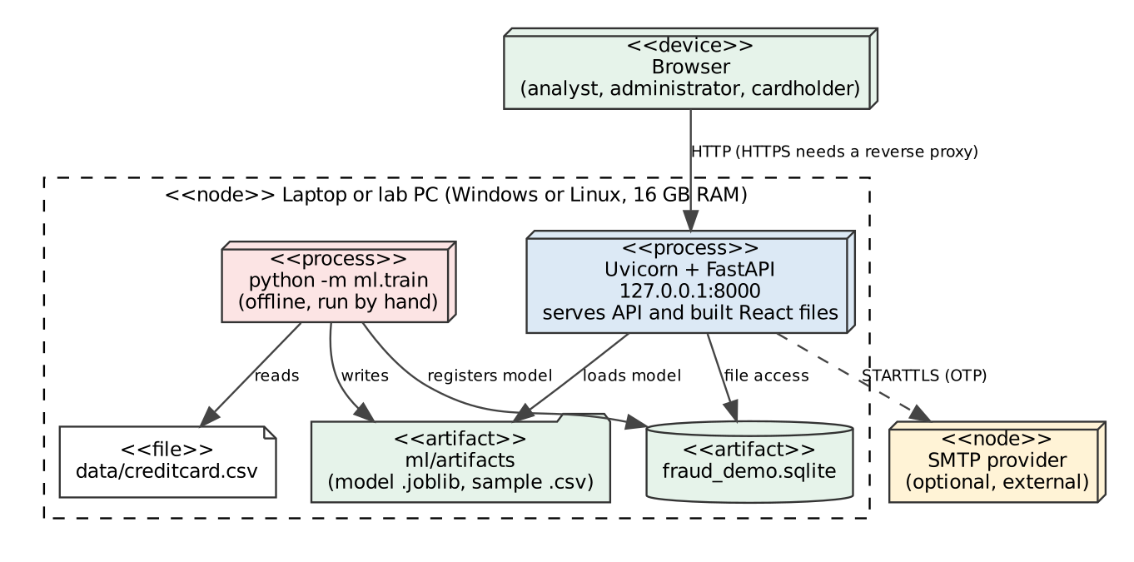
Fig. 10.2: As-built deployment of the demonstrator
Result:- The deployment diagram showing the hardware nodes and their communication paths was drawn.

Experiment 11: Testing: Unit Testing and Integration Testing with a Testing Tool
Aim:- To perform unit testing and integration testing, with black-box test design, on the working code of the Credit Card Fraud Detection System using a testing tool.
Software Used:- pytest 8 with the FastAPI test client and pytest-cov (coverage.py) for the Python back end; Vitest with Testing Library for the React front end; the TypeScript compiler in strict mode. Python 3.12.3.

Theory
Unit testing checks the smallest testable parts (functions and classes) in isolation. Integration testing checks that units work together, here through the real HTTP interface and a real database. Black-box (functional) testing designs cases from the specification without looking at the code: boundary value analysis tests values at and next to the edges of an input range, equivalence class partitioning tests one representative of each class of inputs that should behave alike, and decision-table testing covers every combination of conditions. Structural (white-box) testing is measured here as statement coverage. Regression testing means rerunning the whole suite after every change.

Test environment and method
Every test creates its own temporary SQLite database, so tests are independent and never touch the demo database. The API is called through the FastAPI test client (the real application, routing, validation, services and database). Test data is deterministic. The rule-based scoring unit is tested directly with explicit inputs; the ML component is tested with the shipped model and with a stub.

A. Unit testing
Unit | What is verified | Tests in
scoring.HeuristicScorer | Each of the nine rules adds its documented points; thresholds are strict (amount exactly ₹50,000 is not flagged); score cap at 1.0 and factors always sum to the score; benchmark rows skip rules | test_scoring
scoring.decide | APPROVE / HOLD / DECLINE boundaries at 0.25 and 0.65 | test_scoring, BVA-25..30
scoring.HybridScorer | Noisy-OR combination with the model; fallback to rules without features or when no model is live | test_scoring
schemas.models validators | Amount, token, country, currency, channel, PAN-like values, control characters, feature vector | test_exp11_black_box, test_workflows
geo.haversine_km, to_inr | Distance between known cities, unknown city handling, fixed demo FX | test_scoring, test_india_and_alerts
integrity.row_hash + audit chain | Hash chain verifies; edits and deletions are detected | test_india_and_alerts
core.security | Argon2 hashes, token signing and expiry | test_auth
ml_service.ModelService | Loads only verified artifacts inside the artifacts directory; refuses tampered or foreign files; prediction failure falls back to rules | test_ml

B. Integration testing
Integration tests drive complete workflows through the API and check the database and audit trail afterwards, for example: submit a transaction → alert and cardholder message created → cardholder replies “not me” → card blocked → analyst verdict → audit chain still verifies. Other covered flows: duplicate and concurrent verdicts (exactly one succeeds), blocked card rejection, assignment rules for analysts and administrators, configuration changes applied to new transactions, user management and last-administrator protection, password and one-time-code sign-in (wrong, expired and reused codes), model deploy, retire, replay and tampered-artifact refusal, migration of a version-1 database in place, rollback when an audit write fails, database failure returning 503, and static-file path traversal.
Test module | Kind | Tests
test_auth.py | Integration (sign-in, one-time code, roles, user management, CLI) | 18
test_db_and_failures.py | Integration (migrations, isolation, failure handling, static serving) | 7
test_exp11_black_box.py | Black-box design (boundary value, equivalence class, decision table, state transition) | 64
test_india_and_alerts.py | Integration (India features, alerts, cardholder reply, assignment, audit chain) | 19
test_ml.py | Integration (model registry, replay, tamper checks) | 10
test_scoring.py | Unit (rule engine, decision thresholds, hybrid scorer) | 17
test_smoke.py | Integration (original five API scenarios) | 5
test_workflows.py | Integration + validation (API, database, reports, CSV) | 41
Total (backend, pytest) |  | 181
Frontend (Vitest + Testing Library) | Component and flow tests with a mocked API | 26

C. Black-box test design
Boundary value analysis
ID | Input under test | Test values | Expected
BVA-1..6 | amount (valid 0.01 to 100,000,000) | 0 | 0.01 | 0.02 | 99,999,999.99 | 100,000,000 | 100,000,000.01 | reject, accept, accept, accept, accept, reject
BVA-7..12 | card token length (valid 4 to 40) | 3 | 4 | 5 | 39 | 40 | 41 characters | reject, accept ×5 up to 40, reject at 41
BVA-13..15 | country code length (valid 2) | 1 | 2 | 3 letters | reject, accept, reject
BVA-16..18 | benchmark feature count (valid 28) | 27 | 28 | 29 values | reject, accept, reject
BVA-19..21 | high-amount rule (limit ₹50,000) | 49,999.99 | 50,000 | 50,000.01 | no flag, no flag, flag
BVA-22..24 | velocity rule (limit 4 earlier transactions) | 3 | 4 | 5 | no flag, flag, flag
BVA-25..30 | decision thresholds (approve ≤ 0.25 < hold ≤ 0.65) | 0.2499 | 0.25 | 0.2501 | 0.6499 | 0.65 | 0.6501 | APPROVE, APPROVE, HOLD, HOLD, HOLD, DECLINE

Equivalence class partitioning
ID | Input | Equivalence classes (representative value) | Expected
ECP-1..7 | channel | POS, ONLINE, ATM, WALLET (valid); FAX, “online”, empty (invalid) | valid accepted; invalid rejected (422)
ECP-8..15 | currency | INR, USD, EUR, GBP, AED, SGD (valid); JPY, “inr” (invalid) | valid accepted; invalid rejected
ECP-16..22 | card token | SYNTH-IN-1001, a_b-c_9 (valid); with space, with symbol, markup, 16-digit and 19-digit card numbers (invalid) | valid accepted; invalid rejected; card numbers never stored

Decision table for the three independent scoring rules
ID | C1 blocked country | C2 amount above ₹50,000 | C3 online channel | Score | Decision
DT-1 | No | No | No | 0.04 | APPROVE
DT-2 | No | No | Yes | 0.14 | APPROVE
DT-3 | No | Yes | No | 0.39 | HOLD
DT-4 | No | Yes | Yes | 0.49 | HOLD
DT-5 | Yes | No | No | 0.79 | DECLINE
DT-6 | Yes | No | Yes | 0.89 | DECLINE
DT-7 | Yes | Yes | No | 1.00 (capped) | DECLINE
DT-8 | Yes | Yes | Yes | 1.00 (capped) | DECLINE

State-transition cases ST-1 to ST-4 confirm that an alert can be resolved exactly once: any second verdict, in any combination, returns a conflict (409). All cases above were executed by pytest and passed.

D. Results
Measure | Result
Back-end tests (pytest) | 181 run, 0 failed, 0 skipped
Back-end statement coverage (pytest-cov) | 96.6% of 1552 statements
Front-end tests (Vitest) | 26 run, 0 failed
TypeScript strict type check | passed
Scoring latency, in-process | median 5.8 ms, 95th percentile 7.7 ms over 300 requests (excludes network)
Size of the code base (non-blank lines) | 1,988 Python, 1,572 TypeScript/CSS, 885 Python test lines

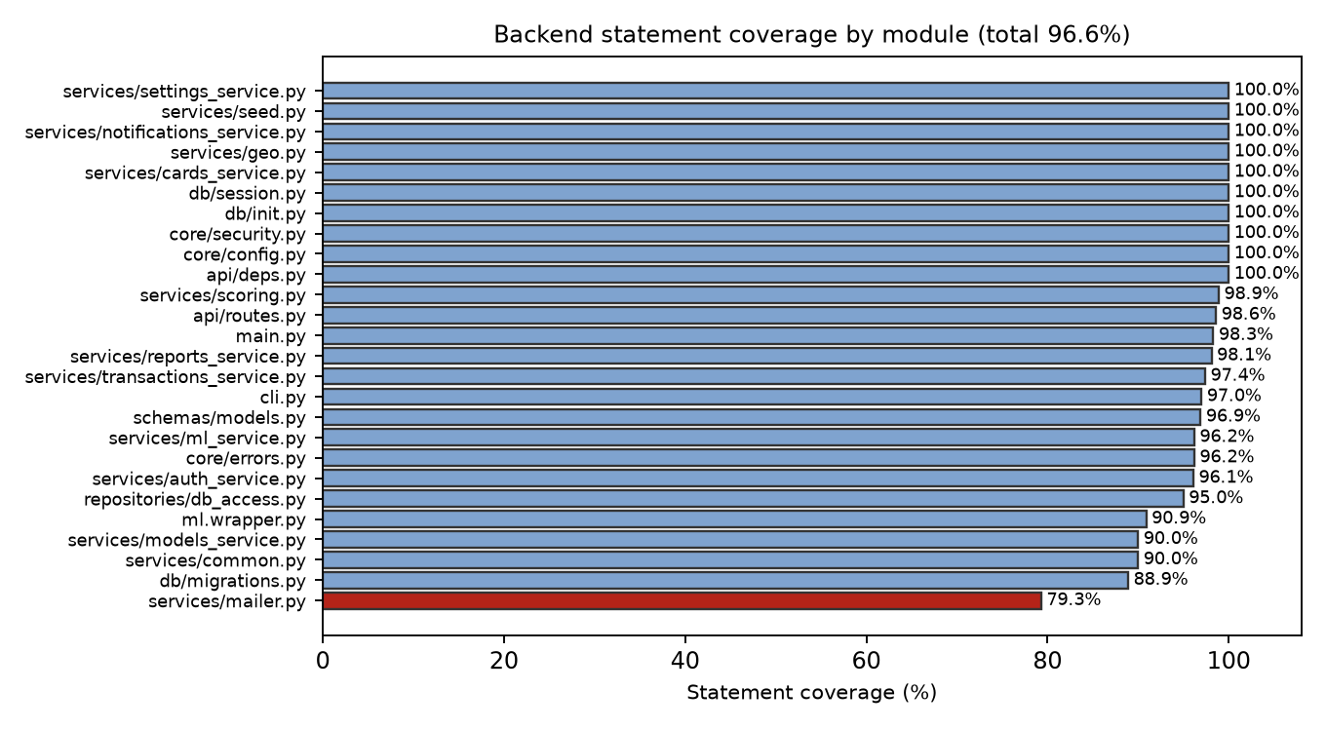
Fig. 11.1: Statement coverage by back-end module (measured by pytest-cov)
Lowest-covered modules: app/services/mailer.py 79.3%; app/db/migrations.py 88.9%; app/services/common.py 90.0%; app/services/models_service.py 90.0%. Statements not covered are mostly defensive branches (unreachable database errors, optional dependency fallbacks) and command-line paths that need a real terminal or mail server.

E. Defects found by the tests during development
• The score explanation did not add up when the score was capped at 1.0 (factors summed to more than the score). Found by the persisted-explanation test; fixed by adding an explicit negative “score cap” factor.
• A page crashed to a blank screen when the server returned data in an unexpected shape. Found by a front-end test; fixed with an error boundary that shows a recoverable message.
• Two simultaneous verdicts on one alert could both appear to succeed. The concurrency test drives eight parallel requests; the review is now an atomic update so exactly one succeeds.

Commands to reproduce
python -m pytest --cov=app | cd frontend && npm test && npm run typecheck | python scripts/collect_results.py (records the figures above)

Limitations
The suites do not include load testing, penetration testing, mutation testing, screen-reader accessibility checks or automated browser tests; the user interface was checked through component tests with a mocked API. The model’s quality is reported separately on the ML page (held-out test split), not by these functional tests.
Result:- Unit tests, integration tests and black-box test cases (boundary value, equivalence class, decision table, state transition) were designed and executed with pytest and Vitest, and the measured results and coverage are recorded above.

Experiment 12: Effort Estimation using Function Point (FP) Analysis
Aim:- To estimate the size and effort of the Credit Card Fraud Detection System using Function Point analysis.
Software Used:- Python script (docs/lab-file/build_lab_file.py) for the arithmetic; the same tables can be reproduced in a spreadsheet.

Theory
Function Point analysis measures the size of software from the functions it gives its users, independent of the programming language. Five kinds of function are counted: external inputs (EI) that bring data in or change data, external outputs (EO) that present derived or calculated data, external inquiries (EQ) that retrieve data without calculation, internal logical files (ILF) that the system maintains, and external interface files (EIF) that it only reads. Each function is rated Low, Average or High complexity and given a weight (EI 3/4/6, EO 4/5/7, EQ 3/4/6, ILF 7/10/15, EIF 5/7/10). The sum is the unadjusted function points (UFP). Fourteen general system characteristics (GSC), each rated 0 to 5, give the total degree of influence TDI, the value adjustment factor VAF = 0.65 + 0.01 × TDI, and AFP = UFP × VAF. Effort follows from AFP and a productivity figure.

Function count for the working system
External inputs | Complexity | FP
Submit transaction | High | 6
Record analyst verdict | Average | 4
Assign or unassign alert | Low | 3
Update risk configuration | Average | 4
Block or unblock card | Low | 3
Create or update user, reset password | Average | 4
Sign in with password and one-time code | Average | 4
Cardholder reply (“Was this you?”) | Average | 4
Change own password | Low | 3
Deploy or retire model | Average | 4
Replay benchmark sample | Average | 4
Subtotal |  | 43

External outputs | Complexity | FP
Score response with factors and decision | Average | 5
Overview and report with aggregates | High | 7
Analyst productivity report | Average | 5
Transactions CSV export | Low | 4
Confirmed-label CSV export | Low | 4
Cardholder notification message | Average | 5
Audit integrity verification result | Average | 5
Subtotal |  | 35

External inquiries | Complexity | FP
Transaction search and list | Average | 4
Transaction detail with history and audit trail | High | 6
Alert queue | Average | 4
Cards list | Low | 3
Audit log list | Low | 3
Users list | Low | 3
Model registry and metrics | Average | 4
Rules and configuration view | Low | 3
Cardholder messages outbox | Low | 3
Reply-link information (public) | Low | 3
Health check | Low | 3
Subtotal |  | 39

Internal logical files | Complexity | FP
transactions (with scoring explanation) | Average | 10
customers | Low | 7
cards | Low | 7
merchants | Low | 7
fraud_alerts | Low | 7
ml_models | Low | 7
users (analysts) | Low | 7
notifications | Low | 7
audit log | Low | 7
config | Low | 7
Subtotal |  | 73

External interface file | Complexity | FP
ULB benchmark sample file (read-only reference data) | Low | 5
Subtotal |  | 5

Function type | Count | UFP
EI | 11 | 43
EO | 7 | 35
EQ | 11 | 39
ILF | 10 | 73
EIF | 1 | 5
Unadjusted function points (UFP) |  | 195

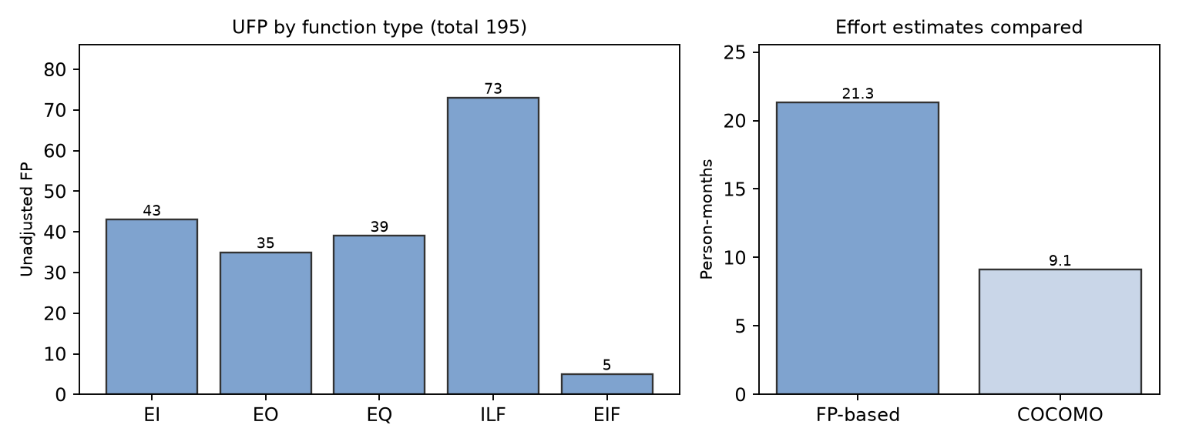
Fig. 12.1: Unadjusted function points by function type, and FP-based versus COCOMO effort
Complexity ratings are the team’s judgement from the number of data element types and files referenced by each function; they are assumptions, not measurements.

General system characteristics
No. | Characteristic | Rating (0 to 5) | Reason
1 | Data communications | 4 | Browser to server over REST/JSON
2 | Distributed data processing | 1 | One process; training is offline
3 | Performance | 3 | Latency objective; in-process scoring
4 | Heavily used configuration | 2 | Runs on a laptop; no hardware constraint
5 | Transaction rate | 3 | Bursts expected, low sustained rate in the demo
6 | On-line data entry | 5 | All entry through the web interface or API
7 | End-user efficiency | 4 | Filters, URL state, confirmation dialogs
8 | On-line update | 4 | Verdicts, blocks and configuration update immediately
9 | Complex processing | 4 | Scoring, geography, ML, access control
10 | Reusability | 3 | Scorer interface and services are reusable
11 | Installation ease | 3 | Documented commands; no services to install
12 | Operational ease | 3 | Migrations, health check, audit verification
13 | Multiple sites | 1 | Single site
14 | Facilitate change | 4 | Modular layers, configurable thresholds, versioned schema
 | Total degree of influence (TDI) | 44

VAF = 0.65 + 0.01 × 44 = 1.09. AFP = 195 × 1.09 = 212.6 function points.

Effort estimate
Assumption: a productivity of 10 function points per person-month (a commonly quoted planning figure for small business applications; replace it with your own team’s data if you have any). Effort = 212.6 ÷ 10 = 21.3 person-months. With a team of three working in parallel this is about 7.1 months before allowing for overlap, testing and documentation.
Cross-check (not a replacement): the implemented code has 3,560 non-blank lines of application code (3.56 KLOC). Basic COCOMO, organic mode, gives effort = 2.4 × KLOC^1.05 = 9.1 person-months and development time = 2.5 × effort^0.38 = 5.8 months. Function points count what the design specifies; COCOMO counts what was written, so the two are expected to differ.
Limits of this estimate: it is a size and effort estimate made from the finished design for a classroom project, not a bid. It excludes documentation effort, learning time and rework, and the productivity figure is assumed.
Result:- The system was sized at 195 unadjusted function points (212.6 adjusted, VAF 1.09), giving an estimated effort of 21.3 person-months at the assumed productivity of 10 FP per person-month.

Experiment 13: Time Line Chart: Gantt Chart and PERT Chart
Aim:- To prepare a time line (Gantt) chart and a PERT chart for the Credit Card Fraud Detection System project.
Software Used:- Python with Graphviz and Matplotlib (docs/lab-file/diagrams.py); the same network can be drawn in MS Project or any planning tool.

Theory
A Gantt chart shows each activity as a bar on a calendar, so start, duration and overlap are visible. PERT (Program Evaluation and Review Technique) draws activities as a network with dependencies and uses three duration estimates: optimistic O, most likely M and pessimistic P. The expected time is TE = (O + 4M + P) / 6 and the standard deviation SD = (P − O) / 6. A forward pass gives each activity’s earliest start (ES) and finish (EF); a backward pass from the project end gives the latest start (LS) and finish (LF). Slack = LS − ES. Activities with zero slack form the critical path, which fixes the project duration (CPM). The SD of the path is the square root of the sum of the variances of its activities.

Activities and estimates
Durations are in weeks. The schedule is a planning baseline for the project; week 1 is the project start date and should be mapped to your semester calendar.
ID | Activity | Pred. | O | M | P | TE | SD | ES | EF | LS | LF | Slack
A1 | Problem statement (Exp 1) | - | 0.5 | 1 | 1.5 | 1.0 | 0.17 | 0.0 | 1.0 | 0.0 | 1.0 | 0.0
A2 | SRS (Exp 2) | A1 | 1 | 1.5 | 3 | 1.67 | 0.33 | 1.0 | 2.67 | 1.0 | 2.67 | 0.0
A3 | DFD + structure chart (Exp 3) | A2 | 1 | 1.5 | 2 | 1.5 | 0.17 | 2.67 | 4.17 | 6.34 | 7.84 | 3.67
A4 | ER + use case (Exp 4-5) | A2 | 1 | 1.5 | 2.5 | 1.58 | 0.25 | 2.67 | 4.25 | 6.26 | 7.84 | 3.59
A5 | Class, object, state, activity (Exp 6-7) | A3,A4 | 1 | 2 | 3 | 2.0 | 0.33 | 4.25 | 6.25 | 7.84 | 9.84 | 3.59
A6 | Sequence, component, deployment (Exp 8-10) | A5 | 1 | 2 | 3 | 2.0 | 0.33 | 6.25 | 8.25 | 9.84 | 11.84 | 3.59
B1 | Backend: API, database, scoring | A2 | 2 | 3 | 5 | 3.17 | 0.5 | 2.67 | 5.84 | 2.67 | 5.84 | 0.0
B2 | Frontend (React) | B1 | 2 | 3 | 4 | 3.0 | 0.33 | 5.84 | 8.84 | 5.84 | 8.84 | 0.0
B3 | ML pipeline (train, evaluate, register) | B1 | 1 | 2 | 3 | 2.0 | 0.33 | 5.84 | 7.84 | 6.84 | 8.84 | 1.0
B4 | Sign-in, OTP, cardholder messages | B1 | 1 | 1.5 | 2.5 | 1.58 | 0.25 | 5.84 | 7.42 | 7.26 | 8.84 | 1.42
B5 | Integration and testing (Exp 11) | B2,B3,B4 | 1 | 2 | 3 | 2.0 | 0.33 | 8.84 | 10.84 | 8.84 | 10.84 | 0.0
C1 | Function-point estimate (Exp 12) | B5 | 0.5 | 1 | 1.5 | 1.0 | 0.17 | 10.84 | 11.84 | 10.84 | 11.84 | 0.0
C2 | Gantt / PERT charts (Exp 13) | A2 | 0.5 | 1 | 1.5 | 1.0 | 0.17 | 2.67 | 3.67 | 10.84 | 11.84 | 8.17
D1 | Compile and review lab file | A6,C1,C2 | 1 | 1.5 | 2 | 1.5 | 0.17 | 11.84 | 13.34 | 11.84 | 13.34 | 0.0
D2 | Demo rehearsal and submission | B5,D1 | 0.5 | 1 | 1.5 | 1.0 | 0.17 | 13.34 | 14.34 | 13.34 | 14.34 | 0.0

Gantt chart
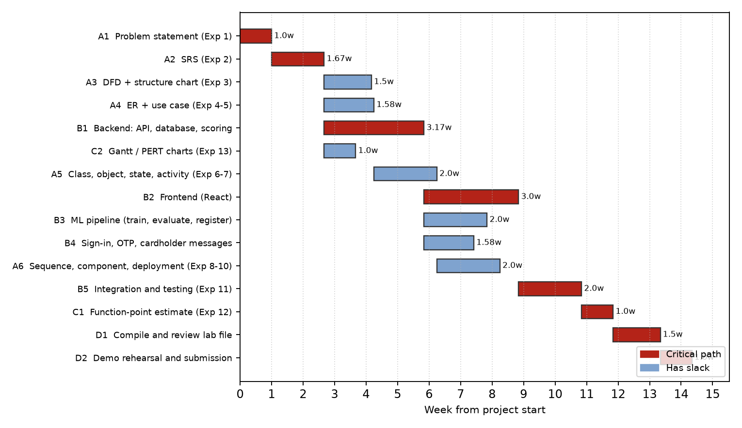
Fig. 13.1: Gantt chart (earliest-start schedule; critical activities in red)

PERT network
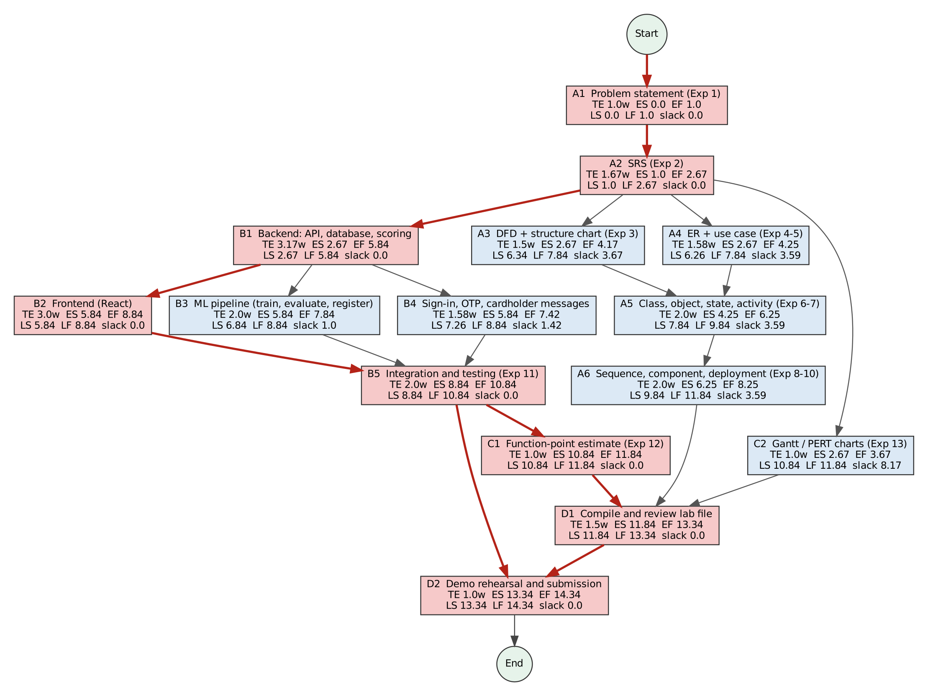
Fig. 13.2: PERT network with ES, EF, LS, LF and slack (critical path in red)

Analysis
Critical path: A1 → A2 → B1 → B2 → B5 → C1 → D1 → D2. Expected project duration: 14.34 weeks. Standard deviation of the path: 0.83 weeks. Using the normal approximation, the probability of finishing within 16 weeks is about 98% (z = 2.00). Activities with the most slack (for example the Gantt/PERT charts, A6 and the ML pipeline) can absorb delay without moving the end date; any delay in backend, frontend, integration testing, estimation or the final compilation delays the whole project.
Result:- The Gantt and PERT charts were prepared; the critical path is A1 → A2 → B1 → B2 → B5 → C1 → D1 → D2 with an expected duration of 14.34 weeks.

Appendix A: Running the Working Demonstrator
Prerequisites: Python 3.11 or newer and Node.js 20 or newer. No database server, Docker or Redis.
pip install -r requirements.txt | cd frontend && npm install && npm run build | python -m app.cli create-user --email you@example.com --name "Your Name" --role admin | uvicorn app.main:app --host 127.0.0.1 --port 8000
Open http://127.0.0.1:8000. Set FRAUD_LOGIN_OTP=true to require an e-mail code at sign-in (printed in the server terminal in development, or sent by SMTP when FRAUD_OTP_DELIVERY=smtp is configured). Set FRAUD_AUTH_REQUIRED=false for a no-login demo on a machine only you use. The model is trained with python -m ml.train --csv data/creditcard.csv (the dataset is not distributed with the project; download it from Kaggle).
Suggested demonstration path: Overview → Alerts and cases → open a held transaction (score factors, cardholder, history) → assign to yourself → Cardholder messages → open the reply link and answer “not me” → return to the alert and record a verdict → Cards (blocked token) → Audit log → Verify integrity → ML model → Replay 25 rows → Reports.
Honest limits to state during the viva: synthetic data only; the model was trained on a 2013 European dataset and applies to benchmark-feature transactions; notifications are simulated; SQLite instead of PostgreSQL; no TLS; not a payment system and not PCI DSS certified.

Appendix B: Screenshots of the Working Demonstrator
Screenshots taken from the running application (synthetic demo data, Chromium at 1440 × 900). The page-by-page set is in docs/screenshots/ in the repository.
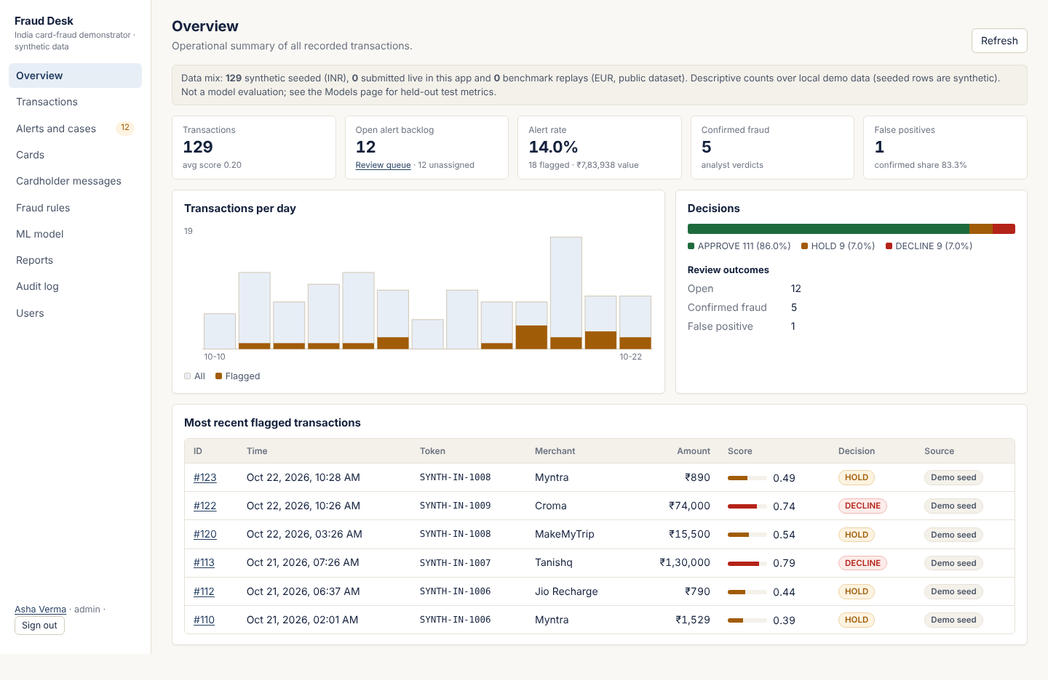
Fig. B.1: Overview: volume, decisions, backlog and flagged value in ₹
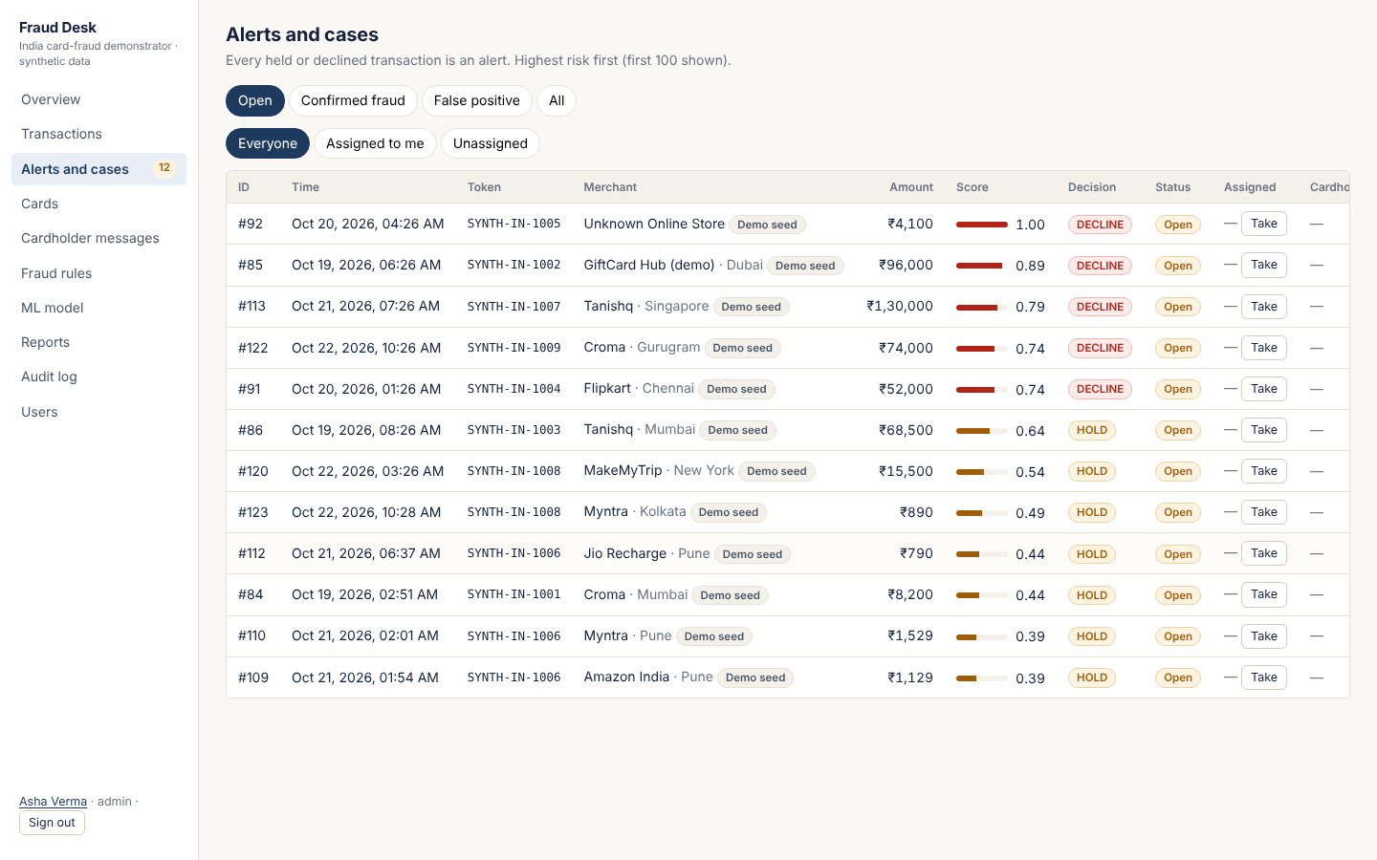
Fig. B.2: Alerts and cases: queue ordered by risk, with assignment
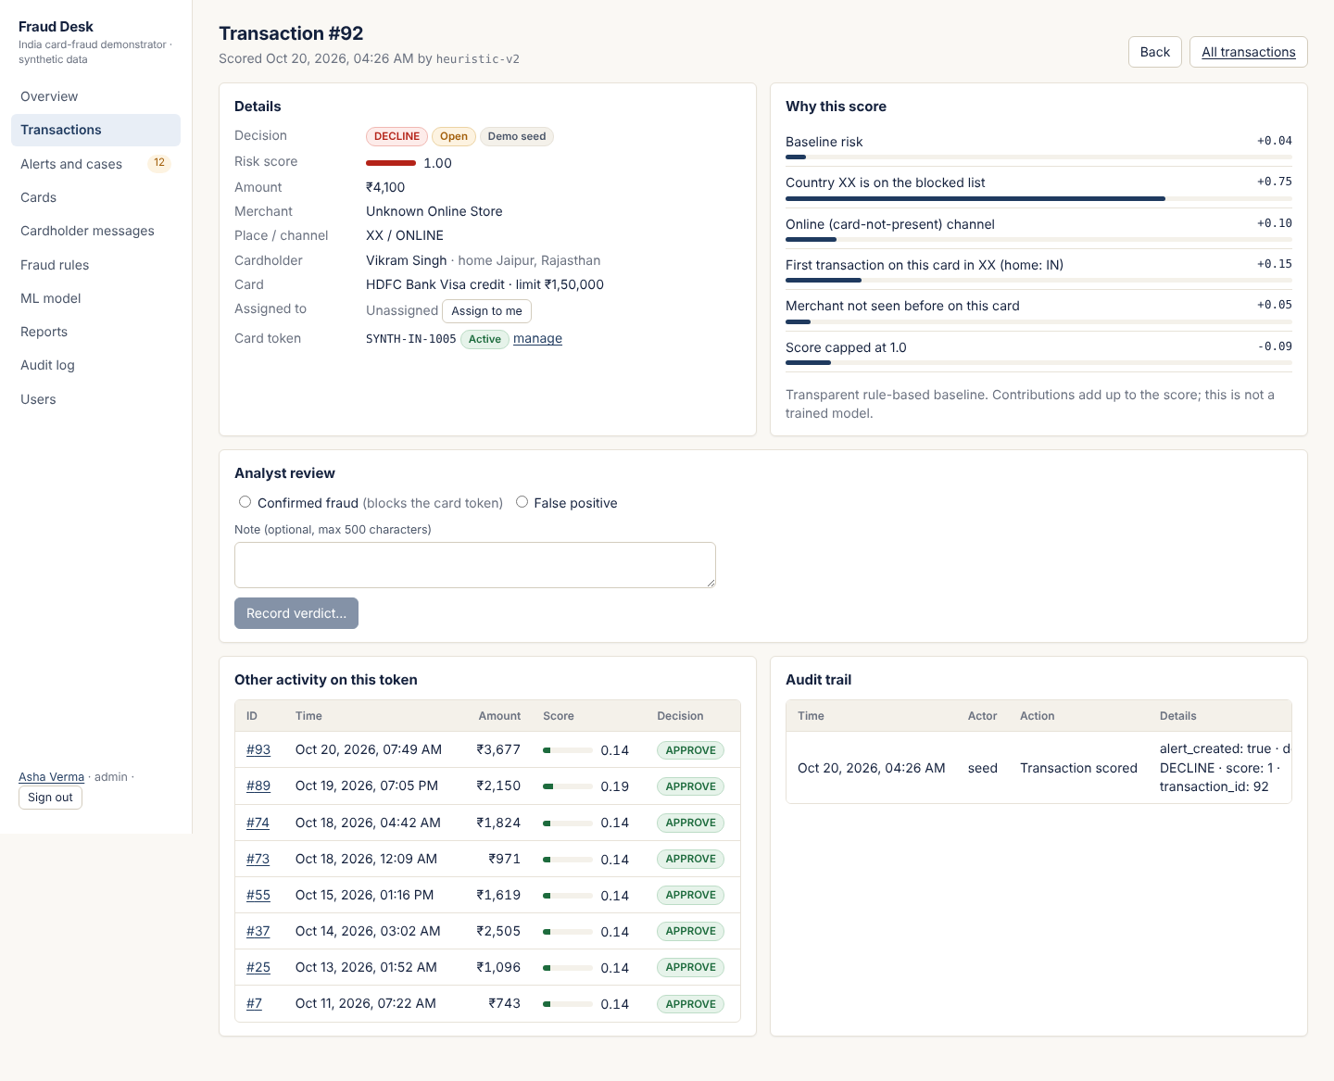
Fig. B.3: Transaction page: score factors, cardholder, history, audit trail and verdict
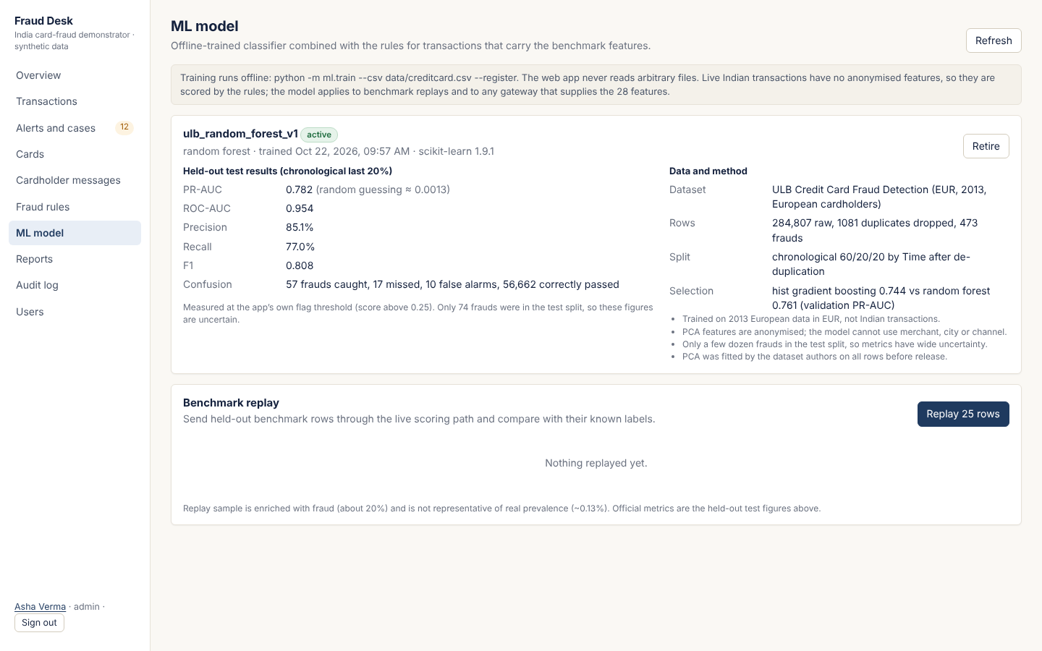
Fig. B.4: ML model page: held-out metrics, data and method, caveats
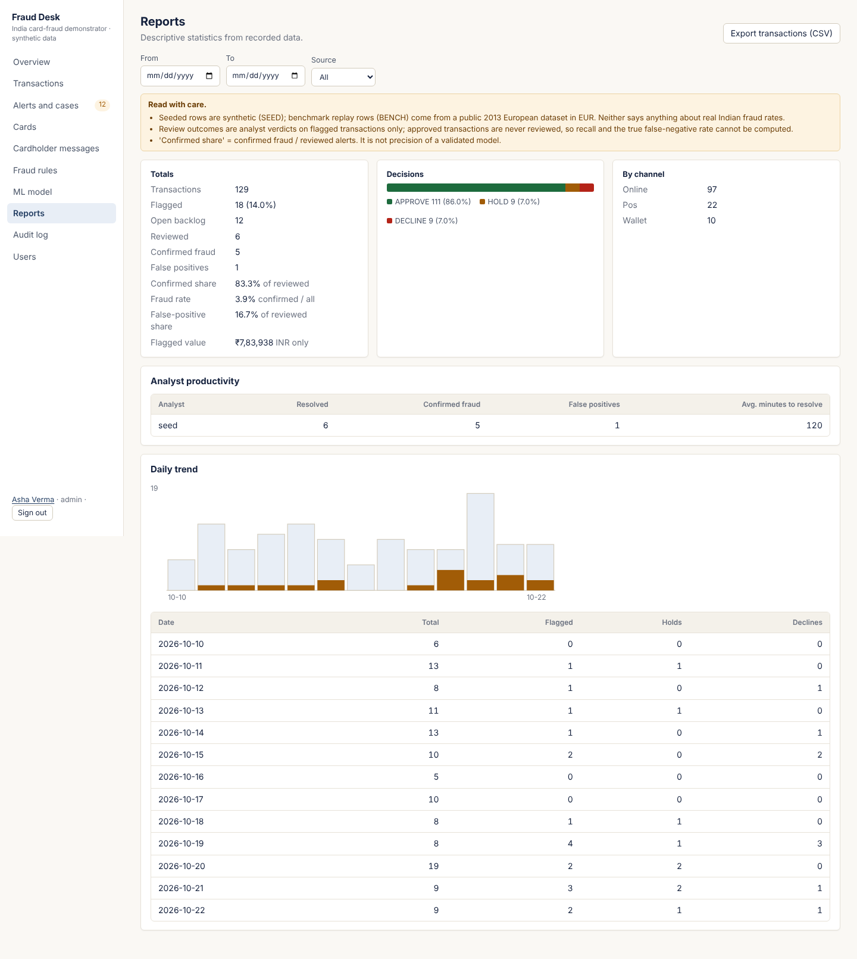
Fig. B.5: Reports: totals, rates, analyst productivity and daily trend

