MindTrack
Application Deployment
(Deploy the given React application to a production ready state)

Application:
Clone the below mentioned repository and deploy the application (Run application in port 3000).
Repo URL : https://github.com/Vennilavan12/Brain-Tasks-App.git

GIT REPO FINAL: https://github.com/bhavitharamohan/Devops-Project-.git

Docker:
- Dockerize the application by creating Dockerfile
- Build an application and check output using docker image.

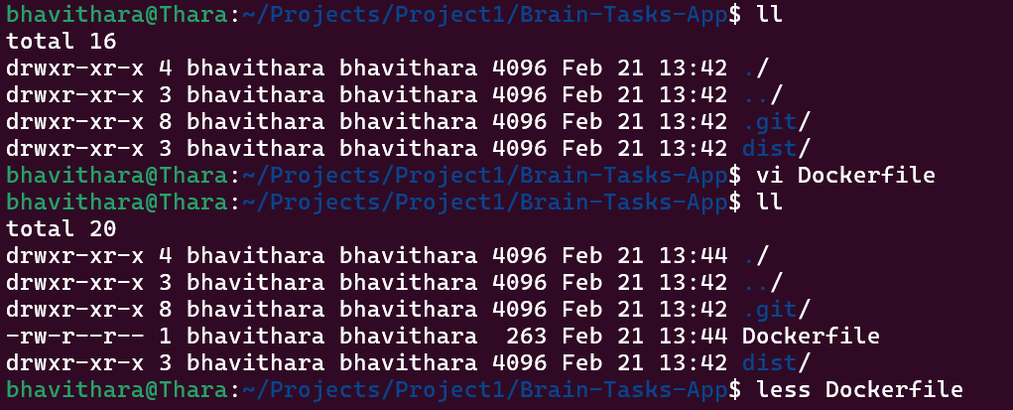

File Content:
# Use lightweight nginx image
FROM nginx:alpine

# Remove default nginx content
RUN rm -rf /usr/share/nginx/html/*

# Copy dist folder into nginx html directory
COPY dist/ /usr/share/nginx/html/

# Expose port 3000
EXPOSE 3000

CMD ["nginx", "-g", "daemon off;"]

Commands Used:
docker build -t brain-tasks-app .
docker run -d -p 3000:80 brain-tasks-app
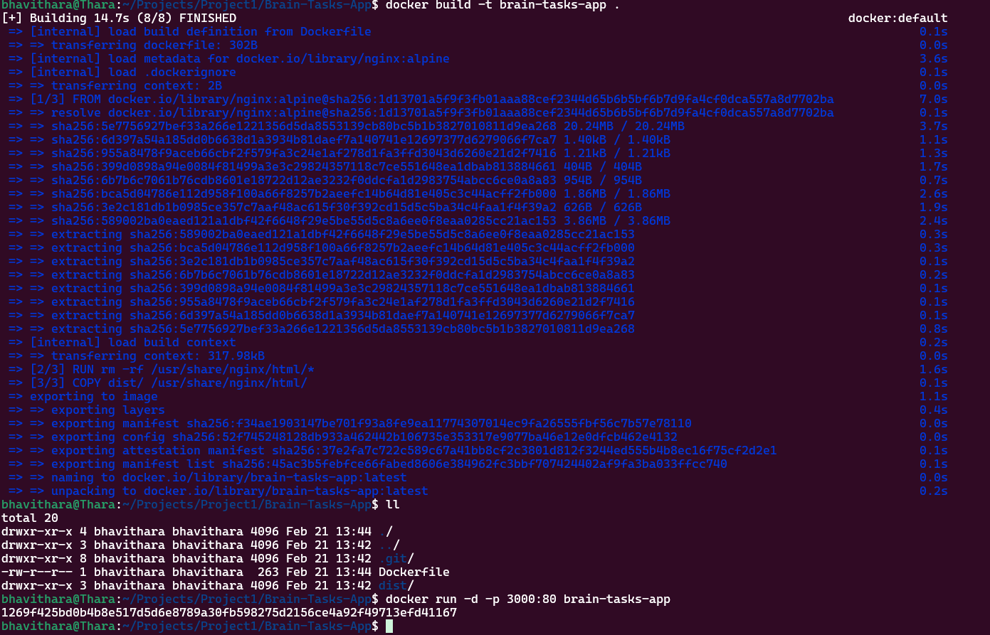

http://localhost:3000

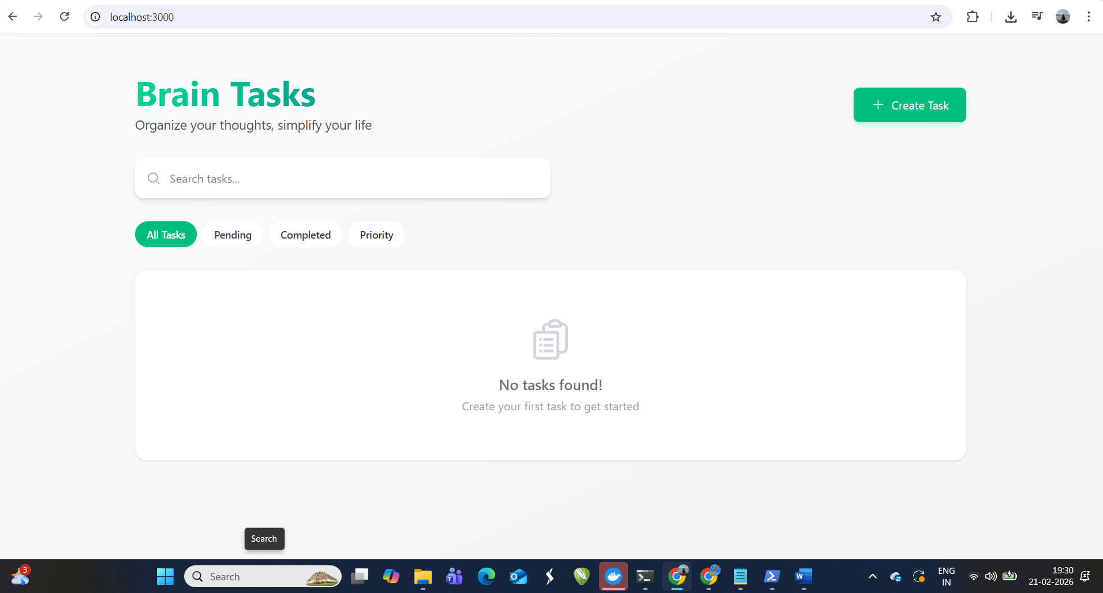

ECR:
- Create an AWS ECR repository for store docker images.

Commands Used:
- Create ECR Repository:
aws ecr create-repository \
--repository-name brain-tasks-app \
--region ap-south-1
- Authentication Docker to ECR:
aws ecr get-login-password --region ap-south-1 | \
docker login --username AWS \
--password-stdin <your_account_id>.dkr.ecr.ap-south-1.amazonaws.com
- Image Tag:
docker tag brain-tasks-app:latest \
<account_id>.dkr.ecr.ap-south-1.amazonaws.com/brain-tasks-app:latest
- Push Image:
docker push <account_id>.dkr.ecr.ap-south-1.amazonaws.com/brain-tasks-app:latest

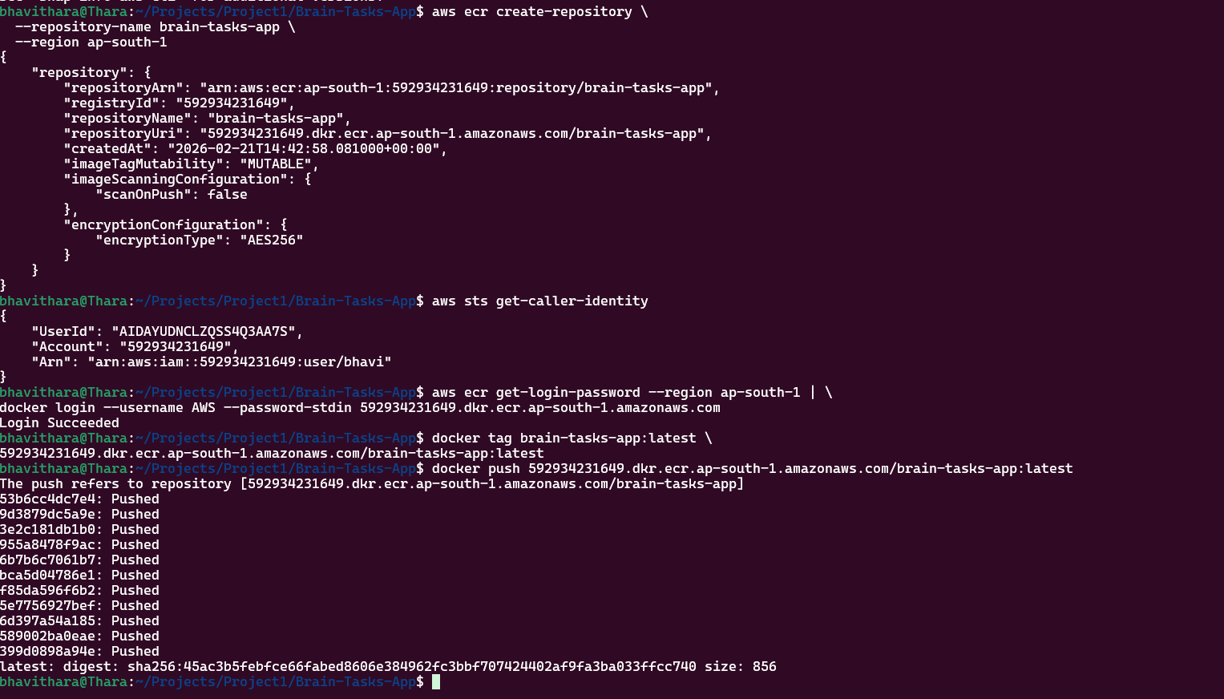

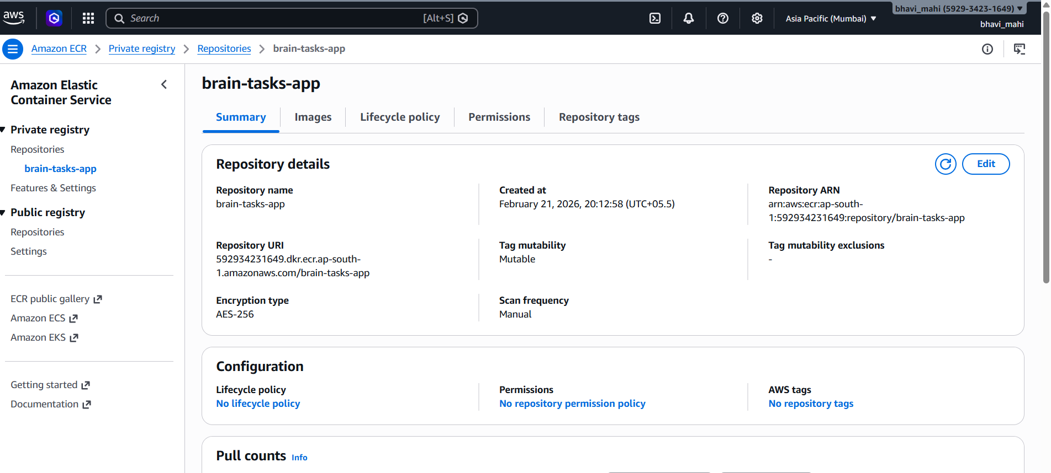
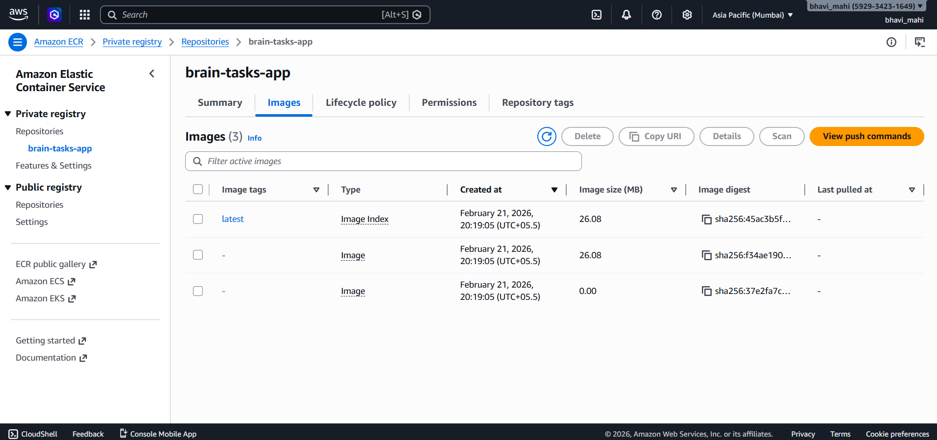

Kubernetes:
- Setup Kubernetes in AWS EKS and Confirm EKS cluster is running.
- Write deployment and service YAML files.
- Deploy using kubectl via Codedeploy.

Commands used:

eksctl create cluster --name brain-cluster --region ap-south-1 --node-type t3.small --nodes 1
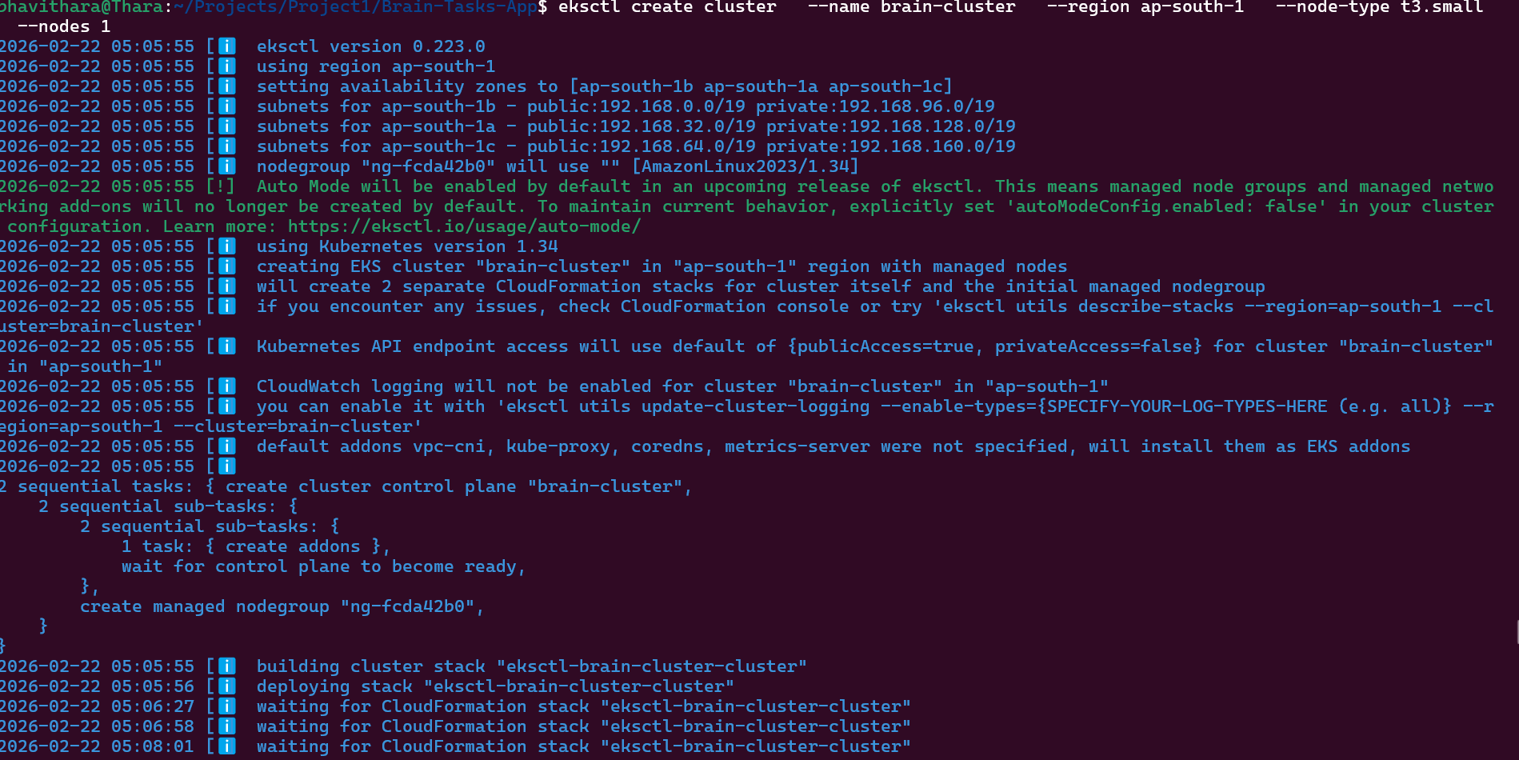
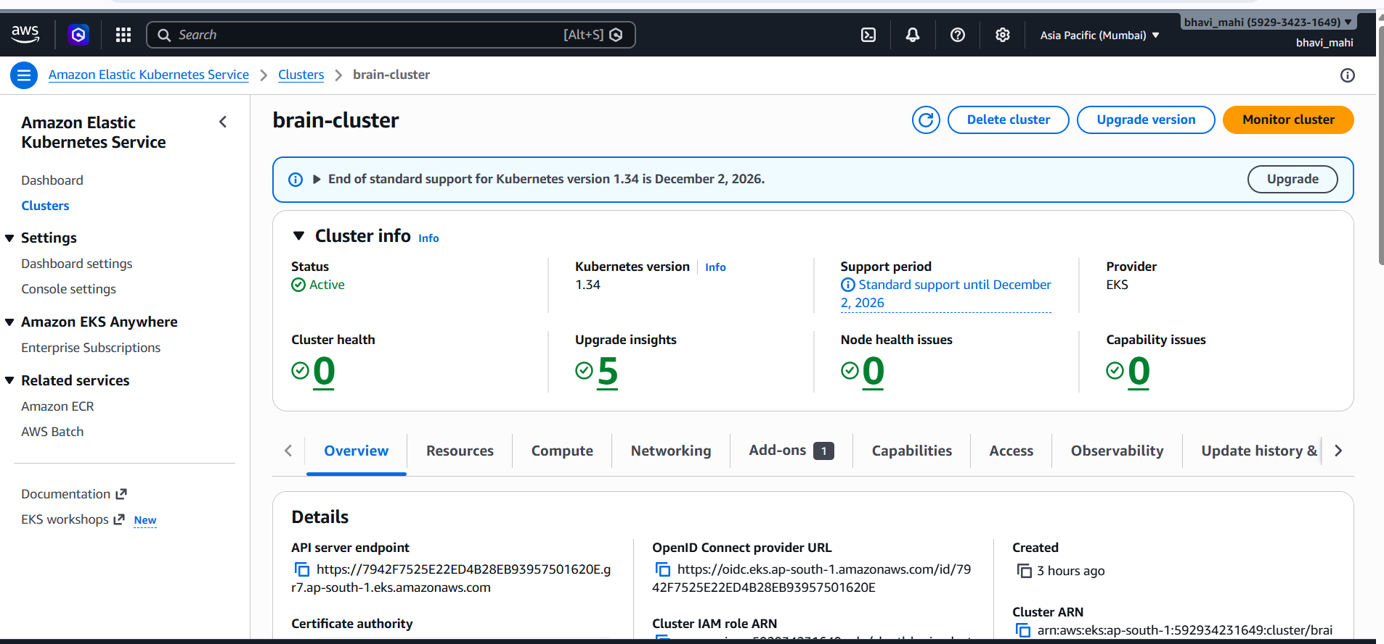

Deployment and Service yaml files are in github link :
https://github.com/bhavitharamohan/Devops-Project-/tree/main/k8s

CodeBuild:
- Create a CodeBuild project:
- Source: Connect to your repository
- Environment: Use managed image (Amazon Linux, Ubuntu)
- Write and define commands in buildspec.yml.

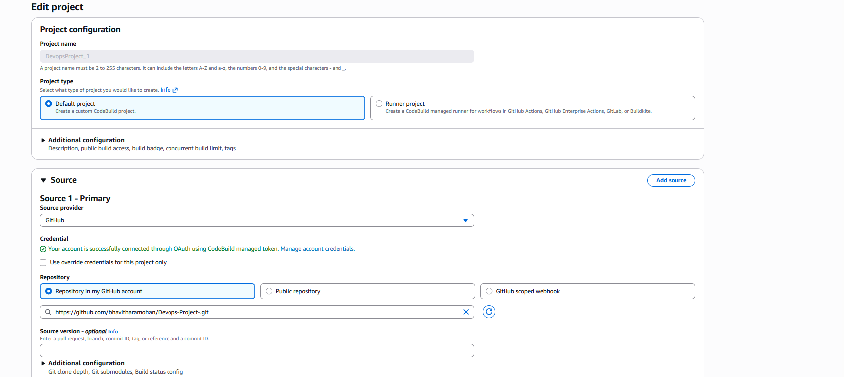

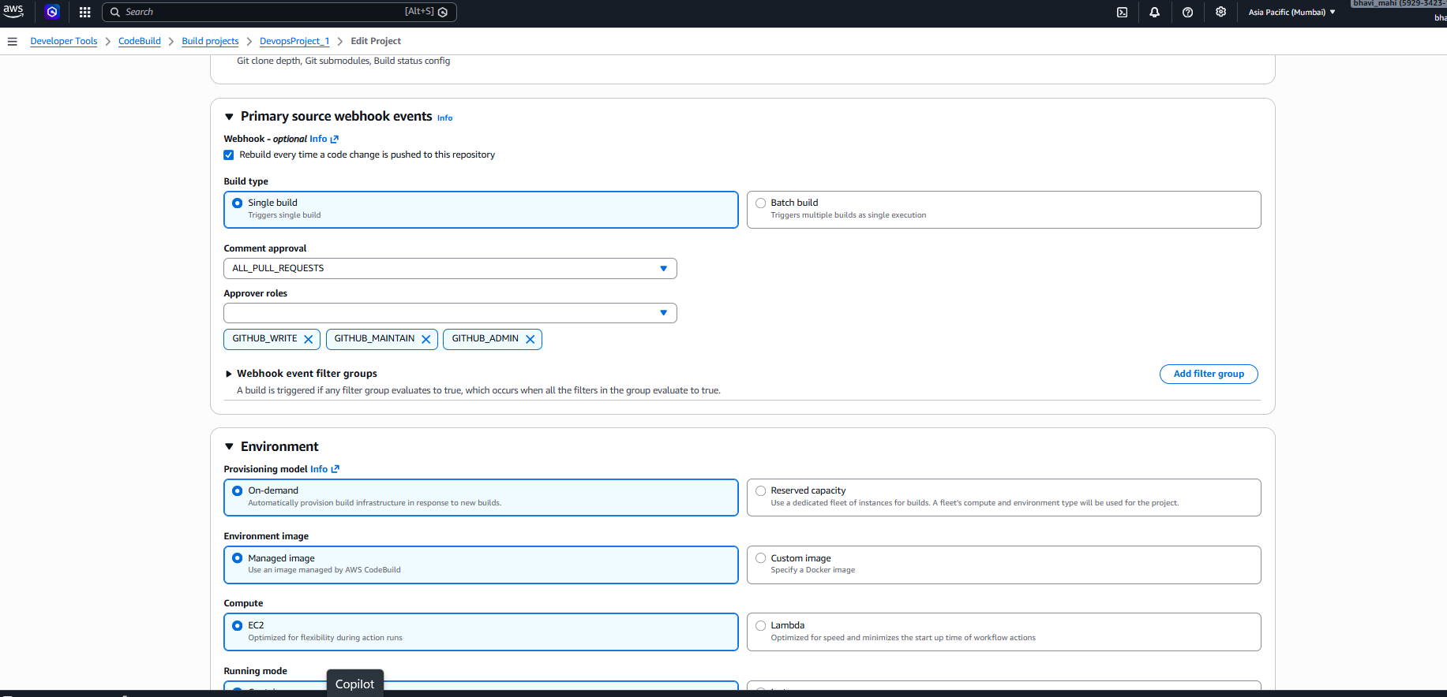

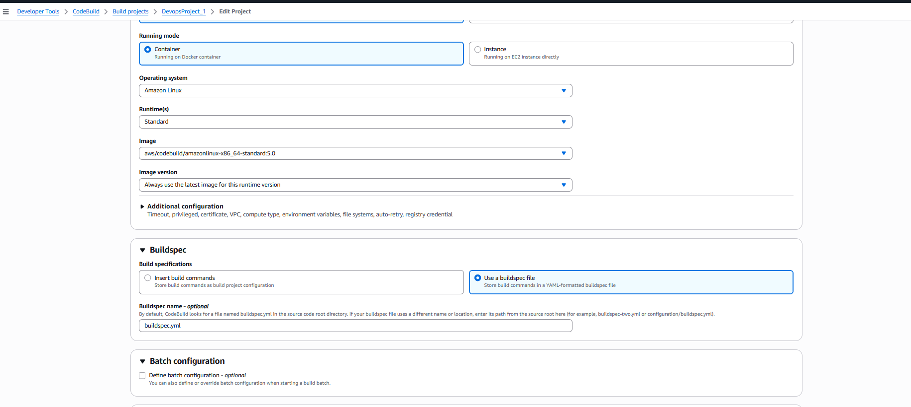
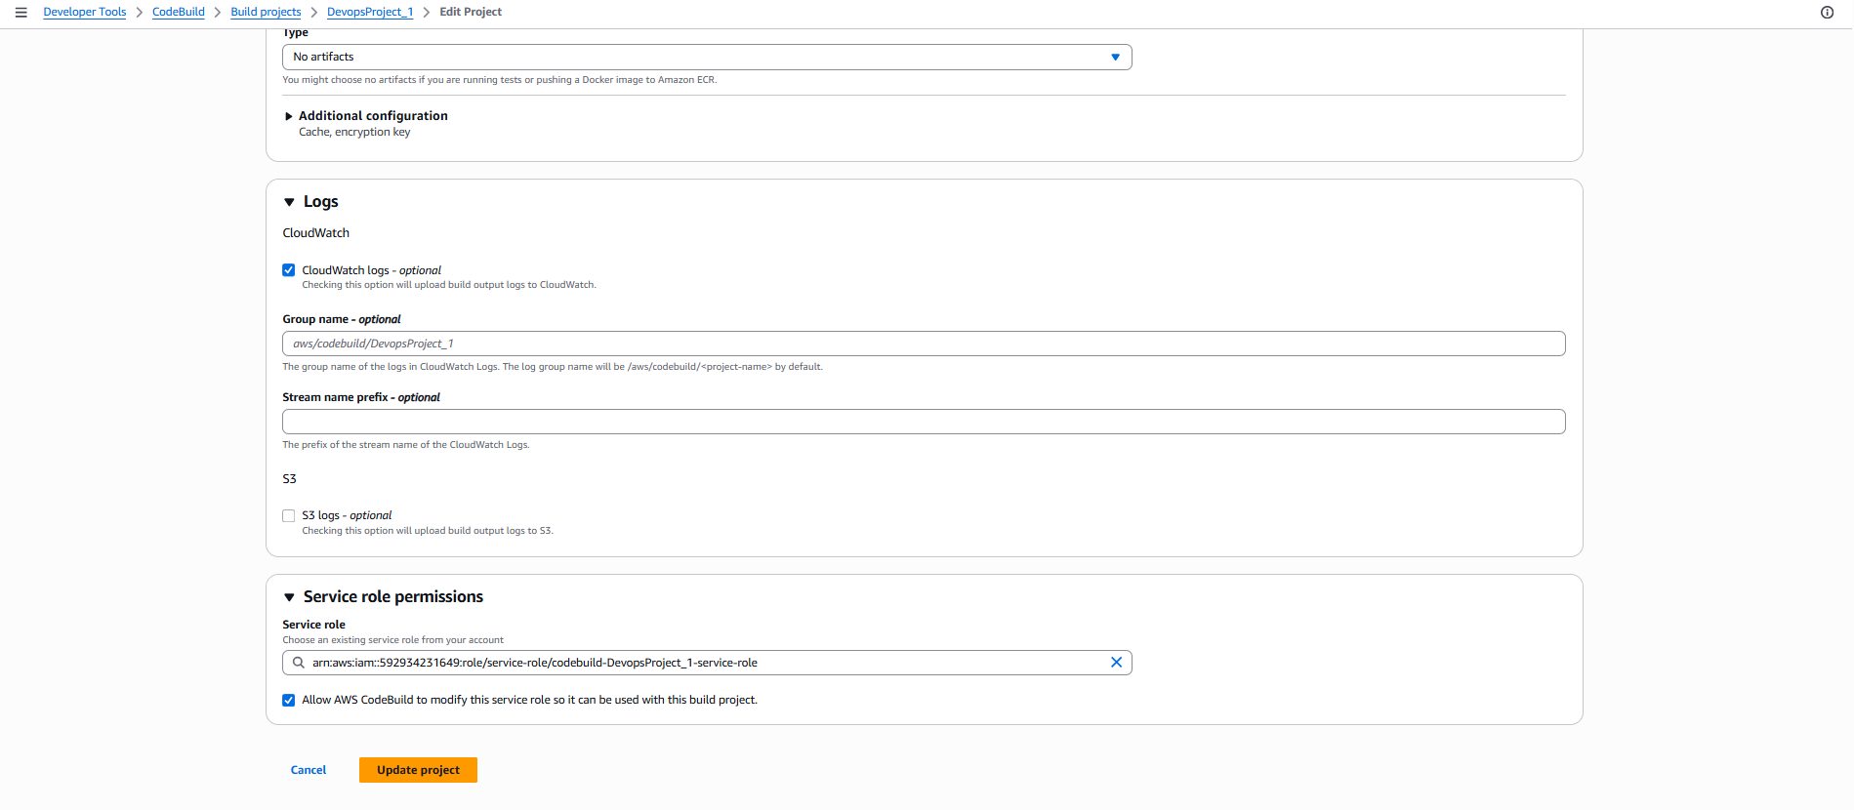
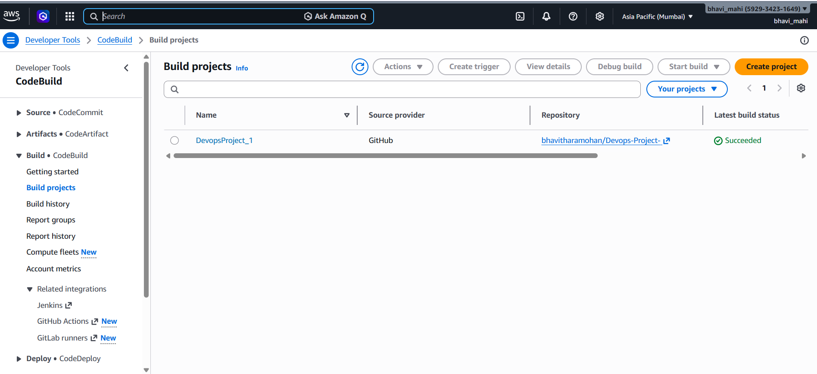

Version Control:
- Push the codebase to a Git provider (GitHub).
- Use CLI commands to push code.

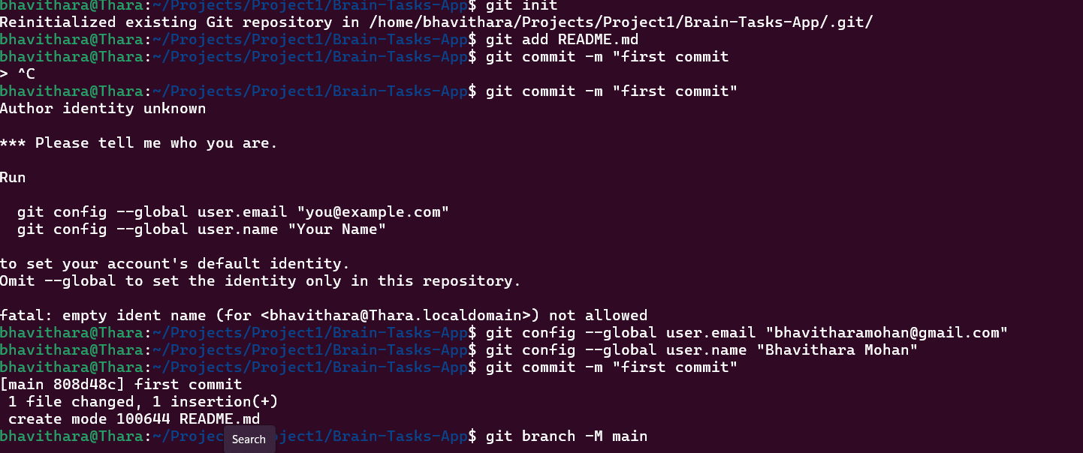

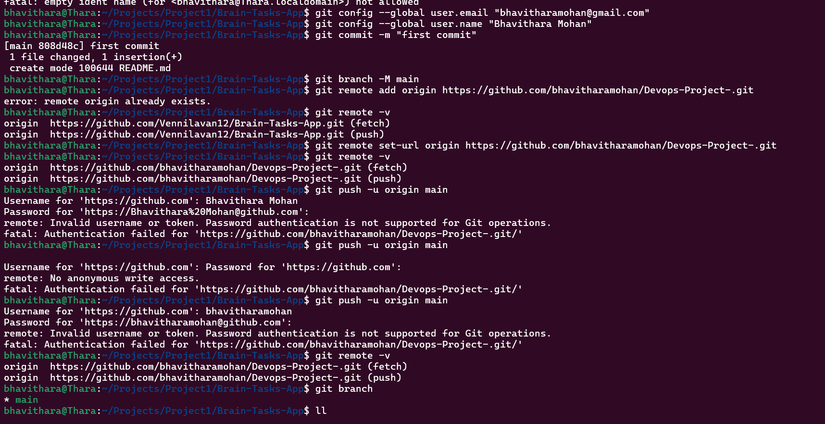

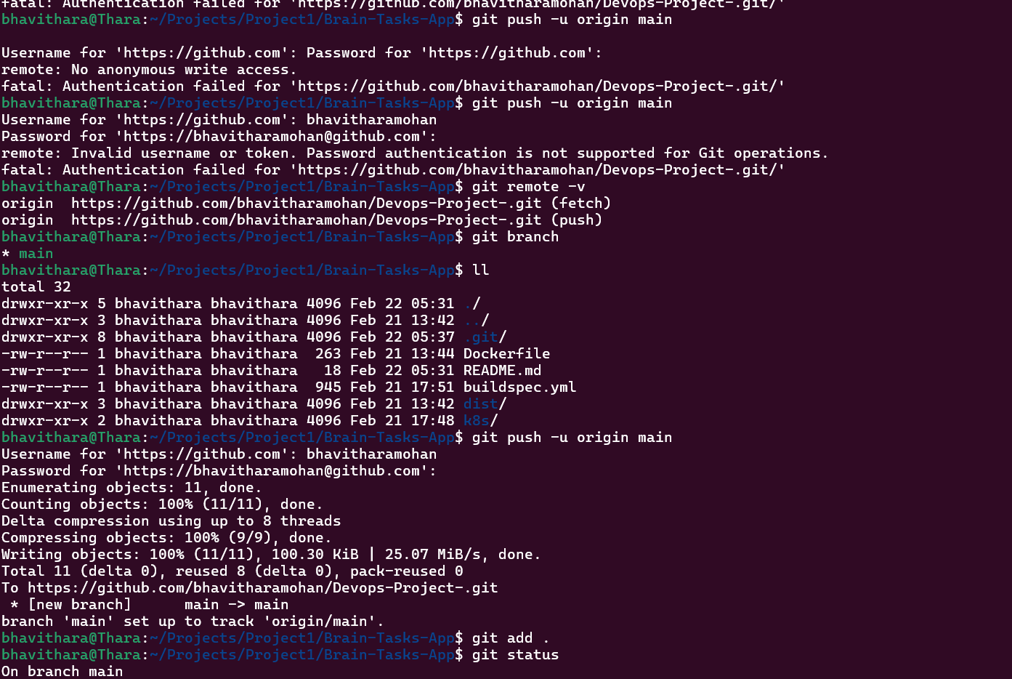

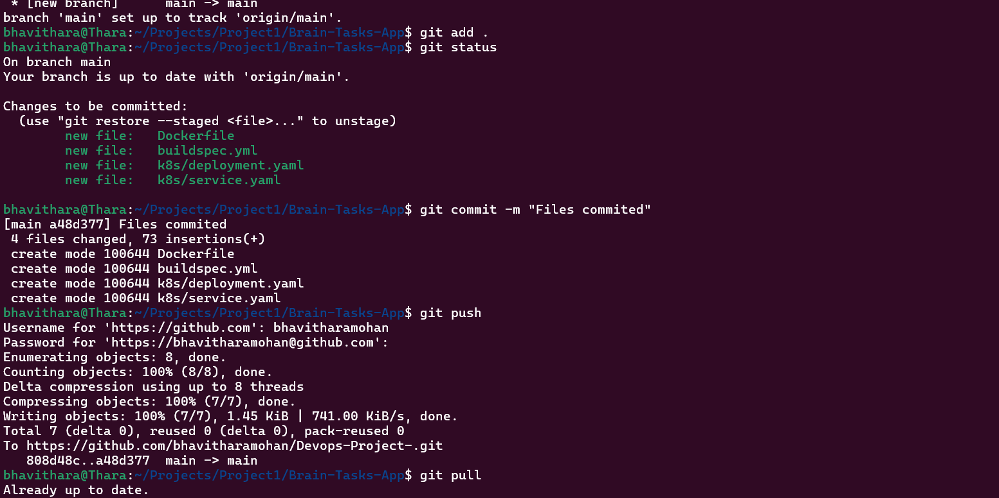

CodePipeline:
- Source: GitHub
- Build: AWS CodeBuild project
- Deploy: AWS CodeDeploy or deploy to EKS via Lambda or custom script.
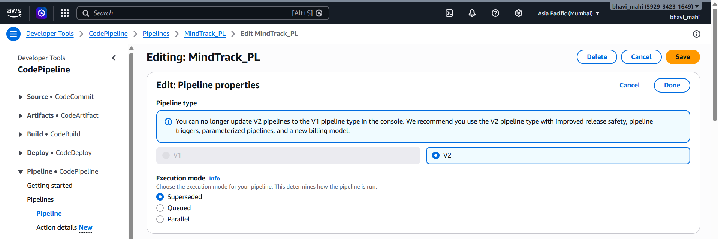

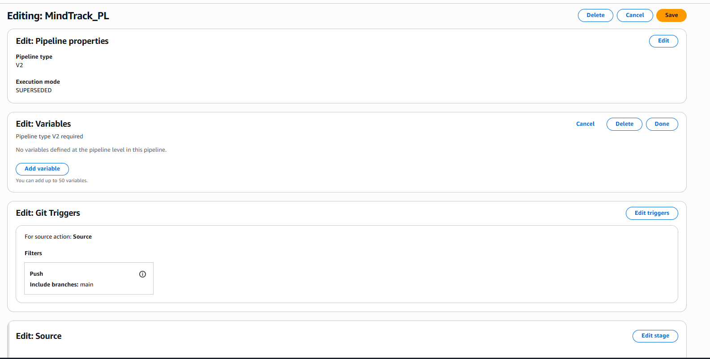

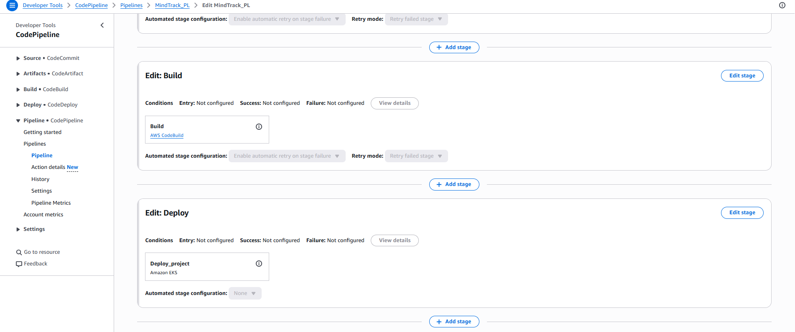
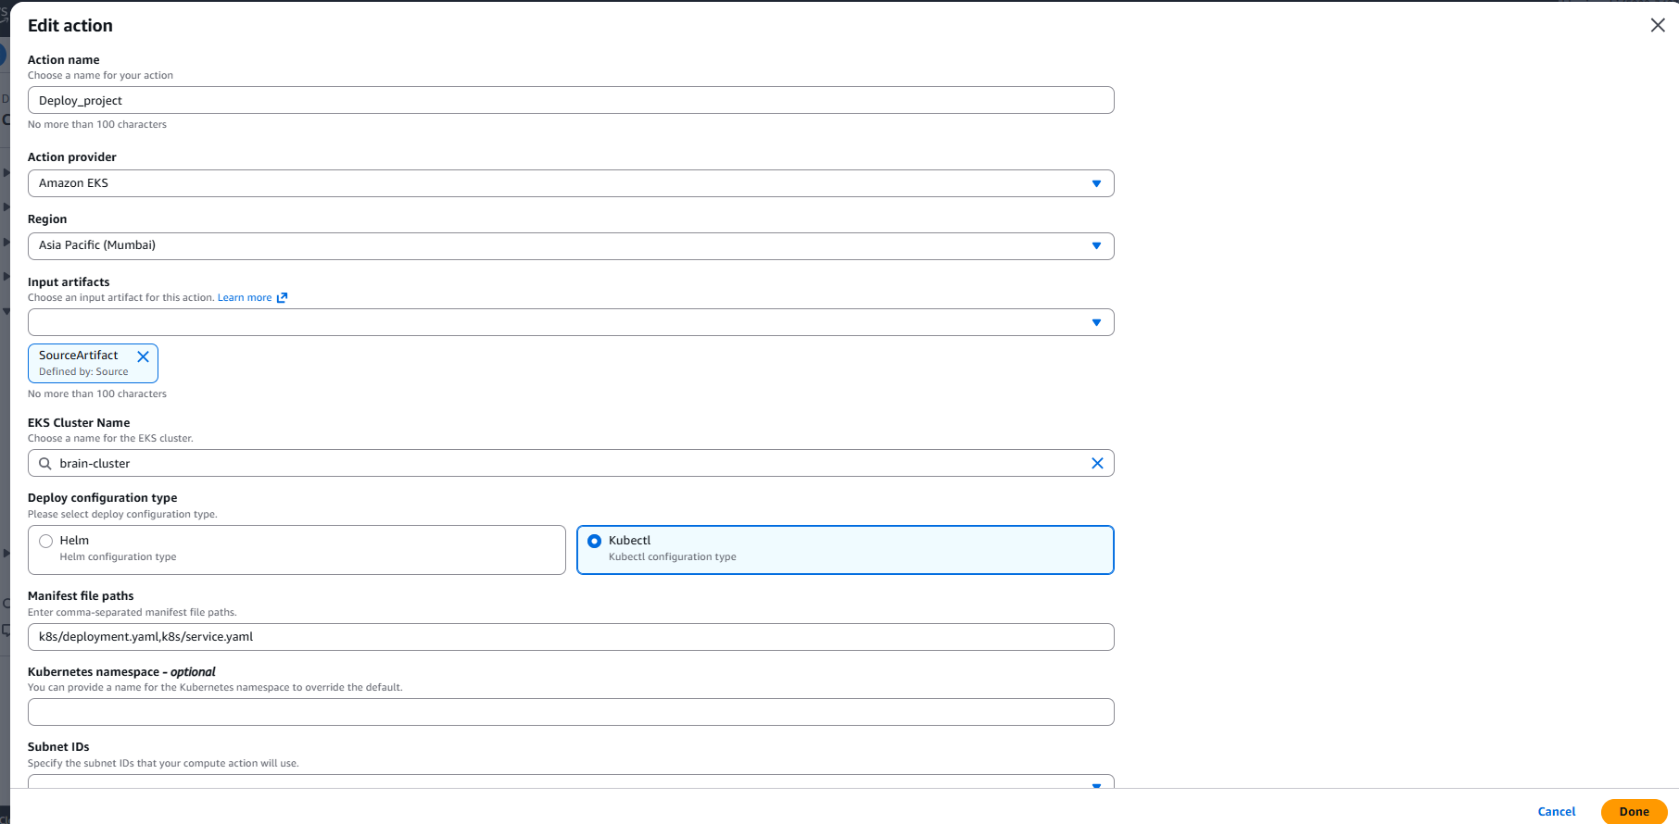

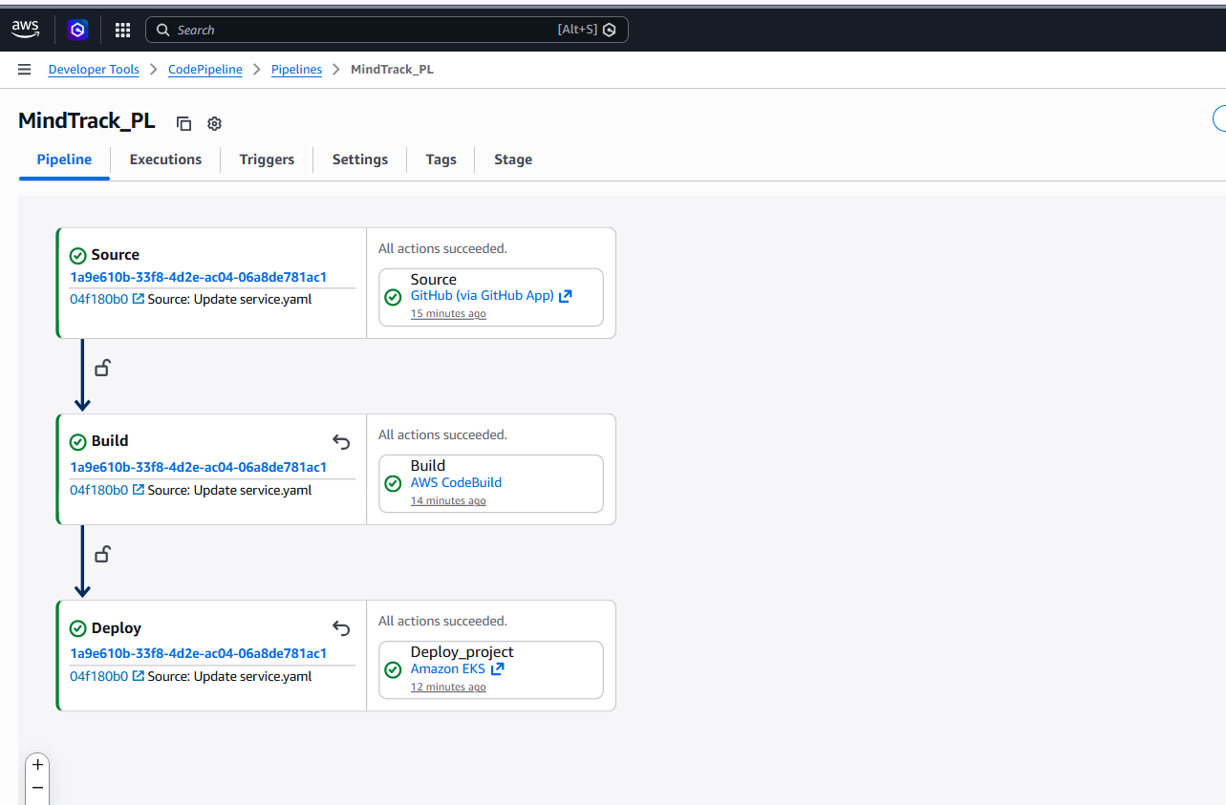

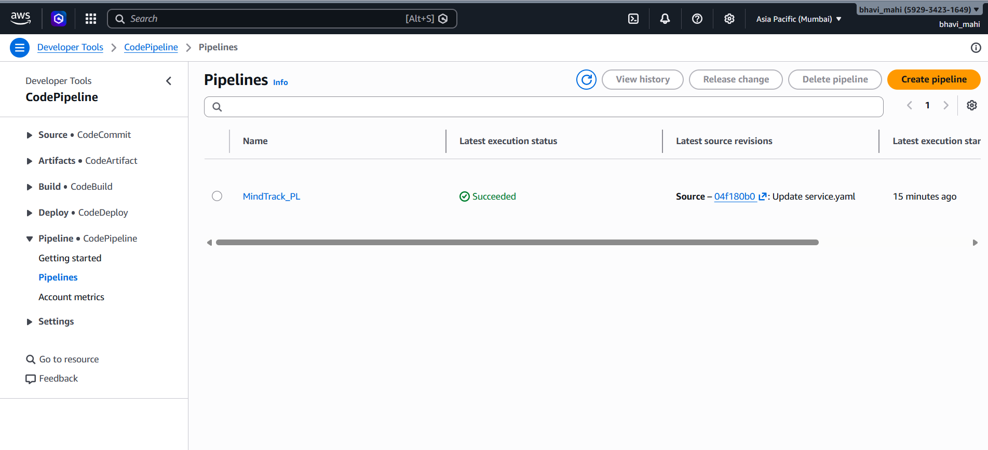

Monitoring:
- Use CloudWatch Logs to track build, deploy, and application logs.
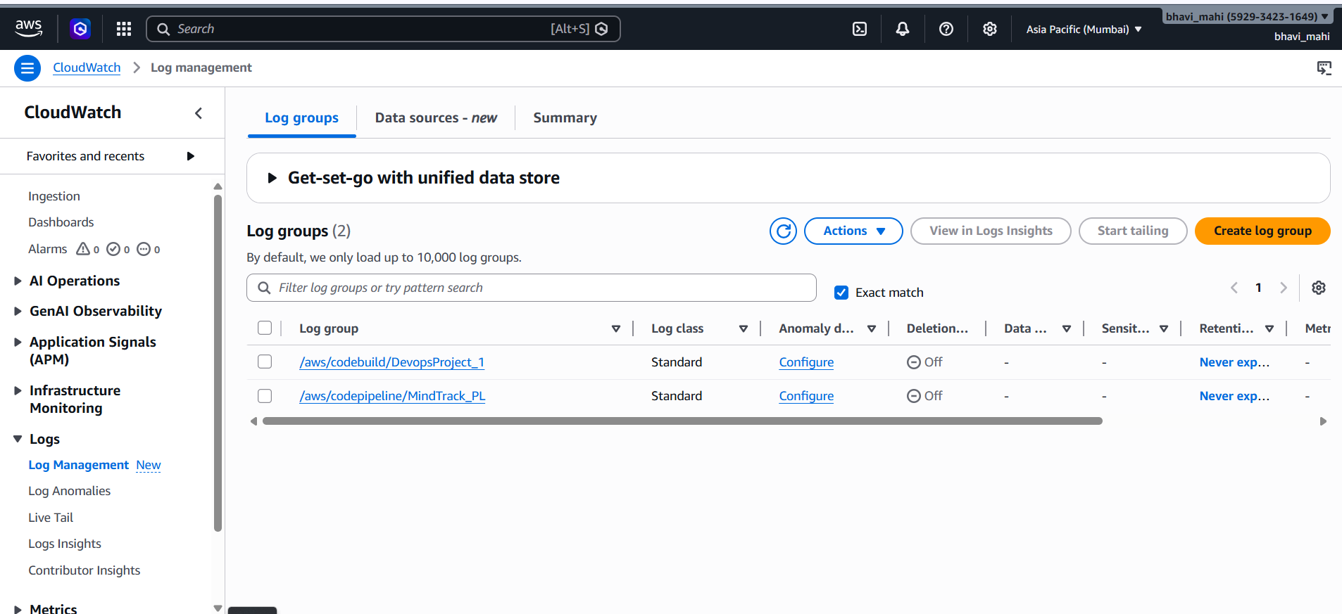

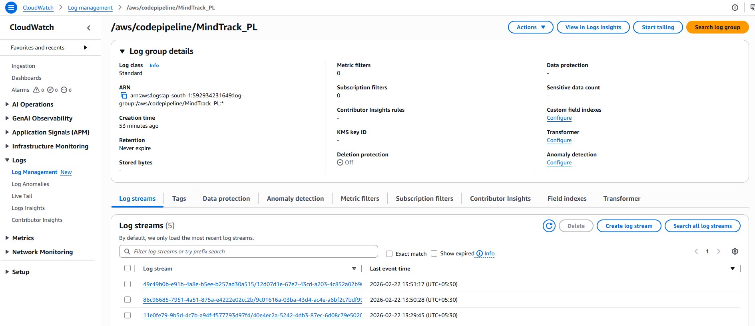

Application:
URL:
http://a13d4d87b855f4885b1bd7ccdb8db9fe-739657671.ap-south-1.elb.amazonaws.com/

