Install docker on EC2 and explore the docker commands (docker images, containers, volumes, network)

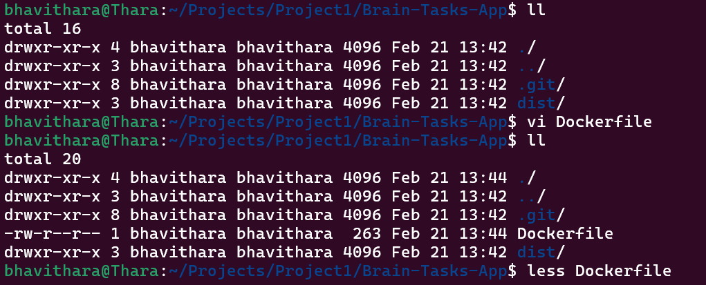

# Use lightweight nginx image
FROM nginx:alpine

# Remove default nginx content
RUN rm -rf /usr/share/nginx/html/*

# Copy dist folder into nginx html directory
COPY dist/ /usr/share/nginx/html/

# Expose port 3000
EXPOSE 3000

CMD ["nginx", "-g", "daemon off;"]

Commands Used:
docker build -t brain-tasks-app .
docker run -d -p 3000:80 brain-tasks-app
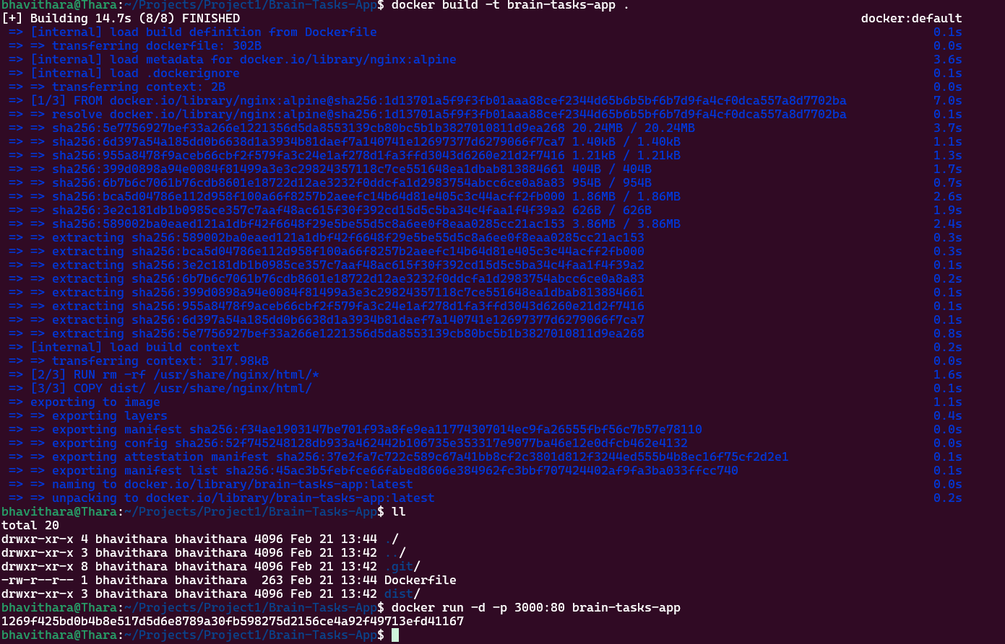

Commands Used:
- Create ECR Repository:
aws ecr create-repository \
--repository-name brain-tasks-app \
--region ap-south-1
- Authentication Docker to ECR:
aws ecr get-login-password --region ap-south-1 | \
docker login --username AWS \
--password-stdin <your_account_id>.dkr.ecr.ap-south-1.amazonaws.com
- Image Tag:
docker tag brain-tasks-app:latest \
<account_id>.dkr.ecr.ap-south-1.amazonaws.com/brain-tasks-app:latest
- Push Image:
docker push <account_id>.dkr.ecr.ap-south-1.amazonaws.com/brain-tasks-app:latest

