Trend Store
Application:
Clone the below mentioned repository and deploy the application (Run application in port 3000).
Repo URL : https://github.com/Vennilavan12/Trend.git

Docker:
- Dockerize the application by creating Dockerfile
- Build an application and check output using docker image.

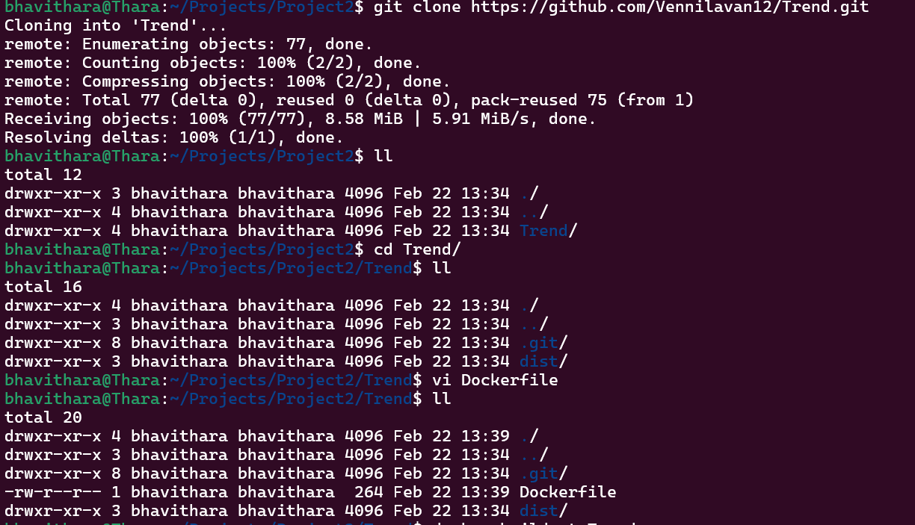

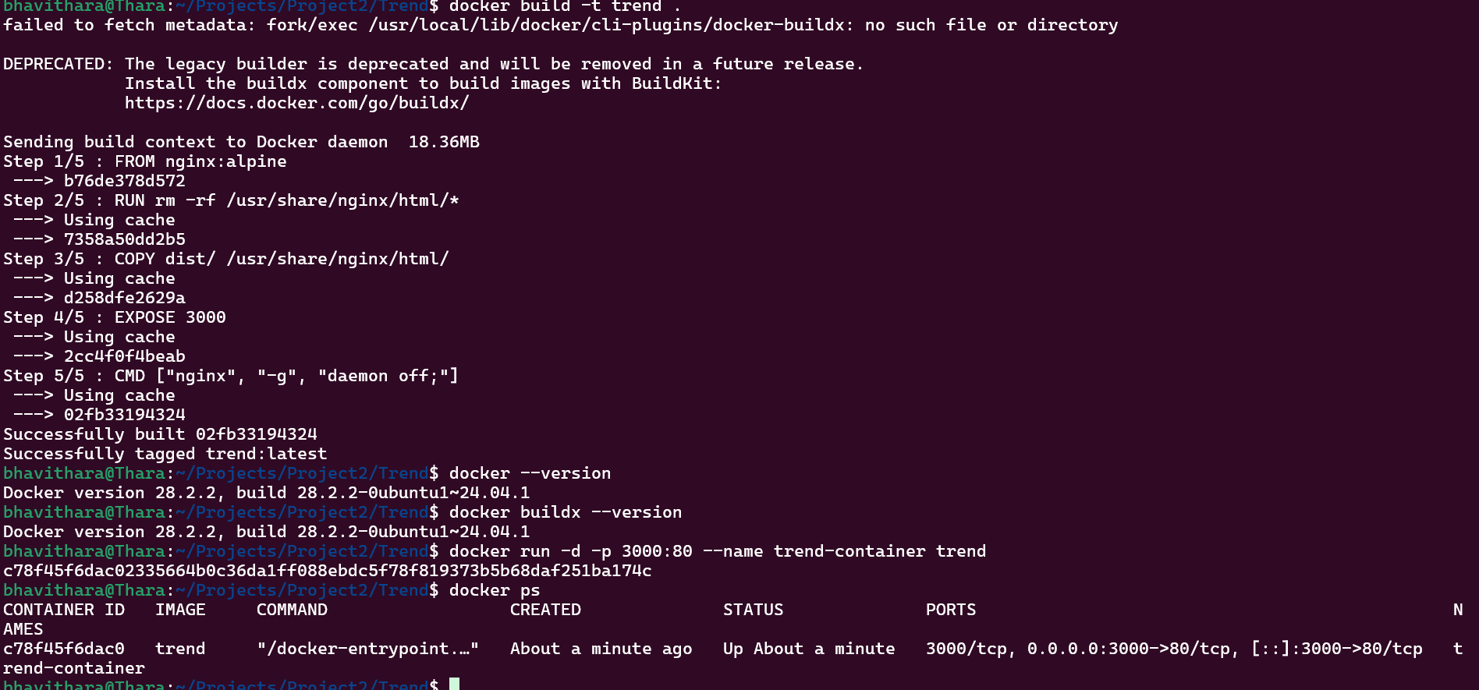

File Content:
# Use lightweight nginx image
FROM nginx:alpine

# Remove default nginx content
RUN rm -rf /usr/share/nginx/html/*

# Copy dist folder into nginx html directory
COPY dist/ /usr/share/nginx/html/

# Expose port 3000
EXPOSE 3000

CMD ["nginx", "-g", "daemon off;"]

Commands Used:
docker build -trend.
docker run -d -p 3000:80 --name trend-container trend

Terraform:
- Define infrastructure in main.tf to create VPC, IAM, EC2 with Jenkins, etc.
- Use terraform command to provision infrastructure.

Commands Used:
Mkdir terraform-jenkins
Cd terraform-jenkins
Vim main.tf

provider "aws" {
region = "ap-south-1"
}
resource "aws_vpc" "my_vpc" {
cidr_block = "10.0.0.0/16"

tags = {
Name = "jenkins-vpc"
}
}
resource "aws_subnet" "my_subnet" {
vpc_id = aws_vpc.my_vpc.id
cidr_block = "10.0.1.0/24"
availability_zone = "ap-south-1a"

tags = {
Name = "jenkins-subnet"
}
}
resource "aws_internet_gateway" "gw" {
vpc_id = aws_vpc.my_vpc.id

tags = {
Name = "jenkins-igw"
}
}
resource "aws_route_table" "rt" {
vpc_id = aws_vpc.my_vpc.id

route {
cidr_block = "0.0.0.0/0"
gateway_id = aws_internet_gateway.gw.id
}

tags = {
Name = "jenkins-rt"
}
}
resource "aws_route_table_association" "rta" {
subnet_id = aws_subnet.my_subnet.id
route_table_id = aws_route_table.rt.id
}
resource "aws_security_group" "jenkins_sg" {
vpc_id = aws_vpc.my_vpc.id

ingress {
from_port = 22
to_port = 22
protocol = "tcp"
cidr_blocks = ["0.0.0.0/0"]
}

ingress {
from_port = 8080
to_port = 8080
protocol = "tcp"
cidr_blocks = ["0.0.0.0/0"]
}

egress {
from_port = 0
to_port = 0
protocol = "-1"
cidr_blocks = ["0.0.0.0/0"]
}

tags = {
Name = "jenkins-sg"
}
}
resource "aws_instance" "jenkins_server" {
ami = "ami-0f5ee92e2d63afc18" # Amazon Linux 2 (ap-south-1)
instance_type = "t2.micro"
subnet_id = aws_subnet.my_subnet.id
vpc_security_group_ids = [aws_security_group.jenkins_sg.id]
associate_public_ip_address = true

tags = {
Name = "jenkins-server"
}
}

Terraform init
Terraform plan
Terraform apply

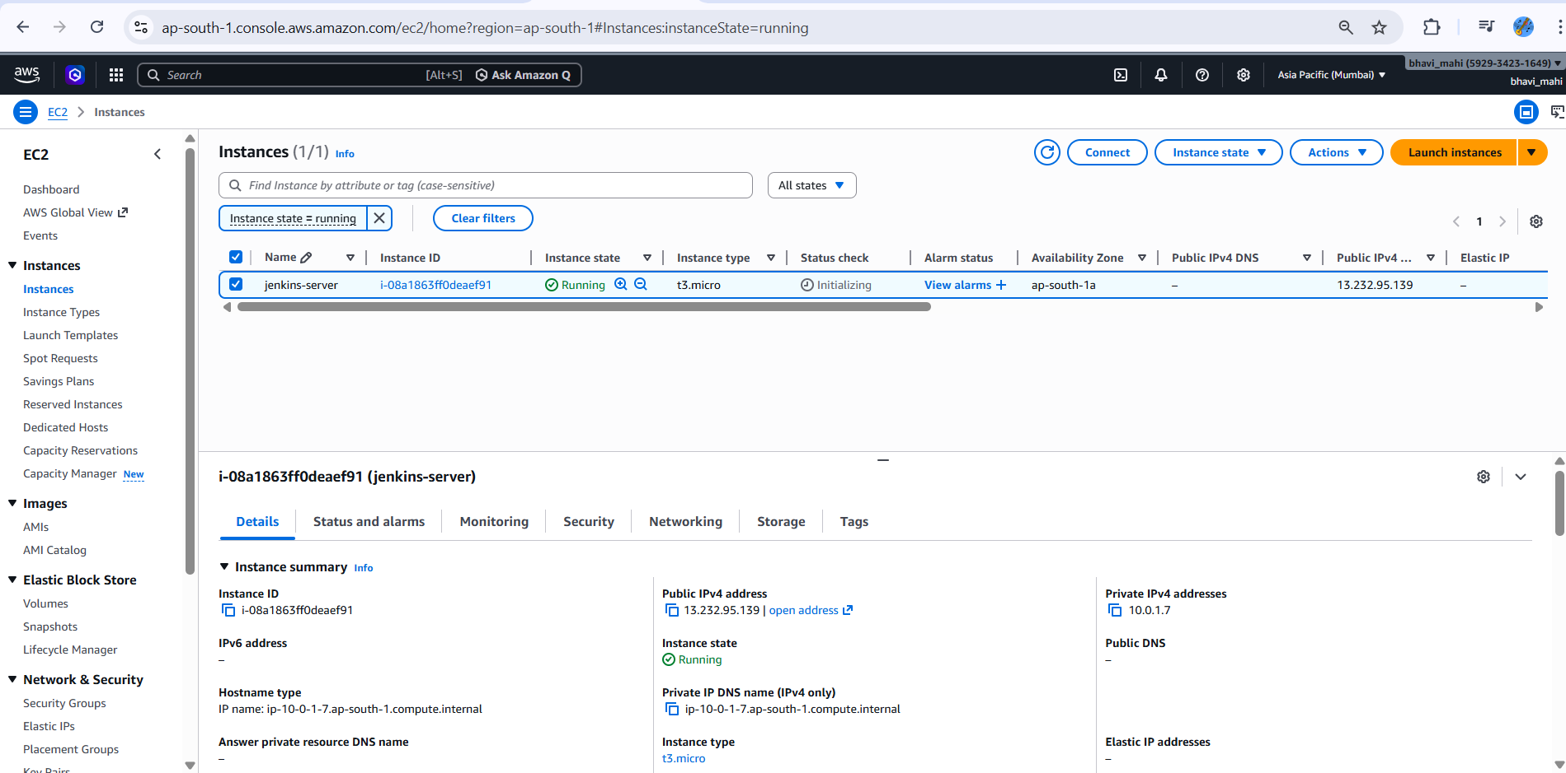

DockerHub:
- Create a DockerHub repository.

Docker login
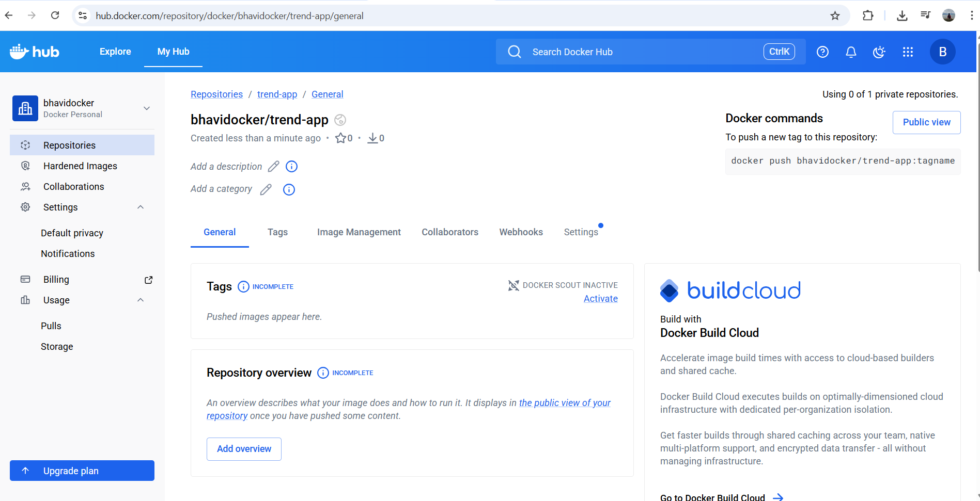

docker build -t trend-app .
docker tag trend-app bhavidocker/trend-app:latest
docker push bhavidocker/trend-app:latest

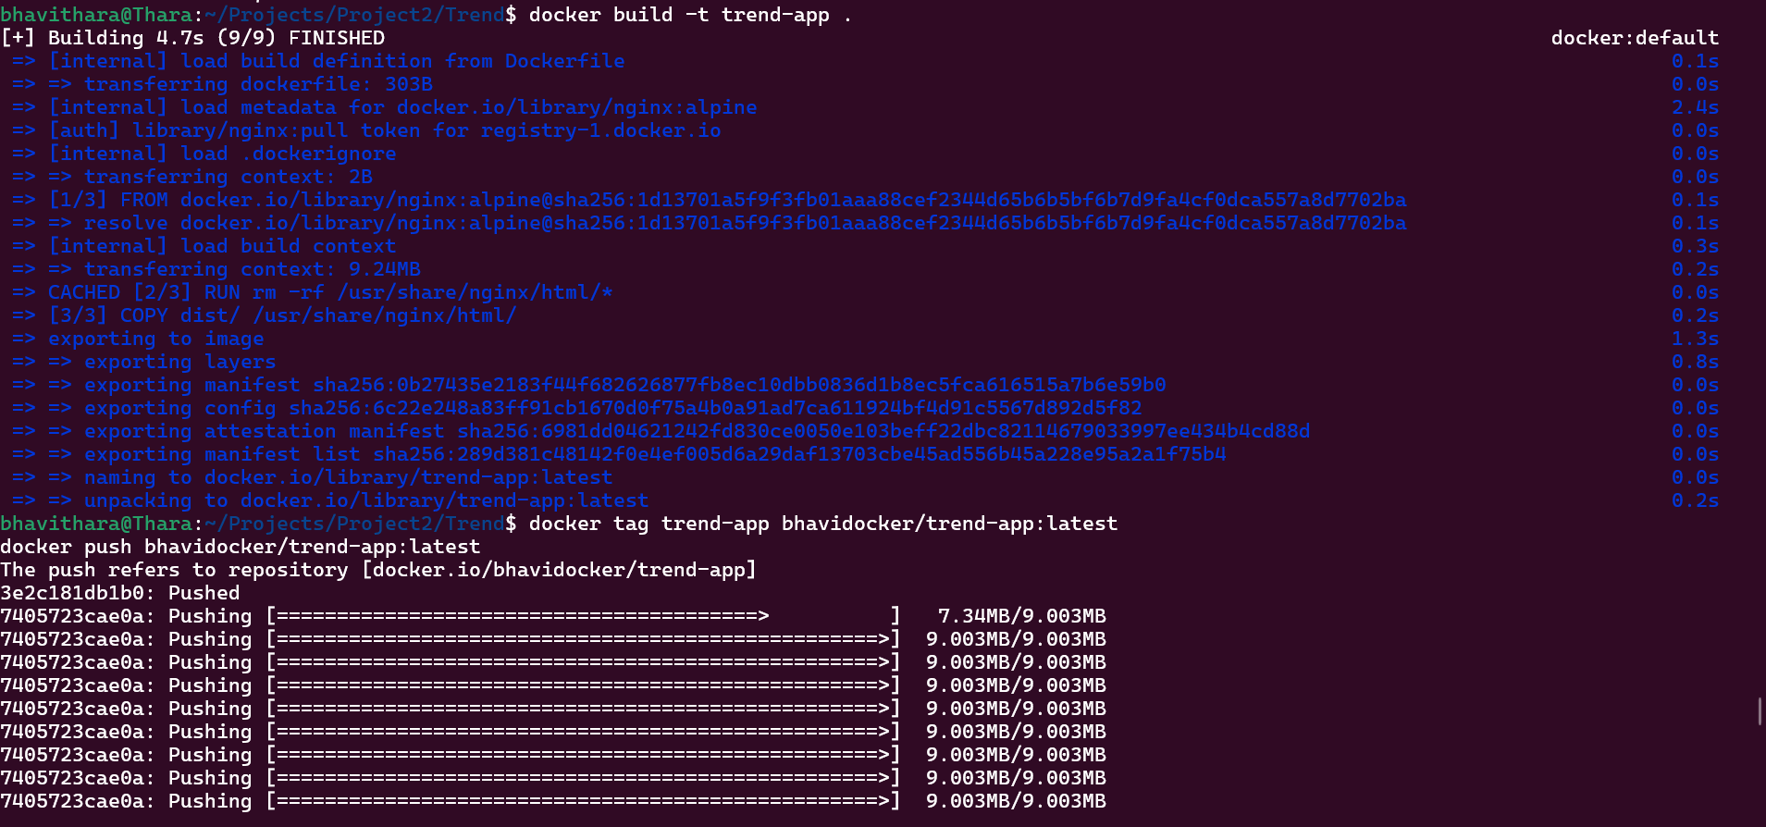

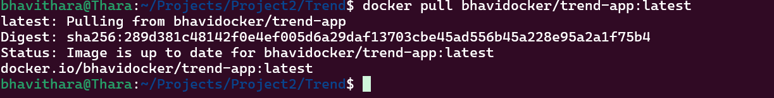
Kubernetes:
- Setup Kubernetes in AWS EKS and Confirm EKS cluster is running.
- Write deployment and service YAML files.
- Deploy using kubectl via Jenkins.

eksctl create cluster --name trend-cluster --region ap-south-1 --nodegroup-name trend-nodes --node-type t3.small --nodes 2

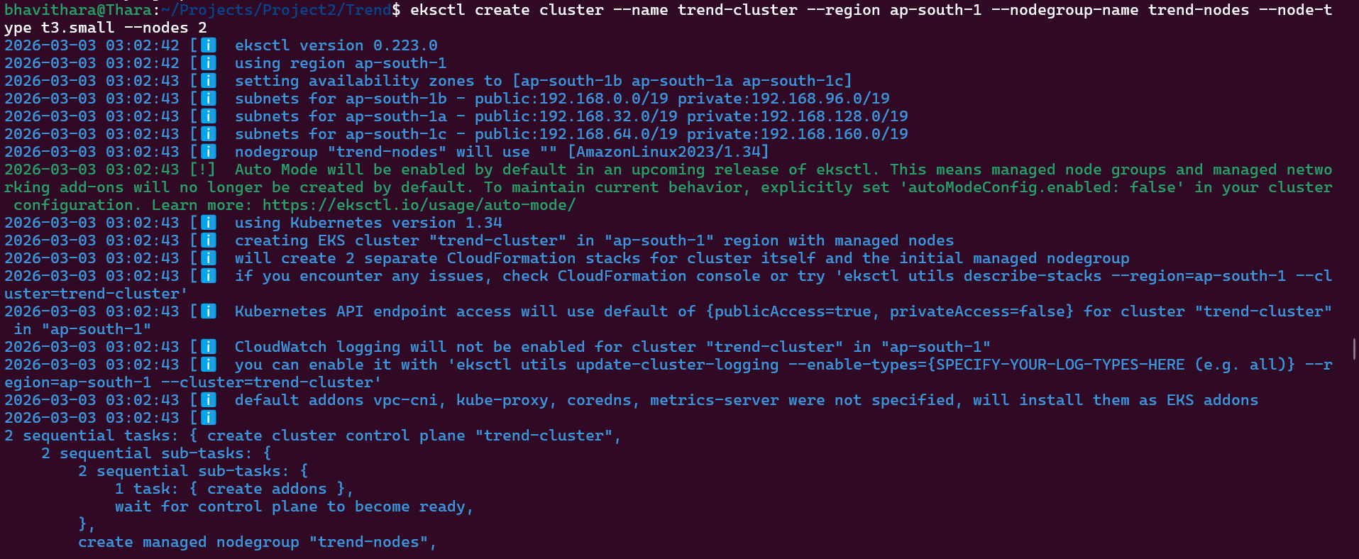

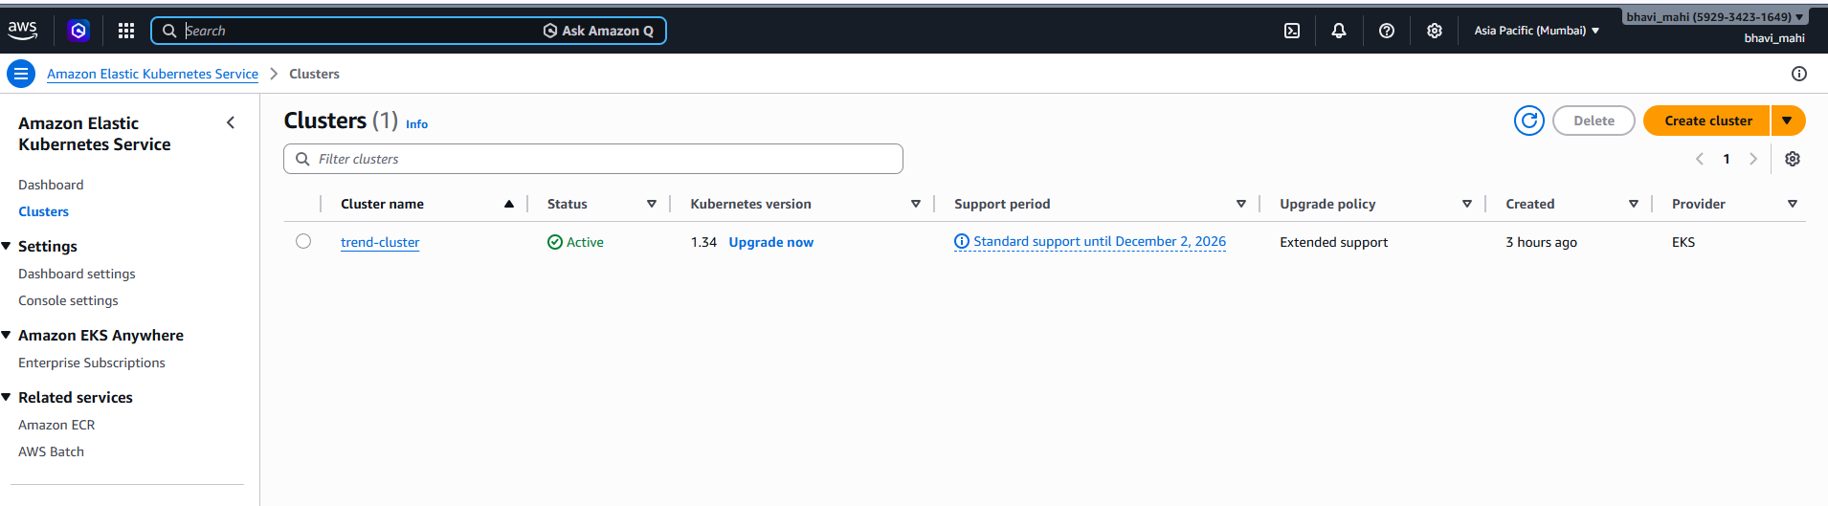

Version Control:
- Push the codebase to a Git provider (GitHub).
- Add gitignore and dockerignore files and use CLI commands to push code.

Jenkins:
- Install Jenkins and necessary plugins (Docker, Git, Kubernetes, Pipeline) for build, push &deploy applications.
- Setup Github and jenkins integration using github webhook build trigger for auto build for every commit.
- Create a declarative pipeline script and pipeline project to build, push & deploy using CI-CD.

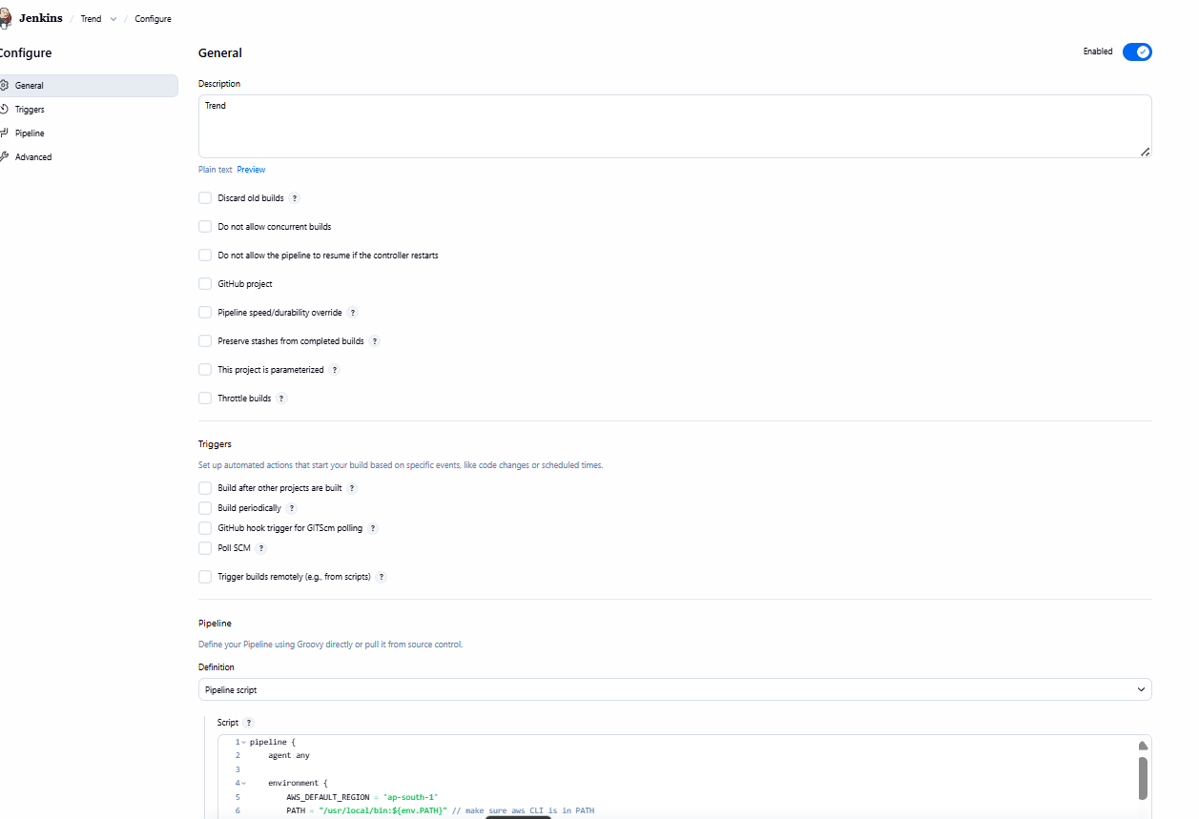

Script in Jenkins:
pipeline {
agent any

environment {
AWS_DEFAULT_REGION = 'ap-south-1'
PATH = "/usr/local/bin:${env.PATH}" // make sure aws CLI is in PATH
}

stages {
stage('Checkout Code') {
steps {
git branch: 'main',
url: 'https://github.com/bhavitharamohan/Devops-Trend.git',
credentialsId: 'github-creds'
}
}

stage('Docker Build & Push') {
steps {
withCredentials([usernamePassword(credentialsId: 'dockerhub-creds', usernameVariable: 'DOCKER_USER', passwordVariable: 'DOCKER_PASS')]) {
sh '''
docker build -t bhavidocker/trend-app .
echo $DOCKER_PASS | docker login -u $DOCKER_USER --password-stdin
docker push bhavidocker/trend-app
'''
}
}
}

stage('Deploy to EKS') {
steps {
withCredentials([[
$class: 'AmazonWebServicesCredentialsBinding',
credentialsId: 'aws-cred'
]]) {
// Inject AWS keys as environment variables for aws CLI
withEnv([
"AWS_ACCESS_KEY_ID=${env.AWS_ACCESS_KEY_ID}",
"AWS_SECRET_ACCESS_KEY=${env.AWS_SECRET_ACCESS_KEY}"
]) {
sh '''
# Update kubeconfig for the Jenkins user
aws eks update-kubeconfig --name trend-cluster --region $AWS_DEFAULT_REGION

# Verify connection
kubectl get nodes

# Apply your deployment and service
kubectl apply -f deployment.yaml
kubectl apply -f service.yaml
'''
}
}
}
}
}
}

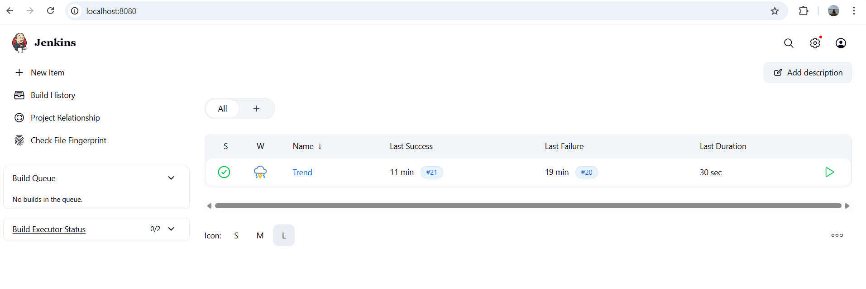

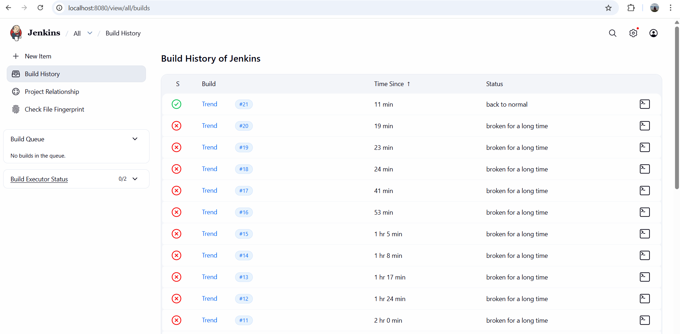

Webhook :

Jenkin is running in localhost so webhook wont allow public host.
So used ngrok to modify the hostname as below
Command used:
ngrok http 8080

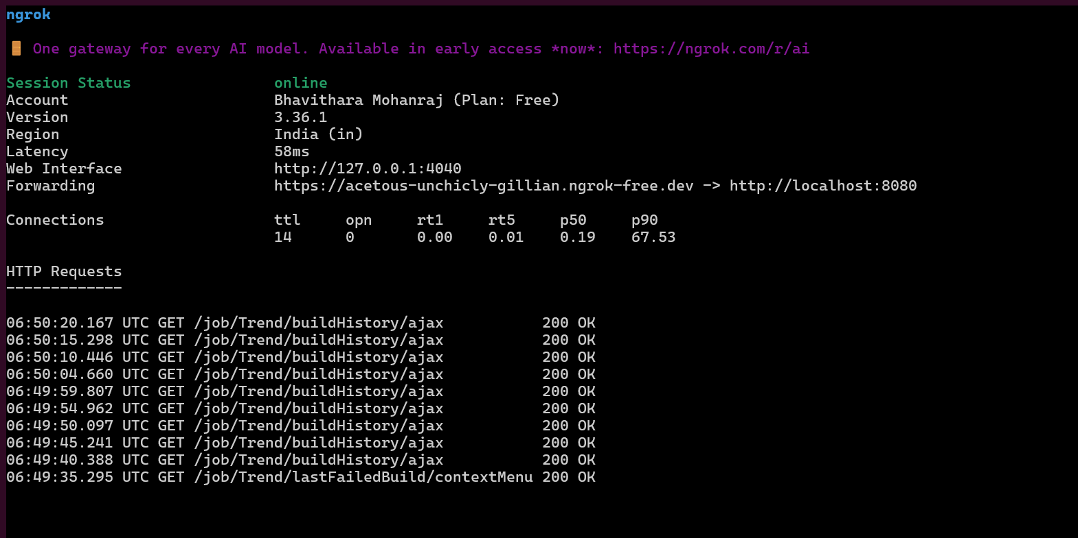
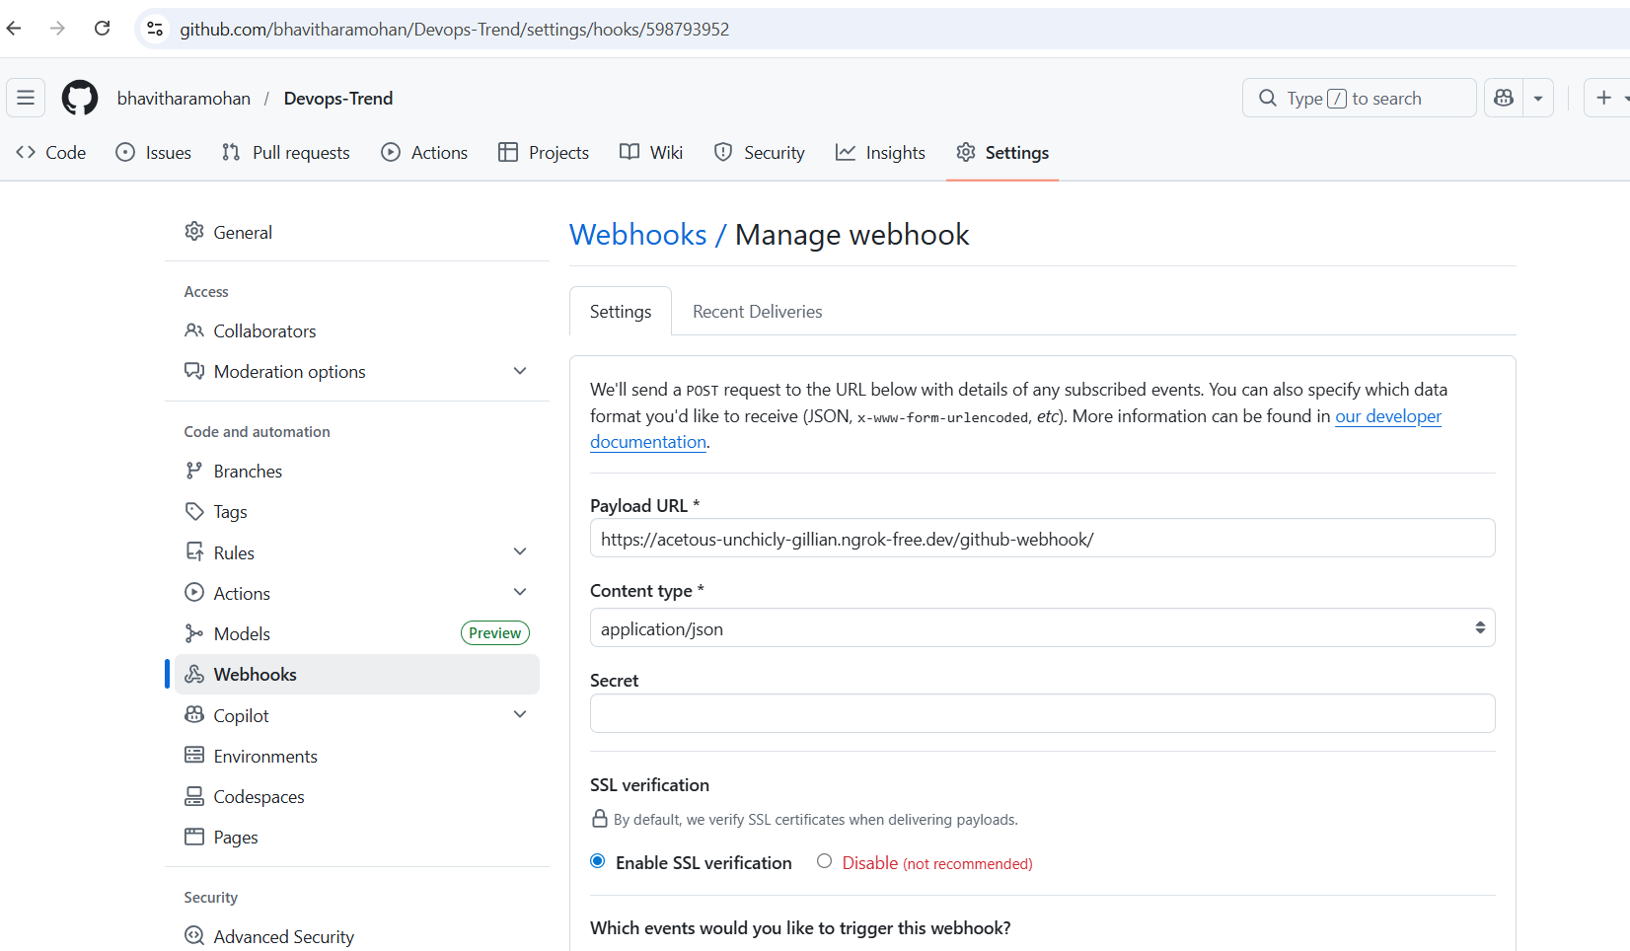

Now build will run automatically if we commit in git.

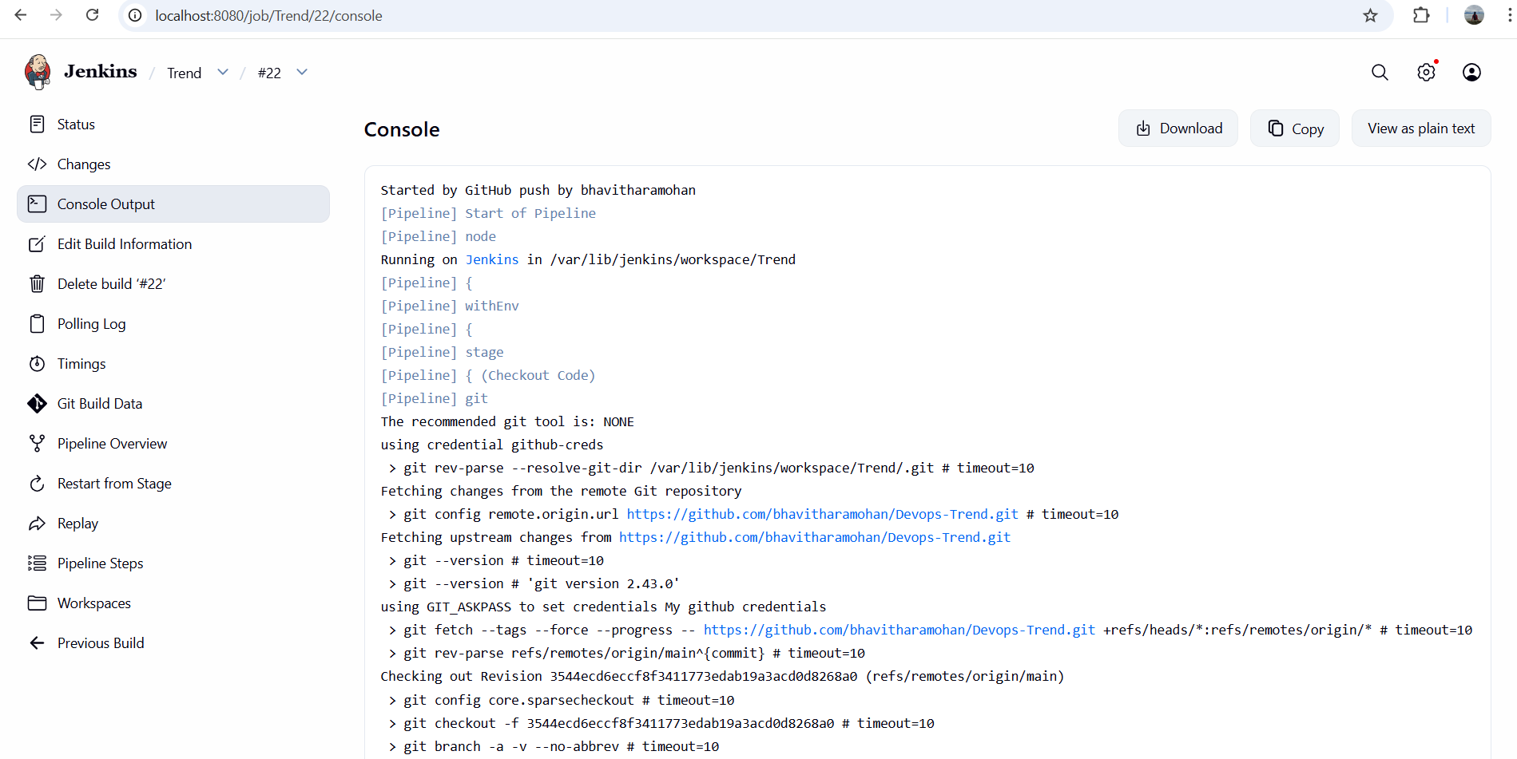

Monitoring:
- Setup a monitoring system to check the health of the cluster or application (opensource) is highly appreciable.
Command used:

helm repo add prometheus-community https://prometheus-community.github.io/helm-charts
helm install monitoring prometheus-community/kube-prometheus-stack
kubectl get svc
