Business Process Model (BPMN)
CRM System Upgrade – Salesforce Build, Phase 1 | Version 1.0 | October 20, 2026 | Author: Bhavna Rao, Business Analyst

1. How to Read the Diagrams
Symbol | Meaning
Green circle | Start of the process
Red circle | End of the process
White rounded box | A step done by a person
Blue rounded box | A step done automatically by Salesforce
Yellow diamond (X) | A decision (exclusive gateway): only one path is taken
Horizontal band (swimlane) | Who does the step

2. As-Is vs To-Be Summary
Area | As-is (today) | To-be (Phase 1)
Leads | Kept in spreadsheets; re-typed when they become customers | Lead record converted in one click to account, contact and deal
Pipeline | Weekly spreadsheet; no live view | Kanban board and live dashboard
Discounts | Any discount allowed; no review | Over 40% blocked; over 20% flagged and a review task sent automatically
Cases | Tracked in email inboxes | Case records with priority; urgent list view
Reporting | Built by hand | Reports and dashboard from live data

3. Process 1: Lead to Close with Discount Review
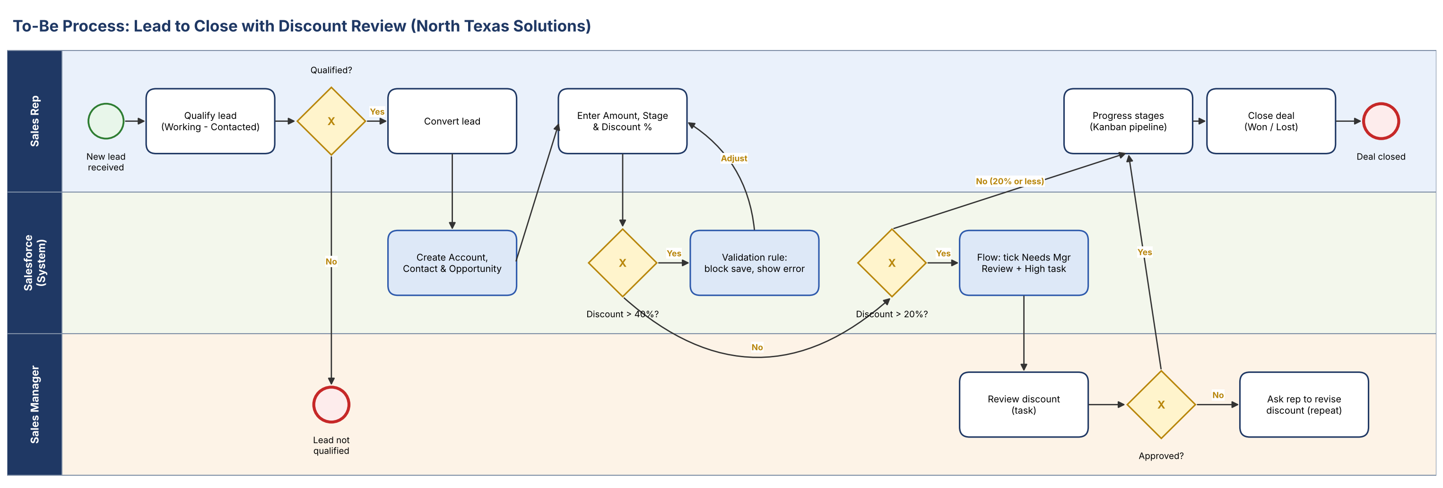
Figure 1. Lead to Close with Discount Review (swimlanes: Sales Rep, Salesforce, Sales Manager)
# | Lane | Step | Decision / rule
1 | Sales Rep | Qualify the new lead | Not qualified: process ends
2 | Sales Rep | Convert the lead | BR-3
3 | Salesforce | Create linked account, contact and opportunity
4 | Sales Rep | Enter amount, stage and discount
5 | Salesforce | Validation rule checks discount | Over 40%: save blocked (BR-1)
6 | Salesforce | Flow checks discount | Over 20%: tick Needs Manager Review and create High task (BR-2)
7 | Sales Manager | Review the discount task | Not approved: rep revises discount
8 | Sales Rep | Move the deal through stages and close it | Closed deals leave open pipeline (BR-5)

4. Process 2: Customer Case Handling
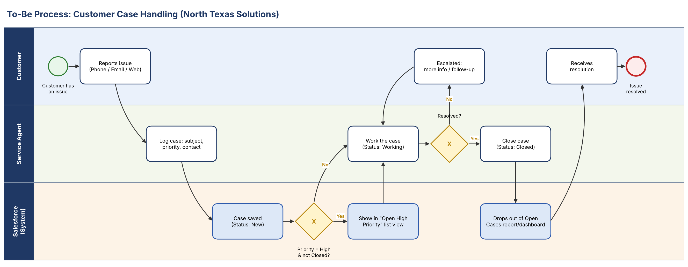
Figure 2. Customer Case Handling (swimlanes: Customer, Service Agent, Salesforce)
# | Lane | Step | Decision / rule
1 | Customer | Reports an issue by phone, email or web
2 | Service Agent | Logs the case with subject, priority and contact
3 | Salesforce | Saves the case as New | High and not Closed: shows in Open High Priority list
4 | Service Agent | Works the case (Working) | Not resolved: Escalated, then back to work
5 | Service Agent | Closes the case (Closed)
6 | Salesforce | Case drops out of open-case report and dashboard | BR-4

Note: the manager's approve or reject decision is recorded through the review task in Phase 1. A formal Salesforce approval process with approve/reject buttons is a Phase 2 option.

