Salesforce App Build – Configuration and Evidence
CRM System Upgrade – Salesforce Build, Phase 1 | Salesforce Developer Edition | October 20, 2026 | Built by Bhavna Rao
This document shows what was built in Salesforce, part by part, with screenshots as evidence. All records are sample data for North Texas Solutions, a sample company.

Build Summary
Component | What was built | Count
Custom fields | Industry Segment (Account), Discount %, Needs Manager Review (Opportunity) | 3
Records | Accounts 6, contacts 6, leads 3 (1 converted), opportunities 7, cases 4 | 26
Validation rule | Discount_Max_40 | 1
Flow | Big Discount Review (record-triggered, 2 actions) | 1
List view | Open High Priority (Cases) | 1
Reports | Pipeline by Stage, Open Pipeline, Open Cases by Priority | 3
Dashboard | Sales & Service Overview (3 components) | 1
Security | Roles: Sales Manager, Sales Rep; Opportunity sharing Private | 2 roles
Tests / defects | 11 test cases passed; 3 defects found and fixed | 11 / 3

Part 1: Custom Fields (FR-008)
I checked whether the standard Industry field could be reused. It holds Salesforce's broad list, so I added a separate field for the company's own segments and left the standard field untouched.
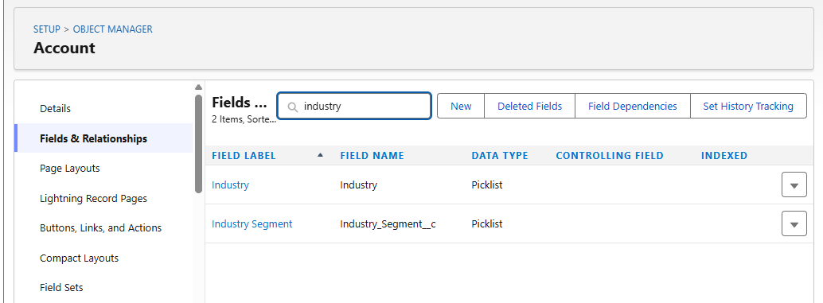
Industry Segment picklist on Account, next to the standard Industry field
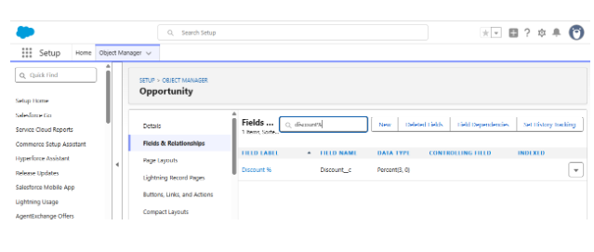
Discount % (Percent 3,0) on Opportunity
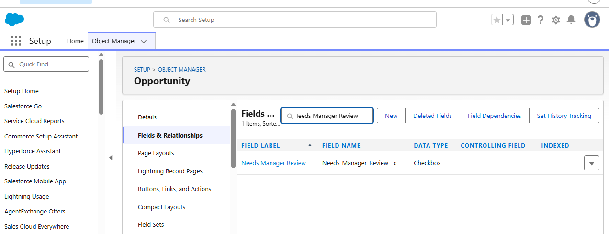
Needs Manager Review checkbox on Opportunity

Part 2: Accounts and Contacts (FR-001)
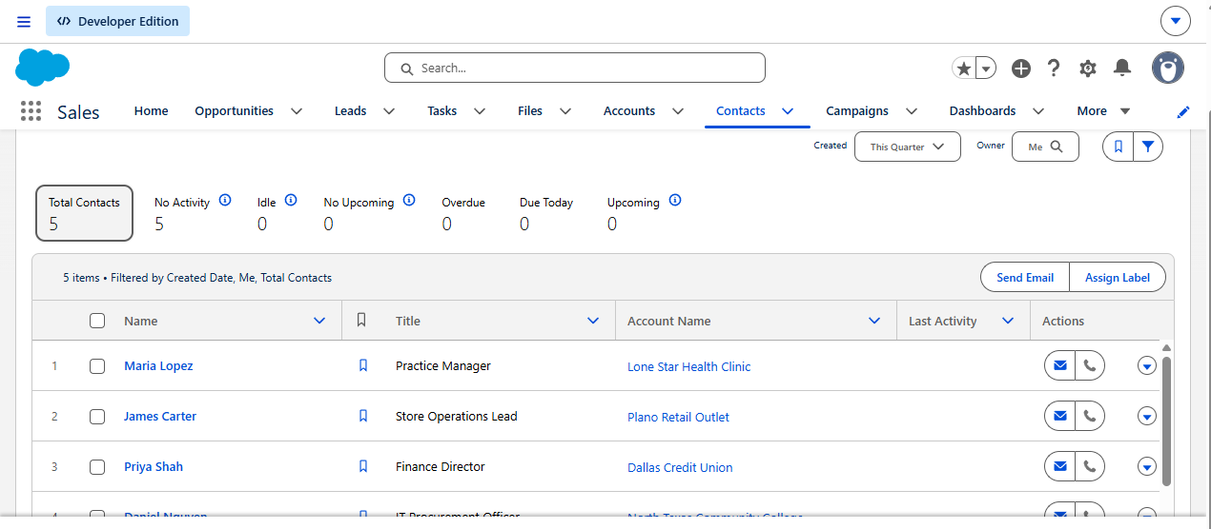
Contacts, each linked to an account

Part 3: Leads and Pipeline (FR-002)
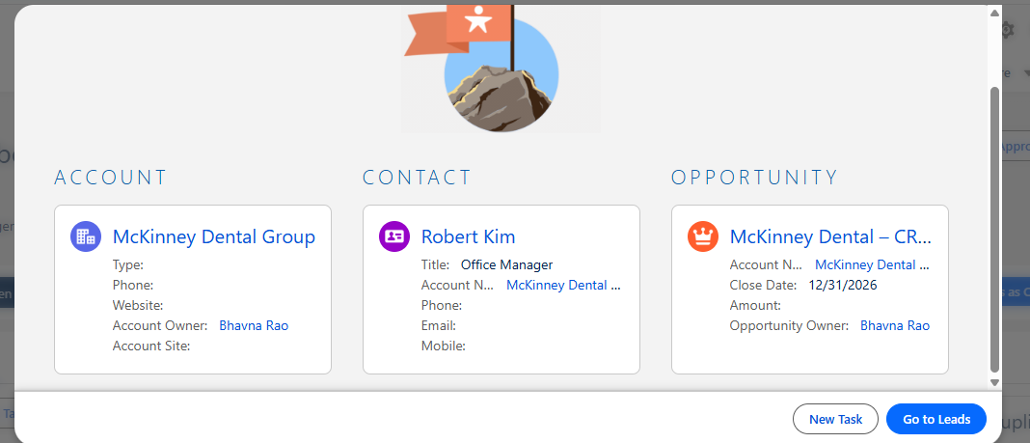
Lead conversion created an account, a contact and an opportunity in one step
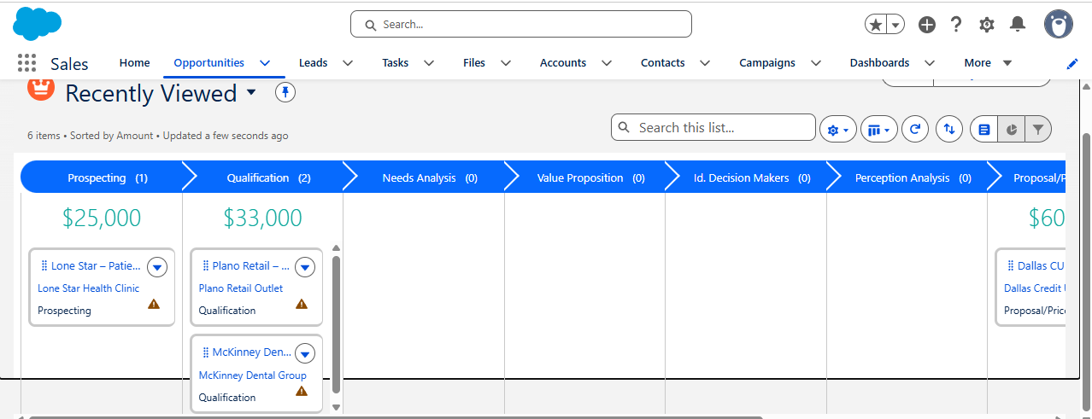
Kanban pipeline with totals by stage (part 1)
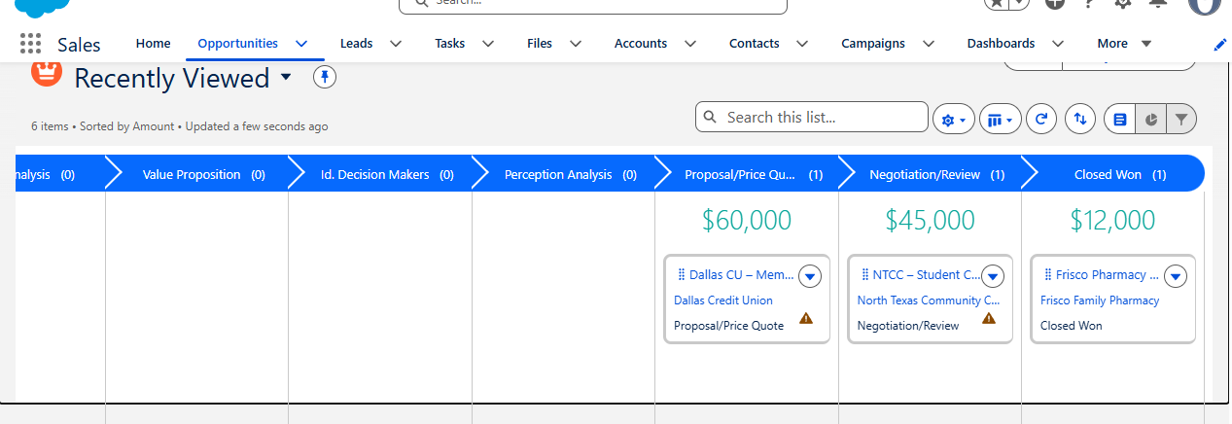
Kanban pipeline (part 2)
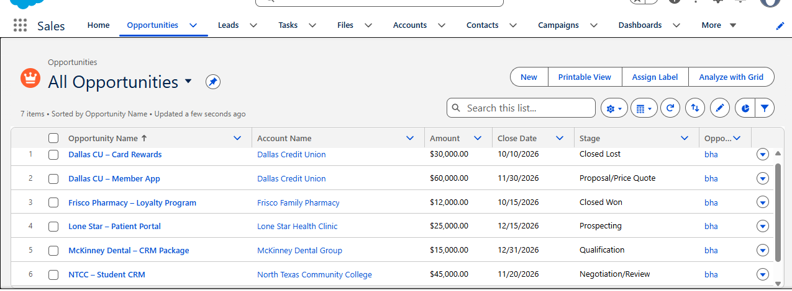
All 7 opportunities

Part 4: Validation Rule and Flow (FR-006)
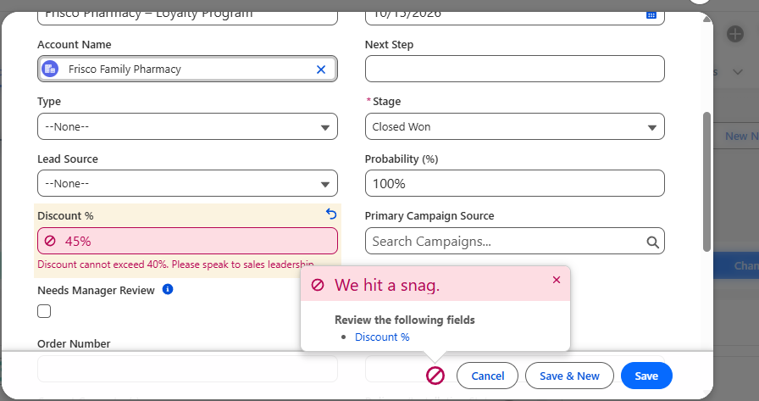
Validation rule blocks a 45% discount
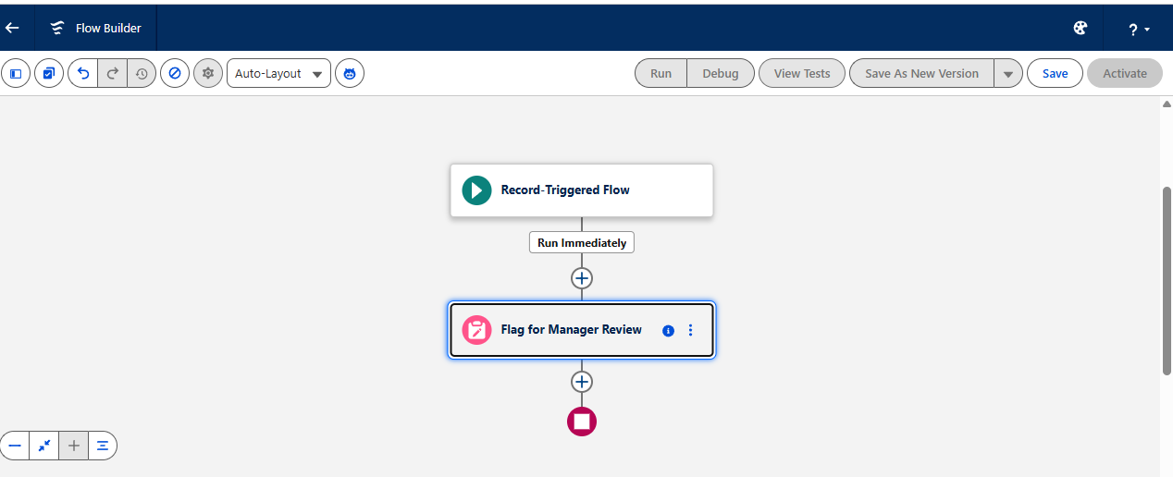
Flow: trigger and Update Records step
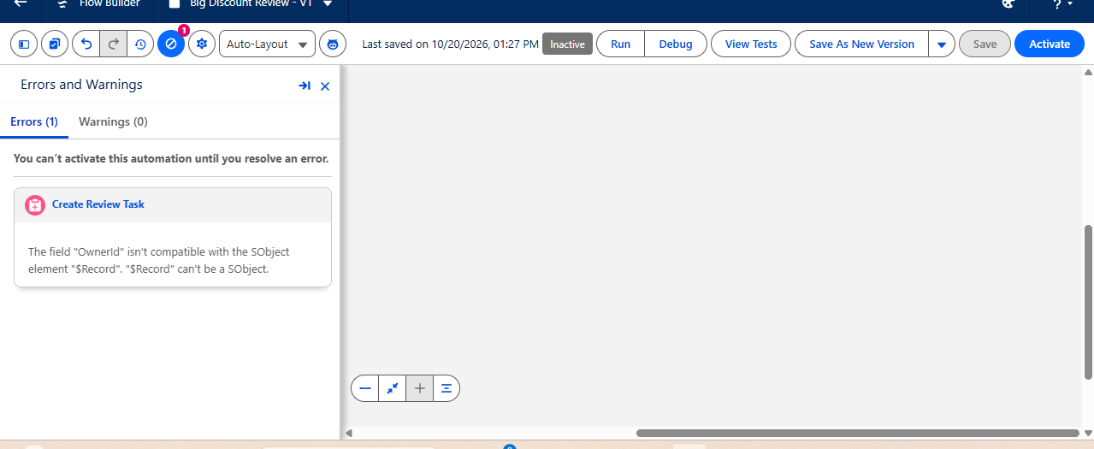
DEF-01: Flow error found before activation
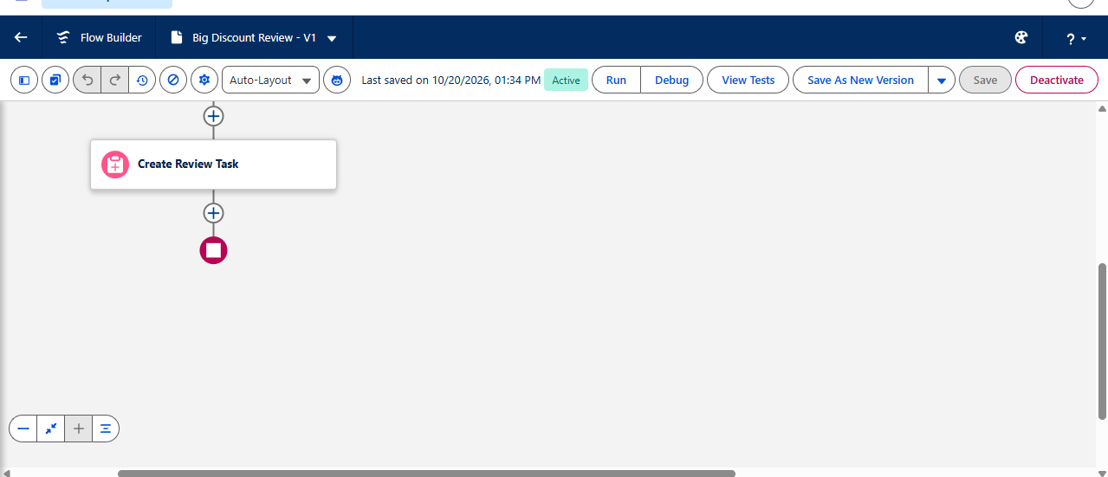
Flow fixed and Active
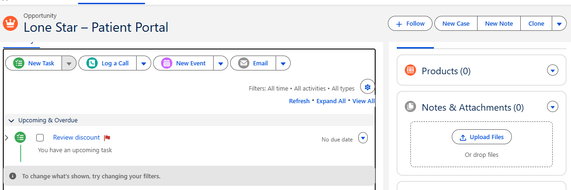
TC-05: review task created at 25%
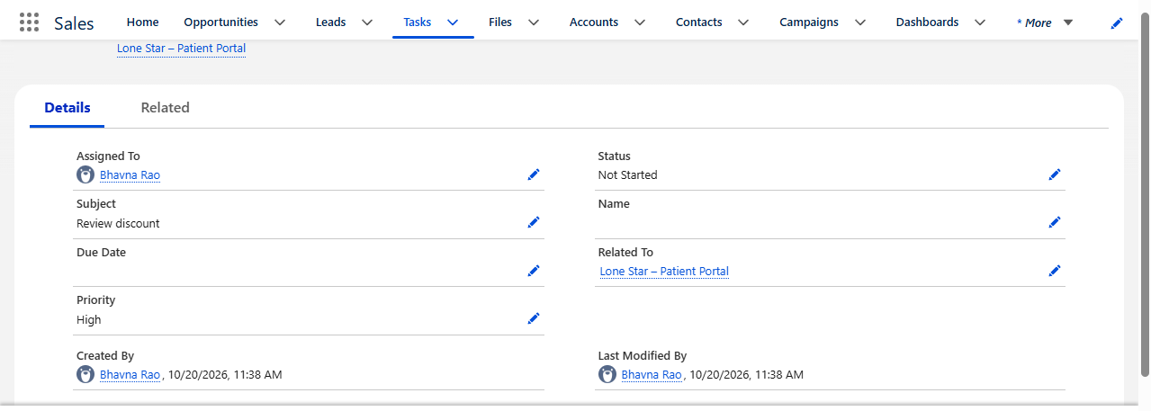
TC-05: task assigned to the owner and related to the deal, High priority
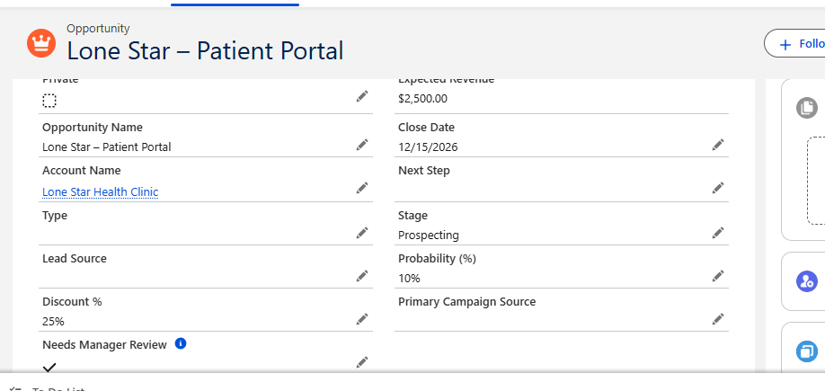
TC-05: Needs Manager Review ticked
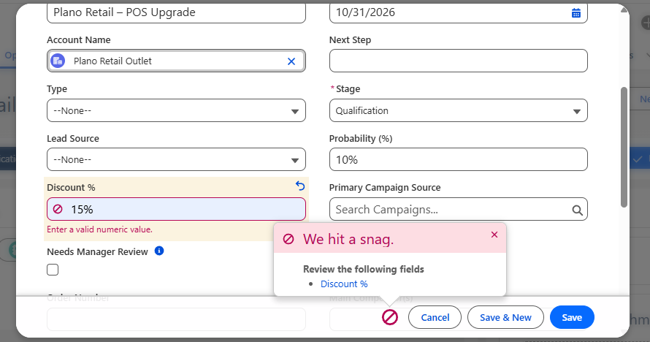
TC-06: "15%" rejected by the field's data-type check
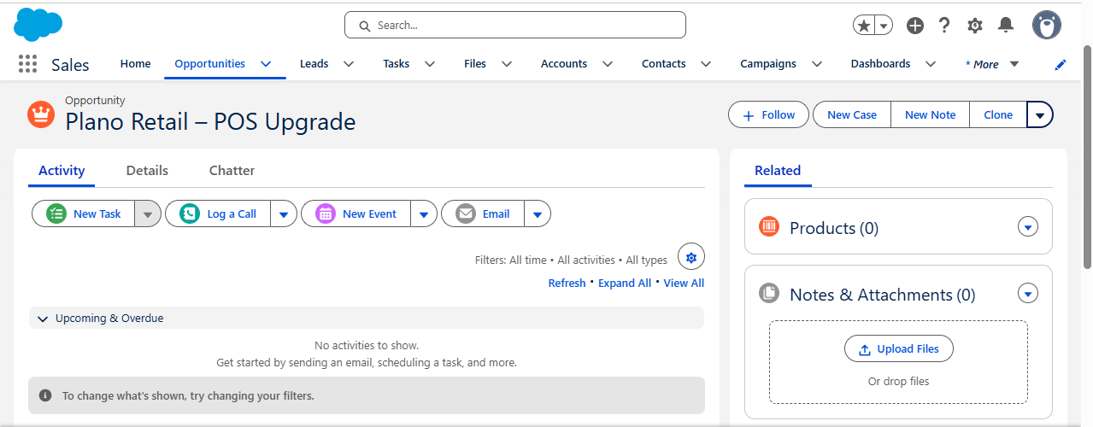
TC-06: no task at 15%
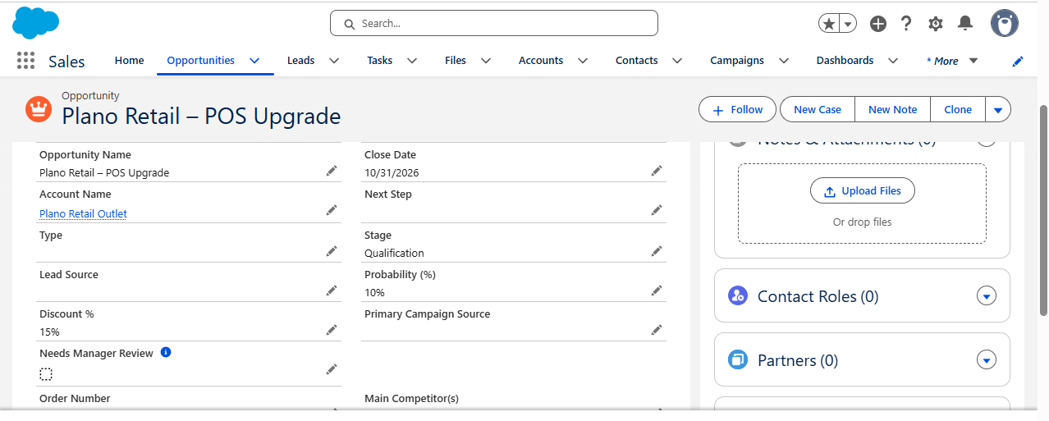
TC-06: not flagged at 15%
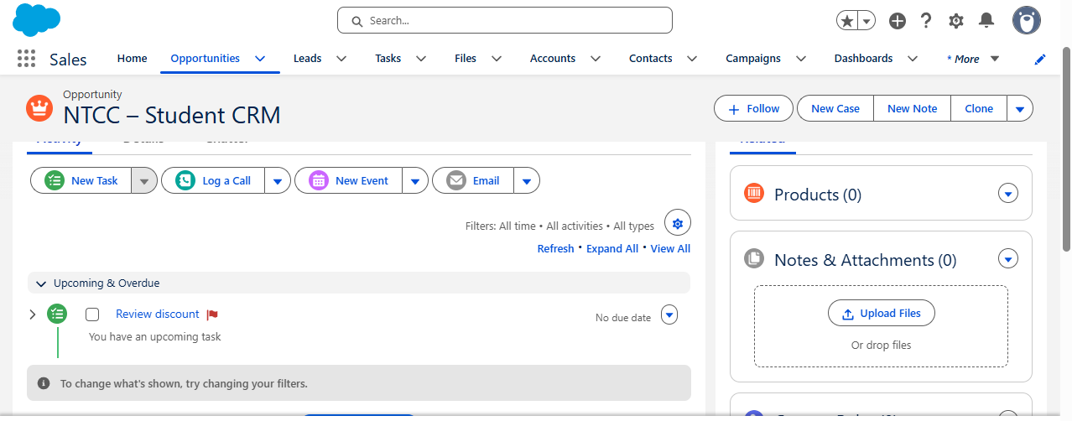
TC-07: task created when NTCC went from 15% back to 25%

Part 5: Case Management (FR-007)
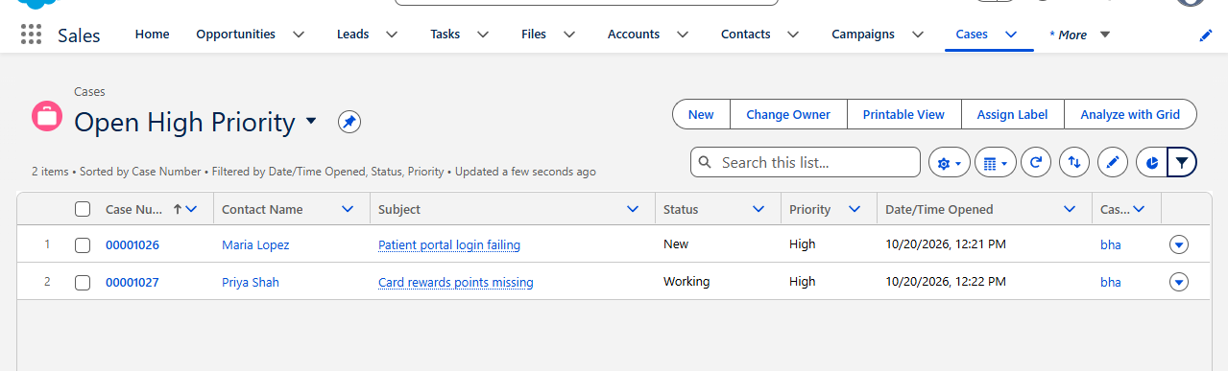
Open High Priority list view: 2 cases
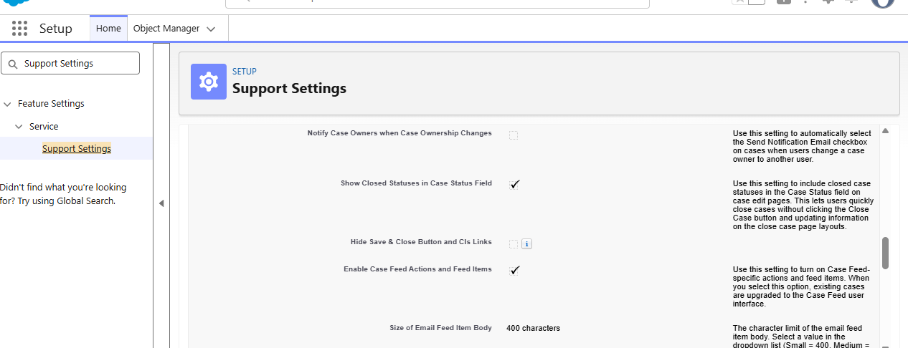
Support Settings: closed statuses shown in the Status field

Part 6: Reports and Dashboard (FR-003)
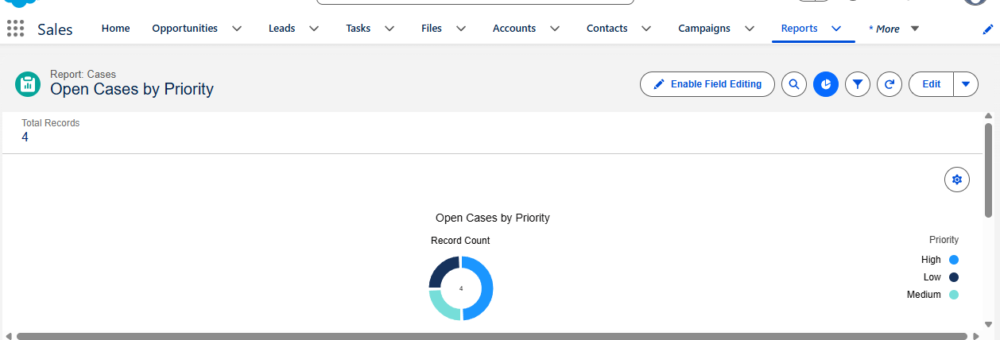
DEF-02: report showed 4 open cases
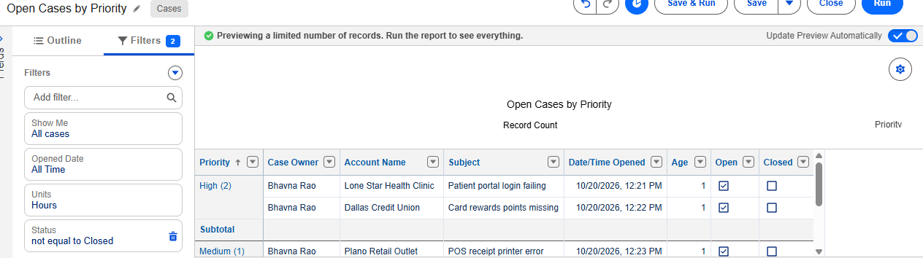
Report filter was correct (Status not equal to Closed)
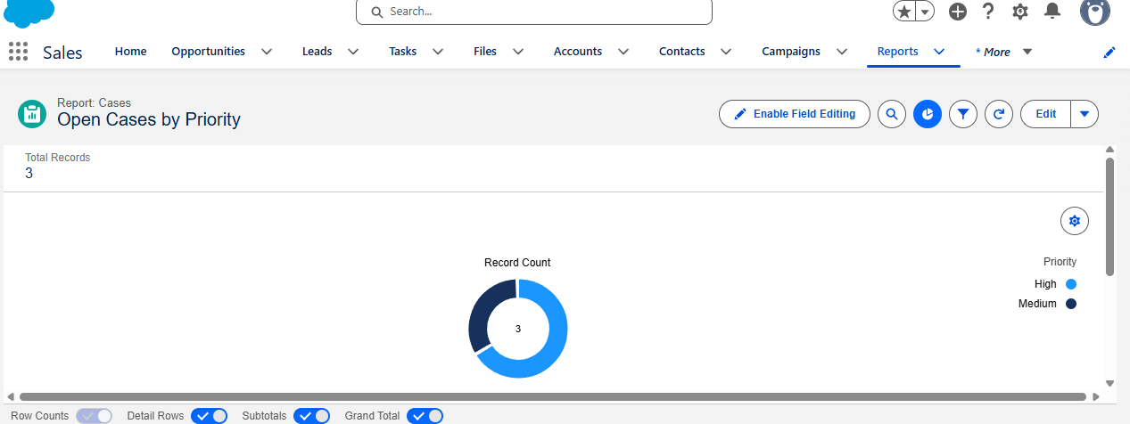
After closing the case: 3 open cases
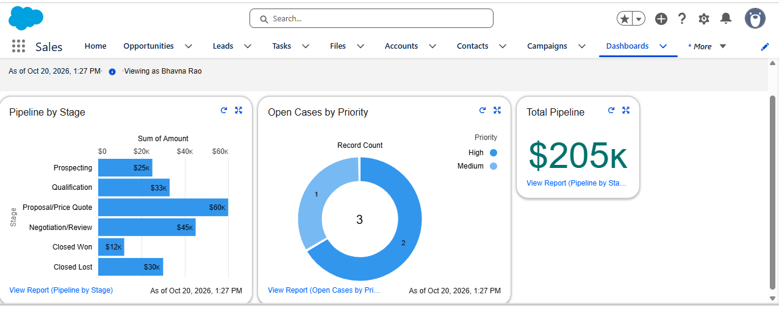
Dashboard before the DEF-03 fix: KPI showed $205K including closed deals
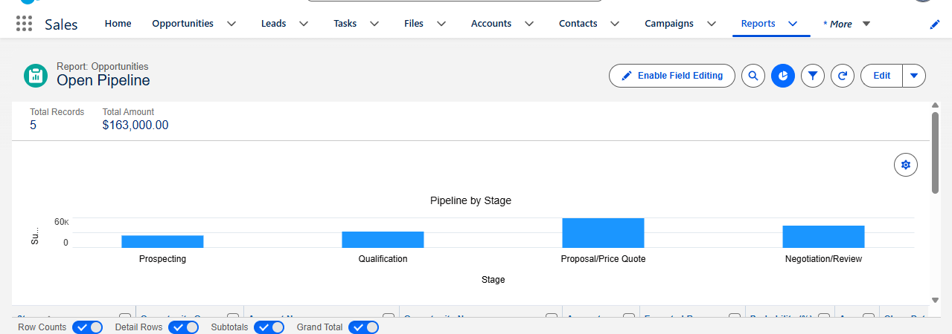
DEF-03 fix: Open Pipeline report, 5 open deals, $163,000
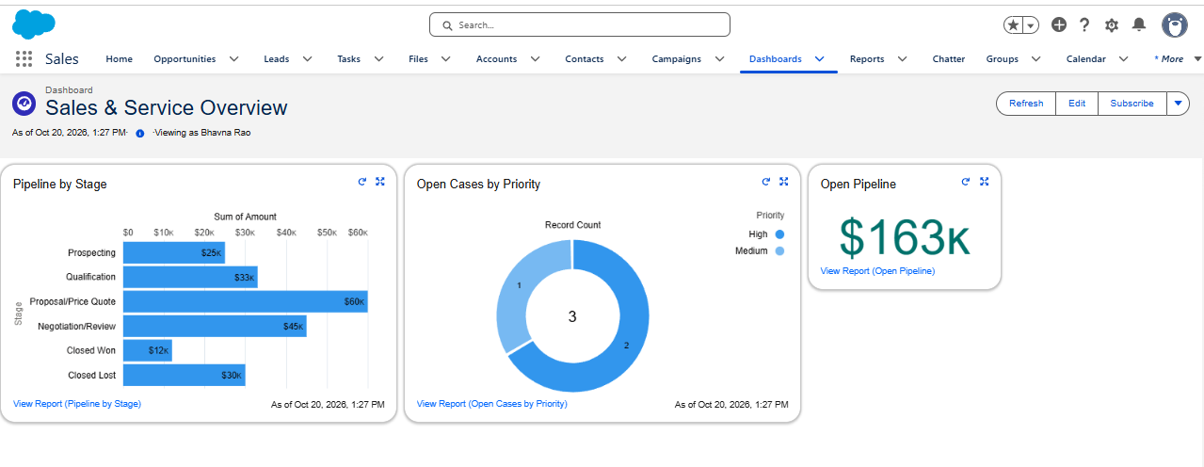
Dashboard after the fix: Open Pipeline KPI shows $163K

Part 7: Security (NFR)
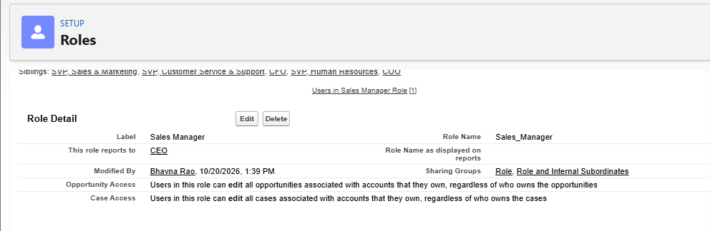
Sales Manager role reporting to CEO
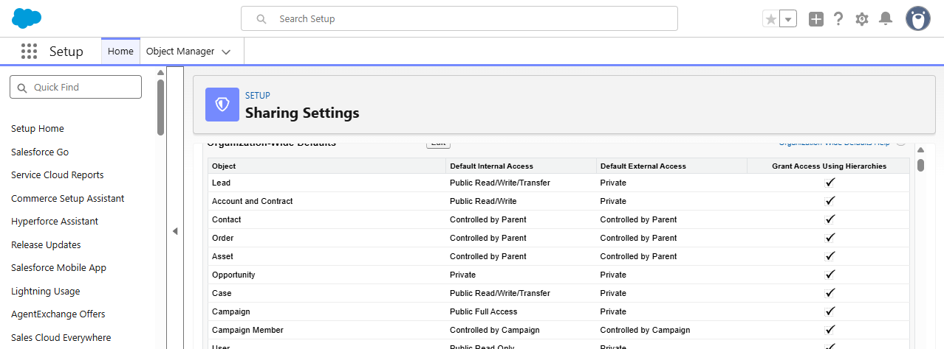
Opportunity org-wide default set to Private
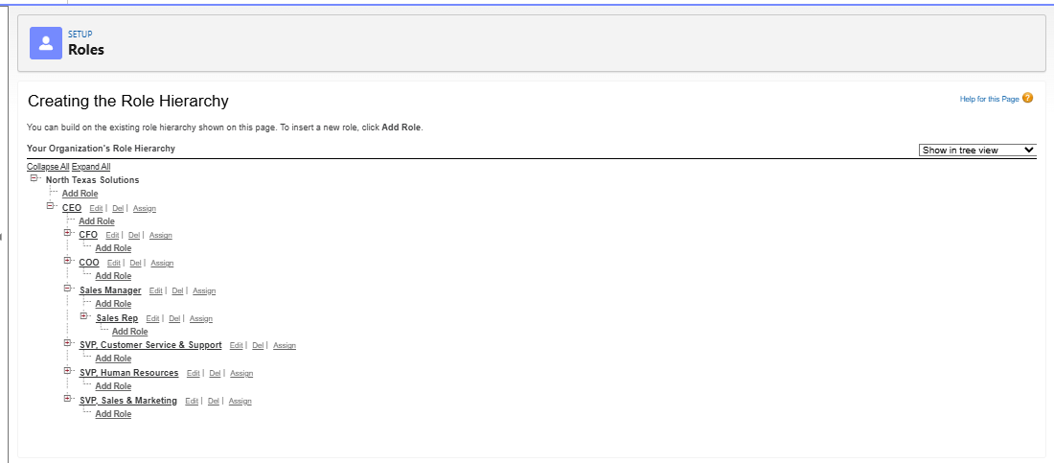
Role hierarchy: CEO > Sales Manager > Sales Rep

Phase 2 Backlog
- FR-004 marketing automation integration and FR-005 offline mobile access (Must Have, deferred)
- Add a due date to the review task
- Formal approval process with approve/reject buttons
- Log in as a Sales Rep test user to prove Private sharing end to end
- One-time update to flag deals that were already over 20% before go-live

