1. You have to visit the PW Skills website (https://pwskills.com/) and have to hide the logo by using the developer tool.

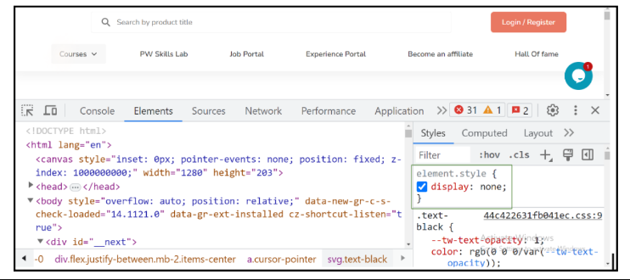

1. You have to visit the PW Skills website (https://pwskills.com/) and have to change the content of the ‘Login /Register’ button to ‘Connect with us’ using the developer tool. This should be done using the elements of developer tools

