Post-Harvest Loss Prevention System
IoT-Driven Spoilage Risk Prediction & Storage Optimization — Project Report

1. Abstract
This project builds a machine-learning system that predicts spoilage risk for stored produce using IoT sensor data such as temperature, humidity, ethylene and CO2 levels. A regression model estimates the remaining shelf life of a batch, from which the system derives a spoilage-risk category and raises alerts for unsafe storage conditions. A companion optimization module searches over feasible storage settings to recommend the conditions most likely to extend shelf life, directly supporting the goal of reducing food waste across the supply chain.

2. Dataset
The system was trained on Produce_Dataset.csv: 100,000 records covering 16 fruit and vegetable types across 8 Indian states, with IoT sensor readings (temperature, humidity, light intensity, CO2, ethylene, moisture), logistics data (transport mode, distance to market, cold-chain availability), and storage metadata (storage type, package type, storage duration). There were no missing values.
During exploratory analysis, three columns — Spoilage_Risk, Alert_Status, and Recommendation — were found to be deterministic functions of Shelf_Life (e.g. Shelf_Life ≤ 5 days always maps to 'High' risk / 'Critical' alert). These were therefore excluded from the model's input features to avoid label leakage, and are instead derived downstream from the model's own shelf-life prediction — mirroring how the system would work in a real deployment, where shelf life is the thing that must actually be predicted from sensor readings.

3. Modeling Approach

3.1 Shelf-Life Regression Model
A Histogram-based Gradient Boosting Regressor (scikit-learn) predicts remaining shelf life in days from 14 numeric sensor/logistics features and 14 categorical features (produce type, storage type, weather, etc.), using native categorical splitting. Data was split 80/20 (train/test, stratified by risk category for comparability with the classifier).
Metric | Value | Metric | Value
MAE | 2.30 days | RMSE | 3.02 days
R² | 0.79 | Test set size | 20,000 records

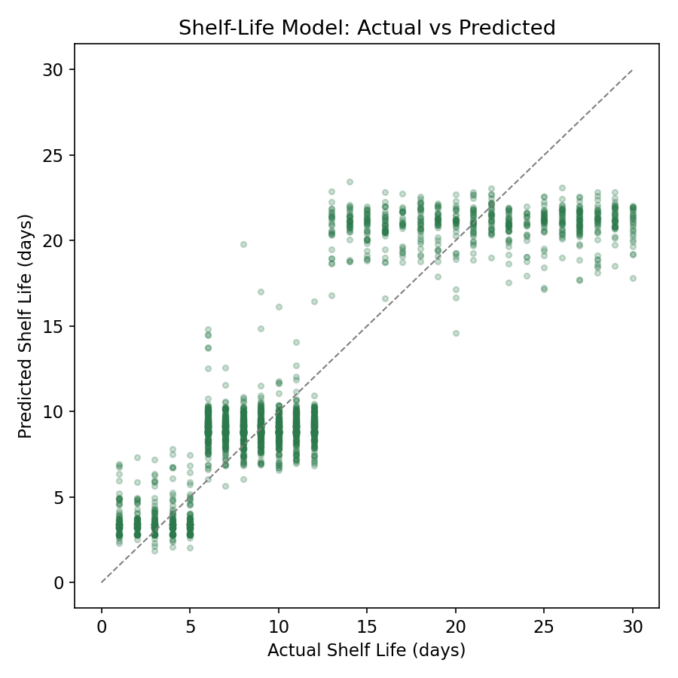
Figure 1: Predicted vs. actual shelf life on held-out test data. Points near the diagonal are accurate predictions.

3.2 Spoilage-Risk Classifier
A second Histogram-based Gradient Boosting Classifier predicts the Low / Medium / High risk category directly, as a fast cross-check against the regression-derived risk category.
Metric | Value | Metric | Value
Accuracy | 99.8% | Macro F1 | 0.997

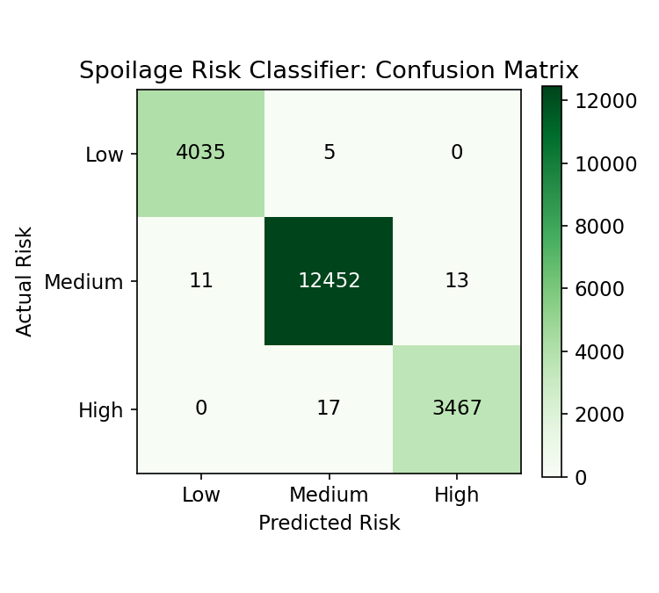
Figure 2: Confusion matrix for the spoilage-risk classifier on the test set.

3.3 What Drives Spoilage
Permutation importance on the regression model shows which factors matter most for shelf life:
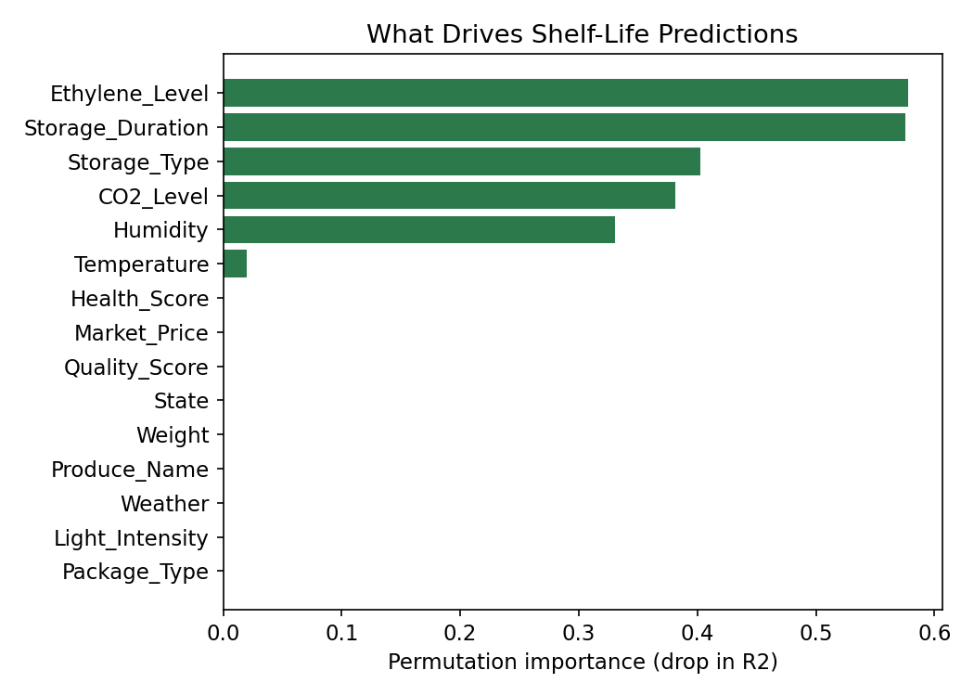
Figure 3: Feature importance (drop in R² when a feature is shuffled).
- Ethylene level and storage duration are the two strongest predictors — high ethylene accelerates ripening/decay, and the longer produce sits, the shorter its remaining life.
- Storage type and CO2 level are next — controlled-atmosphere and cold storage meaningfully outperform ambient storage.
- Humidity has a clear effect; temperature matters but less than expected on its own, likely because its effect is partly captured through ethylene/CO2 dynamics.
- Produce identity, market factors, and geography contribute comparatively little once sensor conditions are known.

4. Alerting System
The trained regression model feeds directly into a rule-based alerting layer that classifies any new reading into an actionable status:
Shelf Life | Risk | Alert | Action
≤ 5 days | High | Critical | Immediate sale/processing
6–12 days | Medium | Warning | Improve storage conditions
≥ 13 days | Low | Normal | Conditions optimal

This mirrors the thresholds observed in the source data and gives supply-chain operators a single, interpretable signal rather than a raw day count.

5. Storage Optimization
For any given batch, the optimizer grid-searches over adjustable storage parameters — temperature, humidity, storage type, and cold-chain use — and re-scores each combination with the shelf-life model to surface the setting predicted to extend shelf life the most. Example, for a batch of bananas currently predicted at 3.9 days remaining (High risk):
Setting | Temp | Humidity | Storage Type | Predicted
Current | 13.8°C | 88% | Controlled Atmosphere | 3.9 days
Best found | 14°C | 65% | Cold Storage | 9.7 days (+5.8)

This turns the model from a passive predictor into an actionable recommendation engine — the core aim of the abstract's 'optimization methods suggest improved storage strategies'.

6. Risk Patterns Across Produce Types
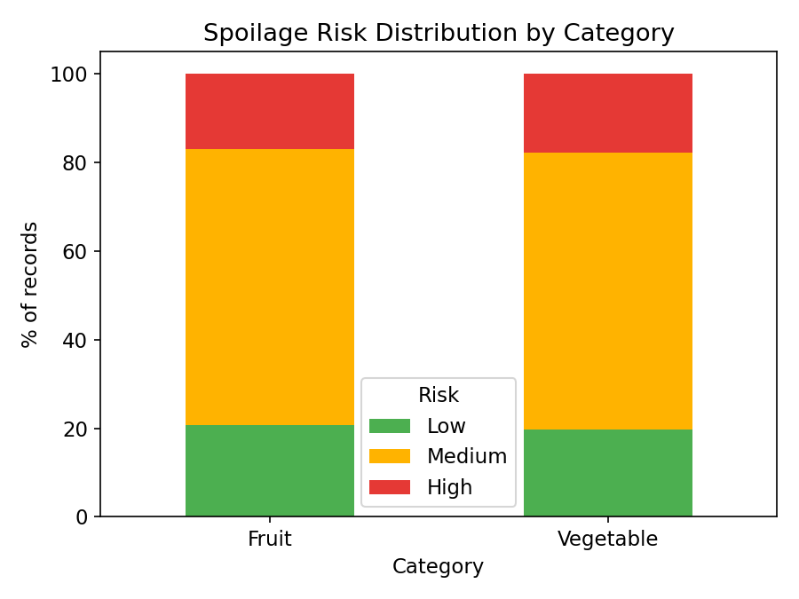
Figure 4: Share of records falling into each risk band, by produce category.
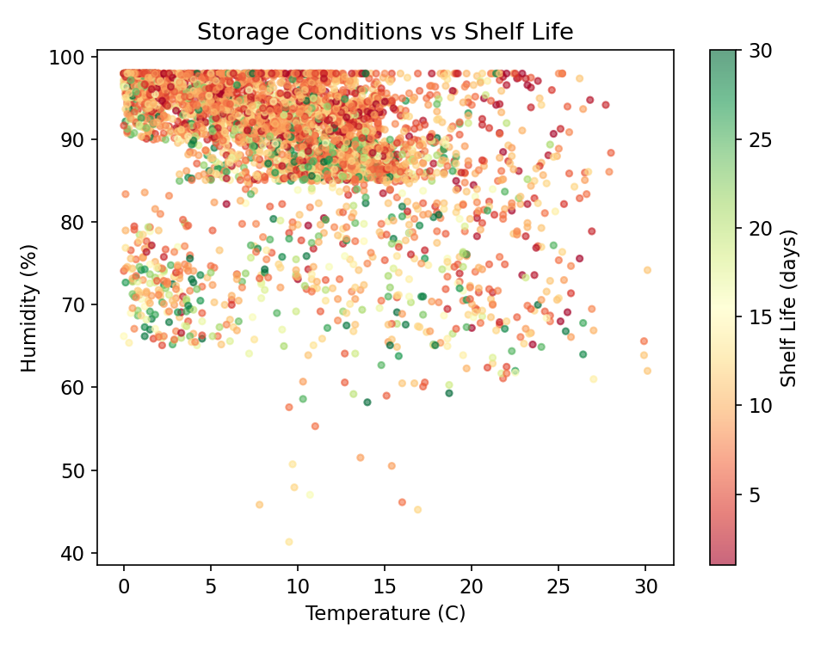
Figure 5: Shelf life across the temperature/humidity storage space — greener points indicate longer remaining life.

7. Deliverables
- train_models.py — end-to-end pipeline: data loading, preprocessing, model training/evaluation, alerting logic, and the storage optimizer.
- shelf_life_regressor.pkl / spoilage_risk_classifier.pkl — trained model artifacts, ready to load with joblib for inference.
- model_metrics.json — saved evaluation metrics and feature importances.
- This report, summarizing methodology, results, and business implications.

8. Limitations & Next Steps
- The dataset is synthetic/simulated; before production deployment the models should be validated and recalibrated against real sensor logs from actual cold chains.
- Shelf-life prediction error of ~2.3 days is a meaningful risk margin at the boundary between Medium and High risk — a tighter model or wider safety buffers would reduce false 'Normal' classifications.
- The optimizer currently treats storage parameters independently of cost; a production version should weigh predicted shelf-life gains against Storage_Cost to recommend economically sound, not just spoilage-minimizing, changes.
- Real-time deployment would wrap predict_and_alert() behind an API/streaming layer so IoT devices can trigger alerts continuously rather than in batch.

