

Name: Bhavna Thakur

ID NO. :- 21EL095

Division :- 11

Subject:- Digital System Design

Branch :- Electronics

Assignment :- 1

# Q-1 :-Write a Verilog code for 2*4 decoder.

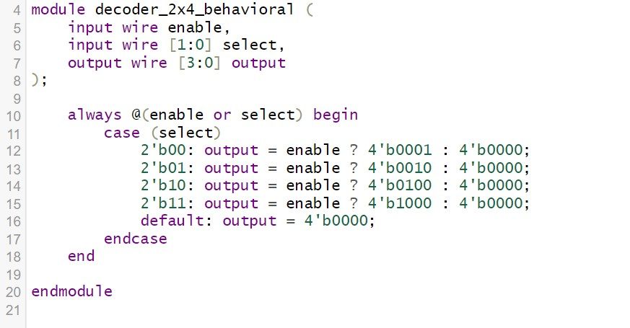

**TESTBENCH**

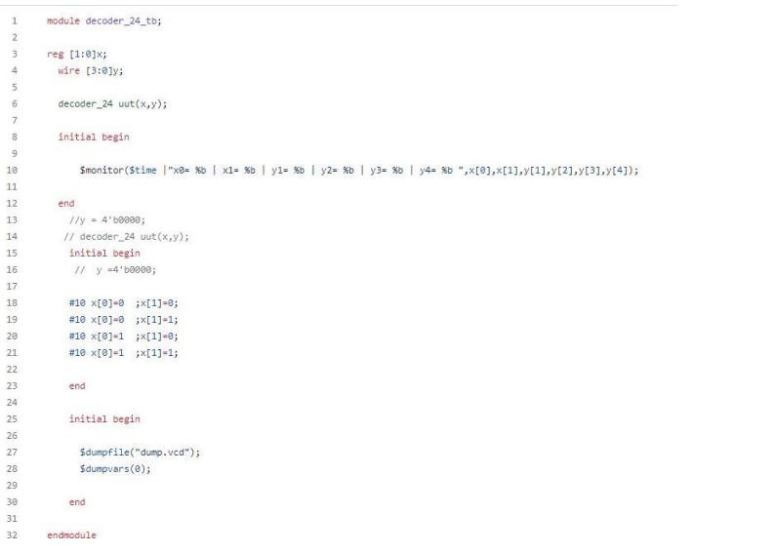

**OUTPUT:-**

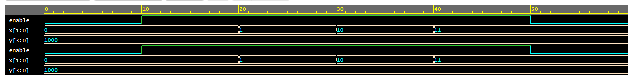

Q-2 :- Write a Verilog code for full subtractor.

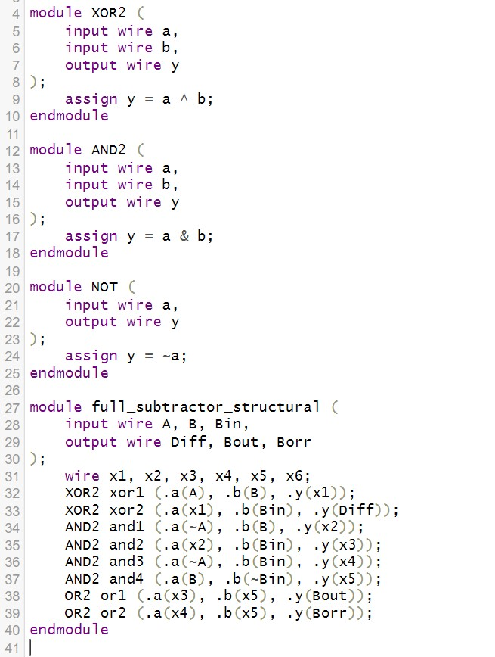

**TESTBENCH**

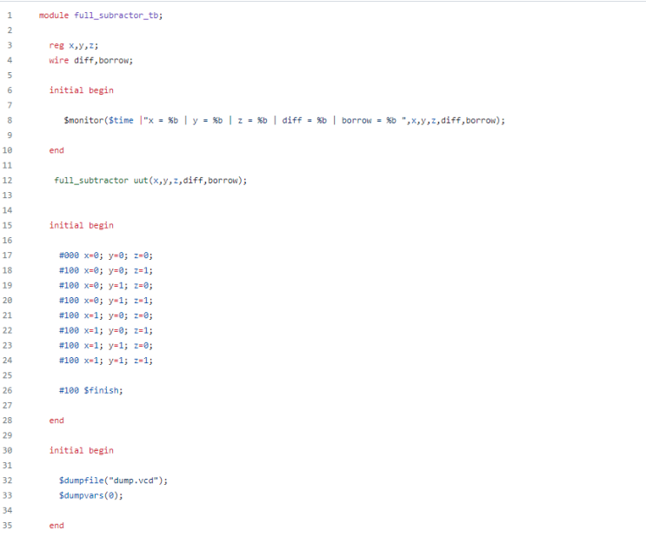

**OUTPUT:-**

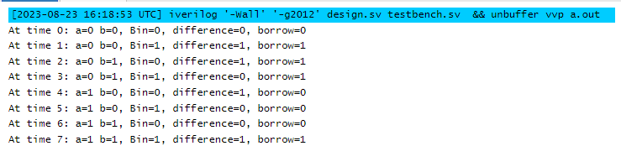

Q-3 :- Write a Verilog code for 2-bit comparator.

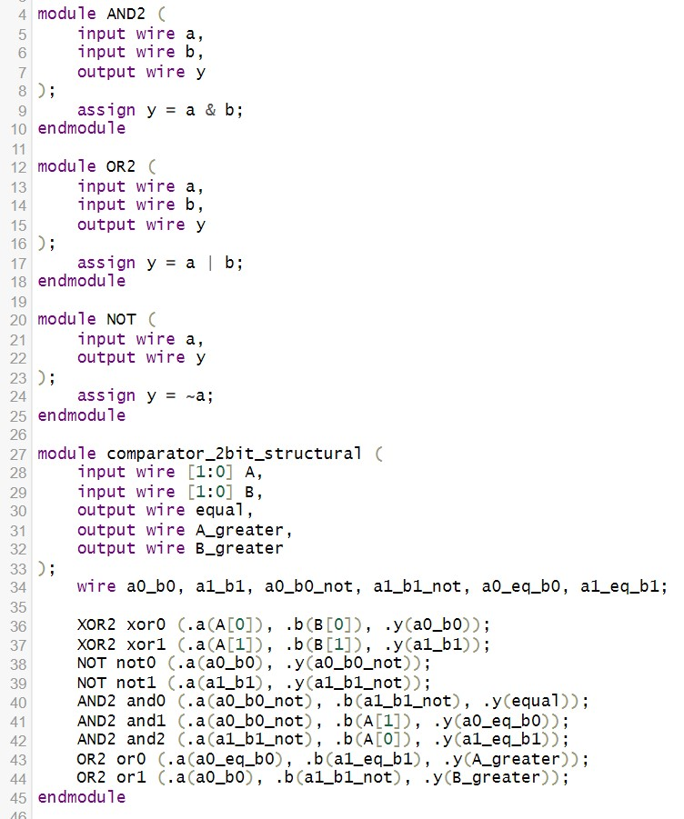

TESTBENCH

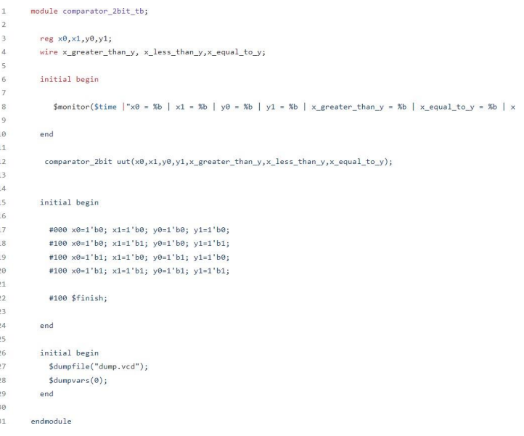

**OUTPUT:-**

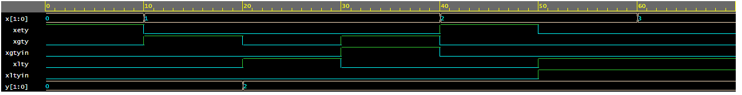

Q-4:- Write a Verilog code for 3 bit binary to gray convertor.

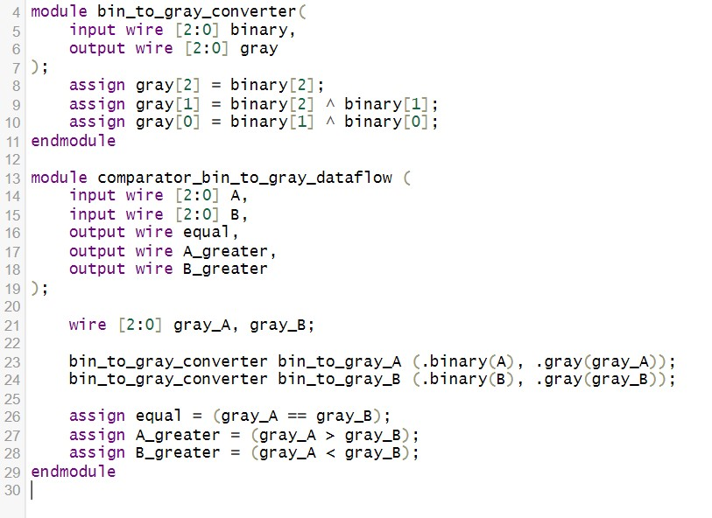

TESTBENCH

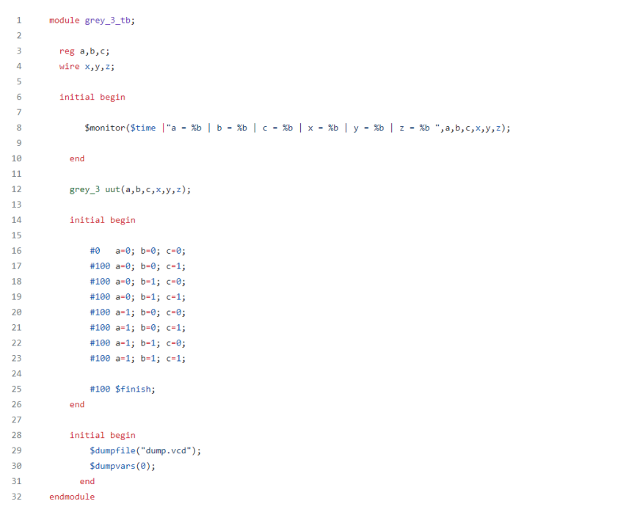

**OUTPUT:-**



Q-5 :- Write a Verilog code for BCD to excess 3 convertors.

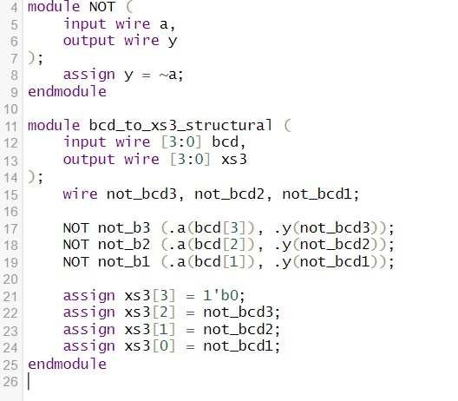

**TESTBENCH**

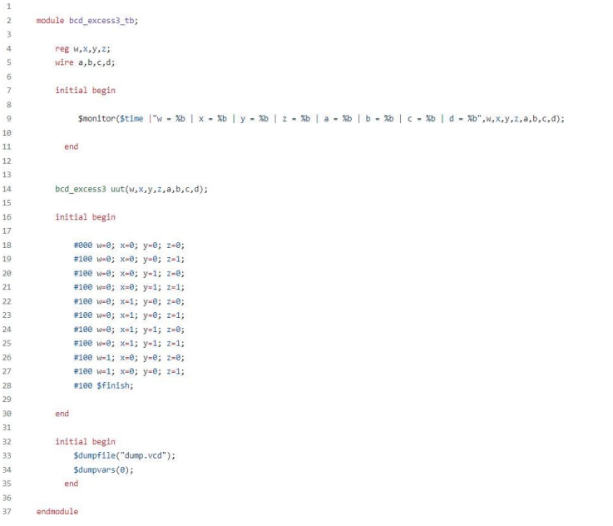

**OUTPUT:-**

