

Name: Bhavna Thakur

ID NO. :- 21EL095

Division :- 11

Subject:- Digital System Design

Branch :- Electronics

Assignment: - 2

Design 4-bit Ripple Carry Adder with the help of 1-bit adder

VERILOG CODE:-

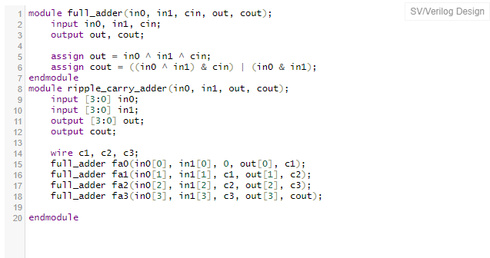

TEST BENCH

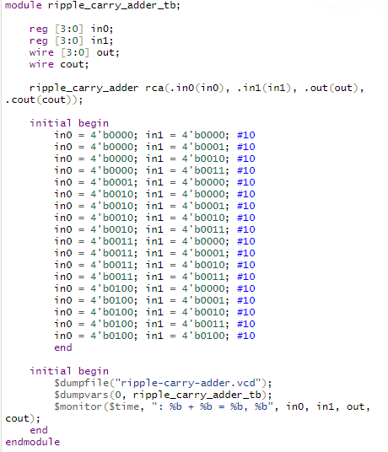

OUTPUT

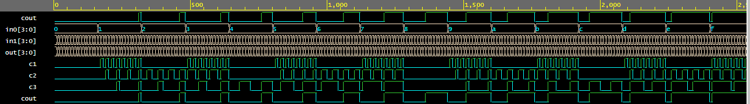

Design D-flipflop and reuse it to implement 4- bit Johnson Counter

Verilog code

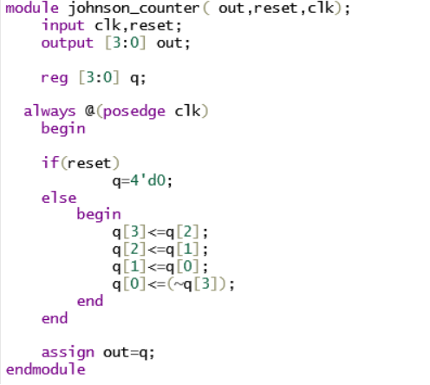

TEST BENCH

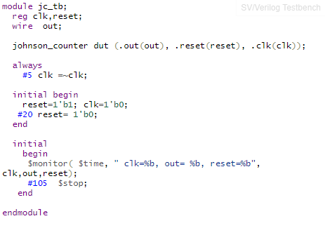

OUTPUT

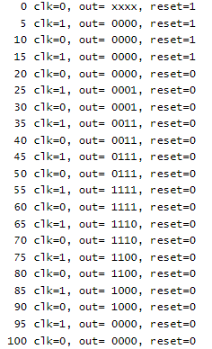

Reuse 2:1 Mux code to implement 8:1 Mux

VERILOG CODE:-

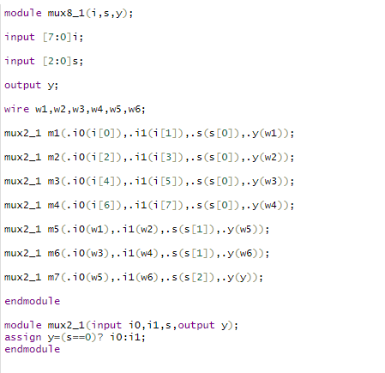

TEST BENCH:-

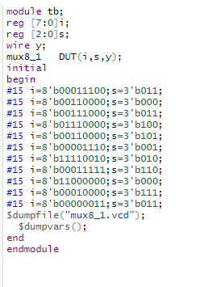

OUTPUT:-

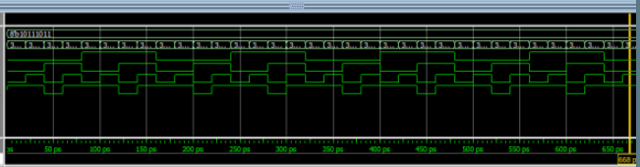

Design a Full Subtractor with Gate Level Modelling Style. (Use primitive gates)

VERILOG CODE:-

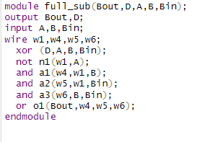

TEST BENCH:-

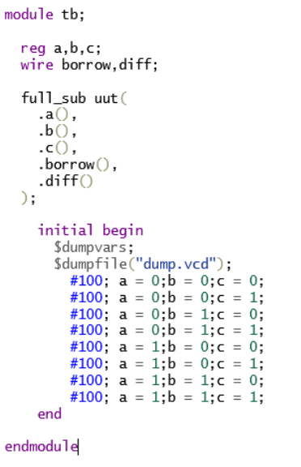

OUTPUT:-

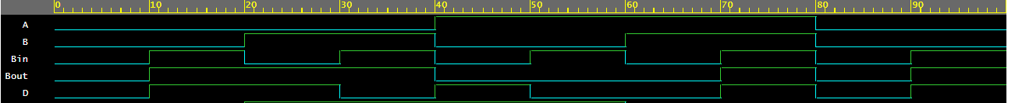

Design a 2X4 decoder using gate level modelling

VERILOG CODE:-

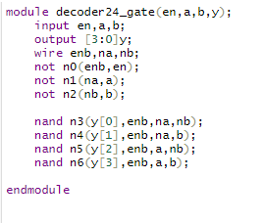

TEST BENCH:-

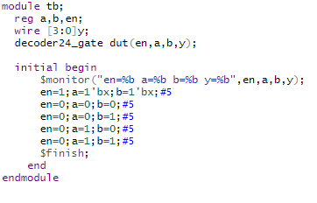

OUTPUT:-

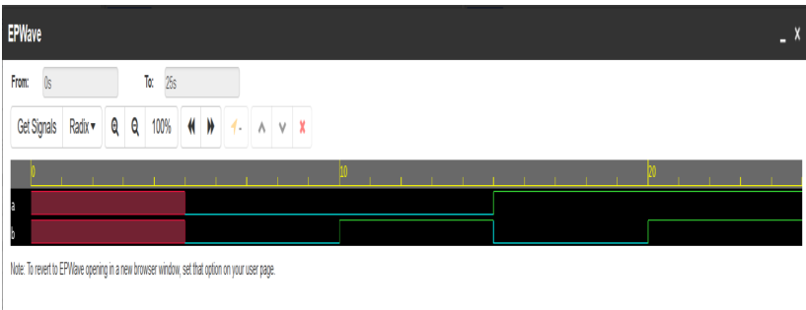

Design a 4x1 mux using operators. (Use data flow)

VERILOG CODE: -

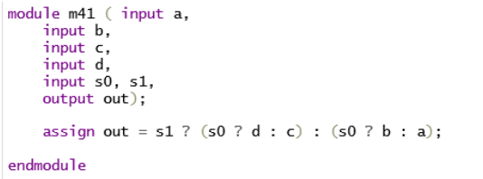

TEST BENCH: -

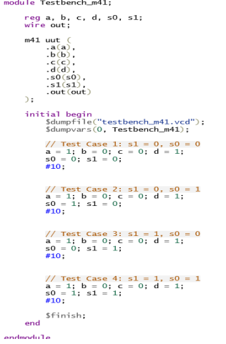

OUTPUT: -

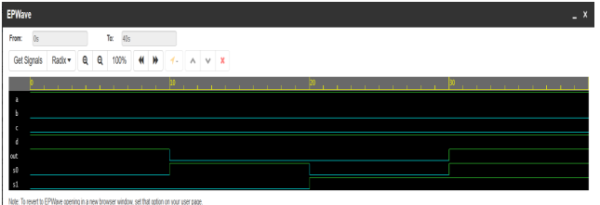

Design a Full adder using half adder.

VERILOG CODE:-

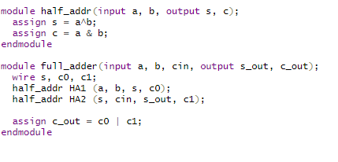

TEST BENCH: -

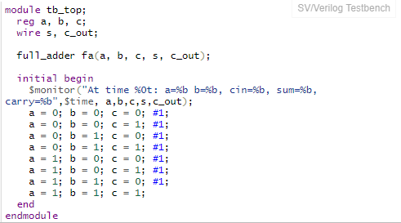

Output

