
PRODUCT FRAMEWORK
Destination
Content Hub
One place where destination information is put in once, checked, and made available to every travel agent who sells that destination.
Prepared for The Walshe Group · Version 1.0 · For review

What this document is  A plain description of what the platform does, who uses it and what has to be built. Written to be reviewed by operations and business teams. | What it settles  The purpose of the platform, the people it serves, the functionality required, and how information moves through it.

Contents
 | Section |  | Section
1 | Overview | 7 | Comparison with Elevate Tourism
2 | Scope | 8 | Non-functional requirements
3 | Who uses it | 9 | Security and data handling
4 | How it works | 10 | Assumptions, dependencies and risks
5 | Functional requirements | 11 | Points to confirm
6 | Workflows

1. Overview

1.1 Where things stand today
A tourism board creates its marketing material in one place, its markets adapt it in another, and travel agents sell the destination to the traveller somewhere else again. No single system covers all three.
- Content sits across too many separate tools - a website system, social scheduling, media monitoring, graphic design, image libraries and brand guideline documents, each one apart from the next.
- Every market or office needs its own access to every one of those tools.
- A single destination client runs across six or more disconnected tools with no shared workflow.
- Head office material is often not adapted for individual markets. Some boards send one version worldwide; others hand markets the assets and leave them to manage alone.
- Content created by travellers and influencers is uncontrolled and sometimes off-brand.
- Direct traffic to destination websites is down 30 to 40 per cent, and being found accurately by AI tools now matters as much as being found by search.
- The trade network of more than 10,000 agents receives a static email about once a month. Nothing about it is live or personalised, and most agents do not have the skills to create destination marketing themselves.
1.2 The problem
 | The problem | Who feels it
1 | Information is scattered. Creating, approving, sending and measuring content all happen in different systems, so nothing is in one place and nothing rolls up. | Tourism boards and their market offices
2 | Head office material does not fit the market. It arrives in one language, one season and one cultural frame, and is either used unchanged or rebuilt by hand. | Market offices and representation teams
3 | Agents cannot market the destination well. They are sent static files and no way to use them, and there is no record of whether anything was used at all. | Travel agents, and boards indirectly
4 | Travellers find information that is out of date or simply wrong, because the board's accurate information is not where people are now looking. | Tourism boards

1.3 What is being built
The Destination Content Hub
A single platform where a tourism board puts its information in once - in whatever format it already holds it - and where every travel agent approved to sell that destination can find that information, make it their own and send it to their customers.
The Walshe Group puts information into the same platform, and that information reaches the same agents in the same way.
Everything an agent can see has been checked, approved and is still valid. That single guarantee is what the platform exists to provide.

1.4 What it does
Takes information in, in any form  Boards and the Walshe Group upload files as they already hold them. The platform reads them, describes them, and asks only for what it could not work out by itself. | Makes it safe to hand out  Each item records where it may be used, in which markets and until when. Nothing reaches an agent before someone has approved it.
Gets it to the agent, ready to use  Agents find what they need, add their own branding, and send it to their customers through their own channels - in minutes, without design or writing skill. | Shows what happened  Every item is traced from the moment it is published to how it performed and which agents are active, so a board can finally see its trade network working.

2. Scope

2.1 What the platform covers
- One platform serving many destinations, each kept completely separate from the others.
- The full life of a piece of information: taken in, checked, approved, adapted, handed out, used, measured and retired.
- Two different experiences - one for tourism boards and their market teams, one for travel agents.
- Automated help with describing, organising, drafting, resizing and adapting content for each market.
- Sending directly to an agent's own social accounts, email lists and messaging contacts.
- Permissions set by market, language, channel and agent group.
- A working view for the Walshe Group to operate the platform on behalf of a destination client.
2.2 What the platform does not do
Not included | Why
Holding customer or consumer databases | Each client keeps its own lists. The platform connects to them only if a client chooses.
Booking, payment or reservations | An enquiry is handed to the agent's existing systems.
Replacing a board's public website | The platform feeds the website rather than replacing it.
Buying advertising | Out of scope for this platform.
Anything facing the travelling public | Every user is a verified business user.
An agency's own back-office systems | These stay where they are.

3. Who uses it

Two kinds of customer use the platform, and the Walshe Group operates it and also puts information into it.
3.1 Tourism boards and destination organisations
Person | What they are responsible for | What they need from the platform
Brand owner | The destination brand and how it is marketed | To see everything published in the destination's name, and to show that it worked
Content manager | Day-to-day content operations across markets | One place to work instead of six, and to stop being the bottleneck
Market manager | One country or region | Material that already fits their market, without waiting on head office
Trade manager | The relationship with agents and tour operators | A trade network that is actually selling, and proof of it

3.2 Travel agents and trade partners
Person | What they are responsible for | What they need from the platform
Independent agent | Their own bookings, selling several destinations | To market like a much larger business without hiring anyone
Agency marketing lead | Marketing for a small or mid-sized agency | Ready campaigns so every agent in the team looks the same
Tour operator product manager | Building and selling packaged travel | Accurate itinerary detail and offers that are still valid

3.3 The Walshe Group
- Operates the platform, sets it up for each destination and supports the people using it.
- Puts its own information into the platform, which then reaches agents in exactly the same way as a board's information does.
- Works inside a destination client's area of the platform where that client has allowed it.
The one tension to hold
The board wants control. The agent wants speed. Every function in this document exists to give both at the same time - control set once by the board, speed felt every day by the agent. Where a design forces a choice between them, the design is wrong.

4. How it works

Information enters from two sources, is checked once, and is then available to every agent who is approved to use it. Results come back and are matched to the item that produced them.
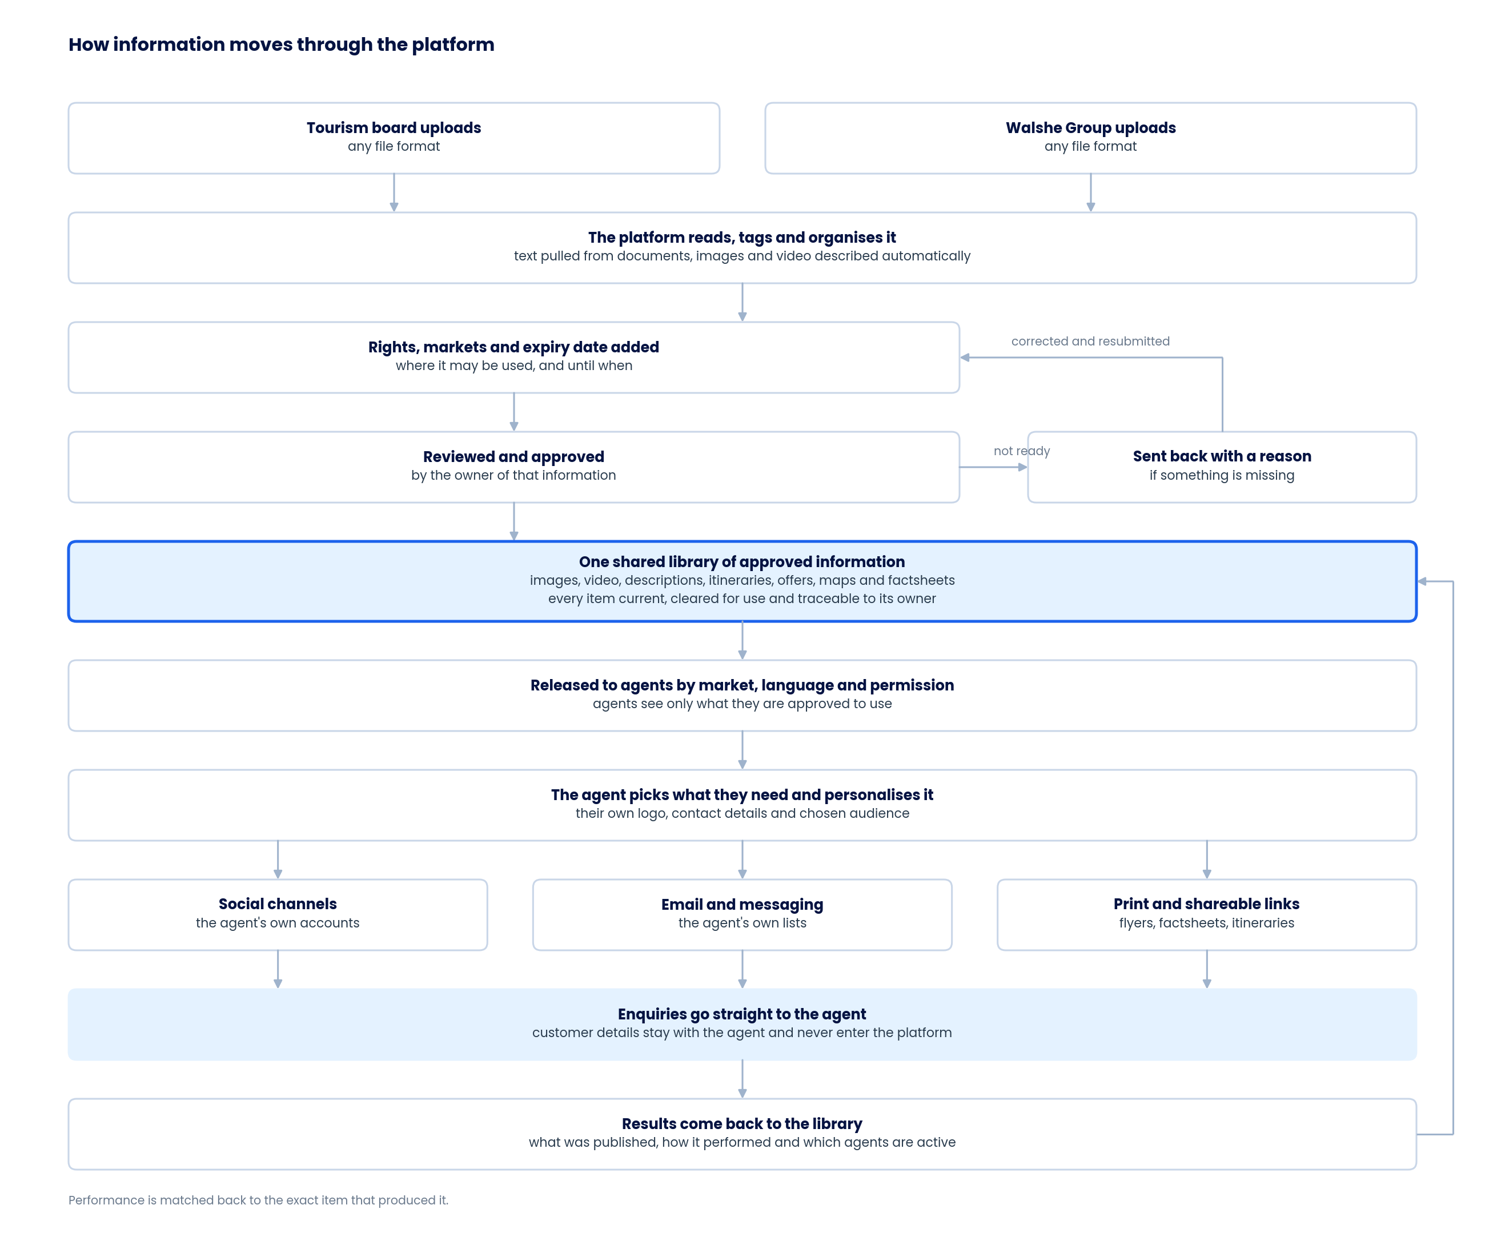
Information flow, from upload to the agent's customer and back
5. Functional requirements

Each function is numbered FR-01 upwards and grouped by the task it belongs to. "Used by" names who performs the function, not who benefits from it.
A. Putting information into the platform

FR | Function | What it does | Used by
FR-01 | Upload in any format | Accepts images, video, audio, documents, spreadsheets, presentations, PDFs and plain text. Nothing has to be converted or reformatted before it is uploaded. | Board, Walshe
FR-02 | Upload in bulk | Whole folders, or the contents of an existing shared drive, can be brought in at once. | Board, Walshe
FR-03 | Read the content out of files | The platform opens documents, PDFs and spreadsheets and pulls out the usable content - descriptions, itineraries, offer terms, hotel and attraction detail - so nobody retypes it. | Board, Walshe
FR-04 | Describe images and video automatically | Each image and video is tagged with what it shows: the place, the season, the activity, and whether people appear in it. | Board, Walshe
FR-05 | Ask only for what is missing | Having read the file, the platform asks the uploader only for what it could not work out on its own. | Board, Walshe
FR-06 | Record where every item came from | Every item shows who uploaded it and which organisation it belongs to. | All
FR-07 | Record how each item may be used | Which markets, which languages, which channels, and the date it stops being valid. | Board, Walshe
FR-08 | Mark what must not be promoted | Locations, properties or subjects that are off-limits are flagged once and then never appear anywhere in the platform. | Board
FR-09 | Find duplicates | Near-identical uploads are detected and grouped rather than stored twice. | Board, Walshe
FR-10 | Accept outside contributions | Approved photographers, operators and partners submit content into a review queue without being given access to the library itself. | Board, Walshe

B. Checking and approving

FR | Function | What it does | Used by
FR-11 | Nothing reaches an agent unapproved | Uploaded items stay invisible to agents until someone with authority to approve has released them. | Board, Walshe
FR-12 | Approval sits with the owner | A board approves its own content. The Walshe Group approves its own. A board may also choose to approve Walshe Group content about its destination. | Board, Walshe
FR-13 | Approve in bulk | A reviewer releases a whole batch in one action once the details are complete. | Board, Walshe
FR-14 | Send back with a reason | Anything not ready goes back to the uploader with the specific reason, and returns to the same point once corrected. | Board, Walshe
FR-15 | Status visible on every item | Draft, in review, approved, expiring soon, expired or withdrawn. | All
FR-16 | A full record of who did what | Every upload, edit, approval, release and withdrawal is recorded and can be exported. | Board, Walshe

C. Deciding who can see what

FR | Function | What it does | Used by
FR-17 | Named roles | Each person has a role that decides what they can see and what they can do. | Board, Walshe
FR-18 | Access by market and language | Content is released to some markets and languages and not others. | Board, Walshe
FR-19 | Agent groups | Agents are grouped, and content can be released to one group and not another. | Board, Walshe
FR-20 | Agents verified before access | A new agent is checked against the approved trade list before any content is released to them. | Walshe
FR-21 | Delegated working access | A board gives the Walshe Group working access inside its own area without handing over ownership or the ability to change its rules. | Board
FR-22 | Access withdrawn immediately | Removing someone ends their session, freezes their drafts and stops anything they had scheduled. | Board, Walshe

Roles
Role | Sits with | What they can do | What they cannot do
Board administrator | Tourism board | Everything inside their own destination, including granting access | Reach another destination
Brand owner | Tourism board | Set brand rules, approve content and templates | Change platform settings
Market manager | Board or market office | Adapt and release content for their assigned markets | Change master items or another market's content
Trade manager | Tourism board | Manage agent groups, training and access | Approve brand content
Walshe operator | Walshe Group | Upload and manage content, and work inside a client's area where permitted | Change a board's brand rules
Agency administrator | Travel agency | Manage their agency's users, branding and channels | See another agency's activity
Agent | Travel agency | Find, personalise and send approved content | Reach content outside their permissions
Contributor | Outside party | Submit content into a review queue | See the library
Reviewer | Board or Walshe Group | View content, permissions and records | Change anything
Platform administrator | Platform team | Manage set-up, integrations and platform health | Read client content without a recorded, time-limited permission

D. Finding information

FR | Function | What it does | Used by
FR-23 | Search in plain language | Typing what is wanted in ordinary words returns it - for example a beach photo with no people in it, cleared for use in a particular market. | Agent, Board
FR-24 | Ask the built-in assistant | A chatbot takes plain-language requests - find the right content, answer a question about a destination or an offer, or begin a post - and hands off to the tools that finish the job, so no one faces a blank screen. | Agent, Board
FR-25 | Browse by destination, theme, season and audience | For people who would rather look than search. | Agent, Board
FR-26 | Agents see only what they may use | Anything outside an agent's permissions does not appear at all, including in search results. | Agent
FR-27 | Every item shows whether it is current | Valid, expiring soon or expired, shown on the item itself. | All
FR-28 | Download in the format needed | Different sizes, crops and file types produced on request. | Agent, Board
FR-29 | Save collections | Agents keep the items they return to most often. | Agent
FR-30 | Alerts on new and changed content | An agent is told when something they use has been added, updated or withdrawn. | Agent
FR-31 | Every destination in one place | An agent selling several destinations works in one place rather than logging into several portals. | Agent

E. Turning information into marketing

FR | Function | What it does | Used by
FR-32 | Ready-made templates | Posts, emails, flyers and factsheets already laid out and already on-brand. | Agent, Board
FR-33 | Suggested next posts | For an agent who is not sure where to start, the platform recommends content worth sending - based on what they have and have not used, and what has worked for similar agents. | Agent
FR-34 | The agent's own details applied automatically | Logo, contact details, licence number and booking link are stored once and applied to everything afterwards. | Agent
FR-35 | Choose the customer, get the right version | The same destination presented for honeymooners, families, groups, older travellers or corporate bookings. | Agent
FR-36 | Wording drafted from approved information only | Any text the platform drafts is built from information already in the library. It cannot state something that is not there. | Agent, Board
FR-37 | Sized for each channel automatically | One item becomes the right shape and length for every place it is sent. | Agent, Board
FR-38 | Adapted into the market language | Not a word-for-word translation - wording, references and tone are adapted for the market, and a person reviews it before release. | Board
FR-39 | Attach a current offer | Only offers that are live can be attached, with their correct terms and end date. | Agent
FR-40 | Build an itinerary or factsheet | Assembled from approved parts and exported as a document or a shareable link. | Agent
FR-41 | Only permitted areas can be changed | Logo placement, colours and mandatory wording are fixed. Headline, image choice and contact details are open. | Agent
FR-42 | Checked before anything goes out | Brand rules, expiry dates, channel requirements and permissions are checked automatically. If a check fails, the platform says what to fix in plain words. | Agent, Board

F. Sending it out

FR | Function | What it does | Used by
FR-43 | Social media integration | The agent connects their own social accounts once, then schedules and posts straight from the platform and sees how those posts performed in the same place - one connected loop, no switching tools. The platform never holds a password and posts only with the agent's permission. | Agent
FR-44 | Schedule for later | Anything can be queued for a date and time. | Agent, Board
FR-45 | Send by email | Through the agent's own list, which stays theirs. | Agent
FR-46 | Send by messaging | To the agent's own contacts who have agreed to receive messages. | Agent
FR-47 | Download print-ready files | Flyers, counter cards, window material and trade-show collateral. | Agent, Board
FR-48 | Share as a link | For anything easier sent as a link than a file. | Agent
FR-49 | Enquiries go to the agent | Every item carries the agent's own link or form. Customer details reach the agent and never enter the platform. | Agent
FR-50 | Failed sends are reported | Anything that fails is retried and reported. Nothing is dropped silently. | Agent, Walshe

G. Keeping information correct

FR | Function | What it does | Used by
FR-51 | Everything carries an expiry date | Set when the item is added, and visible on it from then on. | Board, Walshe
FR-52 | Expired items withdraw themselves | Removed from the library, from agent drafts and from anything already scheduled, on the date, without anyone having to remember. | All
FR-53 | Change it once, it changes everywhere | Updating an item flags every version of it already in use so nothing old stays in circulation. | Board, Walshe
FR-54 | Remove anything immediately | One action removes an item from every part of the platform and from anything scheduled to go out. | Board, Walshe
FR-55 | Pause everything at once | During a weather event, a safety incident or similar, all promotional sending is paused across every market and approved messaging is put in its place. | Board
FR-56 | Alerts on ageing and missing content | Warns when items are about to expire, and when a destination, season or channel has nothing available to use. | Board, Walshe

H. Planning what goes out

FR | Function | What it does | Used by
FR-57 | A standing content calendar | A regular rhythm per destination and market, so no market or agent is left with nothing to send. | Board, Walshe
FR-58 | Seasonal and event prompts | Booking seasons, festivals, holidays and new air routes prompt ready-made content while it is still current. | Board, Agent
FR-59 | Campaign packs | Head office releases a campaign as one pack - material, wording, templates and timing - that a market accepts in a single action. | Board
FR-60 | Timed release | Content unlocks on a set date, by market and by agent group, so launches hold. | Board, Walshe

I. Reporting & Analytics

FR | Function | What it does | Used by
FR-61 | What was published, and by whom | Every item sent is recorded against the agent, the market and the campaign. | Board, Walshe
FR-62 | How it performed | Reach, engagement and clicks matched back to the exact item that produced them. | Board, Agent
FR-63 | Which agents are active | Who is sending, how often, and which groups have gone quiet. | Board, Walshe
FR-64 | Which content earns its place | What is used most, and what has never been used at all. | Board
FR-65 | Reports by market and campaign | Performance brought together across markets, agencies and campaigns in one view. | Board
FR-66 | Export and connect | Reports export on a schedule and can be fed into the board's own reporting systems. | Board, Walshe

J. Running the platform

FR | Function | What it does | Used by
FR-67 | Set up a new destination | A new destination goes live with its branding, roles and starter templates without development work. | Walshe
FR-68 | Each destination sees its own branding | The platform carries the destination's identity for the people using it. | Board, Walshe
FR-69 | The platform in the user's own language | The screens themselves, not only the content inside them. | All
FR-70 | Guided first use | A new agent is walked through to their first finished item rather than given a tour of features. | Agent
FR-71 | Help inside the platform | Guidance and support where the person is, not in a separate manual. | All
FR-72 | Settings changed by an administrator | Templates, roles, groups, approval rules and channel settings, all without a developer. | Board, Walshe

6. Workflows

6.1 What a tourism board does
The board's work is front-loaded. It sets the rules once, and the platform applies them every time an agent uses the content.
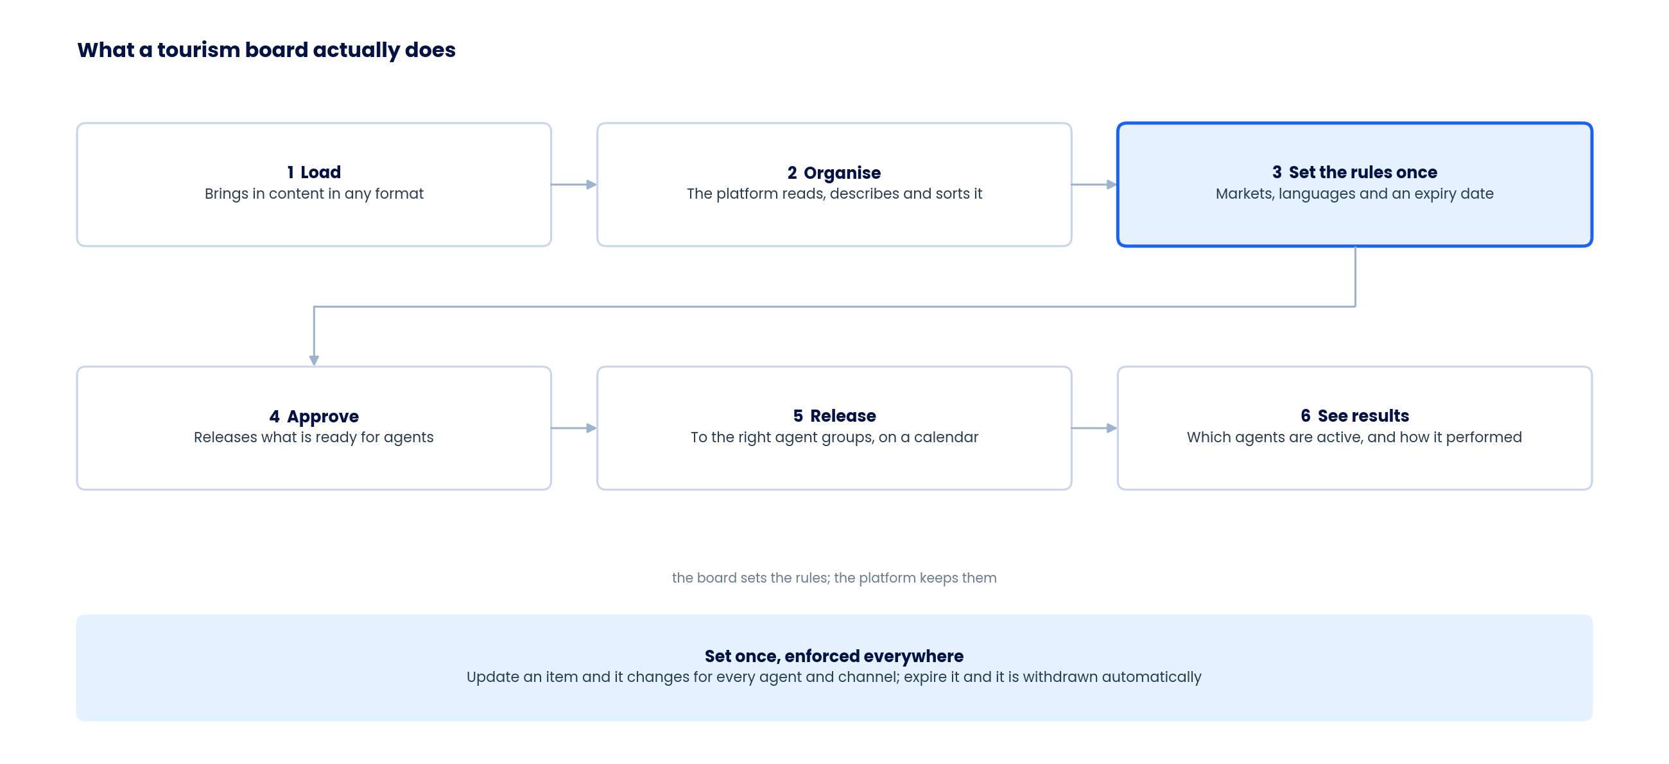
The board's path from loading content to seeing results
- The board loads content in whatever format it already holds - nothing has to be reformatted first.
- Control is set once. Where an item may be used, in which markets and until when, is decided at the start and applied automatically after that.
- The board can see its trade network working - which agents are active and how content performed - without asking anyone for a report.
6.2 What an agent does
Three real decisions from the agent - who the customer is, what to change, and when to send. Everything else is done for them.
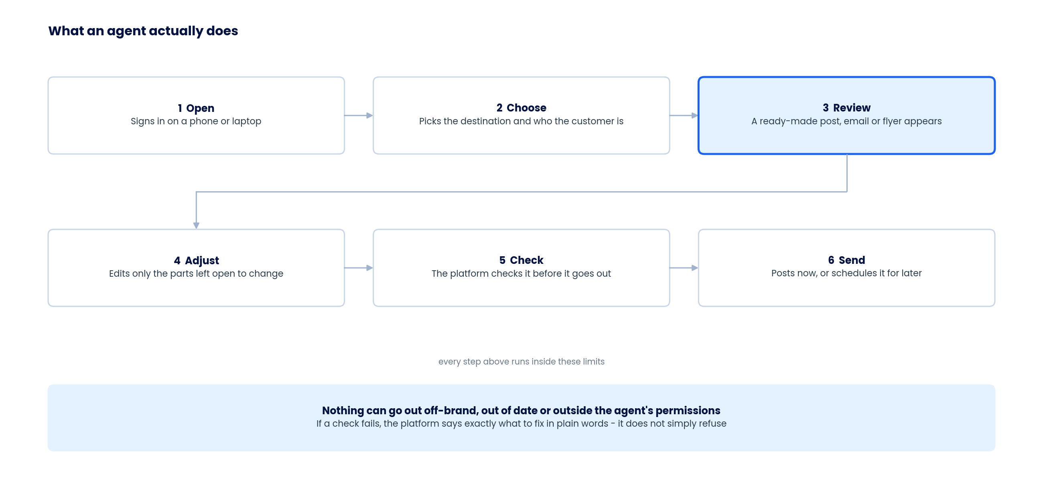
The agent's path from opening the platform to sending something
- The check is there to help, not to block. It names the specific thing to fix in the agent's own words.
- An agent who has never used the platform should reach a finished, sendable item in their first few minutes.
- Results return automatically, so the agent and the board both learn what worked without anyone reporting it.
6.3 Where data sits
Information moves down through the platform and results come back up. Customer details never enter it at any point.
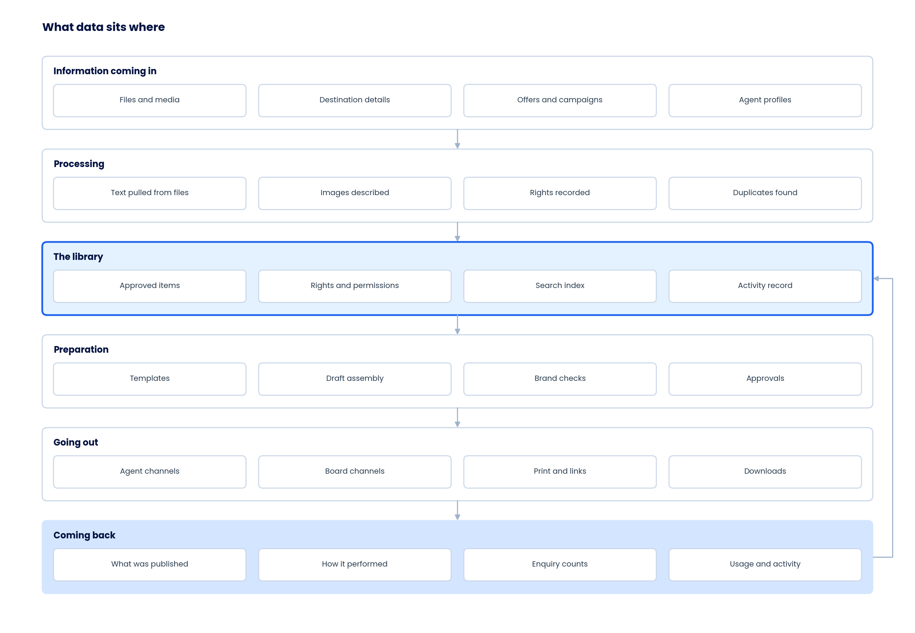
What the platform holds at each stage, and what returns to it
6.4 The boundaries that must hold
- Customer details do not enter the platform. Enquiries are captured on the agent's own link and returned only as counts.
- An agent's client list stays with the agent, and can be removed by them at any time.
- Destinations do not touch. Content, records and search are kept entirely separate for each one.
- Client content is not used to train shared models.
- Usage rights travel with the item. Anything leaving the platform carries its terms and its credit line.
6.5 What sets the platform in motion
When this happens | This follows automatically
An item is approved | It is indexed, released to the agent groups allowed to use it, and the people who need it are told
A master item is changed | Every version already in use is flagged so nothing outdated stays in circulation
An offer opens or closes | It becomes attachable, or stops being attachable, in every agent's workspace at once
An expiry date is reached | The item is withdrawn from the library, from drafts and from anything scheduled
Something is sent | It is recorded against the agent and the item, and performance starts being collected
A location is marked off-limits | It disappears from search, from drafting and from everything an agent can select
Everything is paused | All promotional sending stops across every market and approved messaging replaces it
Access is withdrawn | The session ends, drafts freeze and anything scheduled is stopped

7. Comparison with Elevate Tourism

Elevate Tourism (elevatetourism.com) is the closest named platform in this space. It is built to help tourism operators and destination leaders improve their own marketing, not to distribute a board's content to a network of travel agents, so the overlap is limited. The table compares the key steps in the workflow.
Feature | Elevate Tourism | Destination Content Hub | Confidence Score
Central content library | ✗ | ✓ | Derived
Upload content in any format | ✗ | ✓ | Derived
Content approval and brand control | ✗ | ✓ | Derived
Rights, markets and expiry control | ✗ | ✓ | Derived
Distribution to travel agents | ✗ | ✓ | Confirmed
Agent personalisation and co-branding | ✗ | ✓ | Derived
Social media integration | ✗ | ✓ | Derived
AI content drafting | ✓ | ✓ | Confirmed
AI assistant (chatbot) | ✗ | ✓ | Derived
Ready-made templates and campaigns | ✓ | ✓ | Confirmed
Reporting and analytics | ✗ | ✓ | Derived
Multi-destination, white-label platform | ✗ | ✓ | Derived

The confidence column refers to the Elevate Tourism column, since we do not have access to their platform. “Confirmed” means stated directly on their website; “Derived” means reasoned from what is publicly visible.
8. Non-functional requirements

These decide whether the platform works for a real agent on a phone, and whether a board's own review process will accept it.
Area | What is required | Why it matters here
Speed | The agent workspace opens in under two seconds on a normal mobile connection. A search returns in under a second. A first draft appears in under fifteen seconds. | An agent gives up on slowness long before they give up on features
Scale | Built to hold many destinations, tens of thousands of agents and millions of items without being rebuilt. | The same platform has to serve one destination and a hundred
Availability | Available 99.9 per cent of the time. Anything scheduled still goes out if the platform restarts. | A launch-day post cannot be sent the following day instead
Works on a phone | Every agent task can be completed on a phone. | Many agents have no desktop at all
Large files | Video and large images upload reliably on a weak connection and resume if interrupted. | Uploads happen from hotel lobbies and airports, not only from offices
Languages | Content and the platform itself in any language, including right-to-left scripts, with local date and currency formats. | The whole point is that one version does not fit every market
Accessibility | Meets recognised accessibility standards, and content carries captions and image descriptions. | Publicly funded boards are usually required to evidence this
Where data is held | Each destination's information can be held in a chosen region. | Some boards cannot hold information outside their own jurisdiction
Recovery | Restorable to any point within the last fifteen minutes, and back in service within four hours. | Losing the record of usage rights is worse than losing a file
Taking data out | A board can export everything it holds - items, details, permissions and records - at any time, in an open format. | Removes the largest single objection in any review
Connecting | Everything the platform does is available to a board's own systems through a documented interface. | Boards will keep systems this platform is not replacing
Monitoring | Failures, delays and unusual usage are visible to the operating team before a client notices them. | Support should not begin with a client's complaint

9. Security and data handling

Most destination boards are publicly funded, which means their own review process decides whether the platform can be adopted. These positions are written to hold up to that review.
Area | Position
Separation | No destination can reach another destination's content, records or search results under any circumstance.
Signing in | Organisations sign in through their own systems where they have them. Individual agents use secure sign-in with a second factor available.
Channel access | The platform never holds a social or email password. An agent authorises their own accounts and can withdraw that permission at any time.
Customer data | Customer and consumer details do not enter the platform at any point.
Staff and agent data | Personal details of the people using the platform are handled under the data protection law that applies in each market.
Content rights | Every item records how it may be used and cannot be used outside those terms, anywhere in the platform.
Automated drafting | Anything the platform drafts is recorded with what it was built from and who approved it, so it can always be accounted for.
Automated content marking | Content produced with automated help is marked, and how that is disclosed can be set for each market.
Model training | Client content is not used to train shared models without written permission.
Records | Every action is recorded and can be exported on request.
Support access | Platform staff cannot see a client's content except under a recorded permission that the client grants and that expires.
Outside suppliers | Every supplier involved in running the platform is named and disclosed to clients.

10. Assumptions, dependencies and risks

9.1 What we are assuming
Assumption | If it turns out to be wrong
Boards will place their brand material and brand rules in the platform | Without the material there is nothing for an agent to use
Agents want better marketing material and will use a tool that gives it to them | The agent side falls away, and the value to the board with it. This is the biggest untested assumption here
Existing content can be brought across with a record of how it may be used | Bringing content across becomes a rights-clearing exercise with its own timeline
Agents will connect their own channel accounts | Print, email and link sharing must work fully for agents who connect nothing
Boards will accept automatic checks in place of approving every single item | Approval becomes a queue, and the speed the agent needs disappears
The platform holds content only, and customer databases stay with each client | The platform inherits obligations that belong to the client

9.2 What we depend on
Dependency | Why it matters
Access to a real group of agents to test with | Nothing else can confirm whether agents will use it
A board's brand rules and a sample of its content | Without them there is nothing to build the first version around
Records of how existing content may be used | Determines whether bringing content across takes a week or a quarter
Permission from each social platform to publish on an agent's behalf | These approvals sit with outside companies and take time, so they start early
A decision on where each client's data must be held | Shapes how the platform is built, not just how it is configured
Enough content for the destinations going first | A thin library makes even a good platform look empty

9.3 What could go wrong
Risk | Early sign | What we do about it
Agents do not use it | Few agents send anything a second time | Test with a real group before the first release is fixed, and make sure the first session ends with something actually sent
Approval is set so tight that nothing useful comes out | The approval queue grows through the pilot | Show the board that the checks and templates already protect the brand, and start with one narrow type of content
Channel permissions take longer than expected | Applications still open after several weeks | Start them at the very beginning, and open with the channels that are ready
The output is only adequate | Agents use it once and go back to what they had | Put the effort into the templates and the creative direction, not only into the automation behind them
Existing content has no usage records | Items arriving with nothing recorded against them | Hold anything without a usage record aside rather than releasing it
Agents already have too many portals to log into | Low take-up despite good content | Put every destination an agent sells in one place, and make it work properly on a phone
The platform is shaped around one destination only | Every requirement traces back to a single client | Confirm the second destination's needs before the second stage is locked

11. Points to confirm

Five things to settle in this review. Each one changes what gets built first.
 | Point | Options
1 | Which destination and which market go first | A destination already running across many tools, or a smaller board with a simpler library
2 | Which channels agents most need on day one | Social only, or social together with email and messaging
3 | How much a board wants to approve | Approve the templates and let agents work freely, or approve templates and spot-check what goes out
4 | Where each client's data must be held | A single region for all clients, or a region chosen per client
5 | Access to a group of agents for testing | A small group from one market, or a mixed group across several markets

What happens next
- A working version of the agent experience, end to end, to test the speed claim with real agents.
- The permission applications with each social platform, started immediately, because they run on someone else's timetable.
- A review of a sample of existing content, to size how much of it can be brought across as it stands.
- A second round of this document once the five points above are settled.

Ready for your review.
Mark up anything in this document that does not match how your teams actually work - that is what the next round is for.
www.bigsteptech.com

