**A SEMINAR REPORT**

ON

**INTERNET of THINGS : SMART IRRIGATION SYSTEM**

BY

**SARVESH THOKE**

**ROLL NO:18U456**

UNDER THE GUIDANCE OF

**Prof.P.S.Desai**



DEPARTMENT OF COMPUTER ENGINEERING

SMT KASHIBAI NAVALE COLLEGE OF ENGINEERING,

PUNE-411041

Accredited by naac

**SAVITRIBAI PHULE PUNE UNIVERSITY 2019-20**



Date:

## Certificate

This is to certify that Sarvesh Tryambak Thoke has successfully completed his seminar work on “ Smart Irrigation System Using Internet of Things ” at Smt. Kashibai Navale College of Engineering , Pune in the partial fulfillment of the Graduate Degree course in T.E. at the Department of Computer Engineering, in the academic Year 2019-2020 Semester -VI as prescribed by the Savitribai Phule Pune University.

Prof. P.S.Desai Dr. P. N. Mahalle

Guide Head of Department

. Department of Computer Engineering

Dr. A. V. Deshpande Principal

Smt Kashibai Navale College of Engineering

## Acknowledgement

With due respect and gratitude I take the opportunity to thank those who have helped me directly and indirectly. I convey my sincere thanks to Dr. P. N. MAHALLE, HOD Computer Dept. and Prof P.S.Desai for their help in select- ing the seminar topic and support.

I thank to my seminar guide Prof P.S.Desai for her guidance, timely help and valuable suggestions without which this seminar would not have been possible. Her direction has always been encouraging as well as inspiring for me. Attempts have been made to minimize the errors in the report.

I would also like to express my appreciation and thanks to all my friends who knowingly or unknowingly have assisted and encourage me throughout my hard work.

Sarvesh Thoke

Roll No.-18U456

T.E Comp 2019-2020

ii

## Abstract

Internet of Things plays very important role in agriculture Industry. In order to attain maximum production of food IoT gives abstract idea for implementation overcomes time and place constraint over wired communication especially IT de- velopment from automation data collection.In this paper , we are implementing smart irrigation using wide area network , Bluetooth and MQTT (Message Queuing Telememntay Transport). This methodology implements monitoring and function of communication protocol. MQTT is IoT dedicated Protocol, thereby enhancing thepossibility of development of agricultural IoT

iii

## Acronyms

LPWAN Low Power Wide Area Network

MQTT Message Queuing Telementary Transport

WSN Wireless Sensor Network

iv

# List of Figures

3.1 System Construction. . . . . . . . . . . . . . . . . . . . . . . . . . . 5

4.1 Types of communication. . . . . . . . . . . . . . . . . . . . . . . . . 7

4.2 MQTT protocol as Broker. . . . . . . . . . . . . . . . . . . . . . . . 8

* 1. Publish-Subscriber Model. 11
  2. Tree Diagram. 12

v

# Contents

### Certificate i

Acknowledgements ii

Abstract iii

Acronyms iv

1. Introduction 1

1.1 Motivation . . . . . . . . . . . . . . . . . . . . . . . . . . . . . . . 3

1. Literature Review 4
2. SYSTEM CONSTRCTION 5
3. Comminication Protocol 7
4. HARDWARE DESIGN 9

5.1 Arduino . . . . . . . . . . . . . . . . . . . . . . . . . . . . . . . . . 9

5.2 PCB Layout . . . . . . . . . . . . . . . . . . . . . . . . . . . . . . . 9

1. Message Design 11
   1. Bottom-Up Approach 12
2. Challenges 13
   1. Environmental Challenges 13

vi

* 1. Wildlife challenges 13

1. Results And Future Work 15
2. Conclusion 16

References 17

vii

# Chapter 1 Introduction

In accordance with industrialization, the application of automation technology to agriculture is attempting from the necessity of mass production of food.Agricultural automation began with information technology and the collection of crop growth. The data collection requires a sensor to collect environmental and growth data and a server to store the data, and the farmer adjusts the environment and cultivates plants based on the collected data. Since the current smart irrigation has evolved based on the greenhouse environment, the farmer’s environment can be controlled from the control of devices such as fans, heaters and air conditioners installed in the greenhouse. However, most of the smart irrigation systems so far have difficulties in installing additional devices as wired communication systems, and environmental sensing and control are connected to the greenhouse range. Wired Communication systems have limitations in distance and location , so sensors cannot be installed in large areas of arcs, mountains, sea, or animals in the housing.

To improve the scalability and usability of the new smart farm system by over- coming the problem of application limitations of wired devices in agriculture by using wireless communication module. However, since the current technology level of the wireless communication system suffers from a power shortage problem, the development of the low power wireless communication module is being activated,

and with the development of the battery technology, the change speed from the wired system to the wireless system is accelerating

SKNCOE TE Comp. 2

## 1.1 Motivation

Current technology level of the wireless communication system suffers from a power shortage problem, the development of the low power wireless communication module is being activated, and with the development of the battery technology, the change speed from the wired system to the wireless.To suggest some modern Technique to overcome with wired communication ,this implementation is used

The advanced method system is a merged structure of existing method and new technology, it is anticipated that it will be possible to save maintenance cost of existing devices and to provide compatibility with new devices

SKNCOE TE Comp. 3

# Chapter 2 Literature Review

In this paper, smart irrigation system using low power Bluetooth and Low Power Wide Area Networks communication modules including the wired communication network used in the existing farm was constructed. In addition, the system implements the monitoring and control functions using the MQ Telemetry Transport communica- tion method, which is an IoT dedicated protocol, thereby enhancing the possibility of development of agriculture.

The proposed system in this paper is a smart farm wired / wireless system with node - server - database and external control structure. A conclusion may review the main points of the paper. In order to solve the power problem and space limitation of the wired system, which is a limitation of the existing smart irrigation, we implemented a communication method using Bluetooth and LPWAN module as low power module. In addition, by applying a simple solution to the bit loss that can occur in wireless communication, the intermodule message exchange has been successfully performed and by applying a standardized message exchange method that can be applied as an existing related technical field, the possibility of expanding the technology application in the IoT field can be confirmed. As communication between objects is expected to be the starting point for industrial automation, environmental and growth data collected from the proposed system can be expected for future big data agriculture and artificial intelligence agriculture.

4

# Chapter 3

**SYSTEM CONSTRCTION**

The overall structure of the system consists of nodes, gateways, servers, databases, and Smartphone’s as system accessory. Following figure shows the physical structure of smart farm system.

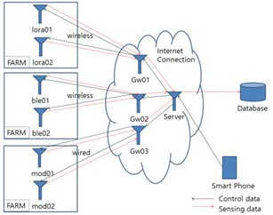

Figure 3.1: System Construction.

The nodes are classifed into LPWAN, Bluetooth, and RS485 communica- tion, and the environmental data collected through the sensors on the node in the farm are transmitted to the gateway through each communication network. The sensors used are temperature, humidity and carbon dioxide measurement sensors, and the sensing data is transmitted in real time. The gateways responsible for each communication

5

network are connected to the Internet and relay the communication between the server and the nodes.

MQTT is easy to construct additional gateways or servers, and connection with service is possible only by IP address. Therefore, the server collects sensing data in real time through each communication network and records it in the database or transmits the command of the service to the gateway.

SKNCOE TE Comp. 6

# Chapter 4 Comminication Protocol

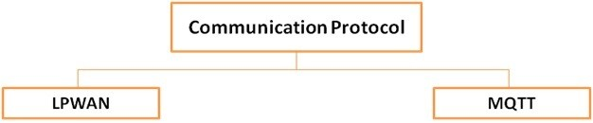

Figure 4.1: Types of communication.

LPWAN

1. It is low power wide area network ,is type of wireless communication network .
2. Operated under low power battery and designed to allow long range communi- cation with low bit rate. MQTT
3. MQTT, is easy to construct additional gateways or servers, and connection with service assessors is possible only by IP address.
4. Therefore, the server collects sensing data in real time through each commu- nication network and records it in the database or transmits the command to the gateway..

7

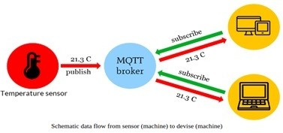

Figure 4.2: MQTT protocol as Broker.

SKNCOE TE Comp. 8

# Chapter 5 HARDWARE DESIGN

## Arduino

Arduino is an open-source hardware and software company, project and user community that designs and manufactures single-board microcontrollers and mi- crocontroller kits for building digital devices and interactive objects that can sense and control both physically and digitally. Its products are licensed under the GNU Lesser General Public License (LGPL) or the GNU General Public License.

## PCB Layout

The hardware confguration for each network. All systems are equipped with sensors and communication modules based on Arduino, and consist of two sensor nodes and one gateway. All gateways have a wireless Internet module, which enables MQTT communication based on IP with the Server The communication module used in the LPWAN communication network is a low- power and high-effciency ra- dio frequency communication module compliant with the IEEE802.15.4e standard. It supports the IPv6 address system in the UDP-based communication environment and has a communication distance of up to 10km at 900MHz. The communication module used in the Bluetooth communication network conforms to the V4.0 stan-

9

dard and has a maximum communication distance of 100m in the 2.4GHz frequency band.

Bluetooth feature is with all smart phones, enabling direct communication with each node as well as through the server, which enabling sensor communication and device control at close Rang.

SKNCOE TE Comp. 10

# Chapter 6 Message Design

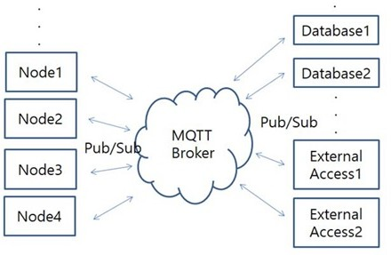The overall structure of the message delivery path through MQTT. Every node has its own physical network, but each network converges to its own gateway, which is connected to broker as a server. The reason for this centralized structure is that an external user can access the broker through the Internet, such as a Smartphone, a tablet, and a PC, and control all the nodes through the broker. Therefore, each gateway and broker acts as an IoT hub that connects the database, external access, and end node as a platform of communication network. We implemented this platform using MQTT.

Figure 6.1: Publish-Subscriber Model.

11

MQTT is a lightweight messaging Protocol that enables asynchronous commu- nication of devices with limited resources. The MQTT consists of a broker acting as a server and one or more clients. The message delivery model is a publish subscribe structure. The Publisher and subscriber are distinguished by topic and determined by the send receive role.

## 6.1 Bottom-Up Approach

The publisher / subscriber structure of this system depends on the topic which depends on the sensing message and the control message. the topic structure of the tree structure. When specifying publisher / subscriber between each node and external device or database, it indicates the order of target specification to be specifed in the message. The main topics used in this system are sensing data and control messages. Sensing data is a message periodically transmitted from node to gateway.

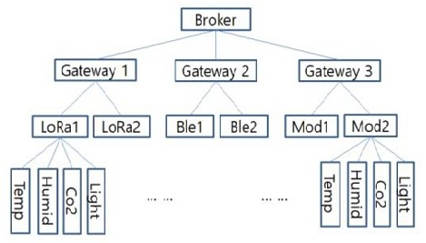

Figure 6.2: Tree Diagram.

SKNCOE TE Comp. 12

# Chapter 7 Challenges

The deployment and maintenance of real-world WSNs are still very challenging. Beyond the general WSN challenges, i.e.hardware constraints of small sensor de- vices, their power consumption, and low-power communication, there are specific additional challenges for long-term outdoor deployments.

## Environmental Challenges

The natural environment has a strong impact on the operability of a WSN. Sensor are exposed to harsh weather conditions with probably high temperature and rain- falls. Also humidity and soil moisture tends to be comparatively high, particularly if devices are directly deployed in the field. During our first deployment, it turned out for instance that the cases. These Designed were not completely sealed and durably water-resistant. As a consequence, condensation water occurred under the difuser cap of some sensors.

## Wildlife challenges

Whenever sensors are deployed in rural areas for an unattended operation, conflicts with animals and wildlife are unavoidable. Moved sensors, nibbled cables, or even

13

bit marks on sensors are not uncommon for ground-level equipment. But also sen- sors placed on higher stands above crop level could temporarily be covered by birds. Particularly in our use case that depends on PAR measurements, this covering is totally interfering. Finally, also insects forming nests in sensor housings can have negative impacts

SKNCOE TE Comp. 14

# Chapter 8

**Results And Future Work**

Although the wireless communication network had worries about data loss com- pared to the wired network used in the existing farms, the implementation of this paper confirmed that the result of similar pattern was received, so that the pro- posed system could be used in ICT agriculture. In case of LPWAN network, it was confirmed that data can be transmitted and received at a distance of 500m outside the building when a gateway is installed in the building. LPWAN is a low power wireless transmission module that can be used not only for the smart farm imple- mented in this paper but also for the management system for attaching and grazing to livestock body. If data transmission / reception in km units is guaranteed in accordance with the distance in the specification, an additional relay gateway may be installed to enable long distance radio frequency control. It could also serve as a low power module for use in pest-resistant emergency networks within the province or integrated management of local greenhouse data. And the bluetooth modules could also be used to build remote controller for farm use by using low power long-distance modules.

In the future, the proposed system is expected to be a base system for studying the development of environmental algorithms for optimal growth of plants using cultivated environment data and plant growth data.

15

# Chapter 9 Conclusion

The proposed system in this paper is a smart irrigation wired /wireless system with node - server - database and external control structure. A conclusion may review the main points of the paper. In order to solve the power problem and space limitation of the wired system, which is a limitation of the existing smart irrigation, we implemented a communication method using Bluetooth and LPWAN module as low power module.

16

### References

* + 1. Chiyurl Yoon, Miyoung Huh, Shin-Gak Kang, Juyoung Park, Changkyu Lee,

Implement Smart Farm With IoT”, IEEE 2018

* + 1. ManlioBacco, Andrea Berton ,Erina Ferro ,” Smart Farming : Op- portunities

, Challenges And Technology Enables”, IEEE- 2018

[4] T. Chi, M. Chen, and Q. Gao, ”Implementation and study of a greenhouse environment surveillance system based on wireless sensor network”, The 2008 In- ternational Conference on Embedded Software and Systems Symposia

[4][http://google.co.in](http://google.co.in/) [5]https://ieeexplore.ieee.org/document/8117219

SKNCOE TE Comp. 17