PROJECT: PHASE II: DECISION MAKING
BHAVY PATEL: 1232769488
HARSH RAMANIK SHAH: 1232278348
POOJA KONDATH: 1230097715
RISHI NIKUNJKUMAR SHAH: 1233162374
INFORMATION TECHNOLOGY
IFT 533: DATA VISUALIZATION AND
REPORTING FOR IT
PROF. ASMAA ELBADRAWY
MARCH 27TH, 2025

Section 1: Used Visualization Tools
For our dashboard, we have selected Tableau as the primary visualization tool.
- Tableau is ideal for building highly interactive, user-friendly dashboards quickly and supports multiple chart types such as bar charts, line charts, scatter plots, and pie charts natively.
- Python (Pandas and NumPy) will be used only for data preparation and preprocessing, not for creating visualizations.
We preferred Tableau over other tools like PowerBI due to ease of use, extensive community support, and its strong capabilities for building highly interactive dashboards for sports analytics.

Section 2: Preprocessing

Step 1: Data Loading and Merging
- Loaded matches.csv and deliveries.csv separately using Pandas read_csv().
- Renamed the match_id column in deliveries.csv to id to match matches.csv key.
- Performed an inner join on id to merge match-level data and delivery-level data for integrated analysis.
deliveries.rename(columns={'match_id': 'id'}, inplace=True)
merged_df = pd.merge(matches, deliveries, on='id', how='inner')

Step 2: Column Removal
- Dropped the following unused columns to simplify the dataset:
  - From matches.csv: city, match_type, venue, target_runs, target_overs, method, umpire1, umpire2
  - From deliveries.csv: inning, non_striker, extras_type, dismissal_kind, fielder
merged_df.drop(columns=[
'city', 'match_type', 'venue', 'target_runs', 'target_overs',
'method', 'umpire1', 'umpire2', 'inning', 'non_striker',
'extras_type', 'dismissal_kind', 'fielder'
], inplace=True)

Step 3: Over Categorization
- Created a new column over_phase to categorize overs into:
  - Powerplay (overs 1–6)
  - Middle Overs (overs 7–15)
  - Death Overs (overs 16–20)
merged_df['over_phase'] = np.where(
merged_df['over'] <= 6, 'Powerplay',
np.where(merged_df['over'] <= 15, 'Middle Overs', 'Death Overs'))

Step 4: Handling player_dismissed and is_wicket
- Replaced "NA" values in player_dismissed and is_wicket columns with None.
- Cast is_wicket to integer type for easier aggregation.
merged_df['player_dismissed'].replace('NA', None, inplace=True)
merged_df['is_wicket'] = merged_df['is_wicket'].replace('NA', 0).astype(int)

Step 5: Batting First or Chasing Derivation
- Derived whether a team batted first or chased based on toss_winner, toss_decision, team1, and team2.
- Created a batting_first boolean column:
merged_df['batting_first'] = np.where(
((merged_df['toss_decision'] == 'bat') & (merged_df['toss_winner'] == merged_df['team1'])) |
((merged_df['toss_decision'] == 'field') & (merged_df['toss_winner'] == merged_df['team2'])),
merged_df['team1'], merged_df['team2']
)

Step 6: Super Over Analysis
- Filtered records where super_over == 'Y' for analyzing Super Over performances.
super_over_df = merged_df[merged_df['super_over'] == 'Y']

Step 7: Season Filtering
- Extracted the season information from the date field if needed.
- Filtered dataset to include only the last three seasons (2022–2024):
merged_df['date'] = pd.to_datetime(merged_df['date'])
merged_df['season'] = merged_df['date'].dt.year
merged_df = merged_df[merged_df['season'].isin([2022, 2023, 2024])]

Step 8: Toss Decision and Win Rate Correlation
- Computed win percentages by analyzing toss_decision and winner.
- Created summary tables to visualize correlation between winning the toss, the toss decision, and match outcomes.

Step 9: Result Normalization
- Normalized result types (such as "runs" or "wickets").
- Converted result_margin to numeric type for statistical analysis:
merged_df['result_margin'] = pd.to_numeric(merged_df['result_margin'], errors='coerce')

Step 10: Player of the Match Aggregation
- Grouped player_of_match to count awards per player to identify top performers.
player_awards = merged_df['player_of_match'].value_counts().reset_index()
player_awards.columns = ['player', 'awards']

Step 11: Batter Performance Aggregations
- Grouped by batter to compute:
  - Total Runs
  - Average Runs
  - Number of 30+ scores
batter_stats = merged_df.groupby('batter').agg({
'batsman_runs': ['sum', 'mean']
}).reset_index()
- Counted matches where batter scored 30+ runs:
thirty_plus = merged_df.groupby(['batter', 'id'])['batsman_runs'].sum().reset_index()
thirty_plus = thirty_plus[thirty_plus['batsman_runs'] >= 30]

Step 12: Bowler Performance Aggregations
- Grouped by bowler to calculate:
  - Total wickets (sum of is_wicket)
  - Economy rates (runs conceded per over)
bowler_stats = merged_df.groupby('bowler').agg({
'total_runs': 'sum',
'over': 'count',
'is_wicket': 'sum'
}).reset_index()
bowler_stats['economy'] = bowler_stats['total_runs'] / (bowler_stats['over'] / 6)

Step 13: Runs Aggregations
- Aggregated batsman_runs, extra_runs, and total_runs:
  - Per batter
  - Per match
  - Per season
- This supported calculations like team totals and player-level scoring analytics.

Step 14: Saving Preprocessed Data
- After completing all cleaning and transformations, saved the final datasets into new CSV files for easy import into Tableau:
merged_df.to_csv('final_ipl_data.csv', index=False)

Section 3: List of Final Set of Questions
# | Finalized Question
1 | Which player has won the most "Player of the Match" awards?
2 | What is the average win margin (runs and wickets) for each team?
3 | How does each team perform while batting first versus chasing?
4 | What is the win percentage when choosing to bat or field?
5 | How do players perform in powerplay vs death overs (strike rate, economy)?
6 | Which bowlers have taken the most wickets in overs 16–20?
7 | Which batters consistently score 30+ runs per match?
8 | Who are the most economical bowlers in the last three seasons?
9 | Which players perform best in Super Over matches?
10 | Is there a correlation between toss decision and match outcome (win/loss)?

Section 4: Dashboard Plot Drafts
Plot 1: Visualizes top players by number of "Player of the Match" awards.
Explanation: Bar Chart showing the top 10 players with the highest number of "Player of the Match" awards. This visualization highlights consistently high-performing players across IPL seasons, helping analysts and fans recognize impactful individuals.
Pre-attentive Attributes Used: Length (bar height), Size.
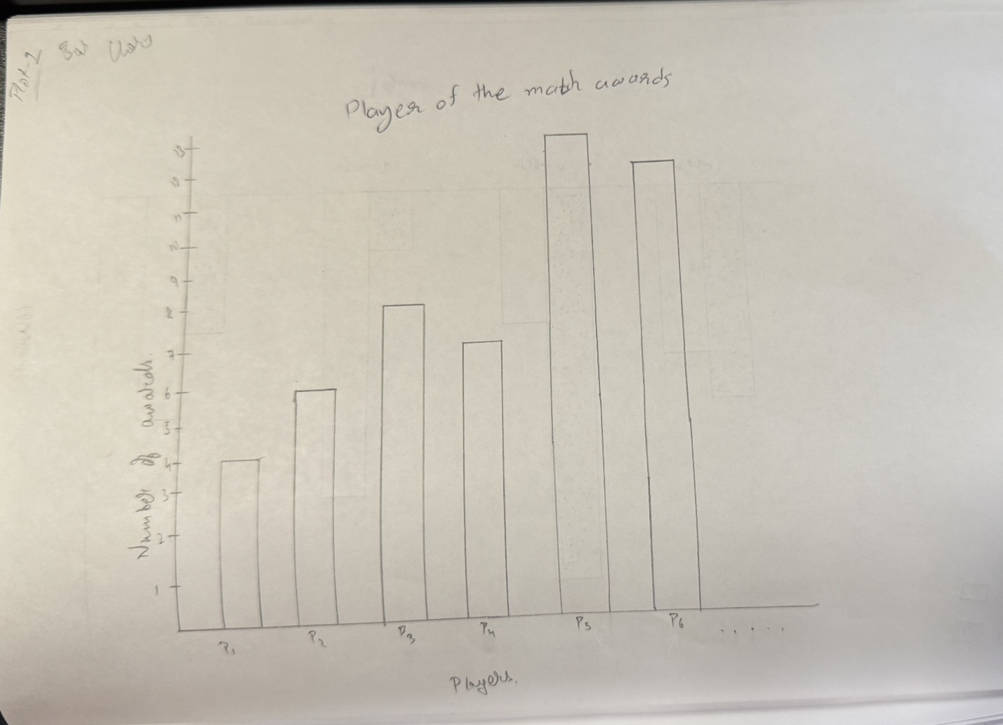

Plot 2: Shows distribution of win margins (runs/wickets) for each team.
Explanation: Grouped Bar Chart displaying the distribution of win margins (by runs and wickets) for each team. It enables users to understand how dominant different teams are when they win and provides insights into team strengths.
Pre-attentive Attributes Used: Length (bar height), Color (grouped by type: wins by runs/wickets). 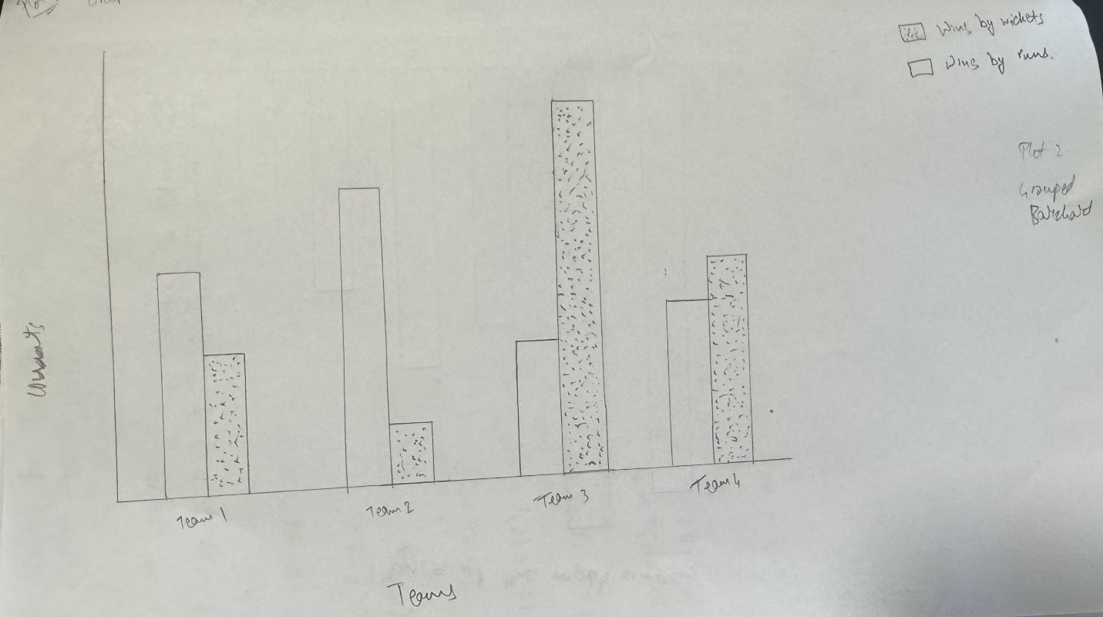

Plot 3: Compares team performance when batting first vs chasing.
Explanation: Stacked Bar Chart comparing team performance when batting first versus chasing. This plot shows how different teams perform under different match scenarios, supporting strategy formulation and match predictions.
Pre-attentive Attributes Used: Length (bar height), Color (bat first vs chase). 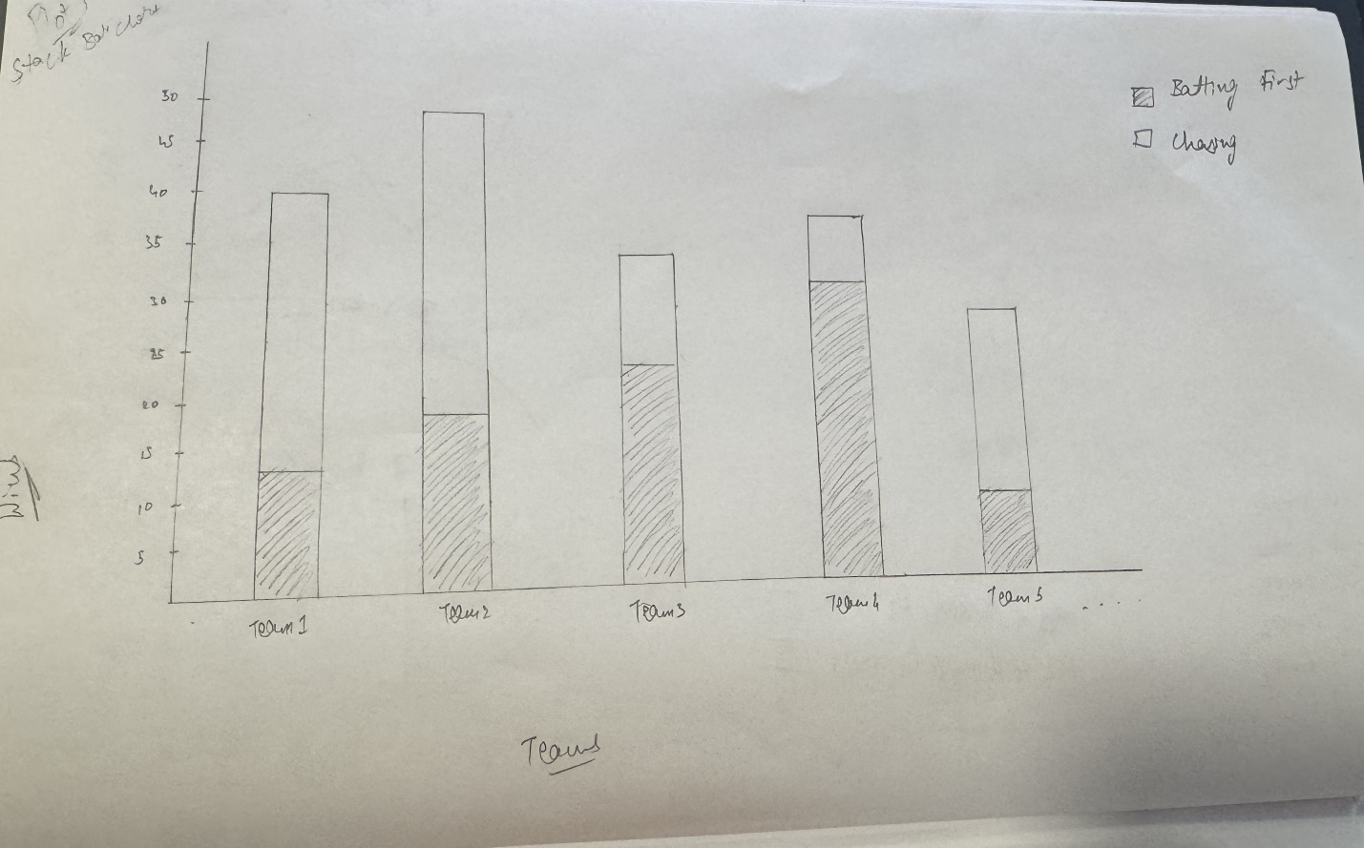

Plot 4: Displays win % when choosing to bat or field after toss.
Explanation: Pie Chart illustrating the win percentage based on toss decisions (choosing to bat or field). It helps identify whether winning the toss and the chosen decision correlates strongly with overall match success.
Pre-attentive Attributes Used: Area (pie sections), Color (bat/field choice). 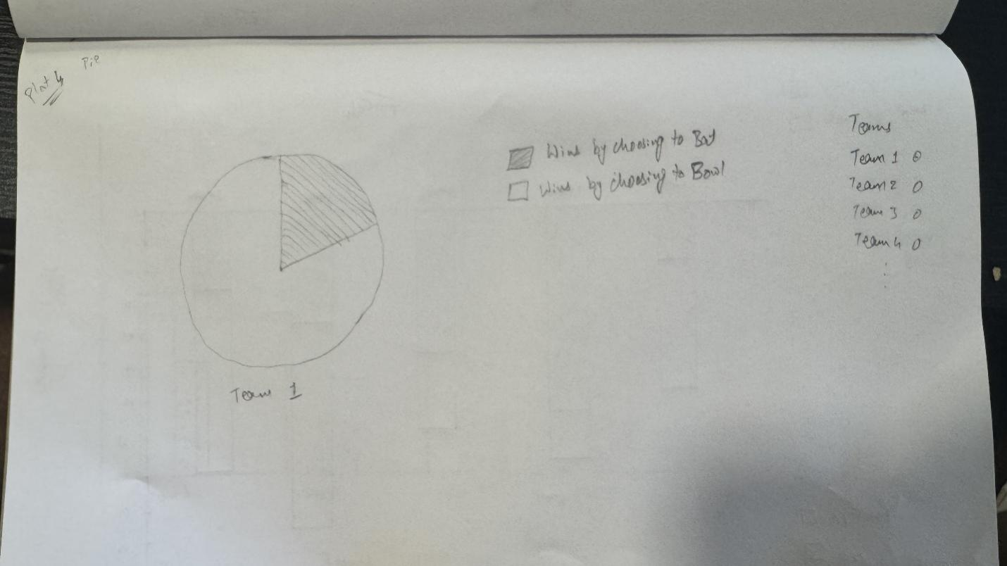

Plot 5: Trends in player performance in Powerplay vs Death Overs
Explanation: Line Chart showing player performance (strike rate or economy rate) during Powerplay (overs 1–6) versus Death Overs (overs 16–20). This visualization highlights specialized players who excel in early or late stages of matches, crucial for team strategy.
Pre-attentive Attributes Used: Position (points on line), Slope (rate of change), Color (over phase).
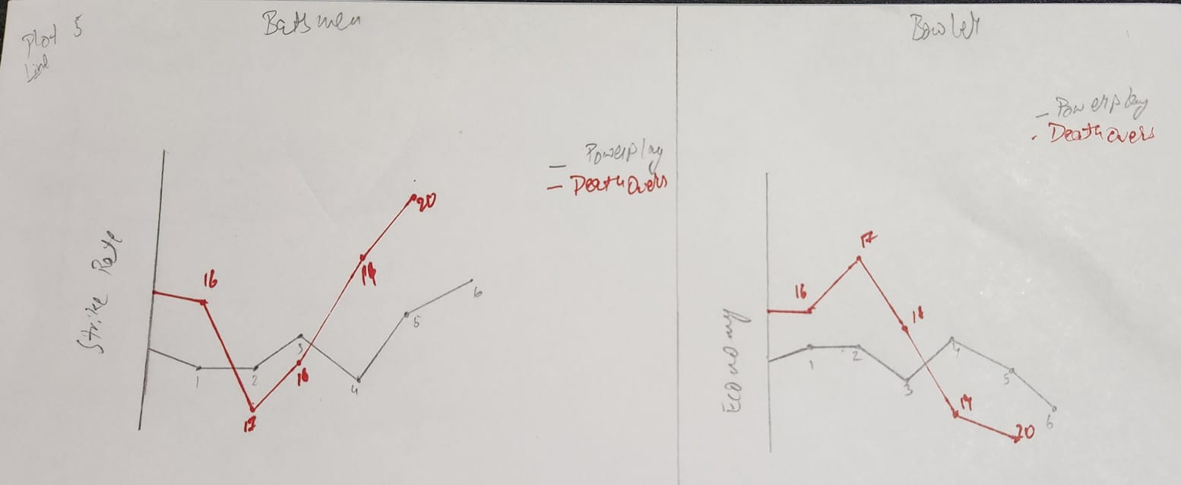

Plot 6: Top bowlers with wickets in critical overs (16–20)
Explanation: Bar Chart displaying the bowlers who have taken the most wickets during critical overs (16–20). It provides insights into bowlers who are most effective during high-pressure endgame scenarios.
Pre-attentive Attributes Used: Size (bar length), Length (height).

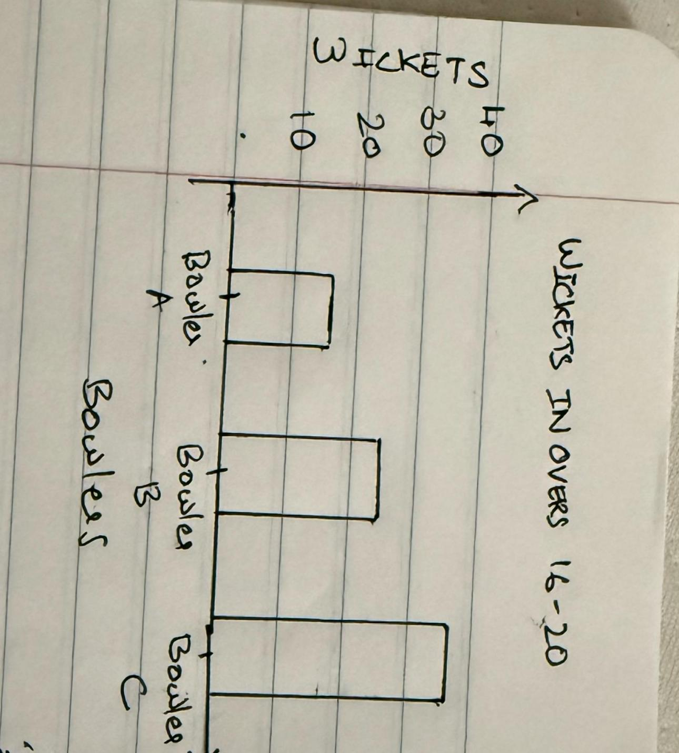

Plot 7: Frequency of players scoring 30+ runs
Explanation: Bar Chart showcasing the number of matches in which players scored 30+ runs.
This helps recognize consistent batting performers who provide stability or explosive starts to their teams.
Pre-attentive Attributes Used: Size (length)
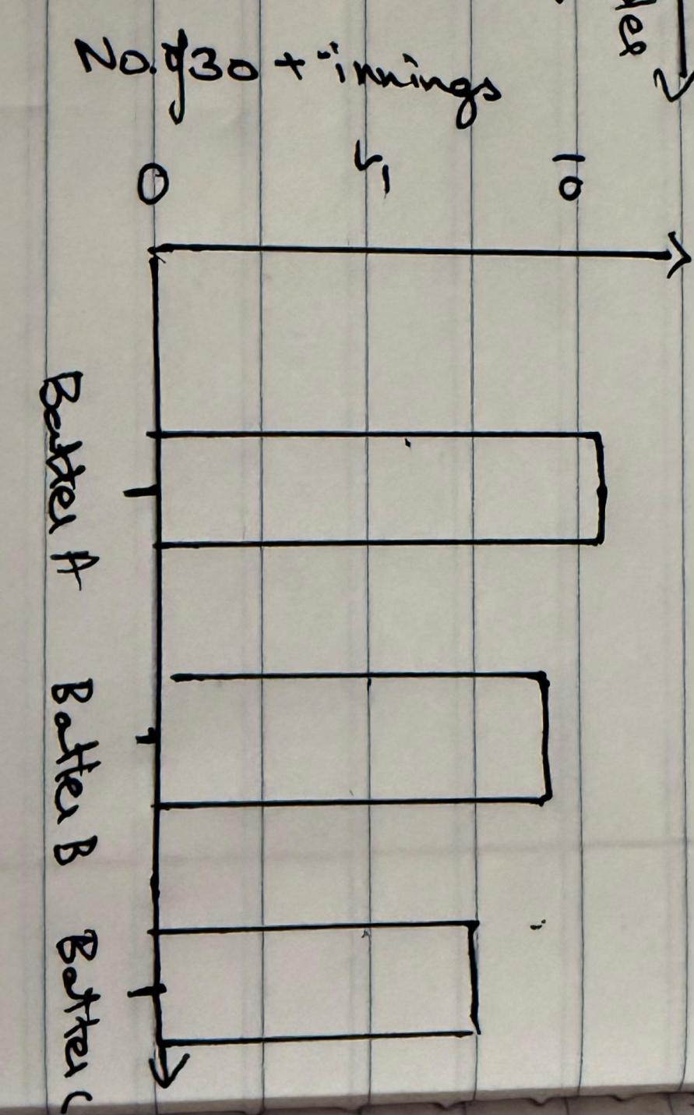
Number of 30+ runs

Plot 8: Shows economy rate vs number of matches for bowlers
Explanation: Scatter Plot plotting economy rate versus the number of matches bowled by bowlers across the last three seasons. It helps to find bowlers who maintain both good economy rates and consistency over time, identifying key assets for teams.
Pre-attentive Attributes Used: Position (scatter location), Color (highlight categories economy greater than threshold). 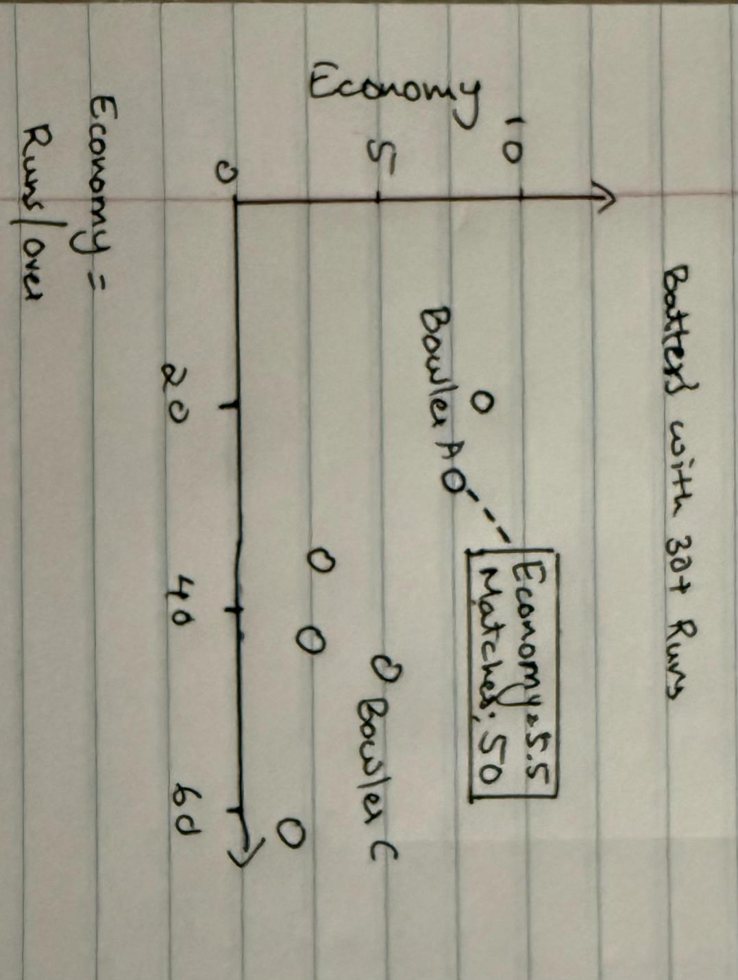

Plot 9: Player statistics in Super Over matches.
Explanation: Table or Bar Chart summarizing player statistics in Super Over matches (batting and bowling performances). This provides insights into clutch performers under extreme match pressure, valuable for fantasy leagues and team selections.
Pre-attentive Attributes Used: Position (player rows), Length/Size (performance metric), Color (highlight good performers).
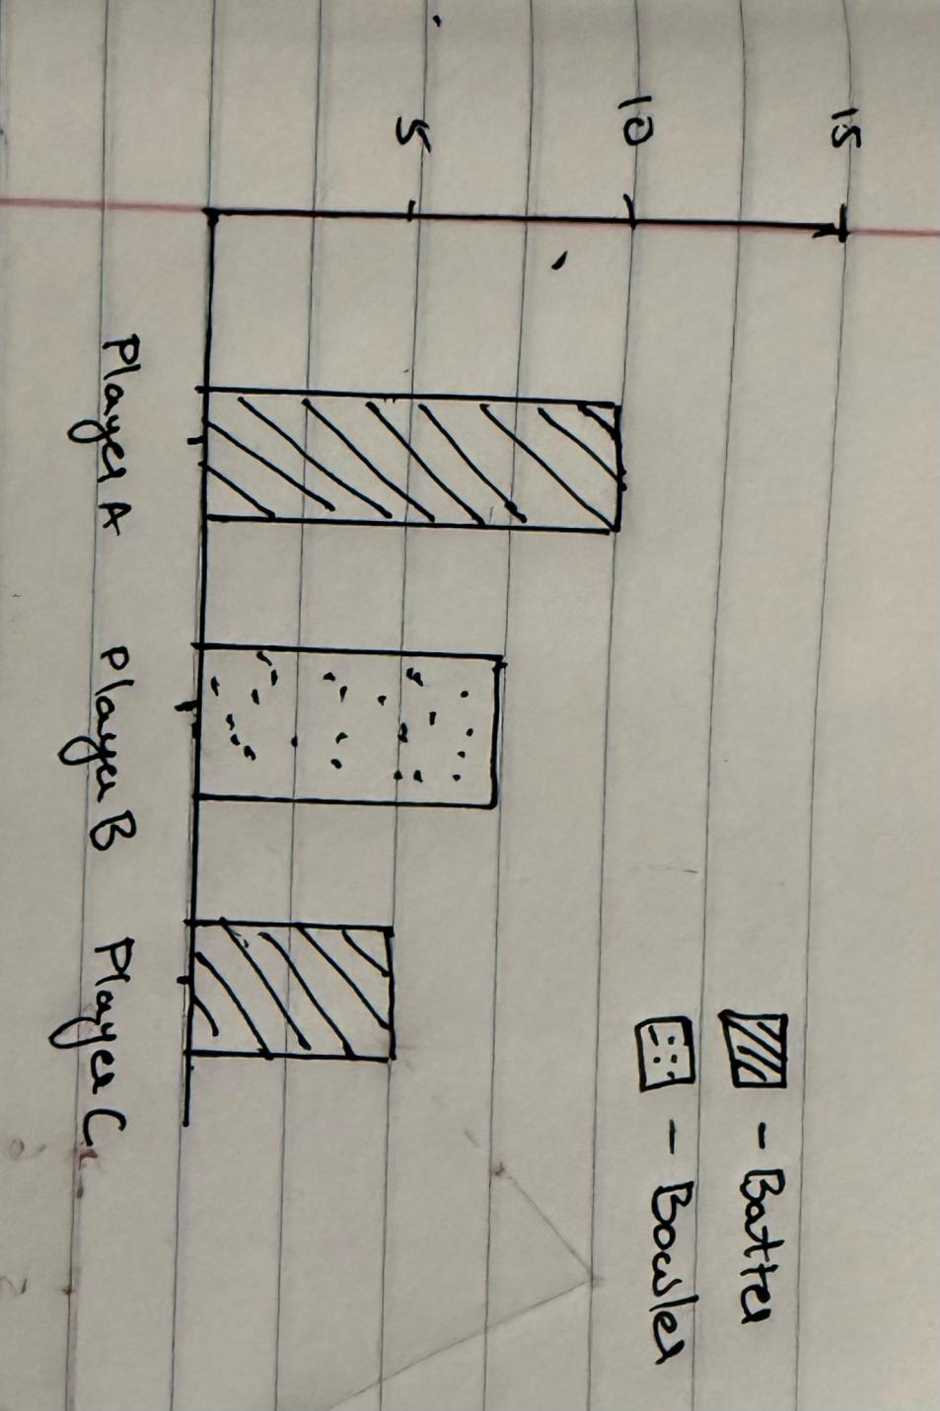

Plot 10: Relation between toss decision and match outcome.
Explanation: Stacked Bar illustrating the relationship between toss decisions (batting or fielding) and final match outcomes. This plot helps detect any patterns or advantages linked to toss strategies, useful for predictive modeling and commentary.
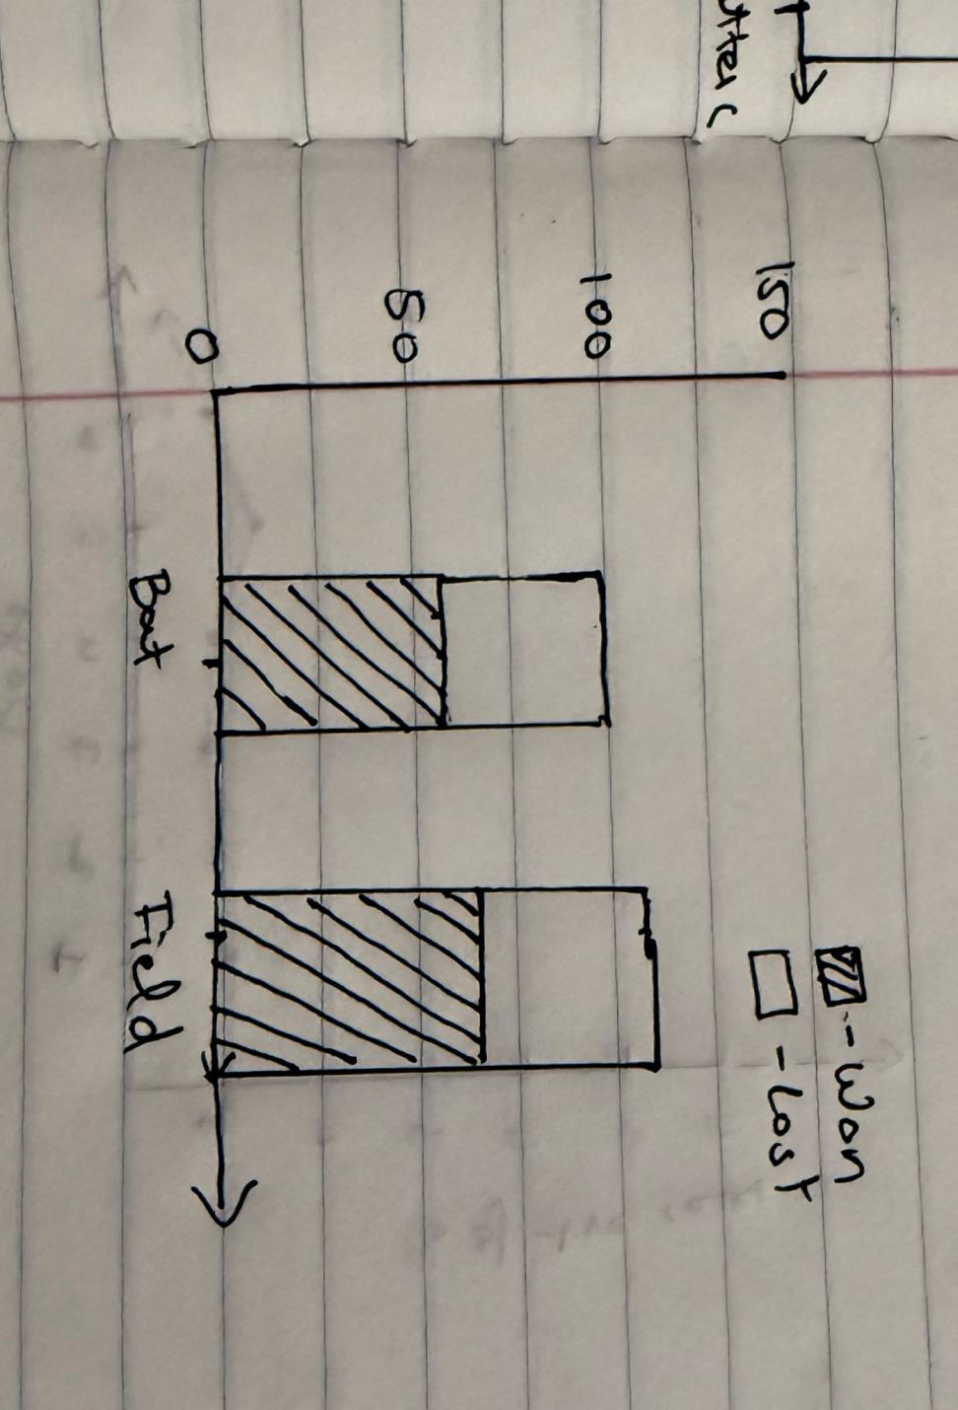

Section 5: Dashboard Interactivity
Interactive Control | Purpose | Affects Which Plots | Control Type | Value Range / Source
Season Filter | Select specific IPL season | All plots | Dropdown | 2008–2024
Team Selector | Focus on a particular team | Win Margins, Bat First/Chase, Toss Win % | Multi-Select Dropdown | All IPL Teams
Player Search | Focus on individual player stats | Player Awards, Runs >30, Death Over Wickets | Search Box | All Player Names
Bat First / Chase Toggle | Switch between batting first and chasing | Team Performance, Toss Decision Analysis | Toggle Switch | Bat First / Chase
Hover Tooltips | Show detailed values like economy rate, runs, wickets | All plots where needed | Hover Interaction | Auto

Team Contributions
Mural Link: https://app.mural.co/t/dvteam4996/m/dvteam4996/1744922420998/75c84000724bd6170a4d9ea44a4b46cc735adce2?sender=uedacee6b058fad1effa28794 Links to an external site.

Team Members and Contributions:
- Bhavy Patel:
Took the lead on Data Selection and initial Preprocessing Steps. Collaborated with Harsh to review dataset structure (matches.csv and deliveries.csv) and finalize data merging strategies. Also worked with Rishi to organize the final Word document and prepare the hand-drawn plot sketches.
- Harsh Ramanik Shah:
Focused on Understanding the Dataset and identifying key attributes for preprocessing. Supported Bhavy during dataset analysis and teamed up with Pooja to define Potential Questions that users would want answered in the dashboard.
- Pooja Kondath:
Worked primarily on identifying Potential Users for the dashboard. Collaborated closely with Harsh to brainstorm and refine Potential Questions. Also helped Bhavy finalize descriptions for dashboard interactivity controls on the Mural board.
- Rishi Nikunjkumar Shah:
Led the design and creation of hand-drawn plot sketches. Worked alongside Bhavy to complete Preprocessing Steps on the Mural board and coordinated with Pooja to ensure that preprocessing matched the needs of the visualization questions.
Each team member actively participated in discussions, content creation, and final reviews of the Word document and Mural board, ensuring that all parts were completed collaboratively and on time.

References
https://www.kaggle.com/datasets/patrickb1912/ipl-complete-dataset-20082020

