PROJECT: PHASE III
BHAVY PATEL: 1232769488
HARSH RAMANIK SHAH: 1232278348
POOJA KONDATH: 1230097715
RISHI NIKUNJKUMAR SHAH: 1233162374
INFORMATION TECHNOLOGY
IFT 533: DATA VISUALIZATION AND
REPORTING FOR IT
PROF. ASMAA ELBADRAWY

Section 1: The Dashboard
The final dashboard is a comprehensive, interactive tool built using Tableau that visualizes key performance metrics and strategic insights from the Indian Premier League (IPL) for the 2022–2024 seasons. It consolidates match-level and delivery-level data into a user-friendly interface, offering a high-level overview and in-depth breakdowns of player and team performances.
The dashboard serves multiple purposes. Primarily, it enables users such as cricket analysts, team strategists, fantasy league participants, and cricket enthusiasts to uncover actionable insights from historical IPL data. It allows them to compare team performance when batting first versus chasing, analyze toss decisions and win correlations, evaluate top-performing players during powerplay and death overs, and identify consistent match-winners.
Each visualization in the dashboard is intentionally designed to answer specific analytical questions, using consistent color schemes and minimal pre-attentive attributes to enhance readability and reduce cognitive load. For example, bar charts are used to highlight top scorers and wicket-takers, pie charts show the impact of toss decisions, and line plots compare performance across overs.
To ensure user engagement and personalization, the dashboard incorporates multiple interactive controls such as dropdown filters (for seasons and teams), player search boxes, and toggle switches (to compare batting strategies). These controls empower users to dynamically adjust the view based on their interests and make meaningful comparisons across various dimensions.
Overall, this dashboard acts as a centralized, visual decision-making support tool, offering a clear, engaging, and data-driven perspective into recent IPL seasons.

Section 2: The Dataset
The dataset used for this dashboard project was sourced from Kaggle and contains comprehensive information about Indian Premier League (IPL) matches spanning multiple seasons. Specifically, two primary CSV files were utilized: matches.csv and deliveries.csv.
- matches.csv includes high-level match details such as match ID, date, season, team names, toss decisions, match outcomes, player of the match, and other contextual information.
- deliveries.csv provides granular ball-by-ball data, including information on the batter, bowler, runs scored, extras, wickets taken, over number, and ball number.
To build a robust analytical foundation for the dashboard, extensive preprocessing was carried out using Python (Pandas and NumPy). Below is a summary of the key preprocessing steps:

1. Merging Datasets: The match_id column in deliveries.csv was renamed to id to match the primary key in matches.csv. An inner join was performed on the id column to create a unified dataset that combines match-level and delivery-level insights.

2. Column Cleanup: Several unused or redundant columns were dropped to simplify the dataset. This included venue, city, umpire names, dismissal details, and others not relevant to the visualizations.

3. Over Phase Categorization: A new column over_phase was created to categorize overs into Powerplay (1–6), Middle Overs (7–15), and Death Overs (16–20) for performance comparisons.

4. Handling Nulls and Data Types: Columns like player_dismissed and is_wicket were cleaned to replace missing or non-standard values with None or converted to appropriate data types for aggregation.

5. Batting First vs. Chasing: A batting_first column was derived to identify whether a team batted first or chased, based on toss winner and decision logic.

6. Super Over Analysis: A separate filtered dataset was created for Super Over matches to analyze high-pressure performance.

7. Season Filtering: To maintain relevancy, the dataset was filtered to include only the last three IPL seasons (2022–2024) by extracting and filtering based on the date column.

8. Toss Outcome and Match Result Analysis: Win percentages and correlations between toss decisions (bat or field) and match results were computed to support strategic insights.

9. Result Normalization: The result margins were standardized and converted to numeric format to support statistical analysis of win margins.

10. Player Performance Aggregation: Batters were grouped to calculate total runs, average runs, and number of 30+ run innings. Bowlers were grouped to calculate total wickets and economy rates.

11. Aggregated Metrics: Aggregations were performed at match, season, and player levels to support comparisons across different timeframes and contexts.

12. Saving Processed Data: The final cleaned and feature-engineered dataset was saved to a new CSV file (final_ipl_data.csv) for easy import into Tableau.

Section 3: Dashboard Users
The IPL Performance Dashboard is designed to serve a broad audience with varying analytical needs, ranging from professional sports analysts to casual fans.

1. Cricket Analysts and Commentators
These users depend on comprehensive, historical data to analyze team strategies, player form, and match outcomes. The dashboard enables them to deliver enriched pre-match, live, and post-match insights by providing visual breakdowns of batting versus chasing performance, death-over efficiency, toss decisions, and player contributions. It helps analysts support their narratives with real-time visuals and statistical evidence.

2. IPL Teams and Coaching Staff
Team strategists and coaching personnel use this dashboard to study patterns in team performance and player consistency. The ability to compare performance across overs, analyze toss-win advantages, and track individual player metrics like economy rates or 30+ run streaks helps with lineup optimization, opposition analysis, and in-game decision-making.

3. Fantasy Cricket Players and App Developers
Fantasy league users require data-backed evidence to make strategic picks. By highlighting high-performing players, strike rates during specific overs, and player impact in Super Overs, the dashboard supports smarter fantasy team creation. Developers of fantasy platforms may also use it to refine recommendation engines and provide engaging insights to users.

4. Students, Educators, and Researchers
Academic users can leverage the dashboard for case studies, assignments, and data analysis training. The integration of real-world IPL data allows students to apply concepts in statistics, data visualization, and predictive modeling. Researchers may use it to validate hypotheses or identify trends within professional sports datasets.

5. Sports Journalists and Bloggers
For media professionals, the dashboard simplifies the process of uncovering compelling stories through data. It enables easy access to player trajectories, head-to-head statistics, and seasonal comparisons, which are useful for writing match previews, analytical features, or social media content that resonates with data-driven audiences.

6. General Cricket Enthusiasts
Casual users and fans can explore performance insights using intuitive controls and visualizations. The dashboard design ensures a smooth experience across devices, allowing non-technical users to engage with IPL analytics through a visually engaging and interactive platform.
By catering to this wide range of stakeholders, the dashboard serves as a centralized and accessible platform for exploring IPL data in both professional and recreational contexts.
Section 4: Questions
The dashboard is designed to answer a targeted set of analytical questions that uncover meaningful patterns in IPL matches, team strategies, and individual player performance. Below is the list of key questions the dashboard addresses:
- Which player has won the most "Player of the Match" awards? (Top 10)
– Identifies consistently impactful players across seasons.
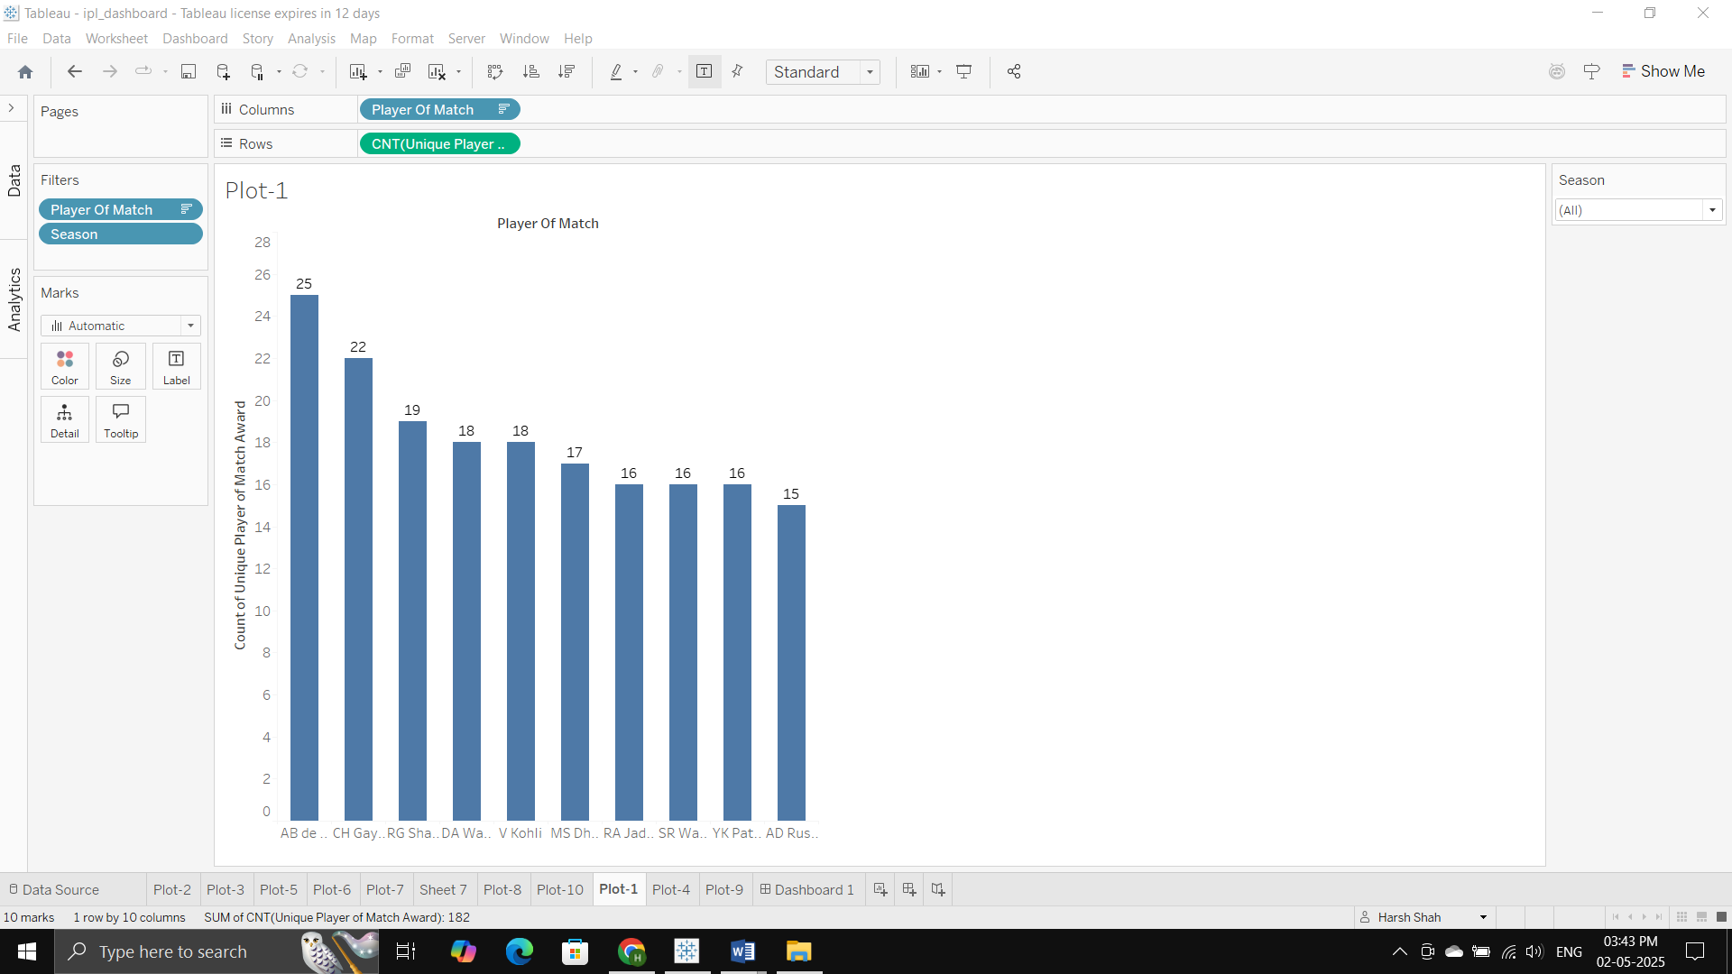
- What is the average win margin (by runs and wickets) for each team?
– Highlights team dominance and match outcomes in terms of scoring gaps.
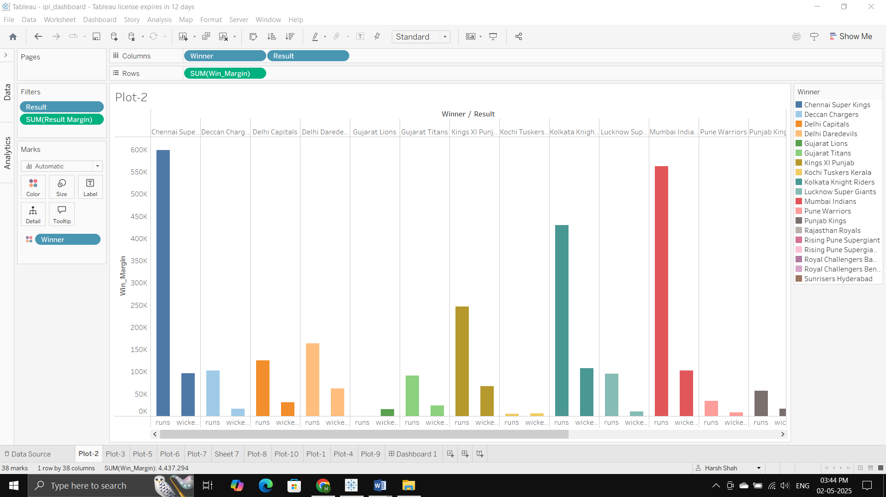
- How does each team perform while batting first versus chasing?
– Compares success rates and outcomes based on match strategy.
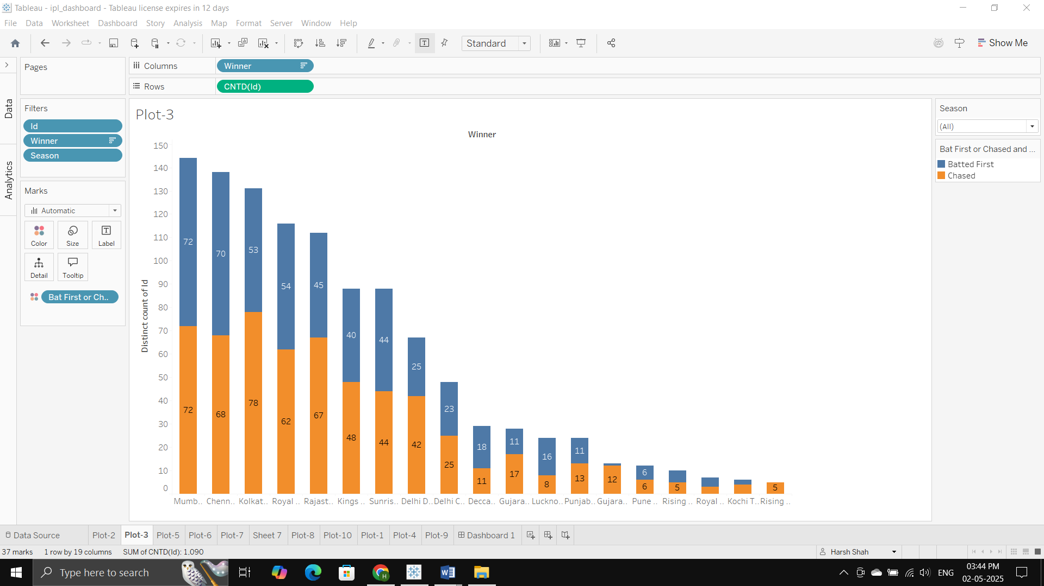
- What is the win percentage when choosing to bat or field after winning the toss?
– Evaluates strategic effectiveness of toss decisions.
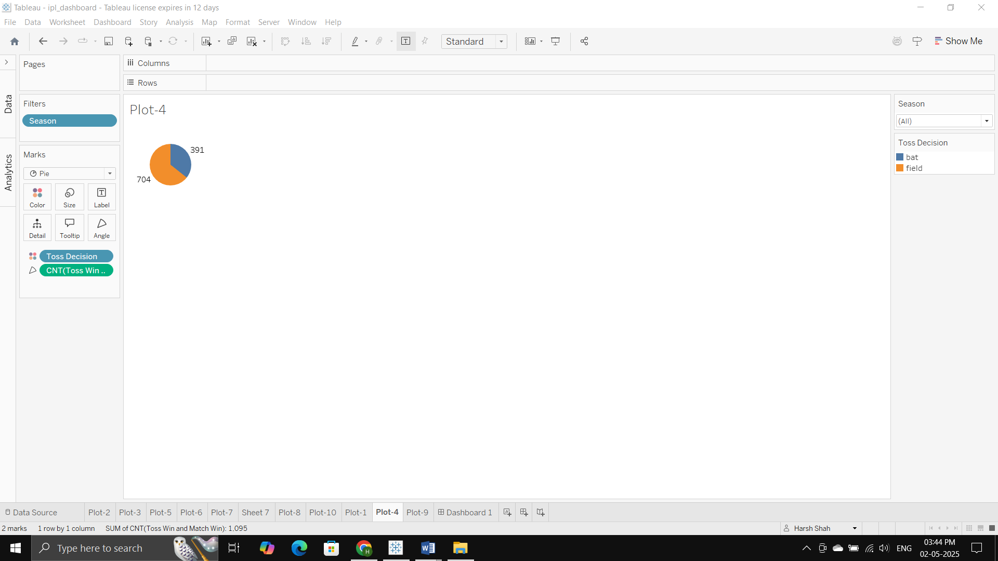
- How do players perform during Powerplay and Death Overs?
– Analyzes strike rates and economy rates in critical overs to assess pressure performance.
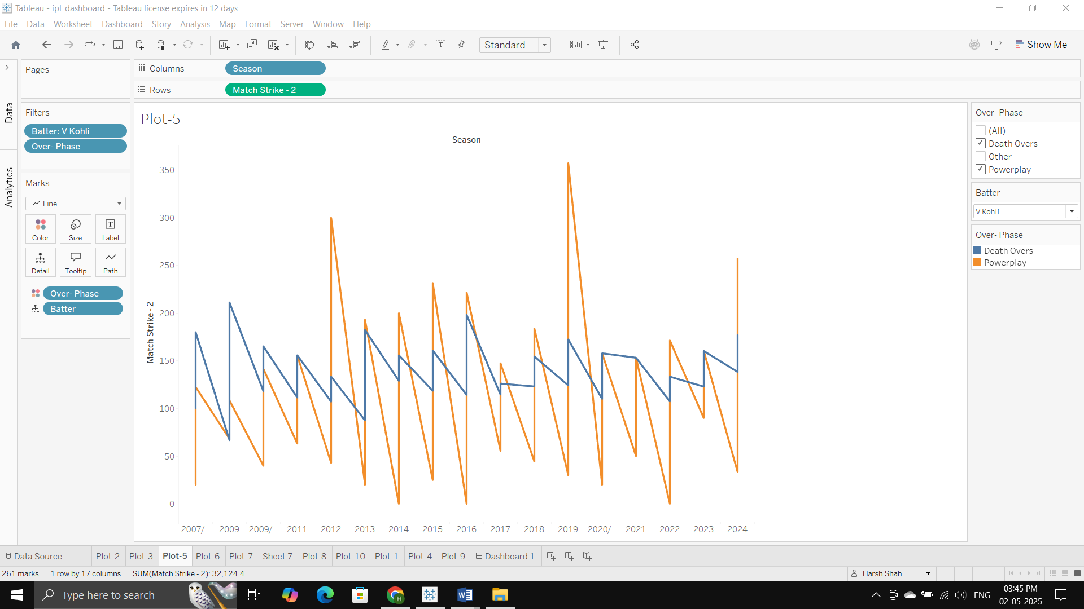
- Which bowlers have taken the most wickets in overs 16–20? (Top 10)
– Highlights clutch performers in high-pressure death overs.
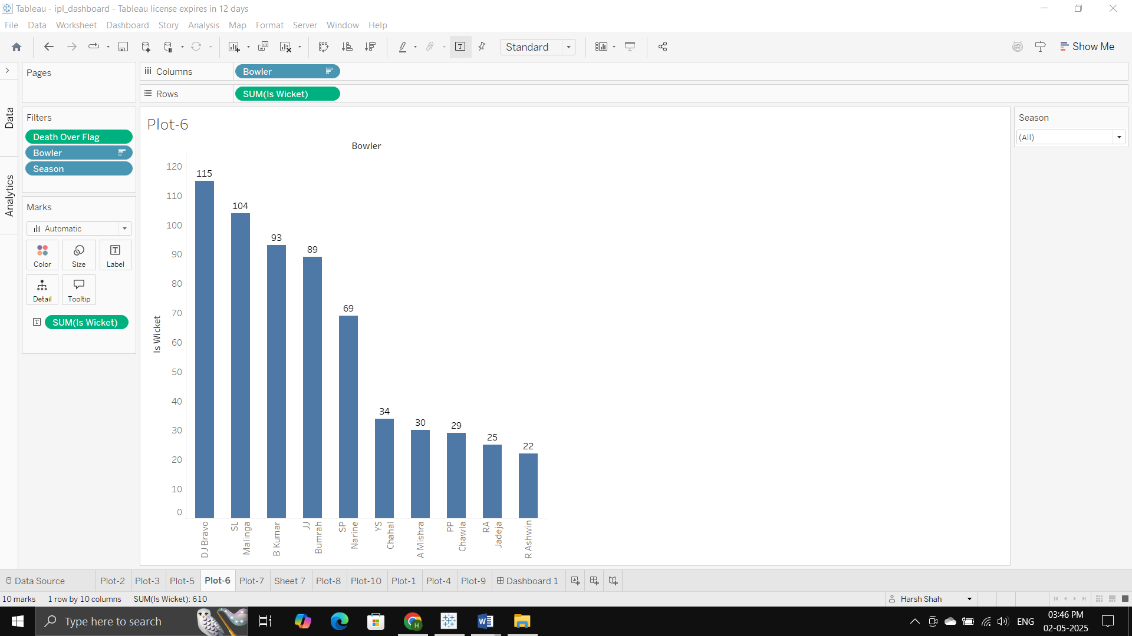
- Which batters consistently score 30+ runs in matches? (Top 10)
– Identifies batters who contribute significantly to their team's stability or momentum.
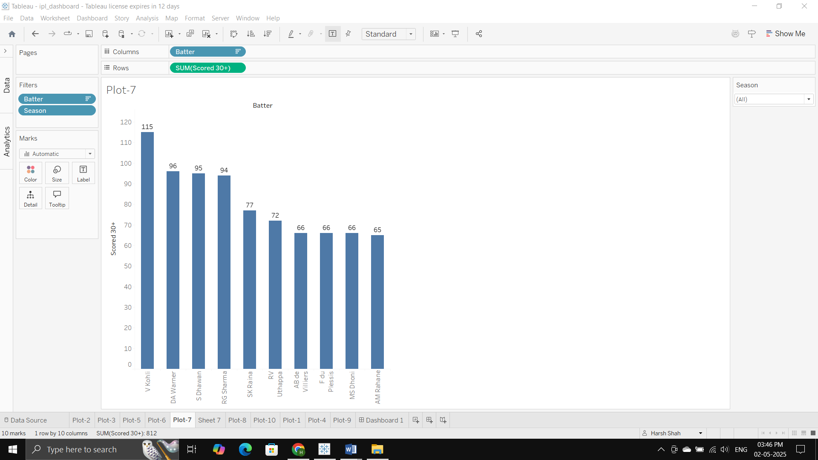
- Who are the most economical bowlers over the last three seasons?
– Surfaces bowlers who effectively limit scoring while maintaining consistency.
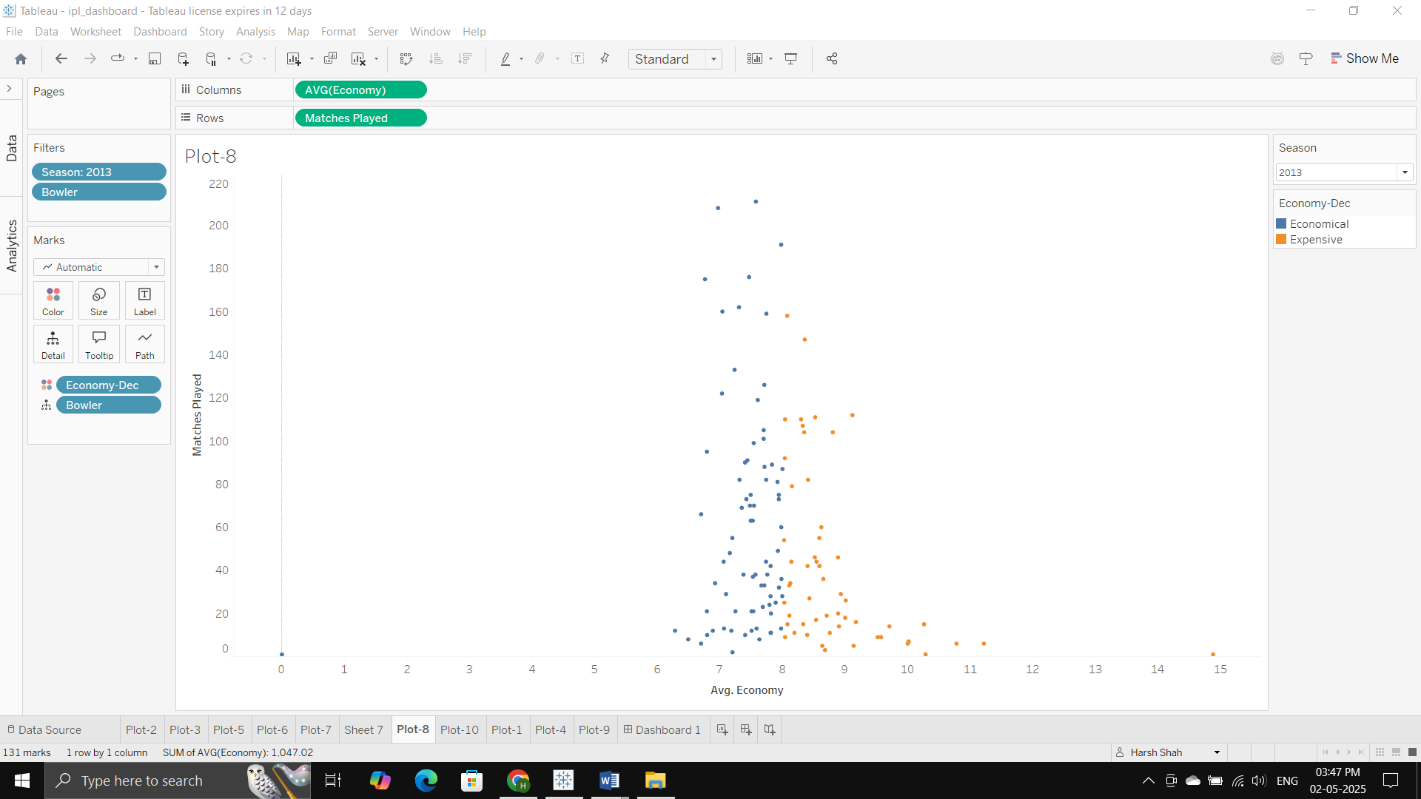
- Which players perform best in Super Over matches? (Top 10)
– Provides insights into high-stakes, sudden-death performance.
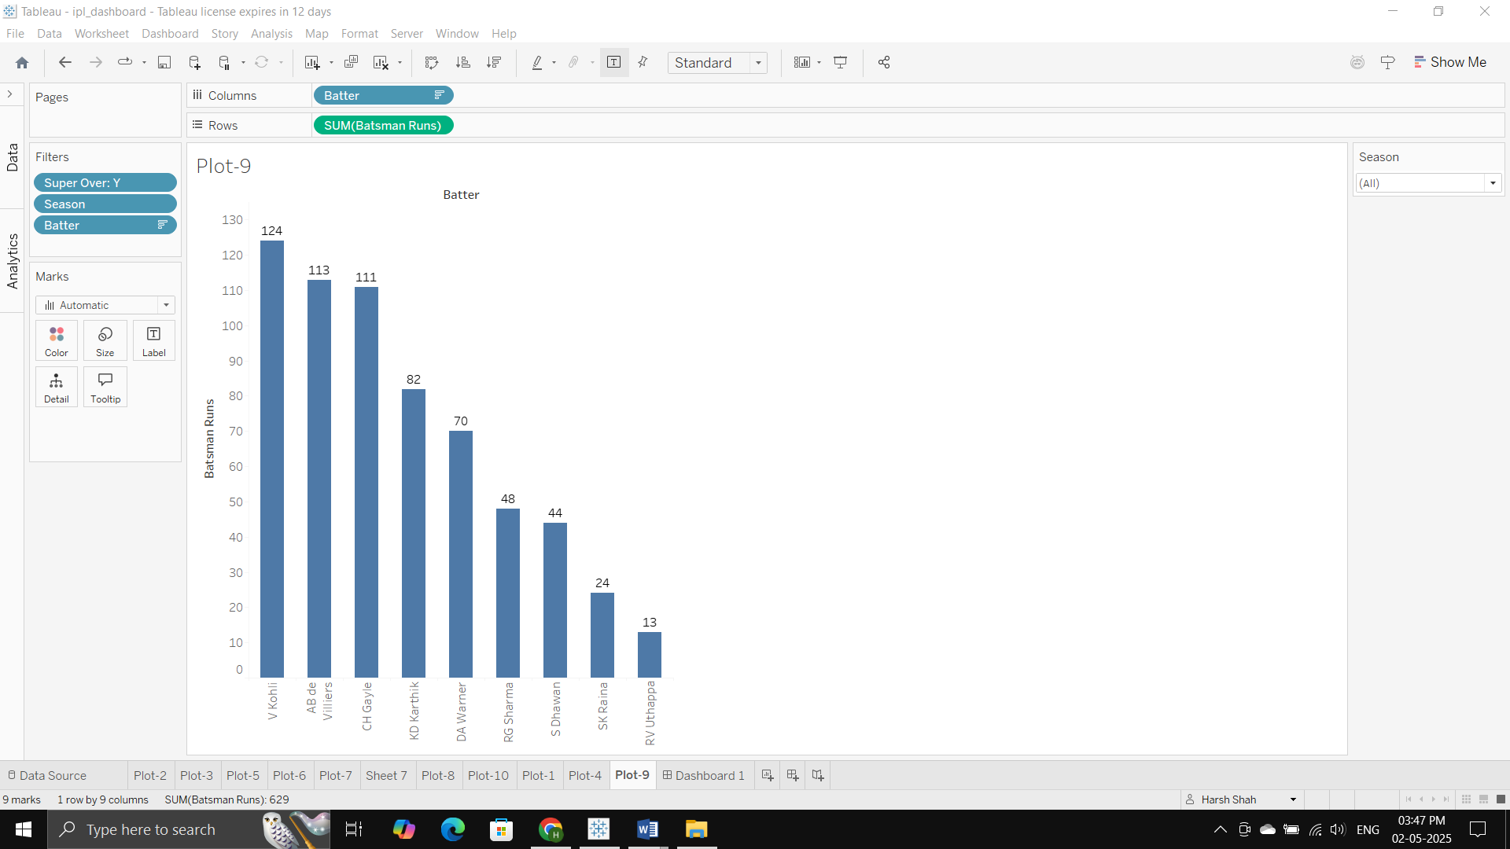
- Is there a correlation between toss decision and match outcome (win/loss)?
– Investigates strategic patterns and potential biases in toss choices.
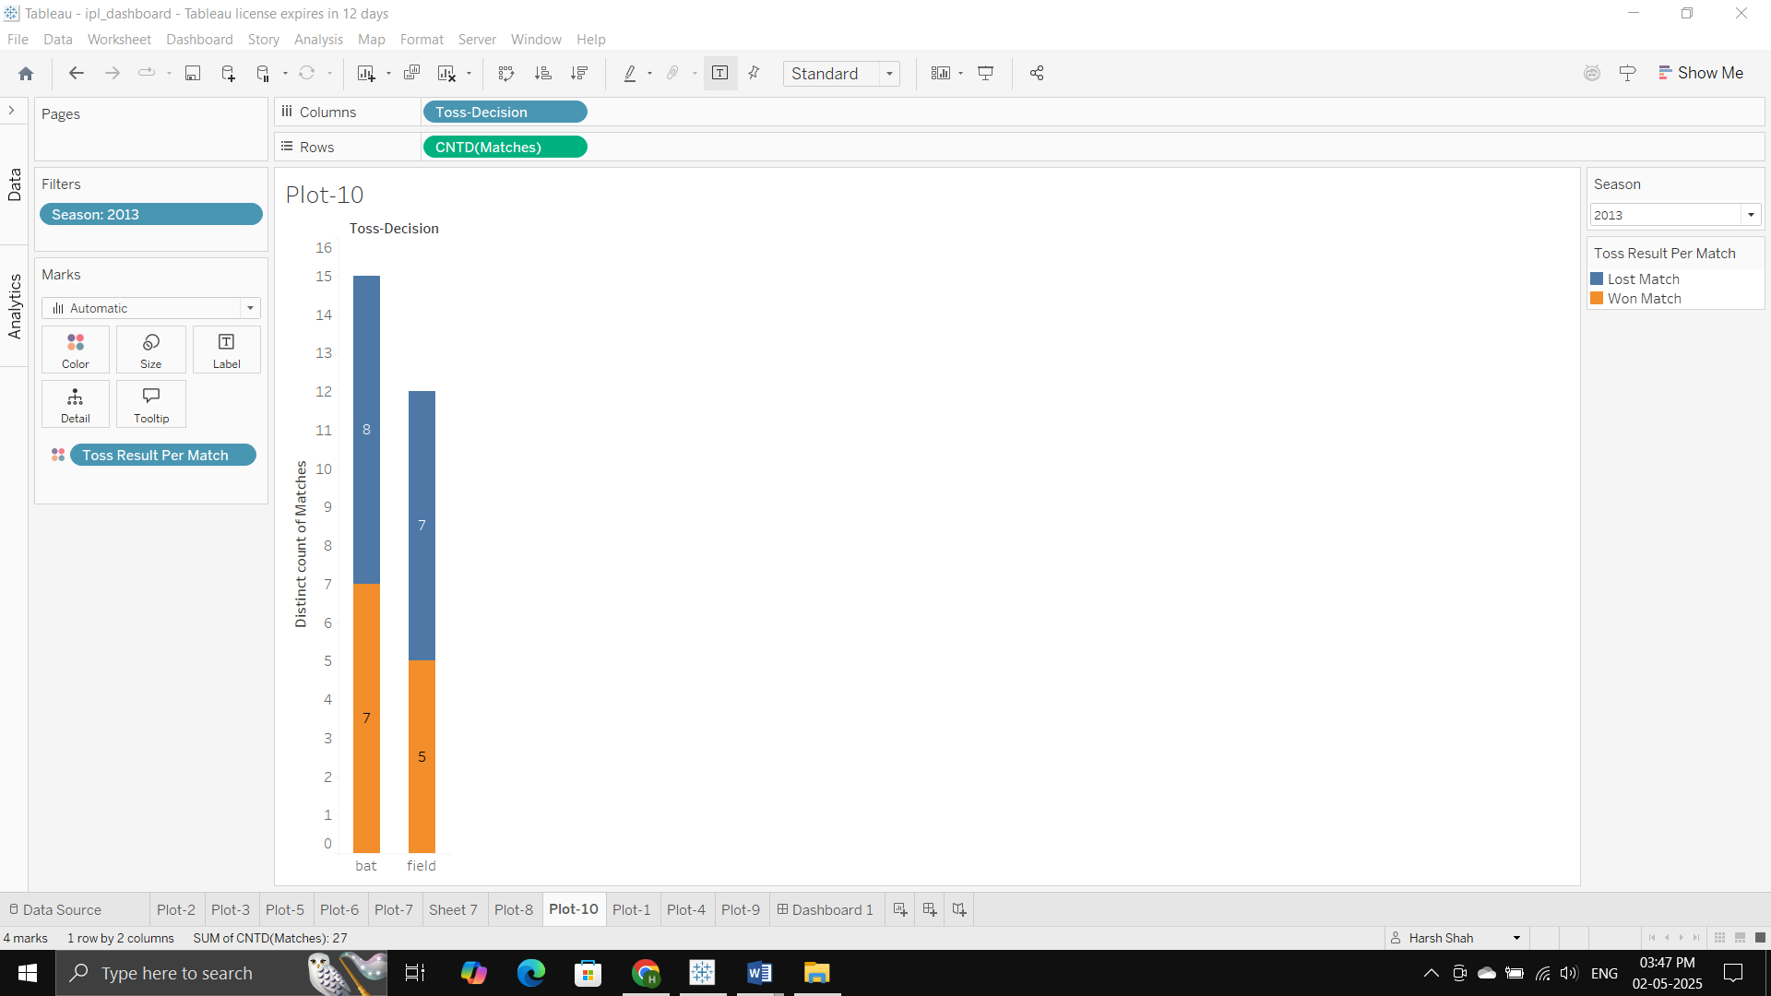Dashboard:
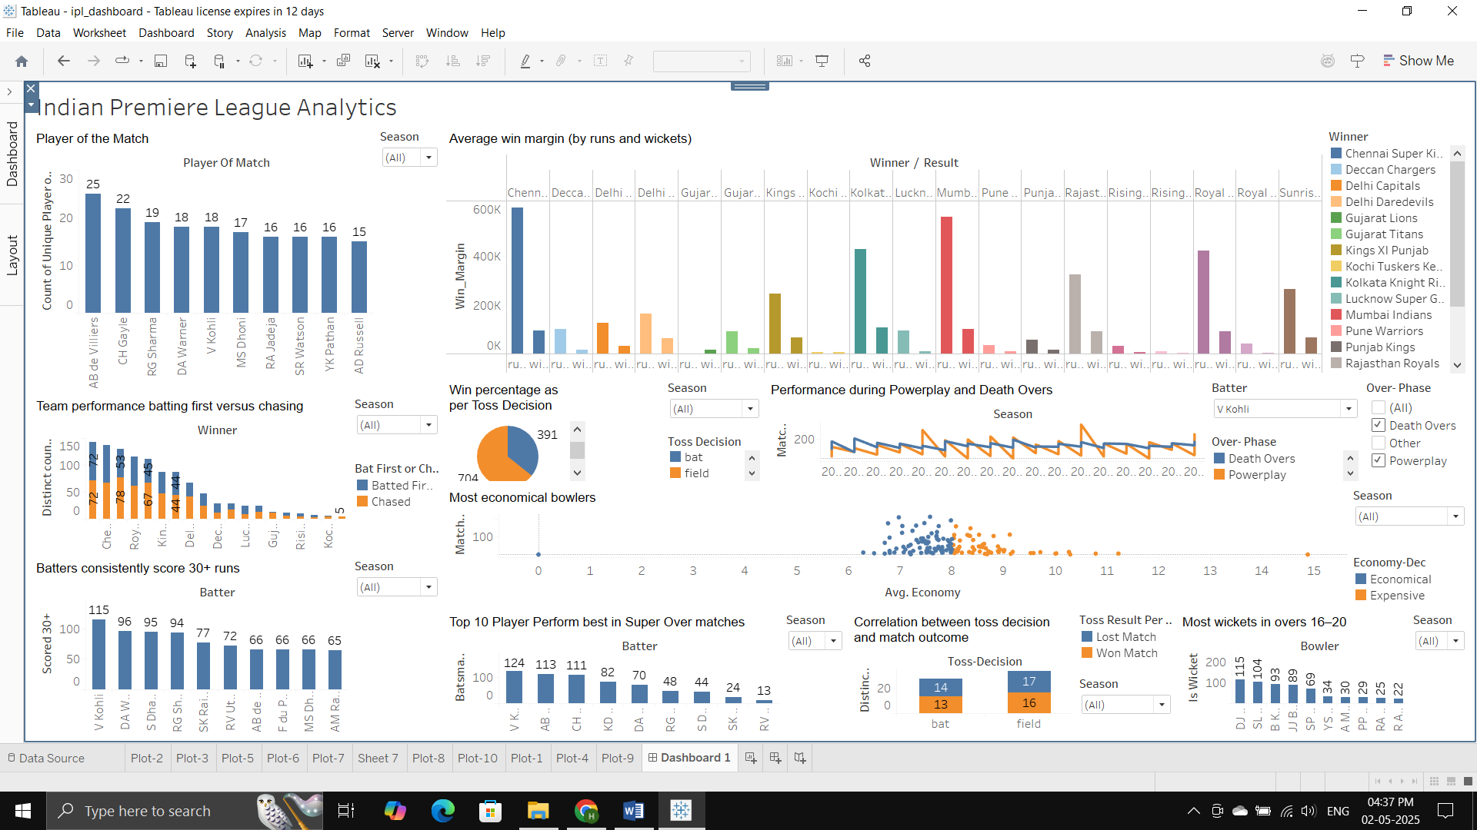
Tableau Dashboard Link:
https://public.tableau.com/app/profile/harsh.shah4033/viz/ipl_dashboard_17462251100950/Dashboard1?publish=yes
Mural:
https://app.mural.co/t/dvteam4996/m/dvteam4996/1744922420998/75c84000724bd6170a4d9ea44a4b46cc735adce2?sender=uedacee6b058fad1effa28794 Links to an external site.

