INTERNSHIP PROJECT REPORT
on
ROUTESHIELD AI: AN INTELLIGENT SAFETY-AWARE ROUTE RECOMMENDATION SYSTEM USING GRADIENT BOOSTING AND OPENSTREETMAP-BASED ROUTING
Submitted in partial fulfillment of the requirement for the degree of
Bachelor of Technology CS-AI & AIDS
by
BHAVYA
(Roll Number : 2401321529006)

Department of AI & AIDS
Greater Noida Institute of Technology, Greater Noida
October 2026
BONAFIDE CERTIFICATE
This is to certify that this project report entitled “ROUTESHIELD AI: AN INTELLIGENT SAFETY-AWARE ROUTE RECOMMENDATION SYSTEM USING GRADIENT BOOSTING AND OPENSTREETMAP-BASED ROUTING” submitted to Greater Noida Institute of Technology, Greater Noida, is a bonafide record of work done by Bhavya under my supervision from “24th June 2026” to “18th September 2026”.
Signature of the Internal Supervisor
Mrs. Vibha Mani, Internal Supervisor
Signature of the Company’s Authority
Mr. Samarth Porwal, Project Mentor
Signature
Dr. Deepak Yadav
Head of Department
Computer Science and Engineering (AI & AIDS)
Place: Greater Noida Institute of Technology
Date: 06 October 2026

ABSTRACT
Navigation applications recommend routes on the basis of distance and travel time, and they do not consider whether a route is safe for the person using it. The shortest path may pass through poorly lit, deserted or high-crime areas, particularly at night, and users have no data with which to compare candidate routes on the basis of personal security. This project presents RouteShield AI, an intelligent safety-aware route recommendation system that addresses this gap.
The system accepts a source and a destination, converts them into coordinates using Nominatim, and retrieves candidate routes from the Open Source Routing Machine (OSRM). For every candidate route, safety indicators covering location (crime rate, street lighting, CCTV availability), time of day, environment (weather, crowd density) and route characteristics (traffic density, distance to emergency services) are extracted. A Gradient Boosting classifier, trained on these indicators, classifies each route as Safe, Moderate or Unsafe and outputs probability scores that are used to select the best route. The classifier is serialized with Joblib and integrated with a Flask backend, and the results are displayed on an interactive, colour-coded Leaflet map. The complete application has been deployed on the web.
The work shows that contextual safety information can be combined with standard routing technology to give users a visual explanation of route safety instead of blind shortest-path data, so that they can make informed travel decisions. The report presents the problem, the review of existing approaches, the methodology and architecture, the implementation, the results and the limitations, and it recommends future work such as real-time crowd-sourced incident reporting and richer map visualisation.
Keywords: Safe route recommendation, Gradient Boosting, OSRM, Leaflet, Flask, route safety classification, OpenStreetMap.

ACKNOWLEDGEMENT
We would like to express our sincere gratitude to our internal supervisor, Mrs. Vibha Mani, and to our company mentor, Mr. Samarth Porwal of MyAnatomy, for their continuous guidance, valuable suggestions and encouragement throughout the internship and the preparation of this report.
We are thankful to Dr. Deepak Yadav, Head of the Department of AI & AIDS, and to the faculty of Greater Noida Institute of Technology, Greater Noida, for providing the academic support and the opportunity to undertake this internship project.
We also thank the engineers and staff of MyAnatomy who shared their time and insight during the project, the developers and communities of the open-source tools used in this work, including OpenStreetMap, OSRM, Nominatim, Flask and Leaflet, and our families and friends for their constant support.

TABLE OF CONTENTS
Chapter / Title Page No.
Certificate ii
Abstract iii
Acknowledgement iv
Table of Contents v
List of Tables vi
List of Figures vii
List of Symbols, Abbreviations and Nomenclature viii
1. INTRODUCTION 1
1.1 Background and Domain 1
1.2 Existing Approaches to Route Recommendation 1
1.3 Problem Statement 1
1.4 Limitations of Current Systems and Their Impact 2
1.5 Related Work and Existing Solutions 2
1.6 Identified Gaps 3
1.7 Scope of the Project 3
1.8 Organization of the Report 3
2. OBJECTIVES 4
2.1 Primary Objective 4
2.2 Specific Objectives 4
2.3 Target Users and Stakeholders 4
3. METHODOLOGY 5
3.1 Research Approach 5
3.2 Data Sources and Safety Indicators 5
3.3 Proposed System Architecture 6
3.4 Geocoding and Candidate Route Generation 6
3.5 Target Labels 7
3.6 Machine Learning Model 7
3.7 Route Ranking and Selection 8
3.8 Model Persistence and Backend Integration 8
3.9 Proposed Evaluation Metrics 8
3.10 Deployed User Interface 9
4. RESOURCES AND LIMITATIONS 10
4.1 Data Resources 10
4.2 Technical Resources 10
4.3 Human Resources 10
4.4 Limitations 10
5. CONCLUSIONS AND RECOMMENDATIONS 11
5.1 Conclusions 11
5.2 Expected Impact 11
5.3 Recommendations and Future Work 11
APPENDIX A SAFETY INDICATORS 13
APPENDIX B IMPLEMENTATION PARAMETERS 14
REFERENCES 15

LIST OF TABLES
Table No. and Title Page No.
Table 1 Approaches used in current route recommendation 1
Table 2 Existing techniques and their limitations 2
Table 3 Target users and stakeholders 4
Table 4 Safety indicators used for classification 5
Table 5 Proposed evaluation metrics and results on the test set 8
Table 6 Technical resources of the system 10
Table 7 Expected impact by stakeholder group 11
Table 8 Safety indicators and their descriptions 13
Table 9 Implementation parameters 14

LIST OF FIGURES
Figure No. and Title Page No.
Fig. 1 Categories of safety indicators used by the model 5
Fig. 2 Workflow of RouteShield AI 6
Fig. 3 Five-layer component interaction in RouteShield AI 6
Fig. 4 Stage-wise construction of a gradient boosting ensemble 7
Fig. 5 Machine learning pipeline of RouteShield AI 8
Fig. 6 Planner page of the RouteShield AI prototype 9
Fig. 7 Colour-coded safety-ranked routes on the interactive map 9

LIST OF SYMBOLS, ABBREVIATIONS AND NOMENCLATURE
Abbreviations
Abbreviation | Full form
AI | Artificial Intelligence
AIDS | Artificial Intelligence and Data Science
API | Application Programming Interface
CCTV | Closed-Circuit Television
HTTP | Hypertext Transfer Protocol
JSON | JavaScript Object Notation
ML | Machine Learning
OSM | OpenStreetMap
OSRM | Open Source Routing Machine
REST | Representational State Transfer
UI | User Interface
URL | Uniform Resource Locator
Nomenclature
Term | Meaning in this report
Candidate route | One of the alternative routes returned by the routing engine for a source and destination.
Safety indicator | A measurable factor, such as street lighting or crowd density, that describes how safe a route is.
Feature vector | The ordered set of safety indicator values of one route, given to the model.
Safety class | The label assigned to a route: Safe, Moderate or Unsafe.
Weak learner | A simple model, usually a shallow decision tree, combined with others in boosting.
ν (learning rate) | Weight with which each new weak learner is added to the ensemble.
F(x), h_m(x) | Ensemble model after all stages; weak learner added at stage m.

CHAPTER 1

INTRODUCTION

1.1 Background and Domain
This project belongs to the domain of intelligent transportation and location-based services, which is concerned with how people find and choose routes through a city. Navigation applications have become an everyday tool for commuters, students, delivery workers and travellers. A user enters a source and a destination, and the application returns one or more routes ranked by distance or by expected travel time.
This model works well when the only goal is to reach a place quickly. However, the route that is shortest on the map is not always the route that is most suitable for the person travelling on it. A shorter road may pass through a poorly lit stretch, a deserted area, or a neighbourhood with a high incidence of crime, particularly after dark. Information that would help a traveller choose between routes, such as lighting, crowd density, nearby emergency services or the time of day, is not part of the decision that a standard routing engine makes. This gap motivates the present project.

1.2 Existing Approaches to Route Recommendation
Route recommendation today relies on a small number of well-established techniques, summarised in Table 1.
Table 1: Approaches used in current route recommendation
Approach | Role in current route recommendation
Distance calculation | Computes the distance of candidate routes between the location inputs and selects the shortest
Time optimisation | Estimates travel time from road type, speed limits and traffic, and recommends the fastest route
Static road-graph metrics | Treats every road segment as a length or a travel time, with no notion of its surroundings

In all three approaches the output is a route that is optimal in a geometric or temporal sense. Standard systems strictly compute distances for candidate routes, ignoring the surrounding environmental context, and platforms that prioritise travel time may direct users through potentially unsafe zones merely because those routes are mathematically shorter.

1.3 Problem Statement
Traditional navigation systems optimise only for distance and travel time. Safety-related contextual indicators are completely absent from their decision process, so users cannot compare candidate routes on the basis of personal security, and the “shortest path” may lead them through unsafe areas. The problem addressed in this project is how to design a web-based system that, for a given source and destination, generates candidate routes, evaluates each route against contextual safety indicators using a machine learning model, and presents the user with a clear, visual, safety-ranked recommendation.

1.4 Limitations of Current Systems and Their Impact
The analysis of current systems identified the following limitations:
- Context blindness: safety context is entirely absent from modern routing decisions.
- Lack of information: users do not have the data required to compare candidate routes on the basis of personal security.
- Environmental hazards: the shortest path may lead pedestrians or drivers through poorly lit, high-crime or deserted areas.
- Static routing: route ranking relies on static distance metrics and does not adapt to factors such as night-time safety.
These limitations have practical consequences. Travellers are exposed to avoidable risk, especially at night and in unfamiliar surroundings. Users who would accept a longer route for safety have no way of knowing which route is safer. The same route is recommended at noon and at midnight, although its suitability may be very different at the two times.

1.5 Related Work and Existing Solutions
Route planning in road networks is a well-studied problem. Table 2 summarises the key techniques and the limitations that matter for safe route recommendation.
Table 2: Existing techniques and their limitations
Technique | Key features | Limitations
Dijkstra’s algorithm [1] | Classical shortest-path search on a road graph | Optimises length only; no safety information
Contraction hierarchies [2] | Pre-processing that makes shortest-path queries much faster | Faster, but still optimises length or time
OSRM [3] | Real-time routing engine working with OpenStreetMap data | Returns routes without any safety assessment
OpenStreetMap [4] | Collaboratively produced map data of the road network | Road geometry and tags; no direct safety rating of a route
Safe-path research [5] | Treats crime-related data as a factor balanced against path length | Typically relies on a single source of safety information

Dijkstra [1] remains the foundation of most routing engines, and speed-up techniques such as contraction hierarchies [2] allow OSRM [3] to answer queries in real time on OpenStreetMap data, whose characteristics were examined by Haklay and Weber [4]. The idea that the shortest route is not always the best one has been explored in urban safety research: Galbrun et al. [5] examined how to find safe paths in cities by balancing path length against crime-related information.
On the machine learning side, Friedman [6] introduced gradient boosting as a technique for building strong predictive models by combining many weak learners in a stage-wise manner. It performs well on tabular data with mixed feature types and non-linear relationships, which is the nature of the safety data used in this project.

1.6 Identified Gaps
The existing tools fall short of solving the safe-routing problem end to end:
- They optimise distance and time and do not use safety as a decision criterion.
- They do not combine several kinds of safety indicators (location, time, environment and route) in a single assessment.
- They do not adapt the recommendation to the time of day.
- They give no nuanced classification (such as Safe, Moderate and Unsafe) with probability scores.
- They offer no visual explanation that shows the user why one route is preferred over another.

1.7 Scope of the Project
The project aims to design and deploy a safety-aware route recommendation system. The system accepts a source and a destination, converts them into coordinates, retrieves candidate routes, extracts safety features for each route, classifies each route with a trained Gradient Boosting model, selects the best route, and displays all results on an interactive map. Live crowd-sourced incident reports and three-dimensional visualisation are identified as future work. The system is intended for the user groups listed in Table 3.

1.8 Organization of the Report
Chapter 1 introduces the domain, the existing approaches, the problem, related work and the gaps. Chapter 2 states the objectives and the target users. Chapter 3 describes the methodology, including the data and safety indicators, the system architecture, the machine learning pipeline, the evaluation metrics and the deployed user interface. Chapter 4 lists the resources used and the limitations of the work. Chapter 5 presents the conclusions, the expected impact and recommendations for further work. Appendices A and B give supplementary details, followed by the list of references.
CHAPTER 2

OBJECTIVES

2.1 Primary Objective
The primary objective is to develop an intelligent route recommendation system that adds safety context to route planning, so that users can compare routes on contextual safety and make informed travel decisions instead of relying on distance and time alone.

2.2 Specific Objectives
- To study existing route recommendation approaches and identify the limitations that affect traveller safety.
- To identify the safety indicators (location, time, environment and route) that can support an automated safety assessment of a route.
- To generate multiple candidate routes between a given source and destination using an open-source routing engine.
- To train and integrate a Gradient Boosting classifier that predicts a safety class (Safe, Moderate or Unsafe) with probability scores for each route.
- To select the best route from the predicted class and route characteristics.
- To present the candidate routes and their safety classes on an interactive, colour-coded map as a visual explanation.
- To deploy the system as a web application and describe the metrics by which it should be evaluated.

2.3 Target Users and Stakeholders
Table 3 lists the intended users of the system and what each of them expects from it.
Table 3: Target users and stakeholders
User group | Expectation from the system
Pedestrians and student commuters | Compare routes to campus, hostels and transport points, especially in the evening
Women and night-time travellers | See which available route is safer before starting a journey
Two-wheeler and car drivers | Avoid poorly lit or deserted stretches without a large increase in travel time
Delivery and field workers | Plan routes that balance travel time with safety during late hours
Institutions and administrators | Understand route-level safety indicators and extend the system with local data

CHAPTER 3

METHODOLOGY

3.1 Research Approach
The work followed a structured sequence: existing approaches were studied and their limitations identified (Chapter 1); safety indicators describing the context of a route were selected; a Gradient Boosting model suited to mixed-type data with probability outputs was chosen; a pipeline connecting geocoding, routing, feature extraction, prediction and visualisation was designed; and the system was integrated with a backend and deployed on the web.

3.2 Data Sources and Safety Indicators
The knowledge of the model about safety comes from a dataset whose records describe locations and travel situations in terms of safety indicators. The indicators are grouped into four categories (Fig. 1 and Table 4). Road geometry for candidate routes comes from OpenStreetMap data served by OSRM, and addresses are converted into coordinates by Nominatim [7].
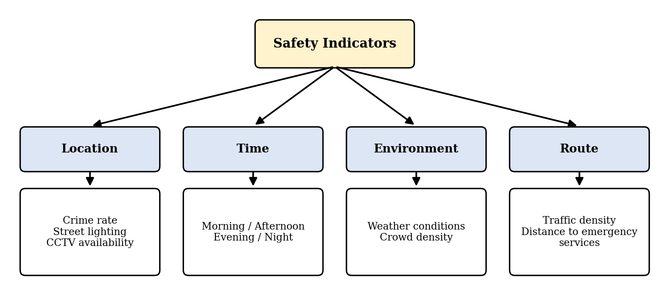
Fig. 1: Categories of safety indicators used by the model
Table 4: Safety indicators used for classification
Category | Indicators | Why it matters
Location | Crime rate, street lighting quality, CCTV availability | Describe the intrinsic security of the area through which a route passes
Time | Morning, afternoon, evening, night | The same area can be safe by day and unsafe at night
Environment | Real-time weather conditions, expected crowd density | Poor weather and deserted streets reduce visibility and the chance of help
Route | Traffic density, distance to nearby emergency services | Indicate how exposed a traveller is and how quickly help can arrive

Dataset source and size: the classifier was trained on a synthetic dataset of 35,000 records for Delhi (RouteShield_Synthetic_Delhi_35000.csv), generated to mimic incident and safety records across 40 Delhi areas and 7 area types (residential, commercial, market, industrial, educational, forest/green belt and isolated/highway) between 2023 and 2025. Each record has 21 columns. After removing the constant City column and the Safety_Score column (which defines the label and would leak it), the model uses 44 features after encoding. Because the dataset is synthetic, the reported accuracy shows how well the model learns the labelling rule and not real-world crime outcomes.

3.3 Proposed System Architecture
The proposed approach is a pipeline in which each stage consumes the output of the previous one, shown in Fig. 2. The user enters a source and a destination. The system converts them into coordinates and retrieves candidate routes. For every candidate route a set of safety features is extracted and given to a trained Gradient Boosting classifier, which predicts a safety class and probability scores. Finally, the best route is chosen and all candidate routes are displayed on a map with their classification.
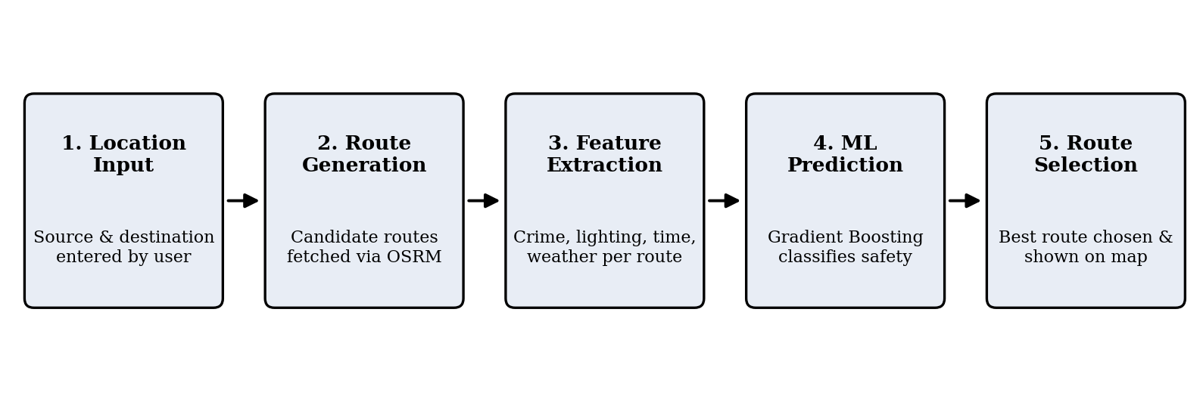
Fig. 2: Workflow of RouteShield AI
The system is built from five cooperating components: the user, Nominatim [7], OSRM [3], a Flask backend [8] and Leaflet [9]. Fig. 3 shows how they interact. The user enters locations, Nominatim converts addresses into coordinates, OSRM generates candidate routes and Leaflet renders the colour-coded result. The Flask backend is the centre of the architecture: it calls the geocoding and routing services, builds the feature vector for every candidate route, invokes the trained model and returns the ranked results.
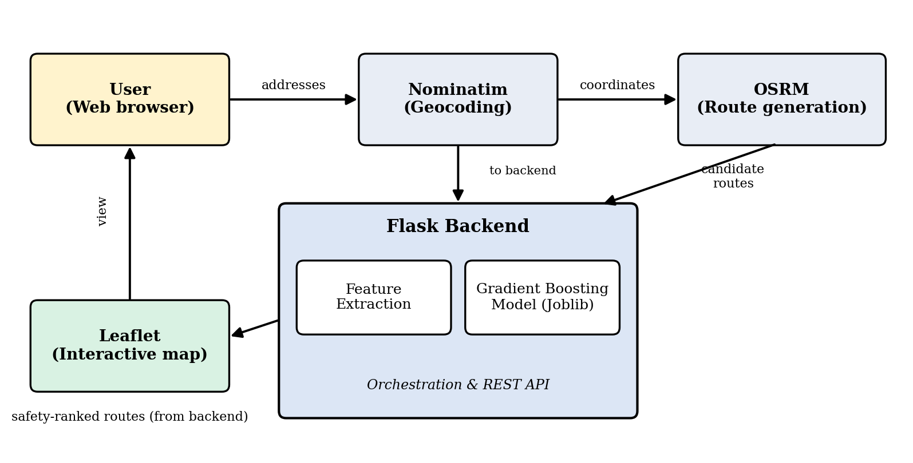
Fig. 3: Five-layer component interaction in RouteShield AI

3.4 Geocoding and Candidate Route Generation
Users describe places by name or address, whereas routing engines work on coordinates. The backend therefore sends the text entered by the user to Nominatim, which returns the corresponding latitude and longitude. The coordinates of the source and the destination are then sent to OSRM, which can return more than one route for the same pair of points. These alternatives form the set of candidate routes.
For every candidate route the backend then extracts the safety indicators of Table 4 and arranges them into a feature vector in the same order and format used when the model was trained. This consistency is essential for the model to produce meaningful predictions.

3.5 Target Labels
Each record in the dataset is assigned one of three labels derived from the safety indicators: Safe, Moderate or Unsafe. A three-level label was preferred over a simple safe/unsafe split because real routes are rarely entirely one or the other. The Moderate class lets the system express caution without rejecting a route, which gives the user more room to weigh safety against travel time.
Label rule: every record carries a Safety_Score from 0 to 100, and the label is derived from it: Unsafe below 35 (observed 0-34.9), Moderate from 35 to 66 (35-65.9) and Safe above 66 (66.1-100). Class distribution: Moderate 17,115, Safe 11,291, Unsafe 6,594. Safety_Score was excluded from the training features to prevent data leakage.

3.6 Machine Learning Model
The classifier is a Gradient Boosting Classifier. It builds an ensemble of weak learners sequentially, with each learner correcting the errors of the previous ones, and it handles class imbalance and non-linear relationships effectively in mixed-type safety feature data. Gradient boosting [6], [10] constructs a model F in stages. At each stage m a new weak learner h_m, usually a shallow decision tree, is fitted to the residual errors of the current ensemble and added with a small weight called the learning rate ν:
F_m(x) = F_(m−1)(x) + ν · h_m(x)
After M stages the final model is the weighted sum of all weak learners (Fig. 4). For three classes the model produces a score for each class, converted into probabilities, and the predicted class is the one with the highest probability.
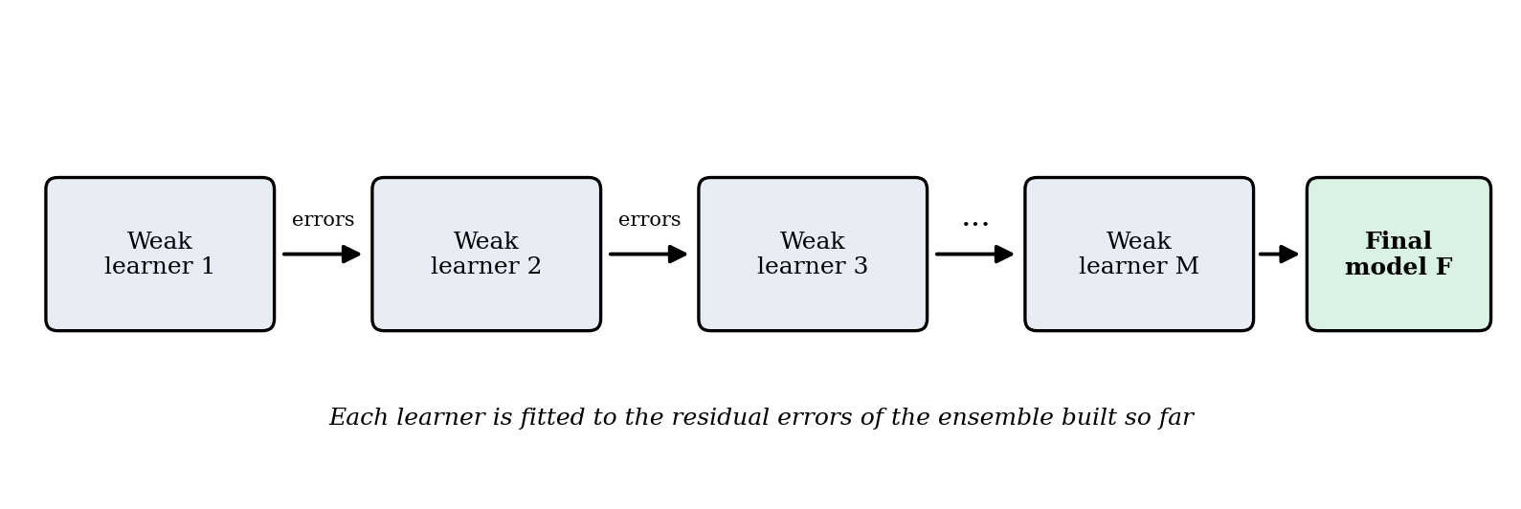
Fig. 4: Stage-wise construction of a gradient boosting ensemble
For each candidate route the backend passes the feature vector to the trained model, which returns probability scores for Safe, Moderate and Unsafe (Fig. 5). The probabilities allow routes of the same class to be ordered: a route with a higher probability of being Safe is preferred.
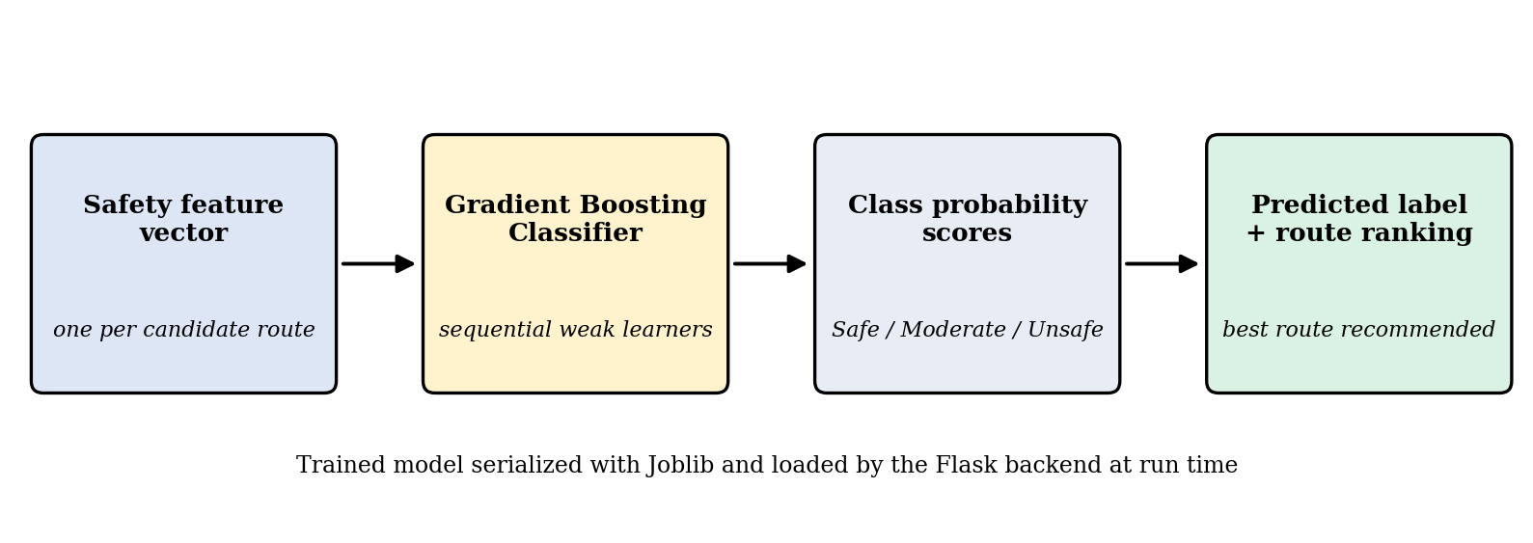
Fig. 5: Machine learning pipeline of RouteShield AI

3.7 Route Ranking and Selection
Once all candidate routes are classified, the best route is chosen from the predicted safety class and its probability scores, with route characteristics such as distance used to distinguish routes of the same class. All candidates stay visible on the map, colour-coded by class, with the chosen route highlighted. The final decision stays with the user.

3.8 Model Persistence and Backend Integration
After training, the model is serialized with Joblib [11] and loaded by the Flask backend when the application starts, so it is not retrained on every request. The interface and the backend communicate over HTTP in the style of a REST API [12]: the interface sends the user inputs and the backend responds with structured data describing the routes, their classes and probabilities. The complete application is deployed on the Render cloud platform.

3.9 Proposed Evaluation Metrics
The quality of the classifier should be judged on data not used for training. For a three-class problem the standard measures are listed in Table 5. Recall for the Unsafe class is of particular importance, because failing to flag an unsafe route is a more serious error than flagging a safe route as moderate.
Table 5: Proposed evaluation metrics and results on the test set
Metric | What it measures | Result
Accuracy | Share of all routes classified correctly | 95.06% (5-fold CV 95.31% ± 0.21)
Precision (per class) | Share of routes predicted in a class that truly belong to it | Safe 0.96, Moderate 0.94, Unsafe 0.96
Recall (per class) | Share of routes truly in a class that were found | Safe 0.94, Moderate 0.96, Unsafe 0.95
F1-score | Harmonic mean of precision and recall | Safe 0.95, Moderate 0.95, Unsafe 0.96; weighted F1 0.9506

3.10 Deployed User Interface
The system has been deployed as a web application at https://routeshield-ai-1.onrender.com/#planner. Fig. 6 shows the planner page of the prototype. The user enters a starting point and a destination, chooses the travel time and the travel mode (for example, Driving), and can tick an option to avoid isolated or poorly lit roads. The page also offers buttons to use the current location and to start live navigation, and an SOS button and an Emergency section are available from the top menu.
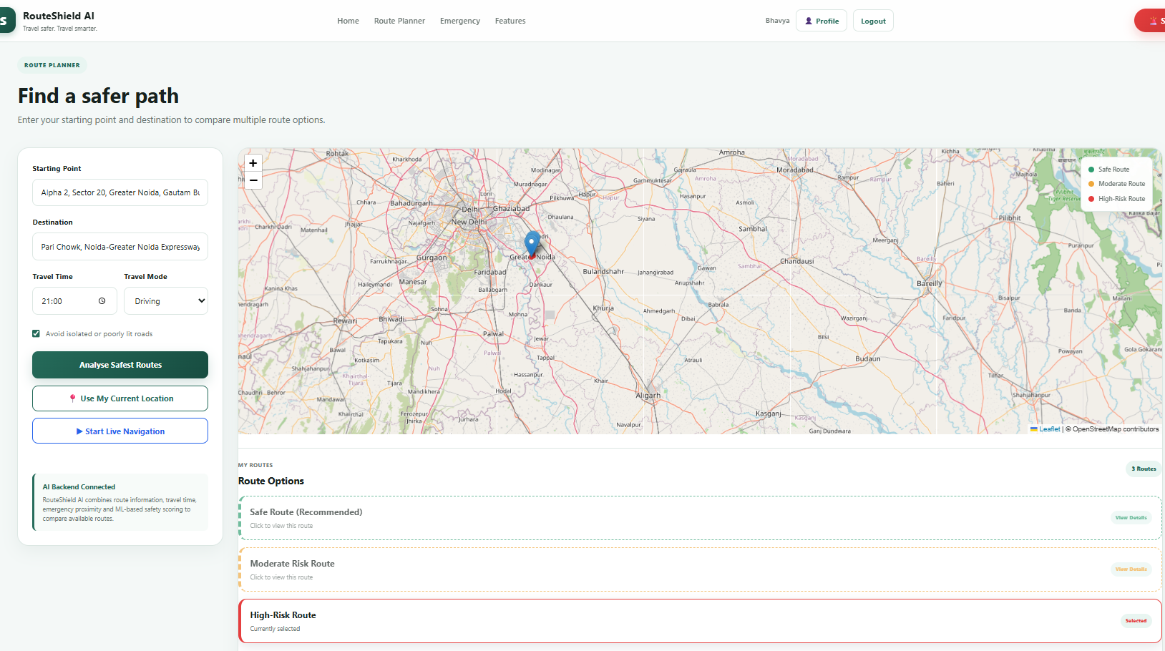
Fig. 6: Planner page of the RouteShield AI prototype
On selecting “Analyse Safest Routes”, the backend combines route information, travel time, emergency proximity and ML-based safety scoring, and lists the available routes as Safe Route (Recommended), Moderate Risk Route and High-Risk Route. The map legend uses the same three classes; the class called Unsafe in this report appears as High-Risk in the interface. Each candidate route is drawn in the colour of its class so that the classification can be understood at a glance (Fig. 7).
Insert screenshot of the map with colour-coded routes and the recommended route here.
Fig. 7: Colour-coded safety-ranked routes on the interactive map
CHAPTER 4

RESOURCES AND LIMITATIONS

4.1 Data Resources
The main data resources are the safety dataset used to train the classifier (indicators of Table 4) and the OpenStreetMap road data used by OSRM and Nominatim.

4.2 Technical Resources
Table 6 lists the technical components of the system.
Table 6: Technical resources of the system
Component | Technology | Purpose
Geocoding | Nominatim | Convert address text to latitude and longitude
Routing | OSRM | Generate candidate routes between coordinates
Backend | Flask (Python) | Orchestrate the workflow and serve REST-style requests
Machine learning | Gradient Boosting Classifier | Classify routes as Safe, Moderate or Unsafe
Model storage | Joblib | Serialize the trained model for the backend
Visualisation | Leaflet | Interactive map with colour-coded routes
Hosting | Render | Online deployment of the application

4.3 Human Resources
The work was carried out by a team of five members, namely Bhavya, Niharika, Somya, Aanshika Singh and Priya, under the guidance of the internal supervisor and the company’s authority named in the certificate.

4.4 Limitations
The following limitations apply to this work:
- Data quality and labels: the classifier can only learn the patterns present in its training data, and the Safe, Moderate and Unsafe labels are derived from indicators, not independent measurements of risk.
- External services and estimates: geocoding and routing depend on Nominatim and OSRM, whose public instances have capacity limits, and indicators such as crowd density can only be estimated.
- Decision aid only: the system cannot predict individual incidents and should be used with the traveller’s own judgement.
CHAPTER 5

CONCLUSIONS AND RECOMMENDATIONS

5.1 Conclusions
The conclusions are drawn with reference to the objectives stated in Chapter 2.
- Existing route recommendation optimises distance and time and is blind to safety context, which exposes travellers to avoidable risk (Objective 1).
- Location, time, environment and route indicators together give a practical basis for assessing the safety of a route (Objective 2).
- Candidate routes from OSRM can be assessed by a Gradient Boosting classifier that assigns Safe, Moderate or Unsafe labels with probability scores, which allows nuanced comparison (Objectives 3 and 4).
- RouteShield AI provides dynamic visual explanations for route safety instead of blind shortest-path data (Objectives 5 and 6).
- The modular design and the web deployment make the system accessible to any user with a browser and easy to extend (Objective 7).

5.2 Expected Impact
Table 7 summarises the expected benefits.
Table 7: Expected impact by stakeholder group
Group | Expected benefits
Travellers | Informed route choice; reduced exposure to poorly lit or deserted areas; clear visual understanding of route safety
Institutions | A basis for advising students and staff on safer routes
Developers | A modular pipeline in which routing, features, model and interface can be improved independently

5.3 Recommendations and Future Work
The following recommendations would help to accomplish the project objectives and to extend them:
- Integrate real-time crowd-sourced incident reporting so that safety data stays current.
- Add enhanced 3D visualisations and interactive nodes within the Leaflet map interface.
- Show which indicators contributed most to a prediction and evaluate the model with cross-validation and user feedback.
- Train on larger data from more areas and times of day, and build a mobile application on the same backend.
APPENDIX A

SAFETY INDICATORS
The feature set of RouteShield AI uses the indicators listed in Table 8.
Table 8: Safety indicators and their descriptions
Indicator | Category | Description
Crime rate | Location | Level of recorded criminal activity in the area of the route
Street lighting quality | Location | How well the route is illuminated, which affects visibility after dark
CCTV availability | Location | Presence of camera coverage along or near the route
Time of day | Time | Morning, afternoon, evening or night
Weather conditions | Environment | Prevailing weather at the time of travel
Crowd density | Environment | Expected number of people present in the area
Traffic density | Route | Volume of vehicular traffic on the route
Distance to emergency services | Route | Distance from the route to nearby emergency services

APPENDIX B

IMPLEMENTATION PARAMETERS
To allow someone with a similar background to reproduce the approach, the parameter values used in the implementation are recorded in Table 9.
Table 9: Implementation parameters
Parameter | Value used
Classification algorithm | Gradient Boosting Classifier
Target classes | Safe, Moderate, Unsafe
Model serialization | Joblib
Routing engine | OSRM (OpenStreetMap data)
Geocoding service | Nominatim
Backend framework | Flask
Map library | Leaflet
Hosting platform | Render
Number of training records | 35,000 records (28,000 train, 7,000 test)
Train / test split | 80 / 20 stratified split, random_state = 42
Number of estimators, learning rate, maximum depth | n_estimators = 100, learning_rate = 0.1, max_depth = 3

REFERENCES
1. Dijkstra, E. W., “A note on two problems in connexion with graphs,” Numerische Mathematik, Vol.1, No.1, 1959, pp.269-271.
2. Geisberger, R., Sanders, P., Schultes, D., and Delling, D., “Contraction hierarchies: Faster and simpler hierarchical routing in road networks,” Proceedings of the 7th International Workshop on Experimental Algorithms (WEA 2008), Lecture Notes in Computer Science, Vol.5038, Springer, 2008, pp.319-333.
3. Luxen, D. and Vetter, C., “Real-time routing with OpenStreetMap data,” Proceedings of the 19th ACM SIGSPATIAL International Conference on Advances in Geographic Information Systems, 2011, pp.513-516.
4. Haklay, M. and Weber, P., “OpenStreetMap: User-generated street maps,” IEEE Pervasive Computing, Vol.7, No.4, 2008, pp.12-18.
5. Galbrun, E., Pelechrinis, K., and Terzi, E., “Urban navigation beyond shortest route: The case of safe paths,” Information Systems, Vol.57, 2016, pp.160-171.
6. Friedman, J. H., “Greedy function approximation: A gradient boosting machine,” The Annals of Statistics, Vol.29, No.5, 2001, pp.1189-1232.
7. OpenStreetMap Foundation, “Nominatim documentation,” OpenStreetMap Foundation. [Online]. Available: https://nominatim.org/
8. Pallets Projects, “Flask documentation,” Pallets. [Online]. Available: https://flask.palletsprojects.com/
9. Agafonkin, V., “Leaflet: An open-source JavaScript library for interactive maps.” [Online]. Available: https://leafletjs.com/
10. Hastie, T., Tibshirani, R., and Friedman, J., The Elements of Statistical Learning: Data Mining, Inference, and Prediction, 2nd ed., Springer, New York, 2009.
11. Joblib Developers, “Joblib: Running Python functions as pipeline jobs.” [Online]. Available: https://joblib.readthedocs.io/
12. Fielding, R. T., “Architectural styles and the design of network-based software architectures,” Ph.D. dissertation, University of California, Irvine, 2000.

