Option 1: After executing the final program, this Spreadsheet Operations window will appear.

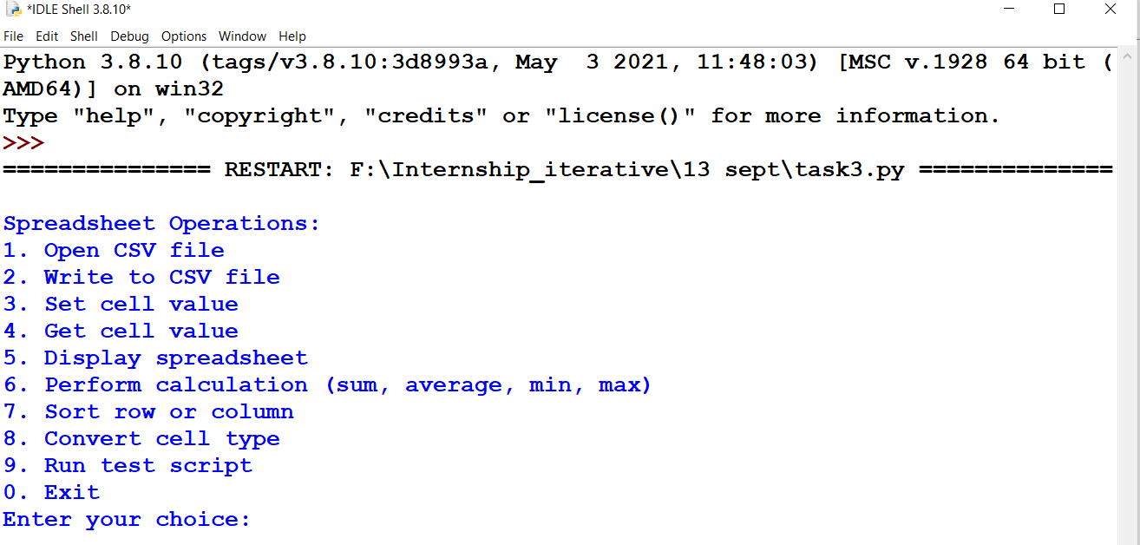

Option 2: When we select the option 1, then the csv file gets loaded successfully.

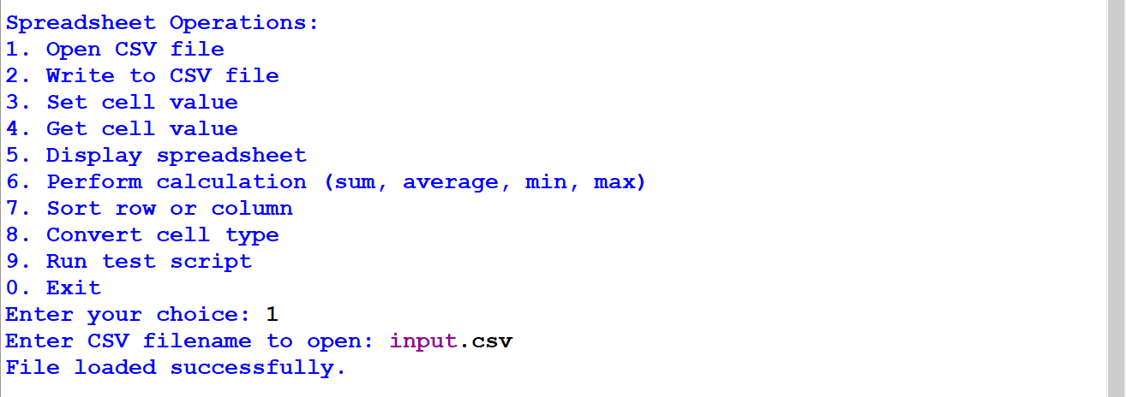

Option 3: Now, the data of input file gets written in output file.

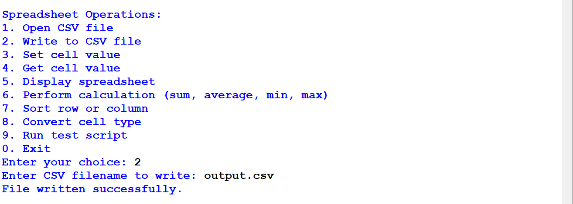

Option 4: Set cell value.

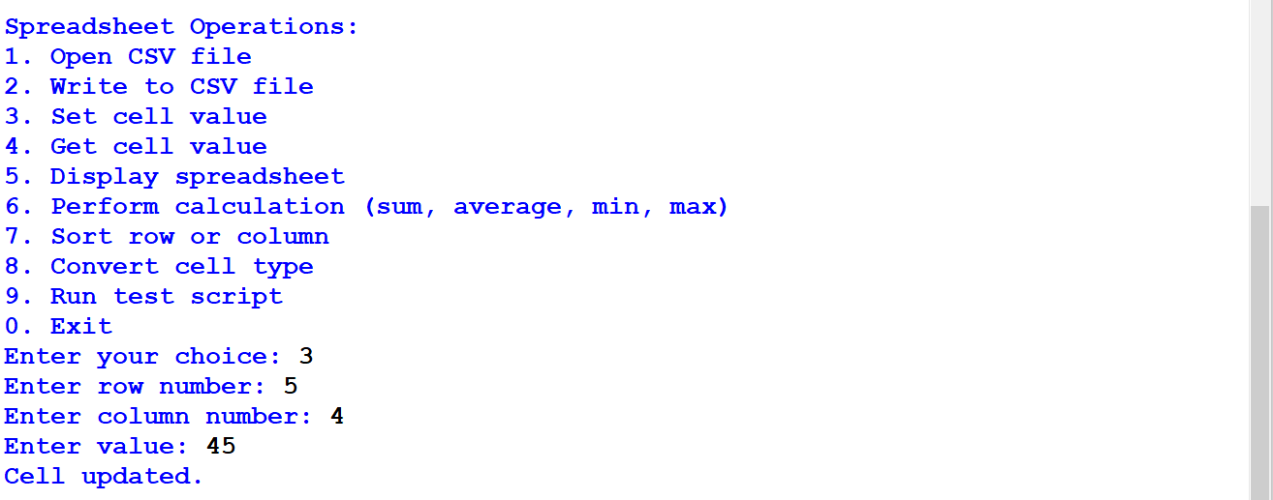

Option 5: Get cell value.

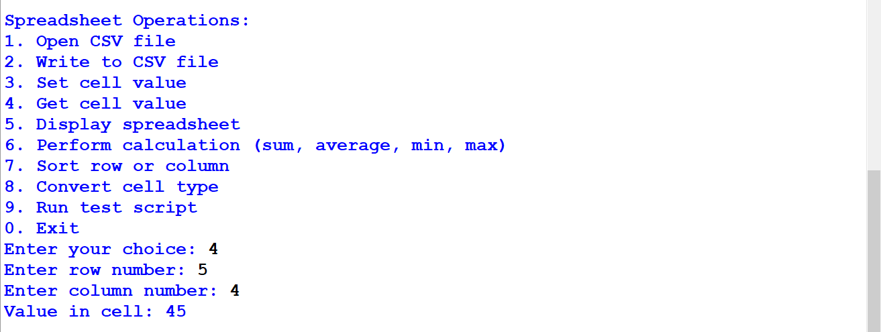

Option 6: Display spreadsheet

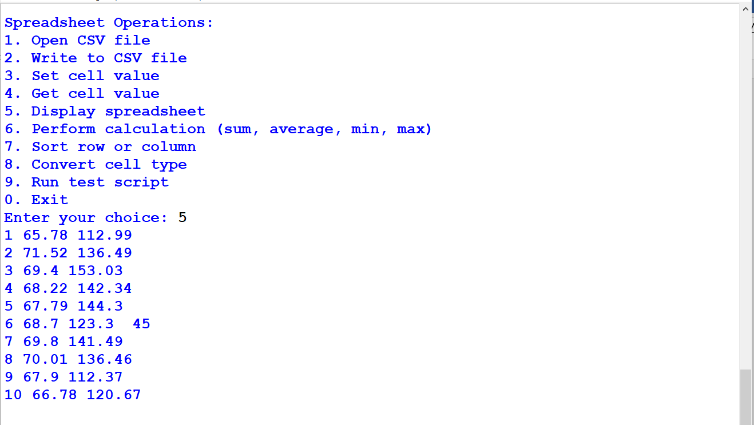

Option 7: Perform calculation…

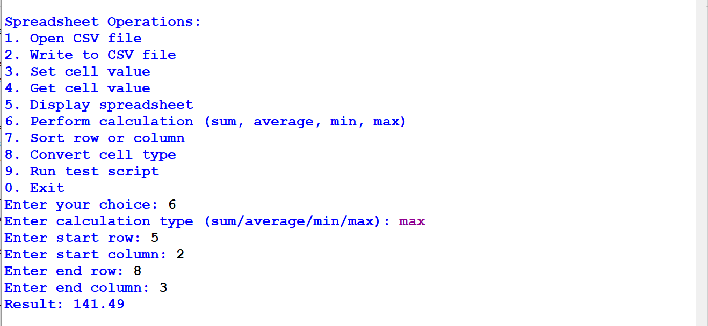

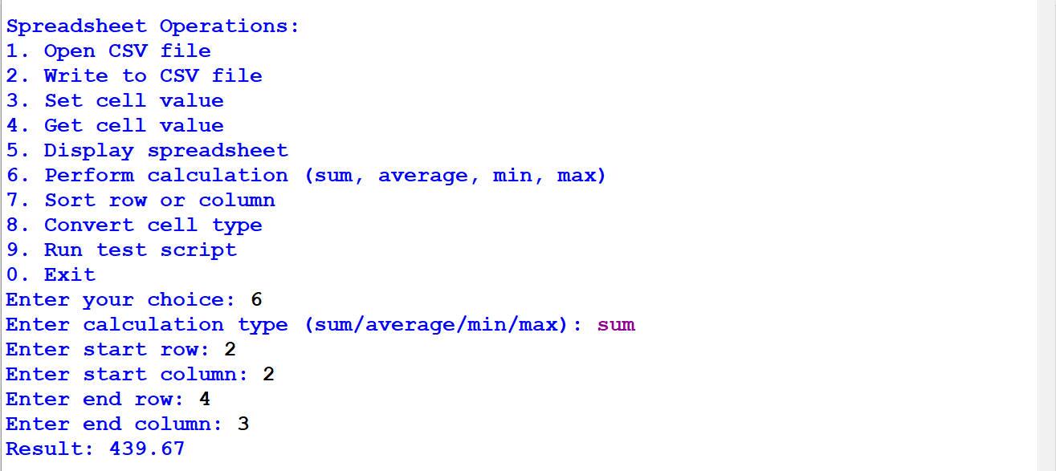

Option 8: Sort row or column

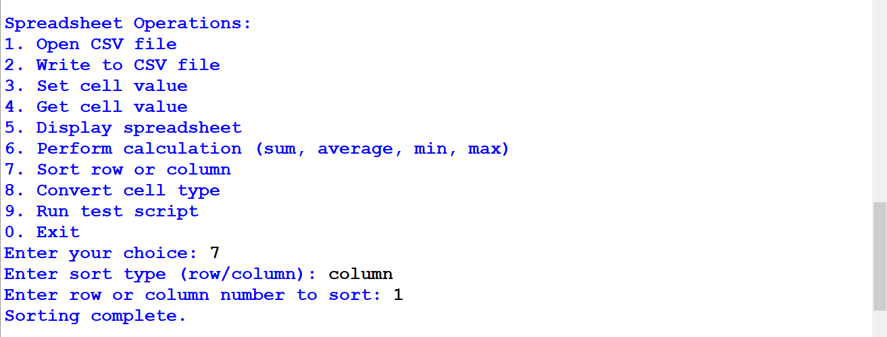

Option 9: Convert cell type

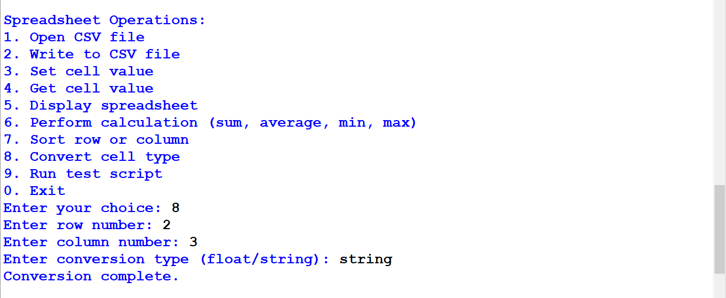

Option 10: Run test script

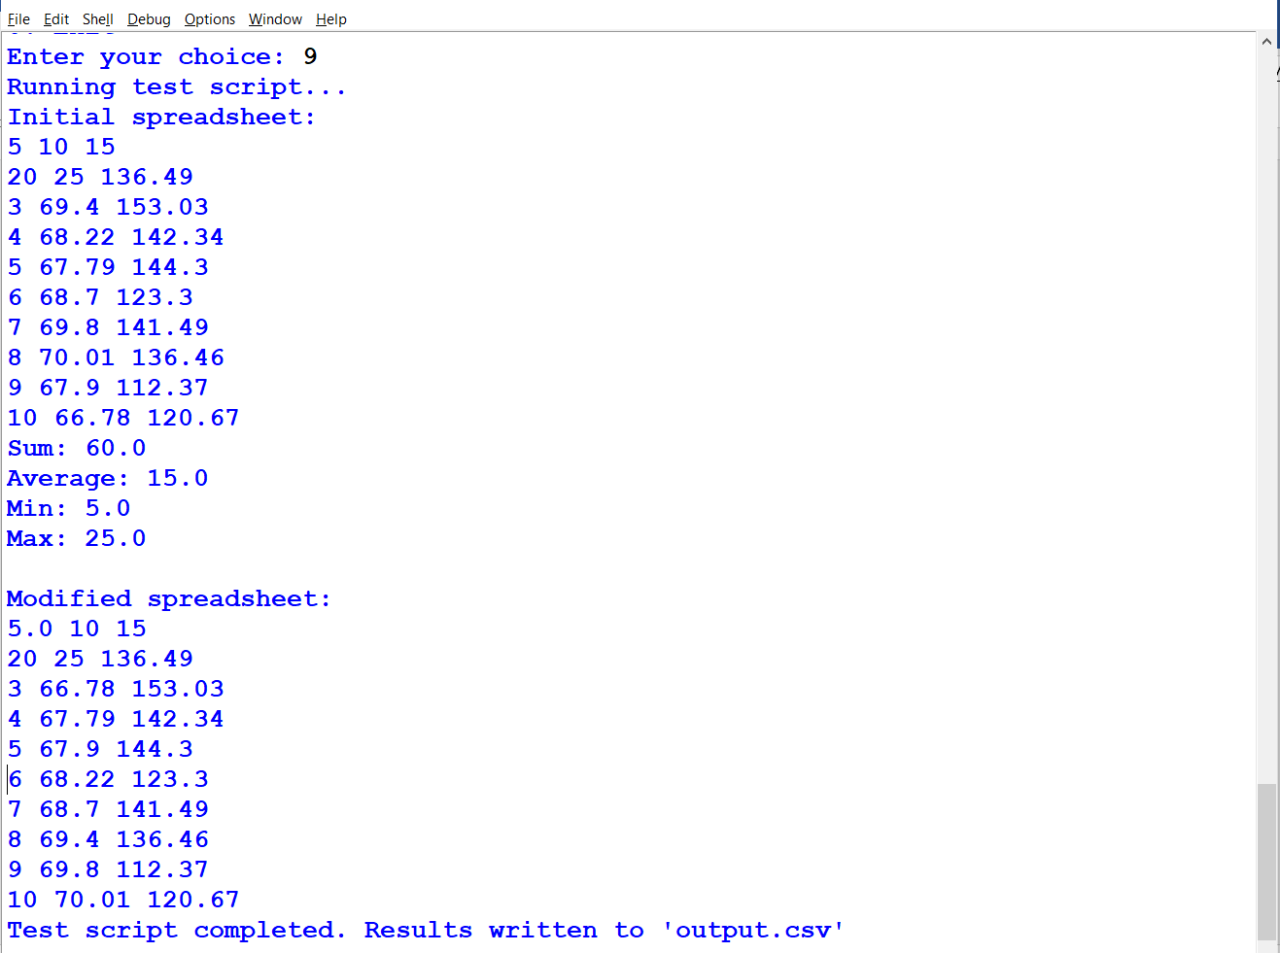

Option 11: Exit