Student name:

  Student id:

# Data Visualisation in R

Table of Contents

Data Visualisation in R 0

1. Introduction 2

2. Theoretical Foundations 2

3. Data Visualization Techniques in R 2

4. Design Principles and Best Practices 2

5. Data Preparation and Wrangling 3

6. Interactive Visualizations and Dashboards 3

7. Case Study Examples 3

8. Conclusion 10

# 1. Introduction

Data visualization has become an indispensable tool in advanced data analysis, offering a powerful means to uncover insights, identify patterns, and facilitate informed decision-making. In today's data-driven world, the ability to effectively visualize complex datasets is crucial for analysts, researchers, and decision-makers across various fields.

The significance of data visualization lies in its capacity to transform raw data into meaningful visual representations that can be easily interpreted and understood. By leveraging human perceptual and cognitive abilities, well-designed visualizations can reveal trends, relationships, and anomalies that might otherwise remain hidden in large datasets.

# 2. Theoretical Foundations

The effectiveness of data visualization is rooted in principles of human perception and cognition. The human visual system is highly adept at processing visual information, allowing us to quickly recognize patterns, colors, and spatial relationships. This innate ability forms the basis of data visualization theory.

Key principles include:

1. Pre-attentive processing: Certain visual attributes, such as color, size, and shape, are processed rapidly and automatically by our visual system.
2. Gestalt principles: These describe how we perceive and organize visual elements, including proximity, similarity, and continuity.
3. Color theory: Understanding how colors interact and affect perception is crucial for effective visualizations.

Recent advancements in visualization theory have focused on the role of interactivity and user engagement. Research has shown that interactive visualizations can enhance understanding and exploration of complex datasets by allowing users to manipulate and explore data in real-time.

# 3. Data Visualization Techniques in R

R offers a wide array of visualization techniques, from basic plots to advanced, interactive visualizations. Some key techniques include:

1. ggplot2: A powerful and flexible package for creating static visualizations.
2. plotly: Enables the creation of interactive plots.
3. leaflet: Used for interactive mapping and geospatial visualizations.
4. networkD3: Facilitates the creation of interactive network graphs.
5. dygraphs: Specialized for time series visualizations.

Each technique has its strengths and limitations. For instance, ggplot2 excels in creating publication-quality static plots but lacks interactivity. Plotly, on the other hand, offers interactivity but may be more complex to set up initially.

# 4. Design Principles and Best Practices

Effective data visualizations adhere to several key design principles:

1. Clarity: The visualization should clearly communicate the intended message.
2. Simplicity: Avoid unnecessary complexity or "chart junk".
3. Accuracy: Ensure the visualization accurately represents the underlying data.
4. Consistency: Use consistent design elements throughout the visualization.

Color plays a crucial role in visualization. It can be used to highlight important data points, distinguish between categories, or represent continuous variables. However, it's important to consider color blindness and choose color palettes that are accessible to all users.

Layout and typography also significantly impact the effectiveness of a visualization. A well-structured layout guides the viewer's eye through the data, while appropriate typography enhances readability and hierarchy of information.

# 5. Data Preparation and Wrangling

Before creating visualizations, it's often necessary to prepare and wrangle the data. In R, packages like dplyr and tidyr are invaluable for these tasks. Common data preparation steps include:

1. Handling missing data: This might involve imputation or filtering.
2. Dealing with outliers: Techniques like winsorization or log transformation can be useful.
3. Data reshaping: Converting between wide and long formats to suit different visualization needs.

# 6. Interactive Visualizations and Dashboards

Interactive visualizations allow users to explore data dynamically. In R, packages like Shiny and Plotly excel in creating such visualizations. Shiny, in particular, enables the creation of web applications with interactive plots and user inputs.

Benefits of interactive visualizations include:

1. Exploration: Users can dive deep into specific data points or subsets.
2. Customization: Users can adjust parameters to view data from different perspectives.
3. Engagement: Interactivity can make complex data more accessible and engaging.

Challenges include increased complexity in development and potential performance issues with large datasets.

# 7. Case Study Examples

**Case Study 1: Exploring Religious Income Distribution**

Objective: To analyze and interpret the income distribution patterns across different religious affiliations using multiple visualization techniques.

Data: The dataset used is the "relig_income" dataset, which contains information about income ranges for various religious groups.

Visualization Techniques:

1. Stacked Bar Chart
2. Heatmap
3. Scatter Plot

Analysis:

1. Stacked Bar Chart:
   * This visualization provides an overview of income distribution across different religious groups for various income ranges.
   * Key observations: a. Evangelical Protestants and Catholics have the highest representation across most income brackets. b. There's a general trend of higher counts in the middle-income ranges ($30k-$75k) for most religious groups. c. Smaller religious groups like Hindu, Muslim, and Orthodox have noticeably lower counts across all income ranges.
2. Heatmap:
   * The heatmap offers a color-coded representation of income distribution, allowing for quick identification of patterns.
   * Key insights: a. Evangelical Protestants, Catholics, and Mainline Protestants show the most intense colors, indicating higher counts across income ranges. b. There's a noticeable concentration of darker colors in the $50-75k range for many religious groups, suggesting a common income peak. c. Smaller religious groups and "Other" categories show consistently lighter colors, indicating lower counts across all income ranges.
3. Scatter Plot:
   * This plot compares the lowest income bracket (<$10k) with the high-income bracket ($75-100k) for each religious group.
   * Notable findings: a. Most religious groups cluster near the origin, indicating relatively low counts in both extreme income brackets. b. Evangelical Protestants, Catholics, and Mainline Protestants stand out with higher counts in both low and high-income brackets. c. There's a positive correlation between the counts in the lowest and highest income brackets, suggesting that larger religious groups have more representation across the income spectrum.

Insights and Conclusions:

1. Size Effect: Larger religious groups (Evangelical Protestants, Catholics, Mainline Protestants) consistently show higher counts across all income ranges, which may be more reflective of their overall population size rather than specific income trends.
2. Middle-Class Concentration: Most religious groups show a higher concentration in middle-income ranges ($30k-$75k), suggesting a general alignment with the broader middle-class income distribution in the population.
3. Income Diversity: While some religious groups show higher concentrations in certain income brackets, all groups display representation across the entire income spectrum, indicating income diversity within each religious affiliation.
4. Smaller Groups' Representation: Hindu, Muslim, and other smaller religious groups consistently show lower counts across all income ranges, which may be due to smaller population sizes in the sampled data rather than specific income patterns.
5. Correlation of Extremes: The scatter plot reveals that religious groups with higher counts in the lowest income bracket also tend to have higher counts in the highest income bracket, suggesting a complex relationship between religion and income that isn't simply linear.

Limitations and Further Research:

* The visualizations don't account for the overall population size of each religious group, which could skew interpretations.
* Further analysis could include normalization of the data to account for population sizes and regional distribution of religious groups.
* Additional demographic factors (age, education, geography) could provide more context to these income distribution patterns.

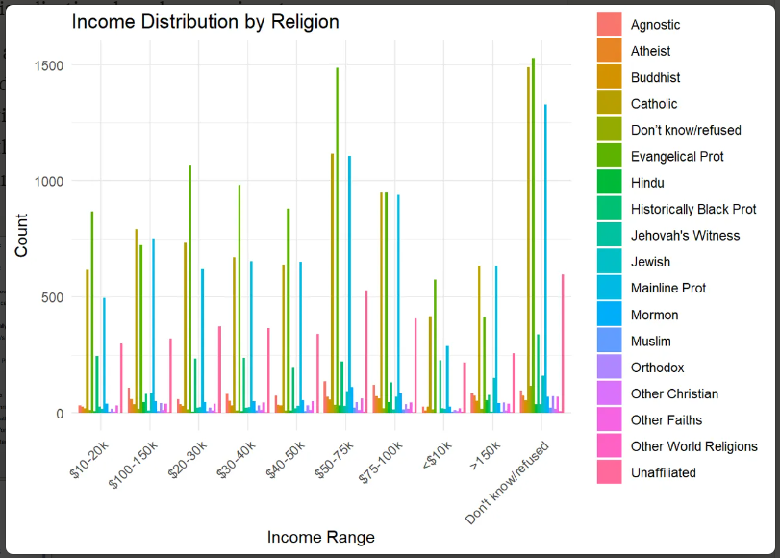

Figure : Income distribution

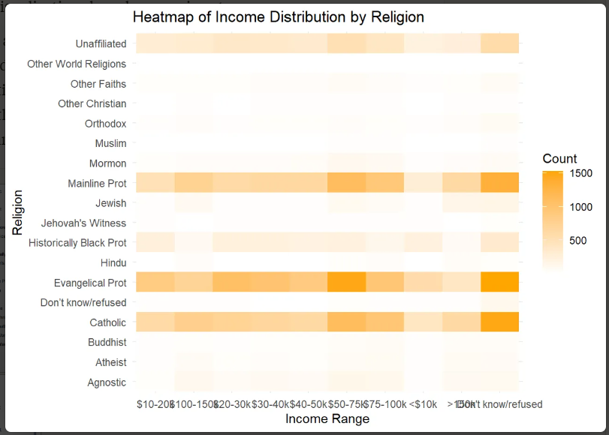

Figure : Income distribuiton by religion heatmap

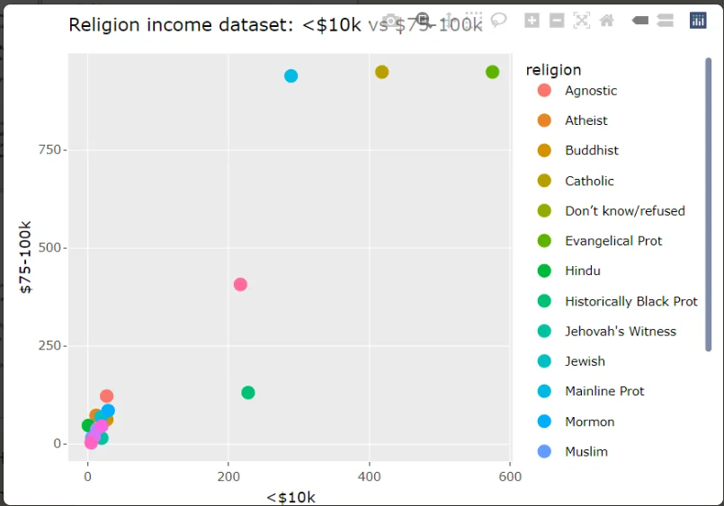

Figure : Religon incoome <$10k vs $75-100k

**Case Study 2: Interactive Analysis of Religious Income Distribution**

Objective: To demonstrate the power of interactive data visualization in exploring and comparing income distributions across different religious groups using a Shiny dashboard.

Data: The dataset used is the "relig_income" dataset, containing information about income ranges for various religious groups.

Dashboard Components:

1. Scatter Plot: Comparing two selected income brackets across religious groups
2. Bar Chart: Showing a comparison of selected income ranges for chosen religions
3. Data Table: Displaying detailed income data for selected religions
4. Interactive Controls: Allowing users to select variables and filter religions

Analysis:

1. Interactive Scatter Plot:
   * The scatter plot compares two income brackets (in this case, $75-100k vs <$10k) for different religious groups.
   * Key observations: a. Most religious groups cluster near the origin, indicating relatively low counts in both extreme income brackets. b. Evangelical Protestants and Catholics stand out with higher counts in both income brackets. c. The plot reveals a general positive correlation between the two income brackets across religions.
2. Dynamic Bar Chart:
   * This chart compares the selected income ranges ($75-100k and <$10k) for the chosen religions.
   * Insights: a. For most religions shown, the count in the $75-100k bracket is higher than in the <$10k bracket. b. Catholic and Evangelical Protestant groups show significantly higher counts in both brackets compared to other religions. c. The chart allows for quick visual comparison of income distribution patterns across selected religions.
3. Interactive Data Table:
   * Provides detailed income data for all brackets for the selected religions.
   * Benefits: a. Allows users to see exact counts for each income bracket. b. Facilitates sorting and searching functionalities for more detailed analysis. c. Complements the visualizations by providing precise numerical data.
4. User Interaction Features:
   * The dashboard allows users to: a. Select different income brackets for the X and Y axes of the scatter plot. b. Choose which religions to include in the analysis. c. Dynamically update all visualizations based on these selections.

Insights and Conclusions:

1. Customizable Comparisons: The ability to select different income brackets for comparison allows users to explore various aspects of income distribution. For example, comparing <$10k with $75-100k reveals disparities between low and high-income representation within religious groups.
2. Religious Group Size Impact: Larger religious groups (e.g., Catholics, Evangelical Protestants) consistently show higher counts across income brackets, which may reflect their larger overall population rather than specific income trends.
3. Income Distribution Patterns: The scatter plot reveals that religions with higher counts in one income bracket tend to have higher counts in others, suggesting that income distribution patterns might be more influenced by group size than by religion-specific economic factors.
4. Flexible Data Exploration: The interactive nature of the dashboard allows for the exploration of specific hypotheses or questions about religious income distribution. Users can focus on particular religions or income ranges of interest.
5. Comparative Analysis: The bar chart facilitates easy comparison between selected religions for chosen income brackets, highlighting relative differences in income distribution across religious groups.
6. Detailed Data Access: The inclusion of a sortable and searchable data table provides access to precise figures, allowing for more detailed analysis beyond visual representations.

Limitations and Further Improvements:

1. Normalization: The current visualization doesn't account for the overall population size of each religious group. Incorporating a normalization feature could provide more accurate comparisons.
2. Additional Demographics: Including other demographic factors (e.g., age, education, geographic location) could provide more context to the income distribution patterns.
3. Trend Analysis: Adding features to visualize trends across all income brackets for selected religions could offer insights into overall income distribution shapes for each group.
4. Statistical Analysis: Incorporating basic statistical measures (e.g., median income, income inequality metrics) could enhance the analytical depth of the dashboard.
5. Improved Visualization Options: Adding more chart types (e.g., box plots, density plots) could provide additional perspectives on the data.

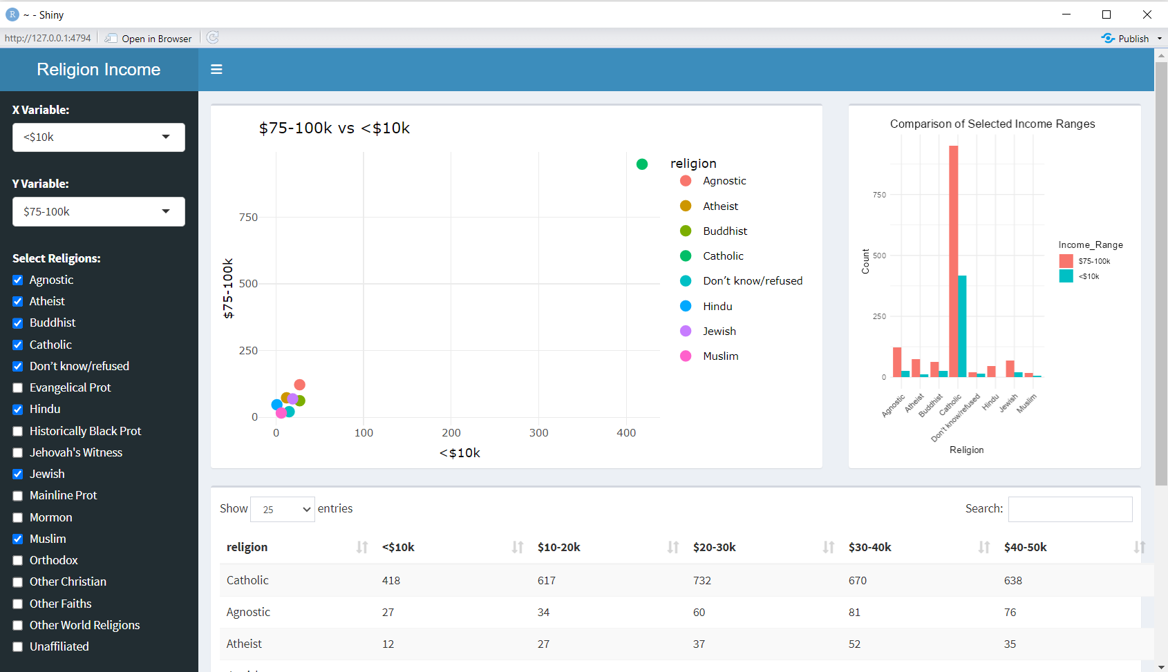

Figure 4: Shiny Dashboard

# 8. Conclusion

Through this investigation, we've explored various advanced data visualization techniques in R, from theoretical foundations to practical applications. The case studies demonstrate how interactive visualizations can provide deep insights into complex datasets like religious income distribution.

Key findings include:

1. The power of interactivity in exploring multidimensional data.
2. The importance of data preparation in creating effective visualizations.
3. The value of comparative visualizations in identifying patterns and trends.

Challenges in data visualization include handling large datasets, ensuring accessibility, and balancing complexity with clarity. Future directions may involve incorporating machine learning techniques for more advanced data exploration and the development of more sophisticated interactive visualization tools.

As data continues to grow in volume and complexity, the role of advanced visualization techniques in R will become increasingly crucial for extracting meaningful insights and driving informed decision-making.