**FeedVey App**

**Bhavya Goyal**

**102203638**

# Contents

1. Introduction
2. System Study and Analysis
3. System Requirements
4. Project Diagram
5. My Learning

# Introduction

This project enables the user to obtain feedback for his/her product.

This app brings the product to various people from different areas and takes the feedback from them and provide it to the manufacturer.

It can be organization or city based and can also work as a source to aware people that a free sample is available for your feedback in the nearby shop.

We ensure that the product is provided to diversified areas and keep account of who has already tried the product. We also try to get some feedbacks from experienced people.

# System Study and Analysis

We took reference from the OLX app and made a layout for our own app. As OLX app provides people a chance to sell as well as buy secondhand products through the app, We allow our users a way to ask as well as receive the feedback.

Our aim is to allow the future entrepreneurs to reach more costumers and make new and better products by using the feedbacks.

# System Requirements

Software Requirements

1. Operating System: Windows 10/11
2. Front-End: Android Studio/Visual Studio Code, Flutter
3. Back-End: MySQL

About Flutter

Flutter is an open source UI software development kit created by Google. It is used to develop cross-platform applications for Android, iOS, Linux, macOS, Windows, Google Fuchsia, and the web from a single codebase.

Flutter apps are written in the Dart language and make use of many of the language’s more advanced features.

Dart is a programming language designed for client development, such as for the web and mobile apps. It is developed by Google and can be used to build server and desktop applications. It is an object-oriented and a class-based language with a syntax similar to that of C.

Hardware Requirements

1. Processor: Intel i3 or later

2. Hard Disk: 512 GB or more

3. RAM: 4GB or more

# Project Diagram

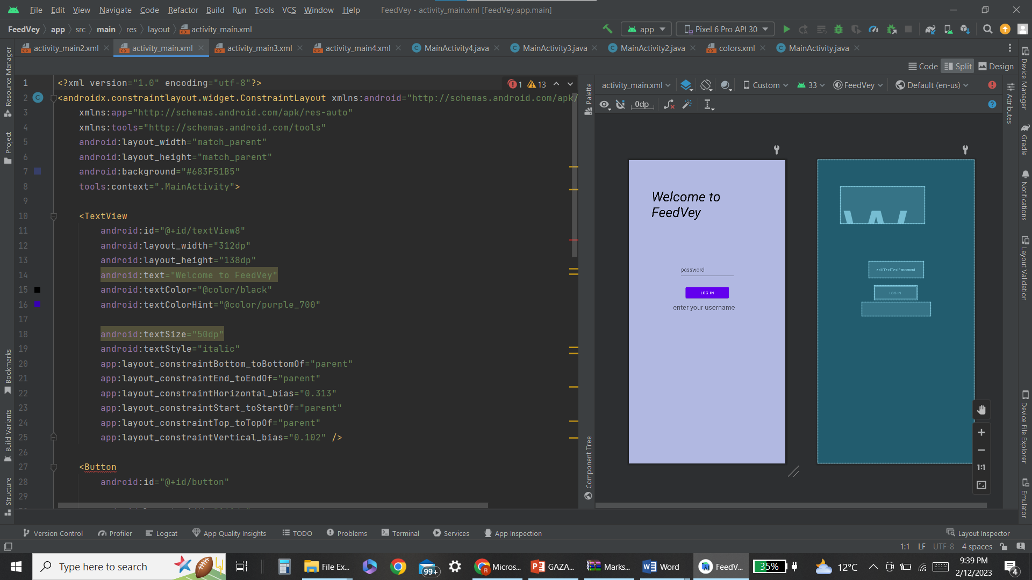

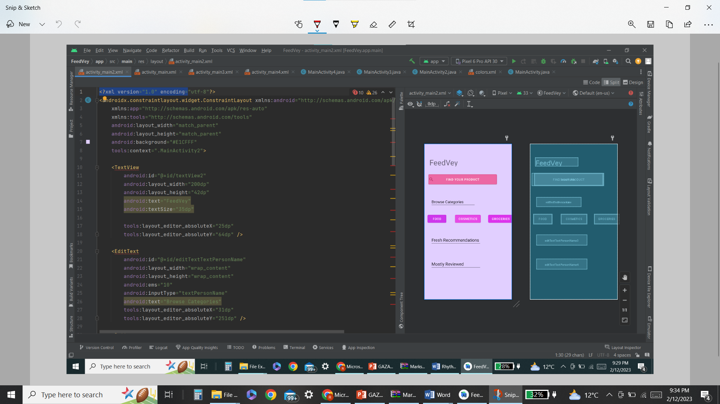

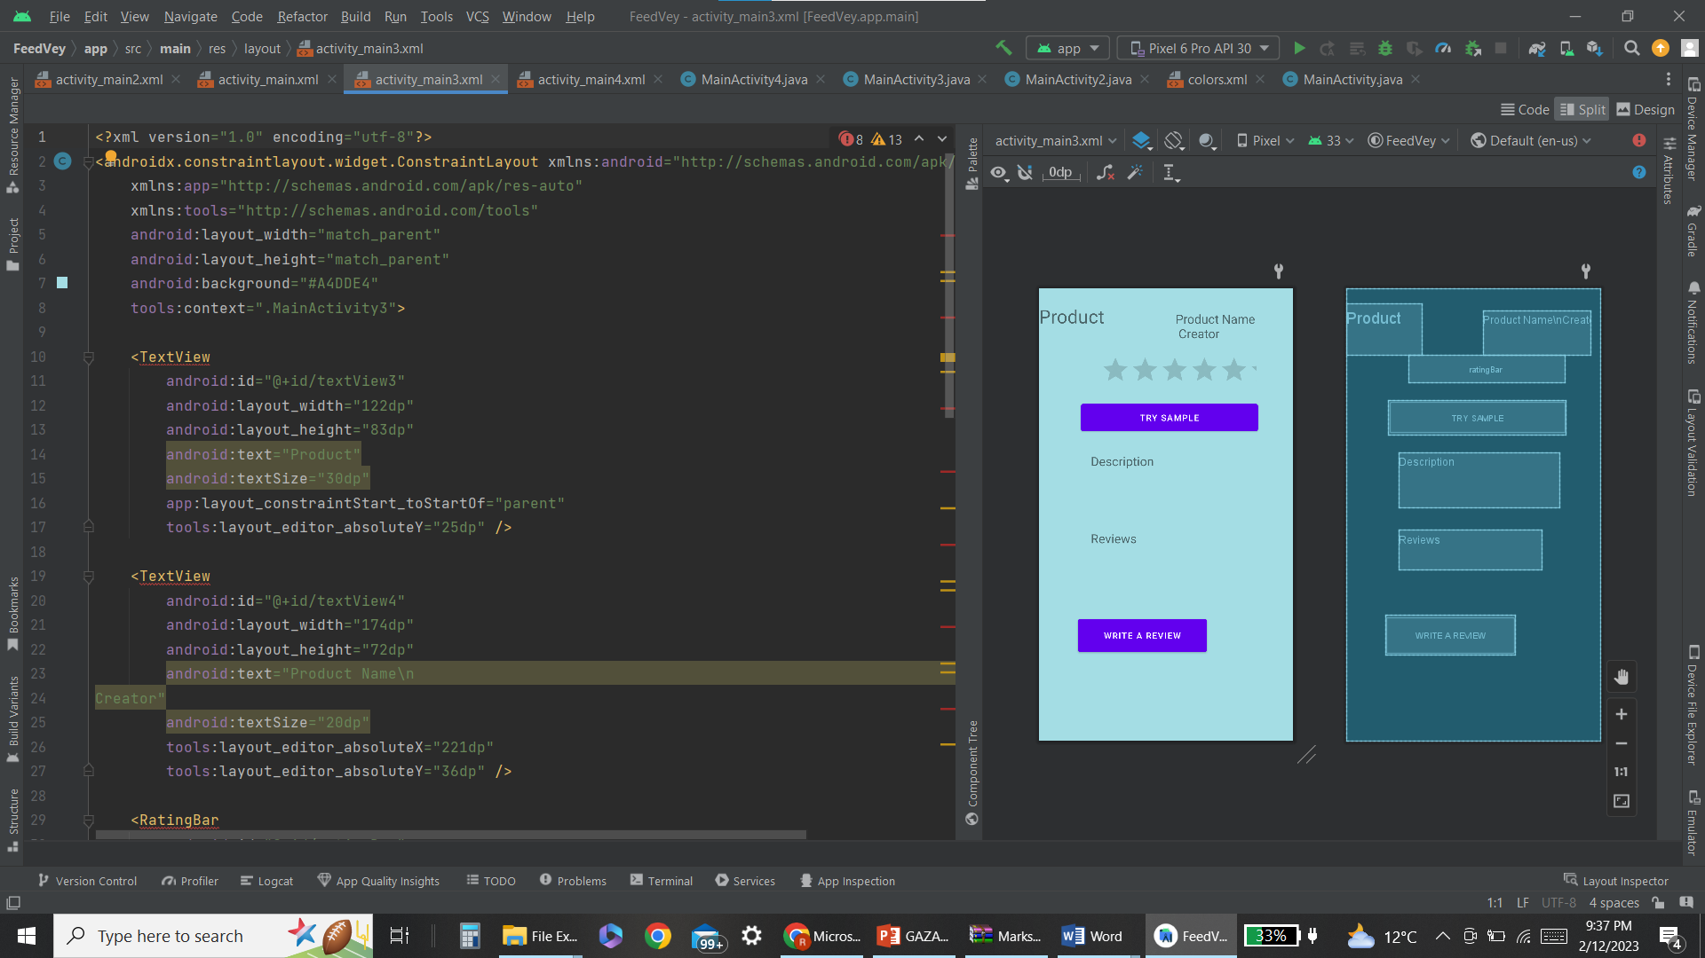

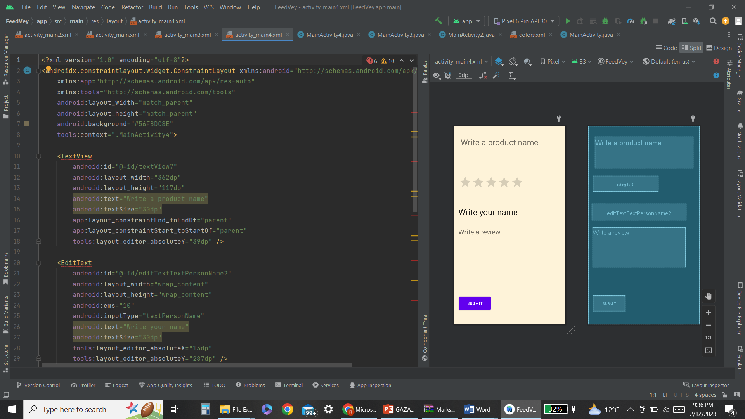

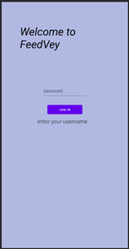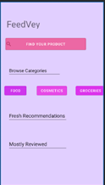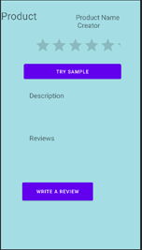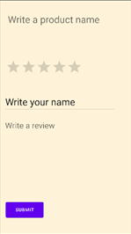

# My Learning

This project has lead me to learn many new things like:

1. How application like flutter and android studio work.
2. How to design a page of an application.
3. How to connect pages with each other.
4. How to work on front-end and back-end separately and connect them with each other.

And there are many more things that I came to know that how basically technology work.

How big companies make application and launch that for users. I would like to learn more things like this.