Signals and Systems (CT 203)

Tutorial Sheet-05 DA-IICT, Gandhinagar.

Problem 1 Consider a linear time-invariant (LTI) system whose response to the signal 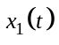 in Fig. 1a is the signal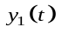in Fig. 1b. Determine and sketch carefully response of the system to the input 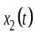 shown in Fig. 1c.
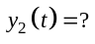
LTI
System
0
1
2
1
(a)
t
Fig.1. A continuous-time LTI system
0
1
2
1
(b)
t
2
0
1
0.5
(c)
t
-1.5
2
3
4

Problem 2. Find the impulse response, 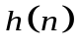 of following systems
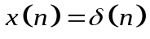
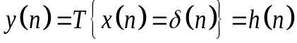
System

Fig.2a. Concept of Impulse Excitation

    - Ideal Delay System, 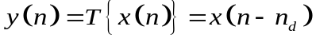
    - Moving Average System,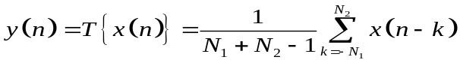
    - Accumulator System, 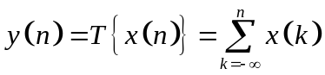
    - Forward Difference system, 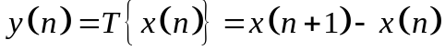
    - Backward Difference system,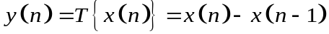
    - Linear interpolator system, 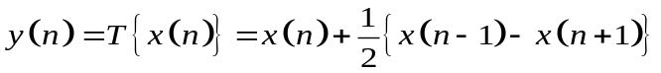

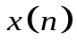
Accumulator
System
Fig.2b. Ideal Delay System

Forward Difference System
Fig.2c. Moving Average (MA) System

Problem 3 Consider an input 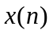 and a unit impulse response 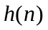 given by,
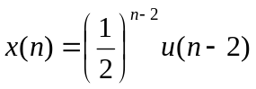
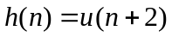

Determine and plot output,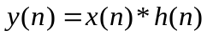.

Problem 4 Let 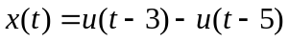 and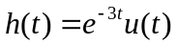, then compute following,
(a) 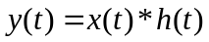
(b) 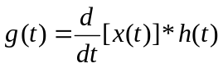
(c) How is 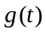 related to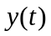 ?

Problem 5Consider a causal LTI system whose input and output 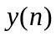 are related by the difference equation. 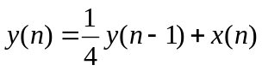 . Determine if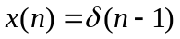.
Problem 6 Let  be the triangular pulse shown in Fig. 1(a) and let  be the impulse train shown in fig.(b)

Fig.1b
h(t)
t
t
-2T
-T
0
T
2T
+1
-1

Fig. 1a
x(t)
Determine and sketch for the following values of T.
(a) T=4 (b) T=2 (c) T=3/2 (d) T=1

