Field Behaviour Observation
Optional Bodily Injury (Optional BI) – Policy-Level Propagation
Policy # | Effective Date | Screen | Field
MCAQ003334 | 04/01/2026 | Vehicle Information | Optional BI

1. Observation
Optional BI does not behave as a vehicle-level field. When the Optional BI limit is changed on Vehicle 1 (Vehicle Information screen), the same value is automatically applied to every other vehicle on the policy and to the Drive Other Car Coverage screen. The field is therefore driven at policy level, even though it is displayed and editable on each individual vehicle screen.

2. Field Details
Attribute | Value | Notes
Screen label | Optional BI | Shown under the "Coverages:" block
Screens where visible | Vehicle Information (all vehicles), Drive Other Car Coverage | Same label on each screen
Control type | Dropdown (split limit) | Displayed as per-claim / per-accident, e.g. 30/60
Value at time of capture | 30/60 | Identical on all three screens
Editable on each screen | Yes | But edit is not isolated to that vehicle
Effective scope | Policy level | Single stored value shared by all vehicles / coverages

3. Screens Affected (pre-change state)
The captures below were taken before the change. All three screens show Optional BI = 30/60.
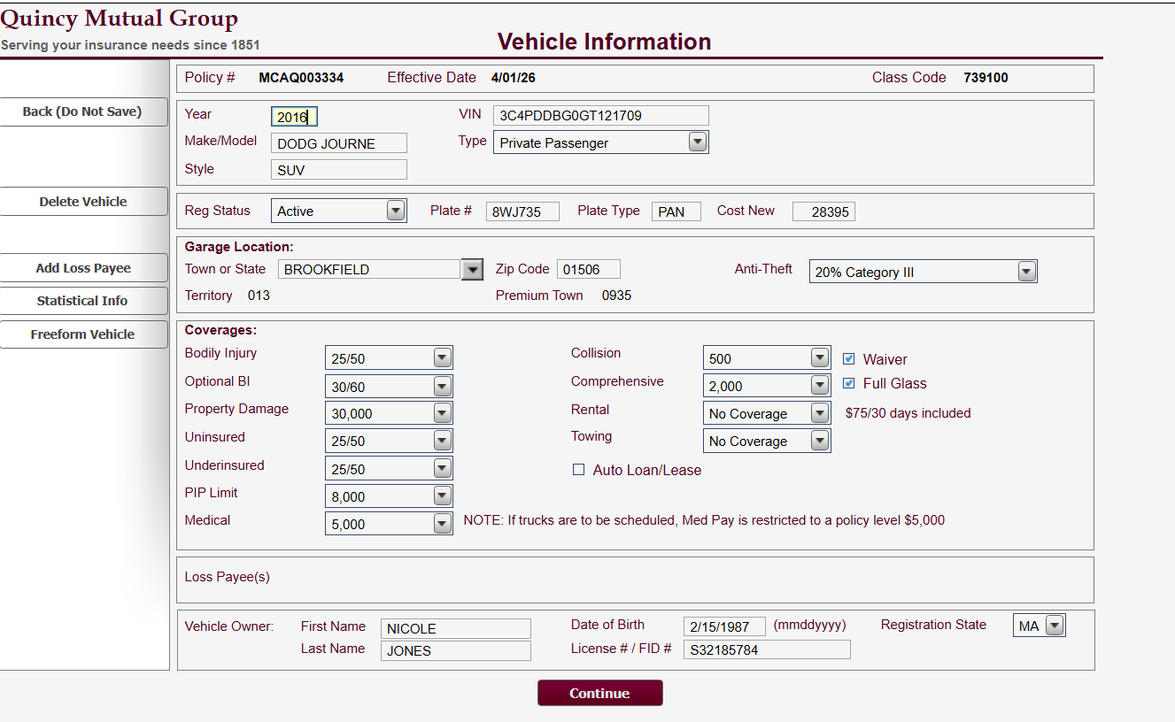
Screenshot 1 – Vehicle 1: 2016 DODG JOURNE (SUV), Class Code 739100 — Optional BI = 30/60
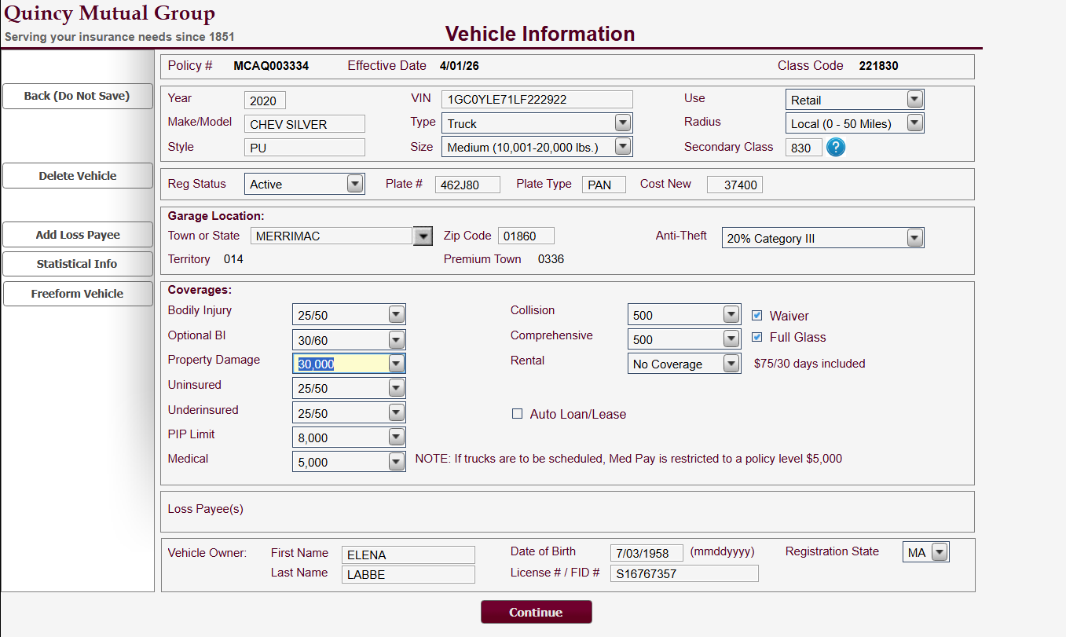
Screenshot 2 – Vehicle 2: 2020 CHEV SILVER (Truck), Class Code 221830 — Optional BI = 30/60
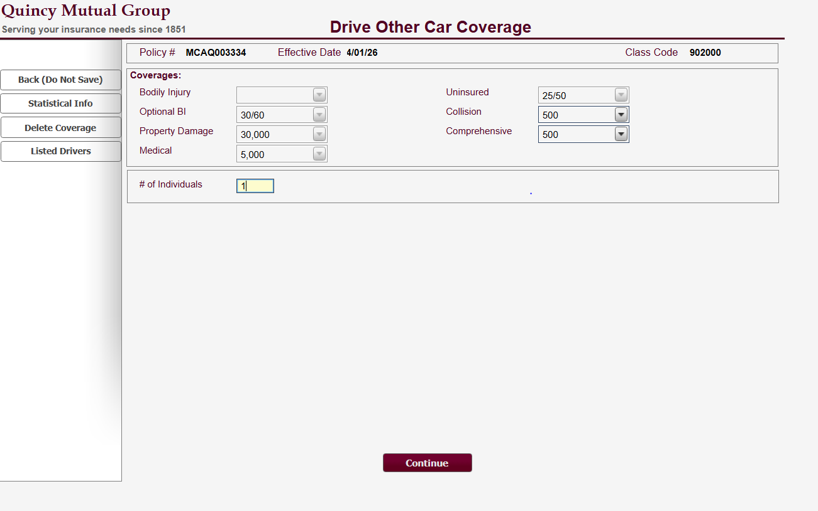
Screenshot 3 – Drive Other Car Coverage, Class Code 902000 — Optional BI = 30/60

4. Steps to Reproduce
- Open policy MCAQ003334 (Effective Date 04/01/26).
- Go to Vehicle Information for Vehicle 1 and note Optional BI = 30/60.
- Change the Optional BI dropdown on Vehicle 1 to a different limit and click Continue.
- Re-open Vehicle Information for Vehicle 2 – Optional BI reflects the new value.
- Open the Drive Other Car Coverage screen – Optional BI also reflects the new value.
Result: the change made on one vehicle is applied across all vehicles and Drive Other Car Coverage. No warning or confirmation message is displayed to the user before the values are overwritten.

5. Impact
- Mapping: Optional BI should be mapped once at policy level, not repeated per vehicle record. A per-vehicle mapping would imply values can differ, which the screen behaviour does not allow.
- Payload construction: sending different Optional BI values for different vehicles in the same request is not a valid scenario and may cause the last value to win silently.
- Split-limit handling: as with other split-limit fields, the displayed value (e.g. 30/60) must be split on "/" and each part stored in its own per-claim / per-accident field after the ×1000 conversion.
- Testing: any test case that sets Optional BI per vehicle needs to be rewritten as a single policy-level test case.
- User experience: because the field is editable on every vehicle screen, a user can unintentionally change the limit for the whole policy while editing one vehicle.

6. Open Questions for Confirmation
# | Question | Status
1 | Is Optional BI stored as a single policy-level value in DB2, or as a value repeated on each vehicle row? | Open
2 | Confirm the DB field name(s) and format for the per-claim and per-accident components of Optional BI. | Open
3 | Is the propagation intended business behaviour, or a screen defect? | Open
4 | Does the same propagation apply to the other split-limit coverages shown per vehicle (Bodily Injury, Uninsured, Underinsured, PIP Limit, Medical, Property Damage)? | Open
5 | If Optional BI is policy level, which value is sent when vehicles are added or deleted mid-term? | Open
6 | Should the screen display Optional BI as read-only on vehicles other than the first, or move it to the Policy Information screen? | Open
Post-change screenshots to be attached once the updated values are captured.

