**Electric Vehicle-to-Vehicle Energy Transfer Using On-Board Converters**

**Objective:** The main objective of this project is to transfer Energy from electric vehicle to vehicle by using on-board converters.

**Abstract:** In this project, a V2V approaches with an off-board power-sharing interface add extra space and cost for EV users. Furthermore, V2V power transfer using on-board type-2 chargers reported in the literature is not efficient due to redundant conversion stages. This article proposes a new method for V2V power transfer by directly connecting the two EV batteries together for sharing energy through the type-2 ac charger input ports and switches. The active rectifiers of on-board type-2 chargers are not used for rectification during V2V charging, instead only a few switches are used as interfaces to connect the two EV batteries together, to avoid redundant power conversion and associated losses which effectively improve the overall V2V efficiency. The possible V2V charging scenarios of the proposed V2V approach are validated using a MATLAB/Simulink simulation study. a scaled experimental prototype is developed to validate the proposed V2V method practically. the simulation results can be evaluated by using MATLAB/Simulink Software.

**Keywords:** Electric vehicle (EV), on-board type-2 ac charger, vehicle-to-vehicle (V2V) charging, battery, DC-DC Converter.

**Existing System:** In the existing system, on-board chargers, an off-board V2V charger, dc fast-charging stations with respect to charging time, power density, power level, cost, and review of recent typologies for conventional and future charging methods.

**Disadvantages:**

* Higher efficiency
* High cost
* Power losses

**Proposed System:** In the proposed system, a new method for V2V power transfer by directly connecting the two EV batteries together for sharing energy through the type-2 ac charger input ports and switches. The active rectifiers of on-board type-2 chargers are not used for rectification during V2V charging, instead only a few switches are used as interfaces to connect the two EV batteries together, to avoid redundant power conversion and associated losses which effectively improve the overall V2V efficiency.

**Project Block Diagram:**

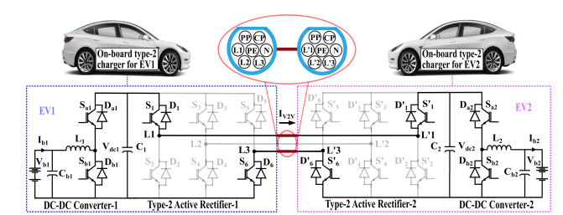**Fig. Proposed topology for V2V operation.**

**Advantages:**

* Improved power density of EV Charger
* Range extension
* compatibility

**Applications:**

* Electric Vehicle charging applications
* Regenerative energy Sharing
* Balancing Grid Load

**Software & Hardware Requirements:**

**Software Configuration:**

Operating System : Windows 7/8/10

Application Software: Matlab / Simulink

**Hardware Configuration:**

RAM : 8 GB

Processor : I3 / I5 (Mostly prefer)

**Learning Outcomes:**

* Introduction to Matlab/Simulink
* What is EISPACK & LINPACK
* How to start with MATLAB
* About Matlab language
* About tools & libraries
* Application of Matlab/Simulink
* About Matlab desktop
* Features of Matlab/Simulink
* Basics on Matlab/Simulink
* Introduction to Electrical Drives
* Introduction to Electrical vehicles
* Introduction to bidirectional converter
* Introduction to Voltage Source Converters (VSC)
* Project Development Skills:
  + Problem analyzing skills
  + Problem solving skills
  + Creativity and imaginary skills
  + Programming skills
  + Deployment
  + Testing skills
  + Debugging skills
  + Project presentation skills
  + Thesis writing skills