**Electric Vehicle-to-Vehicle Energy Transfer Using On-Board Converters**

**Abstract:** Electric vehicle-to-vehicle (V2V) charging is a recent approach for sharing energy among electric vehicles (EVs). Existing V2V approaches with an off-board power-sharing interface add extra space and cost for EV users. Furthermore, V2V power transfer using on-board type-2 chargers reported in the literature is not efficient due to redundant conversion stages. This article proposes a new method for V2V power transfer by directly connecting the two EV batteries together for sharing energy through the type-2 ac charger input ports and switches. The active rectifiers of on-board type-2 chargers are not used for rectification during V2V charging, instead only a few switches are used as interfaces to connect the two EV batteries together, to avoid redundant power conversion and associated losses which effectively improve the overall V2V efficiency. The possible V2V charging scenarios of the proposed V2V approach are validated using a MATLAB/Simulink simulation study. Furthermore, a scaled experimental prototype is developed to validate the proposed V2V method practically.

**Index Terms:** Electric vehicle (EV), on-board type-2 ac charger, vehicle-to-vehicle (V2V) charging

**CHAPTER-1**

**INTRODUCTION**

THE electric vehicle (EV) charging is conventionally done through type-1 and -2 (single/three-phase) ac on-board slow chargers with the power range of 3.3–19.4 kW. A comprehensive review of bidirectional topologies with single/two stage rectification with power factor correction for on-board chargers in the commercial EVs is discussed in [1] and [2]. Detailed comparison of type-1, -2, and the dc fast-charging stations with respect to charging time, power density, power level, cost, and review of recent typologies for conventional and future charging methods is discussed in [3] and [4]. Furthermore, high power (>50 kW) external off-board dc fastcharging stations are established to charge EV batteries, with a charging time of less than an hour [5]. In spite of these conventional EV charging methods, the EV users are experiencing range anxiety due to limited charging infrastructure [6].

In recent days, vehicle-to-vehicle (V2V) charging is emerging as an alternate method to share energy between two EVs, in the case of non-availability of both the ac grid and the dc fast-charging stations. The V2V charging allows EV users to cooperatively share energy with each other with minimum infrastructure and cost and reduce range anxiety. Mainly there are two aspects to V2V energy sharing: first, the communication aspects of V2V, which provides a platform for EV users to interact with each other to find the energy sharing match, to decide provider and receiver preferences, and tariff. In [7]–[10] game theory-based algorithms to match the receiver EV, provider EV, the nearest meeting point, and the communication aspects of the V2V are presented.

The second important aspect of V2V is the power interface for the actual power transfer, that is, controlling the direction of power flow based on the receiver and provider preference, and a buck or boost conversion based on the EV battery’s voltage level. Using the ac power grid as a common energy aggregator with off-board bidirectional power converters for accomplishing an indirect V2V energy transfer is one of the basic V2V approaches presented in [11] and [12] where the conversion efficiency is low due to multiple redundant conversion stages. An off-board V2V charger using an off-board bidirectional interleaved dc–dc converter with a possibility of integration to the grid is presented in [13]. Similar V2V charging approaches with an off-board power interface are presented in [14] and [15].

Similarly, a commercial 50 kW off-board V2V charger from Andromeda Power is available in the market to share energy between two EVs [16], [17]. But this off-board V2V approach requires an external V2V interface which may result in extra cost and car space for the EV users.

On the other hand, V2V approaches by re-utilizing the on-board type-1 and -2 chargers as power interfaces are presented in [18] and [19]. Basically, the on-board type-1 and -2 chargers consist of an ac to dc converter (active rectifier) stage followed by a dc–dc converter [for constant current and constant voltage (CCCV) charge control]. In [18], a V2V charging approach by connecting the type-1 charger input ports of the two EVs is presented as shown in Fig. 1(a), wherein the provider EV battery dc output is first converted into single-phase ac using the bidirectional two-stage on-board type-1 ac charger. This ac power output of the provider EV is fed as input to the two-stage on-board type-1 converter to charge the receiver EV battery. Cascaded converter losses due to redundant conversion stages lead to lower V2V charging efficiency in [18]. In [19], V2V charging by directly connecting the dc-link of the two EVs using mechanical switches is presented as shown in Fig. 1(b). However, practically, there is no direct access to the dc-link of battery side dc–dc converters for establishing the presented direct connection. Thus, the V2V approach presented in [19] is not a practically feasible solution without customized design modifications and additional charging ports for bringing out the dc-link terminals of the two EVs.

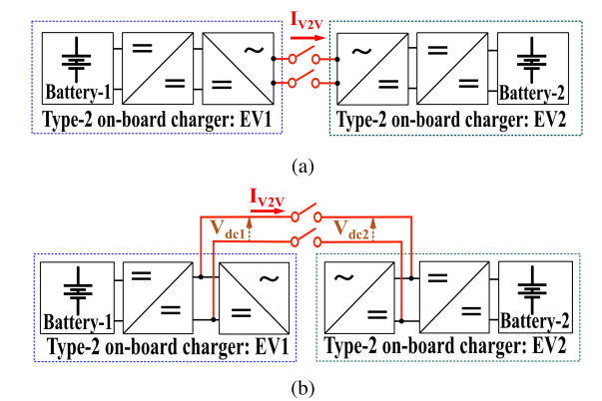

**Fig. 1. V2V operations: (a) ac V2V operation and (b) dc V2V operation.**

This article proposes a V2V charging approach for EVs through the on-board type-2 chargers by directly connecting the on-board type-2 power inlet ports, which eliminates the need for external hardware or additional power inlet ports for V2V operation. Furthermore, the proposed V2V approach utilizes the active rectifier stages as a connection interface to connect two EV batteries which in turn reduces the total conversion stages in the V2V energy transfer path. Reduced conversion stages reduce the overall active switches contributing to switching and conduction losses which significantly increases the efficiency. In the proposed V2V approach, mode selection logic is presented to decide buck/boost operating modes, based on the battery voltage levels and the power flow direction, based on the EV user’s preference. Control of power flow in either direction provides greater flexibility for the EV users to be a provider or receiver irrespective of the difference in both EV battery voltage ratings. The proposed approach of connecting the two EV batteries through on-board active rectifier switches eliminates the need for an off-board V2V interface unlike [16], additional contactor switches in contrast to [19], redundant power transfer stages compared to [18], and associated losses that improve the overall V2V efficiency.

The rest of the article is structured as follows. In Section II, the power converter configuration and its operating modes for possible V2V modes of the proposed approach are discussed. The control scheme for the proposed V2V approach is described in Section III. Performance improvement of the proposed V2V with respect to efficiency and other aspects are discussed in detail in Section IV in addition to simulation results. The experimental validation of the proposed V2V approach with a scaled lab prototype is discussed in Section V. Finally, the article is concluded in Section VI.

**Literature survey:**

* **J. Yuan, L. Dorn-Gomba, A. D. Callegaro, J. Reimers, and A. Emadi,** The fast development of electric vehicles (EVs) provides significant opportunities to further utilize clean energies in the automotive. On-board chargers (OBCs) are widely used in EVs because of their simple installation and low cost. Limited space in the vehicle and short charging time require an OBC to be power-dense and highly efficient. Moreover, the possibility for EVs to deliver power back to the grid has increased the interest in bidirectional power flow solutions in the automotive market. This paper presents a comprehensive overview and investigation on the state-of-the-art solutions of bidirectional OBCs. It reviews the current status, including architectures and configurations, smart operation modes, industry standards, major components, and commercially available products. A detailed overview of the promising topologies for bidirectional OBCs, including two-stage and single-stage structures, is provided. Future trends and challenges for topologies, wide bandgap technologies, thermal management, system integration, and wireless charging systems are also discussed in this paper.
* **M. Y. Metwly, M. S. Abdel-Majeed, A. S. Abdel-Khalik, R. A. Hamdy, M. S. Hamad, and S.** Ahmed, Integrated on-board battery chargers (OBCs) have been recently introduced as an optimal/elegant solution to increase electric vehicle (EV) market penetration as well as minimize overall EV cost. Unlike conventional off-board and on-board battery chargers, integrated OBCs exploit the existing propulsion equipment for battery charging without extra bulky components and/or dedicated infrastructure. OBCs are broadly categorized into three-phase and single-phase types with unidirectional or bidirectional power flow. This paper starts with surveying the main topologies introduced in the recent literature employing either induction or permanent magnet motors to realize fully integrated slow (single-phase) and fast (three-phase) on-board EV battery charging systems, with emphasis on topologies that entail no or minimum hardware reconfiguration. Although, permanent magnet (PM) motors with conventional double-layer distributed winding layouts have been deployed in most commercial EV motors, the non-overlapped fractional slot concentrated winding (FSCW) has been the prevailing choice in the most recent permanent magnet motor designs due to its outstanding operational merits. Hence, a thorough investigation of the impact different FSCW stator winding designs have on machine performance under the charging process is presented in this paper. To this end, the induced magnet losses, which represent a challenging demerit of the FSCW, have been used to compare different topologies under both propulsion and charging operation modes. Based on the introduced comparative study, the optimal slot/pole combinations that correspond to the best compromise under both operational modes have been highlighted.
* **Khaligh and M. D’Antonio,** This paper provides a comprehensive review and analyses on the state-of-the-art and future trends for high-power conductive on-board chargers (OBCs) for electric vehicles. To provide a global context, a summary of global charging standards and electric vehicle (EV) related trends are presented, which demonstrates momentum toward the OBCs with higher power rating. High-power OBCs are either unidirectional or bidirectional, and they have either an integrated or non-integrated system architecture. Non-integrated high-power OBCs are studied both from industry and academia, and the former are used to illustrate the current state of the art. The latter are classified on the basis of the converter design approach, studied for their principle of operation, and compared over power density, weight, efficiency, and other metrics. In addition to non-integrated OBCs, recent advancements in propulsion-machine integrated OBC solutions are also presented. Other integrated OBC techniques, such as system integration with the EV's auxiliary power module and wireless charging systems, are also discussed. Finally, future charging strategies and functionalities in charging infrastructures are addressed, and global OBC trends are summarized.
* **V. T. Tran, D. Sutanto, and K. M. Muttaqi,** Electric vehicle battery (EVB) charger topologies play a vital role to increase the penetration of EVs. This paper reviews the status quo of EV battery (EVB) chargers in term of converter topologies, operation modes, and power control strategies for EVs. EVB Chargers are classified based on their power levels and power flow direction. Referring to power ratings, EV chargers can be divided into Level 1, Level 2 and Level 3. Level 1 and Level 2 are normally compatible with on-board chargers while Level 3 is used for an off-board charger. Unidirectional/ bidirectional power flow can be obtained at all power levels. However, bidirectional power flow is usually designed for Level 3 chargers as it can provide the huge benefit of transferring power back to grid when needed. Moreover, the different operation modes of an EVB charger are also presented. There are two main modes: Grid-to-Vehicle (V1G or G2V) and Vehicle-to-Grid (V2G). The V2G mode helps bring EV batteries to become active distributed sources in smart grids and is the crucial solution for a high EV penetration. Future trend and authors' recommendations with preliminary simulation and experimental results are demonstrated in this paper.
* **M. R. Khalid, I. A. Khan, S. Hameed, M. S. J. Asghar, and J.-S. Ro,** The penetration of electric vehicles (EVs) in the transportation sector is increasing but conventional internal combustion engine (ICE) based vehicles dominates. To accelerate the adoption of EVs and to achieve sustainable transportation, the bottlenecks need to be elevated that mainly include the high cost EVs, range anxiety, lack of EV charging infrastructure, and the pollution of the grid due to EV chargers. The high cost of EVs is due to costly energy storage systems (ESS) with high energy density. This paper provides a comprehensive review of EV technology that mainly includes electric vehicle supply equipment (EVSE), ESS, and EV chargers. A detailed discussion is presented on the state-of-the-art of EV chargers that include on-/off-board chargers. Different topologies are discussed with low-/high-frequency transformers. The different available power levels for charging are discussed. To reduce the range anxiety the EV chargers based on inductive power transfer (IPT) are discussed. The last part of the paper focuses on the negative impact of EV chargers along with the remedies that can be adopted. The international standards decided by different institutions and adopted universally are discussed in the latter part of this paper and finally, this paper concludes with the near to future advancement in EV technology.
* **M. Yilmaz and P. T. Krein,** This paper reviews the current status and implementation of battery chargers, charging power levels, and infrastructure for plug-in electric vehicles and hybrids. Charger systems are categorized into off-board and on-board types with unidirectional or bidirectional power flow. Unidirectional charging limits hardware requirements and simplifies interconnection issues. Bidirectional charging supports battery energy injection back to the grid. Typical on-board chargers restrict power because of weight, space, and cost constraints. They can be integrated with the electric drive to avoid these problems. The availability of charging infrastructure reduces on-board energy storage requirements and costs. On-board charger systems can be conductive or inductive. An off-board charger can be designed for high charging rates and is less constrained by size and weight. Level 1 (convenience), Level 2 (primary), and Level 3 (fast) power levels are discussed. Future aspects such as roadbed charging are presented. Various power level chargers and infrastructure configurations are presented, compared, and evaluated based on amount of power, charging time and location, cost, equipment, and other factors.

**CHAPTER-2**

**ELECTRIC VEHICLES**

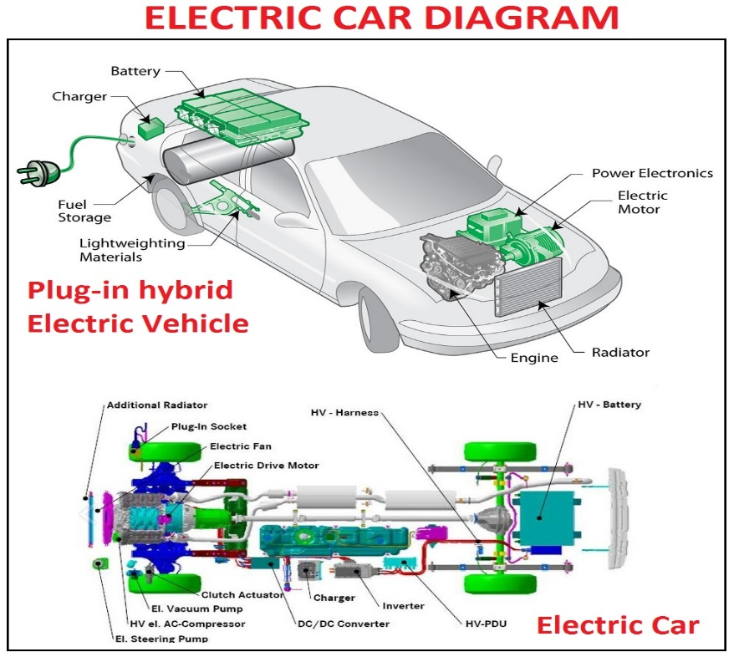

**Fig. Electric Vehicle**

**INTRODUCTION**

Electric vehicles (EVs) have a surprisingly long history that dates back to the early 19th century. The first electric vehicle was invented by Scottish inventor Robert Anderson in 1832, which used non-rechargeable primary cells. However, the first practical electric vehicle was not developed until the late 1800s.

In 1884, Thomas Parker, a British inventor, built the first practical electric car, which used lead-acid batteries and had a range of about 48 kilometers. By the turn of the century, electric cars were becoming increasingly popular, particularly in urban areas, as they were quiet, easy to operate, and did not produce exhaust emissions.

However, the invention of the gasoline-powered internal combustion engine and the mass production of automobiles by companies such as Ford quickly made gasoline-powered cars more affordable and popular. As a result, the popularity of electric cars declined, and they became a niche product.

In the 1970s, the oil crisis led to renewed interest in electric vehicles as a way to reduce reliance on imported oil. This led to the development of several new electric cars, including the General Motors EV1, which was introduced in the 1990s.

In the 2000s, advances in battery technology and the need to reduce greenhouse gas emissions from transportation led to a renewed interest in electric vehicles. Companies such as Tesla, Nissan, and General Motors began to produce modern electric cars with longer ranges and better performance.

Today, Electric cars are gaining more popularity and becoming more widespread, as numerous nations worldwide establish goals to eliminate petrol-fueled vehicles in the forthcoming years. The history of electric vehicles shows that while their popularity has waxed and waned over the years, they have the potential to be an important part of the transition to a more sustainable and low-carbon transportation system

**What is the need of EVs?**

Electric vehicles (EVs) are needed for several reasons:

**Environmental concerns:** EVs have the potential to reduce greenhouse gas emissions and improve air quality. They produce zero emissions at the tailpipe, which can help reduce the harmful effects of air pollution on human health and the environment.

**Energy security:** EVs can help reduce a country's dependence on foreign oil and increase energy security by using domestically-produced electricity.

**Economic benefits:** The production of EVs can create jobs in the manufacturing and supply chain sectors. Additionally, EVs have lower operating costs than traditional gasoline-powered vehicles, which can save consumers money in the long run.

**Technological innovation:** The development of EVs has spurred technological innovation in battery technology, charging infrastructure, and other related fields. This innovation can lead to new and improved products and services that benefit society as a whole.

Overall, EVs are an important tool for addressing climate change, improving air quality, enhancing energy security, and promoting economic development and technological innovation.

**Working of EVs**

Electric vehicles (EVs) operate using an electric motor and a rechargeable battery instead of an internal combustion engine. The battery stores electrical energy that powers the motor, which turns the wheels and propels the vehicle forward.

The process of powering an EV starts with plugging the vehicle into an electrical outlet or a charging station. The battery is charged using electricity from the grid, which is converted into direct current (DC) power and stored in the battery.

When the driver wants to move the vehicle, they activate the accelerator pedal. This sends a signal to the controller, which determines how much power to send from the battery to the motor. The motor then converts the electrical energy from the battery into mechanical energy, which turns the wheels and moves the vehicle forward.

As the vehicle moves, the battery gradually discharges, and the range of the vehicle decreases. When the battery level drops below a certain point, the driver needs to recharge the battery using a charging station or electrical outlet.

Regenerative braking is another important feature of many EVs. When the driver brakes, the motor acts as a generator and converts some of the vehicle's kinetic energy back into electrical energy, which is then used to recharge the battery. This helps to extend the range of the vehicle and improve overall energy efficiency.

**Types of EVs**

Electric vehicles (EVs) are vehicles that are powered by electric motors and batteries rather than by internal combustion engines that burn fossil fuels. There are several different types of EVs, including:

**Battery Electric Vehicles (BEVs):** These vehicles are powered solely by electricity and have no internal combustion engine. They are charged by plugging them into an external power source, such as an EV charging station, and can travel for hundreds of kilometers on a single charge.

**Hybrid Electric Vehicles (HEVs):** These automobiles are equipped with both an electric motor and an internal combustion engine that runs on gasoline. The electric motor provides assistance to the engine during acceleration and at lower speeds, resulting in improved fuel efficiency and reduced emissions.

**Plug-in Hybrid Electric Vehicles (PHEVs):** These vehicles are similar to HEVs, but they have larger batteries that can be charged by plugging them into an external power source. They can travel for a short distance on electric power alone before the engine takes over.

**Fuel Cell Electric Vehicles (FCEVs):** These automobiles employ hydrogen fuel cells to generate electricity that drives their electric motors. They produce no emissions other than water vapor.

Electric vehicles offer several advantages over traditional gasoline-powered vehicles, including:

**Zero tailpipe emissions:** EVs produce no exhaust emissions, making them much cleaner and less polluting than gasoline-powered vehicles.

**Lower operating costs:** Electric motors are more efficient than internal combustion engines, meaning that EVs are cheaper to operate and maintain.

**Reduced dependence on oil:** Electric vehicles can be powered by a variety of sources, including renewable energy sources like solar and wind power, reducing dependence on oil and other fossil fuels.

**Quiet and smooth:** Electric motors produce very little noise and vibration, making EVs quieter and smoother to drive than traditional vehicles.

**Performance benefits:** Electric motors provide instant torque, meaning that EVs can be very quick and responsive, and can offer a smooth and enjoyable driving experience.

Overall, electric vehicles are becoming an increasingly popular and important part of the transition to a more sustainable and low-carbon transportation system

**ADVANTAGES**

Electric vehicles (EVs) offer several advantages over traditional gasoline-powered vehicles, including:

**Zero tailpipe emissions:** EVs produce no exhaust emissions, making them much cleaner and less polluting than gasoline-powered vehicles. This can help to improve air quality and reduce the impact of transportation on public health and the environment.

**Lower operating costs:** Electric motors are more efficient than internal combustion engines, meaning that EVs are cheaper to operate and maintain. EVs also have fewer moving parts, which can reduce the need for maintenance and repairs.

**Reduced dependence on oil:** Electric vehicles can be powered by a variety of sources, including RES like solar and wind power, reducing dependence on oil and other fossil fuels. This can help to improve energy security and reduce the risk of price volatility associated with oil.

**Quiet and smooth:** Electric motors produce very little noise and vibration, making EVs quieter and smoother to drive than traditional vehicles. This can provide a more enjoyable driving experience and reduce noise pollution in urban areas.

**Performance benefits:** Electric motors provide instant torque, meaning that EVs can be very quick and responsive, and can offer a smooth and enjoyable driving experience. EVs can also be designed with a low center of gravity, which can improve handling and stability.

**Cost savings:** In many cases, EVs can provide significant cost savings over the lifetime of the vehicle. Although they may have a higher purchase price.

**APPLICATIONS**

Electric vehicles (EVs) have several applications and benefits, including:

**Personal transportation**: Electric cars, trucks, and motorcycles are increasingly being used as a primary means of transportation for individuals and families. EVs offer a more sustainable and environmentally friendly option compared to traditional gasoline-powered vehicles.

**Public transportation:** Many cities are adopting electric buses and trains as a way to reduce emissions and improve air quality. EVs can also provide a quieter and more comfortable ride for passengers.

**Commercial transportation:** Electric trucks and vans are becoming more common in commercial fleets, especially for last-mile delivery and urban transportation. Electric vehicles can offer lower operating costs and reduced maintenance needs, making them an attractive option for businesses.

**Renewable energy integration:** EVs can serve as a means of storing excess RES like wind and solar power. This helps to balance the grid and ensure a reliable supply of energy.

**Emergency services:** Electric vehicles are being used by emergency services like police, fire, and ambulance services. EVs offer fast and quiet response times, making them well-suited for urban environments.

**Agriculture and mining:** Electric tractors and mining equipment are becoming more common in these industries, offering a quieter and more sustainable option compared to traditional diesel-powered equipment.

Overall, the applications of EVs are diverse and offer a range of benefits, including reduced emissions, lower operating costs, and improved energy security.

**CHAPTER-3**

**BUCK-BOOST CONVERTER**

**HISTORY**

The buck-boost converter is a type of DC-DC converter that can step up or step down an input voltage to obtain a different output voltage. It is widely used in electronic devices to regulate voltage levels and power consumption.

The history of the buck-boost converter can be traced back to the early 1900s when the first DC-DC converters were developed. However, it was not until the 1960s that the first commercial buck-boost converter was introduced. The early designs of the buck-boost converter were relatively simple and consisted of a transformer, a diode, and a capacitor.

In the 1970s, new advances in semiconductor technology led to the development of more efficient and reliable buck-boost converters. The use of power MOSFETs and bipolar transistors enabled higher switching frequencies and better control over the converter's output. The 1980s saw the introduction of integrated circuits (ICs) specifically designed for buck-boost converters, further improving their performance and reducing their cost.

In recent years, the buck-boost converter has become increasingly popular in battery-powered devices such as smartphones, tablets, and laptops. The converter's ability to step up or step down voltage levels makes it an ideal solution for managing battery power and extending battery life. Newer designs of the buck-boost converter also incorporate advanced control algorithms, which enable faster response times and better efficiency.

Overall, the buck-boost converter has a long and rich history of development, and its continued evolution will undoubtedly play an essential role in the future of power electronics.

**WHAT IS BUCK-BOOST CONVERTER**

A buck-boost converter is a type of DC-DC converter that can either step up or step down the input voltage to obtain a different output voltage. This is achieved by controlling the duty cycle of a switch (usually a transistor) that is connected to an inductor and a capacitor.

When the switch is closed, the inductor stores energy from the input voltage, and when the switch is open, the inductor releases the stored energy into the output circuit. By adjusting the duty cycle of the switch, the converter can regulate the output voltage.

The buck-boost converter is widely used in electronic devices to regulate voltage levels and power consumption. It is particularly useful in battery-powered devices such as smartphones, laptops, and tablets, where the input voltage can vary significantly depending on the battery's charge level.

Compared to other DC-DC converters, the buck-boost converter has the advantage of being able to operate over a wider input voltage range, making it more versatile in many applications. It also has a relatively simple circuit design, making it a cost-effective solution for many applications.

**WHAT IS THE NEED OF BUCK-BOOST CONVERTER**

The need for a buck-boost converter arises when a DC voltage source needs to be converted to a different voltage level for a particular application. This is required in many electronic devices where the input voltage can vary, or where the output voltage needs to be different from the input voltage.

For example, in battery-powered devices such as smartphones or laptops, the battery voltage can vary depending on its charge level. A buck-boost converter can be used to maintain a stable output voltage, regardless of the battery's charge level. In this case, the buck-boost converter can step up or step down the battery voltage as needed to maintain a stable output voltage.

In other applications, such as LED lighting or motor control, the input voltage may be fixed, but the output voltage needs to be different. A buck-boost converter can be used to step up or step down the input voltage to the required output voltage level.

Overall, the need for a buck-boost converter arises when there is a requirement to convert a DC voltage source to a different voltage level, and a versatile and cost-effective solution is needed. The buck-boost converter's ability to step up or step down the input voltage makes it a popular choice in many applications where a stable output voltage is required.

**WORKING**

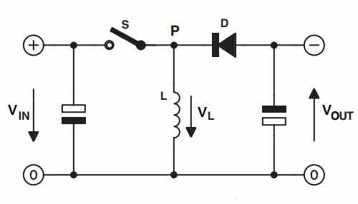

**Fig. buck-boost converter**

The working of a buck-boost converter can be explained in the following steps:

During the first half of the switching cycle, the switch (usually a transistor) is turned on, allowing current to flow from the input voltage source through the inductor.

As the current flows through the inductor, it stores energy in its magnetic field, which causes the current to increase gradually.

During the second half of the switching cycle, the switch is turned off, causing the inductor's magnetic field to collapse. The collapsing magnetic field causes the inductor to generate a voltage that opposes the input voltage.

The voltage generated by the inductor charges the output capacitor and provides a constant voltage to the load.

The switch is then turned back on, and the cycle repeats.

By adjusting the duty cycle of the switch, the buck-boost converter can regulate the output voltage. If the duty cycle is less than 50%, the converter operates in step-down mode, where the output voltage is less than the input voltage. If the duty cycle is greater than 50%, the converter operates in step-up mode, where the output voltage is greater than the input voltage.

The inductor and capacitor in the buck-boost converter act as energy storage devices, allowing the converter to provide a stable output voltage even when the input voltage varies. The converter's efficiency can be improved by using high-frequency switching and optimizing the inductor and capacitor values to reduce losses.

Overall, the buck-boost converter provides a versatile and cost-effective solution for converting DC voltage sources to different voltage levels, making it an essential component in many electronic devices.

**ADVANTGAES**

The buck-boost converter has several advantages, including:

**Versatility:** The buck-boost converter can both step up and step down the input voltage, making it a versatile solution for many applications.

**Wide Input Voltage Range:** The buck-boost converter can operate over a wide input voltage range, making it suitable for use with a variety of DC voltage sources.

**High Efficiency:** The buck-boost converter can achieve high efficiency by minimizing the losses in the switching and energy storage components.

**Simple Circuit Design:** The buck-boost converter has a relatively simple circuit design, making it easy to implement and cost-effective.

**Low Ripple:** The buck-boost converter can provide a stable output voltage with low ripple, making it suitable for applications that require a stable power supply.

**Protection:** The buck-boost converter can include various protection features, such as overvoltage protection, overcurrent protection, and thermal protection, to ensure safe and reliable operation.

Overall, the buck-boost converter's versatility, efficiency, and simple design make it a popular choice in many applications where a stable and efficient DC voltage source is required.

**DISADVANTAGES**

The buck-boost converter has several disadvantages, including:

**Complexity:** While the basic circuit of a buck-boost converter is relatively simple, more complex circuitry may be needed to achieve higher efficiency, stability, and protection. This complexity can increase the cost and size of the converter.

**Voltage Ripple:** Although the buck-boost converter can provide a stable output voltage, it can also produce high-frequency voltage ripple due to the switching operation. Additional filtering may be needed to reduce this ripple.

**Electromagnetic Interference (EMI):** The high-frequency switching operation of the buck-boost converter can also generate electromagnetic interference that can affect other electronic devices. Shielding or filtering may be needed to minimize this interference.

**Noise:** The switching operation of the buck-boost converter can also produce audible noise, which can be a concern in some applications.

**Limited Power Output:** The buck-boost converter is typically used in low-power applications, and its power output is limited compared to other types of DC-DC converters.

Overall, while the buck-boost converter has several advantages, it also has some limitations that should be considered when choosing a DC-DC converter for a particular application.

**APPLICATIONS**

The buck-boost converter is used in a wide range of applications where a DC voltage source needs to be converted to a different voltage level. Some common applications of the buck-boost converter include:

**Battery-Powered Devices:** Buck-boost converters are used in many battery-powered devices, such as smartphones, laptops, and portable medical devices, to maintain a stable output voltage regardless of the battery's charge level.

**LED Lighting:** Buck-boost converters are used in LED lighting applications to provide a stable output voltage to the LEDs, regardless of the input voltage or LED load.

**Motor Control:** Buck-boost converters are used in motor control applications to adjust the voltage applied to the motor to control its speed or torque.

**Solar Power Systems:** Buck-boost converters are used in solar power systems to step up or step down the voltage output of solar panels to match the input voltage of the battery or grid.

**Automotive Electronics:** Buck-boost converters are used in automotive electronics to provide stable power to electronic components, such as infotainment systems, GPS, and sensors.

**Industrial Automation:** Buck-boost converters are used in industrial automation applications, such as robotics, to provide a stable and efficient power source to control electronics.

Overall, the buck-boost converter's ability to step up or step down the input voltage makes it a versatile and essential component in many electronic devices and systems.

**CHAPTER-4**

**BATTERY**

**History**

The history of batteries dates back to the ancient times when people used jars filled with vinegar or lemon juice and copper or iron rods to create a weak electric current. However, the first true battery, which could produce a steady flow of electricity, was invented by Alessandro Volta in 1800.

Volta's battery was made up of alternating layers of zinc and copper discs, separated by pieces of cardboard soaked in brine. When the discs were connected by a wire, a current flowed through it. This was the first time that anyone had created a reliable, controllable source of electricity.

The next major development in battery technology came in the 19th century, when scientists discovered that different metals could be used to produce different voltages. This led to the invention of the first rechargeable battery, the lead-acid battery, in 1859 by French engineer Gaston Planté.

Over the years, many other types of batteries were developed, including nickel-cadmium, nickel-metal hydride, and lithium-ion batteries. These batteries are used in a wide range of applications, from powering small electronic devices to storing renewable energy.

In recent years, there has been a lot of research into developing more advanced battery technologies, such as solid-state batteries and flow batteries, which promise higher energy densities, faster charging times, and longer lifetimes. With the increasing demand for energy storage solutions, the history of batteries is still being written.

**Introduction**

Batteries are devices that accumulate electrical energy and discharge it as required. They are made up of one or more electrochemical cells, consisting of an anode and a cathode, as well as an electrolyte that enables ion movement between the electrodes. Once a battery is linked to an electrical circuit, the chemical reactions within the cells initiate the movement of electrons from the negative electrode through the circuit to the positive electrode (cathode), creating an electrical current and the battery maintains its electrical charge. Batteries come in various shapes, sizes, and chemistries, and are employed in diverse applications, such as powering small items such as remote controls and flashlights, as well as more significant systems such as renewable energy systems and electric vehicles.

**Types of batteries**

There are many different types of batteries, each with their own unique characteristics and applications. Here are some of the most common types:

**Lead-acid batteries:** These are the oldest and most widely used type of rechargeable battery. They are used in cars, boats, and other vehicles, as well as in backup power systems.

**Nickel-cadmium (NiCd) batteries:** These are also rechargeable batteries and are commonly used in portable power tools, cameras, and other electronic devices.

**Nickel-metal hydride (NiMH) batteries:** These are similar to NiCd batteries but have a higher energy density, making them useful in hybrid cars and other applications.

**Lithium-ion (Li-ion) batteries:** These are rechargeable batteries that are commonly used in laptops, smartphones, and other portable electronic devices. They are known for their high energy density and long lifespan.

**Lithium-polymer (Li-poly) batteries:** These are a type of Li-ion battery that uses a polymer electrolyte instead of a liquid electrolyte. They are lighter and more flexible than standard Li-ion batteries, making them useful in thin devices like smartphones and tablets.

**Alkaline batteries:** These are non-rechargeable batteries that are commonly used in household devices like flashlights, toys, and remote controls.

**Zinc-carbon batteries:** These are also non-rechargeable batteries and are similar to alkaline batteries. They are commonly used in low-drain devices like clocks and radios.

**Silver oxide batteries**: These are small, button-cell batteries that are commonly used in watches, calculators, and hearing aids.

**Zinc-air batteries:** These are used in hearing aids and other medical devices, as well as in some electric vehicles.

There are many other types of batteries, including sodium-ion, flow, and solid-state batteries, which are still being developed and tested for various applications.

**Advantages of batteries**

Batteries have several advantages that make them useful in a wide range of applications. Here are some of the most significant advantages:

**Portable:** Batteries are portable, meaning they can be easily transported and used in locations where there is no access to a power outlet.

**Reliable:** Batteries are a reliable source of power because they can provide a consistent voltage output, even when the input voltage fluctuates.

**Long-lasting:** Many batteries have a long lifespan and can provide power for several years, making them a cost-effective solution for long-term applications.

**Rechargeable**: Rechargeable batteries can be reused multiple times, reducing waste and saving money in the long run.

**Environmentally friendly:** Many types of batteries can be recycled, reducing the environmental impact of disposing of them.

**Versatile:** Batteries can be used in a wide range of applications, from powering small electronic devices to storing renewable energy.

**Independent:** Batteries can provide power independently of the power grid, making them useful in remote locations or during power outages.

Overall, batteries provide a convenient and reliable source of power for a wide range of applications, making them an essential component of modern life.

**Applications**

Batteries are used in a wide variety of applications, from powering small electronic devices to providing backup power for entire buildings. Here are some of the most common applications of batteries:

**Portable electronics:** Batteries are used to power a wide range of portable electronics, including smartphones, laptops, cameras, and handheld gaming devices.

**Electric vehicles:** Batteries are used to power electric vehicles, including cars, buses, and bicycles.

**Renewable energy storage:** Batteries are used to store energy generated by renewable sources such as solar panels and wind turbines.

**Backup power:** Batteries are used as backup power in case of power outages or other emergencies, providing temporary power for homes, hospitals, and other critical infrastructure.

**Aerospace:** Batteries are used in spacecraft, satellites, and other aerospace applications, providing power for navigation systems, communication equipment, and other critical systems.

**Medical devices:** Batteries are used in a wide range of medical devices, including pacemakers, hearing aids, and other implantable devices.

**Military applications:** Batteries are used in military equipment such as radios, night vision goggles, and unmanned aerial vehicles.

**Marine applications:** Batteries are used to power boats and other marine vessels, as well as for underwater exploration and research.

Overall, batteries are essential components of modern life, providing reliable and portable power for a wide range of applications.

**Lithium ion batteries**

Lithium-ion batteries are a type of rechargeable battery that have become increasingly popular in recent years, particularly in portable electronic devices such as smartphones, laptops, and tablets. They are also used in electric vehicles and renewable energy storage systems.

The key advantage of lithium-ion batteries is their high energy density, which means they can store a large amount of energy in a relatively small and lightweight package. This makes them ideal for use in portable devices where weight and size are important factors.

Lithium-ion batteries work by using lithium ions to move between two electrodes, the anode and cathode, which are separated by an electrolyte. During charging, the lithium ions move from the cathode to the anode, and during discharging, they move from the anode back to the cathode, generating electrical energy.

One of the challenges with lithium-ion batteries is their tendency to degrade over time and lose their capacity to store energy. This can be exacerbated by high temperatures or fast charging rates. However, advancements in battery chemistry and manufacturing processes have improved the performance and longevity of lithium-ion batteries.

Overall, lithium-ion batteries have become a popular choice due to their high energy density, long cycle life, and ability to be recharged multiple times. They have revolutionized the way we power our electronic devices and are expected to play a significant role in the transition to cleaner and more sustainable energy sources.

**Charging and discharging of lithium ion batteries**

The charging and discharging process of lithium-ion batteries involves the movement of lithium ions between the positive and negative electrodes, through the electrolyte. Here's a more detailed explanation:

**Charging:**

The lithium-ion battery is connected to a power source, and a charger sends an electric current through the battery.

The current causes lithium ions to move from the cathode (positive electrode) to the anode (negative electrode), where they are stored.

The voltage of the battery increases as more lithium ions are stored in the anode.

When the battery is fully charged, the charger stops sending current to the battery.

**Discharging:**

The lithium-ion battery is connected to a device, and a circuit allows the electric current to flow from the anode to the cathode.

As the current flows, lithium ions move from the anode to the cathode, generating electrical energy.

The voltage of the battery decreases as more lithium ions are transferred to the cathode.

When the battery is discharged to a certain point, the device will stop functioning and the battery needs to be recharged.

It's important to note that lithium-ion batteries have a limited number of charge-discharge cycles before their performance begins to degrade. Therefore, it's important to avoid overcharging or over-discharging the battery and to use an appropriate charger and charging rate. Additionally, exposing the battery to high temperatures or physical damage can also degrade its performance and safety.

**CHAPTER-5**

**RECTIFIER**

**History**

Rectifiers are electronic devices that convert alternating current (AC) to direct current (DC). The earliest rectifiers were vacuum tube rectifiers, which were invented in the early 20th century.

One of the first vacuum tube rectifiers was the Fleming valve, invented by John Ambrose Fleming in 1904. The Fleming valve used a heated cathode and a positively charged anode, and allowed current to flow in only one direction.

In 1906, Lee De Forest invented the Audion tube, which was an improvement on the Fleming valve. The Audion tube had three elements: a heated cathode, a grid, and an anode. By varying the voltage on the grid, the Audion tube could amplify a weak signal.

During World War II, solid-state rectifiers were developed as a more efficient and reliable alternative to vacuum tube rectifiers. Solid-state rectifiers are made from semiconductor materials, such as silicon or germanium.

The first solid-state rectifiers were point-contact diodes, invented by William Shockley and his colleagues at Bell Labs in 1947. Point-contact diodes were soon replaced by the more reliable and efficient junction diodes, which were invented by Russell Ohl and his colleagues at Bell Labs in 1948.

Since then, numerous improvements have been made in the design and manufacture of rectifiers, leading to the development of more efficient and reliable rectifiers that are used in a wide range of electronic devices.

**What is rectifier?**

A rectifier is an electronic device that converts alternating current (AC) to direct current (DC). AC is a type of electrical current that changes direction periodically, while DC flows in only one direction.

Rectifiers are commonly used in power supplies for electronic devices, where DC power is required for proper operation. The rectifier typically uses diodes, which are electronic components that allow current to flow in one direction but not in the other direction. When an AC voltage is applied to the diodes, they conduct current in one direction during the positive half-cycle of the AC signal, and in the opposite direction during the negative half-cycle. By using a combination of diodes, the AC signal can be converted to a DC signal.

There are different types of rectifiers, including half-wave rectifiers, full-wave rectifiers, and bridge rectifiers. The choice of rectifier depends on the specific application and the required voltage and current levels. Rectifiers are essential components in a wide range of electronic devices, including power supplies, motor drives, and battery chargers.

**What is need of rectifier?**

The need for rectifiers arises from the fact that many electronic devices require direct current (DC) power to operate, while the electrical power supplied by utility companies is usually in the form of alternating current (AC). AC power periodically changes direction, which can be useful for transmitting power over long distances, but most electronic devices require a steady flow of power in one direction.

Rectifiers are used to convert AC power into DC power, which can then be used to power electronic devices. Without rectifiers, many electronic devices, such as computers, televisions, and mobile phones, would not be able to operate.

Furthermore, rectifiers are essential in converting the AC power to DC power that is used to charge batteries for electronic devices. Without rectifiers, it would not be possible to charge batteries using AC power.

Overall, rectifiers play a crucial role in enabling the use of AC power to power electronic devices and in converting the power to a form that can be used to charge batteries, which is essential in modern electronics.

**Working**

The basic working principle of a rectifier is to convert alternating current (AC) to direct current (DC) by allowing current to flow in only one direction. This is done using a semiconductor device called a diode, which allows current to flow in one direction but not in the opposite direction.

In a simple half-wave rectifier circuit, the AC input voltage is applied to the anode of a diode, and the cathode of the diode is connected to a load resistor and a DC output voltage. During the positive half-cycle of the AC signal, the diode becomes forward-biased and conducts current in the forward direction, allowing current to flow through the load resistor and producing a positive voltage across the load. During the negative half-cycle of the AC signal, the diode becomes reverse-biased and does not conduct current, so no current flows through the load resistor and the voltage across the load is zero.

A full-wave rectifier circuit is more efficient than a half-wave rectifier, as it uses both the positive and negative half-cycles of the AC signal to produce a DC output voltage. This is achieved using a four-diode bridge rectifier circuit, which consists of four diodes arranged in a bridge configuration. The AC input voltage is applied to the two diagonally opposite terminals of the bridge, and the DC output voltage is taken from the remaining two terminals. During the positive half-cycle of the AC signal, the two diodes on the positive side of the bridge become forward-biased and conduct current, while the two diodes on the negative side of the bridge become reverse-biased and do not conduct current. During the negative half-cycle of the AC signal, the roles of the diodes are reversed, allowing current to flow through the load resistor in the opposite direction, producing a positive voltage across the load.

**Advantages**

Rectifiers are electronic devices that are used to convert an alternating current (AC) to a direct current (DC). The advantages of rectifiers include:

**Efficient Power Conversion:** Rectifiers are highly efficient in converting AC to DC power, with minimal energy loss. This makes them ideal for use in a variety of electronic devices.

**Low Cost:** Rectifiers are relatively inexpensive to manufacture and easy to install. They require few components and are readily available in a variety of configurations.

**Compact Size:** Rectifiers are typically small in size and can be easily integrated into electronic circuits without taking up too much space.

**High Reliability:** Rectifiers are very reliable and have a long lifespan, making them a popular choice for electronic devices that require consistent power supply.

**Wide Range of Applications:** Rectifiers are used in a variety of electronic devices, including power supplies, battery chargers, motor control circuits, and audio amplifiers.

**Improved Power Quality:** Rectifiers can improve the power quality of an electrical system by reducing harmonics and improving the power factor.

Overall, the advantages of rectifiers make them an essential component in many electronic devices and applications.

**Drawbacks**

Although rectifiers have many advantages, they also have some drawbacks, including:

**Ripple in Output Voltage:** Rectifiers can produce a DC voltage that is not completely smooth, but rather has a ripple effect caused by the AC input signal. This ripple can cause unwanted noise in electronic circuits.

**Nonlinear Load Characteristics:** The load on the rectifier may not be constant, and changes in the load can cause changes in the output voltage. This can cause issues in electronic devices that require a steady power supply.

**Inefficiency at Low Load Conditions:** Rectifiers may not operate efficiently at low load conditions, as the output voltage may be much higher than the load requires, resulting in wasted power.

**Voltage Drop:** Rectifiers can have a voltage drop across the device, which can cause a decrease in the output voltage.

**Heat Dissipation:** Rectifiers can generate a significant amount of heat, which can lead to thermal issues in electronic devices. This can be addressed with proper heat sink or cooling system design.

**EMI/RFI Interference:** Rectifiers can produce electromagnetic interference (EMI) and radio frequency interference (RFI) that can interfere with other electronic devices in the vicinity.

Overall, the drawbacks of rectifiers must be taken into consideration when designing electronic circuits, and appropriate measures should be taken to mitigate any negative effects.

**Applications**

Rectifiers have many applications in various fields, including:

**Power Supplies:** Rectifiers are widely used in power supplies to convert AC power into DC power. They are used in electronic devices such as computers, televisions, and mobile phones.

**Battery Charging:** Rectifiers are used to charge batteries in electronic devices, such as laptops, smartphones, and electric vehicles.

**Motor Control:** Rectifiers are used in motor control circuits to convert AC power into DC power for the motors.

**Welding**: Rectifiers are used in welding machines to convert AC power into DC power for welding.

**Electroplating:** Rectifiers are used in electroplating applications to convert AC power into DC power for the electroplating process.

**Lighting:** Rectifiers are used in LED lighting systems to convert AC power into DC power for the LED lights.

**Audio Amplification:** Rectifiers are used in audio amplifiers to convert AC power into DC power for powering the audio circuitry.

**High Voltage DC Transmission:** Rectifiers are used in high voltage DC transmission systems to convert AC power into DC power for transmission over long distances.

Overall, rectifiers are an essential component in many electronic devices and applications, making them a critical part of modern technology.

**CHAPER-6**

**PI CONTROLLERS**

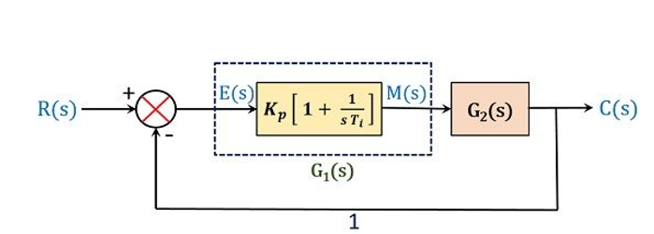

**FIG. PI CONTROLLER**

**INTRODUCTION**

Proportional-Integral (PI) controllers are a type of feedback control system commonly used in industrial automation and process control. They are a combination of two basic control techniques: proportional control and integral control.

Proportional control is a type of control that adjusts the output of a system in proportion to the difference between the desired set point and the actual output. The proportional controller calculates an error signal by subtracting the desired set point from the actual output and then multiplies this error signal by a proportional gain. The proportional gain determines how much the output should be adjusted for a given error signal.

Integral control, on the other hand, is a type of control that considers the accumulated error over time and adjusts the output accordingly. The integral controller calculates the integral of the error signal over time and multiplies this integral value by an integral gain. The integral gain determines how much the output should be adjusted for a given integral error signal.

A PI controller combines proportional and integral control to provide a more effective control system. The proportional component provides a fast response to changes in the error signal, while the integral component eliminates any steady-state error and ensures that the output converges to the set point over time.

PI controllers are widely used in process control applications, such as temperature, pressure, and flow control in chemical and manufacturing industries. They are also used in motion control systems, such as robot control and servo systems.

**History**

The proportional-integral (PI) controller is a type of feedback control system widely used in engineering applications to regulate various processes. The concept of PI controllers has been around for over a century, with various iterations and improvements made over time.

The earliest forms of PI control systems were developed in the late 1800s and early 1900s. One of the pioneers in this field was Nicolas Minorsky, who developed the first automatic steering system for ships in 1912. His system used a feedback mechanism to adjust the rudder angle in response to the ship's deviation from the desired course. Minorsky's system used both proportional and integral control to maintain a stable course and minimize oscillations.

The development of electronic control systems in the mid-20th century led to significant advancements in PI controllers. In the 1940s, Harold Black developed the negative feedback amplifier, which allowed for more precise control of electrical systems. This paved the way for the development of modern PID (proportional-integral-derivative) controllers, which incorporate a derivative term to improve system stability.

Since then, PI controllers have been widely used in various engineering applications, including process control, robotics, and automation. They are valued for their simplicity, ease of use, and effectiveness in regulating processes with varying dynamics and disturbances.

In recent years, advancements in computing and machine learning have enabled the development of more sophisticated control systems, including model-based predictive controllers and adaptive controllers. However, PI controllers continue to be widely used and are often the first choice for many engineering applications.

**TYPES OF PI CONTROLLERS**

There are several variations of PI controllers that are commonly used in industrial control systems. Some of the most common types include:

**Standard PI Controller:** This is the most basic type of PI controller, which combines proportional and integral control. The result produced by the controller is the combination of the proportional and integral components.

**Series PI Controller:** In this type of controller, the integral term is placed in series with the proportional term, rather than adding the two terms together. This type of controller is used when the system dynamics are slow compared to the rate of change of the input signal.

**Parallel PI Controller:** In this type of controller, the integral term is added in parallel with the proportional term. This type of controller is used when the system dynamics are fast compared to the rate of change of the input signal.

**Non-interactive PI Controller:** This type of controller separates the proportional and integral terms so that changes to one term do not affect the other. This can be useful in systems where the two terms have different effects on the system response.

**Auto-tuning PI Controller:** This type of controller automatically adjusts the gains of the proportional and integral terms based on the response of the system. This can be useful in systems where the system dynamics change over time or where the optimal gains are not known.

These different types of PI controllers have different advantages and disadvantages depending on the specific control application. The choice of controller type depends on the system dynamics, control objectives, and performance requirements of the specific control application.

**Advantages of PI Controller:**

**Robustness**: PI controllers are relatively simple and robust control systems that can handle a wide range of operating conditions.

**Easy to implement:** PI controllers are easy to implement in hardware and software, making them a popular choice in industrial control applications.

**Fast response:** PI controllers can respond quickly to changes in the system, allowing for fast and accurate control.

**Reduces steady-state error:** The integral component of the PI controller helps to eliminate steady-state error in the system, ensuring that the output converges to the setpoint over time.

**Applications of PI Controller:**

**Temperature control:** PI controllers are commonly used to control the temperature of industrial processes, such as in chemical and manufacturing industries.

**Pressure control:** PI controllers are used to control pressure in pneumatic and hydraulic systems.

**Motion control:** PI controllers are used in motion control systems, such as robot control and servo systems, to achieve precise and accurate control.

**Speed control:** PI controllers are used to control the speed of motors in industrial applications.

**Flow control:** PI controllers are used to control the flow of fluids in pipelines and other industrial processes.

**Level control:** PI controllers are used to control the level of liquids in tanks and other containers.

Overall, PI controllers are a popular and effective control system that can be applied to a wide range of industrial and process control applications. They are easy to implement, provide fast and accurate control, and help to eliminate steady-state error in the system.

**CHAPTER-7**

**II SYSTEM DESCRIPTION**

The proposed V2V configuration is realized by connecting the existing type-2 charging ports of the provider-EV and the receiver-EV. The two EVs are connected by utilizing the three-phase active rectifier switches. Turning ON the top switch of one of the phases (phase-a, S1 here) and bottom switch of the other phase (phase-c, S6 here) of the active rectifier-1 and the respective phase switches S1 and S 6 of the active rectifier-2 directly connects the two EV batteries through the intermediate dc-link of provider and receiver EVs as shown in Fig. 2. The four switches S1, S6, S1, and S6 are kept ON throughout the V2V power transfer duration. The proposed way of connecting the two EVs realizes a dual bidirectional buck-boost converter that can be controlled to transfer energy between two EVs in either direction regardless of their battery voltage levels.

As the active rectifiers of both the type-2 chargers are used as an interface to connect two dc-links instead of their actual purpose of rectification, other switches of both the active rectifiers are kept OFF throughout the V2V operation. Based on the battery voltage of two EVs, the configuration may operate in one of the possible energy transfer modes as discussed below.

**A) V2V Scenario-1:**

Vbat1 < Vbat2 With the EV-1 battery voltage less than the EV-2 battery voltage and provider–receiver role, there are two possible scenarios of boost and buck operation with power flow in forward or reverse direction, respectively, as explained below.

**1) Forward Boost Mode (EV1 as Provider and EV2 as Receiver):** In this mode, EV1 is charge provider and EV2 is charge receiver with battery-1 having lower voltage than battery-2. Once the direct connection of two EV batteries through the proposed approach (by turning on the switches S1, S6, S1, and S6), EV-1 battery voltage is stepped up to the EV-2 battery voltage by operating the dc–dc converter-1 in the boost mode. During the turn ON period of the switch Sb1, inductor L1 stores energy from EV-1 battery, and the switch Sa1 is complimentary switched to Sb1 as shown in Fig. 3(a). When Sb1 is turned OFF, Sa1 gets turned ON to transfer energy of EV-1 battery and inductor L1 to EV-2 battery through S1, S1, Sa2, and inductor L2. To receive power from the dc-links, switch Sa2 is kept on throughout this V2V mode which makes Vdc1 = Vdc2 = Vbat2 and switch Sb2 is complimentary switched to Sa2 as shown in Fig. 3(b).

**2) Reverse Buck Mode (EV1 as Receiver and EV2 as Provider):** Similar to the forward boost mode in this reverse buck mode, the EV batteries are connected by turning on the switches S1, S6, S1, and S 6 of the active rectifier-1 and 2. The dc–dc converter-1 is operated in buck mode to transfer power from EV-2 battery to EV-1 battery. The diode Da2 gets forward biased as Vbat1 < Vbat2 leading to Vbat2 = Vdc1 = Vdc2 and thus making EV-2 battery available for delivering power to EV-1 battery through the dc-link. During turn ON period of switch Sa1, the energy from the EV-2 battery is transferred to EV-1 battery through inductor L1, Da2, S1, and inductor L2 as shown in Fig. 4(a). During the turn OFF period of Sa1, the energy in the inductor L1 freewheel through switch Sb1 which is complementary switched to Sa1 as shown in Fig. 4(b).

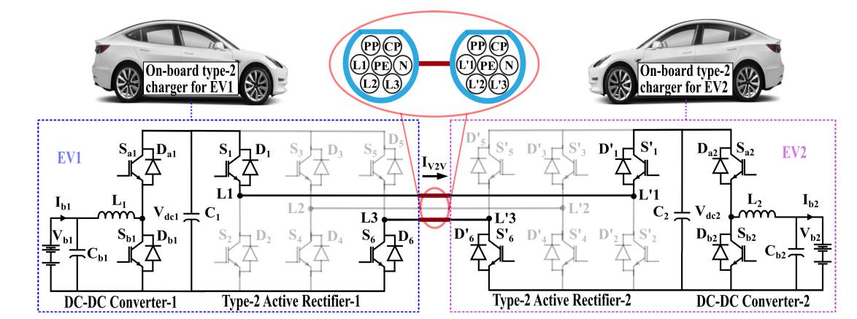

Fig. 2. Proposed topology for V2V operation.

**B. V2V Scenario-2:**

Vbat1 = Vbat2 In this scenario as both EV battery voltages are equal, the dc–dc converters need to be controlled, one in currentcontrolled boost mode and the other in current-controlled buck mode.

**1) Forward Boost Mode (EV1 as Provider and EV2 as Receiver):** In this mode with Vbat1 = Vbat2, power transfer from EV-1 to EV-2 battery is achieved by operating the dc–dc converter-1 in the boost mode and the dc–dc converter-2 is operated in the buck mode with closed-loop current control. During turn ON period of the switch Sb1, inductor L1 stores energy from EV-1 battery and switch Sa1 is complimentary switched to Sb1. At the same instant, the switch Sb2 of dc–dc converter-2 is also ON to freewheel the energy in inductor L2, and the switch Sa2 is complimentary switched to Sb2 as shown in Fig. 5(a). During the turn OFF period of Sb1 and Sb2, the switches Sa1 and Sa2 gets turned on to transfer energy from EV-1 battery to EV-2 battery through L1, S1, S 1, and L2 as shown in Fig. 5(b). This mode can also be achieved by operating provider EV side dc–dc converter in the voltage control mode to regulate the dc-link voltage at a higher voltage than the EV battery voltage and receiver-side dc–dc converter in the current control mode.

**2) Reverse Boost Mode (EV1 as Receiver and EV2 as Provider):** This mode is similar to the forward boost mode with Vbat1 = Vbat2 but the power flow is reversed by operating the dc–dc converter-2 in boost mode and the dc–dc converter-1 is operated in buck mode with closed-loop current control. Voltage control mode could be used to control the power flow in this mode as well.

**C. V2V Scenario-3:**

Vbat1 > Vbat2 The converter operation in this scenario is similar to the Scenario-1 with the power flow direction reversed. 1) Reverse Boost Mode (EV1 as Receiver and EV2 as Provider): This mode is similar to the forward boost mode with Vbat1 < Vbat2 but the power flow is reversed by operating the dc–dc converter-2 of EV-2 in the boost mode, and keeping the Sa1 of the dc–dc converter-1 of EV-1 always ON. 2) Forward Buck Mode (EV1 as Provider and EV2 as Receiver): This mode is similar to the reverse buck mode with Vbat1 < Vbat2 but the power flow is reversed by operating the dc–dc converter-2 of EV-2 in the buck mode, and keeping the Sa1 of the dc–dc converter-1 of EV-1 always ON.

**Control scheme for the proposed v2v approach**

The charging rate and the amount of energy transferred during the proposed V2V approach are controlled by controlling the on-board converters. The mode selector flow shown in Fig. 6 decides the V2V mode based on the EV-1 and EV-2 battery values and the provider receiver information. Furthermore, depending on the mode of operation, the on-board charger converters are controlled for achieving the proposed V2V as discussed next in this section.

A. Control of the Active Rectifiers as V2V Interface Typically, during the normal three-phase ac charging through a type-2 charger, the active rectifier is controlled in d-q control mode to convert the three-phase ac to dc with unity power factor operation at the grid terminals. During the proposed V2V charging, the active rectifier is re-utilized as an interface to access and connect the batteries of the two EVs. After the type-2 charger ports are connected for V2V charging, the gating pulse for the switches S1 and S6 of the active rectifier-1 of the EV-1 and the switches S 1 and S6 of the active rectifier-2 are kept active high throughout the V2V charging for all the modes.

B. Control of DC–DC Converters For the proposed V2V charging approach using the onboard chargers, the dc–dc converters of the type-2 chargers are closed-loop current-controlled. For forward boost and reverse buck mode control (Vbat1 < Vbat2): In these modes, the dc–dc converter-1’s inductor current IL1 in forward or reverse direction is controlled in

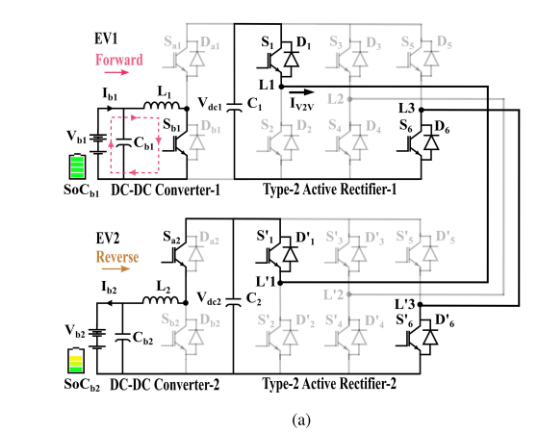

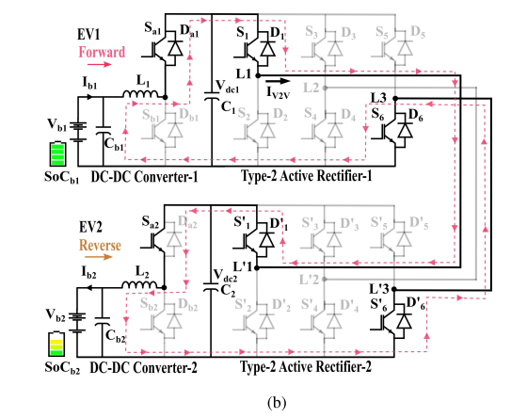

**Fig. 3. Forward boost V2V mode with Vbat1 < Vbat2. (a) L1 stores energy from EV-1 battery. (b) Energy is transferred through dc-link to EV2.**

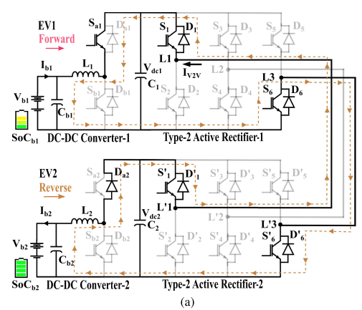

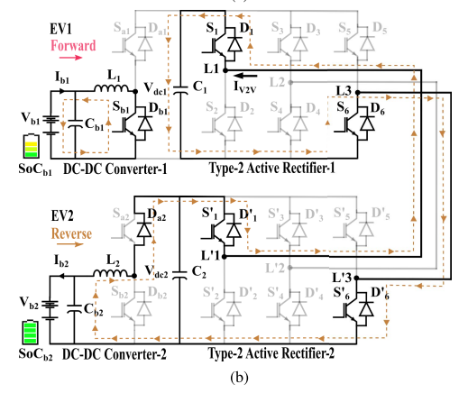

**Fig. 4. Reverse buck V2V mode with Vbat1 < Vbat2. (a) L1 stores energy from EV-2 battery through dc-link. (b) Energy is stored from L1 to EV-1 battery through freewheeling.**

closed-loop by feeding the error between the reference current I ∗ L and the actual inductor current IL1 to a PI controller to generate duty ratio for switch Sa1, and Sb1 is complimentarily switched to Sa1 as shown in Fig. 7. Gating signal to the switch Sa2 is kept active high throughout this mode. The current to control transfer function to the dc–dc converter-1 used to tune the PI controller is given in the following equation, where D is the duty ratio and R2 is the load resistance equivalent to charging current of the EV-2 battery [20]

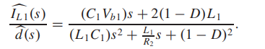1

Reference current I ∗ L is calculated based on the following equation, where Ebat1 and Ebat2 are kWh ratings of the EV-1 and EV-2 batteries, respectively, and Tc is the desired charging time. The minimum values among the two battery ratings and voltage levels are selected to calculate the reference current

2

The maximum value of I ∗ L depends on current rating Is1r of the on-board active rectifier IGBTs (S1, S6, S 1, and S6), if I ∗ L computed from (2) exceeds Is1r, the current reference will be caped to Is1r. Similarly, for the forward buck and reverse boost mode with (Vbat1 > Vbat2), the same control structure is used to control the IL2 in the forward or reverse direction by generating the duty ratio for the switch Sb2 and switch Sa2 is complimentarily switched to Sb2. The gating signal to switch Sa1 is made active high throughout this mode.

Furthermore, in the forward boost mode with (Vbat1 = Vbat2), both the dc–dc converters are operated in current control mode to control IL1 and IL2 in the forward direction. As both the battery voltages are equal in this case, the current reference

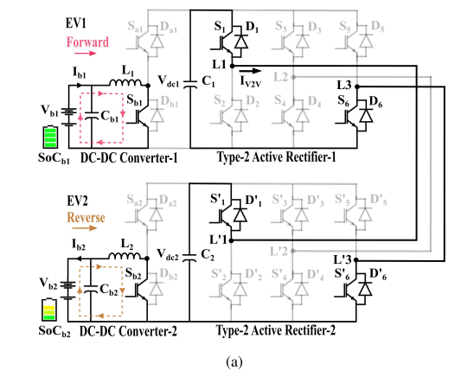

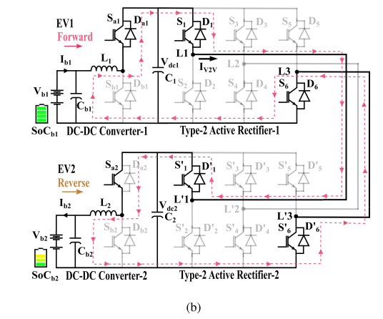

**Fig. 5. Forward boost V2V mode with Vbat1 = Vbat2. (a) L1 and L2 store energy from the batteries. (b) Energy is transferred through dc-link to EV2.**

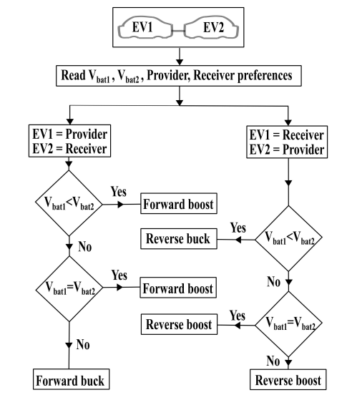

**Fig. 6. Proposed V2V power transfer control flow.**

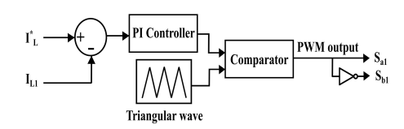

**Fig. 7. Current control structure in forward boost and reverse buck modes (Vbat1 < Vbat2).**

Bidirectional power converter interface for V2V is available. Practical implementation of the proposed V2V approach for commercial EVs assumes that communication between EVs and access to controllers and instrumentation sensors is readily available as detailed in [10]–[12] and proposes to provide a powerful interface for the actual V2V power transfer through the on-board type-2 charger’s hardware components. The provider EV and the receiver EV are connected directly through the existing on-board type-2 charging ports for V2V energy sharing. Depending on the battery voltage levels, provider, and receiver preferences, fetched using the on-board instrumentation sensors and EV user inputs, the V2V mode is decided, as shown in Fig. 6. Based on the mode of operation selected (e.g., forward boost), the power flow direction and the required amount of energy transfer are commanded through the on-board DSP controllers. Active rectifiers of both the on-board chargers are controlled to act as an interface by turning on the top and bottom switches of any two legs. Once the dc-links of both the on-board chargers are connected, depending on the selected V2V mode the battery side dc–dc converter of the on-board chargers is current-controlled, to deliver the required charge to the receiver EV as discussed in the initial parts of this section.

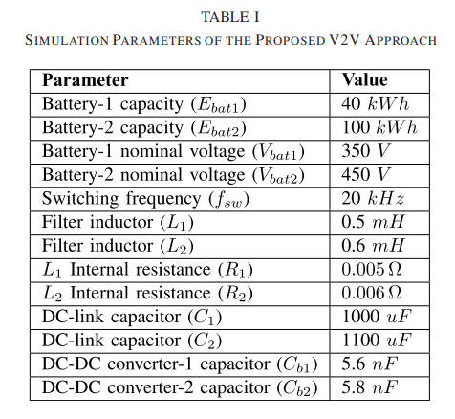

**CHAPTER-8**

**SIMULATION RESULTS AND DISCUSSION**

**Case-1**

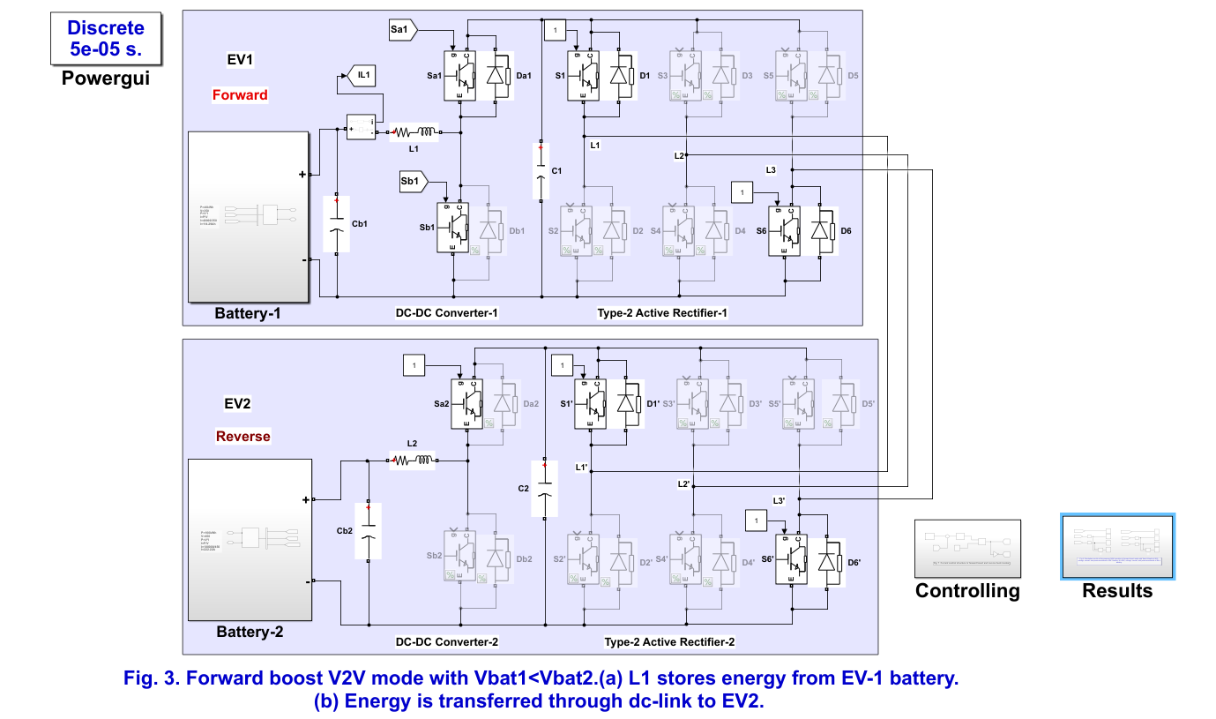

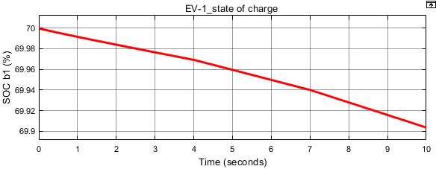

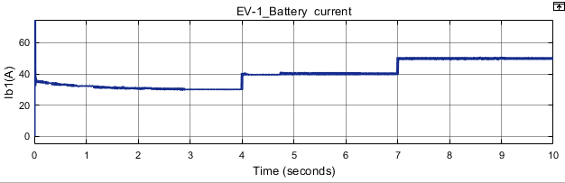

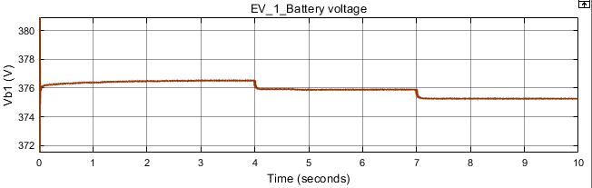

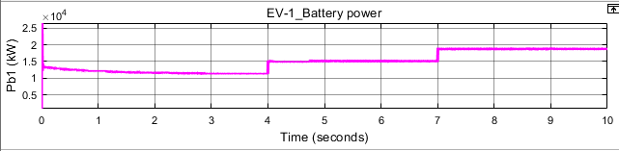

**(a)**

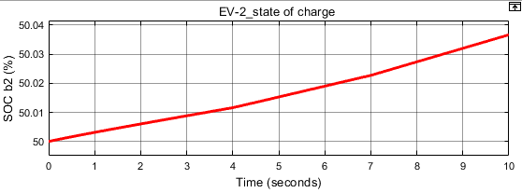

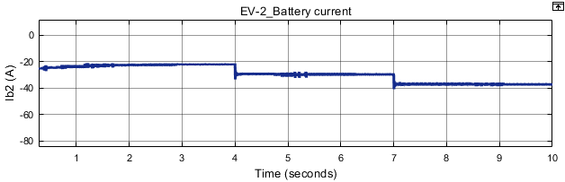

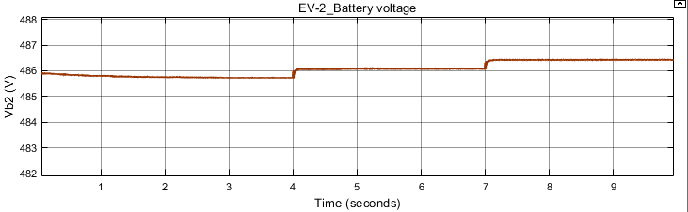

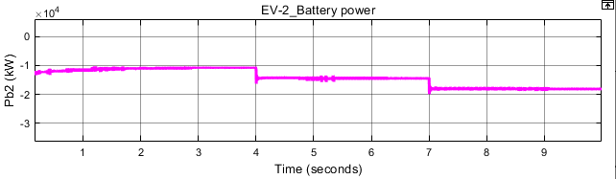

**(b)**

**Fig. 8. Simulation results of the proposed V2V operation in forward boost mode with Vbat1 < Vbat2. (a) SOC, voltage, current, and power waveforms of EV-1 battery. (b) SOC, voltage, current, and power waveforms of EV-2 battery.**

In this mode, the energy is transferred from EV-1 battery to EV-2 battery by controlling the inductor current IL1. The reference inductor current I ∗ L for the forward boost mode is initially kept as 30 A and gradually increased in steps of 10 A up to 50 A to control the EV-1 battery discharge current Ib1. The control of Ib1 and the corresponding drop in state of charge (SOC) of EV-1 SoCb1, voltage Vb1, and the discharged power out of EV-1 battery Pb1 is shown in Fig. 8(a). EV-2 battery charging current Ib2 and the corresponding rise in SoCb2, Vb2, and charged power of EV-2 battery Pb2 are shown in Fig. 8(b). A positive value of battery current represents discharging and a negative value represents the charging of the battery. Discharging and charging currents are within the

**Case-2**

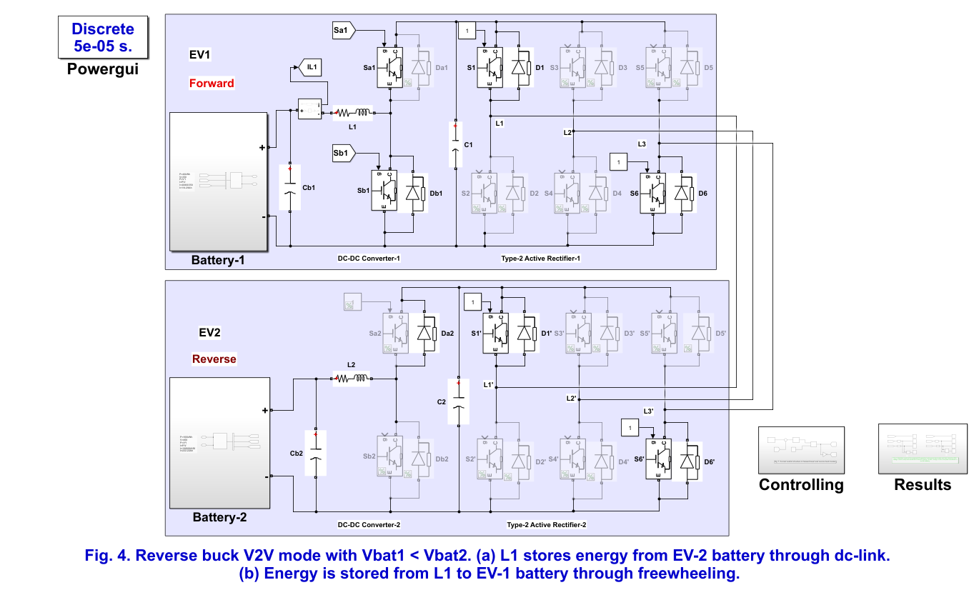

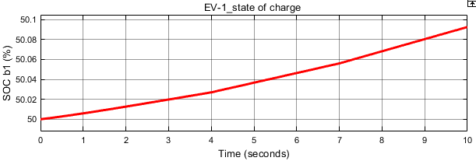

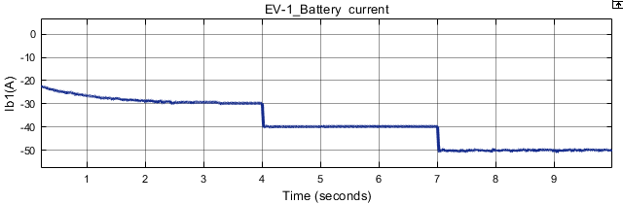

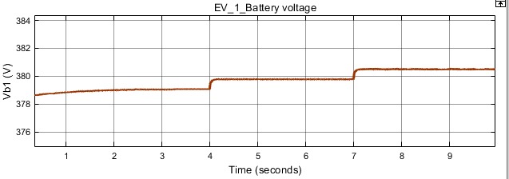

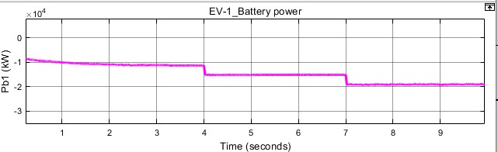

**(a)**

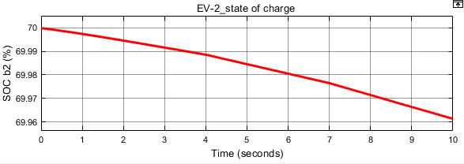

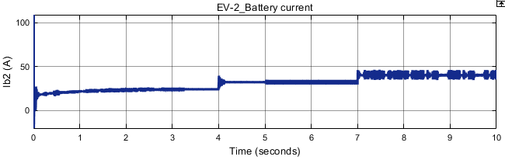

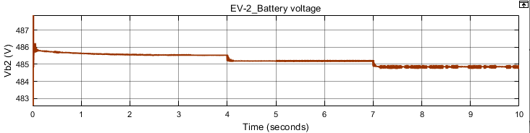

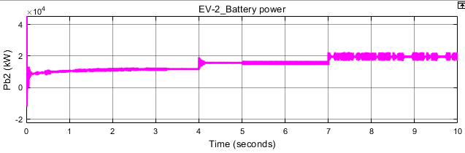

**(b)**

**Fig. 9. Simulation results of the proposed V2V operation in the reverse buck mode with Vbat1 < Vbat2. (a) SOC, voltage, current, and power waveforms of the EV-1 battery. (b) SOC, voltage, current, and power waveforms of the EV-2 battery.**

In this mode, for the same EV-1 and EV-2 battery voltage levels as the forward boost mode but the power flow is reversed. The receiver EV-1 battery is charged with the charging current Ib1 and the corresponding rise in SOC and voltage with the charging power level is shown in Fig. 9(a). The discharging current of the EV-2 battery Ib2 and the corresponding SOC and voltage with the EV-2 battery discharge power are shown in Fig. 9(b).

**Case-3**

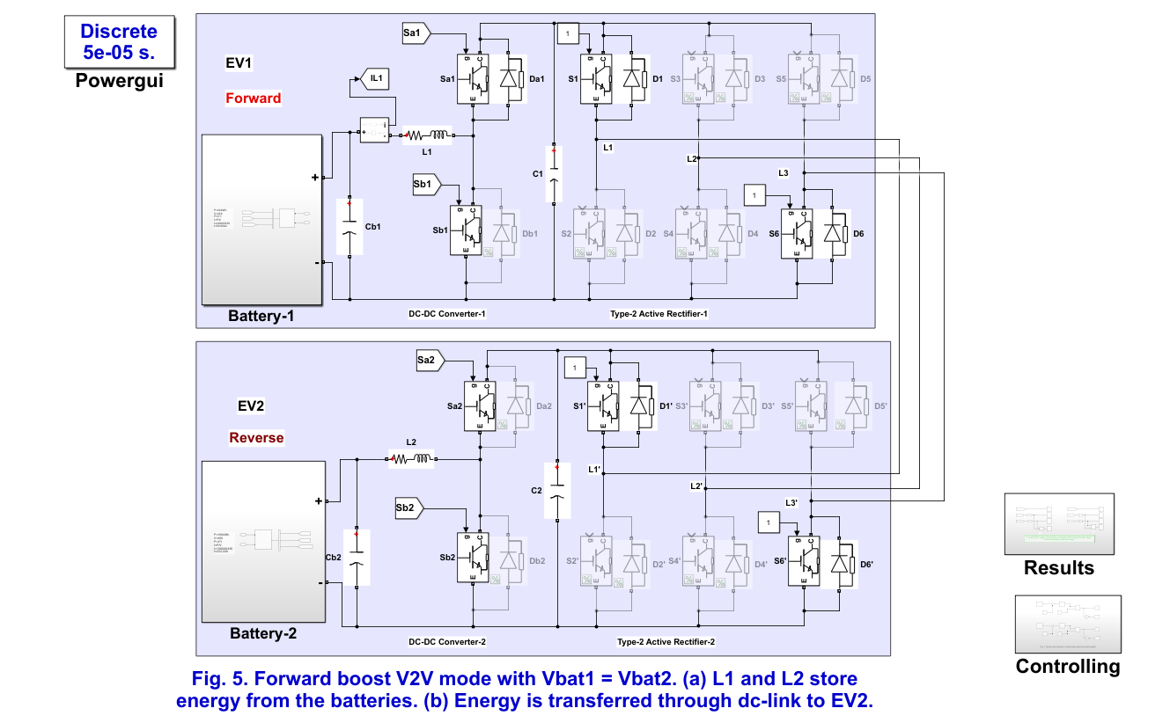

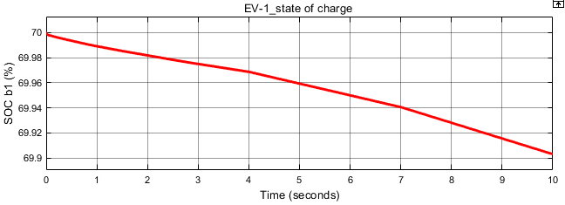

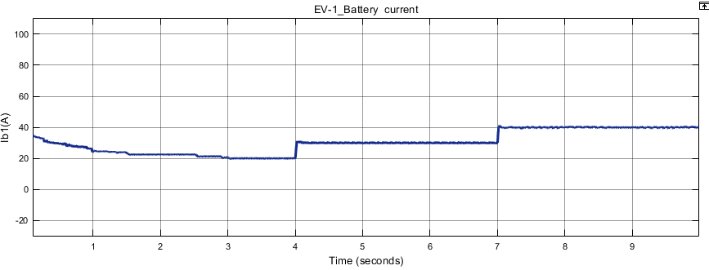

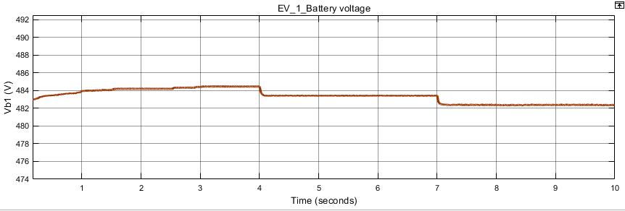

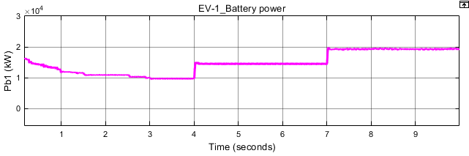

**(a)**

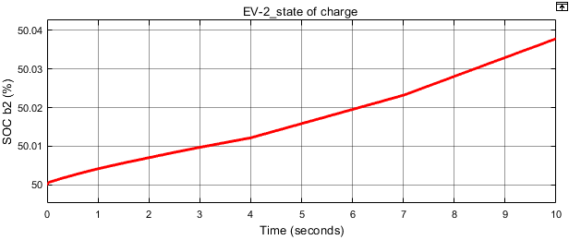

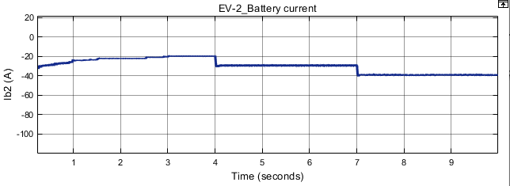

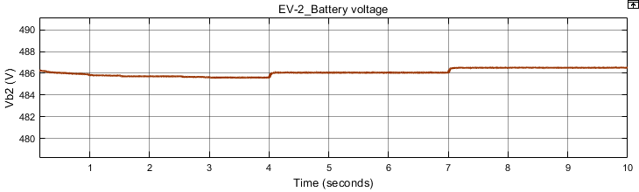

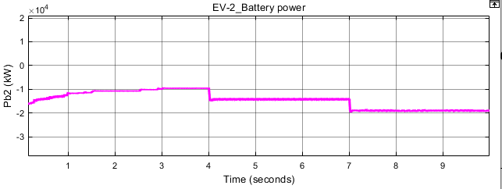

**(b)**

**Fig. 10. Simulation results of the proposed V2V operation in the forward boost mode with Vbat1 = Vbat2. (a) SOC, voltage, current, and power waveforms of EV-1 battery. (b) SOC, voltage, current of EV-2 battery, and dc-link voltage.**

This mode represents the energy transfer between two same model EVs with equal voltage cases. The currents IL1 and IL2 are controlled with the same current reference in the forward direction. Fig. 10(a) shows the discharging current of the EV-1 battery and the corresponding changes in SOC, voltage, and power. The charging current and respective changes in EV-2 battery SOC and voltage with variations in the dc-link voltages are shown in Fig. 10(b). Depending on the current reference value of the dc–dc converter-2, the dc-link voltage will be slightly higher than the EV-2 battery voltage

**CHAPTER-9**

**CONCLUSION**

This article proposes a direct V2V charging approach for power transfer between two EVs without the need for external hardware or additional charging ports. It is an emergency rescue charging solution in the case of non-availability of ac grid and dc fast-charging stations. Connecting two EV batteries directly through the on-board charger ports leads to significant hardware infrastructure savings. The redundant power conversion stages were avoided, which improved the overall efficiency of the proposed V2V approach which is evident in the performance analysis. The proposed V2V approach mitigates range anxiety and cooperatively shares energy between EV users with minimum infrastructure and cost. The proposed V2V method is validated through simulation in MATLAB/Simulink and experimental results which prove the practical effectiveness without modifying the EV power architecture.

**REFERENCES**

[1] J. Yuan, L. Dorn-Gomba, A. D. Callegaro, J. Reimers, and A. Emadi, “A review of bidirectional on-board chargers for electric vehicles,” IEEE Access, vol. 9, pp. 51501–51518, 2021.

[2] M. Y. Metwly, M. S. Abdel-Majeed, A. S. Abdel-Khalik, R. A. Hamdy, M. S. Hamad, and S. Ahmed, “A review of integrated on-board EV battery chargers: Advanced topologies, recent developments and optimal selection of FSCW slot/pole combination,” IEEE Access, vol. 8, pp. 85216–85242, 2020.

[3] A. Khaligh and M. D’Antonio, “Global trends in high-power on-board chargers for electric vehicles,” IEEE Trans. Veh. Technol., vol. 68, no. 4, pp. 3306–3324, Apr. 2019.

[4] V. T. Tran, D. Sutanto, and K. M. Muttaqi, “The state of the art of battery charging infrastructure for electrical vehicles: Topologies, power control strategies, and future trend,” in Proc. Australas. Universities Power Eng. Conf. (AUPEC), Nov. 2017, pp. 1–6.

[5] M. R. Khalid, I. A. Khan, S. Hameed, M. S. J. Asghar, and J.-S. Ro, “A comprehensive review on structural topologies, power levels, energy storage systems, and standards for electric vehicle charging stations and their impacts on grid,” IEEE Access, vol. 9, pp. 128069–128094, 2021.

[6] M. Yilmaz and P. T. Krein, “Review of battery charger topologies, charging power levels, and infrastructure for plug-in electric and hybrid vehicles,” IEEE Trans. Power Electron., vol. 28, no. 5, pp. 2151–2169, May 2013.

[7] G. Li, L. Boukhatem, L. Zhao, and J. Wu, “Direct vehicle-to-vehicle charging strategy in vehicular Ad-Hoc networks,” in Proc. 9th IFIP Int. Conf. New Technol., Mobility Secur. (NTMS), Jan. 2018, pp. 1–5.

[8] R. Q. Zhang, X. Cheng, and L. Q. Yang, “Flexible energy management protocol for cooperative EV-to-EV charging,” IEEE Trans. Intell. Transp. Syst., vol. 20, no. 1, pp. 172–184, Jan. 2019.

[9] D. M. Mughal, J. S. Kim, H. Lee, and M. Y. Chung, “Performance analysis of V2V communications: A novel scheduling assignment and data transmission scheme,” IEEE Trans. Veh. Technol., vol. 68, no. 7, pp. 7045–7056, Jul. 2019.

[10] E. Bulut and M. C. Kisacikoglu, “Mitigating range anxiety via vehicle to-vehicle social charging system,” in Proc. IEEE 85th Veh. Technol. Conf. (VTC Spring), Jun. 2017, pp. 1–5.

[11] P. You and Z. Yang, “Efficient optimal scheduling of charging station with multiple electric vehicles via V2V,” in Proc. IEEE Int. Conf. Smart Grid Commun. (SmartGridComm), Nov. 2014, pp. 716–721.

[12] A.-M. Koufakis, E. S. Rigas, N. Bassiliades, and S. D. Ramchurn, “Towards an optimal EV charging scheduling scheme with V2G and V2V energy transfer,” in Proc. IEEE Int. Conf. Smart Grid Commun. (SmartGridComm), Nov. 2016, pp. 302–307.

[13] E. Ucer et al., “A flexible V2V charger as a new layer of vehicle-grid integration framework,” in Proc. IEEE Transp. Electrific. Conf. Expo (ITEC), Jun. 2019, pp. 1–7.

[14] C. Liu, K. T. Chau, D. Wu, and S. Gao, “Opportunities and challenges of vehicle-to-home, vehicle-to-vehicle, and vehicle-to-grid technologies,” Proc. IEEE, vol. 101, no. 11, pp. 2409–2427, Nov. 2013.

[15] P. Mahure, R. K. Keshri, R. Abhyankar, and G. Buja, “Bidirectional conductive charging of electric vehicles for V2V energy exchange,” in Proc. 46th Annu. Conf. IEEE Ind. Electron. Soc. (IECON), Oct. 2020, pp. 2011–2016.

[16] Andromeda Power. Accessed: Nov. 2021. [Online]. Available: https:// [www.andromedapower.com](http://www.andromedapower.com)

[17] Dec. 2019. Hyundai introduces vehicle to vehicle charging facility. Accessed: Nov. 2021. [Online]. Available: https://www.autocarindia. com/car-news/hyundai-introduces-vehicle-to-vehicle-charging-facility415144

[18] S. Taghizadeh, M. J. Hossain, N. Poursafar, J. Lu, and G. Konstantinou, “A multifunctional single-phase EV on-board charger with a new V2V charging assistance capability,” IEEE Access, vol. 8, pp. 116812–116823, 2020.

[19] T. J. C. Sousa, V. Monteiro, J. C. A. Fernandes, C. Couto, A. A. N. Meléndez, and J. L. Afonso, “New perspectives for vehicle to-vehicle (V2V) power transfer,” in Proc. 44th Annu. Conf. IEEE Ind. Electron. Soc., Oct. 2018, pp. 5183–5188.

[20] R. W. Erickson and D. Maksimovic, Fundamentals of Power Electronics, 2nd ed. Norwell, MA, USA: Springer, 2007.

[21] D. Graovac and M. Purschel, “IGBT power losses calculation using the data-sheet parameters-application note,” Infineon Technol. AG, Neubiberg, Germany, Appl. Note V 1.1, Jan. 2009.