**Distance Metrics in Machine Learning**

**~ Bhavya Patel**

* **INFO:** Distance plays an important role in making the foundation for many effective algorithms in machine learning such as **K- Nearest neighbors** for supervised learning and **K-means clustering** for unsupervised learning.
* **NEED:** *An effective distance metrics improves the performance of our machine learning model, whether that’s for classification or clustering.*

**Types of Distance Metrics**

* **Euclidean**

Euclidean distance is calculated as the square root of the sum of the squared differences between the two vectors.

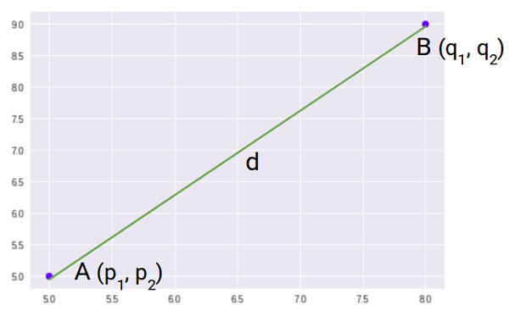

**FORMULA**

euclidean distance formula | distance metrics

**GENERAL FORMULA FOR *n-*dimensional space**

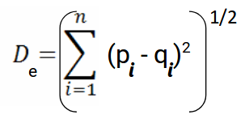

Where, n = number of dimensions

pi, qi = data points

* **Manhattan Distance**

Manhattan Distance is the sum of absolute differences between points across all the dimensions.

It is also known as City-block distance.

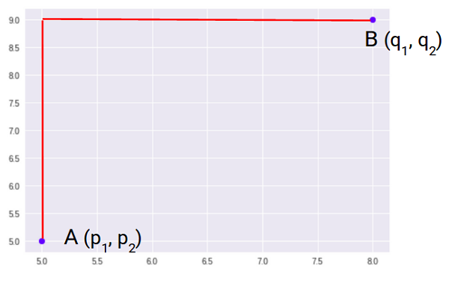

**FORMULA**

manhattan distance formula | distance metrics

**GENERAL FORMULA FOR *n-*dimensional space**

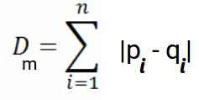

Where, n = number of dimensions

pi, qi = data points

* **Minkowski Distance**

It is generalized form of Euclidean and Manhattan Distance

**FORMULA**

