**Logistic Regression**

* Let’s understand it with an example that how Logistic regression is helpful over Linear regression.
* Suppose that you have dataset containing the column of age and does people have insurance or not.



* Scalar plot of above data

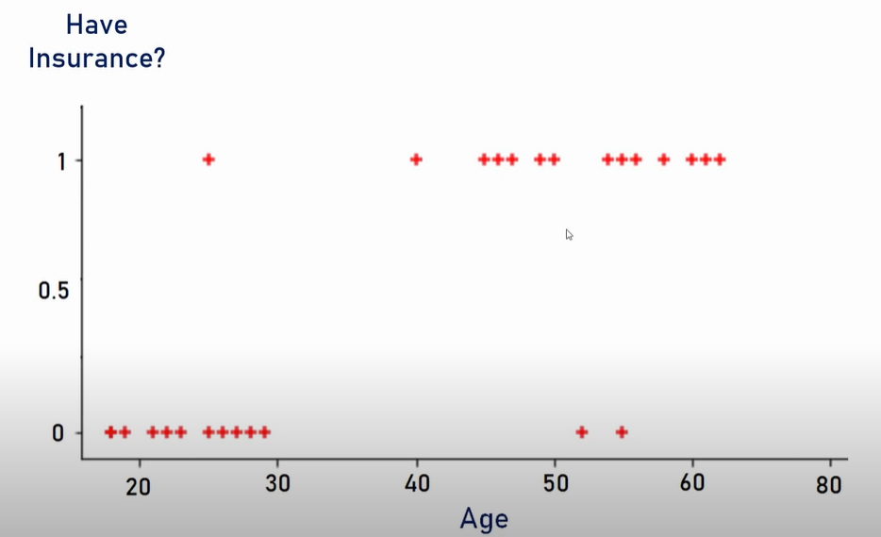

* After applying linear regression on it , Linear regression line looks like this

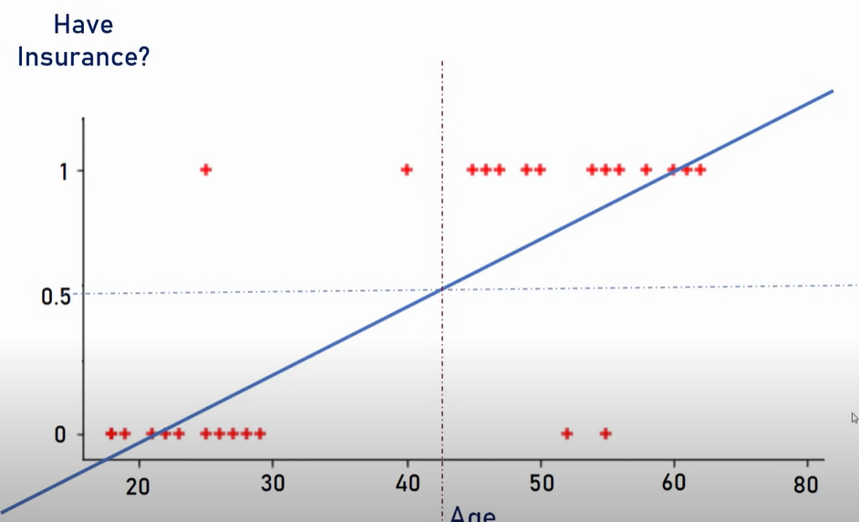

* So, from the above if the probability > 0.5 then it’s more like to have insurance and vice-versa.
* But let’s look at linear regression line when another person of age 80 has insurance.

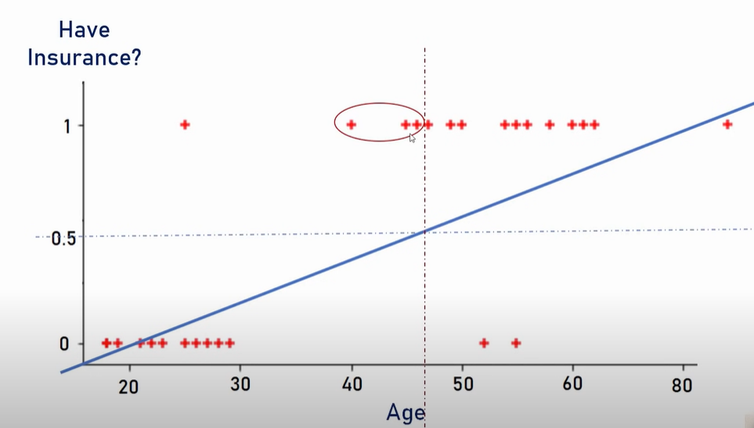

* From the above it seems that we are losing three data points on the left as our line is predicting it wrong when we are doing separation using 0.5 value. To solve this, we use sigmoid function instead of the line y = mx+c.



 