**VISVESVARAYA TECHNOLOGICAL UNIVERSITY**

**“JnanaSangama”, Belgaum -590014, Karnataka.**



**AAT PROJECT REPORT**

**on**

**Cloud Computing – Deploying a Dockerized CRUD application(User Management System)**

***Submitted by***

**Aman Sinha(1BM19CS014)**

**Amit Ramachandran (1BM19CS016)**

**Bhavya Singh (1BM19CS037)**

***Under the Guidance of***

|  |  |
| --- | --- |
| **Prof. Lakshmi Neelima**  **Assistant Professor, BMSCE** |  |

***in partial fulfillment for the award of the degree of***

**BACHELOR OF ENGINEERING**

***in***

**COMPUTER SCIENCE AND ENGINEERING**



**B. M. S. COLLEGE OF ENGINEERING**

**(Autonomous Institution under VTU)**

**BENGALURU-560019**

**Oct-2022 to Feb-2023**

**B. M. S. College of Engineering**

**Bull Temple Road, Bangalore 560019**

(Affiliated to Visvesvaraya Technological University, Belgaum)

**Department of Computer Science and Engineering**



**CERTIFICATE**

This is to certify that the project work entitled “**Cloud Computing – Deploying a Dockerized -Flask Web Application(To-do List)**” carried out by **Aman Sinha(1BM19CS014), Amit Ramachandran (1BM19CS016)** and  **Bhavya Singh (1BM19CS037)** who are bona-fide students of **B. M. S. College of Engineering.** It is in partial fulfillment for the award of **Bachelor of Engineering in Computer Science and Engineering** of the Visveswaraiah Technological University, Belgaum during the year 2022-2023. The project report has been approved as it satisfies the academic requirements in respect of **AAT Cloud Computing (21CS7PECCT)** work prescribed for the said degree.

Signature of the Guide                 Signature of the HOD

Prof. Lakshmi Neelima Dr. Jyothi S Nayak

Assistant Professor Associate Prof. & Head, Dept. of Computer Science Engineering Computer Science Engineering

BMSCE, Bengaluru BMSCE, Bengaluru

**List of Contents**

|  |  |  |
| --- | --- | --- |
| Sl no. | Topic | Page No |
| 1 | Introduction | 4 |
| 2 | Dockers and Flask | 5 |
| 3 | Cloud Solutions for Application Hosting | 7 |
| 4 | AWS EC2 | 12 |
| 5 | Tools Used | 13 |
| 6 | Detailed Design | 14 |
| 7 | Implementation Details | 16 |
| 8 | Results | 20 |
| 9 | Conclusion | 24 |
| 10 | References | 25 |

1. **INTRODUCTION**

1.1 Introduction to Cloud Computing

Cloud Computing is the on-demand availability of [computer](https://en.wikipedia.org/wiki/Computer) [system resources](https://en.wikipedia.org/wiki/System_resource), especially data storage ([cloud storage](https://en.wikipedia.org/wiki/Cloud_storage)) and [computing power](https://en.wikipedia.org/wiki/Computing_power), without direct active management by the user.Large clouds often have functions [distributed](https://en.wikipedia.org/wiki/Distributed_computing) over multiple locations, each of which is a [data center](https://en.wikipedia.org/wiki/Data_center). Cloud computing relies on sharing of resources to achieve coherence. It typically uses a "pay as you go" model, which can help in reducing [capital expenses](https://en.wikipedia.org/wiki/Capital_expenses) but may also lead to unexpected [operating expenses](https://en.wikipedia.org/wiki/Operating_expense) for users.

Cloud Computing exhibits the following characteristics:

* Cost reductions are claimed by cloud providers. A public-cloud delivery model converts [capital expenditures](https://en.wikipedia.org/wiki/Capital_expenditure) (e.g., buying servers) to [operational](https://en.wikipedia.org/wiki/Operational_expenditure) expenditures. This purportedly lowers [barriers to entry](https://en.wikipedia.org/wiki/Barriers_to_entry), as infrastructure is typically provided by a third party and need not be purchased for one-time or infrequent intensive computing tasks. Pricing on a utility computing basis is "fine-grained", with usage-based billing options. As well, fewer in-house IT skills are required for the implementation of projects that use cloud computing. The e-FISCAL project's state-of-the-art repository contains several articles looking into cost aspects in more detail, most of them concluding that cost savings depend on the type of activities supported and the type of infrastructure available in-house.
* [Device and location independence](https://en.wikipedia.org/wiki/Device_independence) enable users to access systems using a web browser regardless of their location or device (e.g., PC, mobile phone). As infrastructure is off-site (typically provided by a third-party) and accessed via the Internet, users can connect to it from anywhere.
* [Maintenance](https://en.wikipedia.org/wiki/Software_maintenance) of the cloud environment is easier because the data is hosted on an outside server maintained by a provider without the need to invest in data center hardware. IT maintenance of cloud computing is managed and updated by the cloud provider's IT maintenance team, reducing cloud computing costs compared with on-premises data centers.
* [Multitenancy](https://en.wikipedia.org/wiki/Multitenancy) enables sharing of resources and costs across a large pool of users thus allowing for
  + centralization of infrastructure in locations with lower costs (such as real estate, electricity, etc.)
  + peak-load capacity increases (users need not engineer and pay for the resources and equipment to meet their highest possible load-levels)
  + utilization and efficiency improvements for systems that are often only 10–20% utilized.

1.2 Problem Statement

Containerizing a “To-Do List” web application using Docker and hosting it on the cloud using AWS EC2.

1. **DOCKERS AND FLASK**

**Docker** is a container management service. The keywords of Docker are develop, ship and run anywhere. The whole idea of Docker is for developers to easily develop applications, ship them into containers which can then be deployed anywhere.

## Features of Docker:

* Docker has the ability to reduce the size of development by providing a smaller footprint of the operating system via containers.
* With containers, it becomes easier for teams across different units, such as development, QA, and Operations to work seamlessly across applications.
* You can deploy Docker containers anywhere, on any physical and virtual machines and even on the cloud.
* Since Docker containers are pretty lightweight, they are very easily scalable.

The illustration below gives us insight into the biggest key benefit of Docker, that is, there is no need for a complete operating system every time we need to bring up a new container, which cuts down on the overall size of containers.

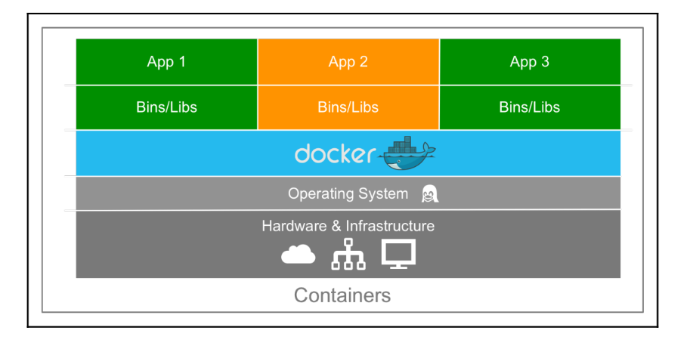

* The server/hardware and infrastructure is used to host multiple virtual machines. So this layer remains the same.
* The Host OS is the base machine such as Linux or Windows. So this layer remains the same.
* Now comes the new generation which is the Docker engine. This is used to run the operating system which earlier used to be virtual machines as Docker containers.

**Flask** is a web framework. This means flask **provides you with tools, libraries and technologies that allow you to build a web application**. This web application can be some web pages, a blog, a wiki or go as big as a web-based calendar application or a commercial website.

Flask is used for developing web applications using python, implemented on Werkzeug and Jinja2.

Advantages of using Flask framework are:

* There is a built-in development server and a fast debugger provided.
* Lightweight
* Secure cookies are supported.
* Templating using Jinja2.
* Request dispatching using REST.
* Support for unit testing is built-in.

1. **CLOUD SOLUTIONS FOR APPLICATION HOSTING**

3.1 Microsoft Azure

Microsoft Azure, formerly known as Windows Azure, is Microsoft's public [cloud computing](https://www.techtarget.com/searchcloudcomputing/definition/cloud-computing) platform. It provides a broad range of cloud services, including compute, analytics, storage and networking. Users can pick and choose from these services to develop and scale new applications or run existing applications in the public cloud.

The Azure platform aims to [help businesses manage challenges](https://www.techtarget.com/searchcloudcomputing/feature/5-tips-that-can-lead-to-Azure-cloud-management-success) and meet their organizational goals. It offers tools that support all industries -- including e-commerce, finance and a variety of Fortune 500 companies -- and is compatible with open source technologies. This gives users the flexibility to use their preferred tools and technologies. In addition, Azure offers four different forms of cloud computing: infrastructure as a service ([IaaS](https://www.techtarget.com/searchcloudcomputing/definition/Infrastructure-as-a-Service-IaaS)), platform as a service ([PaaS](https://www.techtarget.com/searchcloudcomputing/definition/Platform-as-a-Service-PaaS)), software as a service ([SaaS](https://www.techtarget.com/searchcloudcomputing/definition/Software-as-a-Service)) and [serverless](https://www.techtarget.com/searchitoperations/definition/serverless-computing) functions.

Microsoft charges for Azure on a [pay-as-you-go (PAYG)](https://www.techtarget.com/searchstorage/definition/pay-as-you-go-cloud-computing-PAYG-cloud-computing) basis, meaning subscribers receive a bill each month that only charges them for the specific resources and services they have used.

A few popular services provided by Microsoft Azure are:

* Compute. These services enable a user to deploy and manage VMs, containers and batch jobs, as well as support remote application access. Compute resources created within the Azure cloud can be configured with either public IP addresses or private IP addresses, depending on whether the resource needs to be accessible to the outside world.
* Mobile. These products help developers build cloud applications for mobile devices, providing notification services, support for back-end tasks, tools for building application program interfaces (APIs) and the ability to couple geospatial context with data.
* Web. These services support the development and deployment of web applications. They also offer features for search, content delivery, [API management](https://www.techtarget.com/searchapparchitecture/definition/API-management), notification and reporting.
* Storage. This category of services provides scalable cloud storage for structured and unstructured data. It also supports big data projects, persistent storage and archival storage.
* Analytics. These services provide distributed analytics and storage, as well as features for real-time analytics, big data analytics, data lakes, machine learning, business intelligence, [internet of things (IoT)](https://www.techtarget.com/iotagenda/definition/Internet-of-Things-IoT) data streams and data warehousing.
* Networking. This group includes virtual networks, dedicated connections and gateways, as well as services for traffic management and diagnostics, load balancing, DNS hosting and network protection against distributed denial-of-service (DDoS) attacks.

3.2 AWS

The full form of AWS is Amazon Web Services. It is a platform that offers flexible, reliable, scalable, easy-to-use and, cost-effective cloud computing solutions.

AWS is a comprehensive, easy to use computing platform offered Amazon. The platform is developed with a combination of infrastructure as a service (IaaS), platform as a service (PaaS) and packaged software as a service (SaaS) offerings.

Applications of AWS

The most common applications of AWS are storage and backup, websites, gaming, mobile, web, and social media applications. Some of the most crucial applications in detail are as follows:

### 1. Storage and Backup

One of the reasons why many businesses use AWS is because it offers multiple types of storage to choose from and is easily accessible as well. It can be used for storage and file indexing as well as to run critical business applications.

2. Websites

### Businesses can host their websites on the AWS cloud, similar to other web applications.

### 3. Gaming

There is a lot of computing power needed to run gaming applications. AWS makes it easier to provide the best online gaming experience to gamers across the world.

### 4. Mobile, Web and Social Applications

A feature that separates AWS from other cloud services is its capability to launch and scale mobile, e-commerce, and [SaaS applications](https://www.simplilearn.com/what-is-saas-article). API-driven code on AWS can enable companies to build uncompromisingly scalable applications without requiring any OS and other systems.

### 5. Big Data Management and Analytics (Application)

* Amazon Elastic MapReduced to process large amounts of data via the Hadoop framework.
* Amazon Kinesis to analyze and process the streaming data.
* AWS Glue to handle, extract, transform and load jobs.
* Amazon Elasticsearch Service to enable a team to perform log analysis, and tool monitoring with the help of the open source tool, Elastic-search.
* Amazon Athena to query data.
* Amazon QuickSight to visualize data.

### 6. Artificial Intelligence

* Amazon Lex to offer voice and text chatbot technology.
* Amazon Polly to translate text-to-speech translation such as Alexa Voice Services and echo devices.
* Amazon Rekognition to analyze the image and face.

### 7. Messages and Notifications

* Amazon Simple Notification Service (SNS) for effective business or core communication.
* Amazon Simple Email Service (SES) to receive or send emails for IT professionals and marketers.
* Amazon Simple Queue Service (SQS) to enable businesses to subscribe or publish messages to end users.

### 8. Augmented Reality and Virtual Reality

* Amazon Sumerian service enables users to make the use of AR and VR development tools to offer 3D web applications, E-commerce & sales applications, Marketing, Online education, Manufacturing, Training simulations, and Gaming.

### 9. Game Development

* AWS game development tools are used by large game development companies that offer developer back-end services, analytics, and various developer tools.
* AWS allows developers to host game data as well as store the data to analyze the gamer's performance and develop the game accordingly.

### 10. Internet of Things

* AWS IoT service offers a back-end platform to manage IoT devices as well as data ingestion to database services and AWS storage.
* AWS IoT Button offers limited IoT functionality to hardware.
* AWS Greengrass offers AWS computing for IoT device installation.

3.3 Google Cloud Platform

Google Cloud Platform is a set of cloud computing services that Google offers, which runs on the same infrastructure that Google uses for its end-user products, such as YouTube, Gmail, and more. Google Cloud Platform offers a variety of services, including

* Compute
* Network
* Machine learning and AI
* Big data processing

Google Cloud Platform Components

Several components and services are an important feature of Google Cloud Platform; let’s dive into each one individually and learn more about what they provide.

1. Compute

The compute service enables compute and hosting the cloud. The various services under this are as follows:

* App Engine
* Compute Engine
* Kubernetes Engine
* Cloud Functions
* Cloud Run

### 2. Storage and Database

The storage and database service enables the application to store media files, backups, or other file-like objects. The services include:

* Cloud Storage
* Cloud SQL
* Cloud Bigtable
* Cloud Spanner
* Cloud Datastore

### 3. Networking

The networking service enables us to load-balance traffic across resources, create DNS records, and much more. Some of the services include:

* VPC
* Cloud Load Balancing
* Cloud Armor
* Cloud CDN
* Cloud Interconnect
* Cloud DNS
* Network Service Tiers

### 4. Big Data

The big data service enables us to process and query big data in the cloud. A few of the included services are the following:

* BigQuery
* Cloud Dataproc
* Cloud Datalab
* Cloud Data Studio

### 5. Developer Tools

The developer tools service includes tools that enable software and application development.

* Artifact Registry (beta)
* Cloud SDK
* Cloud Code
* CloudBuild
* Cloud Scheduler
* Cloud Tasks

### 6. Identity and Security

This service deals with security and authentication:

* Cloud Identity
* Cloud IAM
* Cloud Data Loss Prevention API
* Security Key Enforcement

### 7. Internet of Things(IoT)

You can leverage GCP to create IoT environments with the following tools:

* Cloud IoT Core
* Edge TPU
* Cloud IoT

### 8. Cloud AI

Cloud AI comprises services related to machine learning, which also encompasses:

* Cloud AutoML
* Cloud Natural Language
* Cloud Speech-to-Text
* Cloud Text-to-Speech
* Cloud Translation API
* Cloud Vision API
* Cloud Video Intelligence

1. **AWS EC2**

Amazon Elastic Compute Cloud (Amazon EC2) provides scalable computing capacity in the Amazon Web Services (AWS) Cloud. Using Amazon EC2 eliminates your need to invest in hardware up front, so you can develop and deploy applications faster. You can use Amazon EC2 to launch as many or as few virtual servers as you need, configure security and networking, and manage storage. Amazon EC2 enables you to scale up or down to handle changes in requirements or spikes in popularity, reducing your need to forecast traffic.

Features of Amazon EC2

* Virtual computing environments, known as instances
* Preconfigured templates for your instances, known as Amazon Machine Images (AMIs), that package the bits you need for your server (including the operating system and additional software)
* Various configurations of CPU, memory, storage, and networking capacity for your instances, known as instance types
* Secure login information for your instances using key pairs (AWS stores the public key, and you store the private key in a secure place)
* Storage volumes for temporary data that's deleted when you stop, hibernate, or terminate your instance, known as instance store volumes
* Persistent storage volumes for your data using Amazon Elastic Block Store (Amazon EBS), known as Amazon EBS volumes
* Multiple physical locations for your resources, such as instances and Amazon EBS volumes, known as Regions and Availability Zones
* A firewall that enables you to specify the protocols, ports, and source IP ranges that can reach your instances using security groups
* Static IPv4 addresses for dynamic cloud computing, known as Elastic IP addresses
* Metadata, known as tags, that you can create and assign to your Amazon EC2 resources
* Virtual networks you can create that are logically isolated from the rest of the AWS Cloud, and that you can optionally connect to your own network, known as virtual private clouds (VPCs)

1. Tools Used

5.1 Tools used for front-end design

* HTML, CSS and JavaScript

5.2 Tools used for back end

* DBSQL Lite - Database
* Docker- To containerize the application.

5.3 Tools used for hosting the application

* AWS EC2

1. Detailed Design

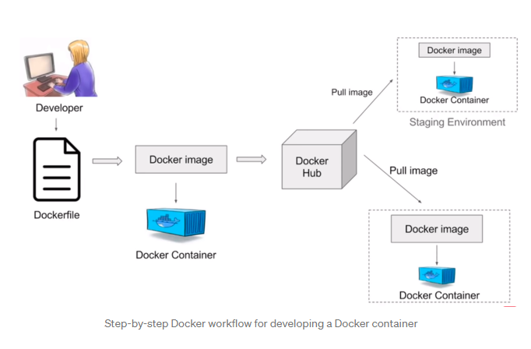

The figure above shows a detailed design for dockerizing an application.

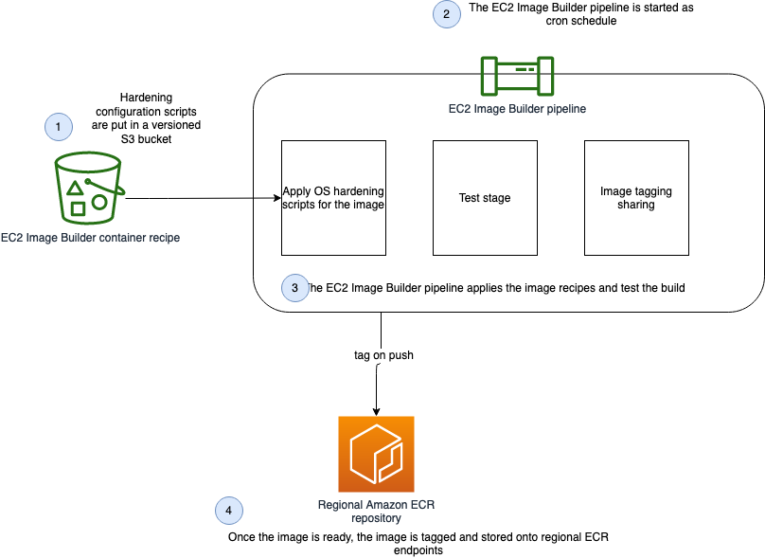

The above figure shows how a dockerized application is hosted on AWS EC2.

1. Implementation Details

* Application code snapshot along with database connectivity

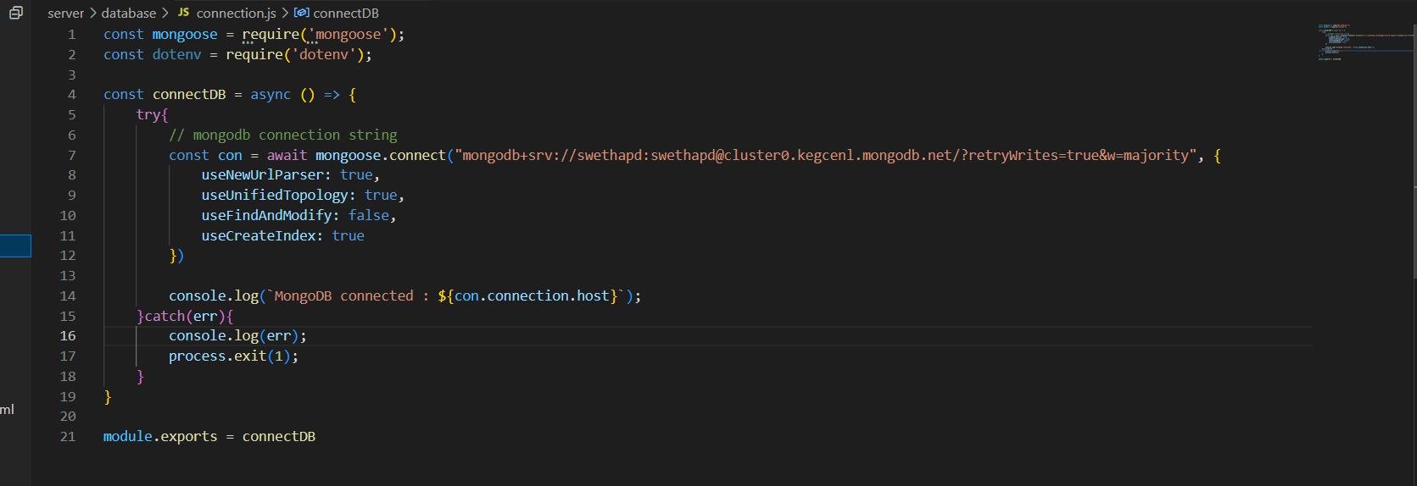

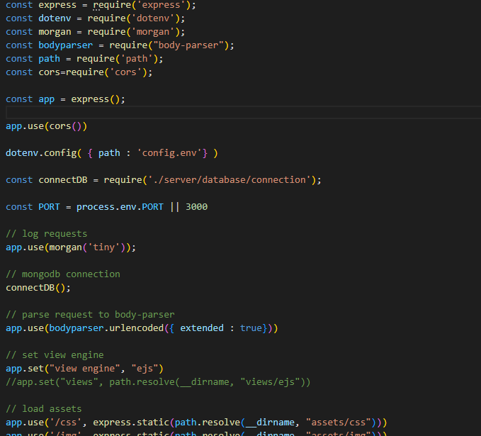

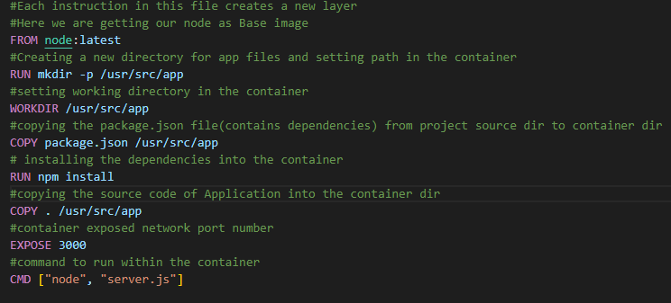

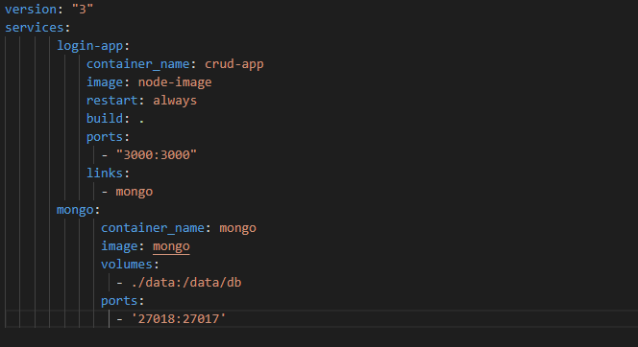

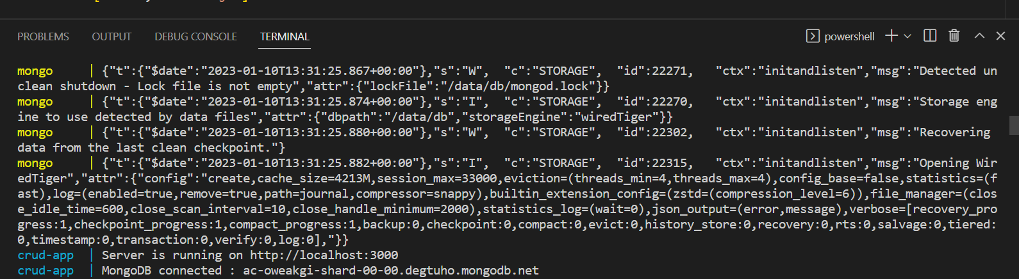

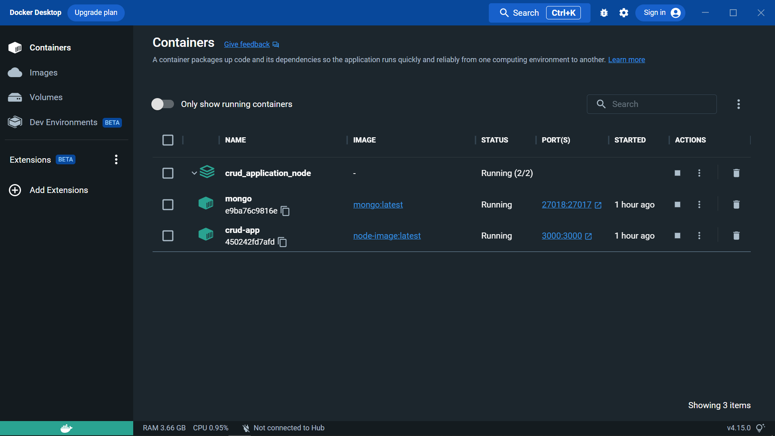

* Commands used to host the application

**docker build -t <name_for_image> .**

**#To list running containers**

**docker ps**

**#To list all the available containers**

**docker ps -a**

**#To start a stopped container**

**docker start <container_name/ID>**

**#To stop a running container**

**docker stop <container_name/ID>**

**docker-compose up .**

* docker login usermanagementsystem.azurecr.io
* docker tag node-image:latest usermanagementsystem.azurecr.io/node-image:latest
* docker push usermanagementsystem.azurecr.io/node-image:latest

1. **Results**

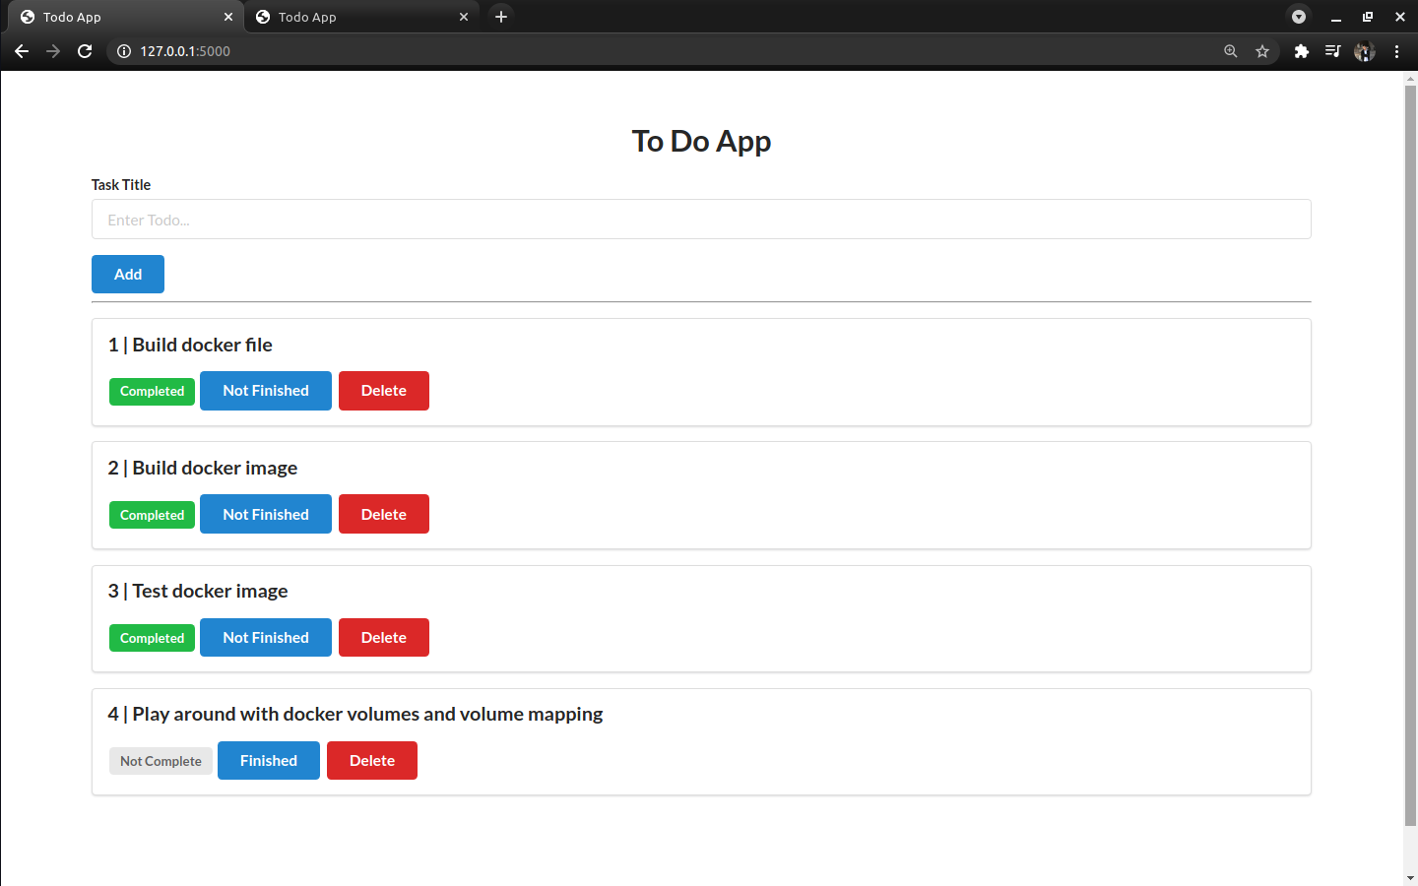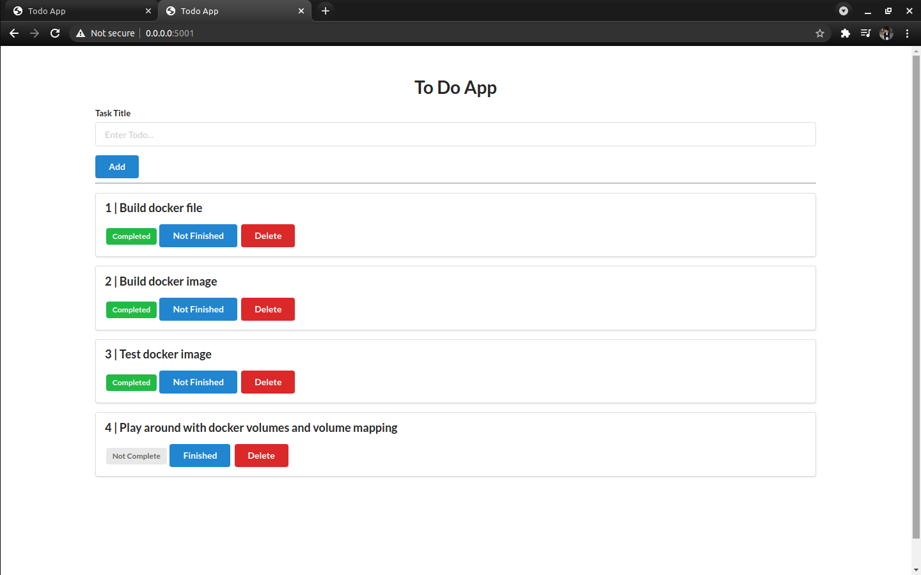

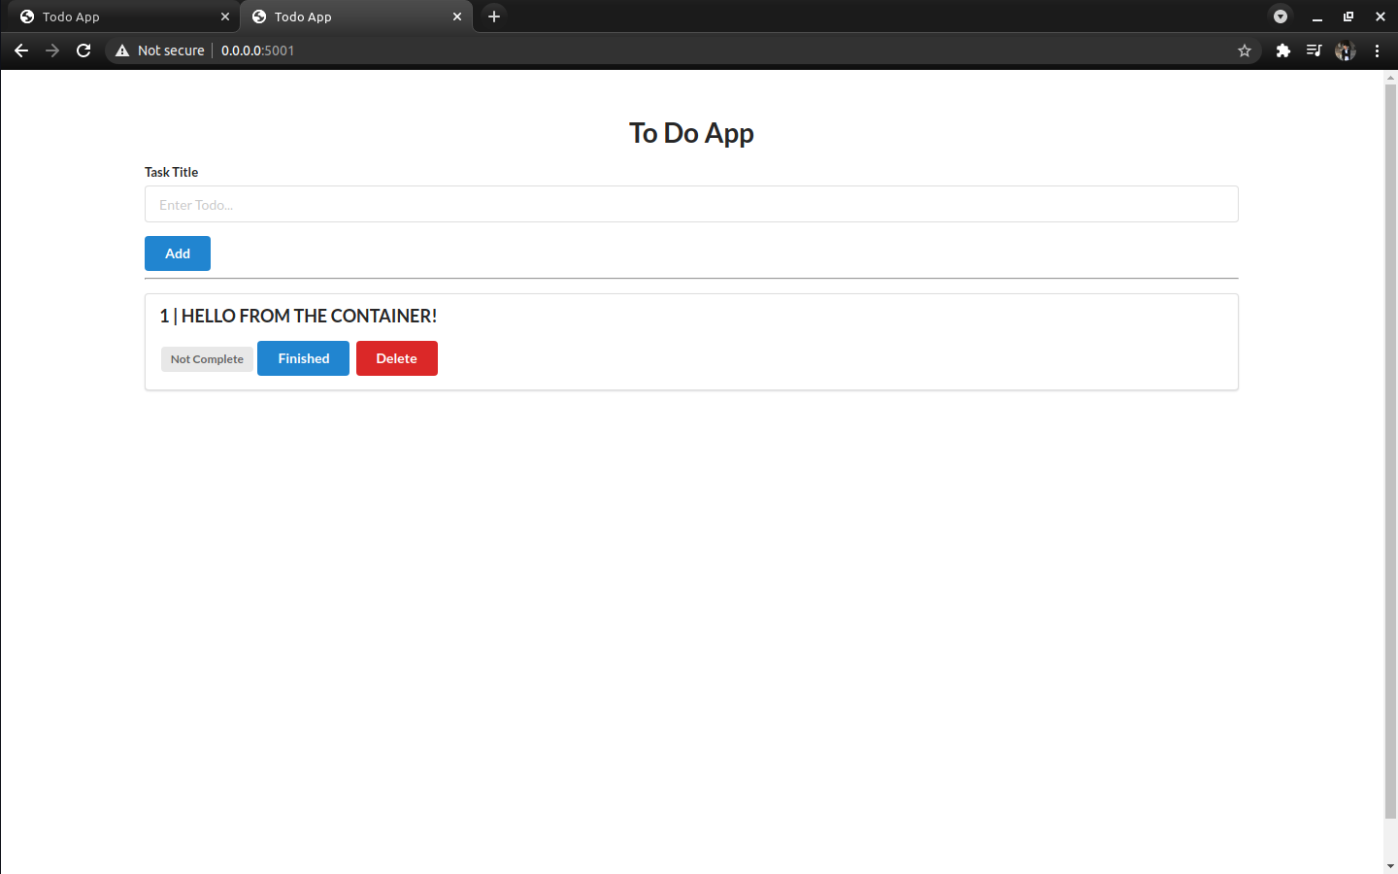

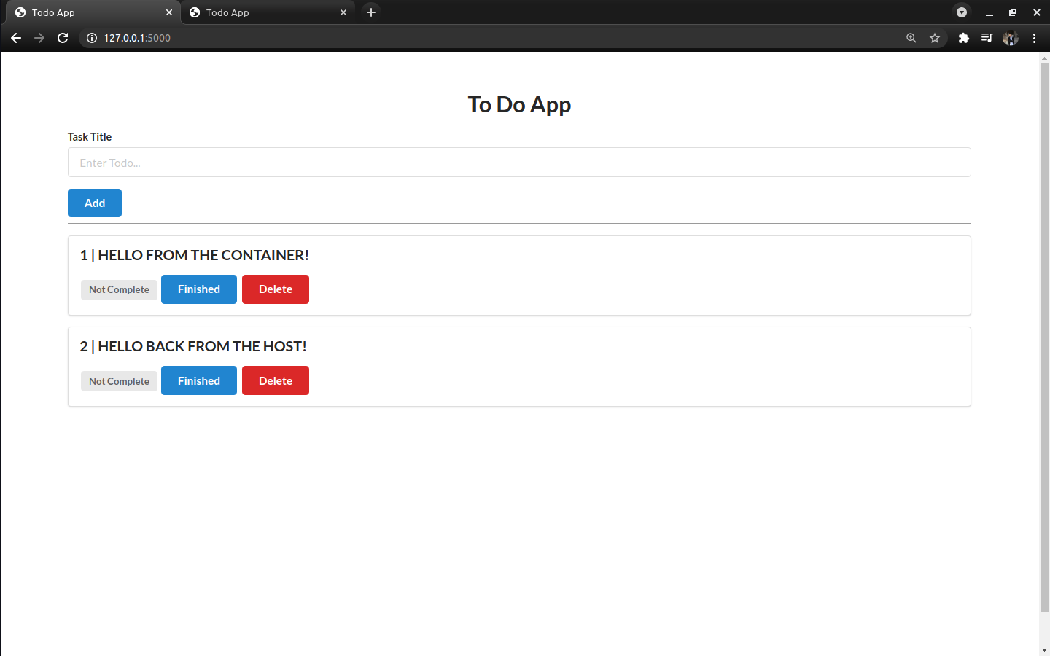

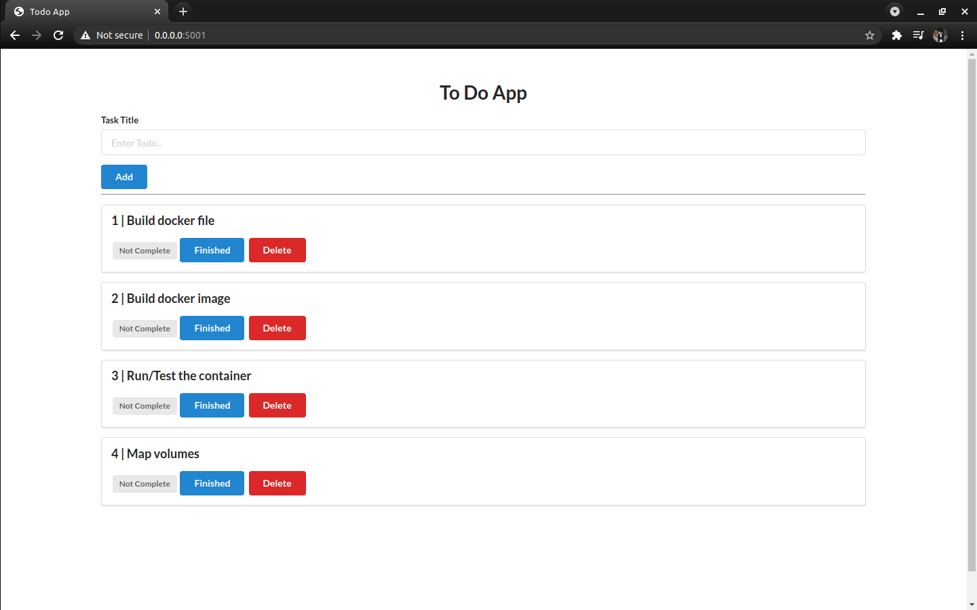

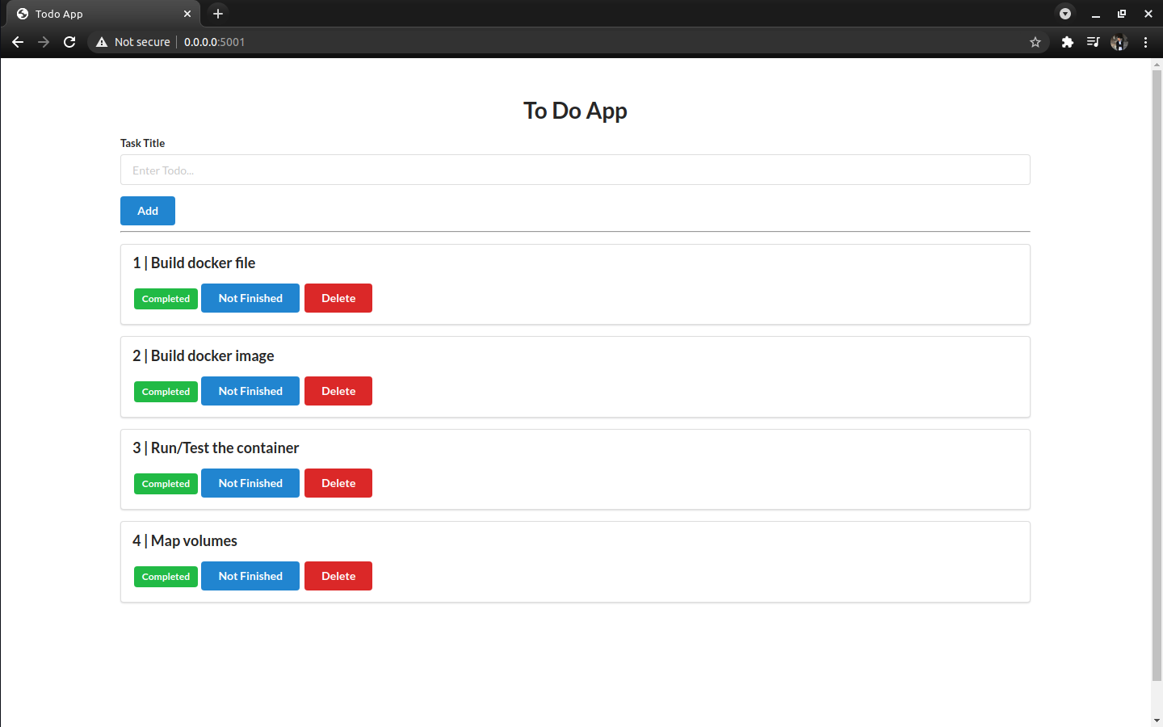

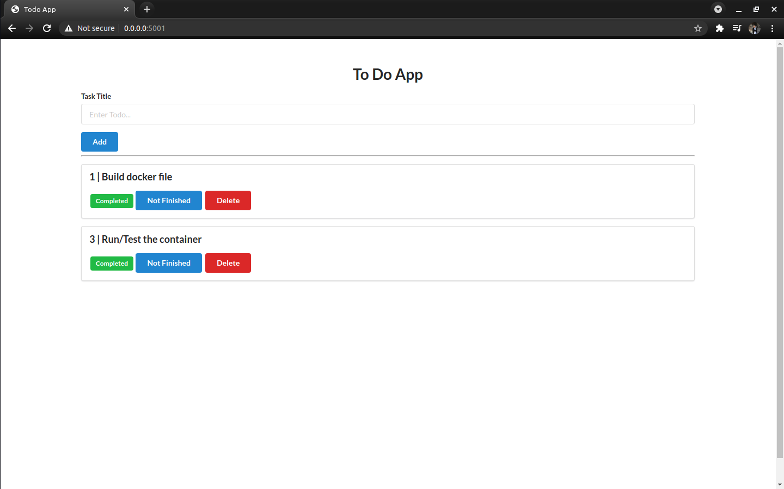

1. **Conclusion**

In conclusion, cloud computing has the potential to have a great impact on the world. It has many benefits that it provides to its users and businesses. It can be a very efficient way of sharing data and deploying applications.

For example, some of the benefits that it provides to businesses is that it reduces operating cost by spending less on maintenance and software upgrades and focusing more on the businesses themselves.

But there are other challenges that cloud computing must overcome. However, as with any infrastructure service, the suitability of cloud computing for your specific use case should be assessed in a risk-based evaluation. Build in time for [research and planning](https://cloudacademy.com/cloud-migration-benefits-risks/) to understand how the cloud will affect your business.

1. **REFERENCES**

[**https://medium.com/zenofai/how-to-build-a-node-js-and-mongodb-application-with-docker-containers-15e535baabf5**](https://medium.com/zenofai/how-to-build-a-node-js-and-mongodb-application-with-docker-containers-15e535baabf5)

[**https://youtu.be/cW34LTeogAg**](https://youtu.be/cW34LTeogAg)

[**https://www.youtube.com/watch?v=QIg3NIgkARI**](https://www.youtube.com/watch?v=QIg3NIgkARI)

**<https://www.geeksforgeeks.org/cloud-computing/>**

[**https://docs.aws.amazon.com/AWSEC2/latest/WindowsGuide/concepts.html**](https://docs.aws.amazon.com/AWSEC2/latest/WindowsGuide/concepts.html)