Aishwarya Varadannanavar

1BM19CS008

LINEAR REGRESSION

import pandas as pd

import numpy as np

from sklearn import linear_model

import matplotlib.pyplot as plt

from sklearn.metrics import mean_squared_error

df = pd.read_csv('/content/homeprices.csv')

df

%matplotlib inline

plt.xlabel('area')

plt.ylabel('price')

plt.scatter(df.area,df.price,color='red',marker='+')

new_df = df.drop('price',axis='columns')

new_df

price = df.drop('area',axis='columns')

price

# Create linear regression object

reg = linear_model.LinearRegression()

reg.fit(new_df,price)

#Predict price of a home with area = 3300 sqr ft

reg.predict([[3300]])

reg.coef_

reg.intercept_

plt.xlabel('area',fontsize=20)

plt.ylabel('price',fontsize=20)

plt.scatter(df.area,df.price,color='red',marker='+')

plt.plot(df.area,reg.predict(df[['area']]),color='blue')

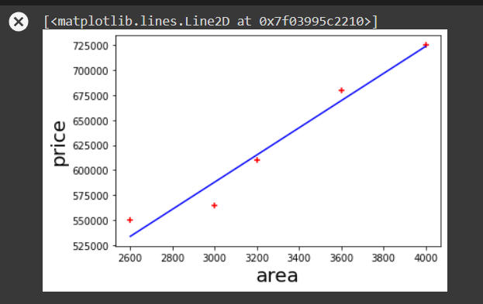

mean_squared_error(df['price'],reg.predict(df[['area']]))

df.price

df1 = pd.read_csv('/content/canada_per_capita_income.csv')

df1

df1 = df1.rename({"per capita income (US$)":"capita"}, axis='columns')

year1 = df1.drop('capita',axis='columns')

year1

capita1 = df1.capita

capita1

# Create linear regression object

reg1 = linear_model.LinearRegression()

reg1.fit(year1,capita1)

reg1.predict([[2020]])

%matplotlib inline

plt.xlabel('year',fontsize=20)

plt.ylabel('percapita',fontsize=20)

plt.scatter(df1.year,df1.capita,color='red',marker='+')

plt.plot(df1.year,reg1.predict(df1[['year']]),color='blue')

