SIMATS ENGINEERING (SAVEETHA SCHOOL OF ENGINEERING)
Department of Computer Science and Engineering
CO1 ASSESSMENT TOOL 2 – Agile Sprint Planning & User Story Workshop

Course Code: | CSA10 / CSA1010 | Course Title: | Software Engineering
CO Assessed: | CO1 | Assessment: | Assessment Tool 2 – Agile Sprint Planning & User Story Workshop
Weightage: | 20% | Total Marks: | 25
CO1 Statement: | Apply advanced methodologies and agile project management techniques to manage software projects effectively
Student Name: | BHAVYA S | Reg. No.: | 192524376
Date: | 12.10.26 | Duration: | 60 minutes
Code of Conduct
I Bhavya S(192524376) (Name / Reg No) certify that this submission is my original work and that I have adhered to the guidelines specified for this assessment. I understand that any violation of academic integrity rules will result in disciplinary action.
Signature of the Student: S.Bhavya

Annexure A – Agile Sprint Planning & User Story Workshop

Instructions to Students:

Each student is assigned an individual software project problem statement. Based on the given problem statement, perform an Agile Sprint Planning and User Story Workshop by applying Agile software engineering practices. Prepare a comprehensive sprint planning document covering the following aspects:

Based on the given problem statement, perform an Agile Sprint Planning and User Story Workshop by applying Agile software engineering practices. Prepare a comprehensive sprint planning document covering the following aspects:

- Identify the Project Vision and Stakeholders
  - Define the project's vision, objectives, and identify all key stakeholders involved.
- Create Epics and User Stories
  - Break down the requirements into Epics and formulate well-structured User Stories using the format:
As a <user>, I want <feature>, so that <benefit>.
- Define Acceptance Criteria
  - Write clear and measurable acceptance criteria for each selected user story using the Given–When–Then format or equivalent.
- Prioritize the Product Backlog
  - Organize and prioritize the product backlog based on business value, customer needs, and project dependencies.
- Plan the Sprint Backlog
  - Select high-priority user stories for the first sprint and divide them into actionable development tasks.
- Estimate Effort Using Story Points
  - Assign story points to each selected user story using an appropriate estimation technique (e.g., Fibonacci sequence or Planning Poker) and justify your estimates.
- Present the Sprint Goal and Expected Deliverables
  - Define a clear sprint goal and describe the expected sprint deliverables, including the features to be completed at the end of the sprint.

Rubrics for Calculation

Criteria | Excellent (5 Marks) | Good (3 Marks) | Satisfactory (2 Marks) | Needs Improvement (1 Mark)
Project Vision & Stakeholder Identification (30%) | Project vision is clear, comprehensive, and aligned with the problem statement. All relevant stakeholders and their roles are correctly identified. | Vision is clear with minor omissions. Most stakeholders are correctly identified. | Vision is partially defined. Some stakeholders are missing or incorrectly identified. | Vision is unclear or incomplete.  Stakeholders are poorly identified or missing.
Epics & User Stories (25%) | Epics are well-defined and user stories are complete, follow Agile format, and fully capture functional requirements. | Epics and user stories are mostly complete with minor formatting or requirement issues. | User stories are partially complete with limited Agile structure. | User stories are incomplete, unclear, or do not follow Agile practices.
Acceptance Criteria (20%) | Acceptance criteria are specific, measurable, testable, and aligned with all user stories. | Acceptance criteria are mostly clear and testable with minor gaps. | Acceptance criteria are partially defined and lack clarity or completeness. | Acceptance criteria are missing or not aligned with user stories.
Product Backlog Prioritization & Sprint Planning (15%) | Product backlog is logically prioritized, sprint backlog is realistic, and task breakdown is complete. | Backlog prioritization and sprint planning are mostly appropriate with minor issues. | Prioritization or sprint planning is partially complete with limited justification. | Backlog prioritization and sprint planning are poorly organized or incomplete.
Story Point Estimation, Sprint Goal & Presentation (10%) | Story point estimation is well justified, sprint goal is clear, deliverables are realistic, and presentation is professional and well organized. | Estimation and sprint goal are mostly appropriate with minor inconsistencies.  Presentation is clear. | Estimation or sprint goal lacks justification.  Presentation is adequate but incomplete. | Estimation is unrealistic or missing. Sprint goal, deliverables, and presentation are unclear or incomplete.

Criteria | Mark
Project Vision & Stakeholder Identification (30%) | /5
Epics & User Stories (25%) | /5
Acceptance Criteria (20%) | /5
Product Backlog Prioritization & Sprint Planning (15%) | /5
Story Point Estimation, Sprint Goal & Presentation (10%) | /5
TOTAL | /25

Personal Expense and Budget Management System

Agile Sprint Planning & User Story Workshop
- Project Vision and Stakeholder Identification Project Vision
The Personal Expense and Budget Management System is a software application designed to help users manage their personal finances efficiently. It allows users to record income and expenses, categorize spending, create monthly budgets, receive alerts when spending approaches budget limits, and view financial reports.

Objectives
  - To maintain accurate records of income and expenses.
  - To categorize expenses such as food, travel, education, shopping, and bills.
  - To create monthly budgets and monitor spending.
  - To notify users when they approach or exceed their budget limits.
  - To generate financial reports that help users improve saving habits.

Stakeholders

Stakeholder | Role and Responsibility
User | Records income and expenses, creates budgets, and views reports.
Project Owner | Defines project objectives and prioritizes requirements.
Product Owner | Maintains the product backlog and clarifies requirements.
Scrum Master | Organizes Scrum activities and removes obstacles.
Development Team | Designs, develops, and integrates application features.
Testing Team | Tests functionality and verifies acceptance criteria.
System Administrator | Manages application configuration, access, and maintenance.
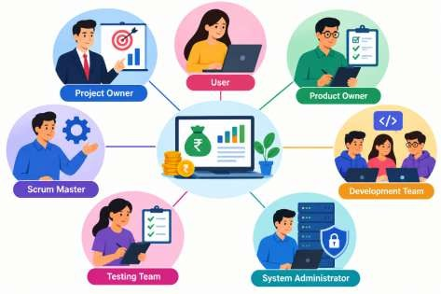

Project Scope

The system will include income and expense tracking, spending categories, budget creation, budget alerts, and financial reports. The initial version will focus on essential financial management features, with advanced analytics and additional features planned for later sprints.

Create Epics and User Stories
An epic is a large functional requirement that can be divided into smaller user stories.

Epic ID | Epic Name | Description
E1 | Income Management | Record and manage income details.
E2 | Expense Management | Record, edit, delete, and categorize expenses.
E3 | Budget Management | Create and monitor monthly budgets.
E4 | Budget Alerts | Notify users about budget limits and overspending.
E5 | Financial Reports | Display summaries of income, expenses, and savings.

User Stories

Story ID | Epic | User Story
US01 | E1 | As a user, I want to record my income so that I can track my earnings.
US02 | E2 | As a user, I want to add an expense with an amount, date, and category so that I can monitor my spending.
US03 | E2 | As a user, I want to edit or delete an expense so that I can  correct mistakes.
US04 | E3 | As a user, I want to create a monthly budget so that I can  control my spending.
US05 | E3 | As a user, I want to view my remaining budget so that I know how much money I can spend.
US06 | E4 | As a user, I want to receive an alert when I reach 80% of my budget so that I can reduce unnecessary spending.
US07 | E4 | As a user, I want to receive an alert when I exceed my budget

 |  | so that I can take corrective action.
US08 | E5 | As a user, I want to view a monthly financial report so that I can understand my financial condition.
US09 | E5 | As a user, I want to view expenses by category so that I can identify where most of my money is spent.

Define Acceptance Criteria

Acceptance criteria specify the conditions that must be satisfied for a user story to be considered complete. The Given–When–Then format makes the requirements measurable and testable.

Story ID | Given | When | Then
US01 | The user is on the income entry page. | The user enters a valid amount, date, and source and clicks Save. | The income record is saved and the total income is updated.
US02 | The user is on the expense entry page. | The user enters a valid amount, date, and category and clicks Save. | The expense is saved and appears in the expense list.
US03 | An expense record exists. | The user edits or deletes the record. | The changes are saved or the record is  removed, and totals are updated.
US04 | The user has opened budget management. | The user enters a valid monthly budget and saves it. | The budget is stored and displayed for the selected month.
US05 | A monthly budget and expense records exist. | The user opens the budget summary. | The system displays the budget, amount spent, and remaining amount correctly.
US06 | A monthly budget is configured. | Total spending reaches or exceeds 80% of the  budget but has not exceeded it. | The system displays a budget warning.
US07 | A monthly budget is configured. | Total spending exceeds the budget. | The system displays an overspending alert.
US08 | Income and expense records exist for a month. | The user selects that month and opens Reports. | The system displays total income, total expenses, and savings for that month.
US09 | Expense records contain categories. | The user opens the category report. | The system displays expense totals grouped by category.

Example calculation: If the monthly budget is ₹10,000 and recorded expenses total ₹8,000, the system should display 80% budget usage and trigger the budget warning.

Prioritize the Product Backlog

Priority | Story ID | User Story / Feature | Reason
Must Have | US01 | Record income | Required to calculate total income.
Must Have | US02 | Add and categorize expenses | Core feature for tracking spending.
Must Have | US04 | Create monthly budget | Required for budget monitoring.
Must Have | US05 | View remaining budget | Depends on budget and expense data.
Should Have | US03 | Edit or delete expenses | Helps correct inaccurate records.
Should Have | US06 | 80% budget alert | Helps prevent overspending.
Should Have | US08 | Monthly financial report | Helps users understand their finances.
Could Have | US09 | Category-wise report | Provides additional spending insights.
Could Have | US07 | Overspending alert | Adds another layer of budget monitoring.

Won't Have in the first release: Advanced investment tracking and bank account integration. These can be considered in future releases.

Sprint Planning
  - Sprint duration: 1 week (5 working days).
  - Sprint approach: Scrum.
  - Sprint team: Product Owner, Scrum Master, developers, and tester.
  - Sprint selection: Start with the basic income and expense functions, then build budget creation and remaining-budget calculation on top of them.

Plan the Sprint Backlog

The first sprint focuses on implementing the basic financial tracking and budget features.

Story ID | Development Task | Responsible Role | Expected Output
US01 | Design income entry form and validation. | Developer | Income entry screen
US01 | Save income records and calculate total income. | Developer | Working income management
US02 | Design expense form and category selection. | Developer | Expense entry screen
US02 | Save expenses and display the expense list. | Developer | Working expense tracking
US04 | Design the monthly budget form. | Developer | Budget creation screen
US04 | Save and retrieve the monthly budget. | Developer | Working budget storage
US05 | Calculate amount spent and remaining budget. | Developer | Budget summary

US01–US05 | Test calculations, input  validation, and integration. | Tester | Tested core features

Suggested Sprint Schedule

Day | Planned Activity
Day 1 | Finalize requirements and design the income and expense forms.
Day 2 | Implement income and expense recording.
Day 3 | Implement monthly budget creation.
Day 4 | Implement remaining-budget calculation and integration.
Day 5 | Test the features, fix defects, and demonstrate the sprint results.
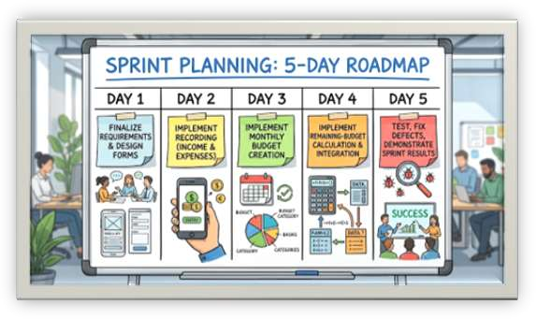

Estimate Effort Using Story Points
Story points estimate the relative effort, complexity, and uncertainty of a user story. The Fibonacci sequence (1, 2, 3, 5, 8, 13) is used for estimation. The team can use Planning Poker to agree on the estimates.

Story ID | User Story | Story Points | Justification
US01 | Record income | 3 | Requires form validation, storage, and total calculation.
US02 | Add and categorize expenses | 5 | Requires expense entry, category selection, validation, and storage.

US03 | Edit or delete expenses | 3 | Requires updating or  removing records and recalculating totals.
US04 | Create monthly budget | 3 | Requires budget input, validation, and storage.
US05 | View remaining budget | 5 | Requires combining budget and expense data and calculating the balance.
US06 | 80% budget alert | 3 | Requires threshold checking and warning display.
US07 | Overspending alert | 3 | Requires detecting  budget overruns and displaying alerts.
US08 | Monthly financial report | 5 | Requires calculating and presenting monthly totals.
US09 | Category-wise report | 5 | Requires grouping expenses and calculating category totals.

First Sprint Estimation

Selected stories: US01, US02, US04, and US05.

Story ID | Story Points
US01 – Record income | 3
US02 – Add expenses | 5
US04 – Create budget | 3
US05 – View remaining budget | 5
Total | 16
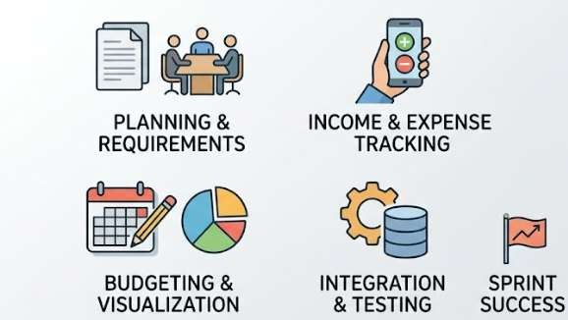

Justification: The first sprint contains 16 story points. This is a proposed initial estimate for a one-week sprint, assuming the team has sufficient capacity. Actual estimates should be adjusted based on team experience and available working hours.

Sprint Goal and Expected Deliverables Sprint Goal
To develop the basic financial tracking module that allows users to record income and expenses, create a monthly budget, and view their remaining budget accurately.

Expected Deliverables
- An income entry form with validation and record storage.
- An expense entry form with expense categories.
- A monthly budget creation feature.
- A budget summary displaying the total budget, amount spent, and remaining amount.
- Tested and integrated core features that satisfy the defined acceptance criteria.

Definition of Done
A user story is considered complete when:
  - The feature is implemented and integrated.
  - Input validation and calculations work correctly.
  - Acceptance criteria are satisfied.
  - Testing is completed and identified defects are resolved.
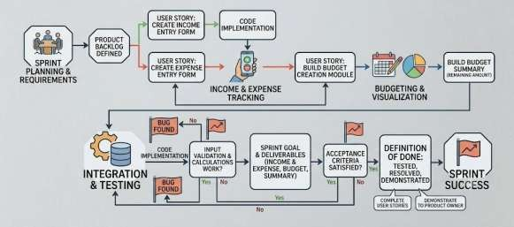
  - The completed feature is demonstrated to the Product Owner.

Expected Outcome
At the end of the first sprint, users should be able to record their income and expenses, set a monthly budget, and monitor their remaining balance. Budget alerts and financial reports will be developed in subsequent sprints.

Fig- Sprint Development Flowchart

Conclusion

The Agile Sprint Planning and User Story Workshop provides a structured approach to developing the Personal Expense and Budget Management System. By defining project objectives, identifying stakeholders, creating epics and user stories, specifying acceptance criteria, prioritizing the backlog, and estimating effort, the team can deliver essential financial management features incrementally. Scrum supports continuous testing, feedback, and improvement throughout development.

