Bluestock Mutual Fund Analytics Capstone Project
Executive Summary
This project analyses the Indian Mutual Fund industry using data engineering, data analytics, risk analysis, and business intelligence techniques. The objective was to build an end-to-end analytics solution that transforms raw mutual fund datasets into actionable insights for investors and financial institutions.
The project includes ETL pipelines, data cleaning, exploratory data analysis, performance analytics, advanced risk metrics, and an interactive Power BI dashboard.

1. Introduction
The Indian Mutual Fund industry has experienced significant growth in assets under management (AUM), investor participation, and SIP contributions. Understanding fund performance, investor behaviour, and market trends is essential for informed investment decisions.
The objective of this project is to analyse mutual fund schemes, benchmark performance, investor transactions, and market trends using modern data analytics techniques.

2. Project Objectives
- Build a complete ETL pipeline.
- Store processed data in SQLite.
- Perform exploratory data analysis.
- Calculate advanced performance metrics.
- Develop an interactive dashboard.
- Conduct advanced investor analytics.
- Generate actionable insights and recommendations.

3. Data Sources
The project uses multiple datasets:
- Mutual Fund NAV History
- Scheme Performance Data
- Industry AUM Statistics
- SIP Inflows
- Category Inflows
- Investor Transactions
- Portfolio Holdings
- Nifty Benchmark Indices
These datasets were cleaned, transformed, and integrated into a unified analytics environment.

4. ETL Pipeline Design
The ETL process consists of:
Extract
Raw CSV files were collected from publicly available mutual fund datasets.
Transform
- Missing value handling
- Data type corrections
- Date standardisation
- Duplicate removal
- Feature engineering
Load
Processed datasets were loaded into SQLite and exported as cleaned CSV files for analytics and dashboarding.

5. Exploratory Data Analysis
Key analyses performed:
- Industry AUM growth trend
- SIP inflow trend
- Fund house comparison
- Folio growth analysis
- Sector allocation analysis
- Demographic analysis
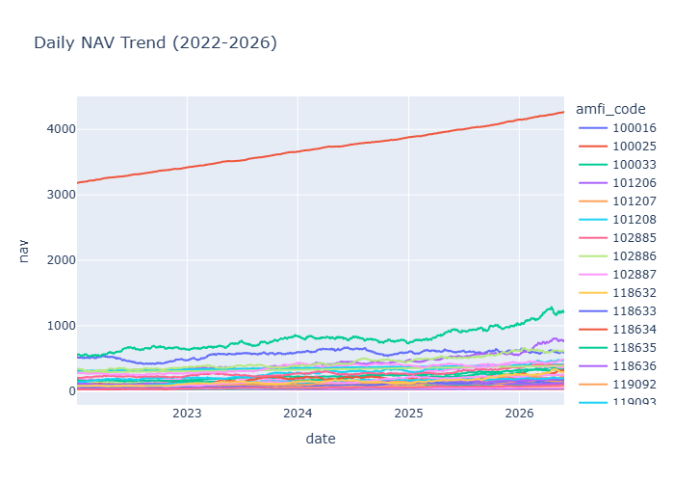
- State-wise investor distribution

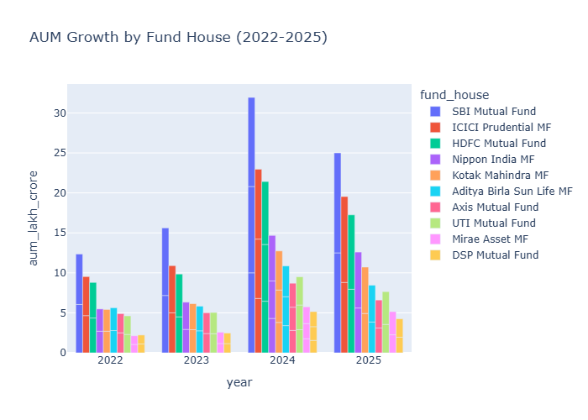

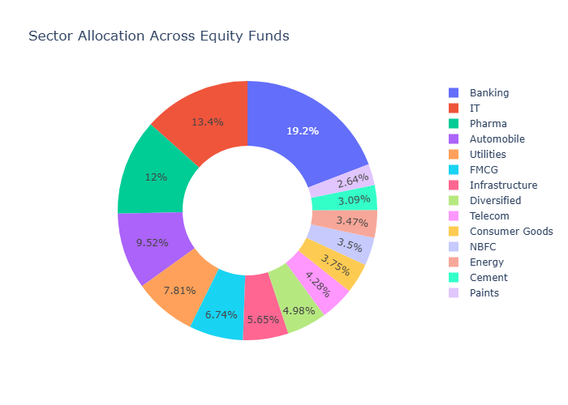

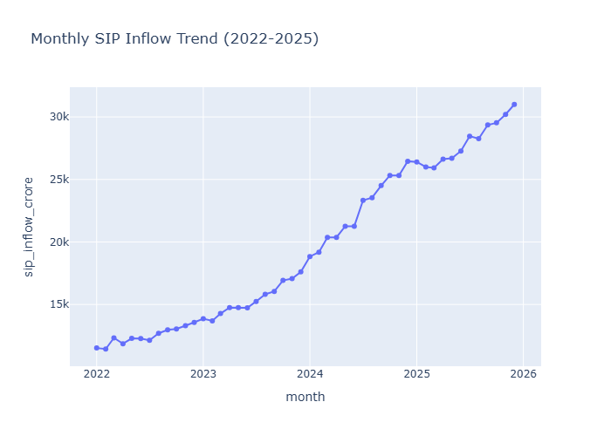

6. Performance Analytics
Metrics calculated:
- Daily Returns
- CAGR (1Y, 3Y, 5Y)
- Sharpe Ratio
- Sortino Ratio
- Alpha
- Beta
- Maximum Drawdown
- Fund Scorecard
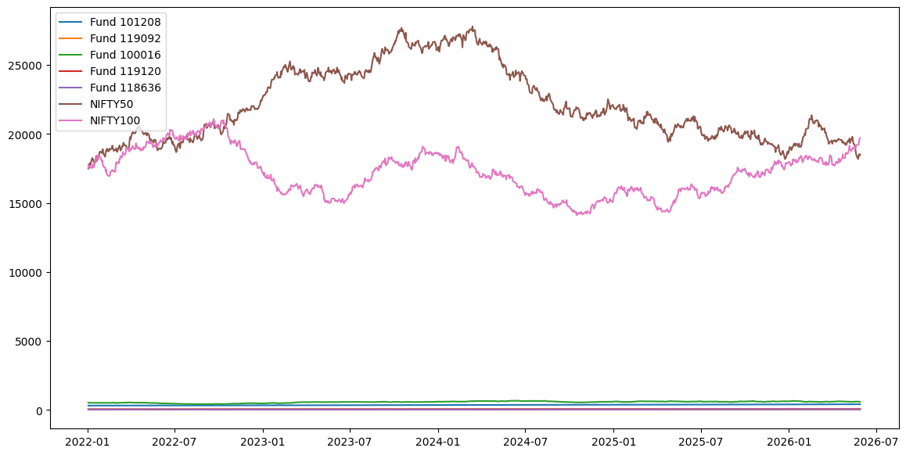
- Tracking Error

7. Advanced Analytics
Advanced risk and investor analyses include:
- Historical VaR
- Conditional VaR
- Rolling Sharpe Ratio
- Investor Cohort Analysis
- SIP Continuity Analysis
- Sector HHI Concentration
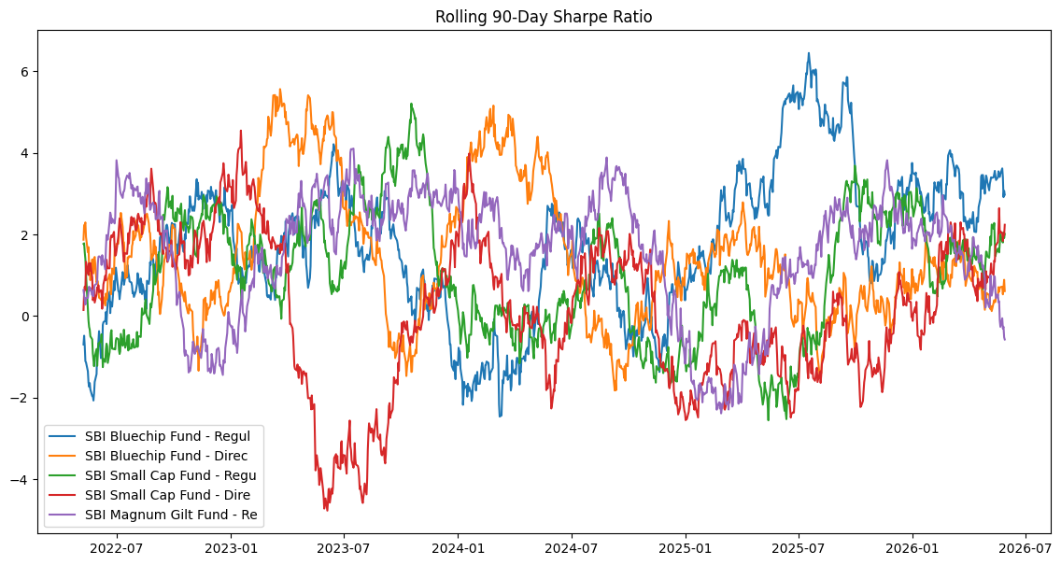
- Fund Recommendation Engine

8. Dashboard Development
Four interactive dashboard pages were developed:
Industry Overview
KPIs, AUM trend, AMC comparison
Fund Performance
Risk-return scatter plot, scorecards, NAV analysis
Investor Analytics
State, age, and transaction insights
SIP & Market Trends
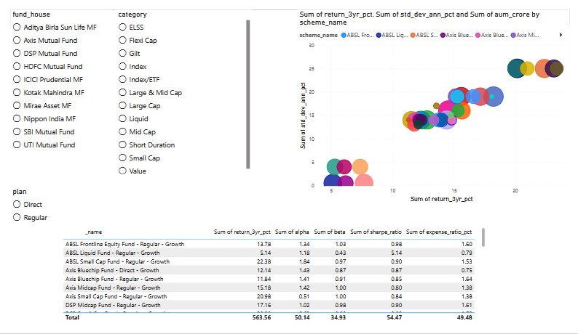
Category inflows, SIP trends, benchmark trends
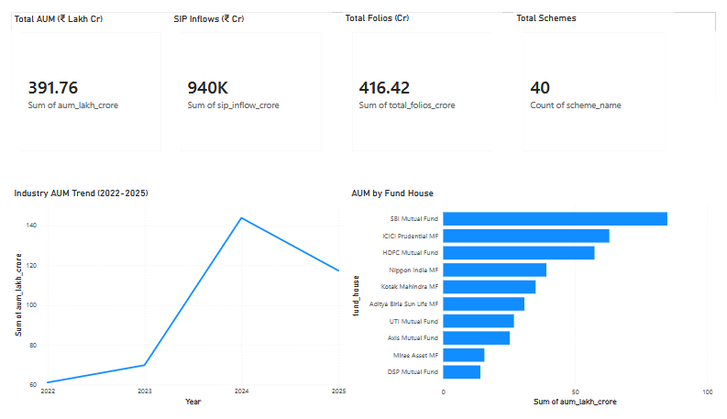

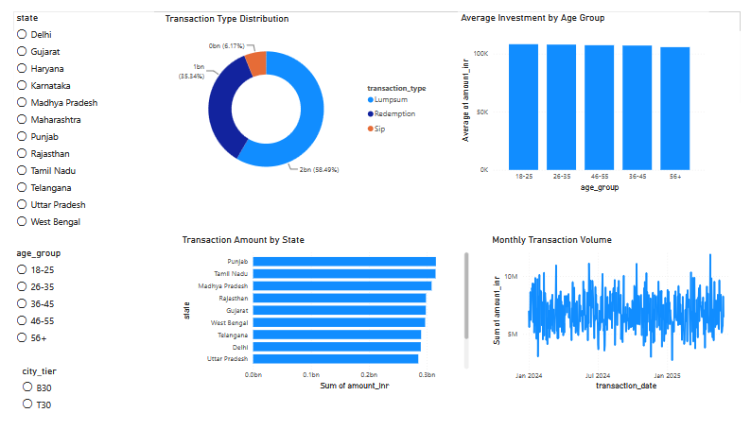
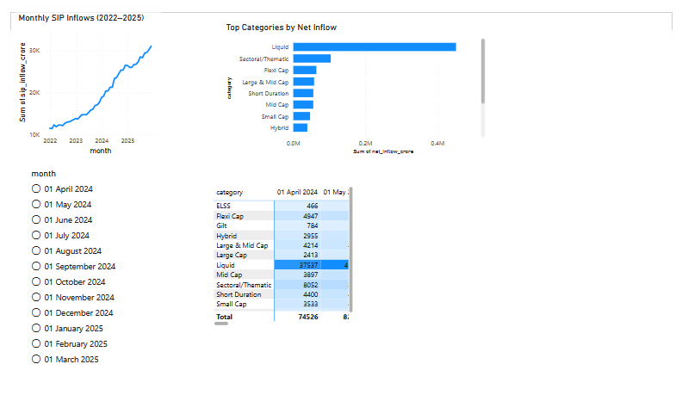

9. Key Findings
- SIP inflows consistently increased across the study period.
- Equity-focused funds generated stronger long-term returns.
- Risk-adjusted performance varied significantly across schemes.
- Investor participation increased steadily across cohorts.
- Several funds displayed concentrated sector exposure.

10. Limitations
- Historical data limitations.
- Market conditions may change future performance.
- Simplified recommendation logic.
- Limited benchmark coverage.

11. Recommendations
- Investors should focus on risk-adjusted returns.
- SIP continuity should be monitored.
- Diversification can reduce concentration risk.
- Dashboard monitoring should be updated periodically.

12. Conclusion
This project successfully demonstrates the complete analytics lifecycle from raw data ingestion to business intelligence reporting. The developed dashboard and analytics framework provide valuable insights into mutual fund performance, investor behaviour, and industry trends.

