FINAL PROJECT SCREENSHOTS

The login to employee management system is provided to admins, whose details are stored in an admins table having two columns name and password.

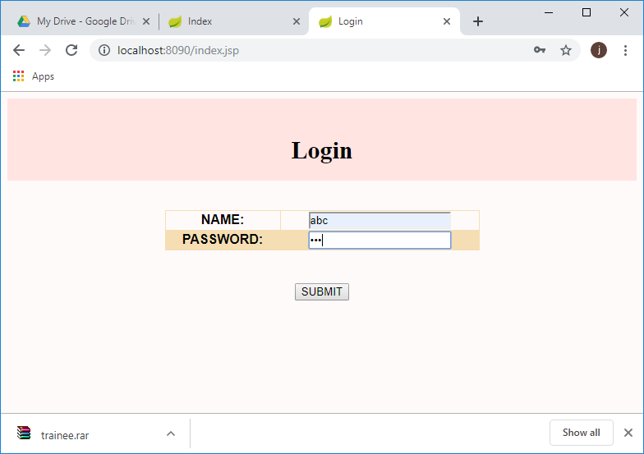

The main menu/ home page:

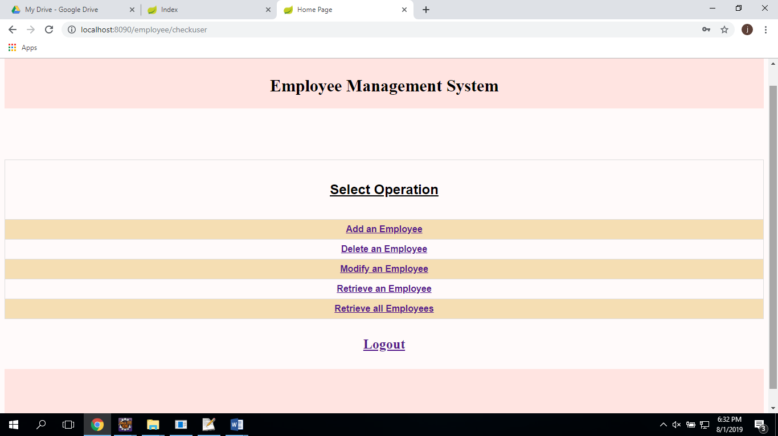

Add an Employee:

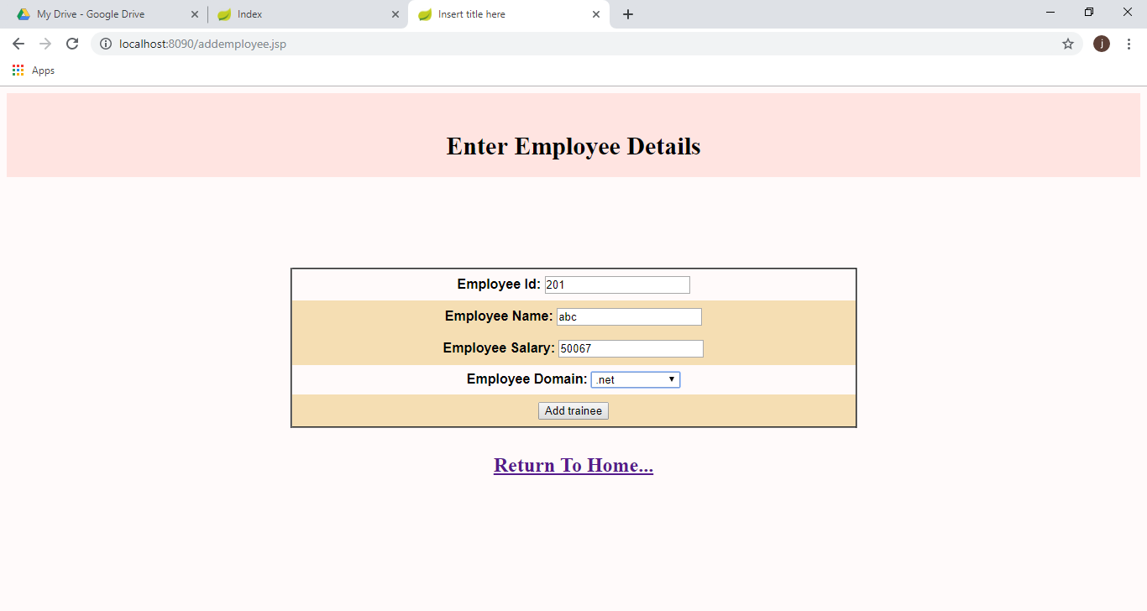

List of all employees:

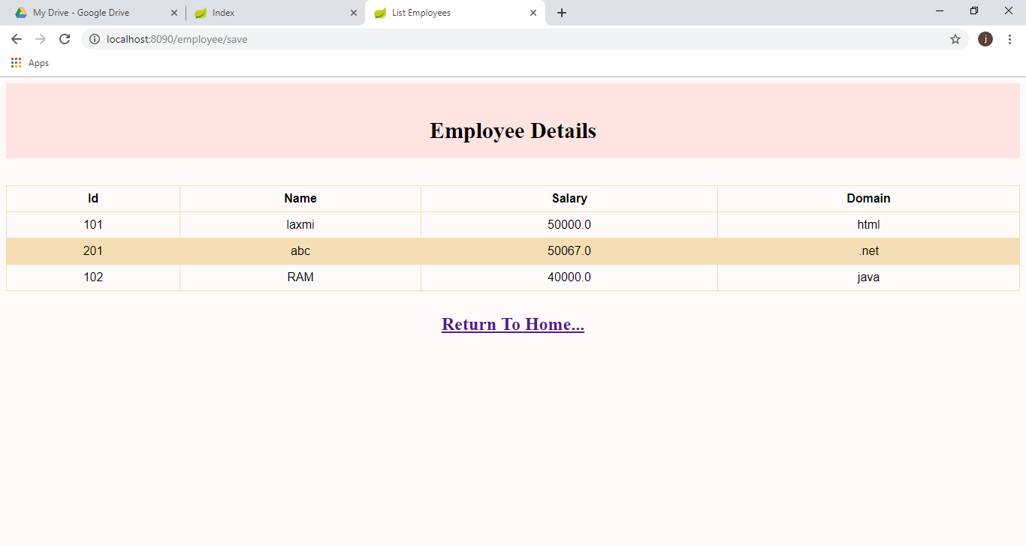

Delete User :

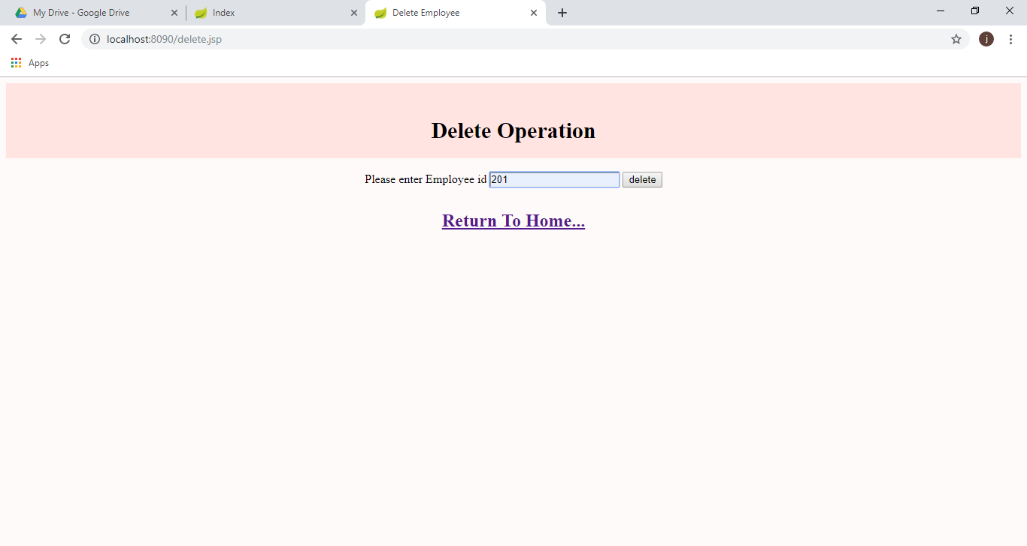

User Retrieval

